Supplementary information

Large Area Homogeneous Deposition of Perovskite in
Fully-Printable Perovskite Solar Cells
S. M. P. Meroni, Y. Mouhamad, F. De Rossi, A. Pockett, J. Baker,
R. Escalante, J. Searle, M. J. Carnie, E. Jewell, G. Oskam and T. M. Watson

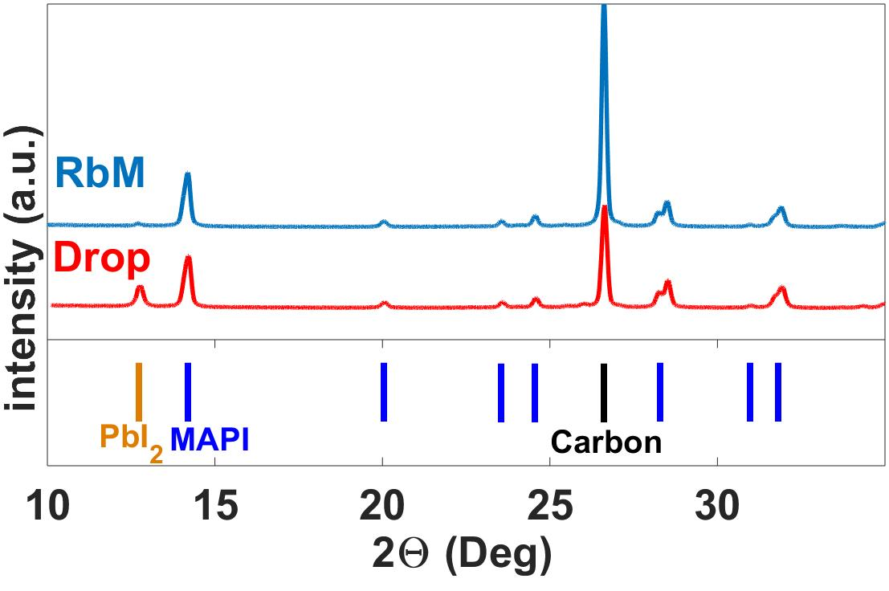
Figure S1 XRD of drop and RbM cells without the use of a collimator.

