Additional File 2

Trends in mean monthly cigarette sales per adult smoker, by pack size, Scotland and England/Wales, 2008-2015
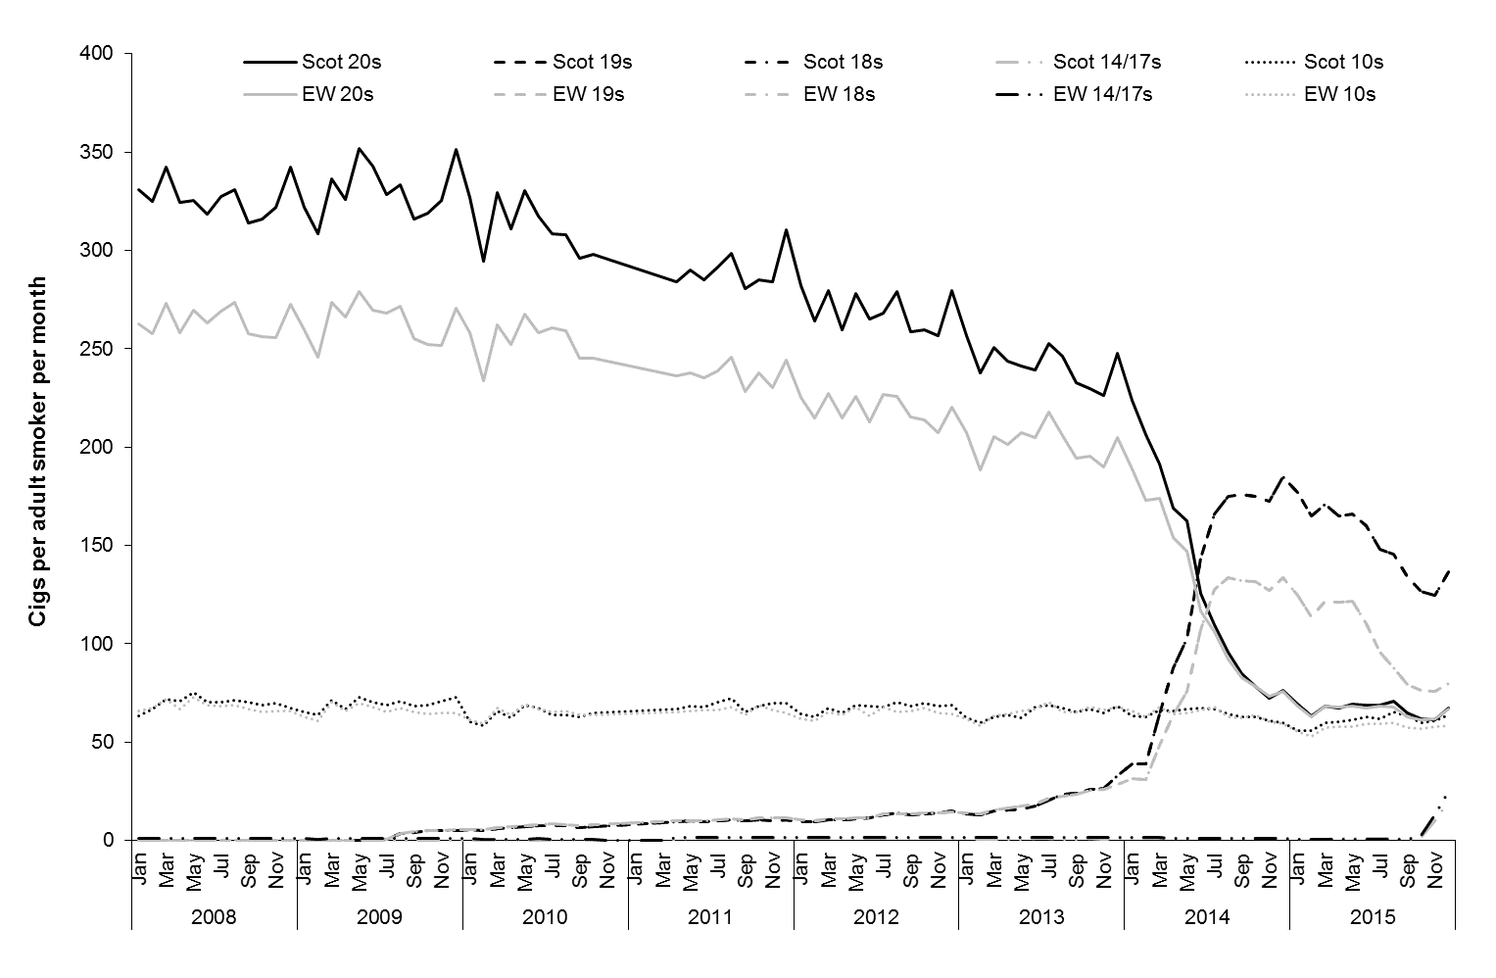
Source: Cigarette sales data were obtained from Nielsen. Notes: Scot = Scotland; EW = England/Wales

