**Phenolic glycosides from *Lavandual angustifolia* Waste**

Nigary Yadikar a, c, Khayrulla Bobakulov d, Haji Akber Aisa a,b,*

a The Key Laboratory of Plant Resources and Chemistry of Arid Zone, Xinjiang Technical Institute of Physics and Chemistry, Chinese Academy of Sciences, Urumqi 830011, China;

b State Key Laboratory Basis of Xinjiang Indigenous Medicinal Plants Resource Utilization, Xinjiang Technical Institute of Physics and Chemistry, Chinese Academy of Sciences, Urumqi 830011, China;

c University of Chinese Academy of Sciences, Beijing 100039, China;

d Institute of the Chemistry of Plant Substances, Academy of Sciences of the Republic of Uzbekistan, Tashkent 100170, Uzbekistan.

*Corresponding authors. Tel.: +86 991 383 5679; fax: +86 991 3838957. *E-mail address*: [haji@ms.xjb.ac.cn](mailto:haji@ms.xjb.ac.cn) (Haji Akber Aisa).

**Supporting information**

1. UV spectrum (methanol) of compound **1**.
2. HR-ESI-MS spectrum (negtive mode) of compound **1**.
3. 1H NMR spectrum (400 MHz, DMSO-*d6*) of compound **1**.
4. 13C NMR spectrum (100 MHz, DMSO-*d6*) of compound **1**.
5. HSQC spectrum (400 MHz, DMSO-*d6*) of compound **1**.
6. HMBC spectrum (400 MHz, DMSO-*d6*) of compound **1**.
7. COSY spectrum (400 MHz, DMSO-*d6*) of compound **1**.
8. NOE spectrum (600 MHz, DMSO-*d6*) of compound **1.**
9. UV spectrum (methanol) of compound **2**.
10. HR-ESI-MS spectrum (positive mode) of compound **2**.
11. 1H NMR spectrum (600 MHz, DMSO-*d6*) of compound **2**.
12. 13C NMR spectrum (150 MHz, DMSO-*d6*) of compound **2**.
13. HSQC spectrum (600 MHz, DMSO-*d6*) of compound **2**.
14. HMBC spectrum (600 MHz, DMSO-*d6*) of compound **2**.
15. COSY spectrum (600 MHz, DMSO-*d6*) of compound **2**.
16. UV spectrum (methanol) of compound **3**.
17. HR-ESI-MS spectrum (positive mode) of compound **3**.
18. IR spectrum of compound **3**.
19. 1H NMR spectrum (600 MHz, DMSO-*d6*) of compound **3**.
20. 13C NMR spectrum (150 MHz, DMSO-*d6*) of compound **3**.
21. HSQC spectrum (600 MHz, DMSO-*d6*) of compound **3**.
22. HMBC spectrum (600 MHz, DMSO-*d6*) of compound **3**.
23. COSY spectrum (600 MHz, DMSO-*d6*) of compound **3**.
24. UV spectrum (methanol) of compound **4**.
25. HR-ESI-MS spectrum (positive mode) of compound **4**.
26. IR spectrum of compound **4**.
27. 1H NMR spectrum (400 MHz, DMSO-*d6*) of compound **4**.
28. 13C NMR spectrum (100 MHz, DMSO-*d6*) of compound **4**.
29. HSQC spectrum (400 MHz, DMSO-*d6*) of compound **4**.
30. HMBC spectrum (400 MHz, DMSO-*d6*) of compound **4**.
31. COSY spectrum (400 MHz, DMSO-*d6*) of compound **4**.

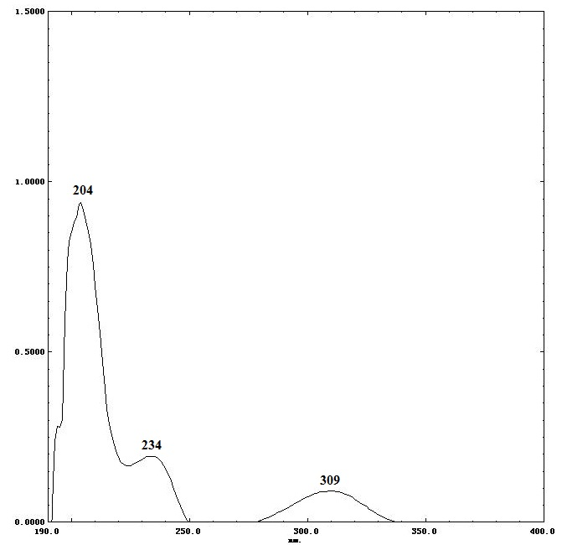

1. UV spectrum (methanol) of compound **1**



1. HR-ESI-MS spectrum (negtive mode) of compound **1**

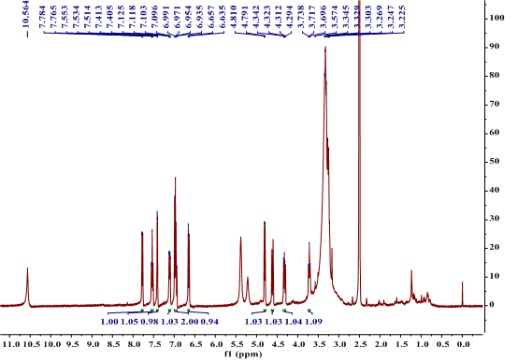

1. 1H NMR spectrum (400 MHz, DMSO-*d6*) of compound **1**

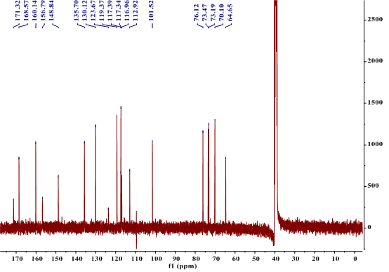

1. 13C NMR spectrum (100 MHz, DMSO-*d6*) of compound **1**

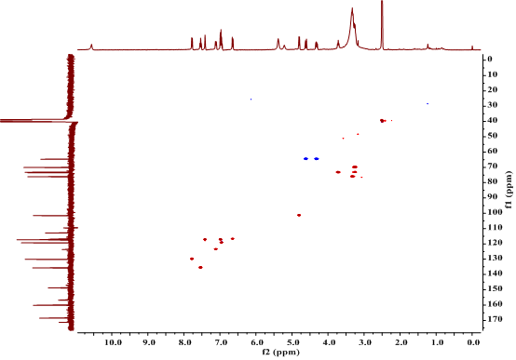

1. HSQC spectrum (400 MHz, DMSO-*d6*) of compound **1**

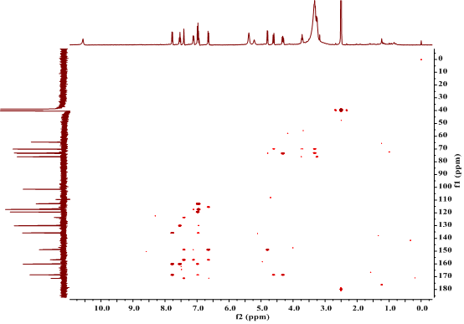

1. HMBC spectrum (400 MHz, DMSO-*d6*) of compound **1**

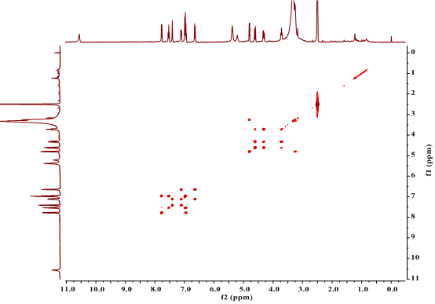

1. COSY spectrum (400 MHz, DMSO-*d6*) of compound **1**

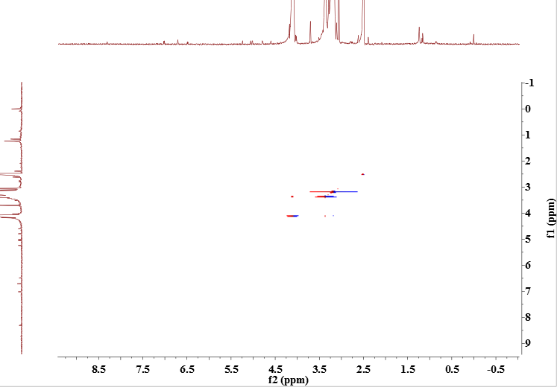

1. NOE spectrum (600 MHz, DMSO-*d6*) of compound **1**

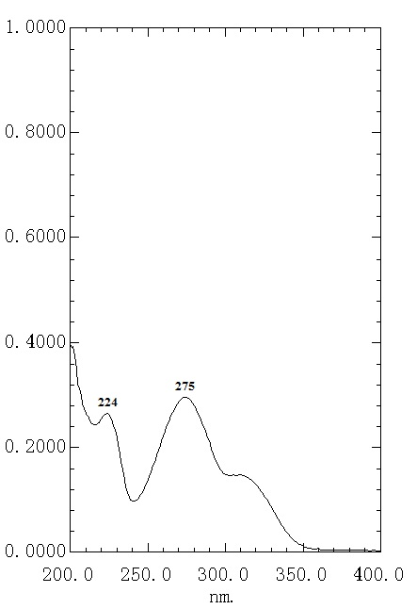

1. UV spectrum (methanol) of compound **2**



1. HR-ESI-MS spectrum (positive mode) of compound **2**

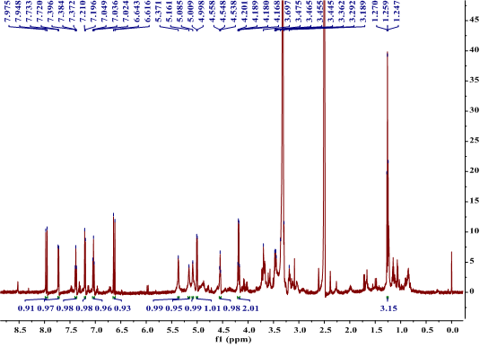

1. 1H NMR spectrum (600 MHz, DMSO-*d6*) of compound **2**

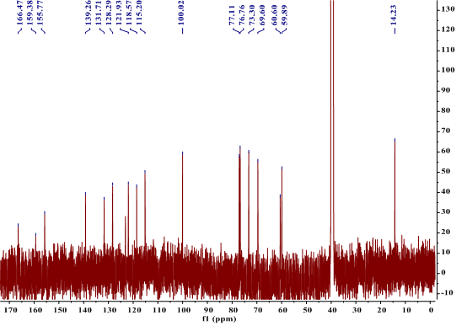

1. 13C NMR spectrum (150 MHz, DMSO-*d6*) of compound **2**

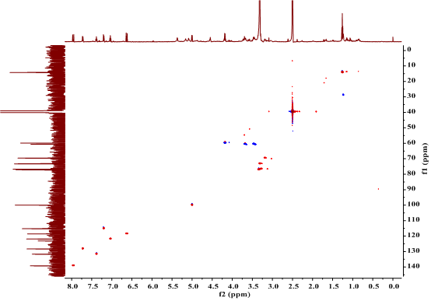

1. HSQC spectrum (600 MHz, DMSO-*d6*) of compound **2**

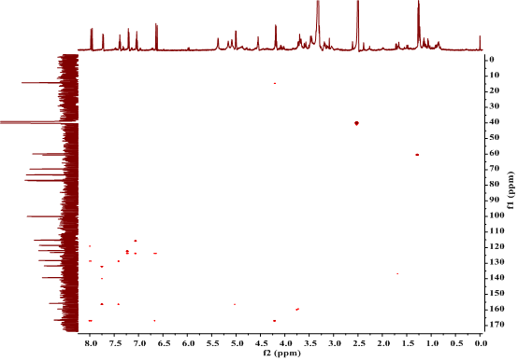

1. HMBC spectrum (600 MHz, DMSO-*d6*) of compound **2**

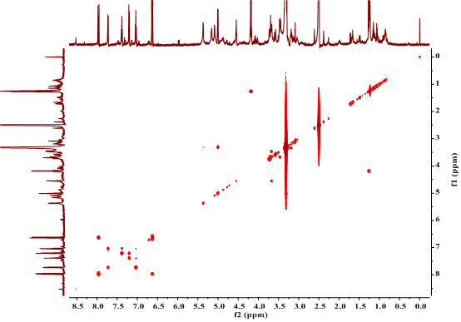

1. COSY spectrum (600 MHz, DMSO-*d6*) of compound **2**

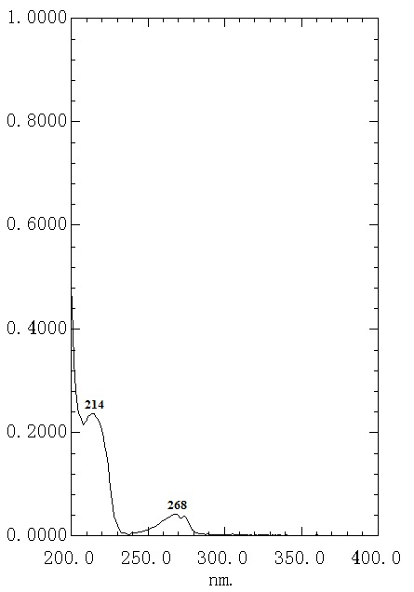

1. UV spectrum (methanol) of compound **3**



1. HR-ESI-MS spectrum (positive mode) of compound **3**

C:\Users\Administrator\Desktop\LA--90.TIF

1. IR spectrum of compound **3**

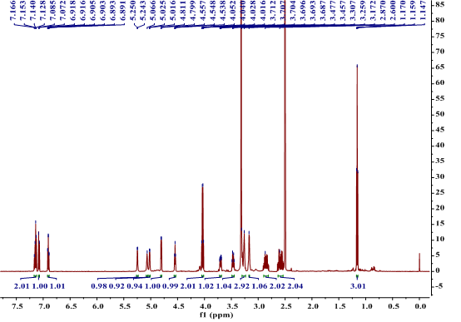

1. 1H NMR spectrum (600 MHz, DMSO-*d6*) of compound **3**

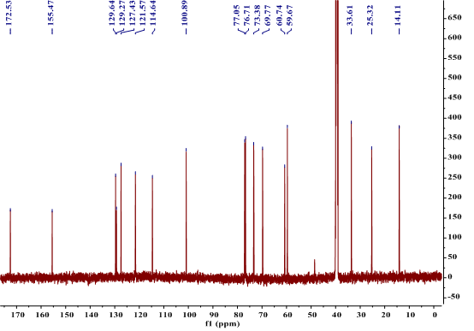

1. 13C NMR spectrum (150 MHz, DMSO-*d6*) of compound **3**

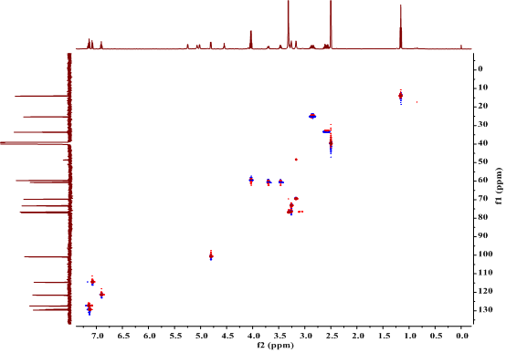

1. HSQC spectrum (600 MHz, DMSO-*d6*) of compound **3**

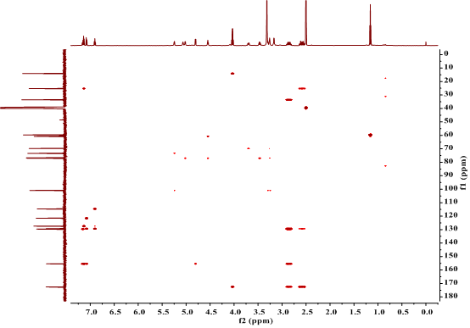

1. HMBC spectrum (600 MHz, DMSO-*d6*) of compound **3**

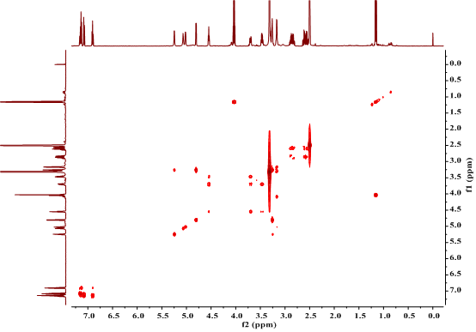

1. COSY spectrum (600 MHz, DMSO-*d6*) of compound **3**

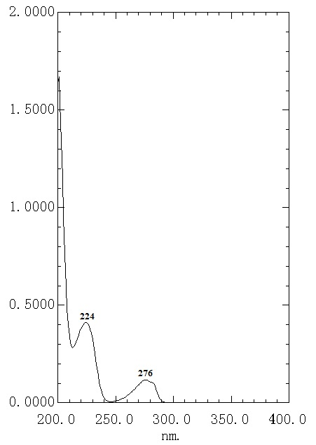

1. UV spectrum (methanol) of compound **4**



1. HR-ESI-MS spectrum (positive mode) of compound **4**

C:\Users\Administrator\Desktop\LA-94.TIF

1. IR spectrum of compound **4**

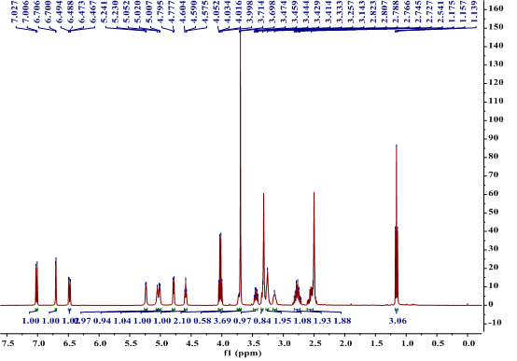

1. 1H NMR spectrum (400 MHz, DMSO-*d6*) of compound **4**

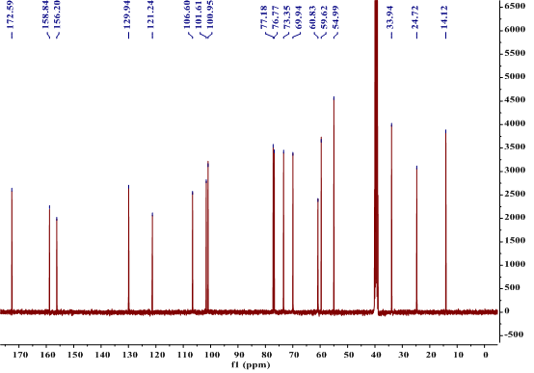

1. 13C NMR spectrum (100 MHz, DMSO-*d6*) of compound **4**

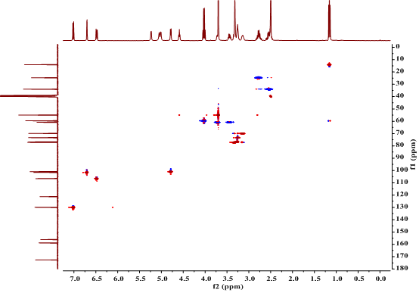

1. HSQC spectrum (400 MHz, DMSO-*d6*) of compound **4**

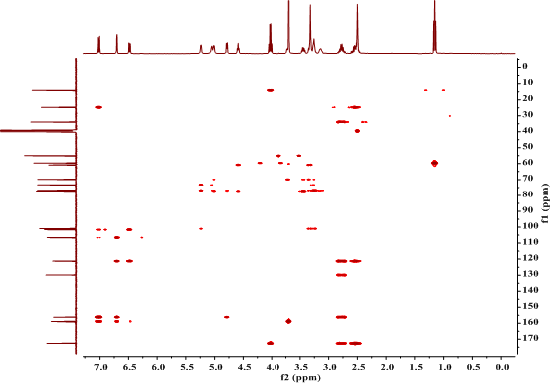

1. HMBC spectrum (400 MHz, DMSO-*d6*) of compound **4**

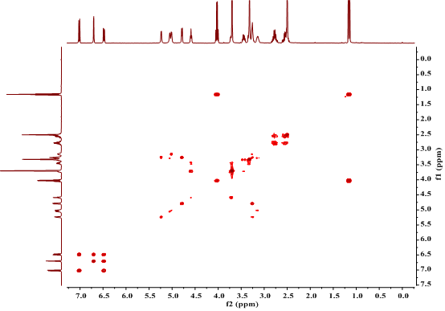

1. COSY spectrum (400 MHz, DMSO-*d6*) of compound **4**