Online Supplementary Material for Mattison et al., [Title]

Table S1. Models of the cohort effect within exclusively matrilineal or patrilineal regions, along with an interaction model. See Table 2 legend for interpretation of coefficients.

 |  | Matrilineal (n=264) | Patrililneal  (n=56) | Lineality x Cohort  (n=320)
Cohort | (<1955)
 | 1955-59 | 1.47 [0.79, 2.73] | 1 [0.19, 5.17] | 1.48 [0.8, 2.74]
 | 1960-64 | 1.85 [1, 3.43] | 5.83 [0.89, 38.43] | 1.87 [1.01, 3.46]
 | 1965-69 | 3.35 [1.87, 5.99] | 12.35 [1.64, 93.12] | 3.58 [2.01, 6.39]
 | 1970-74 | 2.78 [1.53, 5.05] | 14.18 [1.88, 106.9] | 2.81 [1.56, 5.08]
 | 1975-79 | 5.77 [3.11, 10.72] | 24.18 [3.41, 171.44] | 6.27 [3.37, 11.63]
 | 1980-84 | 4.35 [2.62, 7.23] | 15.37 [2.35, 100.38] | 4.43 [2.69, 7.31]
 | 1985-89 | 4.02 [2.42, 6.66] | 24.59 [3.81, 158.68] | 4.05 [2.46, 6.68]
 | 1990-94 | 2.1 [1.16, 3.82] | 2.65 [0.45, 15.7] | 2.2 [1.21, 3.98]
Lineality | (matrilineal)
 | patrilineal |  |  | 2.01 [0.47, 8.53]
Village-level variance |  | 0.0109 | 0.0004 | 0.0007
Interaction: Patrilineal | (<1955)
 | 1955-59 |  |  | 0.72 [0.13, 3.99]
 | 1960-64 |  |  | 1.13 [0.2, 6.57]
 | 1965-69 |  |  | 0.8 [0.13, 4.81]
 | 1970-74 |  |  | 1.2 [0.2, 7.29]
 | 1975-79 |  |  | 0.89 [0.16, 4.94]
 | 1980-84 |  |  | 0.92 [0.18, 4.69]
 | 1985-89 |  |  | 1.44 [0.3, 7.03]
 | 1990-94 |  |  | 0.64 [0.11, 3.65]
negative LL |  | -1034.01 | -147.24 | -1314.00
df (k) |  | 1 | 1 | 18

Table S2. Model of cohort effect on AFB

 |  | Cohort (n=320)
Cohort | (<1955)
 | 1955-59 | 1.76 [1.01, 3.06]
 | 1960-64 | 2.16 [1.24, 3.77]
 | 1965-69 | 1.72 [1.03, 2.87]
 | 1970-74 | 1.82 [1.06, 3.14]
 | 1975-79 | 1.97 [1.16, 3.33]
 | 1980-84 | 1.56 [1.00, 2.43]
 | 1985-89 | 1.60 [1.05, 2.44]
 | 1990-94 | 1.47 [0.95, 2.27]
Village-level variance |  | 0.062
negative LL |  | -1522.2
df (k) |  | 9

Table S3. ALB by cohort

Reproductive Cohort | ALB Mean |  | ALB Median | Range | SD | n total
< 1955 | 37.5 |  | 39 | 21 - 51 | 7 | 36
1955 - 59 | 35.1 |  | 35 | 23 - 47 | 5.3 | 21
1960 - 64 | 32.9 |  | 34 | 21 - 43 | 5.0 | 21
1965 - 69 | 29.3 |  | 28 | 25 - 36 | 3.4 | 27
1970 - 74 | 29 |  | 28 | 22 - 44 | 5.3 | 22
1975 - 79 | 25.9 |  | 25 | 22 - 33 | 2.9 | 25
1980 - 84 | 26.7 |  | 26 | 20 - 38 | 4.5 | 49
1985 - 89 | 25.4 |  | 24 | 20 - 36 | 3.8 | 66
1990 - 94 | 25.3 |  | 25 | 17 - 33 | 3.7 | 53

Figure S1. ALB by village. Note: villages labeled M# are from the matrilineal region while those labeled P# are from the patrilineal area.
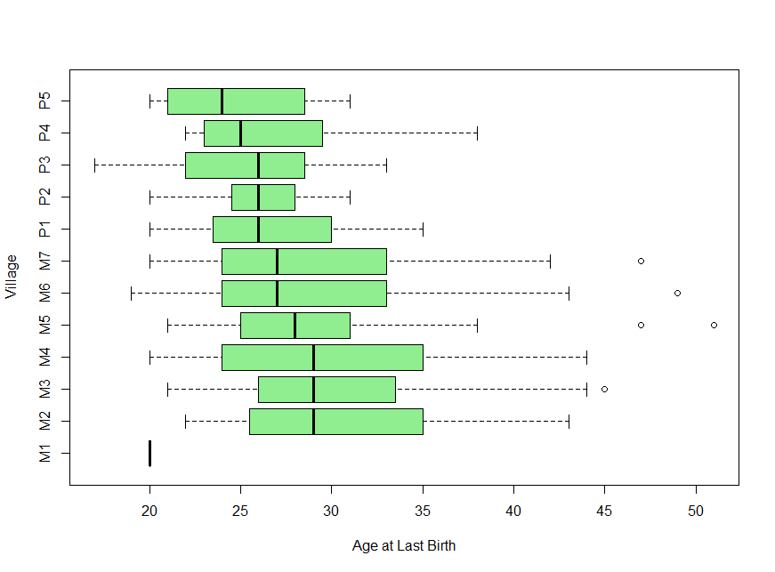

Figure S2. AFB by cohort and lineality

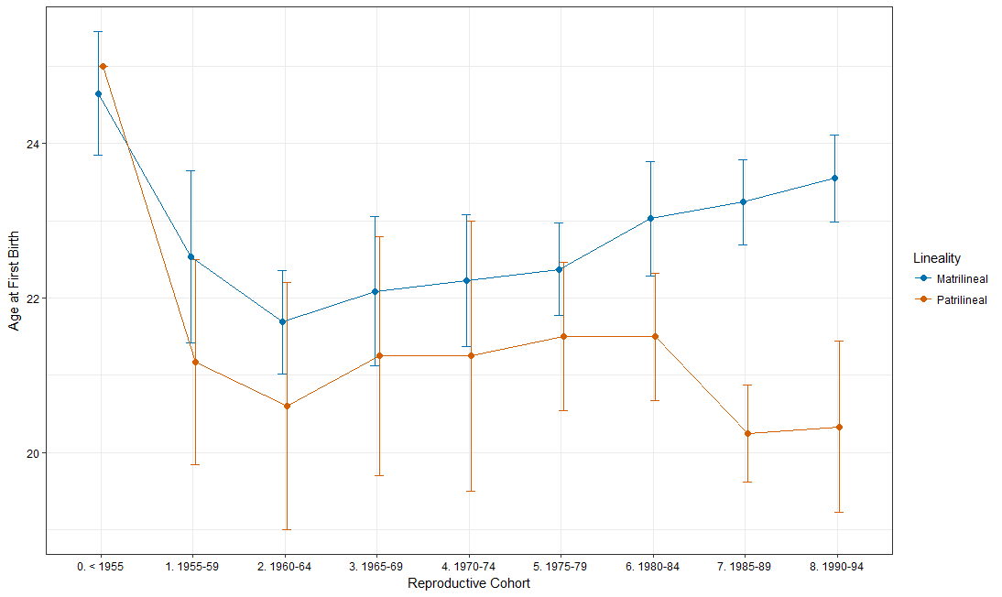
Figure S3. Fertility by cohort and lineality

