Supplementary Material

Fig. S1. Spectrophotometrically measured chlorophyll a concentration at the sampling stations of Lake Mondsee during the heat wave.

Fig. S2. Least-squares linear regression analysis of cyanobacterial biomass (0–21 m average) vs. average summer temperature during 2007–2015. All data were collected in July (2009–2015) or August (2007–2008) at the central station of Lake Mondsee.

Fig. S3. Results from the canonical correspondence analysis of the phytoplankton community composition in relation to the strongest environmental variables tested (temperature and nitrate concentration). Data were derived from biomass calculations from microscopic counts at the central station (S3, 0, and 5 m). Diat = diatoms, Chl = chlorophytes, Chry = chrysophytes, Conj = Conjugatophyceae, Cry = cryptophytes, Cyan = Cyanophyceae, Din = dinoflagellates.

Fig. S4. (a) Particle numbers of diatoms, (b) chlorophytes, (c) chrysophytes, (d) Conjugatophyceae, (e) cryptophytes, (f) Cyanophyceae, and (g) dinoflagellates measured with FlowCAM at all sampling stations during the heat wave.

Fig. S5. Number of cryptophytes at the central station (S3, 0 m) measured with FlowCAM in relation to surface water temperature.

Fig. S6. The Attune flow cytometer (AFC) was able to discriminate >20 clearly defined phototrophic populations. (a) Cells containing phycoerythrin (PE; fluorescence channels YL1 and BL2) and chlorophyll a (fluorescence channels VL4 and BL3) can be separated into 8–9 populations; note that Pop 16 probably comprises 2 different populations and that cells in Pop 17 (Planktothrix rubescens) are located on the chart edge and are therefore barely visible. (b–d) Cells containing very low chlorophyll a can be further divided into at least 5 separate populations. (e–g) Cells without PE fluorescence can be split into at least 6 different populations. Primarily based on their relative phycobiliprotein content (mainly phycoerythrin (PE) and cell size (forward [FSC] and sideward [SSC] scatter), half of those populations (populations 1–6, 10, 14) were identified as single-celled cyanobacteria or microcolonies. The plots show an integrated sample (0–20 m) taken from the central station (S3) in Lake Mondsee on 9 July 2015.

Table S1. Ambient parameters at the sampling stations on the 4 sampling occasions in Lake Mondsee during June/July 2015

Station/Depth | Temperature [°C] |  |  |  | pH |  |  |  | Conductivity [µS cm⁻¹]
 | 30 Jun | 02 Jul | 06 Jul | 09 Jul | 30 Jun | 02 Jul | 06 Jul | 09 Jul | 30 Jun | 02 Jul | 06 Jul | 09 Jul
1 (0–12 m) | 17.3 | 16.8 | 19.5 | 19.9 | 8.55 | 8.43 | 8.42 | 8.45 | 310 | 305 | 304 | 305
3 (0–20 m) | 13.6 | 14.9 | 15.4 | 14.5 | 8.54 | 8.38 | 8.37 | 8.39 | 310 | 309 | 310 | 313
3 (0 m) | 20.5 | 21.4 | 23.6 | 22.7 | 8.54 | 8.47 | 8.43 | 8.42 | 310 | 301 | 303 | 299
3 (5 m) | 18.5 | 18.3 | 21.2 | 20.7 | 8.56 | 8.48 | 8.43 | 8.49 | 300 | 302 | 300 | 303
3 (10 m) | 12.1 | 12.0 | 12.3 | 11.9 | 8.42 | 8.37 | 8.35 | 8.41 | 312 | 312 | 315 | 318
3 (15 m) | 8.6 | 8.5 | 8.9 | 8.2 | 8.36 | 8.29 | 8.32 | 8.32 | 317 | 318 | 318 | 320
3 (20 m) | 7.4 | 8.2 | 7.5 | 7.0 | 8.39 | 8.20 | 8.26 | 8.26 | 319 | 316 | 318 | 317
4 (WA, 0.5 m) | 21.0 | 22.4 | 24.1 | 22.3 | 8.62 | 8.46 | 8.42 | 8.45 | 298 | 297 | 297 | 298
5 (FA, 0.5 m) | 20.7 | 21.8 | 24.0 | 22.4 | 8.63 | 8.46 | 8.42 | 8.44 | 302 | 304 | 298 | 300
6 (0–20 m) | 14.3 | 14.8 | 16.0 | 16.2 | 8.49 | 8.36 | 8.35 | 8.44 | 310 | 309 | 307 | 308
7 (0–20 m) | 16.5 | n.d. | n.d. | n.d. | 8.55 | n.d. | n.d. | n.d. | 306 | n.d. | n.d. | n.d.
8 (0–20 m) | 14.4 | 15.2 | 15.4 | 15.1 | 8.51 | 8.32 | 8.37 | 8.41 | 308 | 310 | 306 | 310
9 (ZA, 0.5 m) | 21.4 | 22.7 | 24.8 | 21.6 | 8.69 | 8.45 | 8.36 | 8.45 | 295 | 297 | 296 | 302
10 (SI, 0 m) | 22.1 | 21.6 | 24.0 | 21.1 | 8.67 | 8.63 | 8.34 | 8.55 | 299 | 324 | 305 | 323
11 (FA, 0 m) | n.d. | 13.5 | n.d. | 14.6 | n.d. | 8.55 | n.d. | 8.24 | n.d. | 441 | n.d. | 440
12 (WK, 0 m) | n.d. | 15.2 | n.d. | 15.5 | n.d. | 8.33 | n.d. | 8.35 | n.d. | 434 | n.d. | 430
13 (ZA, 0 m) | n.d. | 19.0 | n.d. | 19.5 | n.d. | 8.59 | n.d. | 8.64 | n.d. | 323 | n.d. | 311
14 (WA, 0m) | n.d. | 15.1 | n.d. | 15.4 | n.d. | 8.32 | n.d. | 8.34 | n.d. | 417 | n.d. | 396
Table S2. Nutrient levels at the sampling stations on the four sampling occasions in Lake Mondsee during June/July 2015
Station/Depth | Silicate [mg L⁻¹] |  |  |  | Nitrate [mg L⁻¹] |  |  |  | SRP [µg L⁻¹]
 | 30 Jun | 02 Jul | 06 Jul | 09 Jul | 30 Jun | 02 Jul | 06 Jul | 09 Jul | 30 Jun | 02 Jul | 06 Jul | 09 Jul
1 (0–12 m) | 0.52 | 0.54 | 0.54 | 0.50 | 2.10 | 2.05 | 2.04 | 1.93 | <1.0 | <1.0 | <1.0 | <1.0
3 (0–20 m) | 0.61 | 0.62 | 0.62 | 0.59 | 2.25 | 2.18 | 2.16 | 2.21 | <1.0 | <1.0 | <1.0 | <1.0
3 (0 m) | 0.45 | 0.44 | 0.46 | 0.46 | 1.95 | 1.92 | 1.91 | 1.90 | <1.0 | <1.0 | <1.0 | <1.0
3 (5 m) | 0.51 | 0.49 | 0.50 | 0.48 | 1.97 | 1.97 | 1.94 | 1.95 | <1.0 | <1.0 | <1.0 | <1.0
3 (10 m) | 0.60 | 0.65 | 0.64 | 0.61 | 2.23 | 2.23 | 2.27 | 2.24 | <1.0 | <1.0 | <1.0 | <1.0
3 (15 m) | 0.72 | 0.76 | 0.74 | 0.70 | 2.40 | 2.42 | 2.41 | 2.45 | <1.0 | <1.0 | <1.0 | <1.0
3 (20 m) | 0.80 | 0.78 | 0.80 | 0.78 | 2.52 | 2.51 | 2.58 | 2.60 | <1.0 | <1.0 | <1.0 | <1.0
4 (WA, 0.5 m) | 0.44 | 0.48 | 0.48 | 0.48 | 1.91 | 1.90 | 1.90 | 1.88 | <1.0 | <1.0 | <1.0 | <1.0
5 (FA, 0.5 m) | 0.45 | 0.52 | 0.48 | 0.47 | 1.93 | 1.94 | 1.90 | 1.90 | <1.0 | <1.0 | <1.0 | <1.0
6 (0–20 m) | 0.62 | 0.63 | 0.64 | 0.56 | 2.20 | 2.18 | 2.21 | 2.11 | <1.0 | <1.0 | <1.0 | <1.0
7 (0–20 m) | 0.60 | n.d. | n.d. | n.d. | 2.18 | n.d. | n.d. | n.d. | <1.0 | n.d. | n.d. | n.d.
8 (0–20 m) | 0.62 | 0.61 | 0.64 | 0.62 | 2.18 | 2.18 | 2.18 | 2.21 | <1.0 | <1.0 | <1.0 | <1.0
8 (0 m) | 0.45 | n.d. | n.d. | n.d. | 1.90 | n.d. | n.d. | n.d. | <1.0 | n.d. | n.d. | n.d.
9 (ZA, 0.5 m) | 0.51 | 0.46 | 0.54 | 0.49 | 1.83 | 1.89 | 1.77 | 1.88 | <1.0 | <1.0 | <1.0 | <1.0
10 (SI, 0 m) | 0.47 | 0.48 | 0.52 | 0.49 | 1.91 | 1.86 | 1.74 | 1.89 | <1.0 | <1.0 | <1.0 | <1.0
11 (FA, 0 m) | n.d. | 1.53 | n.d. | 1.58 | n.d. | 4.00 | n.d. | 3.89 | n.d. | 5.64 | n.d. | 4.61
12 (WK, 0 m) | n.d. | 1.49 | n.d. | 1.59 | n.d. | 4.99 | n.d. | 3.80 | n.d. | 8.46 | n.d. | 6.14
13 (ZA, 0 m) | n.d. | 0.80 | n.d. | 0.84 | n.d. | 1.40 | n.d. | 1.48 | n.d. | 6.26 | n.d. | 4.30
14 (WA, 0m) | n.d. | 2.38 | n.d. | 2.42 | n.d. | 2.99 | n.d. | 3.21 | n.d. | 4.07 | n.d. | 3.07

Table S3. Summary of the results of the Monte-Carlo permutation test
Environmental factor tested | Df | Chi squared | F | P
Temperature | 1 | 0.051540 | 4.6387 | 0.021
Nitrate | 1 | 0.021245 | 1.9121 | 0.095

Fig. S1

Fig. S2

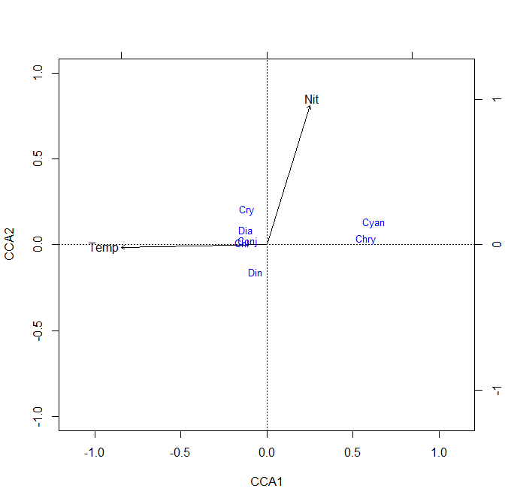
Fig. S3
Fig. S4

Fig. S5

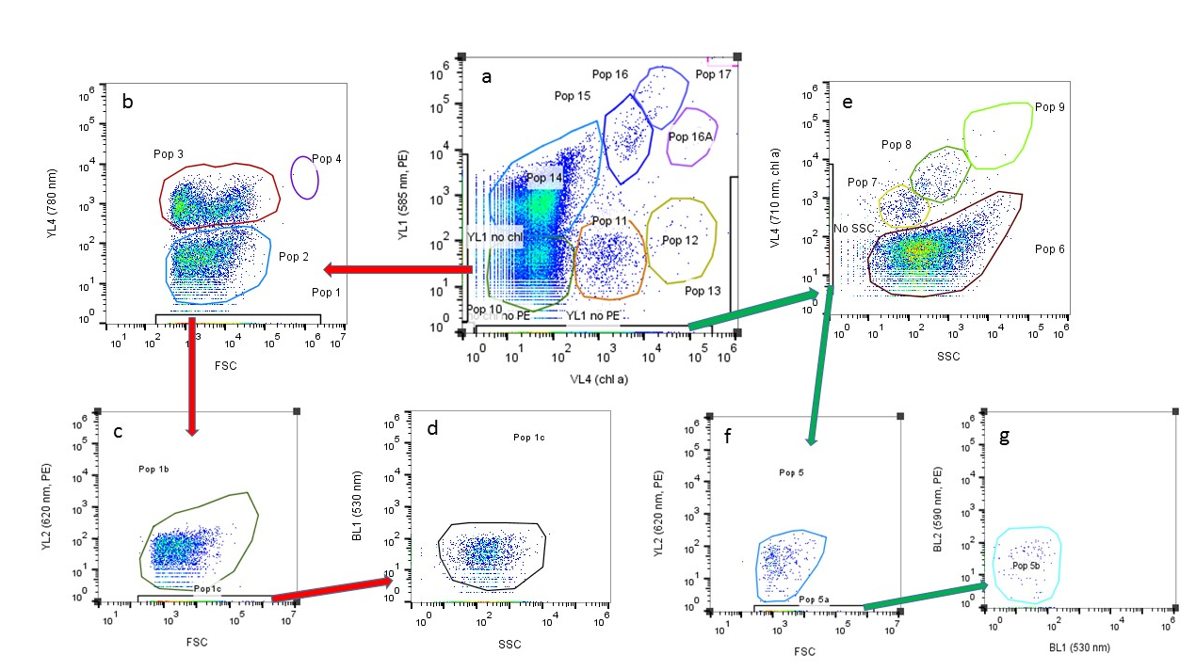
Fig. S6

