SOLVENT-FREE SONOCHEMICAL KABACHNIC-FIELDS REACTION TO SYNTHESIZE SOME NEW α-AMINOPHOSPHONATES CATALYZED BY

NANO BF₃•SiO₂
D. Ravikumar, S. Mohan, Ch. Subramanyam and K. Prasada Rao*
Department of Chemistry, Bapatla Engineering College, Bapatla - 522101, India.
E-mail: prasad17467@gmail.com
Supplementary materials
Spectral data of 5b-5k
Diethyl [(4-(2,4-dichlorophenyl)thiazol-2-ylamino)]-(4-fluorophenyl)methanephosphonate (5b). Yield: 92%; semi solid. ³¹P NMR spectrum (DMSO-d₆): δ 18.9 ppm; ¹H NMR spectrum (400 MHz, DMSO-d₆): δ 8.05-6.94 (m, 8H, Ar-H), 5.29 (s, 1H, C-NH), 4.51(d, J = 9.6 Hz, 1H, P-CH), 4.09 (m, 4H, O-CH₂CH₃), 1.26 (t, J = 7.2 Hz, 6H, O-CH₂CH₃); ¹³C NMR spectrum (100 MHz, DMSO-d₆): δ 166.5 (C-12), 149.2 (C-27), 143.1 (C-9), 138.3 (C-2), 131.9 (C-4), 129.7 (C-17), 128.8 (C-3), 126.8 (C-6), 125.5 (C-25, C-29), 123.6 (C-5), 123.1 (C-1), 114.3 (C-26, C-28), 108.3 (C-10), 63.9 (C-21, C-23), 57.4 (C-15), 16.9 (C-22, C-24); IR (KBr) (ν_{max} cm⁻¹): 3398 (NH), 1498 (C=N), 1236 (P=O); LCMS (m/z, %): 489 (M+H⁺, 100), 491 (M+2, 69); Anal. Calcd for C₂₀H₂₀Cl₂FN₂O₃PS: C, 49.09; H, 4.12; N, 5.72%; found: C, 49.15; H, 4.07; N, 5.77%.
Diethyl [4-(2,4-dichlorophenyl)thiazol-2-ylamino]-(4-nitrophenyl)methanephosphonate (5c). Yield: 97%; semi solid. ³¹P NMR spectrum (DMSO-d₆): δ 19.2 ppm; ¹H NMR spectrum (400 MHz, DMSO-d₆): δ 8.17-6.92 (m, 8H, Ar-H), 5.28 (s, 1H, C-NH), 4.59 (d, J = 9.6 Hz, 1H, P-CH), 4.09 (m, 4H, O-CH₂CH₃), 1.27 (t, J = 7.2 Hz, 6H, O-CH₂CH₃); ¹³C NMR spectrum (100 MHz, DMSO-d₆): δ 166.4 (C-12), 147.1 (C-27), 143.3 (C-9), 141.4 (C-17), 138.3 (C-2), 136.9 (C-4), 131.4 (C-3), 129.7 (C-6), 123.1 (C-5), 123.6 (C-25, C-29), 122.1 (C-1), 114.3 (C-26, C-28), 108.3 (C-10), 63.7 (C-21, C-23), 56.7 (C-15), 16.8 (C-22, C-24); IR (KBr) (ν_{max} cm⁻¹): 3398 (NH), 1497 (C=N), 1239 (P=O); LCMS (m/z, %): 516 (M+H⁺, 100), 518 (M+2, 69); Anal. Calcd for C₂₀H₂₀Cl₂N₃O₅PS: C, 46.52; H, 3.90; N, 8.14%; found: C, 46.59; H, 3.95; N, 8.10%.
Diethyl [4-(2,4-dichlorophenyl)thiazol-2-ylamino]-(4-methoxyphenyl)methanephosphonate (5d). Yield: 91%; semi solid. ³¹P NMR spectrum (DMSO-d₆): δ 17.1 ppm; ¹H NMR spectrum (400 MHz, DMSO-d₆): δ 8.06-6.68 (m, 8H, Ar-H), 5.40 (s, 1H, C-NH), 4.59 (d, J = 9.6 Hz, 1H, P-CH), 4.01 (m, 4H, O-CH₂CH₃), 3.42 (s, 3H, OCH₃), 1.30 (t, J = 7.2 Hz, 6H, O-CH₂CH₃); ¹³C NMR spectrum (100 MHz, DMSO-d₆): δ 166.3 (C-12), 155.4 (C-27), 149.2 (C-9), 138.3 (C-2), 136.9 (C-4), 132.4 (C-3), 128.5 (C-6), 127.6 (C-17), 126.8 (C-5), 125.5 (C-25, C-29), 123.6 (C-1), 114.3 (C-26, C-28), 108.4 (C-10), 63.4 (C-21, C-23), 57.0 (C-31), 55.6 (C-15), 16.7 (C-22, C-24); IR (KBr) (ν_{max} cm⁻¹): 3383 (NH), 1492 (C=N), 1227 (P=O); LCMS (m/z, %): 501 (M+H⁺, 100), 503 (M+2, 69); Anal. Calcd for C₂₁H₂₃Cl₂N₂O₄PS: C, 50.31; H, 4.62; N, 5.59%; found: C, 50.39; H, 4.69; N, 5.52%.
Diethyl (4-chlorophenyl)-[4-(2,4-dichlorophenyl)thiazol-2-ylamino]methanephosphonate (5e). Yield: 93%; semi solid. ³¹P NMR spectrum (DMSO-d₆): δ 17.6 ppm; ¹H NMR spectrum (400 MHz, DMSO-d₆): δ 7.94-6.79 (m, 8H, Ar-H), 5.42 (s, 1H, C-NH), 4.55 (d, J = 9.6 Hz, 1H, P-CH), 4.03 (m, 4H, O-CH₂CH₃), 1.26 (t, J = 7.2 Hz, 6H, O-CH₂CH₃); ¹³C NMR spectrum (100 MHz, DMSO-d₆): δ 166.3 (C-12), 145.6 (C-9), 136.3 (C-2), 134.7 (C-17), 129.8 (C-4), 128.5 (C-27), 127.6 (C-3), 126.8 (C-6), 125.5 (C-26, C-28), 123.6 (C-25, C-29), 123.1 (C-5), 114.3 (C-1), 108.4 (C-10), 63.4 (C-21, C-23), 56.4 (C-15), 16.7 (C-22, C-24); IR (KBr) (ν_{max} cm⁻¹): 3390 (NH), 1494 (C=N), 1238 (P=O); LCMS (m/z, %): 507 (M+H⁺, 100), 505 (M-2, 96), 508 (M+1, 31); Anal. Calcd for C₂₀H₂₀Cl₃N₂O₃PS: C, 47.49; H, 3.99; N, 5.54%; found: C, 47.54; H, 3.93; N, 5.59%.
(E)-Diethyl 1-[4-(2,4-dichlorophenyl)thiazol-2-ylamino]-3-phenylallylphosphonate (5f). Yield: 87%; semi solid. ³¹P NMR spectrum (DMSO-d₆): δ 16.8 ppm; ¹H NMR spectrum (400 MHz, DMSO-d₆): δ 7.94-6.89 (m, 9H, Ar-H), 6.42 (d, J = 10.6 Hz, 1H, Ar-CH=CH-), 6.05 (m, 1H, Ar-CH=CH-), 5.35 (s, 1H, C-NH), 4.42 (d, J = 9.6 Hz, 1H, P-CH), 4.01 (m, 4H, O-CH₂CH₃), 1.23 (t, J = 7.2 Hz, 6H, O-CH₂CH₃); ¹³C NMR spectrum (100 MHz, DMSO-d₆): δ 166.3 (C-12), 144.1 (C-9), 136.3 (C-26), 132.4 (C-2), 129.8 (C-4), 128.5 (C-3), 127.6 (C-6), 127.2 (C-25), 126.8 (C-28, C-30), 125.5 (C-27, C-31), 123.6 (C-5), 123.1(C-29), 122.1 (C-1), 114.3 (C-17), 108.3 (C-10), 63.7 (C-21, C-23), 56.4 (C-15), 16.7 (C-22, C-24); IR (KBr) (ν_{max} cm⁻¹): 3385 (NH), 1491 (C=N), 1229 (P=O); LCMS (m/z, %): 497 (M+H⁺, 100), 499 (M+2, 64); Anal. Calcd for C₂₂H₂₃Cl₂N₂O₃PS: C, 53.13; H, 4.66; N, 5.63%; found: C, 53.19; H, 4.72; N, 5.57%.
Diethyl [4-(2,4-dichlorophenyl)thiazol-2-ylamino]-(3-nitrophenyl)methanephosphonate (5g). Yield: 89%; semi solid. ³¹P NMR spectrum (DMSO-d₆): δ 18.5 ppm; ¹H NMR spectrum (400 MHz, DMSO-d₆): δ 8.39-7.34 (m, 8H, Ar-H), 5.33 (s, 1H, C-NH), 4.55 (d, J = 9.6 Hz, 1H, P-CH), 3.88 (m, 4H, O-CH₂CH₃), 1.27 (t, J = 7.2 Hz, 6H, O-CH₂CH₃); ¹³C NMR spectrum (100 MHz, DMSO-d₆): δ 166.3 (C-12), 151.6 (C-9), 149.2 (C-28), 138.3 (C-17), 136.9 (C-2), 132.4 (C-25), 129.8 (C-4), 128.5 (C-3), 127.6 (C-6), 126.8 (C-26), 125.5 (C-5), 123.6 (C-1), 123.1 (C-29), 122.1 (C-27), 108.4 (C-10), 63.4 (C-21, C-23), 57.0 (C-15), 16.7 (C-22, C-24); IR (KBr) (ν_{max} cm⁻¹): 3394 (NH), 1486 (C=N), 1247 (P=O), 1022 (P-O-C); LCMS (m/z, %): 516 (M+H⁺, 100), 518 (M+2, 69); Anal. Calcd for C₂₀H₂₀Cl₂N₃O₅PS: C, 46.52; H, 3.90; N, 8.14%; found: C, 46.59; H, 3.86; N, 8.21%.
Diethyl (3-chlorophenyl)[4-(2,4-dichlorophenyl)thiazol-2-ylamino]methanephosphonate (5h). Yield: 90%; semi solid. ³¹P NMR spectrum (DMSO-d₆): δ 17.7 ppm; ¹H NMR spectrum (400 MHz, DMSO-d₆): δ 8.14-6.67 (m, 8H, Ar-H), 5.42 (s, 1H, C-NH), 4.74 (d, J = 9.6 Hz, 1H, P-CH), 4.02 (m, 4H, O-CH₂CH₃), 1.19 (t, J = 7.2 Hz, 6H, O-CH₂CH₃); ¹³C NMR spectrum (100 MHz, DMSO-d₆): δ 166.3 (C-12), 149.2 (C-9), 144.5 (C-17), 136.3 (C-2), 132.4 (C-28), 129.8 (C-4), 128.5 (C-3), 127.6 (C-6), 126.8 (C-26), 125.5 (C-5), 124.9 (C-1), 123.6 (C-27), 123.1 (C-29), 114.3 (C-25), 108.4 (C-10), 63.7 (C-21, C-23), 56.4 (C-15), 16.7 (C-22, C-24); IR (KBr) (ν_{max} cm⁻¹): 3390 (NH), 1485 (C=N), 1242 (P=O); LCMS (m/z, %): 507 (M+H⁺, 100), 505 (M-2, 98), 508 (M+1, 34); Anal. Calcd for C₂₀H₂₀Cl₃N₂O₃PS: C, 48.31; H, 4.53; N, 3.31%; found: C, 47.19; H, 4.36; N, 6.49%.
Diethyl (3-chloro-4-fluorophenyl)[4-(2,4-dichlorophenyl)thiazol-2-ylamino]methanephos-phonate (5i). Yield: 92%; semi solid. ³¹P NMR spectrum (DMSO-d₆): δ 18.1 ppm; ¹H NMR spectrum (400 MHz, DMSO-d₆): δ 8.06-6.69 (m, 7H, Ar-H), 5.41 (s, 1H, C-NH), 4.59 (d, J = 9.6 Hz, 1H, P-CH), 4.01 (m, 4H, O-CH₂CH₃), 1.30 (t, J = 7.2 Hz, 6H, O-CH₂CH₃); ¹³C NMR spectrum (100 MHz, DMSO-d₆): δ 166.3 (C-12), 155.2 (C-27), 149.2 (C-9), 138.2 (C-2), 136.9 (C-4), 132.4 (C-17), 129.8 (C-3), 128.5 (C-6), 127.6 (C-29), 126.8 (C-5), 125.5 (C-1), 123.6 (C-25), 123.1 (C-28), 115.2 (C-26), 108.4 (C-10), 63.4 (C-21, C-23), 57.0 (C-15), 16.7 (C-22, C-24); IR (KBr) (ν_{max} cm⁻¹): 3399 (NH), 1502 (C=N), 1248 (P=O); LCMS (m/z, %): 524 (M+H⁺, 100), 522 (M-2, 98), 525 (M+1, 34); Anal. Calcd for C₂₀H₁₉Cl₃FN₂O₃PS: C, 45.86; H, 3.66; N, 5.35%; found: C, 45.91; H, 3.72; N, 5.29%.
Diethyl (2,4-dichlorophenyl)-[4-(2,4-dichlorophenyl)thiazol-2-ylamino]methanephosphonate (5j). Yield: 90%; semi solid. ³¹P NMR spectrum (DMSO-d₆): δ 18.2 ppm; ¹H NMR spectrum (400 MHz, DMSO-d₆): δ 8.10-6.92 (m, 7H, Ar-H), 5.42 (s, 1H, C-NH), 4.74 (d, J = 9.6 Hz, 1H, P-CH), 4.02 (m, 4H, O-CH₂CH₃), 1.19 (t, J = 7.2 Hz, 6H, O-CH₂CH₃); ¹³C NMR spectrum (100 MHz, DMSO-d₆): δ 166.3 (C-12), 149.2 (C-9), 142.5 (C-17), 136.3 (C-2), 133.8 (C-27), 133.5 (C-4), 133.2 (C-29), 132.4 (C-3), 129.8 (C-6), 128.5 (C-28), 127.6 (C-25), 126.8 (C-5), 125.5 (C-1), 123.6 (C-26), 108.4 (C-10), 63.7 (C-21, C-23), 56.4 (C-15), 16.7 (C-22, C-24); IR (KBr) (ν_{max} cm⁻¹): 3394 (NH), 1496 (C=N), 1229 (P=O); LCMS (m/z, %): 541 (M+H⁺, 100), 539 (M-2, 98), 525 (M+2, 50); Anal. Calcd for C₂₀H₁₉Cl₄N₂O₃PS: C, 44.47; H, 3.54; N, 5.19%; found: C, 44.55; H, 3.60; N, 5.12%.
Diethyl [4-(2,4-dichlorophenyl)thiazol-2-ylamino]-(6-methoxypyridin-2-yl)methanephos-phonate (5k). Yield: 94%; semi solid. ³¹P NMR spectrum (DMSO-d₆): δ 19.1 ppm; ¹H NMR spectrum (400 MHz, DMSO-d₆): δ 8.16-6.58 (m, 7H, Ar-H), 5.42 (s, 1H, C-NH), 4.74 (d, J = 9.2 Hz, 1H, P-CH), 4.02 (m, 4H, O-CH₂CH₃), 1.27 (t, J = 7.2 Hz, 6H, O-CH₂CH₃); ¹³C NMR spectrum (100 MHz, DMSO-d₆): δ 166.3 (C-12), 163.8 (C-26), 152.1 (C-17), 149.9 (C-9), 137.5 (C-28), 136.5 (C-2), 132.4 (C-4), 129.3 (C-3), 128.4 (C-6), 125.5 (C-5), 123.6 (C-1), 113.6 (C-29), 111.2 (C-27), 108.3 (C-10), 64.3 (C-21, C-23), 57.0 (C-15), 55.7 (C-31), 16.5 (C-22, C-24); IR (KBr) (ν_{max} cm⁻¹): 3390 (NH), 1488 (C=N), 1225 (P=O); LCMS (m/z, %): 502 (M+H⁺, 100); Anal. Calcd for C₂₀H₂₂Cl₂N₃O₄PS: C, 47.82; H, 4.41; N, 8.36%; found: C, 47.95; H, 4.36; N, 8.42%.
Antioxidant activity
DPPH radical scavenging activity
The evaluation of antioxidant activity of newly synthesized compounds was done by DPPH radical scavenging activity assay by following the method of Cotelle et.al. (1996) after standardization with some modifications. 3 mL of reaction mixture containing 0.2 mL of DPPH (100 μM in methanol), 2.8 mL of test solution at various concentrations such as 25, 50, 75 and 100 μg/mL of the synthesized extracts were incubated at 37 °C for 30 min. The absorbance of the resulting solution was measured at 517 nm using Beckman model DU-40 spectrophotometer. Methanol was used as a blank solvent and a fresh DPPH• solution in methanol served as the control. Ascorbic acid, a natural antioxidant, was used as a positive control. The experiment was carried out in triplicate and the average values are taken as final result. The percentage inhibition of DPPH radical was calculated by comparing the results of the test with those of the control (not treated with extract) using the following equation
Percentage inhibition = A— B/A × 100
Where,
A= Absorbance of control, B= Absorbance of test
(DPPH) + H-A DPPH-H + A
(Purple) (Yellow)
The experiment was carried out in triplicate and the results are presented in Fig. 1.
Superoxide radical scavenging activity
Superoxide radical scavenging activity was measured by following the method of Robak and Gryglewski with minor variations in incubation period and concentration of PMS taken. All the solutions were prepared in 100 mM phosphate buffer (pH 7.4). 1mL of nitro blue tetrazolium (NBT, 156 μM), 1 mL of reduced nicotinamide adenine dinucleotide (NADH, 460 μM) and 3 mL of synthetic compounds (5a-k) of concentrations 25, 50, 75 and 100 μg/mL were mixed and the reaction was continued by the addition of 100 μL of phenazine-methosulphate (60 µM, PMS). The final mixture was incubated for 5 min at room temperature and spectral measurements were made at 560 nm of visible region. The percentage inhibition was calculated using the equation given below.
Percentage inhibition = A— B/A × 100
Where, A= Absorbance of control, B= Absorbance of test
The experiment was carried out in triplicate and the results are presented in Fig. 2.
Nitric oxide (NO) method:
Nitric oxide scavenging activity of tested samples for nitric oxide radicals (NO) was measured using modified protocol of Green et al. and Marcocci et al. All the tested samples in various concentrations (25, 50, 75 and 100 μg/mL) were prepared in methanol and the homogeneous solutions were achieved by stirring on magnetic stirrer. Nitric oxide radicals (NO) were generated from 1 mL of sodium nitroprusside (10 mM) and 1.5 mL of phosphate buffer saline (0.2 M, pH 7.4) were added to different concentrations (25, 50, 75 and 100 μg/mL) of the test compounds and incubated for 150 min at 25 ͦ C. 1 mL of the reaction mixture was treated with 1 mL of Griess reagent (1% sulfanilamide, 2% H₃PO₄ and 0.1% naphthylethylenediamine dihydrochloride). The absorbance of the chromatophore was measured at 546 nm. Butylated hydroxyl toluene was used as positive control. The ability to scavenge the NO radicals was calculated by the following equation.
% of scavenging = [(A _{control} – A _{sample})/A _{control]} × 100
Where A _{control} is the absorbance of the control reaction (all reagents solution without the test compound solution), A _{sample} is the absorbance of the test compound (all the reagents solution with the test compound solution). The experiment was carried out in triplicate and the results are presented in Fig. 3.

Fig. S 1: Plausible reaction mechanism for the nano-BF₃•SiO₂ catalyzed synthesis of α-aminophosphonates

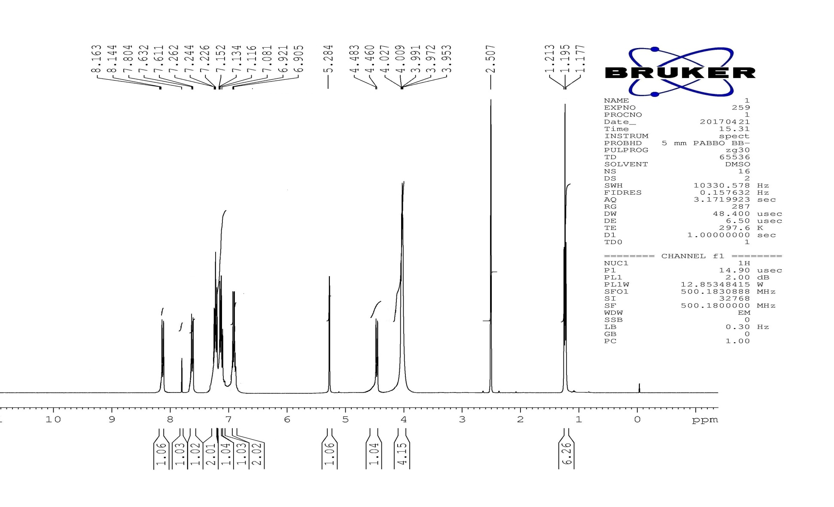
Fig. S 2. ¹H NMR spectrum of Diethyl (4-(2,4-dichlorophenyl)thiazol-2-ylamino)(phenyl)methylphosphonate (5a)

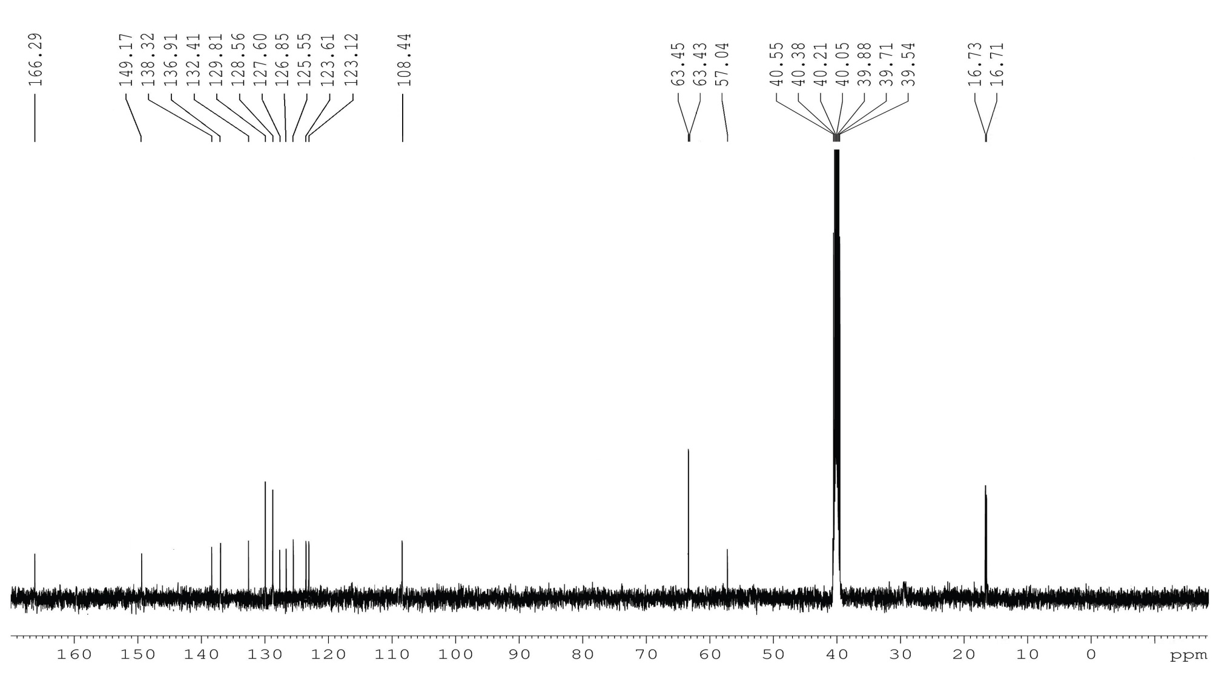
Fig. S 3. ¹³C NMR spectrum of Diethyl (4-(2,4-dichlorophenyl)thiazol-2-ylamino)(phenyl)methylphosphonate (5a)

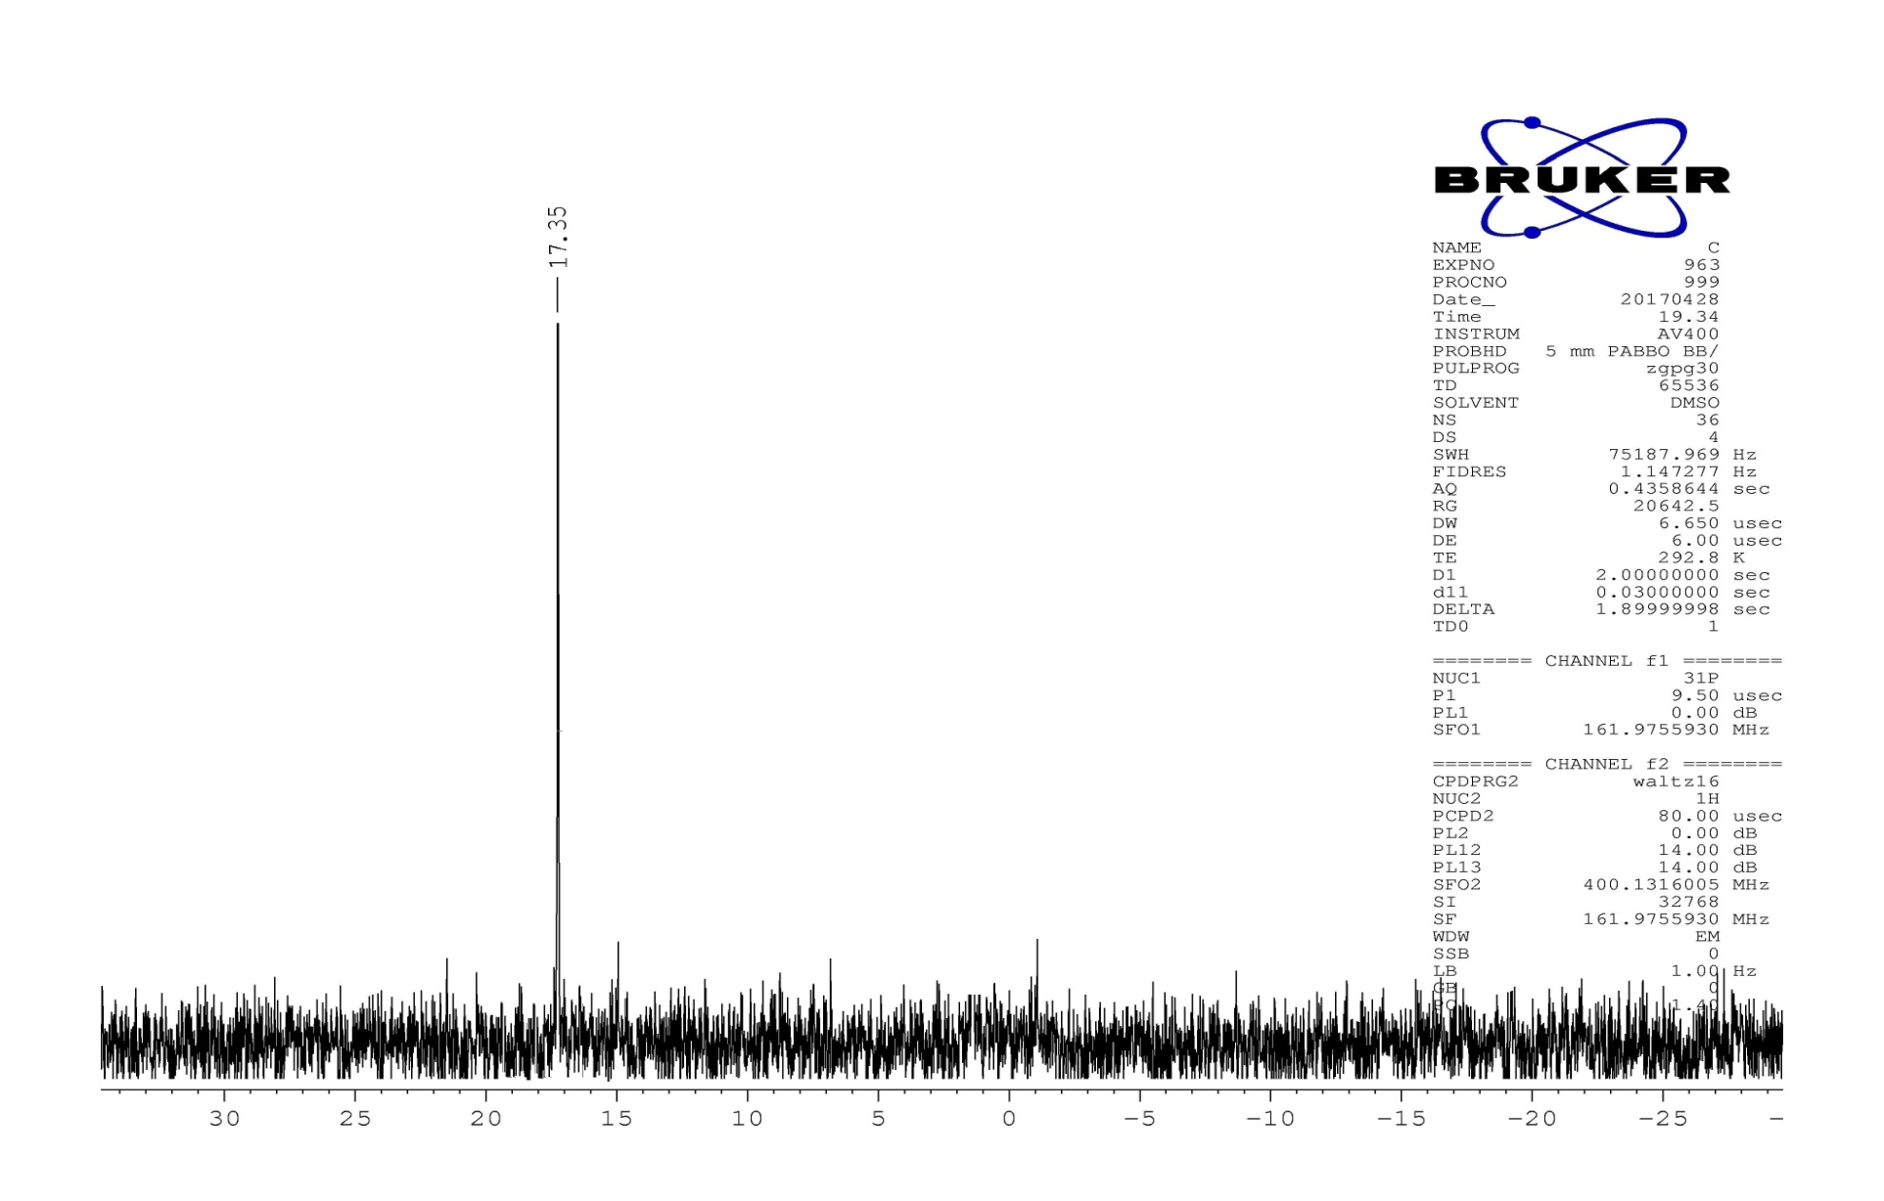
Fig. S 4. ³¹P NMR spectrum of Diethyl (4-(2,4-dichlorophenyl)thiazol-2-ylamino)(phenyl)methylphosphonate (5a)
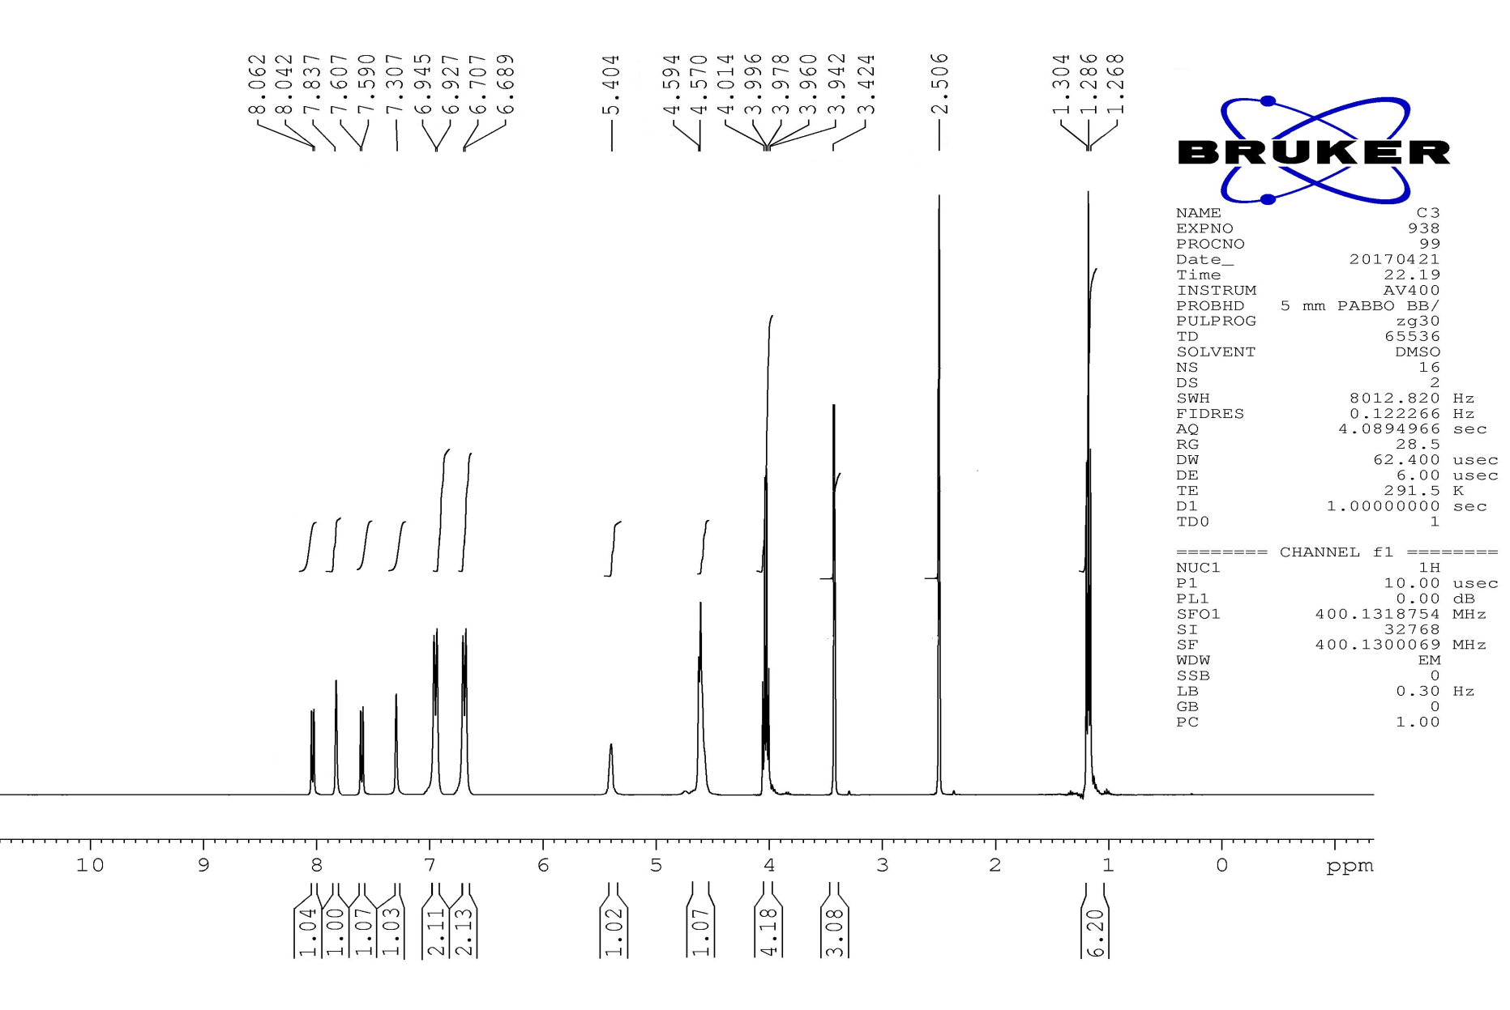
Fig. S 5. ¹H NMR spectrum of Diethyl (4-(2,4-dichlorophenyl)thiazol-2-ylamino)(4-methoxyphenyl)methylphosphonate (5d)
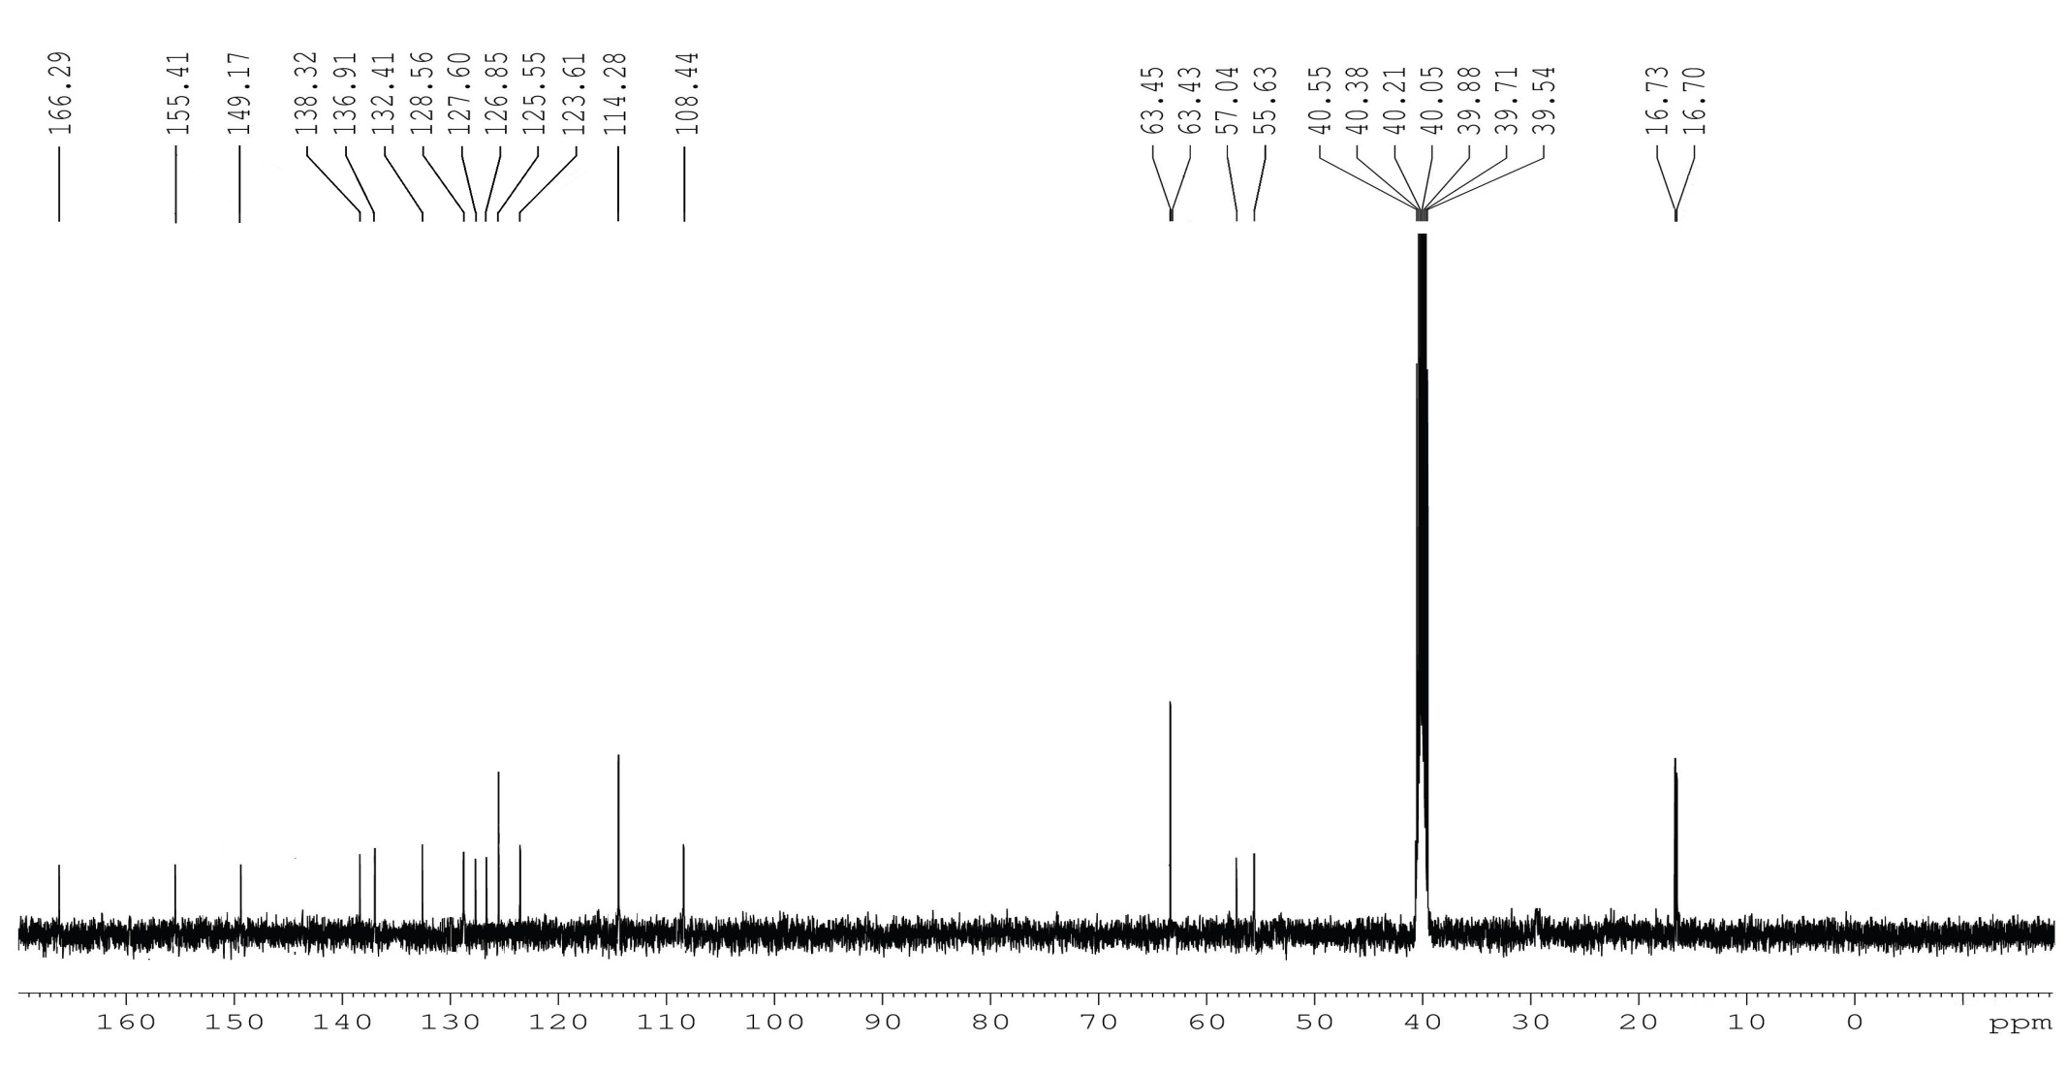
Fig. S 6. ¹³C NMR spectrum of Diethyl (4-(2,4-dichlorophenyl)thiazol-2-ylamino)(4-methoxyphenyl)methylphosphonate (5d)

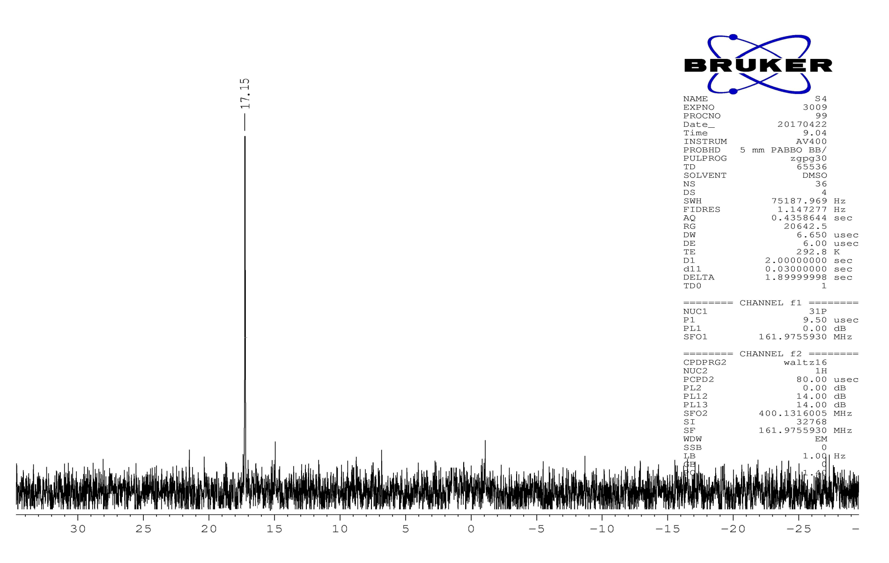
Fig. S 7. ³¹P NMR spectrum of Diethyl (4-(2,4-dichlorophenyl)thiazol-2-ylamino)(4-methoxyphenyl)methylphosphonate (5d)
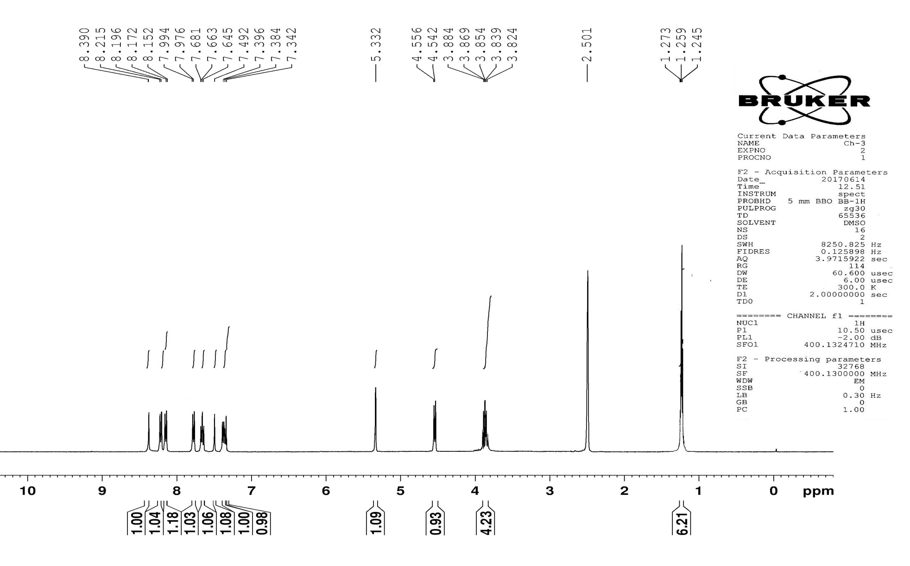
Fig. S 8. ¹H NMR spectrum of Diethyl (4-(2,4-dichlorophenyl)thiazol-2-ylamino)(3-nitrophenyl)methylphosphonate (5g)
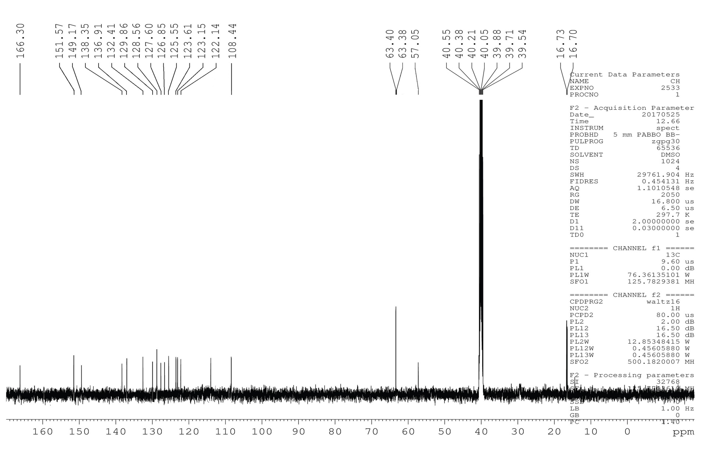
Fig. S 9. ¹³C NMR spectrum of Diethyl (4-(2,4-dichlorophenyl)thiazol-2-ylamino)(3-nitrophenyl)methylphosphonate (5g)
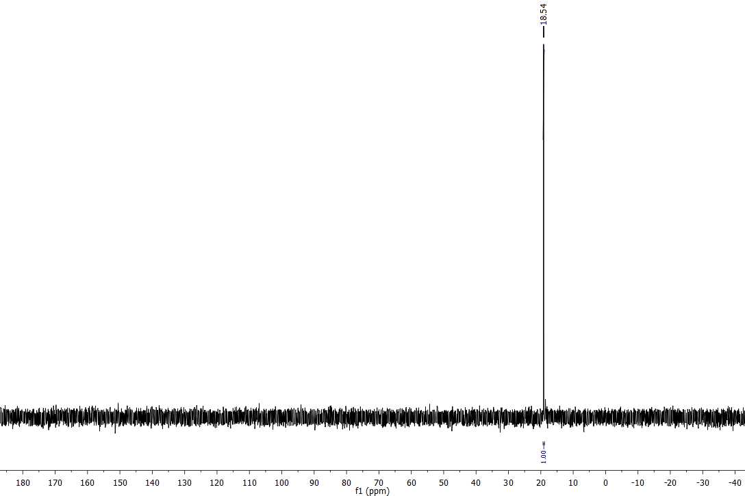
Fig. S 10. ³¹P NMR spectrum of Diethyl (4-(2,4-dichlorophenyl)thiazol-2-ylamino)(3-nitrophenyl)methylphosphonate (5g)
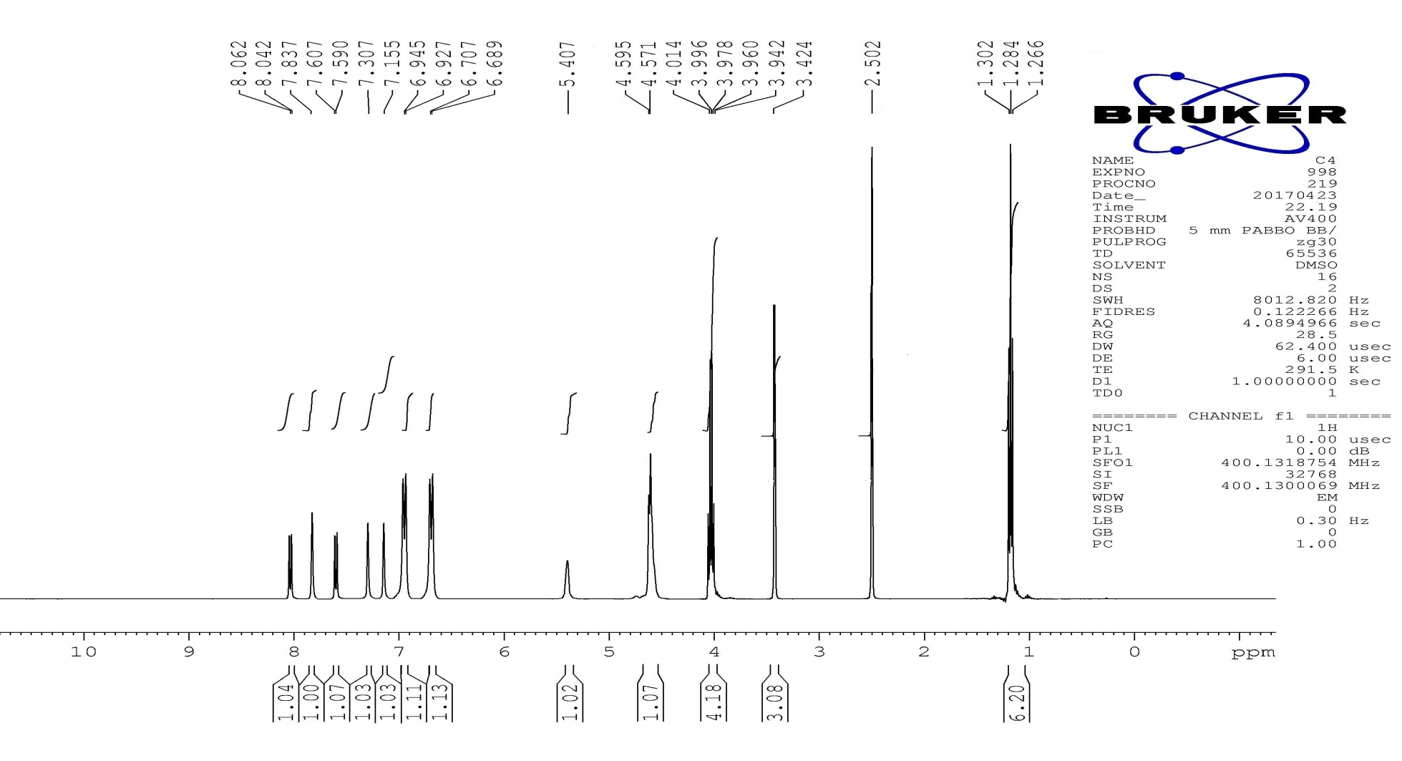
Fig. S 11. ¹H NMR spectrum of Diethyl (3-chloro-4-fluorophenyl)(4-(2,4-dichlorophenyl)thiazol-2-ylamino)methylphosphonate (5i)
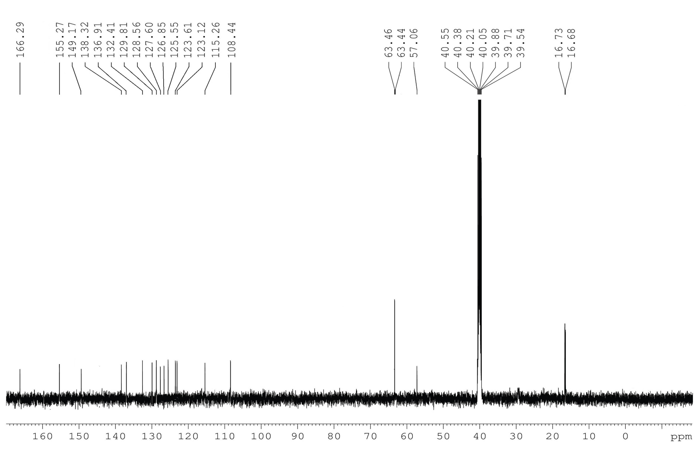
Fig. S 12. ¹³C NMR spectrum of Diethyl (3-chloro-4-fluorophenyl)(4-(2,4-dichlorophenyl)thiazol-2-ylamino)methylphosphonate (5i)

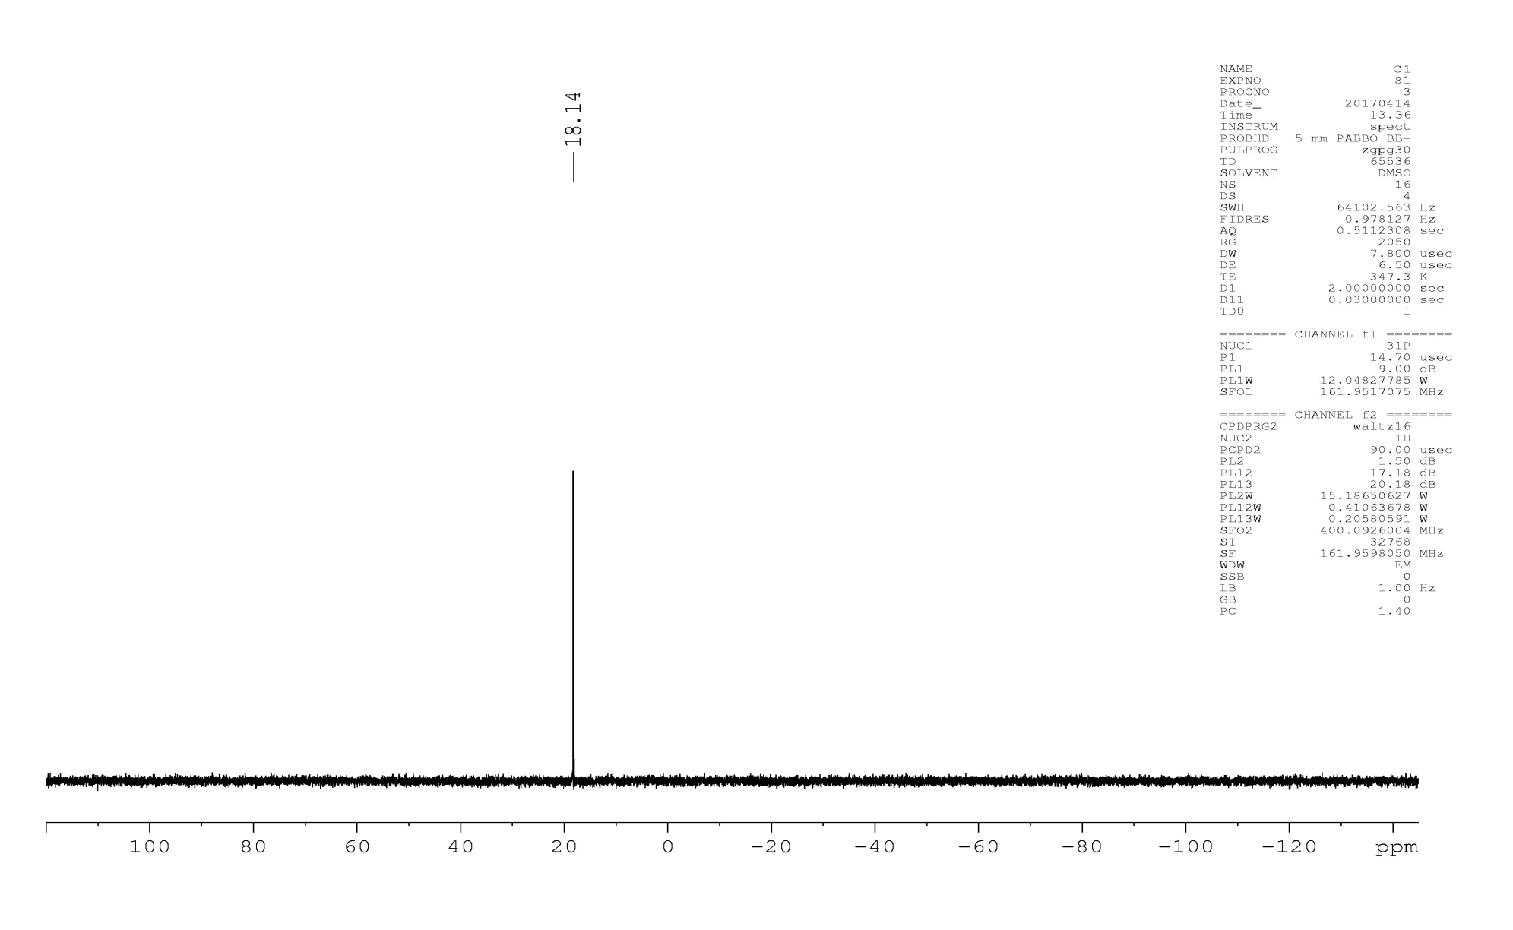
Fig. S 13. ³¹P NMR spectrum of Diethyl (3-chloro-4-fluorophenyl)(4-(2,4-dichlorophenyl)thiazol-2-ylamino)methylphosphonate (5i)
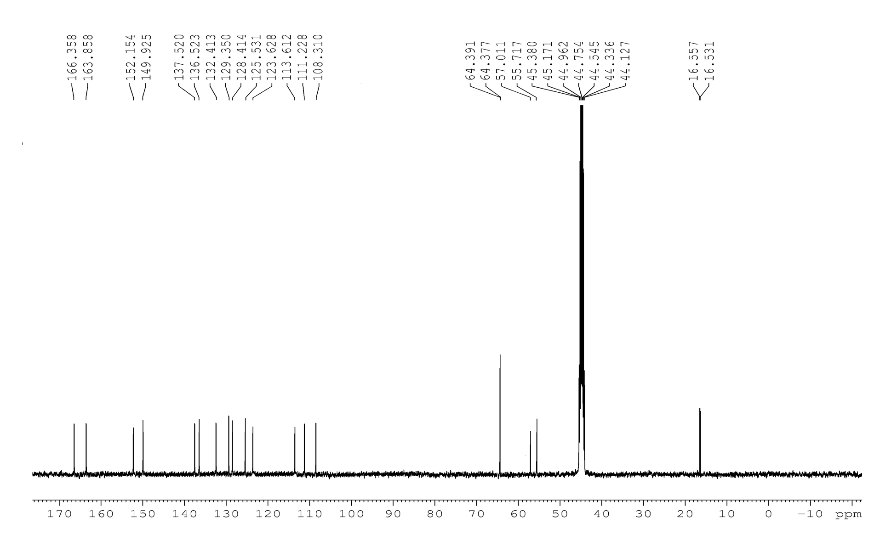
Fig. S 14. ¹³C NMR spectrum of diethyl (4-(2,4-dichlorophenyl)thiazol-2-ylamino)(6-methoxypyridin-2-yl)methylphosphonate (5k)

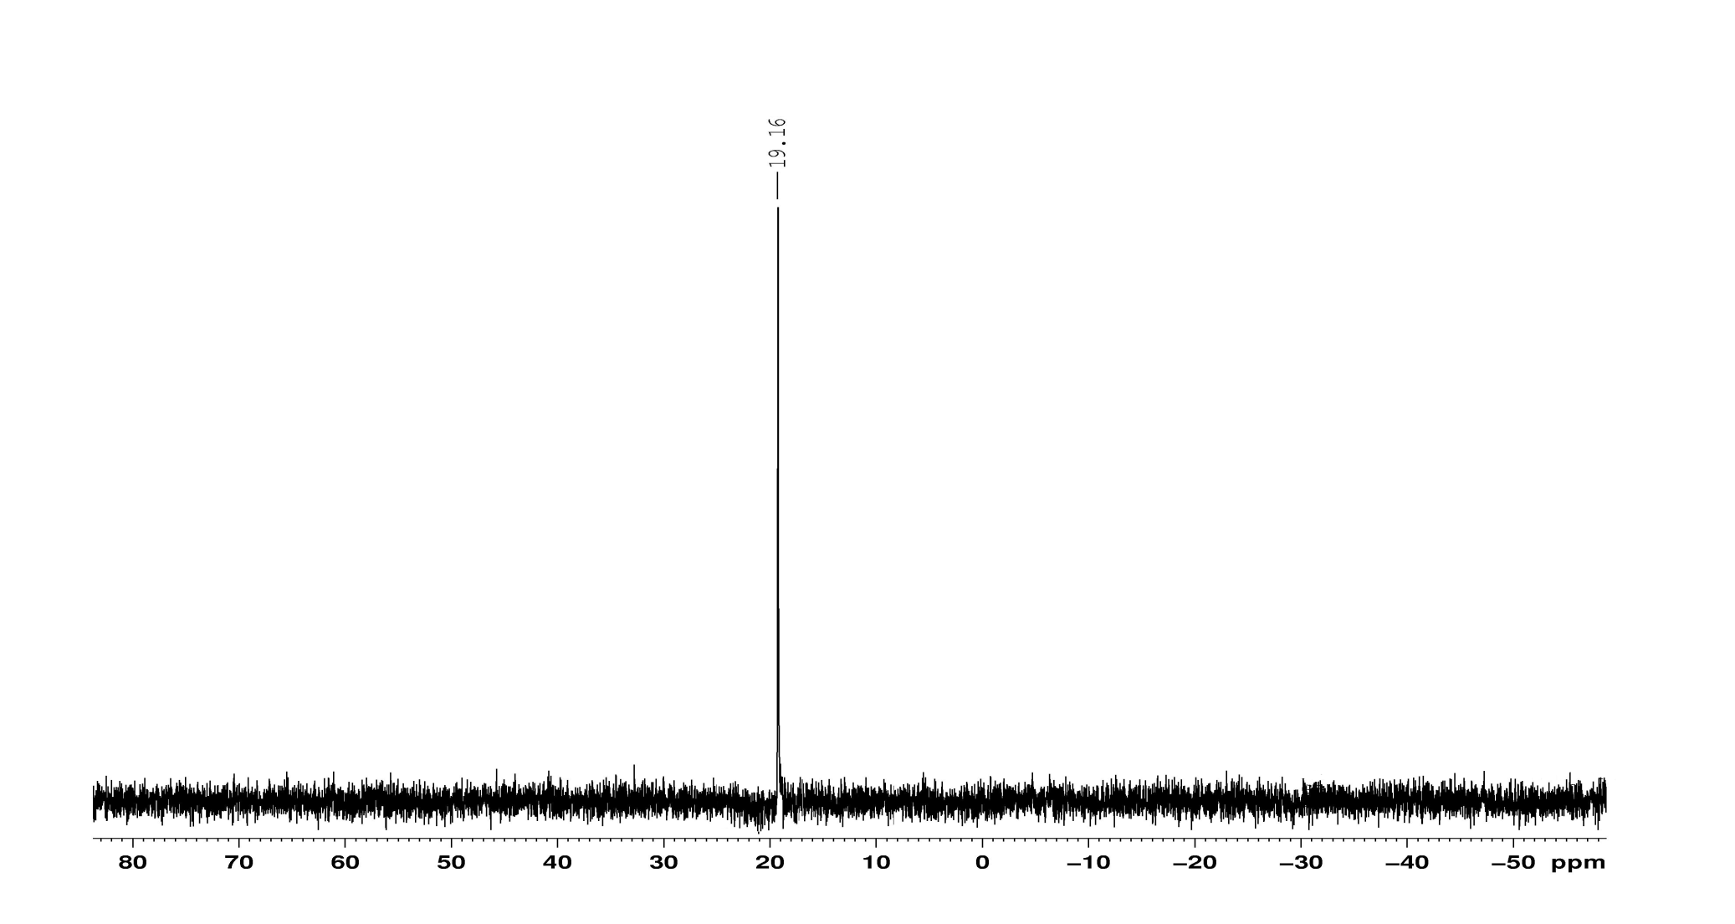
Fig. S 15. ³¹P NMR spectrum of diethyl (4-(2,4-dichlorophenyl)thiazol-2-ylamino)(6-methoxypyridin-2-yl)methylphosphonate (5k)

