Supplemental Information for “Recommended Metric for Tracking Visibility Progress in the Regional Haze Rule”

Brett Gantt, Melinda Beaver, Brian Timin, Phil Lorang
United States Environmental Protection Agency, Research Triangle Park, NC, USA

Contains 4 pages, 3 tables, 2 figures

Metric | Eastern US (all values in %) |  |  |  |  |  |  | Western US (all values in %)
 | SO₄ | NO₃ | OCM | EC | FS | CM | SS | SO₄ | NO₃ | OCM | EC | FS | CM | SS
20% Haziest | 48 | 13 | 21 | 5 | 3 | 8 | 3 | 23 | 8 | 45 | 6 | 3 | 12 | 3
20% Most Impaired | 56 | 17 | 15 | 5 | 1 | 6 | 2 | 40 | 15 | 24 | 6 | 3 | 11 | 2
Table S1. Percentage of total light extinction by aerosol component for sites in the eastern (east of -100°W) and western (west of -100°W) U.S. for days selected as the 20% haziest and 20% most impaired in 2015 as shown in Figure 1

Table S2. Percentage of days in each season selected as the 20% haziest and 20% most impaired in 2015 for sites in the eastern (east of -100°W) and western (west of -100°W) U.S. as shown in Figure 2
Metric | Eastern US (all values in %) |  |  |  | Western US (all values in %)
 | Winter | Spring | Summer | Fall | Winter | Spring | Summer | Fall
20% Haziest | 18 | 22 | 45 | 15 | 8 | 21 | 52 | 19
20% Most Impaired | 32 | 25 | 29 | 14 | 16 | 31 | 31 | 22

Table S3. Percentage of natural and anthropogenic light extinction in days selected as the 20% most impaired in 2015 for sites in the eastern (east of -100°W) and western (west of -100°W) U.S. as shown in Figure 4
Fraction | Eastern US (all values in %) |  |  |  |  |  |  | Western US (all values in %)
 | SO₄ | NO₃ | OCM | EC | FS | CM | SS | SO₄ | NO₃ | OCM | EC | FS | CM | SS
Natural | 24 | 12 | 42 | 2 | 2 | 12 | 6 | 18 | 16 | 31 | 4 | 6 | 21 | 4
Anthropogenic | 70 | 19 | 3 | 5 | 1 | 3 | 0 | 60 | 13 | 17 | 7 | 1 | 3 | 0

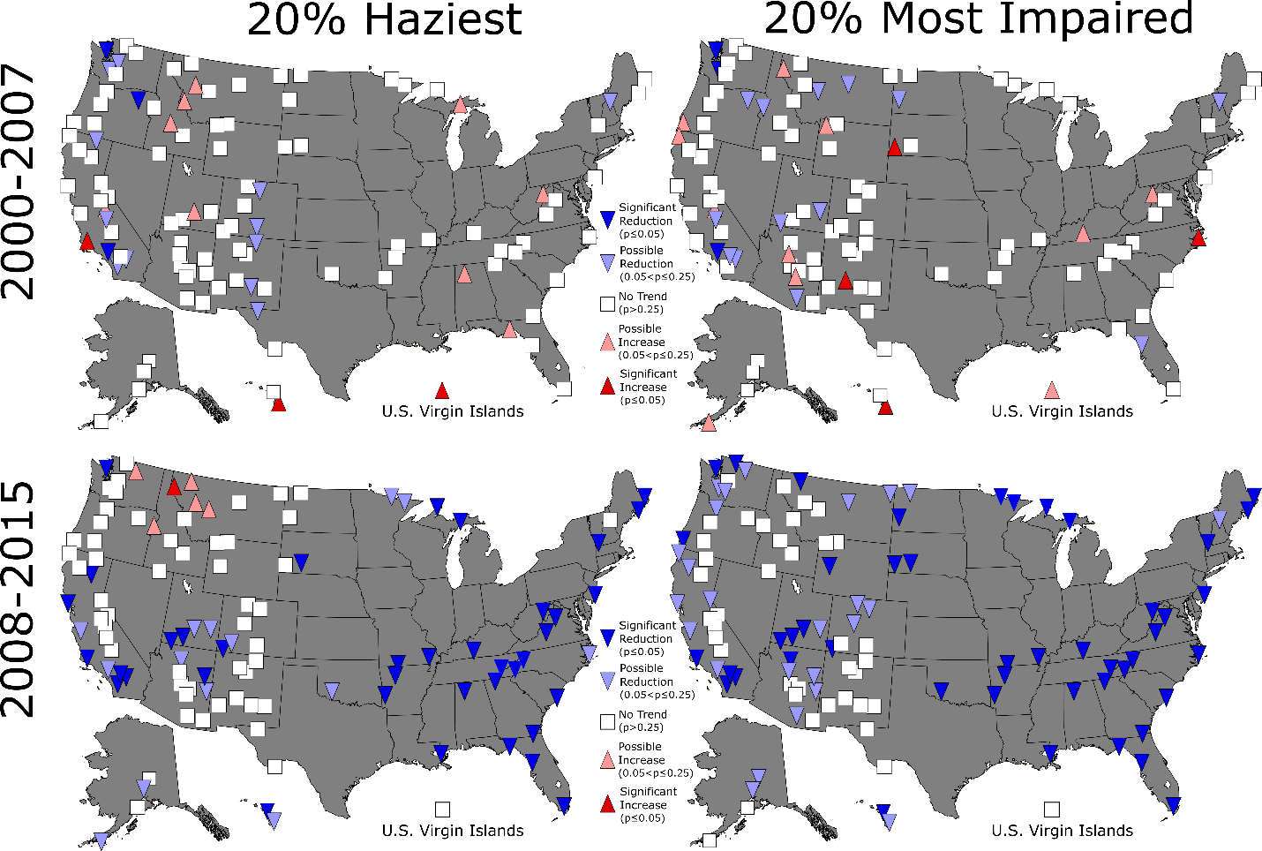
Figure S1. Significance and direction of the linear Pearson correlation coefficient of the deciview trend from 2000 to 2007 (top row) and from 2008 to 2015 (bottom row) for the days selected as the 20% haziest (left column) and 20% most impaired (right column).
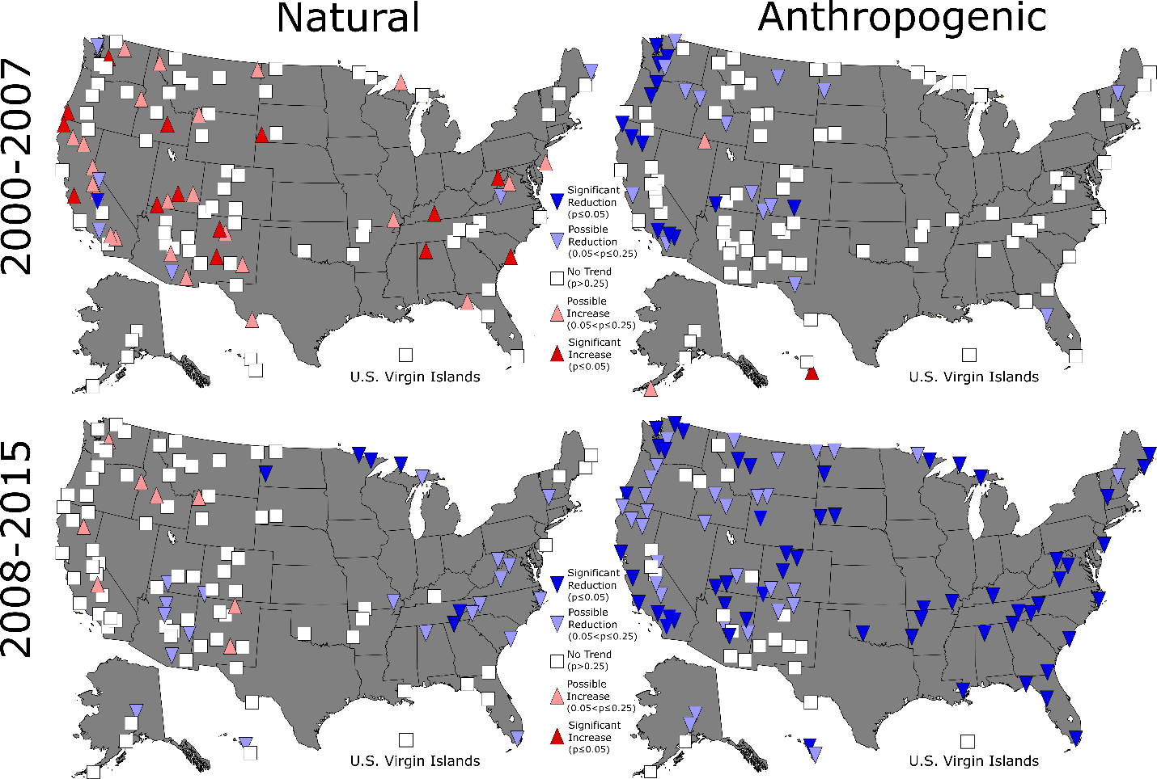
Figure S2. Significance and direction of the linear Pearson correlation coefficient of the natural (left column) and anthropogenic (total-natural; right column) deciview trend on the 20% most impaired days from 2000 to 2007 (top row) and from 2008 to 2015 (bottom row).

