Supplementary information for:

Beneficial use of serum ferritin and heme oxygenase 1 as biomarkers in adult-onset Still's disease: a multicenter retrospective study

Yohei Kirino, Yasushi Kawaguchi, Yoshifumi Tada, Hiroshi Tsukamoto, Toshiyuki Ota, Masahiro Iwamoto, Hiroki Takahashi, Kohei Nagasawa, Shuji Takei, Takahiko Horiuchi, Hisae Ichida, Seiji Minota, Atsuhisa Ueda, Akihide Ohta, Yoshiaki Ishigatsubo

Supplementary figures
Supplementary figure 1
Sum of the scores for the diagnosis of AOSD given by 3 experts. Each expert gave score of 0 for doubtful cases, 1 for suspicious cases, and 2 for definite cases. Patients with sum score of ≥5 were defined as “definite AOSD” cases in the current study.

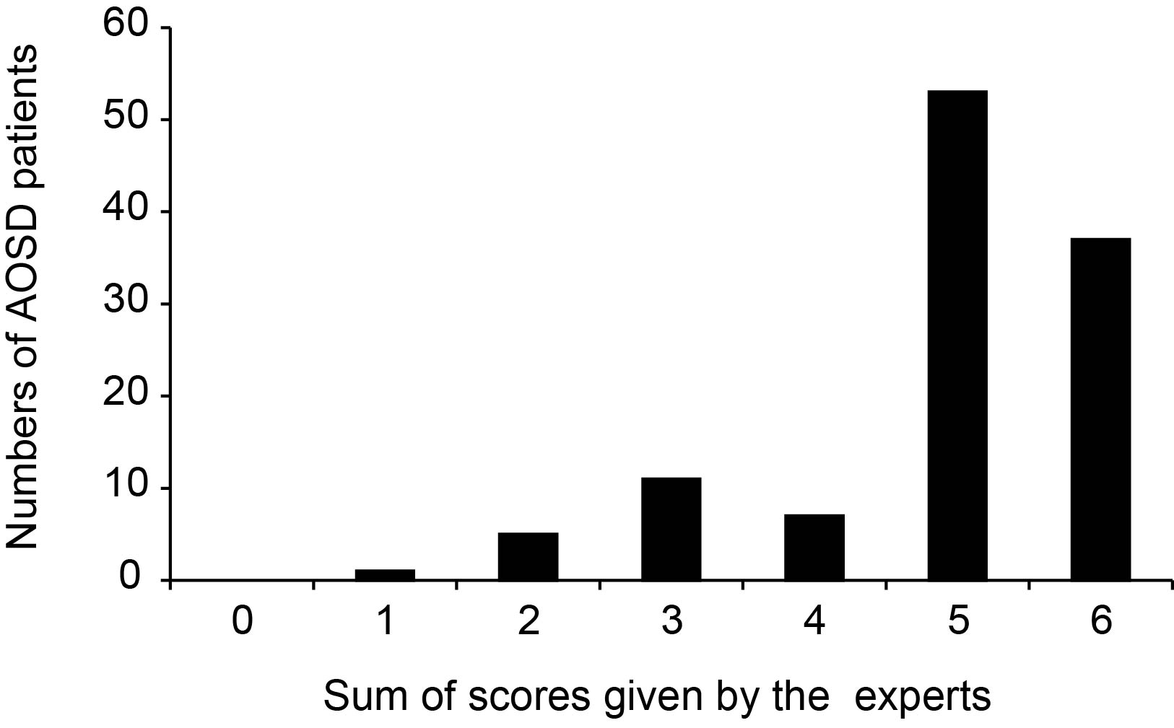

Supplementary figure 2
Work flow for selection of AOSD patients subject to statistical analysis
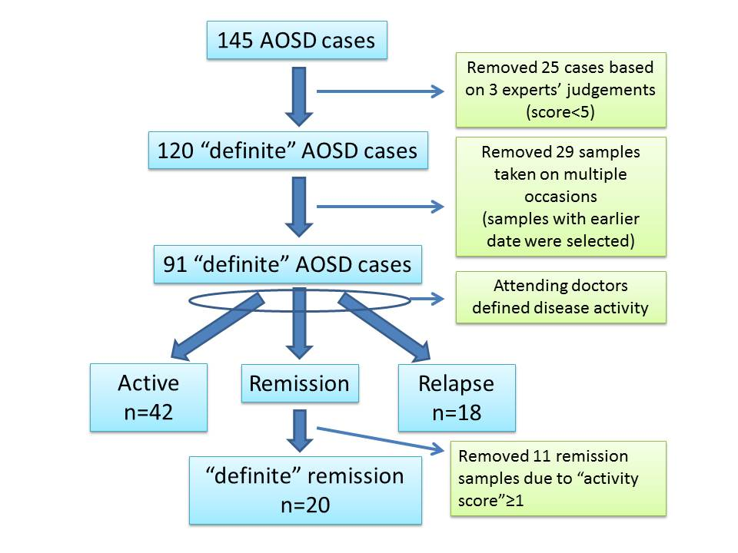
Supplementary figure 3
Activity scores between the 3 AOSD subgroups
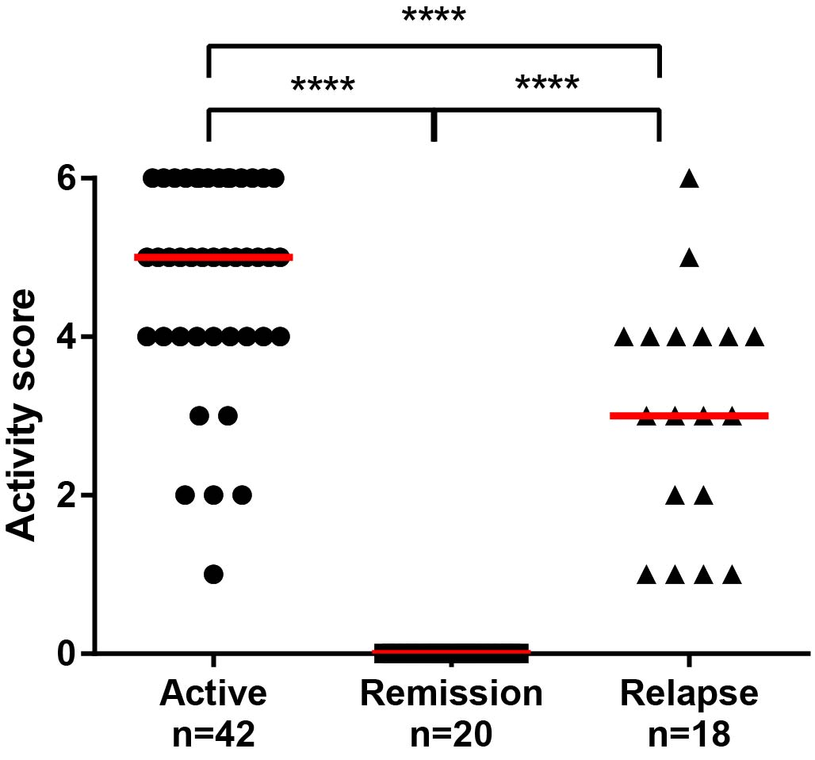
**** p<0.0001 by one-way ANOVA adjusted for multiple comparisons.

Supplementary figure 4
Quality controls of serum ferritin and HO-1 measurements
A, correlation of serum ferritin levels between the levels of ferritin measured at other facilities and Yokohama City University (YCU) Hospital. We measured first 131 AOSD cases enrolled in the study. B, Serum HO-1 levels of an AOSD patient evaluated for five independent experiments from repeated freeze and thawing process. C and D, comparison of serum ferritin and HO-1 levels between male and female AOSD cases in remission. Red horizontal bars indicate median values.

Supplementary Table 1
Disease controls included in the study
Diagnosis | n
Systemic rheumatic diseases
ANCA related vasculitis | 7
Systemic lupus erythematosus | 4
Polymyalgia rheumatica | 3
Takayasu Arteritis | 2
Necrotizing lymphadenitis | 2
Seronegative RA | 3
Giant cell arteritis | 2
Familial Mediterranean fever | 2
Castleman disease | 1
Behçet disease | 1
Polyarteritis nodosa | 1
Infectious diseases
Pneumonia | 2
Culture-positive sepsis | 6
Others
Hemophagocytic syndrome (HPS) | 7
Acute lymphoblastic leukemia | 1
Myelodysplastic syndrome | 1
Acute thyroiditis | 1

All of the patients included were untreated patients at the time of diagnosis. HPS includes rheumatic disease-associated (excluding AOSD) (n=5) and lymphoma associated (n=2) HPS cases.

Supplementary Table 2
Clinical features of AOSD patients and disease controls participated in the study
Components in Yamaguchi’s classification criteria for AOSD | AOSD (%) | Controls  (%)
High-grade fever over 39C° lasting more than a week | 96.3 | 50.0
Arthralgia | 87.5 | 54.3
Typical skin rash | 70.0 | 0
Leukocytosis | 81.3 | 34.8
Sore throat | 76.3 | 15.2
Lymphadenopathy or splenomegaly | 78.8 | 39.1
Liver dysfunction | 73.8 | 52.2
Rheumatoid factor and anti-nuclear antibody negative | 83.8 | 39.1

