Solar Energy Centre for Providing Lighting and Income-Generating Activities for Off-grid Rural Communities in Kenya

O. M. Roche and R. Blanchard
CREST Loughborough University Science and Enterprise Parks LE11 3TU, UK

Appendix

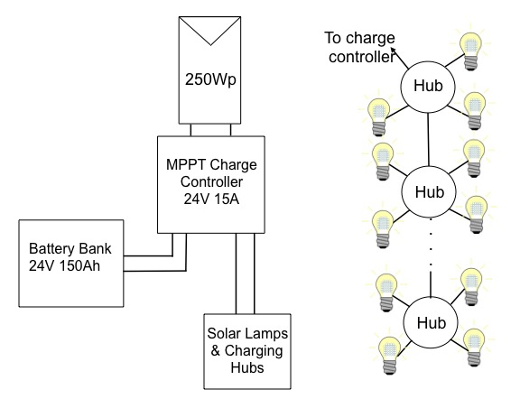
Figure A1 Schematic of solar lamp charging system: a single 250Wp solar panel feeds a 15A MPPT charge controller with inbuilt load control via a 4mm² cable (max. 3m long). The battery bank is made up of a two 150Ah batteries connected in series. The charge controller is connected to the battery bank and to the load via a 6mm² cable (max. 3m long). There is a hub available commercially for charging up to four solar lamps at a time. These hubs can be connected in parallel to charge more than three at once from a single panel. They require the voltage to be between 16V and 24V and the current to be at most 0.5A.

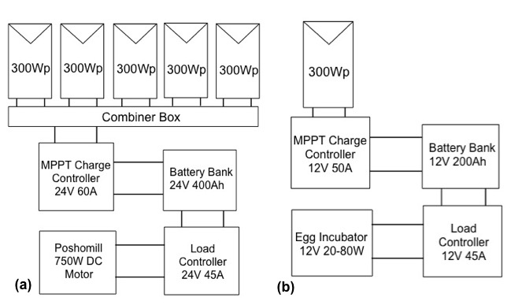
Figure A2 (a) Schematic of the smaller poshomill system: five 300Wp panels are fed to a combiner box with 4mm² cable (1.1m long) and are connected in parallel (32V, 41.8A). The combiner box feeds a 60A MPPT charge controller with 35mm² cable, which in turn is connected to a 24V 400Ah battery bank comprising four 200Ah batteries (wired two in series and two in parallel) via a 35mm² cable. A 45A load controller connects the poshomill to the battery bank also using 35mm² cable. (b) Schematic of egg incubator system: a 300Wp panel feeds a 50A MPPT charge controller via 4mm² cable (max. 3m long). The charge controller is connected to the 12V 200Ah battery via a 13mm² cable (max. 3m long). A 45A separate load controller connects to the battery via a 35mm² cable and connects to the egg incubator.

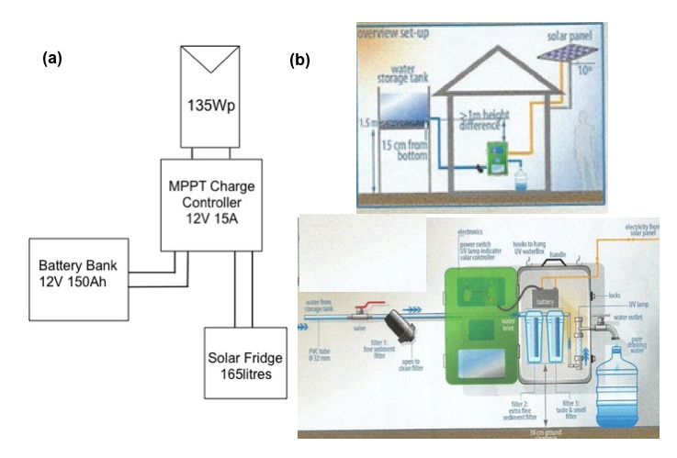
Figure A3 (a) Schematic of Solar Fridge System: a 135Wp panel feeds a 15A MPPT charge controller via a 4mm² cable (max. 2m long) with inbuilt load control connected to a single 150Ah battery with 6mm² cable (max. 1.8m long) and to the solar fridge. (b) Schematic of Water Purification System © Merry Water Services Ltd.

Figure A4 Graph showing dependence of cost per litre of purified water on the number of litres processed per hour. The system can purify 500-1000 litres per hour. However, this system depends on the user collecting and bringing water to the storage tank so the volume of water provided each day is not known.

Sensitivity Analysis

Figure A5 Dependence of Net Present Value [$] of larger poshomill system on fractional change in capital cost, discount rate, O&M costs, battery replacement frequency and weekly rent. The NPV is most sensitive to the weekly rent, followed by the capital costs. The frequency of replacing the battery bank has a strong negative impact at high frequencies but a limited positive impact at low frequency. It is least sensitive to the O&M costs.

Effect of Solar Insolation Data Used

Table A1 Dependence of NPV for the solar lamps on different solar insolation (or meteo) databases. The higher solar insolation allows more solar lamps to be charged from the same system, increasing the revenue and the NPV. In all cases the system was sized to ensure 0% loss of load throughout the lifetime.
Meteo Database | Number of Lamps | NPV [$] | Lost Revenue [$] | Lost Revenue [%]
PVGIS Climate SAF | 35 | 427.27 | 0.00 | 0.00
Meteonorm 6 | 41 | 1,265.78 | 838.52 | 196.25
Meteonorm 7 | 44 | 1,685.04 | 1,257.77 | 294.38
NREL - Nakuru | 42 | 1,415.33 | 988.07 | 231.25

Table A2 Dependence of NPV for the Egg Incubator on different solar insolation (or meteo) databases. The increased solar insolation allows a smaller PV panel to be used which in turn allows a smaller MPPT charge controller with load control function to be used, reducing the capital cost. The system is the same for the three remaining databases.
Meteo Database | Reduction in Capital Costs [$] | NPV [$] | Lost Revenue [$] | Lost Revenue [%]
PVGIS Climate SAF | 0.00 | 534.60 | 0.00 | 0.00
Meteonorm 6 | 575.48 | 1,749.46 | 1,214.87 | 227.25
Meteonorm 7 | 575.48 | 1,749.46 | 1,214.87 | 227.25
NREL - Nakuru | 575.48 | 1,749.46 | 1,214.87 | 227.25

Risk Analysis
The biggest risk to the profitability of the systems proposed is the willingness-to-pay of the villagers. Kerosene prices depend on the cost of Brent Crude Oil, which has seen a recent significant downward trend, and wide variations over the last ten years. In order to estimate a probability table for varying kerosene prices a rough frequency table for varying oil fuel prices was estimated from a graph of the oil price over the last ten years, see Figure A6.

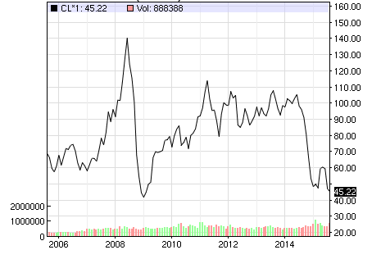
Figure A6 Graph showing how Brent crude oil price varied over the last ten years [1]

The kerosene price in Mogotio over the last year [2] was plotted against the equivalent price of crude oil [1] and a linear relationship was assumed (this is not strictly correct as the Government can influence the price with subsidies but it is the best estimate that can be made with the data available). Equating the average monthly spend on kerosene by villagers gathered during the survey in November 2014 with the kerosene price in Mogotio at the time, allows an estimate for the how their willingness-to-pay for lighting might be affected by the varying kerosene price, see Table A5 for the SHS batteries and Table A6 and Table A7 for the solar lamp system. A ‘What-If’ analysis was used in MS Excel to calculate how the NPV might be affected by the need to reduce the weekly rent in response to a drop in kerosene prices, while keeping it constant at higher kerosene prices. Each calculated NPV was multiplied by a weighting factor given by the fraction of time the equivalent crude oil price held over the last ten years and summed to get an adjusted NPV.

Table A3 Risk table for SHS battery NPV: the affect a drop in kerosene price [2] might have on the amount villagers are willing to pay for the service is calculated and how it might affect the NPV.
Price Oil [$/barrel] | Fraction of the time over last 10 years | Kerosene Price [$/l] | Average Monthly Spend on Kerosene [$] | Equivalent Weekly Rent [$] | Actual Weekly Rent [$] | NPV [$] | Adjusted NPV [$]
 |  |  |  |  | 3,681.07
50 | 0.58 | 3.06 | 0.77 | 0.77 | -1,035.95 | -103.60 | 0.58
60 | 0.59 | 3.11 | 0.79 | 0.79 | -841.04 | -84.10 | 0.59
70 | 0.75 | 3.99 | 1.01 | 1.01 | 2,667.49 | 533.50 | 0.75
80 | 0.80 | 4.24 | 1.08 | 1.08 | 3,681.07 | 368.11 | 0.80
100 | 0.82 | 4.35 | 1.11 | 1.08 | 3,681.07 | 1,472.43 | 0.82
120 | 0.88 | 4.66 | 1.19 | 1.08 | 3,681.07 | 368.11 | 0.88
 |  |  |  |  |  | 2,554.44

Table A4 Risk table for solar lamps with weekly rent of $0.69: the affect a drop in kerosene price [2] might have on the amount villagers are willing to pay for the service is calculated and how it might affect the NPV.
Price Oil [$/barrel] | Fraction of time over last 10 years | Kerosene Price [$/l] | Average monthly Spend on Kerosene [$] | Equivalent Weekly Rent [$] | Actual Weekly Rent [$] | NPV [$] | Adjusted NPV [$]
 |  |  |  |  |  | 427.27
50 | 0.1 | 0.58 | 3.06 | 0.50 | 0.50 | -1,251.39 | -125.14
60 | 0.1 | 0.59 | 3.11 | 0.49 | 0.49 | -1,323.75 | -132.38
70 | 0.2 | 0.75 | 3.99 | 0.65 | 0.65 | 51.01 | 10.20
80 | 0.1 | 0.80 | 4.24 | 0.69 | 0.69 | 427.27 | 42.73
100 | 0.4 | 0.82 | 4.35 | 0.71 | 0.69 | 427.27 | 170.91
120 | 0.1 | 0.88 | 4.66 | 0.75 | 0.69 | 427.27 | 42.73
 |  |  |  |  |  |  | 9.05

Table A5 Risk table for solar lamps with weekly rent of $0.74: the affect a drop in kerosene price [2] might have on the amount villagers are willing to pay for the service is calculated and how it might affect the NPV.
Price Oil [$/barrel] | Fraction of time over last 10 years | Kerosene Price [$/l] | Average monthly Spend on Kerosene [$] | Equivalent Weekly Rent [$] | Actual Weekly Rent [$] | NPV [$] | Adjusted NPV [$]
 |  |  |  |  |  | 874.84
50 | 0.1 | 0.58 | 3.06 | 0.54 | 0.54 | -923.73 | -92.37
60 | 0.1 | 0.59 | 3.11 | 0.53 | 0.53 | -1,001.25 | -100.12
70 | 0.2 | 0.75 | 3.99 | 0.69 | 0.69 | 471.71 | 94.34
80 | 0.1 | 0.80 | 4.24 | 0.74 | 0.74 | 874.84 | 87.48
100 | 0.4 | 0.82 | 4.35 | 0.75 | 0.74 | 874.84 | 349.94
120 | 0.1 | 0.88 | 4.66 | 0.80 | 0.74 | 874.84 | 87.48
 |  |  |  |  |  |  | 426.75

References
[1] Nasdaq. (14 May 2015). Crude Oil. Available: http://www.nasdaq.com/markets/crude-oil.aspx?timeframe=10y.
[2] Energy Regulatory Commission Kenya. (2015). Kerosene Pump Prices. Available: http://www.erc.go.ke/.

