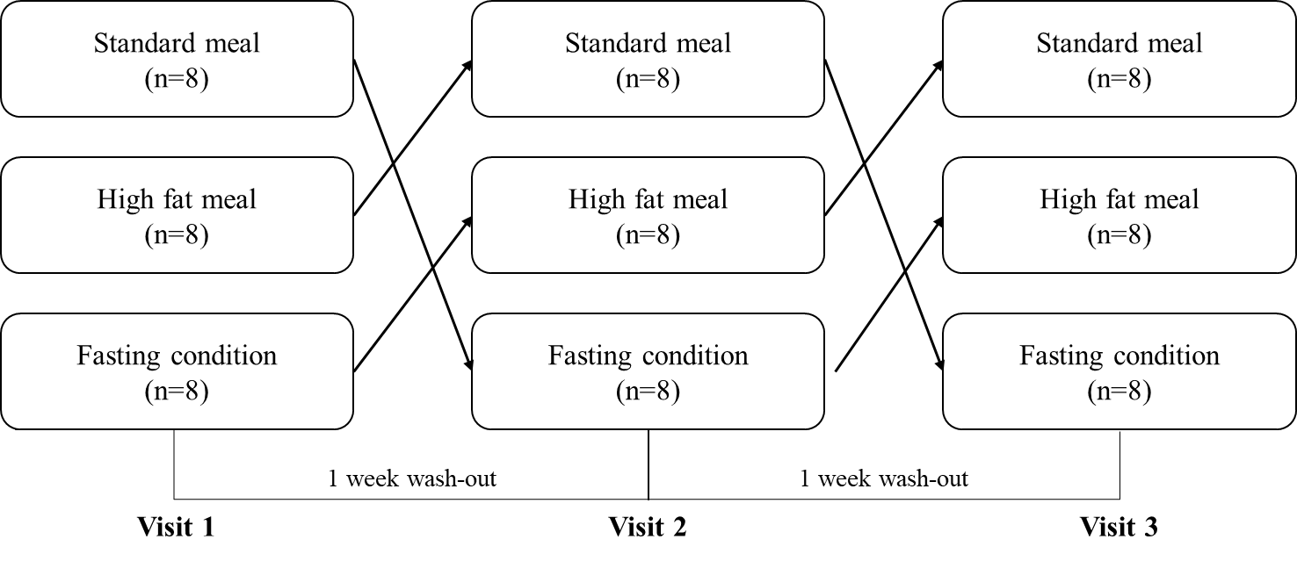
Supplementary 1. Randomised, three-way crossover trial design with a single oral dose of a 250 mg SR fenofibrate capsule and three different food types.

