Overcoming clofazimine intrinsic toxicity: statistical modeling and characterization of solid lipid nanoparticles

Luíse L. Chavesª, Sofia Lima^{a,b}, Alexandre C.C.Vieiraª, Domingos Ferreira^{c}, Bruno Sarmento^{b,d,e}, Salette Reis^{∗a}

ªLAQV, REQUIMTE, Departamento de Ciências Químicas, Faculdade de Farmácia, Universidade do Porto, Porto, Portugal
^{b}CESPU, Instituto de Investigacão e Formação Avançada em Ciências e Tecnologias da Saúde and Instituto Universitário de Ciências da Saúde, Gandra, Portugal
^{c}UCIBIO, REQUIMTE, Laboratório de Tecnologia Farmacêutica, Faculdade de Farmácia, Universidade do Porto, Portugal
^{d}I3S, Instituto de Investigacão e Inovação em Saúde, Universidade do Porto, Portugal
^{e}INEB – Instituto de Engenharia Biomédica, Universidade do Porto, Portugal

Supplementary material

Screening of starting conditions

Selection of the lipid
The selection of the lipid was based on the solubility of CLZ in different biocompatible lipids commonly used to formulate SLNs, namely Cetyl Palmitate, Compritol 888 ATO, Precirol ATO 5, Gelucire 43/01, Softisan 142 and Witepsol E85 and stearic acid. Briefly, a known amount of physical mixtures (PM) of each type of lipid and CLZ (10:1, w/w) were heated at 100°C and then left at room temperature (25°C) until solidification. The presence of drug crystals in the molten mixtures was visually observed. The lipid which could solubilize the higher amount of CLZ was chosen for the formulation of the nanoparticles.

The correct selection of the lipid during the development of SLNs influences their ability to carry the drug and may warrant high values of entrapment efficiency. Moreover, proper melting point of the lipid is essential to maintain the solid state of the particles at room temperature [1, 2].
Among the tested lipids, a more homogenous dispersion of CLZ was observe with Precirol ATO 5, suggesting that this lipid might be able to maximize the entrapment of CLZ in SLNs. The melting temperature was also considered for the selection of the lipid, as it is preferable for storage and process reasons to have lipids with melting point above 50ºC. Most of the tested lipids were unable to completely dissolve CLZ and, presented a low phase transition temperature (below 50ºC), thus were not considered suitable for SLNs-CLZ production. Compritol 888, cetyl palmitate, stearic acid and Precirol ATO 5 were the lipid with higher melting point. As Precirol ATO 5 was able to visually better disperse CLZ, it was selected for the pre-formulation studies.

Development and validation of a spectrophotometric method for CLZ quantification
´An UV-Vis spectrophotometric method was developed and validated regarding linearity, detection limit, quantification limit, precision, accuracy, specificity and robustness [3] using an ultraviolet-visible spectrophotometer (Jasco V-660, Easton, USA). The stock solution was prepared by accurately weighing 5 mg of CLZ with further dissolution in 50 mL of DMSO. The solution was sonicated in water bath for 10 min up to complete solubilization. The linearity was investigated using CLZ stock solutions in HCl 1 M at different concentrations ranging from 0.125 to 1.5 μg mL⁻¹ of CLZ, in triplicated. The limit of detection (LoD) and limit of quantification (LoQ) were determined from angular coefficient (b) obtained from the linear equation of the standard curve, and from the standard deviation of five blank samples (S) (LoD = 3.3(b /S); LoQ = 10(b /S) [3]. Precision was evaluated regarding intermediate precision (assays on different days) and repeatability (different assays on the same day) which were determined with six scans of the CLZ standard solution. Precision levels were calculated by the relative standard deviation percentage (RSD %) from the analytical curves. Accuracy (recovery) was determined by preparing CLZ solutions with unloaded SLNs supernatants. Briefly, known volume of fresh SLNs was diluted with ultrapure water (20 times) and centrifuged at 4,000 xg for 10 min, using Amicon® filters devices. The supernatant was diluted (1:1) with HCl 2 M, to reach final HCl concentration of 1 M, and this solution was used to prepare the samples by adding the CLZ stock solutions to obtain 0.25, 0.50 and 0.75 μg mL⁻¹ (the equivalent of 50, 100 and 150% of the test sample - 0.5 μg mL⁻¹). The samples were analyzed and concentrations were recalculated from the calibration curve. Assays were performed in triplicated. Specificity was evaluated by obtaining UV-Vis spectra of CLZ samples and supernatant of centrifuged SLNs using Amicon® filter device, with different dilutions, between 350-700 nm. Robustness of the method was evaluated by reading the test samples (0.5 μg mL⁻¹) after 4 h, and by preparation the samples from a HCl 1 M acidified from other pH (1.2 and 6.8) solutions.

The very low water solubility of CLZ is not only an issue during the design of new formulations, but also a challenge to have a proper quantification method, which requires a minimum amount of organic solvent, and enough sensibility to quantify low drug concentrations [4].
Few methods for the determination of CLZ in biological fluids [5-7] and pharmaceutical preparations [8] are reported in the literature. Even though, the reported techniques, are time consuming and costly, and in the case of UV-Vis methods, are present lack of sensitivity and requires high levels of toxic organic solvents. Thus, the development and validation of a simple and, sensitive and accurate UV-Vis spectrophotometric method would be highly useful for the analysis of CLZ in bulk nanoformulations.
CLZ is present as reddish crystals, and in an aqueous media almost all the drug precipitates. Despite CLZ poor water solubility, it has three sites of protonation [9], which make it soluble in acidic pH, becoming a purple solution (data not shown).
Spectra for CLZ with different concentrations of HCl were obtained in the range between 350 and 700 nm. Figure S1 A shows CLZ pH dependence, as the pH of the medium decreases, the maximum wavelength of the spectra shifts to higher values.
However, as the pH of the medium increases, the spectra exhibit a different behavior, as the CLZ structure is at molecular conformation resulting in lower intensities of absorbance (Figure S1 A). This behavior allows to reach very low detection limits. The minimum concentration of solvent to obtain spectra of protonated CLZ in the visible region was studied. HCl 1 M was selected for the method validation, which provided a maximum wave length of 528 nm. Linearity of the method was obtained in a range concentration of 0.125 – 1.5 μg mL⁻¹ (Figure S1 B). Least square regression (R²) showed a good correlation coefficient (r=0.9995) and the equation obtained was: absorbance = 0.0735 [CLZ] + 0.00006. The LoD and LoQ were 0.0141 µg mL⁻¹ and 0.0471 µg mL⁻¹ respectively.

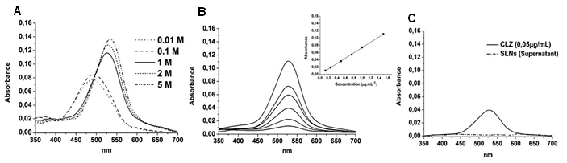
Figure S1: UV-Vis absorption spectra of (A) CLZ samples in different HCl concentrations; (B) calibration curve in the concentration range of 0.125 – 1.500 μg mL^{-1.}in 1 M HCl; and (C) superposition of CLZ sample and SLNs drug-free supernatant, evidencing the selectivity of the method for CLZ.

The relative standard deviation (RSD%) for repeatability, inter-day precision and second analyst analysis were less than 5% (3.8%, 3.2% and 1.3% respectively) indicating reasonable result. The mean percentage of recoveries for the three tested concentrations reached RSD values below 5% (1.82, 1.84 and 0.39% for 0.250, 0.500 and 0.750 µg.mL⁻¹, respectively) demonstrating good agreement between added and quantified amounts of CLZ, and that small changes in CLZ concentrations could be accurately determined. The selectivity of the method was assessed by analyzing the interference of nanoparticles constituents in CLZ quantification. Figure S1 C shows that the SLNs supernatant did not interfere with the absorption spectra of CLZ at 528 nm.
The robustness of the method was assessed by evaluating the stability of the sample after 4 h, and samples preparation in HCl 1 M from already buffered solution. The results show that there were no significant differences between samples read immediately after preparation, and 4 h after performance of unpaired T test (p > 0.05, with 95% of confidence level). ANOVA statistical analysis were performed to compare samples obtained from different pH (1.2, 4.5 and 6.8), and once more no significance was found, with 95% of confidence level.

Optimization and validation assays

Predicted versus obtained values for the dependent variables, which showed high predictability, with few outliers (Figure S2).

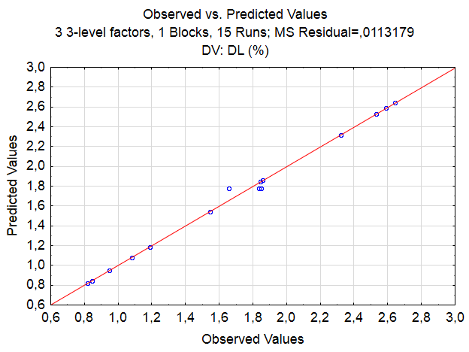
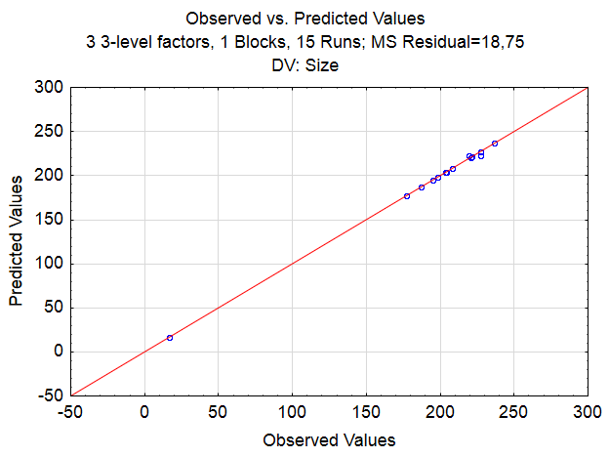
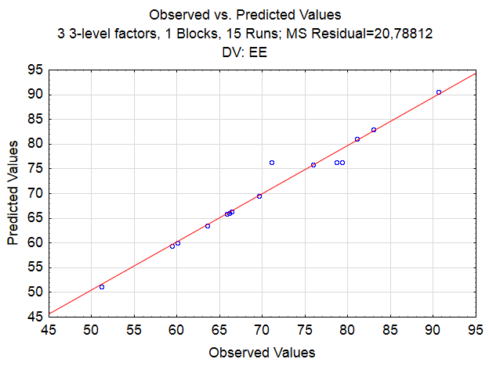
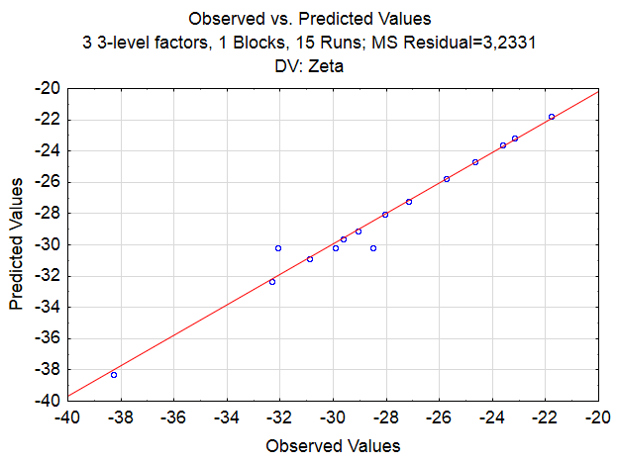
(A)
(B)
(C)
(D)

Figure S2: linear correlation plots between observed and predicted values for the adopted responses; (A) particle size; (B) zeta potential; (C) AE and (D) DL

References
1. Negi L, Jaggi M, Talegaonkar S. 2014 Development of protocol for screening the formulation components and the assessment of common quality problems of nano-structured lipid carriers. Int J Pharm. 461,403-410. (doi: 10.1016/j.ijpharm.2013.12.006)
2. Patil H, Feng X, Ye X, Majumdar S, Repka M. 2015 Continuous Production of Fenofibrate Solid Lipid Nanoparticles by Hot-Melt Extrusion Technology: a Systematic Study Based on a Quality by Design Approach, The AAPS Journal 17, 194-205. (doi: 10.1208/s12248-014-9674-8)
3. Guideline, Validation of analytical procedures: text and methodology. 2015, Q2 (R1) 1.
4. Silva-Buzanello R, Ferro A, Bona E, Cardozo-Filho L, Araújo P, Leimann F, Gonçalves O. 1999 Validation of an Ultraviolet–visible (UV–Vis) technique for the quantitative determination of curcumin in poly(l-lactic acid) nanoparticles, Food Chem 172, 99-104. (doi: 10.1016/j.foodchem.2014.09.016)
5. Borner K, Hartwig H, Leitzke S, Hahn H, Muller RH, Ehlers S. 1999 HPLC determination of clofazimine in tissues and serum of mice after intravenous administration of nanocrystalline or liposomal formulations, Int J Antimicrob Agents 11, 75-9.
6. Queiroz RH, Pereira RC, Gotardo MA, Cordeiro DS, Melchior E Jr. 2003 Determination of clofazimine in leprosy patients by high-performance liquid chromatography, J Anal Toxicol. 27, 377-80.
7. Kapoor V, Shishu G. 2003 A novel validation of HPTLC method for the quantitative determination of clofazimine, Int J Pharm Bio Sci 4, 819 - 828.
8. Saxena S, Singh H, Agrawal V, Ralb J, Singh S. 2013 Estimation of Clofazimine in capsule dosage form by using UV-Vis spectroscopy, Int J Pharm Pharm Sci 5, 635-638.
9. Baik J, Rosania GR. 2012, Macrophages sequester clofazimine in an intracellular liquid crystal-like supramolecular organization, PLoS One 7,) e47494. (doi: 10.1371/journal.pone.0047494)

