Acknowledgments
There are many people who I share this accomplishment with and who deserve the most heartfelt of thanks.
First I would like to thank my parents for all their love and support. My mom always encouraged me to follow my dreams and gave me everything she could to allow me to pursue them. You bought me a home encyclopedia set when you learned that I would read those during library time, while other children read more traditional stories. My father bought me books on science, taught me how to use a computer back when external modems were connection mechanisms, and worked tirelessly on every science fair project.
I would also like to thank my brother. We waged some epic battles, but in the end you taught me how to think outside the box, and how to teach others. I look forward to sharing the next phase of my career with you.
I would like to thank the many friends in my life who have given me a release from all the physics. My lab mates Andy Maloney and Lawrence Herskowitz deserve special thanks. Andy, your love of food gave me a deeper appreciation for food and allowed me to expand my culinary skills. Larry you have been my best friend for almost 10 years now. It has been an incredible journey and I would most certainly not have my PhD if not for you. Thank you for all you have done and all that you are. I would also like to thank John Montoya for the constant discussions about science, philosophy, and science philosophy over coffee. The discussions were the source of much inspiration, and I hope we are still having philosophical debates when we are withering old men. Katie Richardson also deserves praise, for listening to every dramatic event that has happened in my life. We met through education, and our relationship is based on learning and growing, and for thankful.
Finally I would like to thank the many scientists who helped me throughout my education. I would like to thank Dr. Jesse Ernst for his advisement in undergrad, and Dr. Ariel Caticha for his discussions on fundamental physical principles. I’d like to thank the members of my committee: Dr. David Dunlap for his insightful and entertaining educational methods, Dr. Olendorf for his support of open science and participation in developing the Open IGERT program (a failing effort), and Dr. Mary Ann Osley for hosting me in the lab and teaching me all about the wonders of molecular biology.
A very special thanks belongs to Dr. Steve Koch. When I first joined the lab you told us we were going to be different from all the other scientists. We would strive to be kick-ass scientists, with high integrity, and constantly work to push the boundaries of science. You let everyone in the lab be the person that they needed to be, and you encouraged me to find my passion and let it consume me. It turned out I was passionate about a lot of things, but most importantly open science became my biggest passion. You challenged me to be the best open scientist I could be and to have the best open notebook in the world. That challenge began an amazing journey where I met many wonderful people, created lots of personal and career successes, and enlightened me in ways that I would have never expected from a traditional physics education. Thank you for guiding me on this journey, and for giving me the freedom to guide myself. The experience, knowledge, and insights I have gained under your tutelage is more valuable than I could have ever hoped for.
I would also like to thank those scientists who have lent me the use of equipment that allowed the research in this dissertation: Dr. Sanjay Krishna and Steven Myers, Dr. Marek Osinski, Dr. Zach Sharp and Scott Jasechko.
A special thanks to Dr. Maggie Werner-Washburne for funding me through the IMSD program (NIH GM060201), and Dr. Abhaya Datye for funding me through the NSMS IGERT program (NSF #0504276).

The biophysical effects of deuterium oxide on biomolecules and living cells through open notebook science.

Anthony L. Salvagno

B.S., Mathematics, SUNY Albany, 2006
B.S., Physics, SUNY Albany, 2006
M.S., Physics, University of New Mexico, 2010
Ph.D., Physics, University of New Mexico, 2013

Abstract

This dissertation explores various effects of deuterium oxide (D2O also known as heavy water) in nature. Water is everywhere and interacts with just about everything. As such, it would be quite a daunting task to characterize every effect that water exhibits on everything in the universe. This research is a small piece of the puzzle, and provides some fundamental understanding of how water interacts with other molecules. This is done from two viewpoints: (1) the effects of heavy water on living cells and (2) the effects of heavy water on molecules.
Varying concentrations of deuterium oxide were used as the growing solvent for four different organisms: S. cerevisiae, E. coli, A. thaliana, and N. tabacum. In each case growth rates and morphology was assessed and compared to the wild type. Organisms were surveyed for potential phenotypes exhibited in the presence of extremely low and high concentrations of D2O. In every organism, growth is increasingly inhibited in higher concentrations of D2O compared to lower concentrations of D2O. In the case of tobacco, a root hair phenotype was exhibited in the presence of deuterium depleted water (<1ppm deuterium atoms). Roots also grew faster in 1% D2O and DDW, compared to natural water. For Arabidopsis, root germination is statistically indistinguishable between DI water and 33% D2O. Growth of the plant in 10% D2O is identical to that of natural water, and potentially healthier. Meanwhile, plants grown in 60% D2O exhibit slower growth and leaf discoloration. Tests on E. coli reveal inconsistent growth rates, but exhibit increased growth in DDW when adapted to D2O. Cellular and colonial morphology is also very distinguished from the wt. Cells appear to remain joined after cellular fission, while colonies exhibit brainy structures. Yeast morphology is quite different. Yeast cells remain joined after mitosis in 99% D2O, causing large cellular aggregates, while colonies become slightly asymmetric. Adaptation of yeast to D2O was not possible.
Molecular effects were examined using a variety of tools including: dynamic light spectroscopy, Fourier transform-infrared spectroscopy, cavity ring-down spectroscopy, and optical tweezers. Heat induced protein aggregation was possible in H2O, but prevented in the presence of D2O and analyzed via DLS. Deuterium exchange and replacement was observed and quantified using both FT-IR and CRDS. With FT-IR it was possible to identify differences between solvents, while the time-scale of hydrogen-deuterium exchange was quantified for bulk water with CRDS. Using optical tweezers, DNA was overstretched in both H2O and D2O. The average force for DNA overstretching was found to be ~2.5pN higher in D2O compared to H2O.
Deuterium oxide has a stabilizing force on biomolecules, which prevents protein denaturing and can affect the timing for cellular processes. It is because of this molecular property that D2O is observed to affect organisms grown with D2O instead of H2O. Despite this, there seems to be an optimal concentration of deuterium which is above the natural concentration of 155.6ppm. In the presence of deuterium depleted water, cells exhibit signs of stress, further demonstrating that deuterium isn’t merely tolerated in solution, but actually required as hypothesized by Gilbert N. Lewis in 1934.

Table of Contents
Acknowledgments ii
Abstract iv
Table of Contents vi
List of Figures xi
List of Tables xiv
1. Introduction 1
2. Open Notebook Science 6
2.1. Introduction to Open Science 6
2.2. Open Notebook Science (http://goo.gl/7AQat) 8
2.3. Incentives for Being an Open notebook Scientist (http://goo.gl/vcERZ) 9
2.4. The Effect of ONS on Intellectual Property 13
2.4.1. Copyright Law (http://goo.gl/uzXeP) 13
2.4.2. Patent Law (http://goo.gl/YxqgH) 16
2.5. Open Notebook Platforms (http://goo.gl/jSxnY) 19
2.5.1. Wordpress 19
2.5.2. Media Wiki 20
2.5.6. Miscellaneous 24
2.6. Maintaining a Useful Open Notebook (http://goo.gl/9FUSN) 25
2.7. Can ONS Replace the Traditional Publication System? (http://goo.gl/WzZib) 27
2.8. The Future of Open Notebook Science 30
3. Deuterium effects on life 32
3.1 Introduction 32
3.2. Tobacco seed growth in D2O 34
3.2.1. Methods 34
3.2.1.1. Seed Germination Setup (http://goo.gl/2ZRqZ) 34
3.2.2. Germination Rates (http://goo.gl/PQ65E) 36
3.2.3. Morphological response (http://goo.gl/9Fqvg) 39
3.3. Arabidopsis growth in D2O 42
3.3.1. Methods 42
3.3.1.1. Seed Germination Experimental Setup (http://goo.gl/pI8Ia) 43
3.3.1.2. Morphology Experimental Setup (http://goo.gl/pPH33) 43
3.3.2. Germination rates (http://goo.gl/G2FSE) 43
3.3.3. Morphological response (http://goo.gl/Dzb51 and http://goo.gl/y9ouY) 45
3.4. E. coli response to D2O (http://goo.gl/JJfau) 47
3.4.1. Methods (http://goo.gl/2inE2 and http://goo.gl/4sHkr) 47
3.4.2. Growth Rates (http://goo.gl/TM6y1) 48
3.4.3. E. Coli Morphologies (http://goo.gl/UzxtN and http://goo.gl/bzMEg) 52
3.5. S. cerevisiae growth in D2O (http://goo.gl/HNG9c) 56
3.5.1. Methods (http://goo.gl/Km8ai and http://goo.gl/pYQxD) 56
3.5.2. Yeast Morphologies 57
3.5.3. Growth Rates 60
3.6. Discussion 61
4. Molecular effects of deuterium 63
4.1. Introduction 63
4.2. Deuterium and DNA 65
4.2.1. Double-Stranded DNA Construct (http://goo.gl/7PJoz) 66
4.2.1.1. Sequences (http://goo.gl/ORrGb) 67
4.2.1.2. Protocol (http://goo.gl/x1jlz) 68
4.2.2. Tethering DNA 69
4.2.2.1. Buffers (http://goo.gl/lRnfR) 70
4.2.2.2. Microspheres 70
4.2.2.3. Preparing the Flow Cell (http://goo.gl/WnFae) 71
4.2.2.4. Protocol (http://goo.gl/ar63S) 73
4.2.2.5. Tethering Analysis (http://goo.gl/Vd9qL) 74
4.2.3. Stretching DNA in D2O 74
4.2.3.1. Optical Tweezer Development 74
4.2.3.2. Experimental Results 76
4.3. Protein Aggregation Studies 78
4.3.1. Catalase (http://goo.gl/0qxQB) 79
4.3.2. Ovalbumin (http://goo.gl/0qxQB) 81
4.3.3. Yeast Extract Peptone Dextrose Media (http://goo.gl/q8KZg) 82
4.4. The mechanism of deuterium exchange 84
4.4.1. FT-IR Spectroscopy (http://goo.gl/E0XF3) 85
4.4.2. Cavity Ring-Down Spectroscopy (http://goo.gl/g75pN) 89
4.5. Discussion 92
5. Conclusion 94
6. References 96
7. Appendices 100
7.1. Shotgun DNA Mapping (http://goo.gl/LWExj) 100
7.1.1. Designing and creating the construct (http://goo.gl/CEJ1i) 101
7.1.2. Anchor Unit (http://goo.gl/kI9y7) 102
7.1.2.1. Sequences 104
7.1.3. Adapter Duplex (http://goo.gl/MmEBA) 104
7.1.3.1. Sequences (http://goo.gl/WVTOF) 106
7.1.3.2. Protocol (http://goo.gl/cqdqT) 107
7.1.4. Unzipping DNA (http://goo.gl/exNsZ) 107
7.1.4.1. Protocol (http://goo.gl/dxNK5 and http://goo.gl/e4MHZ) 108
7.1.5. Combining the Pieces (http://goo.gl/3KOPa) 108
7.1.6. Conclusion 109
7.2. Crowdfunding for research 109
7.3. Open Science Education 111
7.4. Physics 308L - Electronics Junior Lab (http://goo.gl/H9xOH) 112
7.5. A Personal Account of Real-Time Peer Review (http://goo.gl/T47CZ) 113
7.6. The Power of Cloud-Based Technology and Open Notebook Science (http://goo.gl/5lWsu) 115

List of Figures
Figure 1: The pink square highlights a seed that has germinated, while the orange square shows an ungerminated seed. 49
Figure 2: Tobacco seed germination rates from Crumley et. al. 49
Figure 3: Tobacco seed germination rate in varying concentrations of D2O. 50
Figure 4: Tobacco seed germination in deuterium depleted water, deionized water, and 1% deuterium oxide. 51
Figure 5: Tobacco root growth rates in DI water, deuterium depleted water, and 1% D2O. 52
Figure 6: Tobacco seeds grown for 27 days in deuterium depleted water exhibit distress through pronounced root hair growth. 53
Figure 7: Seeds grown in purified deionized water for 25 days do not exhibit root hair growth. 54
Figure 8: Seeds grown in DDW exhibit root hair growth at early stage of germination. 54
Figure 9: Contaminated sample of tobacco seeds. Mold growth (fuzziness on the right) took over the sample, but is distinguishable from the root hair phenotype (hairs on the left). 55
Figure 10: Arabidopsis seed germination rates in DI water, 33% D2O, 66% D2O, and 99% D2O. 57
Figure 11: Plants grown in agar solution with nutrients in DDW, 10% D2O, and 60% D2O. The Arabidopsis in 10% D2O grows equally healthy to the plant in DDW, but increasing the D2O concentration adversely affects plant growth and induces leaf pigment discoloration. 58
Figure 12: Arabidopsis grown in 99% D2O. Plant growth is due to deuterium replacement at the surface. A few days after this image was taken, the plant was found dead. 59
Figure 13: Arabidopsis grown in deuterium depleted water and tap water. Roots become more entangled in the presence of DDW compared to plants grown in tap water and DI water (not shown). 60
Figure 14: E. coli growth in varying concentrations of deuterium oxide. 62
Figure 15: E. coli 24 hour growth in D2O over 39 days. At day 25 the 24h growth drastically changes indicating that E. coli has adapted to the 99% D2O media. 63
Figure 16: Growth rates of the adapted E. coli in 99% D2O and deuterium depleted water. A projection of wt cells grown in DI water is included for comparison. 64
Figure 17: Morphology of wild type E. coli cells grown in LB media made with DI water and LB made with D2O. This is compared to E. coli cells adapted to growth in pure D2O and grown in DI LB media and D2O LB media. 66
Figure 18: E. coli colony morphologies grown on solid media in the presence of D2O and DI water. Here D2O adapted cells are compared to wt cells. 68
Figure 19: Yeast colony morphology on solid media in varying concentrations of D2O. 70
Figure 20: Yeast cells grown in vary concentrations of D2O in liquid YPD media. 71
Figure 21: Yeast grown in 99.9% D2O fail to complete cell division, forming large aggregates of joined yeast cells. 72
Figure 22: Yeast grown in liquid YPD in varying concentrations of D2O. 73
Figure 23: Comparison of kinesin processivity in H2O compared to D2O. In this case the kinesin molecule is represented by a sneaker, and the microtubule is represented by the orange cylinder. 77
Figure 24: Force vs extension of dsDNA in solutions of sodium ions. This figure is used without permission from Wenner et al (Jay R. Wenner, 2002). 79
Figure 25: Two channel flow-cell for use in DNA tethering experiments. 85
Figure 26: 3D schematic of the optical tweezers setup. 88
Figure 27: Diagram of trapping forces on a microsphere. 89
Figure 28: DNA overstretching in D2O. 90
Figure 29: Comparison of the average overstretch force for DNA tethered in D2O and H2O. 91
Figure 30: Scattering intensity of Catalase in D2O and H2O. Higher intesity is created by the presence of larger particles. 93
Figure 31: Scattering intensity for ovalbumin in H2O and D2O. 94
Figure 32: Ovalbumin solution before (left) and after (right) an aggregation experiment. Notice that after the experiment, aggregation can be observed by eye due to the cloudy appearance of the solution. 95
Figure 33: YPD deterioration in H2O (blue) compared to D2O (red) after 2 weeks. There is also a fresh sample of DI YPD (green) for comparison. 96
Figure 34: (Figure 12 again) Plant growing in supposedly 99% D2O, but because of atmospheric water vapor interactions, the concentration of D2O is significantly less. 98
Figure 35: Absorbance spectra for H2O and D2O in the infrared. Used without permission from WebExhibits.org (Causes of Color - Colors from Vibration). 99
Figure 36: FT-IR transmission spectra for DDW, DI water, 99% D2O, and mixtures of the water types. 100
Figure 37: FT-IR data (from Figure 36) compared to water spectrum analysis by Seigelstein in 1981. 101
Figure 38: Enlargement of Figure 37 showing absorbance features in D2O and their analogs in H2O. 102
Figure 39: Diagram of cavity ring-down spectroscopy. Used without permission from Picarro (Cavity Ring-Down Spectroscopy). 103
Figure 40: Top - CRDS analysis of DDW (gray circles) and D/18O spiked water (purple circles) over a few days. Both water types regress toward natural water isotope ratios. Bottom: Close-up of natural range of waters. Regression of DDW shown as the black line. 104
Figure 41: Diagram of the process of unzipping DNA. 115

List of Tables
Table 1: Bare-essentials of copyright law………………………………………………………...14
Table 2: Comparison of heavy water to light water………………………………………………63
Table 3: Reaction components and concentrations for pALS overstretching DNA……………..68
Table 4: Reaction conditions for pALS overstretching PCR……………………………………..69

1. Introduction
I joined the KochLab in the Spring of 2007. It was a brand new lab that, at the time, was comprised of Dr. Koch, myself, and my best friend Larry Herskowitz (who is now Dr. Herskowitz). In our first lab meeting, Dr. Koch discussed his scientific endeavors up to that point (some of which are continued in this dissertation) and introduced the concept of open science.
Open science was, and still is, an emerging paradigm, and is not to be confused with a particular field of science. The core concept of open science is providing access to information and it is through the opening of scientific research that many new endeavors have become possible. Many of these endeavors have changed the way scientists approach research and acquire data. Citizen science, for instance, has brought a mass scale of human analysis to previously unsolvable problems. Even sharing data has led to new forms of collaboration. Data repositories have allowed scientists to share data with the world in hopes of finding new uses for the shared data. Tools like DataOne have emerged to provide some organization to the new data. Meanwhile, open notebook science has emerged to open the entire scientific process and practitioners make every stage of research accessible including protocols, raw data, data analysis, and much more open to scrutiny.
When Dr. Koch first introduced open science, he described a world of collaboration and transparency. As a lab, and as individuals, we had nothing to hide. We would let the quality of our experiments stand for themselves. The transparent approach was going to be the mechanism that set us apart from the rest of the world. It would distinguish our research.
As Koch described the real world, and compared it to our future practices, I was surprised to find out that labs weren’t naturally like this. While there are plenty of labs that produce high quality research, there are also a number of labs that exploit the traditional system to falsify their claims, perform sloppy experiments, or stretch data for the sake of publication rights. In fact, Koch’s scientific development was from this particular environment.
He spent some time as a postdoc at Sandia National Labs (SNL). Some of his research at SNL was classified, if not only for its governmental affiliation. Even the research that wasn’t classified wasn’t necessarily encouraged to be shared. Before his time at Sandia, he was a graduate student at Cornell and the lab he worked in was a strictly closed environment. After the time he spent in graduate school and in a national lab, he felt it was time for a change. If not for his shift in perspective, I would not be the scientist I am today.
Back in 2007, the lab focus was on developing a technology called Shotgun DNA Mapping (detailed in Appendix A), which was an expansion on the research Koch had undertaken at Cornell. He had come in contact with the developers of a (then new) website known as OpenWetWare.org (OWW), and they were willing to give us access to private space on the site. Since we were one of the first groups to join their fold, we would be the experiment to see how the site could be used for scientific collaboration. We could use the site however we saw fit, but the main purpose was to maintain electronic notebooks that could be accessed and edited from anywhere.
In the Spring of 2009, our collaborator, Dr. Mary Ann Osley graciously hosted me in her lab so I could be trained to undertake the molecular biology portion of the Shotgun DNA Mapping project. At the time, the lab was operating solely via the private site OWW provided, but we also had public space. In one meeting, to prepare me for my time in a wetlab, Koch had mentioned that I should put some work in the public space. My first few days in the lab, I happily obliged, but quickly ran into a roadblock. I was spending so much time writing information on the public site, while also maintaining my private notebook that I had stopped being efficient. So I made the smartest decision I have ever made in my scientific career: I stopped working on the private site and moved all of my research to the public site in my open notebook.
That was the beginning of my journey.
I began learning the HTML and CSS web languages to build a better notebook. I began learning about cloud technology to expand the capabilities of my notebook. I began experimenting with various web software and incorporating them into my notebook. Slowly I had developed a decent knowledge of available tools and how to make the most efficient and powerful notebook. And the knowledge was expanding by the day.
In 2010, the lab received grant money from DTRA to study how the solvent (water) affects kinesin, a molecular motor that processes along microtubules. Larry had finished developing the software necessary for Shotgun DNA Mapping and started working on a simulation to study various aspects of kinesin processivity. Andy Maloney, a dear friend, veteran graduate student, and now PhD, had joined the lab and began work developing the gliding motility assay to experimentally study kinesin processivity. Eventually new students, Nadia Fernandez-Oropeza and Pranav Rathi joined the lab to fill out the team. Nadia would continue the work Andy pioneered, and Pranav began work on the optical tweezers that would be used for DNA experiments and hopefully kinesin studies.
I, unsuccessfully, continued my research with the molecular biology behind Shotgun DNA Mapping, while the lab switched gears to D2O-kinesin interaction. Every effort had resulted in a dead-end or failure, and finally in the Summer of 2011, I began to investigate the role of deuterium in life.
During literature searches into the background of the group’s experiments, Koch had stumbled upon the very basic research of Gilbert Lewis, who was an extremely decorated scientist, but was also the first person to purify D2O from natural water. Lewis had performed some simple experiments growing tobacco seeds in 99% pure D2O and found that the plants didn’t germinate in the “heavy” water. Lewis’ work sparked a new field of studies, and many other scientists began to study how heavy water affects living organisms.
Unfortunately in the 1960’s, the investigations into the effects of heavy water slowed down and virtually ceased. Many of the questions that Lewis and others proposed would remain unanswered and unacknowledged until that summer in 2011, when Dr. Koch proposed that I investigate the questions initially asked by Dr. Gilbert Lewis in 1932. He also gave me a challenge:
I should strive to keep the best open notebook in the world.
Repeating and expanding upon the experiments of Lewis, Crumley, and many others was a perfect application for open notebook science. First, the record between the past and the present had been severed and there should be some connection made between the two time periods. Second, the experiments performed at that time were crude and poorly documented. Any potential future work could be made much simpler if only there was some bridge.
It is my hope that the research documented here, all of which can be accessed via my newer open notebook, is the connection between the past and the future. I have gone through the experiments of the past and re-documented their findings. I’ve also repeated their experiments and documented every step of the process. In doing so, I hope to insure that no one will ever need to spend time to decipher my methods. The objective with my research through open notebook science, is that someone down the line (if not myself) can pick up from where I left off without the painstaking effort that was required from me.
When I began my first open notebook, I had no idea the impact this simple idea could have. The impact of the simple notion of sharing one’s research has been amazing. The initial reaction to my approach wasn’t knee jerk, condescending, or negative in any way. In fact when presented with open notebook science initially, Koch had warned me that there would be scientists who would oppose our philosophy and methods. And while I have met just a few of those, for the most part the response has been overwhelmingly positive. To encourage the positive reception, I began documenting everything that I had learned about open notebook science: best tools, incentives, benefits with regard to copyright and patent law, and the uses it can have in scientific culture.
I don’t know if I ever fulfilled the challenge set forth by Dr. Koch in 2011, but I certainly rose to it. By creating and curating educational resources for open notebook science, I hope that I have enabled scientists around the world to share their research for the benefit of science. And by documenting and sharing my research in full detail, I hope I’ve demonstrated that this practice can be taken seriously and that many others can follow suit in whatever capacity they tolerate. I hope in the years to come, that we can look back at the work of myself and my fellow open notebook scientists and realize this was the tipping point in scientific culture.

2. Open Notebook Science

2.1. Introduction to Open Science
Open science (Open Science) is the philosophy that scientific information be made accessible broadly to all levels of society. It is an umbrella term for multiple approaches to the dissemination of scientific information and includes the practices of citizen science (Citizen Science), science outreach and science blogging, open notebook science, open data sharing, and open access (Open Access) to scholarly work among other things.
Most of the open science push is a result of the push for open access to peer reviewed literature. As scientific journals began hosting literature on the web, access to the articles was more viable. Despite publication to the web being a relatively low cost outlet, subscription prices have increased steadily (Serials Crisis) and above the rate of inflation (Serials Crisis).
For perspective my own website is maintained for $70 a year, but the cost for subscription for Science (digital content only) is $146 per person per year. Granted there are other costs associated with publication, but you can see that the cost per person per journal would add up to insurmountable funds for most individuals. Institutions do receive a “group” discount, but ultimately not every university can afford to subscribe to every journal.
Because of this issue, open access journals have become more prevalent. Publishers like PLoS put the burden of publication cost on scientists who wish to publish with the platform. But even this mechanism has its drawbacks, as the cost per paper is still high (Publishing Fees). To combat this, even newer publishers like PeerJ, have simplified the publishing model and authors are charged a single, reasonable lifetime fee for publishing rights.
As open access publication has gained steam, so have other open scientific endeavors. To supplement open access to publications, open access data and video repositories have emerged to give anyone access to hard scientific information. For example, figshare is an open data repository that gives scientists a permanent DOI (digital object identifier) and the ability for their shared data to be cited. On the other hand, BenchFly, a digital video repository much like YouTube, allows scientists to document their methods and provide open access to those protocols.
Other endeavors take open science to a new level. Citizen science projects allow anyone to partake in the scientific process. Galaxy Zoo allows anyone on the planet with a connection to the web to categorize objects photographed via the Sloan Digital Sky Survey. While various ecological projects like NestWatch, allow amateur and professional bird watchers to collect data on bird nesting habits and submit it to a database for analysis. Many of these endeavors have led to startling discoveries and contributed peer reviewed work (Nereid, 2008).
Even scientific outreach has pushed the boundaries of open science. The emergence of science blogs and scientific blogging has helped expand science literacy of the public. Many blogs are maintained by real scientists reporting on either their own research, or digesting the research of peers. Several endeavors have emerged to bring more scientists into the mix. The #SciFund Challenge was developed as a crowdfunding opportunity to encourage researchers to share their science in hopes of attracting donors to contribute to their projects (See Appendix 7.2.).
It is very apparent that open science is still developing conceptually and in practice, and can grow to encompass much more. While I have been a part, in some way, with many of the programs mentioned above, I have mainly focused my efforts on the development of open notebook science (ONS) and ONS policy and philosophy. Ideally, open notebook science can act as a transition between a lot of these open science endeavors, and can even bridge traditional science with open science practices.

2.2. Open Notebook Science (http://goo.gl/7AQat)
Open notebook science is simply the practice of making your entire research project available online as it is recorded. This online location is known as an open notebook and is the online analog to the paper notebook most scientists keep in their lab. It is the storage center for project plans, experimental protocols and setups, raw data, and even unfiltered interpretations. An open notebook can be any kind of website, as long as it suits the needs of the scientist and is available publicly (for useful notebook platforms see Section 2.5)
Open notebook science was first coined in 2006 by Jean-Claude Bradley (Drexel University), to clarify a subdivision of open science (which at the time was known as open source science) and to avoid confusion with the term open sourced software. The term itself is an umbrella for several types of notebooks that are classified by publication time, from immediate to delayed posting, and content, ranging from all research content to some content.
Ideally, every scientist would maintain an open notebook in real-time which would encompass all aspects of their research. But many fears about dealing with complete open access, conflicts with intellectual property and publications, and online data overload hamper this movement. To combat this, practitioners encourage any form of open notebook science, even if that means uploading some information for a project from many years ago that never saw the light of day.
The goal of this practice is to enhance the scientific process. Through open notebooks, scientists would no longer need to repeat experimental errors made by colleagues. Access to raw data and published analyzed data would be provided. There would be no need to search through old handwritten notes from past lab members or past projects.
The benefits of ONS are numerous, not just personally but professionally as well. What’s more, many of the fears and drawbacks are actually misconceptions and don’t interfere with traditional scientific culture. In the coming sections, I will detail the incentives for open notebook science, discuss the role of intellectual property, present useful platforms, and describe the principles of keeping an open notebook. I will also present a thought experiment for using ONS as a potential replacement for current publication practices. Finally I will describe the future progression of open notebook science.

2.3. Incentives for Being an Open notebook Scientist (http://goo.gl/vcERZ)
The scientific culture has become an incentivized one. Grant money is frequently awarded to scientists who have the most clout, the highest number of publications, and the publications with the highest impact and citations. Future career positions are also based on these numbers. So it makes sense that good work receives good rewards.
Unfortunately, it is a common misconception that open research is a system where academic creativity and labor are simply given away with no reward. Given the state of the traditional system, the rewards for practicing ONS seem low. However, there are plenty of tools in development that provide incentive to practicing scientists. Not only is there professional recognition opportunities, but there are many personal incentives for maintaining an open notebook.
Open notebook science can enhance your academic prowess through two main mechanisms: (1) experimental errors, shortcuts, and falsification will be reduced and (2) personal research efficiency will increase.
The best open notebook platforms (Section 2.5) have features that allow easy organization and searching mechanisms. Maintaining a well organized notebook is a essential to any research project for future lab members and for personal development and reference. By keeping an electronic record, the time to maintain the notebook, and reference past projects and experiments is minimized. As the technology improves, many of these processes can be automated further widening the gap between the capabilities of electronic and open notebooks over traditional paper notebooks.
By maintaining an open record, the scientific process becomes transparent. Mistakes made in the lab become costly to the scientific reputation of the experimenter. If the error persists through publication, the chance for the flaw to be discovered is increased, and publication retraction may be required. Through open notebook science, experimental errors may be noticed sooner in the research process, not just by the experimenter, but by other lab members, collaborators, and other researchers independent of the lab.
Scientists may also feel immediate pressure from online exposure. This pressure could limit mistakes in the lab, which may be brought on by shortcuts in the experiment procedure, data acquisition, and analysis. The psychological effects of having to share protocols and results in full detail and in real-time could prevent shortcuts from having a negative effect on the research. To add to this, inconsistencies in the experiment (caused by non-thorough reporting) could be discovered, impacting the reputation of the lab and the experimenter.
Ultimately publishing openly in real time, forces an examiner to be careful, thorough, and explicit. Any errors made in an experiment could be remedied immediately, instead of down the line. Immediate fixes will have much less impact on a research project, which will save a research time, the lab money, and everyone some humility. No one will be able to question the integrity of the research, because the entire record will be available to anyone.
Open notebook science can increase the efficiency of all scientific research in a manner similar to the enhancement of the individual scientist. In this sense, the scale of benefit is much larger and can impact entire fields of science in addition to individuals and groups.
As experiments are peer reviewed and published, colleagues can follow the work of their peers through literature updates. Unfortunately, the peer review process can be time consuming and preeminent work could be delayed because of a variety of processes. ONS could provide an immediate workaround for the time delay of the peer review process. As research is published in real-time, or as near real-time as possible, colleagues could stay up-to-date with the latest research. Science would be operating at the forefront of thought instead of lagging behind.
Additionally, experimental procedure would benefit. As all research is published, experimenters would have access to detailed protocols, both failed and operational. This would decrease the time to start an experiment or even repeat an experiment from another lab. In the case of repeatability, the time to ensure the viability of an experiment would be dramatically decreased. No longer would an experiment be subject to interpretational error.
In addition to providing scientific methods, raw data could be used and reused in ways that were previously impossible. The internet is a huge loosely connected network of information, and can be at times disconnected. Tools have emerged and will continue to develop to make sense of all the new data being created daily. Tools like Dryad and DataOne provide data hosting, archiving, and searching (among other tools) to connect scientists from around the world to data from taken in distant locations. By providing access to data, new discoveries can be made that are only possible via electronic methods. For example, Google scientists partnered with the Center for Disease control to show that influenza outbreaks could be detected through local search queries (J. Ginsberg, 2009).
Previously it is mentioned that the publication process is time consuming, but this isn’t to say that open notebook science would replace the peer review publication model (but I’ll discuss how that could be possible in Section 2.7). Instead, I would argue that it could greatly supplement it. Open notebook science could hypothetically result in a data deluge (not unlike the current internet system). Scientists may feel overwhelmed with having to read every protocol or data set created by every lab they wish to follow. In this scenario, the current methods would be more than suitable. However, having access to the open notebook account of the experiments documented in a publication would provide deeper insight into the experimental record.
Open notebook science can provide new measures to a scientific career. Traditionally, a scientific career is evaluated based on several criteria: (1) grant awards, (2) peer reviewed publications, and (3) citations. When evaluating scientific merit, the number of publications and citations play the largest role.
As data becomes more accessible, and thus usable, there has arisen a need for the data to be credited. As such, many tools have emerged that allow scientists to organize, use, and reuse data and be credited for sharing data and to credit others for using data. Many of these tools have been developed specifically for scientific use (see figshare and ImpactStory).
While there are tools specifically designed to provide alternative metric analysis (altmetrics) of scientific data, many traditional web analysis tools can also be useful and are freely available. Web analytics software, for instance, can track user information for visitors to an open notebook. The value of an open notebook can be measured by analyzing the pages that are most frequently visited, the duration of the visit, and where the visit led (to another post in the experiment perhaps).
Many website commenting systems like Disqus, provide link tracking capabilities (linkback counting) and social media propagation. Mostly, the purpose is to aggregate the entire conversation relating to a post in one location. This can, however, serve a dual purpose and provide an alternative take on the traditional meaning for citations. Standard web etiquette is such that users can directly link to other websites instead of through a traditional citation, as a means of providing credit for work and for pointing users directly to a source. This same practice exists in social media because of various limits imposed on users. While counting linkbacks isn’t meant to supplant citation merits, it could be used to provide a more complete account of scientific documentation and use.
Providing full, real-time access to research can have many benefits for the scientific community as a whole. Aside from the measurable impacts listed previously, there can be many more unknown benefits. Personally speaking, I’ve had several career milestones because of an online random encounter. I’ve made many personal and career network connections because my research is openly accessible. As such, it is my personal opinion that research should be made available, simply because one can never know what good may come because of the availability of information.

2.4. The Effect of ONS on Intellectual Property
Note: The contained information pertains strictly to the US legal system, and is based on information I alone researched. I am in no way a lawyer and offer no legal advice, but thought it would be foolish to not share basic copyright and patent law policy for scientific consideration.
One of the biggest arguments I hear against open research is the fear about not being able to protect your intellectual property, also known as the fear of being scooped. The biggest oversight in that argument is that IP violations occur in traditional scientific culture both accidentally and maliciously. In an open environment, however, there is a greater risk of attracting this behavior if only because scientific research is made publicly available. With that said, there is nothing about being open that is any more inviting of harmful activity than in the traditional system. In fact, because of the current US legal system, being open may be more beneficial to protecting scientific information.
With regards to the US legal system, there are two primary protections available to scientists: (1) copyright law would protect recorded scientific information, for example data and ideas, while (2) patent law would protect scientific processes, production, procedures, etc.
Despite what is commonly believed, in no way does open notebook science prevent either protection from applying to scientific intellectual property. Open notebook science can actually stake your claim on IP and provide immediate protection. For patent law, patent protection is granted for one year once a work is publicly disclosed. If a patent is not filed, the IP becomes public domain and a patent can never be filed. In the case of copyright law, copyright applies from the moment of fixation (the moment scientific information is documented). In both cases, open notebook science can be used either as a defensive tactic to protect IP, or as an offensive tactic to prevent others from profiting from scientific IP.

2.4.1. Copyright Law (http://goo.gl/uzXeP)
Copyright law is essentially very simple, and has been made increasingly simple since it was originally expanded upon in the US Constitution. The most recent addendum to this statute came about in the 1976 Copyright Act, which defined rights to copyright holders (exclusive rights), how copyright is achieved, and even what does/does not constitute infringement (fair use).
While the law is simple in principle, copyright infringement is not necessarily black and white. In some instances it is questionable as to what is even copyrightable. In others, the matter of fair use is debatable. Even when there is infringement, it can be tough to prove because there are varying degrees of copying or "borrowing."
The bare-essential rules of copyright law can be seen in Table 1:
Copyright is applied immediately from the moment any work is tangibly recorded, both publicly and privately.
To be protected a work needs to be original (not novel) and there needs to be a minimum element of creativity (known as expression).
The exclusive rights provided to copyright holders are reproduction, distribution, derivation, performance, and display.
Copyright infringement is a federal offense!
Even though copyright is applied immediately, in order to file suit for infringement a copyright needs to be registered with the US Copyright Office.
A copyright is not violated if it has been determined that the infringer has a fair use of the material. Fair use is a broad definition and is only created as a defense in infringement suits.
Table 1: Bare-essentials of copyright law.
Rule 2 from Table 1 may reveal that copyright law doesn’t apply to most of science intellectual property, because it is fact based and process driven. Patent law was developed for this very reason. While there are no statutes against having dual protection in the form of patents and copyrights, it is not likely to receive copyright protection if there is patent protection since the copyright lasts much longer than the patent. But that's not to say none of science is copyrightable.
In fact, journal articles are in fact copyrighted. It can be interpreted that there is creative expression in organizing scientific discoveries (which are fact based) and that would make them copyrightable. Journals hold the copyrights for publications and have exclusive right to copy and distribute the articles any any material contained within. And there are cases where they've tried to enforce it.
In that link, the author tries to distribute (via publishing in her blog) figures from a publication and receives a cease and desist letter. Unfortunately it will never be known if there was a violation because the infringement never went to trial. She made an argument for fair use, which probably has some grounds, but skirted around the issue by recreating the figures using the original data (which is NOT copyrightable), thus making her own original figures which are therefore copyrightable. There is a chance that she has no fair use argument since her reuse (even through attribution) is a clear violation of distribution rights and can be viewed as falling within the same scope of the original publication.
In the case of publications, scientists waive their copyright upon submission and acceptance for publication and dissemination, and grant that copyright to the journal. Not all scientific output is formatted for publication, or released at all. In that case, it would greatly benefit scientists to publish their figures via an open notebook to provide copyright protection for their research (if that is in fact the goal).
With regards to the traditional science system, scientists are offered protection from the moment they record their data and create figures based on that data. They are even protected at conferences where they present their research (either via an oral or poster format). This is specifically useful in the case of scientific scooping, which isn't as rampant as we make it out to be but is still a major fear in the community. If there is a case of potential copyright infringement, you have the right to file suit (once you apply for copyright). If you can prove there was access to your research findings and there is substantial copying you may even win your case.
If you are an open scientist, in that you publish your research findings online before peer reviewed publication, you may be in an even better position. You are granted the same rights as a traditional scientist. In the open case, however, the proof of access is much easier to demonstrate since a simple Google search can turn up your findings. The burden is then that you prove there is evidence of copying, which is hard enough as it is.
Because of all the possible interpretations of copyright application to science, I highly advocate the use of the Creative Commons licenses. The CC0 (public domain), CC-BY (use with attribution), and CC-BY-SA (use with attribution and share alike) afford the copyright owner the ability to share their research findings with the community and in turn allow the community to share, use, and reuse those findings without fear of retaliation. It is incredibly important to note that using the CC licenses (with the exception of the CC0) does NOT waive all exclusive rights as a copyright holder. They allow you to waive your rights as long as the reuser of the original work attributes, shares, etc (per terms of the license) in turn. If those stipulations are infringed, you are free to take action. In fact, there is legal precedence of such action (Creative Commons License Upheld by Dutch Court, 2006) (Garlick, 2006) (GateHouse Media v. That's Great News, 2010).
The licenses provide a means for others to use information and data without worrying about moral ambiguities, legal issues, and in turn promote a culture of sharing and attribution. With the CC licenses there will be more societal pressure to do the right thing. When credibility is involved social pressure can work wonders.
For more information, please refer to the US Copyright Office website.

2.4.2. Patent Law (http://goo.gl/YxqgH)
The America Invents Act was initiated in 2011 and institutes some new changes to patent law. The newest inclusion to the law is that now patents are given based on a first-to-file system, whereas previously they were given through a first-to-invent system. This change was implemented on March 16, 2013 as a way to conform to international policy, but also to decrease the burden of the US Patent Office in identifying first-inventor which can be extremely complicated and arduous.
In a first-to-file system, a patent will be granted to the first person to file a patent for a given invention. While the system is as simple as it sounds, it tends to give advantages to larger entities with the resources and efficiency to file patents for every invention conceived. It is outside the scope of this writing to argue the merits of a first-to-file or first-to-invent system, but this is mentioned because there are a couple of workarounds to the first-to-file mandate. The first is through the filing of a provisional application, and the second is through public disclosure. In both cases, there is a one-year grace period under which a patent must be filed lest it become public domain.
The provisional application is a low cost option that grants an inventor protection from competitive patent filings. The fee is $125 for small entity inventors, such as individuals, and $250 for large entities like corporations (Current Fee Schedule). The intellectual property remains a secret during the provisional period until patent. Public disclosure is a free alternative to the provisional patent, in the sense that there is nothing to file with the patent office. With this method, the details of an invention become public information, but no competitor may file a patent.
Scientifically speaking, patentable items include processes, designs, and technology of all sort (although computer programs are hard to patent or copyright). It is usually advantageous to maintain secrecy when dealing with intellectual property, and this culture is especially prevalent in science. As such many universities and institutions have legal services that aid scientists in patent filings. In an effort to maintain confidentiality, it is highly suggested by these services to file provisional applications for all inventions.
Much like copyright, the ultimate goal of a patent is to prevent competitors from stealing and reproducing a work without the inventor benefitting. It is little known fact that patents become public information after filing, generally 18 months after the earliest filing date (Online Chat Transcripts). It is entirely possible for competitors to analyze a patent and create a “non-obvious”derivation of the work that can then be patented. In this scenario the benefit of the patent application is essentially lost.
Open notebook science can be a major benefit to the new patent process. Since it does cost money to file a provisional application, ONS (or other web disclosure) would provide a free alternative to the provisional application. The only difference between the two routes is that through ONS, the patent is immediately public information, while the provisional application maintains invention secrecy. Because the patent will eventually be public domain, the incentive to innovate is delayed a bit through the provisional process.
While ONS publicly discloses a scientific creation and encourages potential modification, it does not promote/encourage stealing the idea. Scientists are still protected from patent infringement. Now, if a competitor sees the notebook entries and makes non-obvious changes to the idea, then they can be granted a new patent, if filed. That is no different from how the patent process currently operates, it simply speeds up the process.
Filing a provision for every idea ever produced and paying $125 every time is a waste of money and resources. It is highly unlikely that every idea/invention will come to fruition. It also gives the US patent office a lot of unnecessary paperwork, and could actually stifle innovation and creativity. ONS would in turn allow a researcher to disseminate their ideas and protect the best ones for the original creator. Resources could be better used to fight for the best ideas and allow others to develop the ideas that won’t necessarily get the same level of attention or ever be produced.
In this way ONS could be used as a defensive tactic to protect a scientist from losing his/her best ideas. It is also possible for open notebook science to be used as an offensive tactic (Bradley, 2010). In this maneuver, the documentation of ideas born from discussions or other endeavors creates prior art (Prior Art) (which is essentially the same as public disclosure). An invention disclosed in prior art is exempt from patent protection. So in the case of public disclosure via ONS inventions would be blocked from filing for patent. Hypothetically, a researcher could publish any and all ideas, techniques, or technologies and prevent all competitors (and peers) from filing for patent.
In the interest of sharing research information, open notebook science may be the best protection against impediments in the scientific process.

2.5. Open Notebook Platforms (http://goo.gl/jSxnY)
The open notebook should ideally be the online representation of a standard lab notebook. Everyone has a different style, need, storage requirement and ultimately the open notebook should reflect this. To make all scientists adapt to one tool makes very little sense and would be a major discouragement to open notebook science. Software engineers take notes in their code, biologists need to take pictures, and mathematicians need any medium that can contain pages of equations.
There are a wide variety of electronic note taking applications available for consumer use both paid and free to use. In particular, I’ve discovered many applications that weren’t designed as electronic notebook platforms, but serve that purpose well. These platforms also have the distinction of being freely available tools and, in some cases, are products of the open source community. The platforms described here have the capability of being the most widely accepted and useful applications. As technology changes, I expect many new and useful tools to emerge and eventually supplant these platforms.

2.5.1. Wordpress
Originally developed as a blogging platform, Wordpress has become much more than that. It is the go to Content Management System (CMS) in web design and is used for online shopping, blogs, artistic portfolios, personal websites, and even open notebooks. Personally speaking, Wordpress is the most versatile platform for open notebooks and should be the model that open notebook scientists look toward.
Wordpress has a very intuitive interface both on the front- and backend. Creating new content requires a couple mouse clicks and the ability to type. The tagging/categorization system keeps your notebook organized and allows for easy navigation. Posts are automatically organized reverse chronologically (like a blog). And editing posts is very easy with several options for bulk editing, saving drafts, revision histories, scheduled publishing, and much more. There is even the capability of creating static pages, where content is sparsely altered (think “About” pages on websites).
As a CMS you can upload images and videos quite easily, but unfortunately you won’t be able to upload all file types (.pdf, .doc, etc) without messing with the website architecture. There is a lot of support from Automattic (makers of Wordpress), and the community of third-party developers is huge with an impressive array of free plug-ins and themes that enable you to tailor the platform to meet your needs. And the comment system allows you to create a community centered around your research, ideal for collaboration, project planning, and even real-time peer review.
Unfortunately many of the features and plug-ins are limited to those who self host (have their own website), but even using a Wordpress.com site has a decent amount of features and is ideal for those who want to get started in open notebook science, have limited technological prowess, or want something that works immediately.
IheartAnthony’s Research is a self-hosted Wordpress blog.

2.5.2. Media Wiki
Almost everyone is familiar with MediaWiki because it is the backbone of Wikipedia. It is an open sourced application that is free to download and install on any public/private server. There are even some websites that allow users to register and begin using their customized version for use. OpenWetWare.org is one such site that is built around sharing scientific research and even has an open notebook setup tool.
With MediaWiki, the possibilities are endless. You can do nearly anything you want: create pages, categories, upload just about any file you want, and so much more. One of the largest advantages of MediaWiki over other platforms is that versioning is very intuitive. The revision history of pages is specially marked on every created page by default and allows visitors to see changes to any page.
However, most of these capabilities require at least a basic knowledge of HTML/CSS and some basic web scripting/coding may be necessary. There are plenty of sites that have tutorials and getting started won’t take very long, but the initial learning curve is a bit more than Wordpress, for instance. Other drawbacks include lack of automated organization or navigation features, which makes finding old notes very difficult. There are several capabilities within MediaWiki that can make this a little easier.
My original open notebook is hosted on the OpenWetWare.org wiki.
2.5.3. Github
Open sourced software developers primarily use GitHub. It is a code repository that makes parallel code editing simple and is probably the most comprehensive tool for sharing and distributing code. It even has social media capabilities built into the site, which makes collaboration incredibly simple.
While not intended to be an open notebook platform, it has several features that make it perfect for the practice. It is possible to upload any file to the repository either online or directly from the command prompt of your PC/Mac. Collaborators and even strangers can copy your code/files and edit them as they see fit without affecting your version. If you allow it, those same collaborators can contribute back to your work directly by combining their work with yours. These features are built into the site structure, so GitHub does this all seamlessly.
GitHub even has a wiki associated with each individual repository, which makes it especially useful for open notebook science. Even if you aren’t a software developer, the use of the wiki combined with the ability to upload any file to your repository allows for a very powerful and dynamic notebook. It doesn’t have many of the features available in MediaWiki, but that doesn’t make it any less useful.
The social media-like capabilities allow you to follow other repositories, comment, contribute, share, etc. Other site architecture adds the support of a blog-like platform within GitHub. This capability isn’t all that user-friendly, but has the potential to make GitHub even more robust and attractive as an ONS platform. While GitHub is a very powerful technology, many of its drawbacks are of the user-friendly sort. Since it was developed with software developers in mind, less tech savvy users may become frustrated with the site interface.
Physics Junior Lab 308-L (Spring 2012) open notebooks, software, and labs are hosted on GitHub. For more information see Appendix 7.4.
2.5.4. Google Drive
Google Drive is a cloud-based office package similar to the Microsoft Office suite of tools. It provides word processing, spreadsheet creation, presentation development, online form hosting, and even a drawing tool. In fact, this document was created in Google Drive. Drive “documents” support basic text formatting, some html, and can host images in-line in documents. Recently, Drive has added the functionality of full file hosting capabilities, similar to Dropbox. It can even convert .pdf and MS Office files into Drive documents for editing.
Google Drive is one of the best and easiest ways to collaborate on the web. Drive allows users to share documents with collaborators for viewing and editing. The most impressive feature is simultaneous editing. Users can interact through inline commenting, or through a chat window within the document. The collaboration features are perfect for joint publication creation, review, and editing. Potentially, it has the power to provide real-time in-document peer review capabilities.
Documents are private by default, but making them public is a simple process. Documents can even be embedded in other websites, for enhanced functionality. The organizational features of Drive work much like the file system in PC or Mac environments. Folders within Drive can even have public sharing or collaborator specific sharing. Any documents placed within shared folders are automatically given the same attributes as the parent folder.
Drive office tools are limited in fuctionality beyond collaboration, publication, and basic editing capabilities. Many features available in other notebook platforms are unavailable in Drive, but it does serve a useful purpose. It even provides a revision history that tracks changes and can revert documents to past states.
Many protocols in this publication are hosted publicly in Google Drive.
2.5.5. Evernote
Evernote was designed as a private notebook type of service. It has just about everything you’d want in a notebook except that the upload features are limited to just pictures and videos. You can organize work in notebooks, and updating a notebook creates a new note. There are tools for smartphones and computers that allow you to work without needing to be on a web browser, and using the system is pretty straight forward since it was developed for the general public. It also has optical character recognition capabilities so images of handwritten words or pdf documents are scoured for text allowing all documents to be searchable within the platform.
By default your notes are private, so if you don’t like the idea of being open this may be the tool for you. There is the option to make your notes public, but the mechanism isn’t all the intuitive and public notes may not be search indexed (which makes it hard for others to find your useful protocols).

2.5.6. Miscellaneous
There are too many tools on the internet to for any one person to keep track of, but if another mechanism is desired, here are some useful and still freely available tools:
- Flickr/Picasa - Hosting images may be a great workaround. Take images of handwritten notes and upload them to a photo repository.
- Social Media - The real-time capabilities of social media gives you the outlet to post what you want when you want it. I’ve used FriendFeed to take notes in real-time before facebook had the feature, and essentially you can do this from any social media platform available. Twitter is a bit limiting in this regard, and data is lost quickly without various workarounds. Many tools are available that aggregate social information in one place (think Storify and HootSuite). So working with multiple outlets is not as burdening.
- Tablets/SmartPhones - There are plenty of apps that let you take notes, share images/videos, bridge platforms and publish to the web right from your phone/tablet. Capabilities are expanded with desktop application access as well.
- Blogs - I’ve already talked about Wordpress, which is more than a blog. But blogging services like Blogger and Tumblr offer comparable features, intuitive interface, and social promotion capabilities.
- Wikispaces - Quick and easy wiki setup in the cloud. No need to self install like Media Wiki, but also not as customizable.
The most important aspect of open notebook science is to find a tool quickly that suits most of your needs. Many of the platforms can be supplemented using other tools that have embed capabilities. IheartAnthony’s Research is a notebook that incorporates Google Drive, SlideShare, Scribd, Google Maps, Youtube, BenchFly, figshare, Mindmeister, and others into the Wordpress structure.
The most approachable platform may be Wordpress since it is very intuitive, has a low learning curve, is very robust, incorporates plug-ins and a variety of themes for customization, features a strong and large user and developer base, and is easy to organize and search. For any scientist wishing to get started in ONS, Wordpress is the place to begin.

2.6. Maintaining a Useful Open Notebook (http://goo.gl/9FUSN)
An open notebook is supposed to enhance the workflow of the researcher maintaining the record and provide the complete record of an experiment for others to follow and verify. Ideally, an open notebook would read like a well run blog: updated regularly, easy to follow, and contain a focused theme. Presented here are some aspects of open notebook science that should be kept in mind while notebooking.
2.6.1. Versatility
Section 2.5 contains a list of the most versatile web platforms that would make a powerful open notebook. It is erroneous to believe that any single technology will be self-contained and supporting system. My notebook contains a lot of supplemental information stored on different web platforms like Google Drive, figshare, SlideShare, and BenchFly for example. As such, the open notebook needs to be a versatile platform capable of changing functions as research needs arise. While it is difficult to predict what future needs will arise, ensure the ONS platform can be as flexible as possible. It is frustrating and time consuming to have to switch notebook platforms, start from scratch, reorganize, and potentially learn a new technology or at least become familiar with a new workflow.
2.6.2. Time Commitment (http://goo.gl/BXTYF)
Keeping an open/electronic notebook shouldn’t be time consuming, but don’t expect it to not require any time and attention. Most scientists keep a paper notebook with them in the lab and should maintain a detailed record of their experiments. Maintaining a good traditional notebook is time consuming, and potential open notebook scientists feel the need to maintain the open notebook in addition to the traditional paper notebook. A lot of time can be saved by developing a new workflow to be completely electronic, or as electronic as possible. Carry a laptop, tablet, or smartphone around and keep real-time notes via those mechanisms. Get used to documenting in the open notebook immediately, while the information is still sharp. It is imperative to do whatever is necessary to minimize the time spent maintaining a notebook, just keep it complete, readable, and up to date.
2.6.3. Access
The most important feature of an open notebook is accessibility. The notebook must be accessible to the primary scientist (the one maintaining the record) and secondly should be accessible to others. This means that you should be able to access the information whenever and wherever you are so make sure you have a reliable hosting service. Accessibility is more than just being able to log onto a computer with internet. There is also the responsibility to ensure the information is easy to find as well. For this you will need to maintain an organized notebook and enable search indexing.
Most web platforms have an internal search feature, but the search feature is never as good as companies that focus strictly on search (see Google). By ensuring the notebook is search engine indexed you will help yourself and others in the long run. Personally speaking, I use Google to search my own notebook more frequently than I use my own notebook’s search feature.
Organizing a notebook goes hand in hand with searching. If a notebook is unorganized then it will be difficult to access important information. Platforms that support the tagging or categorization of notebook entries help a lot, and ones that list posts chronologically can help even more (blogging platforms). Organization is not strictly self-serving.
In web design, studies show (F-Shaped Pattern For Reading Web Content, 2006) (Tarquini, 2007) (Friedman, 2008) that visitors will leave a site if relevant information is not found within a few seconds. The purpose of open notebook science is to provide relevant information to visitors. The goal is to get visitors to surf the notebook because it contains valuable scientific information that can increase the speed and efficiency of their research. If visitors cannot access that information, they will leave and the notebook will have failed its purpose.
Organization and search indexing are not the only means to accessibility. The open notebook needs to be thorough and contain all information that goes into an experiment or project. Writing in shorthand may save a little time and effort, but in the long run it won’t serve anyone. Make sure that everything is documented as best as possible. The time required isn’t much longer, and it will turn out that time is saved later because the notebook is thoroughly organized and complete.
2.6.4. Community
The ability to document audience engagement in real-time as experiments are undertaken is the edge that open notebook science has over all other forms of scientific communication. Make sure the platform you choose has the ability to converse with others. Wikis have talk pages, blogs have commenting systems, and if notes are published via social media, the mechanisms for communication are native. Having access to criticism, support, questions, and comments in real-time can tremendously improve research. It’s not enough to provide access to conversation; you also need to actually engage in conversation. If there is no response to communiqués, then there is no incentive for the community to participate.

2.7. Can ONS Replace the Traditional Publication System? (http://goo.gl/WzZib)
Scientists sacrifice time and repsonsibility to peer review an article in consideration for publication. They do this without financial compensation, and they do this anonymously. Publishers receive free labor during the most time consuming step of the publication process. With the low cost of electronic publication (and in some cases free), what exactly are universities, scientists, and the public paying for? This isn’t to say there are no costs for journals to cover, because there are. This is merely an argument to suggest that if scientists can freely and easily publish and disseminate their research, then what purpose do journals serve?
In order to publish via traditional methods one needs: (1) a publishing platform, (2) peer reviewers, and (3) a distribution mechanism (Hemminger, 2012). In an ideal system, there would also be some sort of formatting process and a copy editor to check the article for style, theme, and voice.
For the purposes of this discussion, the open notebook shall serve as the publication platform. All components necessary for simple publication are contained in many open notebook platforms. The ONS software makes the article accessible by publishing to the web and providing access to web crawlers for search engine indexing. It also archives the document for the lifetime of the website. In this regard, publishers are more likely to stand the test of time, but technology like Google Drive and Wordpress.com sites are equally likely to survive.
The distribution mechanism for open notebooks is essentially the same for publishers as it is for individual scientists. Since print material is not the goal, subscribers are not necessary. In this case, social media distribution is sufficient. The intended audience will likely be competitors, collaborators, colleagues, and others in the field. Most likely this audience is already following the research being reported and will be notified of the publication immediately. Occasionally someone outside the field will be interested in the published topic, and will come across the work by chance.
It is the peer review process that presents a challenge. As previously mentioned, scientists donate their time to review an article. The purpose of a publisher in this case is merely to connect an article with reviewers. It is in this step that publishers fail. Too frequently reviews are submitted that offer no feedback, are not thorough, or outside the scope of the purpose of peer review. The issue here is that reviewers are provided anonymity, which acts as a courage boost to reply with any comment. If this is the nature of feedback that scientists are pursuing, then there is no reason this cannot be attained through their own channels.
Using the commenting system of any notebook platform, allows researchers to receive valuable feedback and show credibility for the work. By sharing criticisms publically (whether anonymously or identified, but preferably identified), readers can be assured that the work has been reviewed and is considered valid research. The most difficult aspect of this part of the publication process is to find willing reviewers and to get them to agree to public review.
Finding peer reviewers could be as simple as sending out a request through the writer’s social network, online communities in the field of research, or even personal colleagues. Once three to five willing reviewers are identified, some ground rules should be detailed. The review process should be performed in a timely manner; feedback can be positive or negative as long as it is constructive; feedback should be complete. The review should also be judged on the scientific credibility and is not to be judged on potential impact or political factors. If these simple rules can be followed, there is no reason that anyone would need to post anonymously.
Once reviews are posted, feedback is accepted, and edits are made (or the process begins again) the article can be published in its new final form to the web. If the peer review process is linked to the final article, there is no reason to discount the credibility of the publication. To go the extra mile, the authors may request acceptance into Google Scholar, PubMed, or other scholarly search engine.
The point of the peer review process is to disseminate credible scientific information, but currently this is not the case. It is time consuming, costly, and overly complicated. Worse is that some peer reviewers aren’t held accountable for poor feedback. Through open notebook science, authors may be able to circumvent the issues surrounding the flaws in the publication process. They may even promote a faster publication system that provides high integrity research and credibility.

2.8. The Future of Open Notebook Science
There are a lot of potential directions to pursue in open notebook science. The biggest need is an educational system built around open science initiatives and the use of open notebook science as a research practice.
I co-wrote an NSF grant for an Integrative Graduate Education and Research Traineeship (IGERT) program that was centered around open science initiatives and the data management needs of that system. The grant was written collaboratively in Google Drive and made publicly available. It was also highly supported by the open science community with featured support from figshare, BenchFly, and PLoS among other institutions. Unfortunately the grant was declined.
Recently I was introduced to a Creative Commons endeavor to create online courses for open research education. I am currently working with that program to develop educational resources for pursuing open research and providing open access.
The community efforts of open science and open notebook science are the most important aspects for changing the scientific culture. In order to enhance the sense of community, an open notebook network needs to be created and maintained. Initially the community of open notebook practitioners was small and most scientists knew each other. The community grows every day, and having access to scientists in specific fields of research is becoming increasingly important.
In order to keep that community growing, it is imperative to share all of the benefits of open notebook science. As such, a location to share ONS success stories should be curated. Once contributors are obtained, this curation is relatively simple. Many online forums are self maintained by community members and it should be no different for open scientists. In fact many open science endeavors are self-curated, as is typical in the open science community.
Overall, the best mechanism to spread open notebook science is through the practice of open notebook science. Ideally, an entire record of every research project that every scientist is a part of should be documented and provided. However, it isn’t necessary to follow that path. In order to complete the paradigm shift, small measures must be taken coinciding with the large ones. I have chosen to share all of my research in real-time to demonstrate the complete and ideal model of open notebook science.
Any researcher can select a few aspects of their research to share. As they become more comfortable with the system, they can select more to share. In time, other members of the scientific community will join in and convince other scientists to join. Shortly thereafter, other disciplines will undertake the effort. Open notebook science isn’t meant strictly for STEM fields. Humanities disciplines could benefit from the open documentation of their research. Even businesses could benefit from open practice.
Through documentation, promotion, use, reuse, and attribution others will begin to see the value in the open system both to scientific culture and individuals. Eventually, those who refuse the new system will be left behind. This is the future of science.

3. Deuterium effects on life

3.1 Introduction
Gilbert Lewis was a scientist of many achievements. Some examples include being nominated for the Nobel Prize an astonishing 35 times, discovering the covalent bond and conceptualizing it with the “Lewis dot structure,” being credited with coining the term “photon,” and, most relevantly to this research, was the first person to purify D2O from naturally occurring water. In doing so Lewis discovered that about 1 in every 6500 hydrogen atoms is the heavy isotope. His estimation was startlingly accurate because the number is closer to 1 in 6420 D/H, while it was previously estimated to be about 1 in 30,000. This work was so important that peers immediately requested samples of D2O for their own studies (Macdonald, 1933).
With what remaining water was left for himself, Lewis characterized some properties of D2O (Macdonald, 1933) and tested the effects of the newly named “heavy” water on tobacco seeds (Lewis, The biochemistry of water containing hydrogen isotope, 1933). He found that seeds placed in 99% D2O failed to germinate, seeds in normal water germinated “almost infallibly,” and seeds in a 50/50 mix germinated, but did so at a reduced rate. Later, Lewis reported that the seeds in 99% D2O exhibited abnormal germination behavior when moved to normal water conditions (Lewis, THE BIOLOGY OF HEAVY WATER, 1934).
In the same publication, Lewis goes on to report experiments with yeast, flatworms, and mice. While his experiments were crude, limited, and resource consuming, his results remain consistent with findings of others, including myself. In his experiments with yeast, Lewis reported no growth in solutions containing D2O (but did report mold after considerable time passed). Experiments involving flatworms indicated inactivity after a few hours, but after washing and placing into normal water, about half the flatworms resumed normal activity (the remainder had died). As for the mice, Lewis reported the appearance of intoxication, but discontinued the experiment due to a diminishing heavy water supply (Lewis, THE BIOLOGY OF HEAVY WATER, 1934).
Lewis then proposed a series of experiments to search for mechanisms that could preferentially use deuterium over hydrogen. He stated, “It is not inconceivable that heavy hydrogen, which exists in small amounts in all natural water, may actually be essential to some plants or animals.” He finishes the discussion by stating that he is currently working to create a sample of water devoid of deuterium.
The Biology of Heavy Water would be Lewis’ last publication on the subject.
While he never examined the potential biological use of deuterium, others began studying the effects of heavy water on living systems. Studies ranged from basic organisms like yeast (Richards, 1934), E. coli (KATZ, 1960), and algae (H. Crespi, 1959), to plants like tobacco (Lewis, THE BIOLOGY OF HEAVY WATER, 1934), Arabidopsis (Smith, 1968), and various grasses (Crumley, 1950), to animals including mice (J. J. Katz, 1962), dogs (KATZ, 1960), etc.
Shortly thereafter, many uses for deuterium began to emerge. Linderstrøm-Lang had experimentally demonstrated hydrogen-deuterium exchange in relation to protein dynamics (S. W. Englander, 1997). Modern analyses, like nuclear magnetic resonance and mass spectroscopy, exploit HD exchange to characterize protein structure (Heavy Water). More generally these techniques use heavy water where hydrogen is the focus of experimentation to avoid signal interference. Heavy water is also used in some nuclear reactors as a neutron moderator and in the Sudbury Neutrino Observatory, in Ontario to detect Cherenkov radiation and mu and tao neutrinos (Heavy Water).
Despite the various paths that deuterium research has developed, no one has ever delved into Lewis’ original hypothesis. A few studies (Sinyak, Grigoriev, Gaydadimov, Gurieva, Levinskih, & Pokrovskii, 2003) (Gleason & Friedman, 1975) (Pricope, Ştefă̆nescu, Tiţescu, Cărăuş, & Ureche, 2003) exist that to demonstrate the effects of deuterium depleted water on life. These studies have questionable methods but indicate biological enhancement in a deuterium free environment. Regardless, the amount of trustworthy publications is few and far between. The literature is so sparse, that patents claim to be able to use deuterium depleted water to enhance crop growth, fight pancreatic disease, lose weight, and have an anti-aging effect (Seki & Usui, 2006).
It is here that my work can have the greatest impact. By publishing results of the following experiments openly I can simultaneously increase the amount of reliable and available literature and deter sensational claims. In addition to that, this research aims to take the next step in understanding the role of deuterium in biology. Several experiments have been repeated (1) to validate the claims by Lewis and others of his time, and (2) to provide thorough documentation of the experiments of the past. In this manner, I hope to bridge the research of the past and enhance the research of the future.

3.2. Tobacco seed growth in D2O
Tobacco (Nicotiana tabacum) has long been cultivated commercially for use in cigars, cigarettes, pipes, etc. In 1933, Gilbert Lewis used tobacco seeds in his experiments because it was available and minuscule so it didn’t require large quantities of pure D2O, which at the time was scarce. In 1950, Crumley et al (Crumley, 1950) expanded upon Lewis’ experiment growing tobacco seeds in different concentrations of D2O. Because of these prior experiments, we chose tobacco seeds for their small size, availability, and to be able to directly compare our results with these prior experiments.

3.2.1. Methods

3.2.1.1. Seed Germination Setup (http://goo.gl/2ZRqZ)
30 tobacco seeds (Cuban Habano and Dark Virginia varieties, The Tobacco Seed Company) were counted and placed into analyslides (Pall Corporation Catalog# 7231). 6ml of water was then placed in each sample. The water types used per experiment varied:
- Trial 1: DI water, DDW, 33% D2O, 66% D2O, and 99.9% D2O. Partial D2O samples were mixed with DI water
- Trial 3: DI water, DDW, 33% D2O mixed with DI water, 33% D2O mixed with DDW, 66% D2O mixed with DI water, 66% D2O mixed with DDW, and 99.9% D2O
- Trial 4: DI water, 33% D2O mixed with DI water, 66% D2O mixed with DI water, and 99.9% D2O
- Trial 5: DI water, DDW, 1% D2O mixed with DDW, 33% D2O mixed with DI water, 33% D2O mixed with DDW, 66% D2O mixed with DI water, 99.9% D2O
Lab conditions were not optimal during Trial 2 so the experiment was aborted. After the addition of water, samples were closed and sealed with vacuum grease (DOW Corning high vacuum grease). One control sample was also created of water with no seeds to ensure no bacterial or mold growth. In the control, seeds were soaked and removed prior to sealing. Seed germination was maintained at 70F.
Seed germination was imaged with a Logitech HD Pro Webcam C910 and an HP Windows XP laptop. Seed germination was counted by hand from the acquired images (see Figure 1).
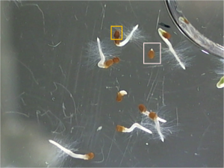
Figure 1: The pink square highlights a seed that has germinated, while the orange square shows an ungerminated seed.

3.2.2. Germination Rates (http://goo.gl/PQ65E)
In 1950, Helen Crumley (Crumley, 1950) grew tobacco seeds in the presence of different concentrations of D2O and found that seeds do, in fact, grow in the presence of 99% D2O (Figure 2). This is in direct opposition to the analysis of Lewis in 1933.
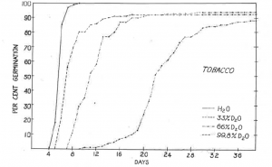
Figure 2: Tobacco seed germination rates from Crumley et. al.

There is a major difference between Crumley and Lewis’ experiments: Lewis submerged his seeds in water, and Crumley soaked her seeds on damp cloth. Both experiments are subject to D2O exchange, but Crumley’s is more so because of evaporation and the fact that the seeds are directly exposed to atmosphere. Because of the difference in methods between the two, I repeated the experiment and then expanded upon it (section 3.2.1.1.).
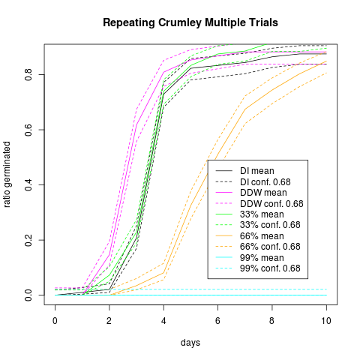
Figure 3: Tobacco seed germination rate in varying concentrations of D2O.

Figure 3, shows the cumulative seed germination rates for each trial of the experiment. It also shows the germination rate for seeds grown in DDW. Here no growth is tracked, simply whether a seed has begun the germination process or not. There is also no observation whether the seedlings are healthy.
Similar to Crumley, seeds grown in DI water and 33% D2O are not statistically distinguishable. But in opposition to Crumley’s observations, it is shown here that seeds grown in 99% D2O do not germinate. While only 10 days are charted, observations were made for 30 days and seeds showed no signs of growth. In fact, Crumley’s observations of seed growth in 99% D2O are in agreement with rates of evaporative hydrogen exchange (section 4.4.) and Lewis’s own observations of seed growth for seeds submerged in D2O and then washed and submerged in normal water (Lewis, THE BIOLOGY OF HEAVY WATER, 1934).
In the last trial of experiments, seeds were also grown in 1% D2O. Germination rates were indistinguishable between seeds grown in DDW, DI water, and 1% D2O (Figure 4). But in analyzing images by eye it seemed there was a difference between the three water samples, so another analysis was required.
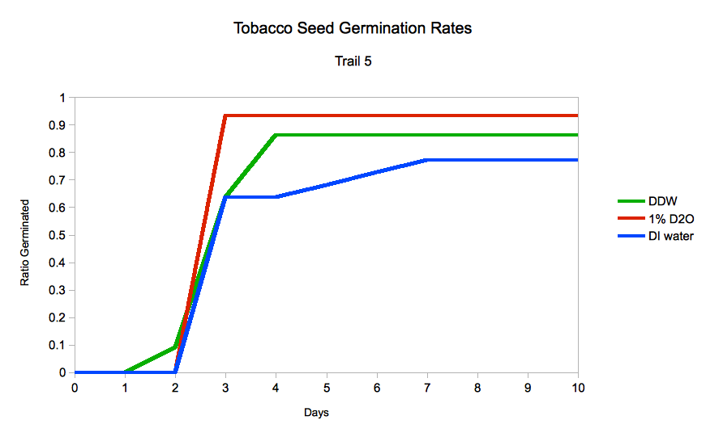
Figure 4: Tobacco seed germination in deuterium depleted water, deionized water, and 1% deuterium oxide.

Using the images acquired to calculate germination rates, it was also possible to measure root length each day (using ImageJ) and from that calculate the growth rate in different water types. Figure 5 tracks the growth rate of seeds placed in DDW, DI water, and 1% D2O. Seeds placed in 1% D2O and DDW grow at nearly double the rate of seeds placed in DI water (1.18 ± 0.10mm/day for 1% D2O, 1.07 ± 0.14mm/day for DDW, and 0.65 ± 0.07mm/day for DI water).
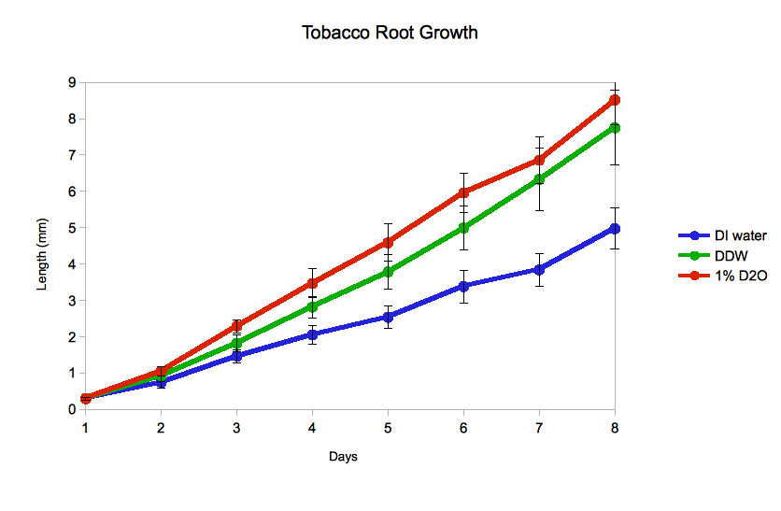
Figure 5: Tobacco root growth rates in DI water, deuterium depleted water, and 1% D2O.

It is apparent that both DDW and D2O induce enhanced growth mechanisms in tobacco seeds, but it is unclear what those may be. Based on the results here and those reported by Sinyak et al (Sinyak, Grigoriev, Gaydadimov, Gurieva, Levinskih, & Pokrovskii, 2003), the functions of H2O and D2O on life may be completely different, as originally proposed by Lewis. More comments on this in section 3.6.

3.2.3. Morphological response (http://goo.gl/9Fqvg)
Simultaneous to the germination experiments, seed root morphology was analyzed when grown in the presence of deuterium depleted water. When analyzing root morphology, three tobacco seeds (Virginia Gold #1 and Dark Virginia, The Tobacco Seed Company) were counted and placed inside macro cuvettes (VWR Catalog# 97000-584) which were filled with a different water type each. Water types included: regular tap water, DI water, and deuterium depleted water. Seed germination was maintained at 70F. Growth data was acquired via a Nikon D40 dSLR with an Opteka 52mm 10x macro lens (Amazon Catalog# B001A5K3BK). Observations were made by eye and recorded.
Seeds grown in the presence of deuterium depleted water exhibited a “hair” growth on the roots, which we called “root hairs” (Figure 6, day 27), while seeds grown in tap water showed none of this growth. Seeds grown in DI water exhibited a diminished root hair growth.
To test whether this phenotype was a product of deuteration or a property of pure water, seeds were placed in samples of different water purity. Seeds were grown in commercially pure water (Sigma-Aldrich) of tissue culture quality (Figure 7, day 25) and molecular biology quality, water purified in the CHTM DI water plant, and our own RoDI water purification system. Seeds were also grown in a simulated standard mean ocean water (SMOW) mixture of DDW and 16mM D2O. In each of these samples root hairs developed, but never to the extent of hair growth in pure DDW.
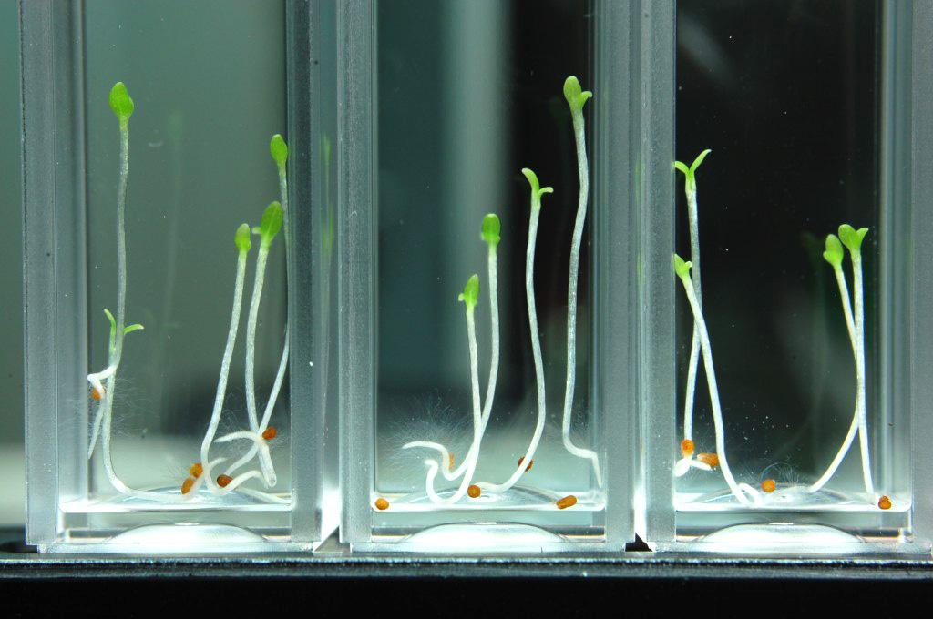
Figure 6: Tobacco seeds grown for 27 days in deuterium depleted water exhibit distress through pronounced root hair growth.

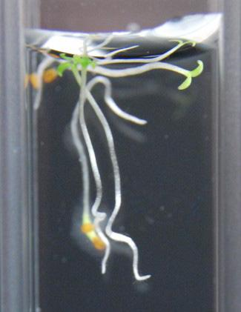
Figure 7: Seeds grown in purified deionized water for 25 days do not exhibit root hair growth.

Root hair was noticeable at a very early stage of seed development, usually just after radicle (first root) emergence (Figure 8).
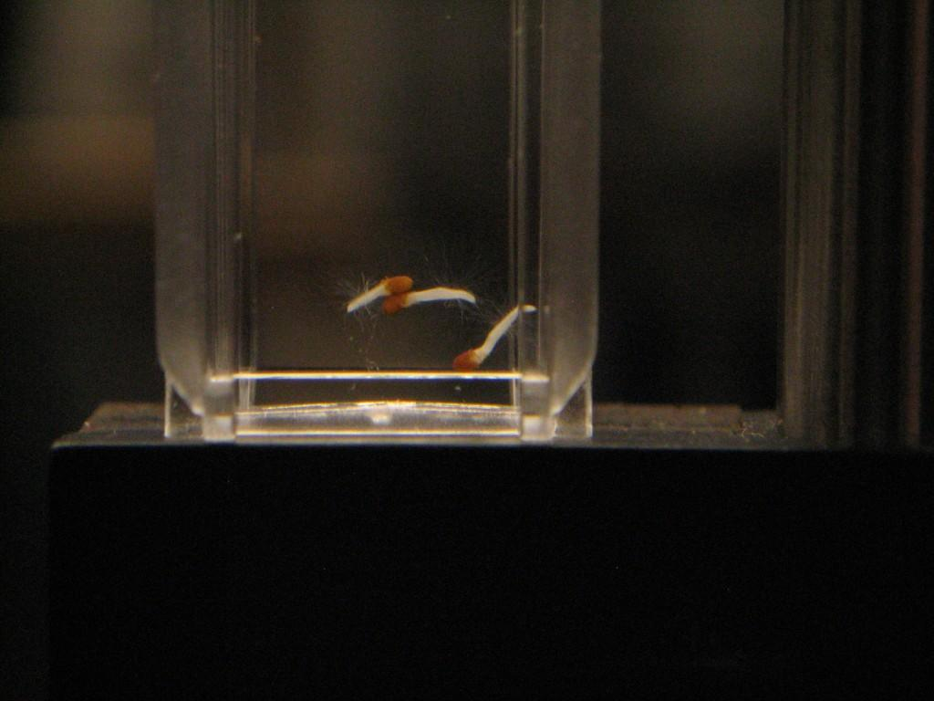
Figure 8: Seeds grown in DDW exhibit root hair growth at early stage of germination.

It should be noted that seeds were not sterilized prior to investigation. Figure 9 shows a sample with mold contamination, which is distinguishable from the phenotype exhibited in the presence of DDW.
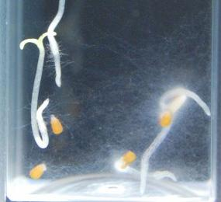
Figure 9: Contaminated sample of tobacco seeds. Mold growth (fuzziness on the right) took over the sample, but is distinguishable from the root hair phenotype (hairs on the left).

3.3. Arabidopsis growth in D2O
Arabidopsis (Arabidopsis thaliana) is a model organism studied for plant biology and genetics. Arabidopsis was the first plant to have its genome sequenced. It’s short life cycle (about 6 weeks) make it ideal to study for a variety purposes. We use Arabidopsis to expand upon Lewis’ and Crumley’s observations.
Tobacco plant growth times made it impossible, within the scope of this project, to study above-ground phenotypes. But because the seeds sprout quickly we were able to analyze root behavior in water. Arabidopsis on the other hand has a short life cycle with estimated germination to fruit times around 3 weeks. This makes it possible to analyze the species for above-ground phenotypical behavior.

3.3.1. Methods

3.3.1.1. Seed Germination Experimental Setup (http://goo.gl/pI8Ia)
21 to 78 Columbia Arabidopsis seeds (Lehle Seeds) were counted per sample and placed into analyslides (Pall Corporation Catalog# 7231). 6ml of water was then placed in each sample. Water types (with seed count) include: DI water (54), 33% D2O in DI water (78), 66% D2O in DI water (48), and 99.9% D2O (21).
After the addition of water, samples were closed and sealed with vacuum grease (DOW Corning high vacuum grease). One control sample was also created of water with no seeds to ensure no bacterial or mold growth. In the control, seeds were soaked and removed prior to sealing. Seed germination was maintained at 70F.
Seed germination was imaged with a Logitech HD Pro Webcam C910 and an HP Windows XP laptop. Seed germination was counted by hand from the acquired images.

3.3.1.2. Morphology Experimental Setup (http://goo.gl/pPH33)
Prior to planting, seeds were sterilized in a 4:1 ethanol/bleach solution and then washed in 100% ethanol. Solid growth media was made from 4.4g/L Murashige and Skoog Basal Medium (MS Media, Sigma-Aldrich Catalog# M0404), 1% agar, and water. Molten solid media was poured in 15mm diameter test tubes and allowed to solidify.
Three seeds were planted per sample and there were three samples per water type. Water types include: DDW, 10% D2O mixed with DDW, 60% D2O mixed with DDW, and 99.9% D2O. These water concentrations were chosen because of availability of D2O and funds.
Seeds were allowed to germinate in darkness, but once first leaves appeared the plants were placed under an incandescent bulb and a fluorescent bulb for 16h a day. They were maintained at 70F.

3.3.2. Germination rates (http://goo.gl/G2FSE)
During Trial 4 of the tobacco seed germination rate experiment (section 3.2.2.) I had decided to try to do a similar experiment using arabidopsis seeds to see if the Crumley hypothesis would be similar. Figure 10 plots the germination ratio of Arabidopsis, over time, in DI water, 33% D2O, 66% D2O, and 99% D2O.
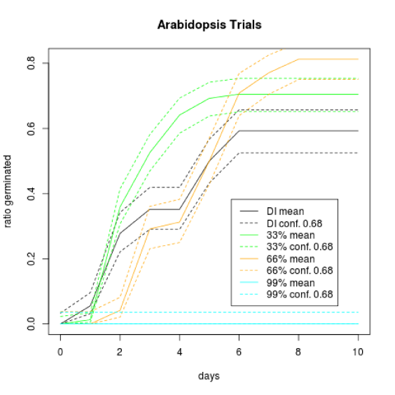
Figure 10: Arabidopsis seed germination rates in DI water, 33% D2O, 66% D2O, and 99% D2O.

Surprisingly the data are not consistent with the results from the tobacco seed experiments. While about 30% of the seeds in DI water sprouted early (within 48 hours), seeds in 33% D2O also sprouted at the same rate in similar number. It was also surprising to report seeds sprouting within 24 hours of water immersion.
The experiment became more challenging to manage due to the growth rate of arabidopsis, the size of the seeds, and the number per sample. All three factors played an important role after day 3 of the experiment, because arabidopsis would shed the seed coat quickly. Counting was extremely difficult as plants would diffuse around the sample while others would still be sprouting. The remaining seed coats could easily be mistaken for ungerminated seeds. Double counting was avoided as best as possible because ungerminated seeds would be a different color than the discarded seed coats.

3.3.3. Morphological response (http://goo.gl/Dzb51 and http://goo.gl/y9ouY)
Arabidopsis was originally placed in a D2O environment in 1968 by Bhatia and Smith (Smith, 1968). They attempted to answer the question, “How does H2O affect a D2O adapted organism?” In their experiment, they grow Arabidopsis in increasing concentration of D2O over several generations. The experiments reveal two important results: (1) the maximum amount of D2O that can be tolerated is increased in later generations, and (2) normal growth rates would return to the next generation of plants when planted in normal water.
Figure 11 shows plant growth in DDW, 10% D2O, and 60% D2O after 7 weeks. Plants grown in 99% D2O at first germinated (Figure 12), but ultimately did not survive. Most likely this is due to hydrogen exchange with the surface media, because once the root spread deeper into the growth media growth ceased and the plant died.
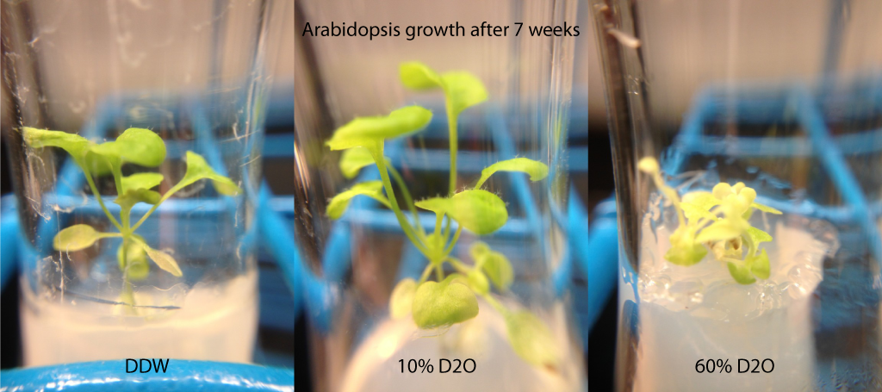
Figure 11: Plants grown in agar solution with nutrients in DDW, 10% D2O, and 60% D2O. The Arabidopsis in 10% D2O grows equally healthy to the plant in DDW, but increasing the D2O concentration adversely affects plant growth and induces leaf pigment discoloration.
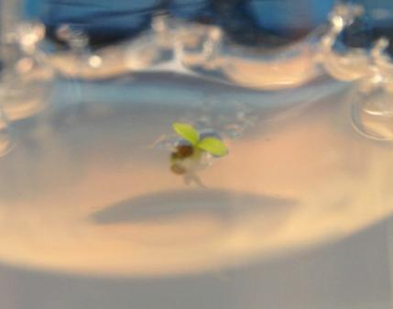
Figure 12: Arabidopsis grown in 99% D2O. Plant growth is due to deuterium replacement at the surface. A few days after this image was taken, the plant was found dead.

Plants in 60% D2O grew significantly slower than plants in either DDW or 10% D2O, which are consistent with tobacco root growth as seen in section 3.2.2. Germination rates between DDW and 10% D2O are expected to be similar based on results from section 3.3.2. However, it was surprising to see that plants in the two different deuterium concentrations grew at the same rate (observed). While plant health in each sample is yet to be determined, phenotypically plants in 60% D2O had a pale green appearance compared to seeds in DDW and 10% D2O. Seeds in both those samples were of similar appearance.
Based on these results it would seem that there could be an optimal concentration of D2O between 0% and 10% D2O.
Before Arabidopsis seeds were planted, they were initially cultivated in a setup similar to that in section 3.2.3. Figure 13 compares the root morphology of Arabidopsis grown in DDW and tap water after 27 days. With tobacco seeds, the development of root hairs was observed in deuterium depleted water. With Arabidopsis a similar observation was not possible, but we did notice that the roots seemed to be more prone to tangling due to a potential increase in root “curviness.”
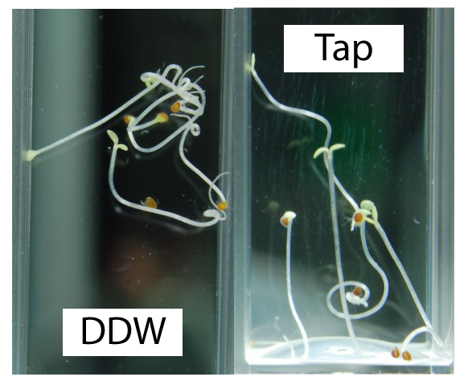
Figure 13: Arabidopsis grown in deuterium depleted water and tap water. Roots become more entangled in the presence of DDW compared to plants grown in tap water and DI water (not shown).

3.4. E. coli response to D2O (http://goo.gl/JJfau)
Escherichia coli is immensely useful in molecular biology for a variety of reasons. It is the most heavily studied prokaryotic organism and as such it is widely accessible. It was selected for these experiments because it was already available in the lab and because of its widespread use in microbiology.

3.4.1. Methods (http://goo.gl/2inE2 and http://goo.gl/4sHkr)
Commercially available competent E. coli (Invitrogen Catalog# 18265-017) was grown in standard liquid LB media (Sigma-Aldrich Catalog# L3022) dissolved in deionized water (DI water, obtained from CHTM DI water plant), deuterium depleted water (DDW, Sigma-Aldrich Catalog# 195294), deuterium oxide (D2O), 30% D2O, and 60% D2O. Autoclaving media is discouraged because of hydrogen deuterium exchange (see Section 4.4.). Instead media was sterilized by filtering through 0.2um syringe filters.
Cultures were started 24 hours prior and diluted in their respective water types (ie culture grown in DI water was diluted 1:10 in a fresh batch of DI LB). The mixed water media (30% and 60% D2O) are comprised of deuterium depleted water and deuterium oxide mixtures by volume. Cultures were grown in 10ml solutions and incubated at 37C. Hourly time points of the growth were recorded for a period of 5 hours with a Thermo Nanodrop 2000c.
E. coli was also grown on solid media with commercially available LB-agar plates (Teknova Catalog# L1100) inoculated from liquid cultures and incubated at 37C. D2O LB-agar plates were made from LB with 2% agar (also commercial) and dissolved in 99.9% D2O (Sigma-Aldrich Catalog# 151882).

3.4.2. Growth Rates (http://goo.gl/TM6y1)
Figure 14 shows the growth of E. coli in different concentrations of D2O. It is apparent that pure D2O affects the growth rate compared to that in DI water. Oddly enough, the growth rates in lower concentrations of deuterium are almost unaffected.
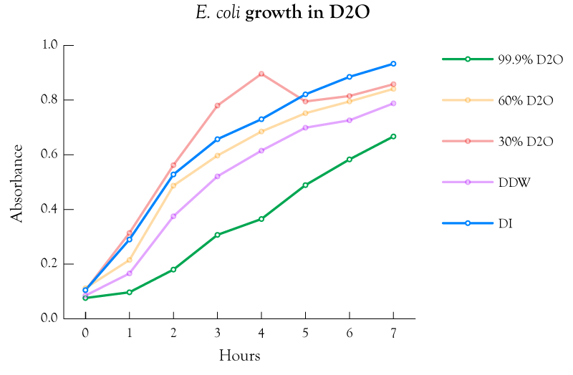
Figure 14: E. coli growth in varying concentrations of deuterium oxide.

An attempt was made to develop a strain of E. coli that was resistant to D2O. This adapted strain was cultivated in 99% D2O for 30 days, inoculating 10% of the culture in new media daily. Growth was recorded every 24 hours. The adaptation progress is shown in Figure 15.
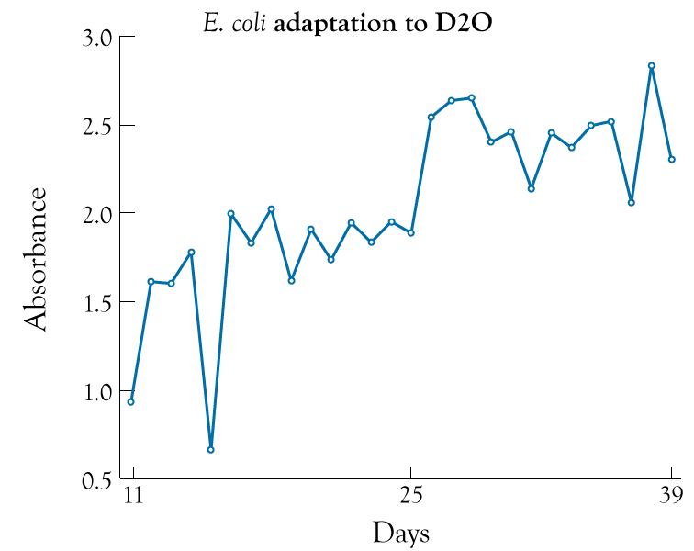
Figure 15: E. coli 24 hour growth in D2O over 39 days. At day 25 the 24h growth drastically changes indicating that E. coli has adapted to the 99% D2O media.

To determine successful/failed adaptation, the adapted strain was inoculated in both 99% D2O and DDW. The comparison of growth in the two media is shown in Figure 16. The growth of the adapted cells in DDW was also compared to the growth of the wt in DDW, and was always found to be faster. A projection of wt growth rates was made based on the growth rates of Figure 14 and input into Figure 16 for comparison.
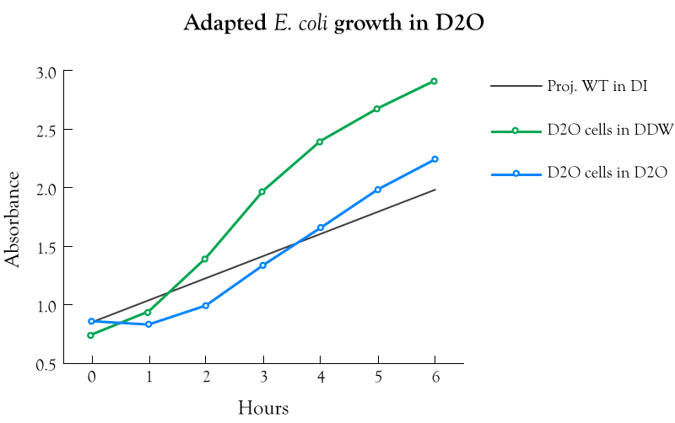
Figure 16: Growth rates of the adapted E. coli in 99% D2O and deuterium depleted water. A projection of wt cells grown in DI water is included for comparison.

The adapted cells inoculated in D2O grow at about the same rate as wt E. coli in DI water, with doubling times of 1.18 hours and 1.58 hours respectively. In deuterium depleted water, however, the adapted cells grow at a much faster rate with a doubling time of 0.765 hours. These times are not in accordance with optimal E. coli doubling times which can be attributed to limitations with equipment. Despite this, the trend for growth is obvious and repeatable.
It is interesting that E. coli is naturally not drastically inhibited by D2O, but when grown in the media for long periods of time, it adapts and grows at a faster rate when introduced into deuterium depleted water. These results suggest a new phenotype for growth in pure D2O, which also affects the growth rates in deuterium depleted water. With Arabidopsis, plants adapted to D2O and grown in normal water exhibited no such phenotype (Smith, 1968). This indicates that adaptation with Arabidopsis is a temporary affect, while adaptation in E. coli is a mutation from the wild type.

3.4.3. E. Coli Morphologies (http://goo.gl/UzxtN and http://goo.gl/bzMEg)
In the presence of D2O, E. coli exhibits different phenotypes both as individual cells and as a colony. In order to compare phenotypes in both cases, E. coli was cultivated in D2O for 30 generations. A comparison of its growth with that of the wild type E. coli can be seen in section 3.4.2.
D2O adapted cells and WT cells were inoculated in both DI LB and D2O LB liquid media each, as demonstrated in section 3.4.2. Figure 17 shows the individual cells of both the wt and the adapted organism compared in both D2O LB media and DI LB media. D2O adapted cells demonstrate a propensity to “stick” together, being joined at the pole. Since E. coli reproduces through binary fission, in the presence of D2O there is a greater chance the E. coli poles will remain joined once reproduction is complete. The cause of this is not well understood, but section 4.3. shows that D2O has a stabilizing effect on biological macromolecules, which could play an important role in E. coli reproduction.
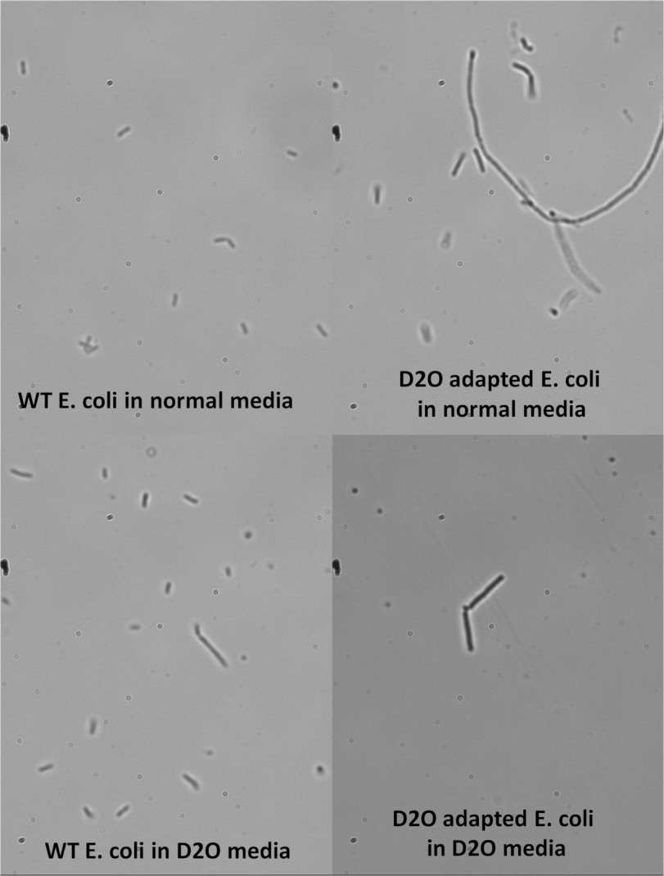
Figure 17: Morphology of wild type E. coli cells grown in LB media made with DI water and LB made with D2O. This is compared to E. coli cells adapted to growth in pure D2O and grown in DI LB media and D2O LB media.
On solid media, E. coli exhibits interesting phenotypical behavior. Figure 18 compares colony morphology of the adapted and wt E. coli grown on both solid D2O and DI LB media. WT E. coli colonies grown in normal conditions exhibit a circular growth pattern, but in the presence of D2O this pattern is affected by the stress cause by D2O. Interestingly enough, D2O adapted E. coli also exhibits signs of distress when grown on D2O solid media developing a “brainy” morphology. When the D2O adapted cells are grown on normal solid media, the colonies grow almost completely uninhibited. Colonies grow so quickly they merge and retain almost no individual structure.
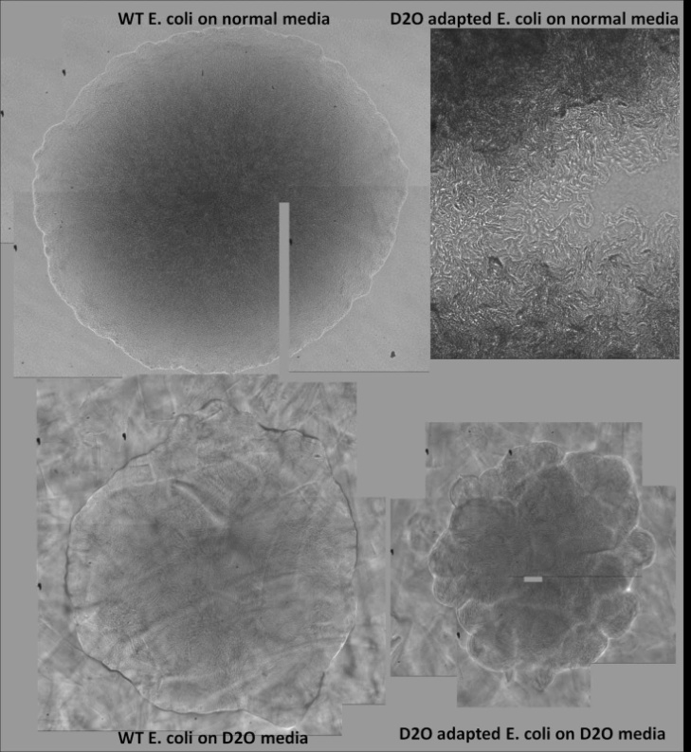
Figure 18: E. coli colony morphologies grown on solid media in the presence of D2O and DI water. Here D2O adapted cells are compared to wt cells.

Since the adapted cells demonstrate increased growth rates compared with wt cells (section 3.4.2.), the stress of the D2O environment must be characterized via alternative measures. It should also be noted that on normal LB media, E. coli cells tend to accumulate in small hemispherical mounds, yet both phenotypes tend to grow more “flat” on D2O media.
Based on these results, it would seem there is some use for deuterium in E. coli cellular processes. Instead of reverting to normal wt behavior in the presence of deionized/ddw water, D2O adapted cells grow completely uninhibited as demonstrated in section 3.4.2. This indicates a mutation from the wt in the presence of D2O. This mutation has phenotypes that also force the cells to remain joined after cell division, and exhibit “brainy” colony structures, in addition to the growth rates observed.

3.5. S. cerevisiae growth in D2O (http://goo.gl/HNG9c)
Saccharomyces cerevisiae, along with E. coli, is one of the most studied microorganisms. Being one of the simplest eukaryotic organisms its use in genetics is unparalleled. Because of this, it is also one of the most accessible organisms. Besides its use in research, it has commercial purposes in brewing and baking. S. cerevisiae was chosen in these experiments because of its use in molecular biology and because of my own personal interest in baking.

3.5.1. Methods (http://goo.gl/Km8ai and http://goo.gl/pYQxD)
Commercially available S. cerevisiae (ATCC #9763) was grown in standard liquid YPD (Affymetrix Catalog# 75858) suspended in DI water, 20% D2O, 40% D2O, 60% D2O, 80% D2O, and 99.9% D2O. Sterilization was attained by filtration using 0.2um syringe filter.
Prior to experimental start, a starter culture was cultivated. During week 1 daily cultures were grown in DI water with measurements of the growth acquired every 24h. Each week after that the concentration of D2O was increased 20%, with continued daily measurements. At the beginning and end of each week measurements were taken hourly for five hours. Cultures were incubated at 30C.
Cultures were also grown on solid media YPD. For basic YPD-agar, commercially available YPD plates were used (Teknova Catalog# Y1000). D2O plates were made from mixtures of D2O and DI water, YPD, and 2% agar.

3.5.2. Yeast Morphologies
Yeast morphologies were studied both as colonies and as individual cells grown in liquid media. Unlike E. coli, yeast colonies seem to be relatively unaffected by the presence of D2O with the exception of rate of development. Colonies of yeast grown on normal solid media would develop overnight, while colonies grown on pure D2O solid media would take about 3 days longer. Figure 19 compares colonies grown on solid media incrementing from natural amounts of D2O up to 99.9% D2O by 20% each step.
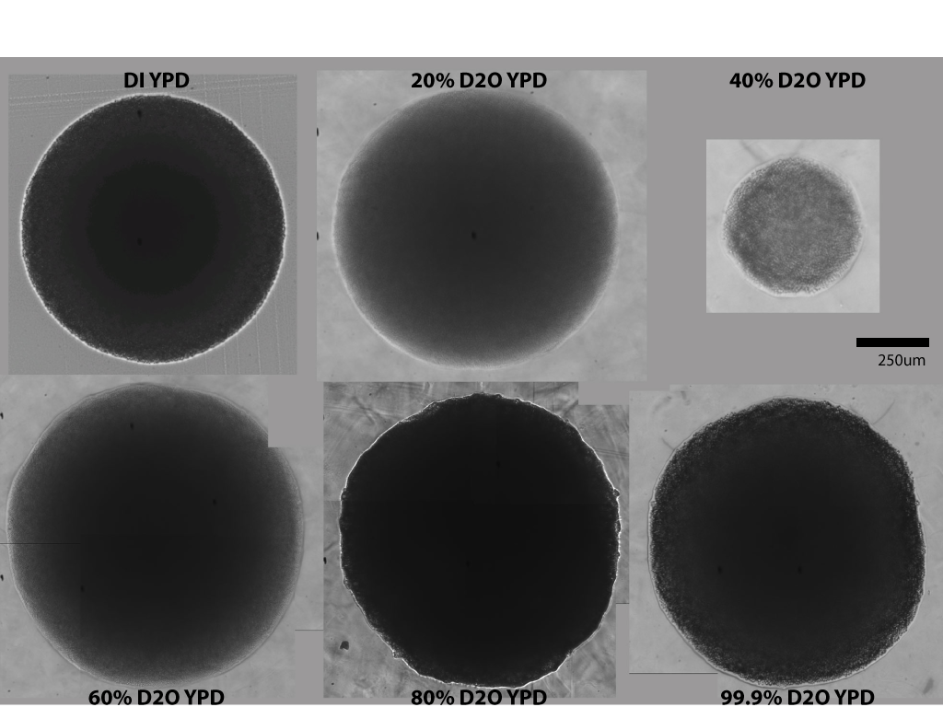
Figure 19: Yeast colony morphology on solid media in varying concentrations of D2O.

At lower concentrations of D2O, yeast colonies take on a more circular appearance, while at 40% D2O the shape becomes irregular. At 80% and 99.9% D2O the irregularity is more prevalent. Despite the irregularity of the shape, yeast growth is not affected in the same way as E. coli colonies.
Yeast grown in liquid media showed significant phenotypical differences. Figure 20 compares cells grown in liquid YPD media incrementing from natural amounts of D2O up to 99.9% D2O by 20% each step. In DI YPD, cells are oblate and exhibit broad cell cycle distribution via bud morphology. As D2O concentration increases, however, cells become more spherical and slightly larger. A very interesting phenotype displayed in pure D2O, is that cells become stalled when undergoing cytokinesis, and fail to complete cell division. Due to this, large clusters of joined yeast cells form and cause aggregates in liquid media. Figure 21 shows one such large aggregate.
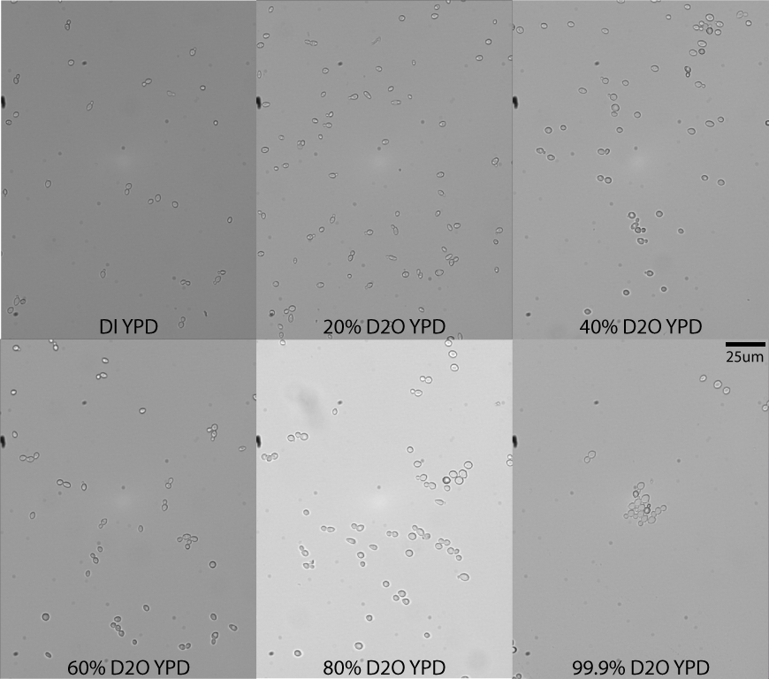
Figure 20: Yeast cells grown in vary concentrations of D2O in liquid YPD media.
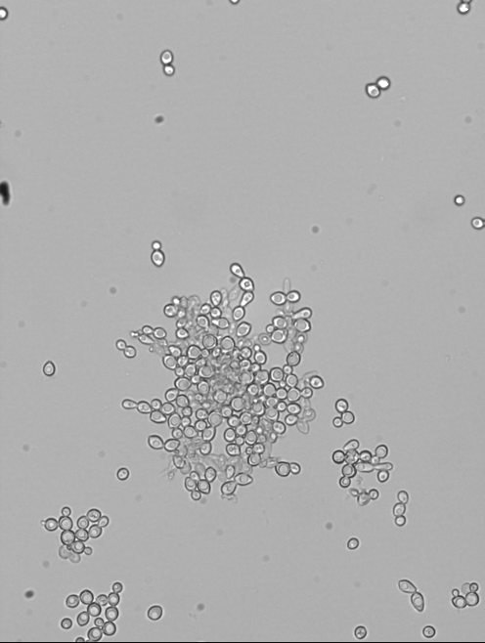
Figure 21: Yeast grown in 99.9% D2O fail to complete cell division, forming large aggregates of joined yeast cells.

The mechanism that causes yeast cells to stall during cell division is not yet known, but may be because of a lack of depolymerization of microtubules. Previous experiments have shown that D2O can stabilize microtubules, which pull chromosomes apart during the final stage of cell division. Without the depolymerization of microtubules, the budding process cannot be completed and the separation of the mother and daughter cells may be stalled. To test this hypothesis, similar experiments should be conducted with yeast grown in low concentrations of the drug Taxol, which has been demonstrated to induce stabilization of microtubules (Schiff, 1980).

3.5.3. Growth Rates
Yeast, unlike E. coli, is highly affected by D2O. Increasing concentrations of heavy water inversely affect the growth rate of yeast, much like it does for tobacco seeds and Arabidopsis. Figure 22 compares the growth of yeast in DI water, 20% D2O, 40% D2O, 60% D2O, 80% D2O, and 99.9% D2O. While yeast grown in low concentrations have similar growth rates, the difference between low and high concentrations is noticeable. The doubling time of yeast in DI water is about 0.67 hr, while the doubling time in 99.9% D2O is about 2.3 hr. It should be noted that the experiment was not optimized for yeast growth, and so the doubling times do not reflect optimal growing conditions. With that said, the pattern of increasing doubling time with increasing D2O concentrations is real and evident.
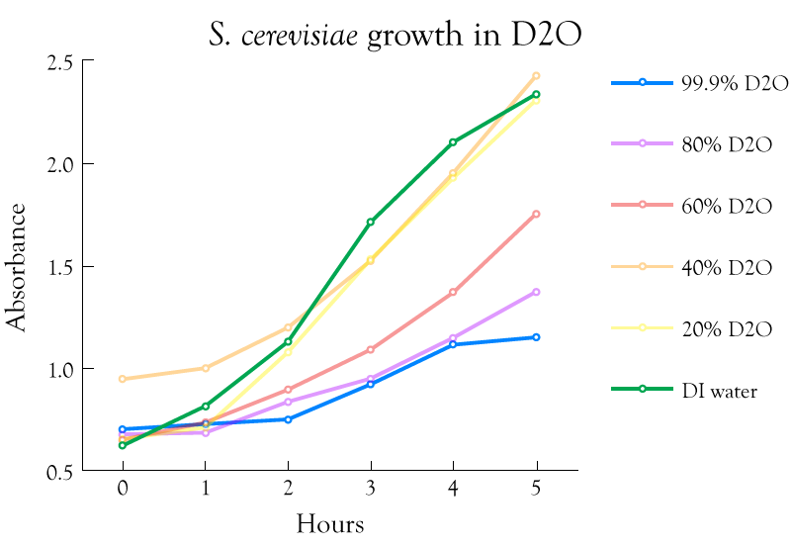
Figure 22: Yeast grown in liquid YPD in varying concentrations of D2O.

Yeast adaptation to D2O was attempted, but it seems that a crucial mechanism in cellular function inhibits this (section 3.5.2.). In the case of yeast (unlike in E. coli adaptation experiments), each week a culture was maintained at a specific concentration of D2O and increased the following week. Once 99.9% D2O was reached, the culture was maintained at that concentration for 17 days. The growth rate of yeast after this time remained unchanged. Based on the work of Unno et al (Unno, 2003), it would seem the best course of action would be to seek a mutant that is resistant to D2O.

3.6. Discussion
Reporting on the word done by Lewis, Crumley, Katz, et al it is clear that high concentrations of deuterium oxide affect the growth rates of a variety of organisms. More complex organisms are affected differently than simpler ones. For example, E. coli is almost unphased in the presence of D2O but yeast exhibits strange cellular behavior in pure heavy water. Likewise, yeast can survive in 99% D2O, but Arabidopsis and tobacco will not grow at all.
But there is evidence that there is some optimal concentration of D2O. Tobacco seeds grow at nearly the same rate in 1% D2O as they do in DDW. In the presence of no deuterium, tobacco roots exhibit strange behavior, growing “root hairs.” It is believed that the root hairs are a sign of stress induced by the extremely low amounts of available deuterium (<1ppm D atoms). If the presence of deuterium inhibits cellular function in high concentrations, extremely low concentrations should be uninhibiting. Thus, it stands to reason that seedlings should grow faster in DDW, than natural water. This was also reported by Sinyak et al (Sinyak, Grigoriev, Gaydadimov, Gurieva, Levinskih, & Pokrovskii, 2003).
The rapid growth in 1% D2O is peculiar, but not unreasonable. Similar results were obtained in the growth of arabidopsis at 10% D2O, which was remarkably similar to growth in DDW. The optimal amount of D2O for biological systems may be higher than the natural water ratio. Here it can be argued that cellular mechanisms are operating at peak efficiency, whereas with DDW effects, it could be surmised that mechanisms are running uncontrolled. In both instances, the phenotypes may be similar, but the underlying molecular processes may be very different.
Similar reports with yeast have been hypothesized by Richards in 1934 (Richards, 1934), when heavy water was very scarce. It may be out of the capabilities of current technology to perform yeast experiments using concentrations of D2O ranging from 0-1%. Yeast typically need to be shaken for optimal growth, which would expose the low doses to atmospheric water vapor. Surface mixing, hydrogen exchange, and evaporation may quickly bring all waters to natural deuterium levels.
Equally interesting to low concentration effects are the effects of high concentrations of D2O on living organisms. New phenotypes were exhibited in the presence of 99.9% D2O in both E. coli and yeast. Large aggregates of joined yeast formed, possibly due to microtubule stabilization, and yeast colonies became asymmetric in high concentrations of D2O. Similar morphologies were exhibited in E. coli, but only after a mutation caused by adaptation to deuterium oxide. Exhibited phenotypes of adapted cells include: joined cells after cell division, faster growth rates in both deuterium oxide and deuterium depleted water, and brainy structures of colonies. E. coli is not currently known to create microtubules. However, it has recently been discovered that some bacteria do have an ancestral form of tubulin, which has been shown to form a bacterial microtubule (Pilhofer M, 2011). Perhaps D2O stabilization of such structures could be the key to discovery.
It is imperative that these results be followed up on, rather than lie dormant for another 80 years. Current technological advances could provide a lot of insight into the biological effects of deuterium oxide, and new cellular mechanisms may be revealed because of these effects.

4. Molecular effects of deuterium

4.1. Introduction
The mass of deuterium, which is composed of a proton and neutron coupled in a spin-1 state, is roughly twice that of hydrogen, which is a single proton. This change slightly affects the electronic structure of deuterium compared to hydrogen, but greatly impacts its chemical properties. For instance, atomic bonds with deuterium (covalent, hydrogen, etc) are stronger than those formed with hydrogen (Deuterium). This leads to significant changes in molecular chemical effects. Table 2 highlights some of the properties of heavy water compared to light water (Heavy Water).
Property | D2O | H2O
Boiling/Freezing Point (°C) | 101.4/3.82 | 100/0
Density (at STP, g/mL) | 1.1056 | 0.9982
Viscosity (at 20°C, mPa·s) | 1.2467 | 1.0016
pH (at 25°C) | 7.43 | 6.9996
Table 2: Comparison of heavy water to light water.
The difference in bonding energies to deuterium or hydrogen can be attributed to the difference in vibrational frequencies caused by the difference in mass between hydrogen and deuterium (KATZ, 1960). In other words, the higher mass of deuterium gives rise to lower vibrational frequencies of bonds-to-deuterium, which in turn causes higher stability in those bonds compared to bonds-to-hydrogen.
Typically when conceptualizing experiments involving water as the solvent, the water molecules are largely ignored. When replacing the solvent with heavy water, it becomes important to consider the solvent effect on the molecules being studied. The hydrogen/deuterium in water molecules form hydrogen-bonds with the examined molecules, and as such, the difference in bond strength can impact the dynamics of the system. This is particularly important when dealing with the pH (or pD). Unfortunately, the kinetic isotope effects aren’t understood well enough to predict molecular behavior in a mixed hydrogen-deuterium environment, for instance in 50% D2O.
To better illustrate this, think of the interaction of kinesin with a microtubule (see Figure 23). As the kinesin is bound to the microtubule, water molecules surround the chemically bound pair and interact with the exterior atoms via hydrogen bonding. When the kinesin head separates from the microtubule, water molecules fill the void of the foot and begin to interact with all the newly exposed surfaces. Replacing the light water with heavy water, affects how the solvent interacts with the molecular surfaces. These fundamental interactions have demonstrated that deuterium affects kinesin processivity (Maloney, 2011).
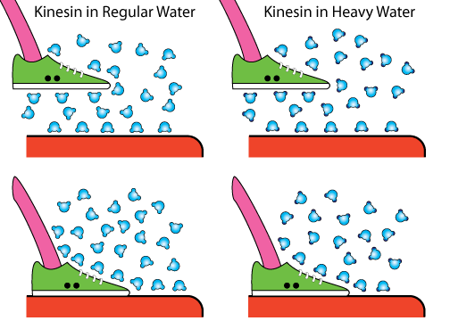
Figure 23: Comparison of kinesin processivity in H2O compared to D2O. In this case the kinesin molecule is represented by a sneaker, and the microtubule is represented by the orange cylinder.

Not only does deuterium interact with surface molecules, but exterior hydrogen and deuterium interact in a process known as hydrogen-deuterium (HD) exchange. In this mechanism, covalently bound hydrogen exchange places with deuterium atoms and vice versa. In naturally occurring water, where the amount of deuterium is relatively low (0.016%) the effect is probably negligible. But in processes exposed to larger amounts of deuterium, like many of the experiments contained in this dissertation, the effects are extremely important.
The HD exchange reaction has even been exploited for use in nuclear magnetic resonance (NMR) spectroscopy experiments, where protein structure can be identified because of the difference in magnetic structure between hydrogen and deuterium (S. W. Englander, 1997) (Sosnick, 1996). Thus, deuterium adapted organism would be extremely beneficial for protein structure identification (Unno, 2003). As the organism creates proteins and enzymes for cellular function, deuterium would be internally incorporated into the structure. NMR would have better resolution of the internal structure and could easily differentiate the protein from the water environment in which it is submersed.
Here I report on the role of deuterium on biomolecules such as DNA, catalase, and ovalbumin, using a variety of tools. I also analyze HD exchange and deuterium replacement in context of bulk water studies in order to ascertain effects these processes have on the experiments contained herein.

4.2. Deuterium and DNA
Originally the protocols contained within this section were designed to be used in a project known as Shotgun DNA Mapping (see Appendix 7.1.). The experiment plan was to unzip single DNA molecule fragments with optical tweezers and use the force vs. extension data to map the fragments’ location within the genome.
Various hurdles within the project forced the experimental plan to change, and when D2O experiments became the primary focus of the lab, the SDM project was amended to study how heavy water affects DNA physical properties.
In these experiments, double-stranded DNA (dsDNA) is overstretched in the presence of buffers suspended in H2O and compared to DNA overstretched in D2O. During DNA overstretch, DNA transitions from double-stranded DNA to two single-strand molecules in the presence of high forces (F ~ 65pN). Figure 24 illustrates this transition in the presence of Na+ at three different concentrations (Jay R. Wenner, 2002).
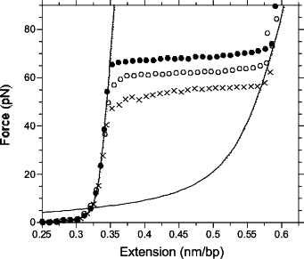
Figure 24: Force vs extension of dsDNA in solutions of sodium ions. This figure is used without permission from Wenner et al (Jay R. Wenner, 2002).

Here a dsDNA construct is designed for flexibility in multiple experiments, tethered to a glass surface, and stretched with optical tweezers in the presence of both D2O and H2O.

4.2.1. Double-Stranded DNA Construct (http://goo.gl/7PJoz)
Multiple steps are required to create a construct for DNA unzipping. The first step is to create a polymerase chain reaction (PCR) product which contains a digoxigenin molecule on one end of the DNA. This molecule allows the entire final construct to be tethered to glass (section 4.2.2.). It is also useful to use the same PCR product to examine the DNA tethering process. A biotin molecule is needed on the other end of the DNA. This biotin couples the DNA to streptavidin coated microspheres for visual identification of DNA tethers.
A custom plasmid was designed for use in multiple experiments. The plasmid was named pALS (plasmid Anthony Louis Salvagno) and was purchased from DNA 2.0. The plasmid contains binding sites for endonucleases BstXI and SapI and a nucleosome binding sequence (A. Thåström, 2004) (section 4.2.1.1.). The restriction sites for BstXI and SapI are sequence-specific and are crucial for creating unzipping DNA (Appendix 7.1.). The nucleosome binding site is useful for experiments that analayze the force vs extension profile of a bound nucleosome on dsDNA in either unzipping or overstretching experiments.
To create the dsDNA needed to proceed with the experiment, a PCR was performed. In the PCR setup the primers contain the required digoxigenin and biotin molecules, and would be incorporated into the final product. With regards to the overstretching experiments, the PCR product could be used immediately once diluted to a suitable concentration. For unzipping, more steps are necessary.

4.2.1.1. Sequences (http://goo.gl/ORrGb)
The sequence for the pALS plasmid is 5kb and contains a 170bp insert with the recognition sites for BstXI and SapI and a high-affinity nucleosome binding site. The plasmid, with insert, was purchased from DNA 2.0. The insert sequence is:
5’ – GCTCTTCCAGCTCCTGGAGATACCCGGTGCTAAGGCCGCTTAATTGGTCGTAGCAAG CTCTAGCACCGCTTAAACGCACGTACGCGCTGTCTACCGCGTTTTAACCGCCAATAGGATTACTTACTAGTCTCTAGGCACGTGTAAGATATATACATCCTGTCCAACGATCTGG - 3’.
To complete the overstretch DNA construct, primers are needed with incorporated digoxgenin and biotin molecules. Primers R4000-dig and and F50-biotin, named for their binding location in the plasmid, incorporate the coupling molecules on the 5’ end. The primers were purchased from Integrated DNA Technologies. Their sequences are:
- F50-bio: 5′ - biotin - TGTGTCGCCCTTAGGTACGAACT - 3′
- R4000-dig: 5′ - digoxigenin - TTCGCTCCAAGCTGGGCTGTGTG - 3′

4.2.1.2. Protocol (http://goo.gl/x1jlz)
The protocol provided here has been successful most recently, but may vary from one machine to another and depends on the quality of reaction ingredients. A good rule of thumb when starting a PCR reaction from scratch is to begin with the generally recommended settings and adjust accordingly. Table 3 contains the component concentrations.
Component | Final Concentration
pALS Template | 0.3ng/ul
R4000-dig | 0.5uM
F50-bio | 0.5uM
10x PCR Buffer | 1x
MgCl2 | 3.5mM
dNTP mix | 0.2mM
Taq | 1 unit
H2O | fill to desired volume
Table 3: Reaction components and concentrations for pALS overstretching DNA.

All components in reaction are commercial, except the water which is supplied by CHTM’s DI water plant. The reaction was performed in a Thermo PCR Sprint thermal cycler. Table 4 contains the reaction conditions of the thermal cycler.

Stage 1 | 96C | 3min | 1 cycle
Stage 2 | 96C | 30sec
 | 40C | 1min
 | 70C | 5min | 35 cycles
Stage 3 | 70C | 9min | 1 cycle
Table 4: Reaction conditions for pALS overstretching PCR.

The machine used was in need of calibration, so reaction conditions appear vastly different from typical conditions. After extensive characterization of the PCR machine used here, the internal temperatures were different than the programmed temperatures (shown in Table 4) and were based on experiments using a “dummy” reaction. The characterization and corresponding temperatures can be found in my notebook (Salvagno, Thermo PCR Sprint Thermocycler Programmed T vs Recorded T, 2012).

4.2.2. Tethering DNA
Tethered particle motion is a useful technique for a diverse set of investigations (Salvagno, Tethering Research, 2010). Experiments include viscosity analysis (D. E. Segall, 2006), DNA length analysis (Philip C. Nelson, 2006), enzyme activity (D. A. Schafer, 1991), and the experiments detailed here. Interestingly enough, tethering protocols for using DNA as the tether vary just as much as the uses for TPM. Variances in technique include buffers, incubation times, cleaning technique, and even raw materials (microspheres, flow cell, DNA length, etc).
The techniques described in this section are no different. Most of the techniques are adapted from the advisor’s PhD program experiments, which are descendents of Block Lab protocols. With that said, here is the DNA tethering protocol that worked best:

4.2.2.1. Buffers (http://goo.gl/lRnfR)
Buffers were made with H2O and D2O as the base. Originally the buffers were intended for use in the Shotgun DNA Mapping experiment. The base buffer is known as Popping Buffer, for its use in DNA unzipping experiments with bound proteins. From popping buffer, a blocking solution is made with commercial blotting grade blocker (BGB), which is non-fat dry milk, available from Bio-Rad (Catalog# 170-6404). Popping buffer contains the following components:
- 50mM NaCl
- 50mM Sodium Phosphate (which is a mixture of dibasic and monobasic sodium phosphate)
- 10mM EDTA
- 0.02% Tween-20
Each component was suspended in either D2O or H2O in larger concentrations, and then mixed together to achieve the final concentrations listed above:
- 4M NaCl was made as a solution in both D2O and H2O
- 500mM Sodium Phosphate (monobasic) in D2O and H2O
- 500mM Sodium Phosphate (dibasic) in D2O and H2O
- 100mM EDTA in D2O and H2O
- Tween was provided as a solution, but diluted in the water of choice.
All chemicals used are commercially available, and purchased from Sigma-Aldrich.

BGB was suspended in both D2O and H2O Popping Buffer at a concentration of 5mg/ml. Phosphate Buffer Solution (PBS) was suspended in H2O to create 20ul aliquots of anti-digoxigenin. Prior to experiment, the anti-dig is diluted 1:10 in Popping Buffer of either H2O or D2O.

4.2.2.2. Microspheres
Microspheres enable the visualization of DNA tethers, and are the structural component that facilitates DNA manipulation via optical tweezers. Microsphere size plays a role in the efficiency of the optical trap and affects the diffusion of the particle. In the case of DNA tethering, it also plays a role in tethering efficiency, a colloquial term used to describe the number of single DNA molecules attached to microspheres. Bigger beads are more likely to tether multiple DNA molecules, and also limits the length of DNA that can be used (see section 4.2.2.5.).
Factoring in the importance of bead size, 0.53um streptavidin coated polystyrene beads were purchased from Bangs Labs (Catalog# CP01N/10045). Similar quality products can be purchased through Invitrogen and Poly Sciences, but note that Bangs is a subsidiary of Poly Sciences and the beads may have identical fabrication processes (if not be identical products).

4.2.2.3. Preparing the Flow Cell (http://goo.gl/WnFae)
The flow cell is a very simple microfluidic device with either a single or double channel comprised of standard double-sided tape and precleaned slides and coverslips (VWR Catalog #48300-025 and #48366-045 respectively). Making the flow cell is very simple and can be done with basic lab equipment. Make sure to wear gloves while making flow cells so as not to contaminate the sample. Figure 25 shows a completed flow cell. The protocol follows, and a video protocol is available on Benchfly (linked above):
- Make strips of tape.
  - Place a piece of tape on a slide so that the tape is completely on the slide.
  - Cut the tape into three strips of equal width using a razor blade.
- Make tape wells.
  - Using curved forceps pull the strips of tape off one slide to be placed on a fresh unused slide. Again the strips should be parallel to the slide.
    - If you pull straight up you will reduce curving of the tape and make it easier to adhere tape to the new slide.
  - Place the strips about 4mm apart. Make sure the tape lies flat, this will prevent leakage between the channels.
    - If you are making one well, then just use two strips of tape.
- Create the flow cell.
  - Place the coverslip over the tape.
  - Use the forceps to press on the coverslip and seal it to the glass.
- Flow your sample and seal.
  - Flow your sample down the flow cell. Capillary force will pull the liquid down to flow cell. Excess liquid can be wicked through using a kim wipe on the opposite end of the channel.
  - Seal your channels with nail polish to prevent evaporation.
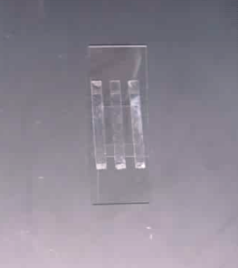
Figure 25: Two channel flow-cell for use in DNA tethering experiments.

4.2.2.4. Protocol (http://goo.gl/ar63S)
The protocol for DNA tethering is relatively simple. It involves four components, small incubation times, and a couple of wash steps. In developing this protocol, several other protocols were tried and produced comparable results. The method is as follows:
- Preparation:
  - Wash microspheres by diluting 1:100 in 1x Popping Buffer. Centrifuge at 6,600g for 5 min and discard supernatant. Repeat protocol 2-3 times and resuspend beads in desired final volume.
  - After washing, the beads tend to clump. Sonication for 3 minutes removes the majority of bead clumps.
  - Dilute a 20ul aliquot of anti-dig 1:10 in PBS.
- Flow one sample volume of anti-dig and incubate for 5 min. This molecule couples to digoxigenin and fixes the DNA to the slide.
- Flow 5 sample volumes of BGB and incubate for 3 min. BGB acts as a surface blocker and hinders DNA and microspheres from bonding to the glass non-specifically.
- Flow one sample volume of DNA and incubate for 10 min.
- Wash out excess DNA with 5 sample volumes of BGB (no incubation time).
- Flow one sample volume of microspheres and incubate for 10 min.
- Wash out excess microspheres with 5 sample volumes of BGB (no incubation time). This step is crucial, as it reduces the number of free beads in solution, which can hinder optical tweezer experiments.
- Seal chamber with nail polish to prevent evaporation.
The term sample volume refers to the volume of sample that can be held in a flow cell channel, and will vary slightly. Generally speaking, the microfluidics cell hold about 10ul of sample per channel using the protocol in section 4.2.2.3.

4.2.2.5. Tethering Analysis (http://goo.gl/Vd9qL)
Tethering efficiency is affected by several factors including bead size, DNA length, DNA concentration, and chemical potency among other things. When buffers, antibodies, and other chemicals have not expired DNA concentration is extremely important for successful TPM. When using specific length DNA tethers, microsphere size should also be considered.
In initial tethering experiments, 0.5um diameter microspheres were used in conjunction with DNA of ~1.1kb, 374nm, in length. 1.0um microspheres were also used, and the amount of visible tethers was drastically reduced due to volume exclusion effects between the microspheres and the glass surface (D. E. Segall, 2006). For this reason, the 4.0kb (~1360nm) pALS construct was developed. When used in conjunction with 1um spheres a higher tethering efficiency is attained.
When DNA length and bead size are ruled out as potential hindrances, DNA concentration is important to consider. In our studies a concentration from about .5nM to 10nM DNA yield the highest amount of single molecule tethers per field of view. Higher concentrations can create multiple tethers, where multiple DNA molecules can attach to the same bead. Conversely, low concentrations will typically yield a lower tethered bead count. In both cases, the amount of usable single molecule tethers were decreased.

4.2.3. Stretching DNA in D2O

4.2.3.1. Optical Tweezer Development
Optical tweezers are an optical system that minimally requires a laser, a microscope objective, a condenser, some steering components, and a detector (in our case a quadrant photo diode) among other things. In our system, we use a 2W 1064nm Nd-YAG laser (Crystal Laser). Steering optics include an acousto-optic modulator, mirrors and 1064nm coated lenses (Thor Labs), an inverted microscope (Olympus IX-71), 60x 1.5NA objective, condenser, quadrant photodiode, and many other mechanical components (Figure 26).
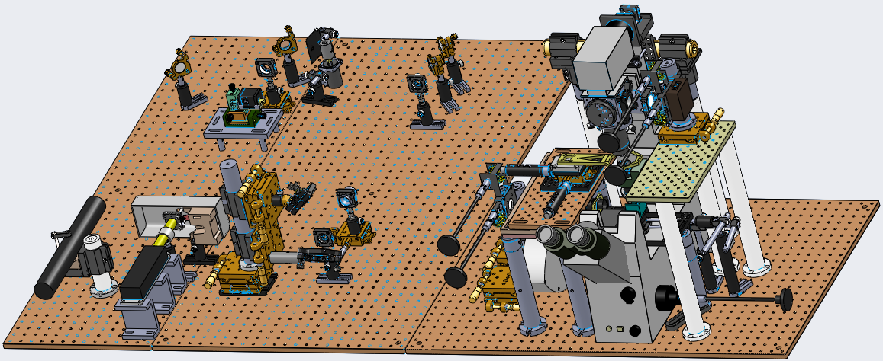
Figure 26: 3D schematic of the optical tweezers setup.

The use of a high powered laser coupled with a high NA objective provide high forces in the trapping plane. By overfilling the back aperture of the objective, the angle of the trap is increased, thus increasing the maximum trapping capabilities. The condenser collimates light exiting the sample plane and images that plane onto the photodetector which tracks the displacement of light.
The focused laser light creates an attractive environment to micron-scale dielectric particles (the microspheres). The focused laser light creates a 3D electric gradient which is cancelled by the microsphere, creating the attraction. The result is a bead trapped at the focus and pushed a little downstream of the beam waist (Figure 27).
Figure 27: Diagram of trapping forces on a microsphere.

Forces exerted by the trap are calculated due to displacements and intensity of the laser on the QPD. The optical trap can be assumed to exert a linear spring force on the microspheres used for DNA manipulation. The power spectrum data of the trap with a bead contained can be correlated to the trap stiffness. Once the maximum stiffness is calibrated, measurements can be taken that provide force information for manipulations. Noise affects measurements because particles in the trap are not stationary and are subject to brownian motion, acoustic vibrations, and thermal fluctuations. For this reason our system is enclosed and acoustically and thermally isolated.
The complete physical details of the KochLab optical tweezer system is documented by Pranav Rathi (Rathi).

4.2.3.2. Experimental Results
Figure 28 shows one overstretching event with D2O as the solvent.
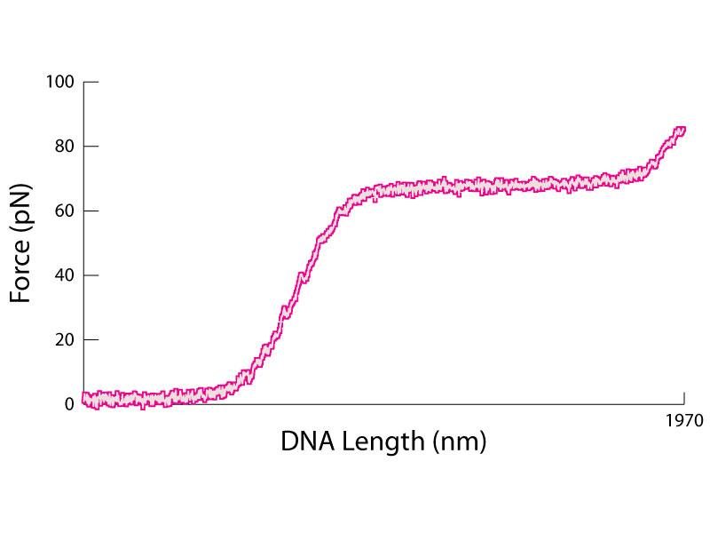
Figure 28: DNA overstretching in D2O.

20 DNA tethers in D2O were compared to 22 DNA tethers in H2O, the results of which can be found in Figure 29. We found that in D2O DNA overstretched at an average force of 67.63±0.34pN, while in H2O DNA overstretched at 65.06±0.53pN. The higher forces seen in D2O can be due to a number of factors. First, water-bound deuterium can form hydrogen bonds with the DNA backbone. Second, free deuterium can exchange with the hydrogen in the DNA bases (A, T, G, and C) which can change the base-pairing bond strength. Third, there may be HD exchange within the DNA backbone, which would increase the covalent bonds there. All these events produce higher bond strengths in D2O compared to H2O, because of the higher bond strengths of deuterium compared to hydrogen.
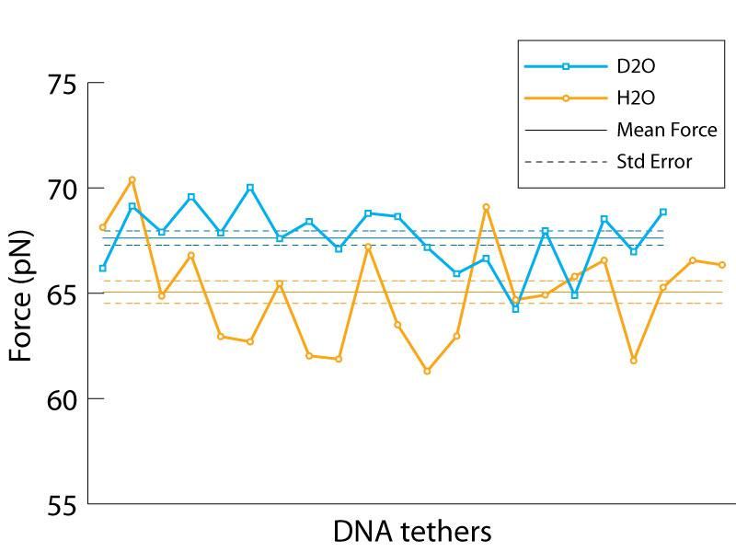
Figure 29: Comparison of the average overstretch force for DNA tethered in D2O and H2O.

4.3. Protein Aggregation Studies
Protein aggregation is the process where misfolded or unfolded proteins accumulate and clump. Protein aggregation in vivo can be toxic (Stefani, 2003) leading to diseases formed from insoluble protein matter, known as amyloidoses (O’Connor, 2010), including Alzheimer’s (Bertram, 2005). Experimentally, assays using pure protein will be less reliable or unrepeatable over time as proteins degrade, denature, and aggregate.
It has been shown that deuterium bonds are more stable than hydrogen bonds (KATZ, 1960). For this reason, investigations have been conducted that look into the effects of D2O on protein structure (Efimova Y. M., 2007), and it has been shown that D2O inhibits protein aggregation for a variety of proteins. Of particular interest, is the effect D2O has on the kinesin motor protein, microtubules, and the constituent tubulin. It has been found that tubulin, which is an unstable protein, is made stable in the presence of D2O (G. Chakrabarti, 1999). Microtubules, which are made up of alpha and beta tubulin, are also stabilized by D2O which promotes construction (assembly) and hinders deconstruction (catastrophe) (D. Panda, 2000).
Because of the stabilizing properties of D2O, using D2O as the solvent instead of H2O can increase chemical longevity and reduce lab costs. The use of D2O in assays may promote a more stable and thus repeatable experiment. Here we study how D2O affects the aggregation of catalase, ovalbumin, and YPD media.
A property of protein aggregation is that solutions become more cloudy as proteins denature and clump. For protein aggregation studies, dynamic light spectroscopy was used as the probing mechanism. A DynaPro Titan TC Dynamic Light Scattering Machine was used with gratitude to Dr. Marek Osinski. DLS has the ability to measure particle size based on light scattering, but for protein aggregation specific particle size isn’t a necessary output. We simply need to know that the average particle size is increasing. When studying YPD, DLS was no longer available so a nanodrop was utilized. These studies were carried out over a longer period of time (to simulate normal media degradation), and so we are looking to identify absorbance of the media which indicates aggregation.
The results in this section are provided with special thanks to Kenji Doering, who carried out the experiments under guidance from myself. His report on the findings can be found on Scribd (Doering).

4.3.1. Catalase (http://goo.gl/0qxQB)
Catalase is an enzyme that breaks down hydrogen peroxide, which can be highly reactive in the cellular environment, into water and oxygen. It appears in a wide variety of organisms and has applications outside of molecular biology including: the removal of hydrogen peroxide from milk, use in contact lens cleaning kits, in beauty products for facial treatments, and in the recognition of bacterial species (Catalase).
Catalase was selected because of its availability in the lab, low cost of purchase, and its highly repeatable aggregation abilities. Aggregation was studied at a concentration of 200ug/ml in D2O, deionized H2O, and deuterium depleted water (DDW). Temperature was steadily increased from room temperature up to 90C. Data were acquired every 3 seconds during temperature ramping. Figure 30 compares the scattering intensity for Catalase aggregation in both H2O and D2O. Results of aggregation in DDW are omitted because of experimental settings inconsistencies.
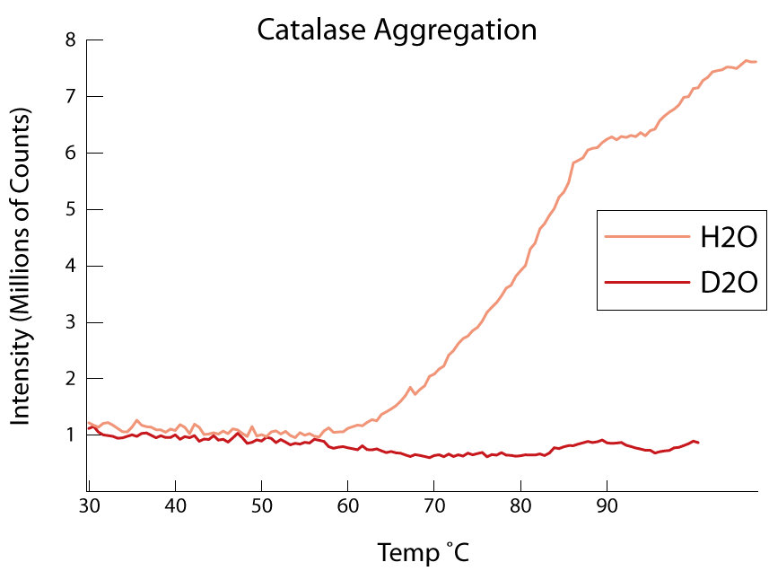
Figure 30: Scattering intensity of Catalase in D2O and H2O. Higher intesity is created by the presence of larger particles.

In H2O, as the sample temperature increases the proteins begin to denature and clump forming aggregates. At higher temperatures, the aggregates grow in size (indicated by the increasing intensity of scattered light). In D2O, however, aggregates do not form indicating that D2O stabilizes the tertiary structure of the protein. Much like DNA (section 4.2.3.2.) this stabilization comes in the form of (1) deuterium bonding between external protein components and deuterium oxide, (2) deuterium exchange with covalently bonded hydrogen in the protein strengthening the covalent bonds, and (3) deuterium bonding between internal-protein deuterium atoms.

4.3.2. Ovalbumin (http://goo.gl/0qxQB)
Ovalbumin is the main constituent of egg whites (Ovalbumin). It is a type of albumin, which are a family of globular proteins that are water soluble and experience heat denaturation. They are extensively studied for protein structure and serve a multitude of roles, most notably as a carrier in blood plasma. The most frequently studied albumin is bovine serum albumin (BSA).
Ovalbumin was selected because of its commercial availability and low cost. It had also been studied in a similar manner to our experiments (Weijers, 2002), and was a great candidate for experimental reproducibility. These experiments also provide us the opportunity to expand on the reported findings of ovalbumin aggregation. Aggregation was studied at a concentration of 200ug/ml in D2O, deionized H2O, and deuterium depleted water (DDW). Temperature was steadily increased from room temperature up to 90C. Data was acquired every 3 seconds during temperature ramping. In one experiment, temperature was ramped slower in 5C increments with 25 acquisitions between each step. Figure 31 compares the scattering intensity for ovalbumin aggregation in both H2O and D2O.
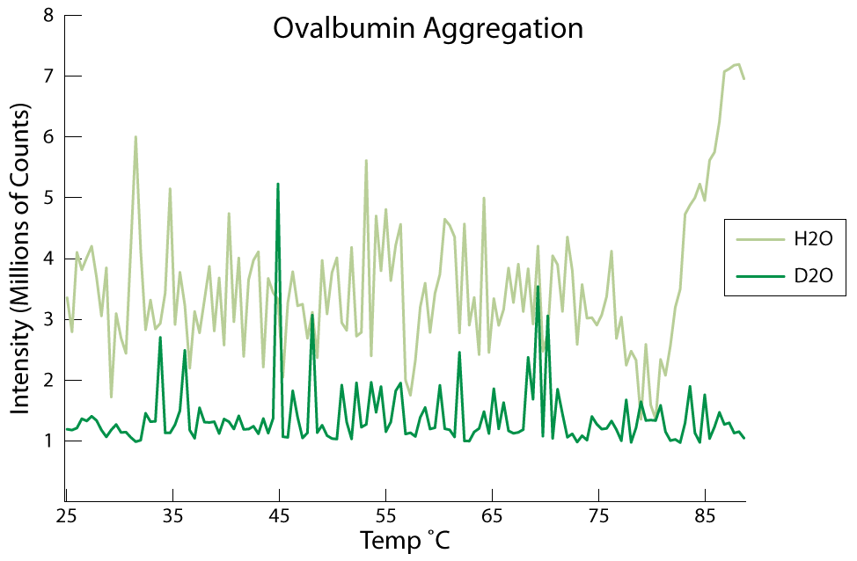
Figure 31: Scattering intensity for ovalbumin in H2O and D2O.
Despite the variance in intensity for ovalbumin in H2O, there is still obvious aggregation at about 80C compared to lower temperatures and compared to ovalbumin in D2O. Aggregation can even be verified by eye (Figure 32). Unfortunately these results were not consistent enough, as several experiments did not produce ovalbumin aggregation. Upon further examination, we found evidence to show that ovalbumin can denature into a secondary structure that exhibits reduced aggregation (BACK, 1962) (N. TAKAHASHI, 2005). This made it hard to ascertain whether D2O aggregation was possible or not, but it should be noted that ovalbumin was never observed to aggregate in D2O, while it aggregated in several trials with H2O.
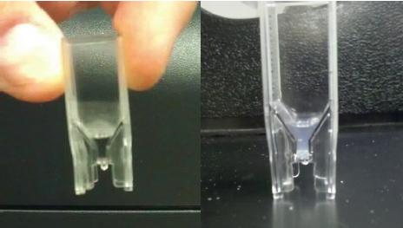
Figure 32: Ovalbumin solution before (left) and after (right) an aggregation experiment. Notice that after the experiment, aggregation can be observed by eye due to the cloudy appearance of the solution.

4.3.3. Yeast Extract Peptone Dextrose Media (http://goo.gl/q8KZg)
Yeast Extract Peptone Dextrose (YPD) is a growing media for yeast that can be used both in solid form, with the addition of agar, or in liquid form. It contains 2% peptone, 1% yeast extract, and 1% glucose with water comprising the rest of the solution.

Like any biological stock, YPD is subject to degradation over time. Figure 33 shows the degradation of YPD in both DI H2O and D2O after 2 weeks at room temperature. In these experiments a Thermo NanoDrop 2000c was used to take a broad spectrum analysis of the transmission properties of YPD. The degraded samples were also compared with a fresh sample of DI YPD to gauge deterioration.

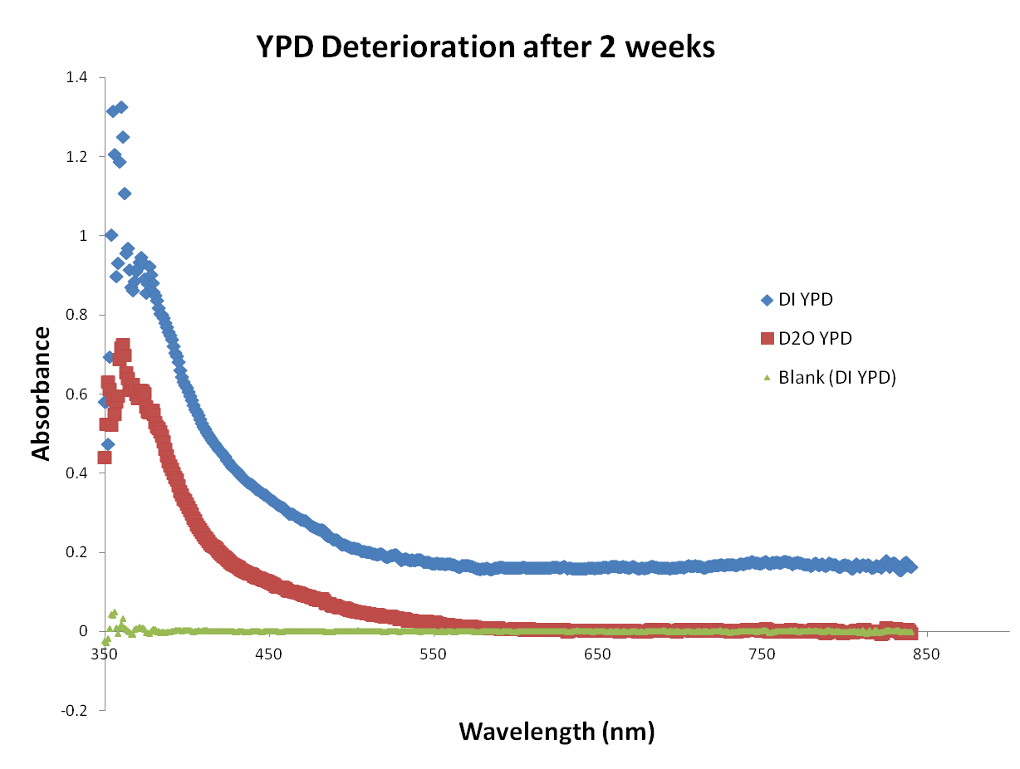
Figure 33: YPD deterioration in H2O (blue) compared to D2O (red) after 2 weeks. There is also a fresh sample of DI YPD (green) for comparison.

Smaller wavelengths of the spectrum reveal degradation in both 2 week samples compared to the fresh sample, but the absorption profile is lower in D2O. When we look at absorption of the samples at wavelengths necessary for cell growth studies (600-700nm), we noticed that there is no impedance in D2O, while the H2O sample has degraded enough to considerably detract from measurements. While YPD is just one biological reagent that would be preserved for longer periods of time in D2O, it seems that many chemicals, reagents, enzymes, proteins, etc would last longer if stored in D2O.

4.4. The mechanism of deuterium exchange
Hydrogen-deuterium (HD) exchange is a mechanism whereby a covalently bonded hydrogen atom can be replaced by a deuterium atom and vice-versa. The reaction is pH dependent with a high frequency of occurance at physiological pH (7.0-8.0). The reaction can be quenched in a highly acidic environment and is done so to control exchange rates for nuclear magnetic resonance or mass spectroscopy experiments.
Usually HD exchange is exploited for use in protein structure analysis. Water is one of the smallest molecules in solution and has access to all surfaces of macromolecules and even some internal structures. As such, physical changes to the water can affect the properties of macromolecules that it interacts with. This gives rise to the importance of HD exchange, as deuterium carried by water can react with proteins to change their structure. Deuterium replacement in proteins can be detected via NMR and mass spectroscopy techniques, because of the difference in physical properties between hydrogen and deuterium.
In the experiments documented here, hydrogen-deuterium exchange plays an even more important role. Many of the experiments are conducted in either deuterium depleted water (<1ppm deuterium content) or deuterium oxide (99.9% D2O). Because of this, exposure to atmosphere can alter the composition of either pure water type. In the case of DDW experiments, deuterium is introduced to the sample via atmospheric water vapor (156ppm D atoms). On the contrary for pure D2O experiments, hydrogen is introduced via atmospheric water vapor. In both cases, solution purity is crucial to the success of the experiment and while complete atmospheric isolation is impossible, access to atmospheric water vapor can be reduced.
Figure 34: (Figure 12 again) Plant growing in supposedly 99% D2O, but because of atmospheric water vapor interactions, the concentration of D2O is significantly less.

It has been recorded through multiple experiments that plants cannot grow in 99% D2O, but Figure 34 shows a seed germinating in 99% D2O. In the paper by Crumley et al, it has been reported that seeds eventually germinate in the presence of 99% D2O. Section 3.2.2. demonstrates that this is, in fact, impossible. The underlying reason behind these erroneous reports is hydrogen-deuterium exchange. As the water is accessible to atmospheric water vapor, the hydrogen/deuterium introduced can swap with the hydrogen/deuterium in solution and change the isotope ratios.
Because of this, we sought to characterize the hydrogen-deuterium exchange reaction with macroscopic experiments in mind. First we analyze differences in water type with Fourier transform infrared spectroscopy and then we look to understand atmospheric exchange rates via a Picarro cavity ring-down spectrometer.

4.4.1. FT-IR Spectroscopy (http://goo.gl/E0XF3)
Fourier transform infrared spectroscopy is a technique that measures the absorbance of a sample. A broadband light source shines into a Michelson interferometer, where the beam is split into two paths, one of which is directed at a movable mirror, and is recombined before entering the sample. The movable mirror creates different path lengths for the light which destructively interferes with light from the second path. This creates a narrower band spectrum that travels through the sample. Different mirror positions correlate to different wavelengths of light. Software is needed to compile the raw data and analyze via Fourier transform.
Because of the physical difference between D2O and H2O, ~11% mass difference, there are differences in the absorption spectra of the two waters. These differences arise from how deuterium and hydrogen transition rotationally, vibrationally, and electronically respectively. Figure 35 shows a comparison of the absorption of H2O and D2O.
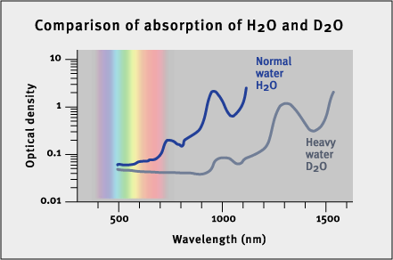
Figure 35: Absorbance spectra for H2O and D2O in the infrared. Used without permission from WebExhibits.org (Causes of Color - Colors from Vibration).

Natural water is sparsely found as pure H2O and pure D2O mixtures. Instead HD exchange creates mostly HOD configurations whenever deuterium is present. As deuterium concentration increases so too does the likelihood of D2O populations in solution. Therefore increasing amounts of deuterium should reveal themselves as a superposition of the H2O and D2O absorption spectra via FTIR spectroscopy.
Five samples were analyzed in a glass cuvette (Spectrocell Catalog# R-4010-T). Because only one cuvette was available, the sample holder was blow dried with nitrogen in between uses. We measured 99.9% D2O, deuterium depleted water (both a fresh sample and one from a bottle opened 3 months prior), deionized water, and a roughly 50/50 mix of D2O and DDW. 3mL of each water type was analyzed. Data from the FTIR spectrometer is output as wavenumber (cm⁻¹) but this can be converted to wavelength easily. Figure 36 shows the results of the experiment (Anthony Salvagno, 2011).
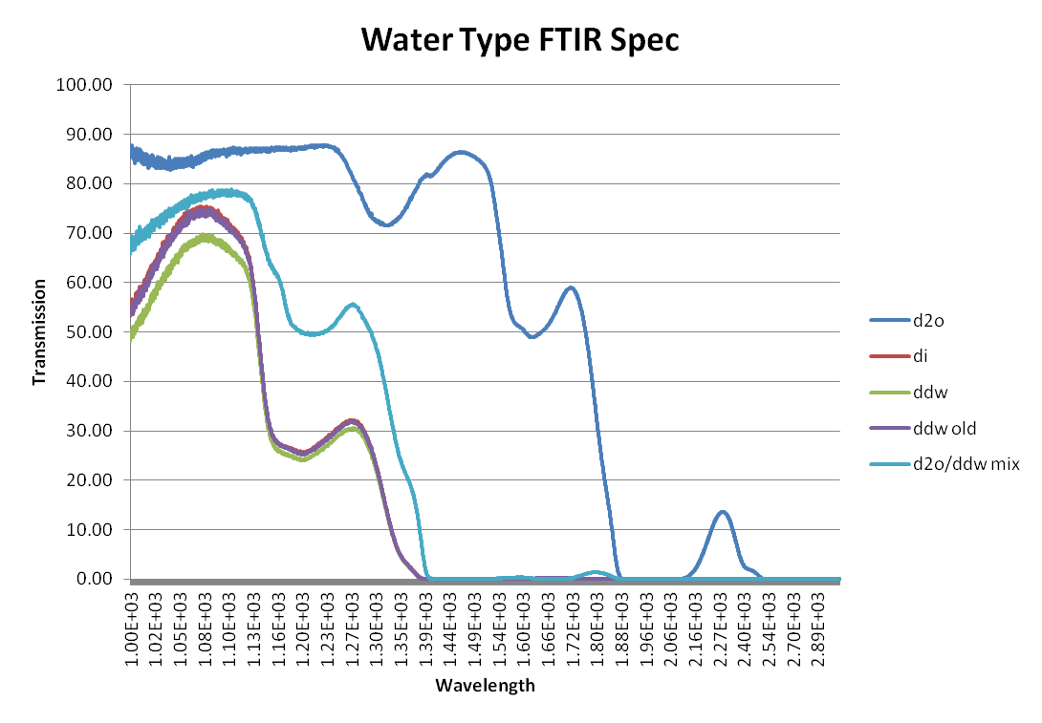
Figure 36: FT-IR transmission spectra for DDW, DI water, 99% D2O, and mixtures of the water types.

The data reveals a significant difference between pure D2O and pure H2O (DDW). In addition, the three mixed waters (DI, old DDW, and the 50/50 mix) exhibit absorbance frequencies that are in-between the spectra of D2O and H2O. Most interesting is that the spectra of the 3 month old DDW sample and the DI sample are identical. This suggests that the deuterium depleted water has undergone HD exchange with atmospheric water vapor and has more or less equilibrated.
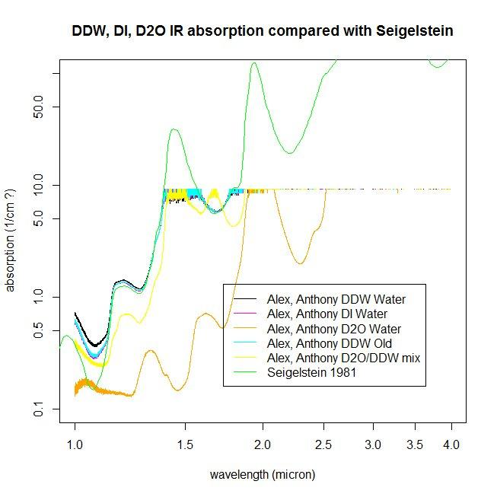
Figure 37: FT-IR data (from Figure 36) compared to water spectrum analysis by Seigelstein in 1981.
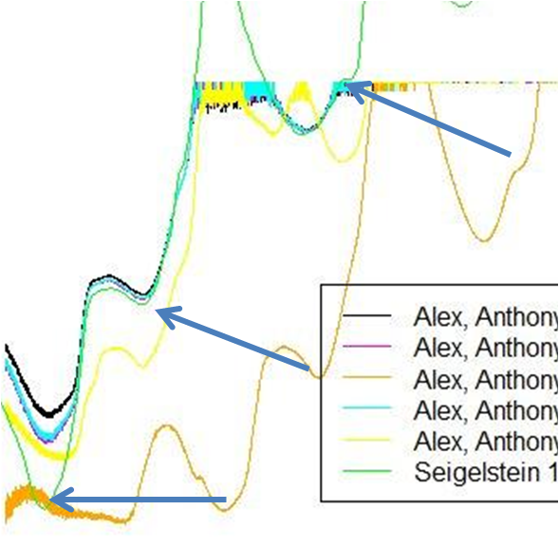
Figure 38: Enlargement of Figure 37 showing absorbance features in D2O and their analogs in H2O.

Figure 37 compares the FTIR data with H2O absorption data from Segelstein (Segelstein, 1981). The Segelstein data correlates very well to our DI water data from about 1um to 1.4um. As shown in Figure 36, the D2O spectrum is significantly different from the natural water spectrum, and these differences can be highlighted through the Segelstein data. Figure 38 shows an enlargement of Figure 37, with arrows indicating analogous features between D2O and H2O. As stated in section 4.1., these features are a result of vibrational differences of heavy water (vs light water) caused by the additional neutron in deuterium.

4.4.2. Cavity Ring-Down Spectroscopy (http://goo.gl/g75pN)
The main difference between FT-IR spectroscopy and cavity ring-down spectroscopy is that through CRDS one can attain an accurate count of the number of atoms present. In this technique, a laser pulse is trapped in a highly reflective resonant cavity with the sample to be measured. Inside the cavity (Figure 39), the pulse is reflected hundreds of times within the cavity creating a very long path length. Once the intensity reaches a certain level, the laser is shut off and the beam is allowed to decay slowly within the chamber. A detector calculates the decay constant based on the time it takes for the beam intensity to decay to 1/e. In the presence of a gas, the beam will decay faster due to absorption and then a calculation can be made to determine the mole fraction of atoms within the chamber.
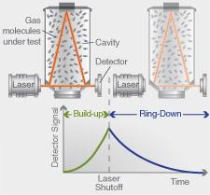
Figure 39: Diagram of cavity ring-down spectroscopy. Used without permission from Picarro (Cavity Ring-Down Spectroscopy).

Working with Scott Jasechko, UNM Earth and Planetary Sciences, we used a Picarro L2130-i analyzer to measure isotopic ratios in two samples of deuterium depleted water (Sigma Aldrich, <1ppm D atoms). One sample was dated January 7, 2012, the other February 16, 2012 which indicates the day the bottles of water were initially opened (exposed to atmosphere). Samples were stored in a desiccator since the opening date. The samples were analyzed on July 19, 2012.
January and February 2012 samples have similar stable oxygen and hydrogen isotope compositions, at roughly δ18O values near -535‰, and δD values close to -1000‰ relative to standard mean ocean water (SMOW (J. C. de WIT, 1980) (Baertschi, 1976)) which is approximately 1/6420 or 155.76ppm. The δD value of -1000 per mille corresponds to a 2H/1H ratio of zero (within analytical error), suggesting that these waters contain near zero amounts of deuterium. These waters are represented by gray and white circles in Figure 40.
It should be noted at this point that the spectrometer used in these measurements is calibrated to measure natural waters that range in δD values from ~-500 to ~+100, so the instrument is not suited to measure the extremely low deuterium abundances expected in these waters.
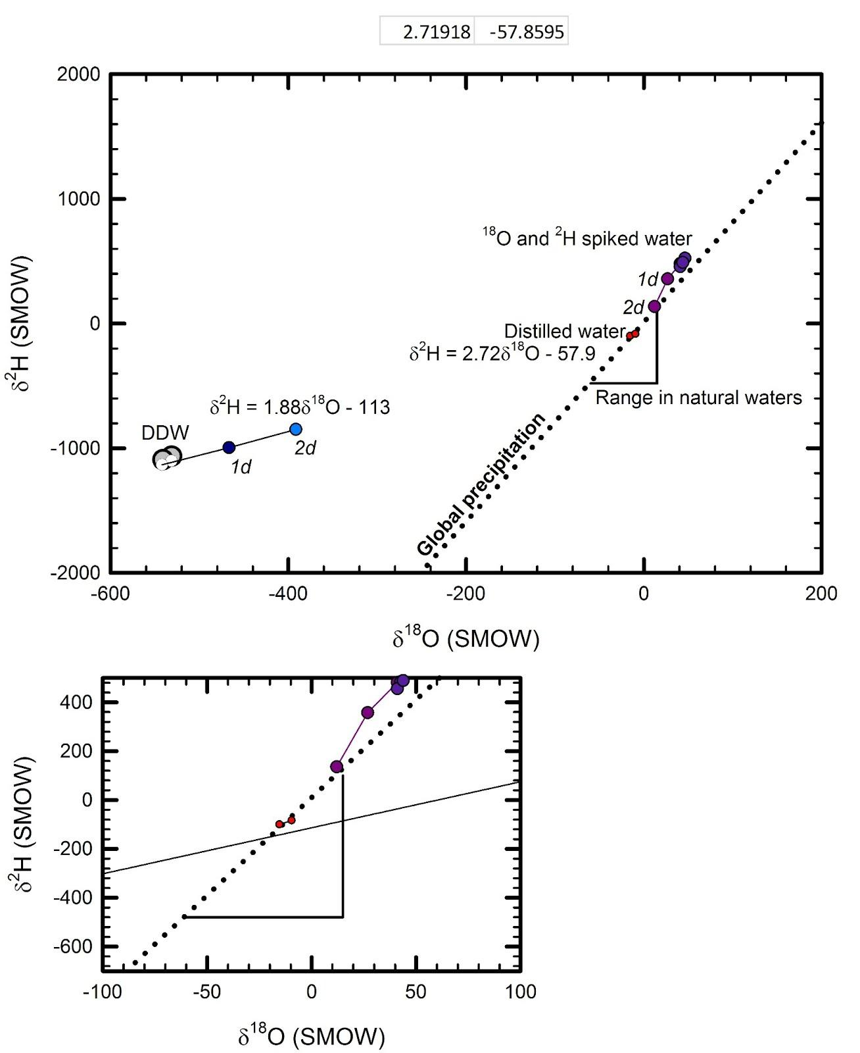
Figure 40: Top - CRDS analysis of DDW (gray circles) and D/18O spiked water (purple circles) over a few days. Both water types regress toward natural water isotope ratios. Bottom: Close-up of natural range of waters. Regression of DDW shown as the black line.
The oxygen isotope composition of these water samples contains roughly half the concentration of 18O when compared to modern oceans (18O/16O of 0.00092 compared to 0.002005 in SMOW). In δD-δ18O space these waters are shown to lie well “above” the global meteoric water line (Craig, 1961) – a rather unique feature that only occurs under special conditions of moisture recycling in nature (Gat, 1994).
In a second measurement, the deuterium depleted waters mentioned above were spiked with small quantities of 18O and D (represented by the blue circles in Figure 40). The original water samples and the spiked samples were exposed to atmosphere over 48 hours and allowed to exchange. Measurements of the samples were recorded every 24 hours. Measurements of DI water were also acquired under the same conditions (red circles), and lie within the natural range of isotopic composition.
Over the span of two days, both unnatural water compositions revert towards a natural water composition. Whether this is due to exchange or mixing is uncertain, but because the regression is linear it can be attributed to an evaporative mechanism. It is also hypothesized that the intersection of both DDW and Spiked water regressions can determine the atmospheric water vapor isotopic composition.
This technique could provide a low cost option for measuring the global concentration of atmospheric water isotopes, since no expensive equipment needs to be brought on site. Tubes of DDW and spiked water can be left on location, exposed to atmosphere for a couple of days. The samples can then be sealed and brought to a lab for analysis. The quantities measured need only be about 1ml in volume for consistency.

4.5. Discussion
The effects of deuterium on living cells observed in Chapter 3 are due to the observations made in this chapter. For eukaryotic organisms like plants, animals, and yeast many of the effects were a result of protein stabilization, which was observed directly for ovalbumin and catalase. Molecular stabilization may also affect many cellular processes where timing is of concern. The DNA experiments of section 4.2.3.2. show that the physical properties of biomolecules change in the presence of D2O. As such, DNA and RNA polymerases, molecular motors, enzymes, restriction endonucleases, and many other macromolecules have specific (and well-documented) rate constants and chemical properties which would be altered in the presence of D2O. Essentially, every study ever conducted in water would also have to be redone in D2O to understand how the solvent affects molecular properties.
In environments that aren’t pure H2O/D2O (ie natural water isotope ratios) a more thorough understanding of solvent effects is needed. As shown here, HD exchange is a concern for pure water environments both in understanding isotope ratios of the solvent, but also in understanding how the solvent interacts with molecules or larger entities like cells. In mixed water media, these effects become more difficult to study because it is complicated to probe exactly how a single molecule will interact with surrounding water molecules. Currently there is no single-molecule probe for solvent isotope effects and simulations of such environments use algorithms that require supercomputer processing capabilities.
Despite these hindrances, and the toxicity of D2O to organisms, there are biological uses for heavy water. Most notably, storage of biology reagents, enzymes, proteins, DNA, etc should be done in D2O instead of H2O (or DI water). This will increase the shelf life of the reagents (especially expensive and fragile ones), and save labs time and money.

5. Conclusion
It has been 80 years since Gilbert Lewis first purified heavy water, defined its properties, tested its effects on living organisms, and created a new field of scientific research. Since that time, many scientists have reported the effects of deuterium oxide on a wide variety of living organisms and began testing isotope effects on smaller scales. It is surprising that few have probed the solvent effects of deuterium on the single molecule level. Even more surprising, is that only a handful of researchers have analyzed effects of deuterium-free environments on biological systems. Additionally, no one has studied the effects of extremely low deuterium environments on biological systems.
In short, Gilbert Lewis’ hypothesis, that life may need deuterium instead of just tolerating it, went unexplored for 80 years.
In 1% D2O, tobacco seeds germinate faster than they would in natural water, indicating that deuterium isn’t merely tolerated, and that there is an optimal amount of deuterium that is above natural water concentrations. Both tobacco and Arabidopsis seeds display root phenotypes that show signs of distress in deuterium depleted water, further illustrating the biological need for deuterium.
Large concentrations of heavy water prove toxic to these organisms, but E. coli, which functions almost normally in pure D2O, can be used to further study the effects of deuterium depleted water. In these studies, a mutant strain that is resistant to high D2O concentrations was developed. When grown in deuterium depleted water, the mutant strain literally grows out of control. This indicates that cellular mechanisms may be uncontrolled without deuterium, and that one function of deuterium is to stabilize cellular processes.
S. cerevisiae was grown in high concentrations of D2O. In 99% D2O the cells stalled during cytokinesis causing large aggregates of joined yeast cells. This was due to the stabilization of biomolecules used in yeast cell division in high concentrations of deuterium. Overstretching experiments with DNA show that the physical properties of biomolecules are changed in D2O compared to H2O. Additionally, studies with catalase and ovalbumin reveal protein stability in D2O. These studies all indicate that simply changing the solvent can affect the chemical properties of biomolecules. These results also provide reasons that can help to explain stalling during cell division in yeast.
While deuterium is twice as heavy as hydrogen, there isn’t much difference in the physical properties of the two atoms. The extra mass of deuterium, however, affects chemical properties much more than it would for other isotopes. This gives rise to the increased bond-to-deuterium strength both covalently and through hydrogen bonding. These bonds are very important when discussing biomolecular structure and function. Understanding phenomena, like hydrogen-deuterium exchange, become important in understanding the role of solvent effects on biomolecules. Additionally, HD exchange should be characterized on the single molecule level, to ascertain molecular effects in mixed water, essentially quantify physical and chemical properties.
All of the experiments discussed in this dissertation indicate a new field of study probing deuterium effects macroscopically, microscopically, and nanoscopically simultaneously. By publishing these studies through open notebook science, I hope to push the research forward much faster than it would propagate via traditional means. In this way, I hope to ensure that another 80 years aren’t required to further explore these hypotheses.

6. References
A. Thåström, L. B. (2004). Nucleosome locations of dominant DNA sequence motifs for histone-DNA interactions and nucleosome positioning. Journal of Molecular Biology , 338 (4), 695-709.
Anthony Salvagno, A. H. (December de 2011). FT-IR Spectroscopy of Different Water Types. (figshare) Obtenido de http://figshare.com/articles/FTIR_spectroscopy_of_different_water_types/89562
BACK, M. B. (1962). Modification of Ovalbumin in Stored Eggs detected by Heat Denaturation. Nature , 193 (4818), 878-879.
Baertschi, P. (1976). Absolute18O content of standard mean ocean water. Earth and Planetary Science Letters , 31 (3), 341-344.
Bertram, R. E. (2005). Cell , 120 (4), 545-555.
Bradley, J.-C. (1 de June de 2010). Use of ONS to protect Open Research: the case of the Ugi approach to Praziquantel. Recuperado el December de 2012, de UsefulChem: http://usefulchem.blogspot.com/2010/06/use-of-ons-to-protect-open-research.html
Catalase. (s.f.). (Wikipedia) Recuperado el February de 2013, de http://en.wikipedia.org/wiki/Catalase
Causes of Color - Colors from Vibration. (s.f.). (WebExhibits) Recuperado el February de 2013, de http://www.webexhibits.org/causesofcolor/5B.html
Cavity Ring-Down Spectroscopy. (s.f.). (Picarro) Recuperado el March de 2013, de http://www.picarro.com/technology/cavity_ring_down_spectroscopy
Citizen Science. (s.f.). Recuperado el December de 2012, de Wikipedia: http://en.wikipedia.org/Citizen_science
Craig, H. (1961). Isotopic Variations in Meteoric Waters. Science , 133 (3465), 1702-1703.
Creative Commons License Upheld by Dutch Court. (16 de March de 2006). Recuperado el December de 2012, de Groklaw: http://www.groklaw.net/article.php?story=20060316052623594
Crumley, H. a. (1950). Influence of deuterium-oxide on germination. Tennessee Academy of Science , 25 (3), 171-186.
Current Fee Schedule. (s.f.). Recuperado el December de 2012, de US Patent and Trademark Office: http://www.uspto.gov/web/offices/ac/qs/ope/fee031913.htm
D. A. Schafer, J. G. (1991). Transcription by single molecules of RNA polymerase observed by light microscopy. Nature , 352 (6334), 444-448.
D. E. Segall, P. C. (2006). Volume-Exclusion Effects in Tethered-Particle Experiments: Bead Size Matters. Physical Review Letters , 96 (8), 88306.
D. Panda, G. C. (2000). Suppression of Microtubule Dynamic Instability and Treadmilling by Deuterium Oxide. Biochemistry , 39 (17), 5075-5081.
Deuterium. (s.f.). (Wikipedia) Recuperado el March de 2013, de http://en.wikipedia.org/wiki/Deuterium
Doering, K. (s.f.). The ability of deuterium oxide to stabilize the kinesin motor protein. (Scribd) Obtenido de http://www.scribd.com/doc/63524819/The-Ability-of-Deuterium-Oxide-to-Stabilize-the-Kinesin-Motor-Protein
Efimova Y. M., H. S. (2007). Stability of globular proteins in H2O and D2O. Biopolymers , 85 (3), 264-273.
Friedman, V. (1 de January de 2008). 10 Principles Of Effective Web Design. Recuperado el December de 2012, de Smashing Magazine: http://uxdesign.smashingmagazine.com/2008/01/31/10-principles-of-effective-web-design/
F-Shaped Pattern For Reading Web Content. (17 de April de 2006). Recuperado el December de 2012, de Nielsen Norman Group: http://www.nngroup.com/articles/f-shaped-pattern-reading-web-content/
G. Chakrabarti, S. K. (1999). Stabilization of Tubulin by Deuterium Oxide. Biochemistry , 38 (10), 3067-3072.
Garlick, M. (23 de March de 2006). Spanish Court Recognizes CC-Music. Recuperado el December de 2012, de Creative Commons News: http://creativecommons.org/weblog/entry/5830
Gat, J. B. (1994). The contribution of evaporation from the Great Lakes to the continental atmosphere: estimate based on stable isotope data. Geophysical Research Letters , 21, 557-560.
GateHouse Media v. That's Great News. (5 de August de 2010). Recuperado el December de 2012, de Digital Media Law Project: http://www.dmlp.org/threats/gatehouse-media-v-thats-great-news#description
Gleason, J. D., & Friedman, I. (1975). Oats may grow better in water depleted in oxygen-18 and deuterium. Nature , 256, 305.
H. Crespi, S. A. (1959). Culture of Algae and other Micro-organisms in Deuerium oxide. Nature , 184 (4687), 729-730.
Heavy Water. (s.f.). Recuperado el January de 2013, de Wikipedia: http://en.wikipedia.org/wiki/Heavy_water#Applications
Hemminger, J. P. (2012). Decoupling the scholarly journal. 6.
J. C. de WIT, C. M. (1980). Determination of the Absolute Hydrogen Isotopic Ratio of V-SMOW and SLAP. Geostandards Newsletter , 4 (1), 33-36.
J. Ginsberg, M. H. (2009). Detecting influenza epidemics using search engine query data. 457 (7232), 1012–1014.
J. J. Katz, H. L. (1962). Course of deuteriation and some physiological effects of deuterium in mice. The American journal of physiology , 203, 907–913.
Jay R. Wenner, M. C. (2002). Salt dependence of the elasticity and overstretching transition of single DNA molecules. Biophysical Journal , 82 (6), 3160-3169.
KATZ, J. J. (1960). Chemical and biological studies with deuterium. American Scientist , 48 (4), 544–580.
Lewis, G. N. (1933). The biochemistry of water containing hydrogen isotope. Journal of the American Chemical Society , 55 (8), 3503-3504.
Lewis, G. N. (1934). THE BIOLOGY OF HEAVY WATER. Science , 79 (2042), 151-153.
Macdonald, G. N. (1933). SOME PROPERTIES OF PURE H2H2O. Journal of the American Chemical Society , 55 (7), 3057-3059.
Maloney, R. (2011). Experimental protocols for and studies of the effects of surface passivation and water isotopes on the gliding speed of microtubules propelled by kinesin-1 (Dissertation document). University of New Mexico, Physics. Retrieved from ProQuest Dissertations and Theses.
N. TAKAHASHI, M. O. (2005). Thermostability of Refolded Ovalbumin and S-Ovalbumin. Bioscience, Biotechnology, and Biochemistry , 69 (5), 922-931.
Nereid. (18 de August de 2008). Galaxy Zoo Papers. Recuperado el December de 2012, de Galaxy Zoo Forum: http://www.galaxyzooforum.org/index.php?topic=271980.0
O’Connor, A. A. (2010). Protein aggregation diseases: pathogenicity and therapeutic perspectives. Nat Rev Drug Discov , 9 (33), 237-248.
Online Chat Transcripts. (s.f.). Recuperado el December de 2012, de US Patent and Trademark Office: http://www.uspto.gov/inventors/independent/chats/faq/transcriptsn_s.jsp
Open Access. (s.f.). Recuperado el December de 2012, de Wikipedia: http://en.wikipedia.org/wiki/Open_access
Open Science. (s.f.). Recuperado el December de 2012, de Wikipedia: http://en.wikipedia.org/wiki/Open_science
Ovalbumin. (s.f.). (Wikipedia) Recuperado el February de 2013, de http://en.wikipedia.org/wiki/Ovalbumin
Philip C. Nelson, C. Z. (2006). Tethered Particle Motion as a Diagnostic of DNA Tether Length. The Journal of Physical Chemistry , 110 (34), 17260-17267.
Pilhofer M, L. M. (2011). Microtubules in Bacteria: Ancient Tubulins Build a Five-Protofilament Homolog of the Eukaryotic Cytoskeleton. PLoS Biology , 9 (12).
Pricope, F., Ştefă̆nescu, Tiţescu, G., Cărăuş, I., & Ureche, D. (2003). Effect of deuterium-depleted water on reproduction of rainbow trout. Environ. Chem. Lett. , 1, 149-151.
Prior Art. (s.f.). Recuperado el February de 2012, de Wikipedia: http://en.wikipedia.org/wiki/Prior_art
Publishing Fees. (s.f.). Recuperado el December de 2012, de PLoS: http://www.plos.org/publish/pricing-policy/publication-fees/
Rathi, P. An automated and user-friendly optical tweezers for biomolecular investigations. University of New Mexico, Physics and Astronomy. Proquest.
Richards, O. (1934). The effect of deuterium on the growth of yeast. Journal of bacteriology , 289-294.
S. W. Englander, L. M. (1997). Hydrogen exchange : The modem legacy of Linderstrom-Lang. Protein Science , 6 (5), 1101-1109.
Salvagno, A. (5 de July de 2010). Tethering Research. (OpenWetWare) Recuperado el 2013, de http://openwetware.org/wiki/User:Anthony_Salvagno/Notebook/Research/2010/07/05/Tethering_Research
Salvagno, A. (23 de August de 2012). Thermo PCR Sprint Thermocycler Programmed T vs Recorded T. (IheartAnthony's Research) Recuperado el 2013, de http://research.iheartanthony.com/2012/08/23/thermo-pcr-sprint-thermocycler-programmed-t-vs-recorded-t/
Schiff, P. B. (1980). Taxol stabilizes microtubules in mouse fibroblast cells. Proceedings of the National Academy of Sciences , 77 (3), 1561-1565.
Segelstein, D. J. (1981). The complex refractive index of water. Dissertation, University of Missouri-Kansas City.
Seki, K., & Usui, T. (2006). Patente nº 2006000104. Japan.
Serials Crisis. (s.f.). Recuperado el December de 2012, de Wikipedia: http://en.wikipedia.org/wiki/Serials_crisis
Sinyak, Y., Grigoriev, A., Gaydadimov, V., Gurieva, T., Levinskih, M., & Pokrovskii, B. S. (2003). Deuterium-free water (1H 2 O) in complex life-support systems of long-term space mission. Acta Astronaut , 52, 575– 580.
Smith, C. B. (1968). Adaptation and growth response of Arabidopsis thaliana to deuterium. Planta , 184, 176–184.
Sosnick, S. E. (1996). Mechanisms and uses of hydrogen exchange. Current opinion in … , 6 (1), 18-23.
Stefani, M. (2003). Protein aggregation and aggregate toxicity: new insights into protein folding, misfolding diseases and biological evolution. Journal of Molecular Medicine , 81 (11), 678-699.
Tarquini, M. (24 de July de 2007). Blasting the Myth of the Fold. Recuperado el December de 2012, de Boxes and Arrows: http://boxesandarrows.com/blasting-the-myth-of-the-fold/
Unno, K. K. (2003). Increased expression of Hsp70 for resistance to deuterium oxide in a yeast mutant cell line. Biological and … , 26, 799-802.
Weijers, M. a. (2002). Light Scattering Study of Heat-InducedAggregation and Gelation of Ovalbumin. Macromolecules , 35, 4753-4762.

7. Appendices

7.1. Shotgun DNA Mapping (http://goo.gl/LWExj)
Shotgun DNA mapping was a technique that the KochLab developed to map protein and enzyme binding locations for a particular DNA fragment. This concept was based on prior work by Steve Koch that showed site specific protein-binding locations could be revealed using single molecule analysis. The technique is simple in principle: unzip a DNA sequence with optical tweezers and compare the data to a library of simulated data for a given genome to figure out where the fragment is located in that genome. Expanding on this, one could map protein locations, by unzipping DNA with proteins bound and then matching the unzipped DNA data through the matching algorithm.
For this to work experiment, we developed three components:
- Optical Tweezers – to unzip DNA and record data
- DNA – to unzip
- A computer simulation – to simulate DNA unzipping and match recorded data to simulated data
I’ve provided a few blog posts in my personal blog to discussing the basic principles of the project. The basics of optical tweezer mechanics are described in Section (4.2.3.1.). The optical tweezer system was developed by Pranav Rathi (Rathi). The computer simulation for unzipping DNA and the matching algorithm were developed by Lawrence Herskowitz et. al. The DNA construct was my specific focus while working on the SDM project, and will be detailed below.
Unfortunately I hit an impassable road block in the experiment. The DNA I created wouldn’t unzip. I tried everything I could think of, reworked the entire process and tried to come up with alternate methods for creating the DNA fragments. Ultimately I had to switch to the project that became this dissertation.
But that doesn’t mean that the project was a complete failure. I’m sure the protocols and techniques I employed can be useful to someone, somewhere, someday and so I’m going to highlight posts from my old notebook here as a way to kind of direct attention to the protocols that summarize my project well and were most useful for me.
In this way, one wouldn’t need to sift through mounds of information just to find one thing. And it would provide visitors here a little more information about my background and something I keep alluding to. All in the name of open science!

7.1.1. Designing and creating the construct (http://goo.gl/CEJ1i)
Step 1 of Shotgun DNA Mapping (SDM from here on out) is to create the unzipping construct. For that you’ll need some DNA.
There are 3 pieces of DNA required to have a completely unzip-ready object. They are:
- The anchor – this is a 1kb/4kb (depending on the situation, kb = kilobases) double stranded sequence that is created from the PCR reaction of a plasmid. In our old cases it was pRL574, but I experimented with another sequence that I named pALS. I may start with the pRL574 plasmid to get started. This piece contains a molecule that allows us to attach the DNA to a glass surface (the microscope slide).
- The adapter duplex – this is technically two single strands of DNA that are annealed together to create a weird double stranded piece. It is ~25bp long and there are tons of variations that I’ve experimented with. This piece contains a molecule that allows us to attach the DNA to a microsphere. It also hosts a space that allow us to essentially break the DNA so we can unzip it.
- The unzipping DNA – this is the DNA that gets unzipped in the experiment. It can be anything essentially, but for the purposes of SDM we use yeast genomic fragments, and in the very near term I’ll be using pBR322 (a commerically available plasmid) to test the reactions and to calibrate the tweeze
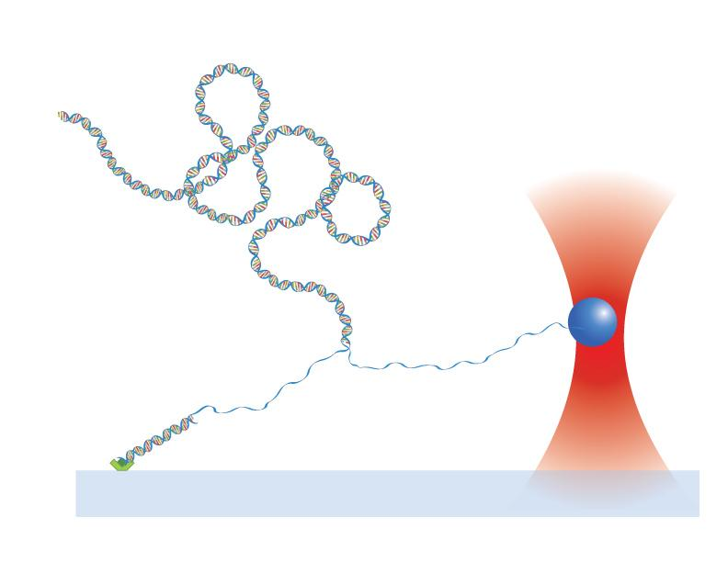
Figure 41: Diagram of the process of unzipping DNA.

7.1.2. Anchor Unit (http://goo.gl/kI9y7)
In order to unzip DNA, you need to create three pieces of DNA that will attach to each other through a ligation reaction. The first piece that I will discuss is the anchor DNA.
The anchor DNA is a very versatile piece of double stranded DNA (dsDNA). From this singular piece, we can choose to unzip DNA or stretch it because of a special sequence contained in the DNA near one end. I’ll get into this a little bit later. But first a couple of questions:
- Why is it called anchor DNA? The reason is because we use this piece of DNA to attach our entire structure to a glass surface. This is the point that anchors our DNA while we pull on it for either stretching or unzipping experiments. One of the bases is designed with a digoxigenin molecule attached to it and that base is placed right at the start of the sequence. In our tethering experiments, we coat our glass with an antibody for digoxigenin (dig for short), cleverly named anti-dig, and chemistry causes the anti-dig to bind with dig. You can understand a lot about antigen-antibody interactions here.
- How can we decide between stretching and unzipping? Because of how we designed the anchor DNA, we can stretch the anchor segment by default. That means once I produce anchor DNA I can tether it and begin stretching experiments. If we want to unzip DNA, then I take the anchor DNA and cut the end off (the side opposite the dig molecule) in a digestion reaction (more on this another time). That reaction gives me a small overhang (when one side of the DNA is longer than the other). From there I can perform a series of reactions that create the DNA sequence necessary to perform unzipping experiments. Notice that the anchor end is left unchanged, and that is what enables us to perform both stretching and unzipping experiments from this one piece of DNA.
Now the third question is, How do you make the anchor sequence? For this we need to know several sequences, possibly perform some cloning, and perform a reaction known as polymerase chain reaction, or PCR.
I’m not going to go into the details of what PCR is and how it works (google searching will reveal a lot more useful information than what I’d be willing to put here), but what I will say is that PCR allows me to make millions/billions of copies of a sequence of DNA starting with just a few strands of the original sequence and some short pieces of DNA called primers.
Our original sequence comes from plasmids. For the anchor sequence I have two possible starting points: pRL574 is a plasmid that dates back to Koch’s graduate days, and about a year and a half ago I created a brand new plasmid called pALS. Both plasmids are viable options, but serve slightly difference purposes:
- pRL574 – for this plasmid we have several different sets of primers that allow us to make anchors of different lengths ~1.1kb and ~4.4kb. The 4.4kb sequence we use primarily for stretching experiments, while the 1.1kb sequence is used in unzipping experiments.
- pALS – this plasmid only produces one length which is about 4kb. But this plasmid allows us to both unzip and stretch as I described above. It also has a couple of very unique features. First, if I cut it in the right spot, I can ligate the plasmid to itself through a special adapter sequence (to be described later). Second, it contains a sequence that is recognizes by nucleosomes, that we could use for more complicated experiments down the road.
So as you can tell, I have some options available to me. Normally I would just pick one plasmid to work with, but I want to work with both and figure out which may be the more viable option down the road. In my next post, I’ll link to and list the sequences needed to make the anchor construct, with some explanations as to what everything is.

7.1.2.1. Sequences
- pRL574- This is a non-commercial plasmid provided by Robert Landick. We have a very small supply so I will have to do some cloning to make an infinite supply!
  - primers – according to notes that I have on OWW and Google Docs I’ve had success with F834-dig as the forward primer (and might be the only primer I have in the lab), R2008 and R1985 as the reverse primers. The difference between the two reverse primers is the length of the PCR sequence, which turns out to be a difference of 23bp.
- pALS- designed by me, purchased and built by DNA 2.0. I’ should have enough for a few PCR reactions, but I may need to clone to replenish my stocks.
  - primers – primer R4500 would bind in two places on the plasmid so I made R4000 to fix this issue. I’ll have to check my paperwork to see which primer has the dig. I think it is supposed to be on the reverse end, but I can’t be sure.
For the protocol of this reaction, see section 4.2.1.2.

7.1.3. Adapter Duplex (http://goo.gl/MmEBA)
It’s called an adapter duplex because it is actually two single stranded pieces of DNA. We call them the top and bottom strand. They are short DNA sequences manufactured from biotech companies. In the past we’ve used Alpha DNA, but I’m thinking of trying someone new. How short are the strands? The bottom strand has about 35 bases and the top is only a few bases longer. Compare that to the anchor sequence which is either 1100 bp (base pairs) or 4400 bp or the unzipping sequence which can be as long or as short as we want (but typically around 3000bp for calibration sequences).
Once our single stranded sequences arrive via mail (we call these short sequence oligonucleotides, or oligos for short), we need to bind the top and bottom strands together in a process called annealing. Most molecular biological reactions involve some kind of enzyme to help the reaction, but annealing is quite a natural process. DNA naturally wants the bases to bind to complementary bases (A-T, G-C) and even in single stranded form, the DNA will self anneal, that is bind to itself. So to get our top and bottom strands to stick together we just put them together in the same tube, heat it up to near boiling temperatures, and slowly bring the temp down so that the top and bottom strands find each other and bind. Once it’s cooled, the adapter duplex is formed and will stay that way unless heated to very high temperatures (near boiling).
There are three key features of the adapter duplex: (1) a biotin molecule, (2) a gap in the DNA backbone, and (3) two non-palindromic overhangs. The overhangs are designed to bind with a very specific sequence. One side can only bind with the overhang I mentioned in the anchor DNA, the other side can only bind with the overhang contained in the unzipping DNA. Right now that particular sequence is very specific to cutting plasmid pBR322 with the enzyme SapI (and any other plasmids that share similar properties).
The biotin is necessary for unzipping. The biotin has a high affinity for streptavidin which coats the microspheres we use for optical tweezing. Typically the biotin in our bottom adapter strand is near the start, but not at the start of the sequence. In more recent iterations, we moved it to the 5′ end completely or added a poly-A overhang with several biotin there. The reason for this is because we’ve been having issues actually unzipping, which I’ll explain in another post. The hope was that by moving the biotin we would get better tethering efficiency and better unzipping. We ended up not getting unzipping results and the tethering efficiency studies were inconclusive.
The bottom strand has both the biotin and the gap (key feature 2), which actually plays a role in the unzipping. Since the tweezers will pull on this side, the gap was designed to aid in the unzipping. Basically the gap was the weakest point in the complete DNA chain and since the microsphere is so close to it the DNA would begin to unzip from this location. The gap is actually a missing phosphorus (the yellow in the image to the right), which prevents the anchor and the bottom adapter strand from connecting to each other. In later iterations we completely removed the first base to make the gap wider, and the poly-A tail I mentioned was also used to prevent there from being any attachment.

7.1.3.1. Sequences (http://goo.gl/WVTOF)
This page lists all the sequences used for the unzipping construct’s adapter duplex. From that list pick two adapters that can anneal: a top and a bottom. The adapters I use are:
- Top Adapter BstXI/SapI - this adapter has the complementary overhangs for both the BstXI site on the anchor DNA and the SapI site on the unzipping DNA.
- Bottom Adapter 1a - which I’ve most recently developed two versions of:
  - GAGCGGATXACTATACTACATTAGAATTCAGAC – this is the original sequence, and the X is actually a dT-biotin (dT is deoxyribonucleotide thymine)
  - TXTXTXAGAGCGGATTACTATACTACATTAGAATTCAGAC - Bottom Adapter 5′ biotin, floppy named because the TXTXTXA is an addition to the 5′ end of the original sequence. The X’s are dT-biotin
  - GAGCGGATTACTATACTACATTAGAATTCAGAC – Bottom 5′-biotin adapter named because I’ve removed the dT-biotin and put the biotin at the 5′ end of the sequence.

7.1.3.2. Protocol (http://goo.gl/cqdqT)
In order to create the adapter duplex you will need to perform an annealing reaction. Basically you just mix your oligos together, heat them to 95C and then slowly cool the mixture. Nature takes care of all the leg work. I’ve done this reaction 3 different ways:
- Heat a cup of water to boiling in a microwave, then remove the water, place your annealing mix in the water (make sure the top is floating), and allow the water to cool on a lab top. Basically allow the water to cool to room temperature (RT).
- Put your mix into a heating block and heat that to 95C (or close to boiling). Once the mix has been heated, remove the block from the heating unit and place on a lab top to cool to RT.
- Put your annealing mix in a PCR machine which can control the temperature very specifically. Create a program that will: (1) heat the mix to 95C for about 5 minutes, (2) slowly lower the temperature to about RT or 4C or whatever cool temp you want, (3) hold at that low temp until you are ready to remove it and move on.
I most often use the third reaction option. My protocol for the experiment can be found at the link included above.

7.1.4. Unzipping DNA (http://goo.gl/exNsZ)
I’ve discussed the anchor DNA (section 7.1.2.) and the adapter duplex (section 7.1.3.), but we wouldn’t be able to measure unzipping forces and shotgun DNA mapping would fail if we didn’t have any DNA to unzip. As I’ve mentioned earlier, the entire construct is assembled through a reaction known as ligation.
For the purposes of this experiment, the reaction works as follows: an enzyme known as DNA ligase looks for compatible ends of DNA and attaches them together. In our construct those ends are the overhangs that I referred to in the other posts. And the construct is designed so that the anchor can only attach to one end of the adapter and the unzipping segment can only attach to the other end of the adapter.
Now technically we can use any piece of DNA to unzip. The catch is that we need to use a plasmid to get the overhang that we need. As I said earlier, one side of the adapter can ligate to the anchor. The other end’s overhang is created by a cut from the enzyme EarI and is specific to the plasmid pBR322 and any other plasmids that have the same multiple cloning site. For instance, for shotgun clones (which will be explained much later) we use pBluescript II, and the enzyme SapI cuts the plasmid with the exact same overhang as EarI does in pBR322.
Because of the proximity of the SapI site to the multiple cloning site, we can stick any piece of DNA into the plasmid for cloning. Then we can cut the plasmid with the unzipping insert with SapI and then ligate this long piece to our unzipping construct.
In calibration experiments, we use pBR322 to test to make sure we have unzipping. And eventually we want to use pBluescript clones of yeast genomic sequences that I made a few years ago.

7.1.4.1. Protocol (http://goo.gl/dxNK5 and http://goo.gl/e4MHZ)
Unzippable DNA is created through a restriction digestion reaction involving EarI or SapI. You can use any DNA sequence as long as it contains the multiple cloning site sequence in pBR322 (which luckily is the same sequence in pBluescript and a variety of other plasmids). We need this sequence because the overhang created through the digestion reaction is complementary one of the overhangs of the adapter duplex. An example digestion reaction can be found here.

7.1.5. Combining the Pieces (http://goo.gl/3KOPa)
In order to create the final unzipping construct, each component (the DNA anchor, adapter duplex, and unzipping DNA) must be combined in a ligation reaction. This particular reaction can be performed in two ways: (1) as two separate ligations reactions where the adapter is ligated to the unzipping DNA, cleaned via reaction cleanup, and then ligated to the anchor DNA, or (2) as one three-piece ligation.
For the three-piece ligation, start with a small concentration of adapter compared to the concentrations of anchor and unzipping DNA and slowly add more adapter at regular intervals (about 30min). The reason for this is to ensure that the ligation creates one continuous piece. If you add equal concentrations of all three pieces, then you could end up with a lot of adapter ligated to both the anchor and the unzipping DNA. Since the adapter is designed to not ligate to itself this would create two fragments that cannot ligate to each other.

7.1.6. Conclusion
After the creation of the DNA construct for unzipping, it is possible to use the steps outlined in Section 4.2.2.4. to tether the DNA and prepare it for unzipping experiments. From here, one would use the matching software to distinguish unzipped sequences from background. Future experiments incorporating single nucleotide polymorphisms, insertions, deletions, repetitive sequences, bound proteins, and many more could be performed to expand upon this work and enhance the robustness of the technique.

7.2. Crowdfunding for research
In May of 2012, I launched an effort to fund the research contained in this manuscript. I joined a collaborative effort known as the #SciFund Challenge, where I would write a proposal describing my research efforts and advertise it to the world in hopes of acquiring funds for supplies and equipment. This endeavor differed from traditional funding models because the #SciFund Challenge is an organization that helps to promote research and raise money through crowdfunding.
Crowdfunding is an endeavor traditionally reserved for artists or manufacturers, where the goal of the project is to raise funds for the creation of a tangible object. Individuals who admire the work and project can donate as much or as little money to the project. As incentive for funding, reward levels are created. A small donation of $20 may receive a small item like a t-shirt promoting the work. A larger donation may receive a working prototype, a limited edition piece, or something sensational for large donations (>$1000).
The #SciFund Challenge is designed to promote scientific research using the platform of crowdfunding. The core value of #SciFund is that scientific outreach will lead to public contributions to science. The community of #SciFund is built around the premise of working together to promote individual research projects. Members provide feedback on funding proposals, share resources, and cross promoting projects. By making the crowdfunding process a community effort, individual proposals benefit from the successes of the group versus individual efforts.
For my particular project, I proposed funding the yeast and e. coli growth experiments detailed in Chapter 2, and hoped to reach a benchmark of $2000 for the project. The proposal process began slightly over one month before the project start date, with a brief proposal summary. This part is necessary to prove that the project is valid scientific research.
After acceptance to the program, the proposal writing process began and would take place over a one month period. It is here that the group effort is most important. First a project summary is written, that includes the importance of the work and why it is interesting. Next rewards are determined for different donor levels. Then, images that highlight interesting aspects of the research are chosen. Finally a video that quickly summarizes the process is created. The video is crucial because donors are more likely to watch a short 2 minute video than they are to read a page of detailed scientific information. Participants are then asked to provide feedback on at least three other projects and include critique on rewards, video, and images provided.
At the end of the month, projects go live and the funding stage begins. #SciFund-ers are asked to promote their project for maximum funding opportunity. Participants are provided basic press release templates and guidelines to help attract attention and develop important marketing material. Users also share resources and will cross promote projects via various media outlets, depending on availability or willingness. Social media plays a large role, as participants can provide updates, thanks, and promotion. Funders can also promote their contributions via social media icons provided on the project page.
With regards to public promotion, I leveraged the University Marketing and Communication department to help promote my project, but also to promote the #SciFund Challenge and spread the word of crowdfunding applications for scientific research. I also benefited from a strong support network of family and friends, and did a lot of promotion through personal interactions. Social media promotion also played a large role, as I provided updates about my project daily. I even began work on the project to show that the research is active and ongoing. By the end of the month of promotion, I had raised $2125, which was more than my target goal.
My project is available via the RocketHub website.

7.3. Open Science Education
After I realized the importance of open science, I began providing educational material on the practice of open science in research, otherwise known as open notebook science. Many colleagues began calling me the open notebook evangelist. At first, I thought the title was endearing. Eventually though, I took the name to heart and used it to fuel my quest to introduce ONS to the world.
Soon I began giving presentations on the matter. These presentations turned into lectures. The lectures turned into conference sessions. And the conference sessions turned into grants and broad impact resources.
In Summer 2012, I worked with Rob Olendorf from the UNM Libraries to co-write an IGERT program centered around data management for open research. We constructed courses built around true scientific collaboration, designed a work environment that enabled communication, fostered a network that would provide real-world opportunities outside academia, and promoted a competition to further the open science movement.
Unfortunately the grant application was denied, but the concepts outlined were not made less important. I still wish to pursue those avenues and provide the environment to train students in open science initiatives. Through this mechanism, I hope to train future scientists to think outside the box, promote data use/reuse, maintain high ethical standards, and encourage them to be the best possible scientists they can be.
Currently I’m working with Creative Commons to develop an online education resource for open research practices. The project is in the early phases, and is leveraging the knowledge of the top open scientists. It is my hope that through this mechanism I can realize the potential of my IGERT goals, no matter how that may come to fruition.
The IGERT program was named “Creating The New Scientist - Training Graduate Students in Open Science and Informatics” and I lovingly referred to it as The Open IGERT. It was written collaboratively and openly in Google Drive.

7.4. Physics 308L - Electronics Junior Lab (http://goo.gl/H9xOH)
In Spring 2011, I was the TA for Physics 308L Electronics Junior Lab, which was taught by Steve Koch. The course was designed around learning basic principles of electronics. Steve amended the course to include Labview programming, open notebook science, and useful social media tools like Github and Instructables. The lessons built up to a final project that required students to design a device that was built around Arduino, document the process openly, and share the device on Instructables with references to all the work. The course website can be found here.
Students were required to participate in several open science related activities, which were designed to explore social interaction within a scientific community. Activities included communication with other students via their open notebooks, data sharing and data reuse, data attribution, Twitter conversations in a scientific context, and contribution of IP to the public domain.
Students were allowed to choose whatever open notebook platform they preferred and were encouraged to engage with one another through their notebooks. They were also encouraged to find information useful to solving problems in the lab and credit the source of the information. Students were especially encouraged to reuse the data of their peers as long as they credited the source and thanked them. For the final project, students were provided an Arduino microprocessor and given the freedom to design and create any device. They were required to document all aspects of the development process openly, and write a publication on the process and publish it to Instructables. Any data analysis was required to be posted to their respective Github accounts.
For the most part, the experience of the class was valuable. The goals were to provide education using tools they would use/find in the real-world, and to develop skills that would be useful throughout their careers. For myself, I was able to gain a deeper understanding into the dynamics of open notebook communities. The students were able to understand ethics involved in open communication. Individual critiques of the course can be found in their open notebooks which are listed on the course homepage linked above.

7.5. A Personal Account of Real-Time Peer Review (http://goo.gl/T47CZ)
In Spring 2012, I began writing a microgrant to get money to fund my travel to ScienceOnline 2012 in Raleigh, NC. The funding agency (UNM GPSA) specified that I write no more than 700 words and right around word 350 I hit a writing block. I felt I had said everything there was to be said and I just couldn't think on how to expand on that.
In an effort to gain direction, I put the document in Google Drive so I could share it and then I asked for feedback. First I asked some friends, but I quickly realized they wouldn't be able to read it right away. So I did what I thought was the next best thing (but turned out to be the very best thing), I asked my Twitter followers for feedback.
Within 20 minutes I had about 15 viewers and several of them had left comments on how to amend the grant. I was so excited. I evaluated the comments and made the changes that I thought were for the best (which turned out to be most of them). I even received a few ideas to expand on my original thoughts. I followed this procedure again about a week later (a few days before the grant deadline) and got even more feedback. After implementing those changes and adding some of my own, I had a complete grant for submission. A few months later I received word that my application had been accepted for funding. It was one of the top five applications based on score.
This was my first experience with peer review. Anyone who came across my application was a follower of myself, or a follower of a follower, and most, if not all, of those followers are scientists, science writers, or involved in science in some way. But this wasn’t an ordinary peer review experience. This was real-time peer review, and it worked.
Granted, the case could be made that this experience isn’t necessarily peer review. The peer review aspect of the grant process was yet to come in the form of the evaluation. But in the hypothetical situation of self-publishing a scientific document, the method and outcome would be the same: (1) find willing peer reviewers, (2) give them a platform to provide feedback, (3) implement the feedback. That is exactly what happened in this story.
So I maintain, why bother publishing in a journal at all?

7.6. The Power of Cloud-Based Technology and Open Notebook Science (http://goo.gl/5lWsu)
This document was initially written and compiled using Google Drive. It was written using multiple computers, in multiple locations. Portions of this document were written solely via mobile technology: on a bus, outside, when my laptop battery was empty, etc.
The open notebook aspect of my research also contributed to a great deal to this dissertation. Large portions of this dissertation are reformatted and edited versions of notebook entries. The effort put into maintaining the notebook played a huge role in the effort to recreate those posts for dissertation format.
These factors created a low-stress writing environment and is, according to Jai Ranganathan, the number one reason others should practice open notebook science.

