Differential phagocytic properties of CD45^{low} microglia and CD45^{high} brain mononuclear phagocytes – activation and age-related effects
Supplemental Information
Authors:
Srikant Rangaraju,# Corresponding Author, Department of Neurology, Emory University. Atlanta, GA 30322. Email: srangar@emory.edu
Syed Ali Raza,# Department of Neurology, 615 Michael Street, Suite 525, Emory University, Atlanta, GA 30322. Email: saraza2@emory.edu
Noel Xiang’An Li, Department of Chemistry, 1515 Dickey Dr. NE, Emory University, Atlanta, GA 30322, Email: noel.li@emory.edu
Ranjita Betarbet, Department of Neurology, 615 Michael Street, Suite 525, Emory University, Atlanta, GA 30322. Email: rbetarb@emory.edu
Eric B. Dammer, Department of Neurology, 615 Michael Street, Suite 525, Emory University, Atlanta, GA 30322. Email: edammer@emory.edu
Duc Duong, Department of Biochemistry, 615 Michael Street, Suite 525, Emory University, Atlanta, GA 30322, Email: dduong@emory.edu
James J. Lah, Department of Neurology, 615 Michael Street, Suite 525, Emory University, Atlanta, GA 30322. Email: jlah@emory.edu
Nicholas T. Seyfried, Department of Biochemistry, 615 Michael Street, Suite 525, Emory University, Atlanta, GA 30322, Email: nseyfri@emory.edu
Allan I. Levey, Department of Neurology, 615 Michael Street, Suite 525, Emory University, Atlanta, GA 30322. Email: alevey@emory.edu
# Co-first authors

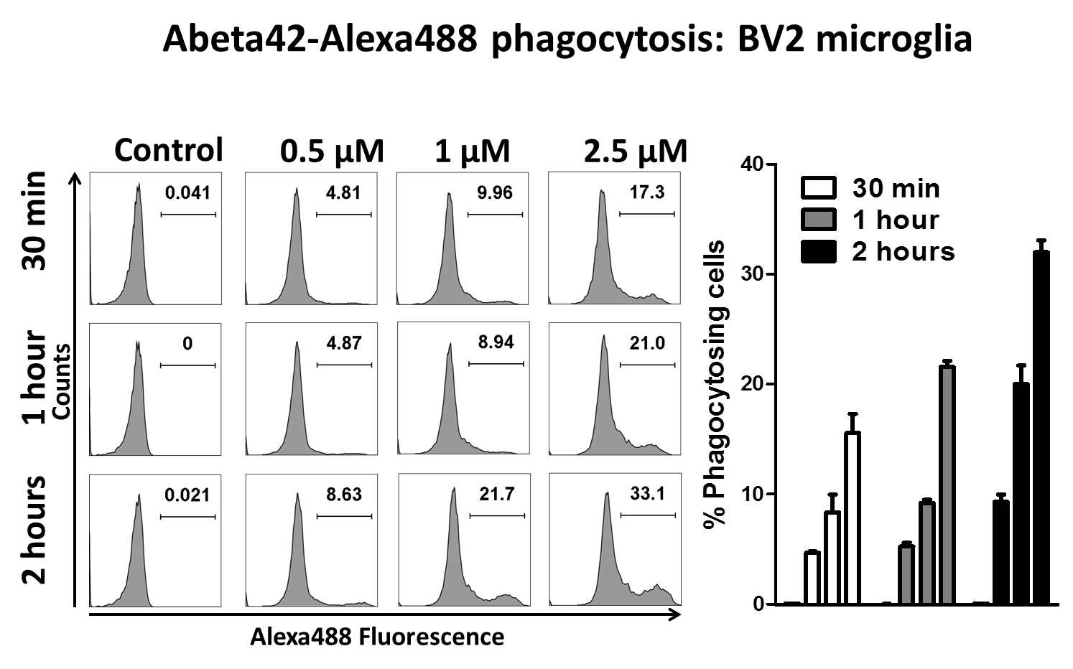Supplemental Figure 1. Optimization of fAβ42-Hilyte488 phagocytosis assay. BV2 cells were treated with varying concentrations of fAβ42-Hilyte488 for 30 min, 1hr or 2 hours after which flow-cytometric analysis was performed. N=3 independent experiments per time point. Proportion of phagocytic cells are shown in each panel.
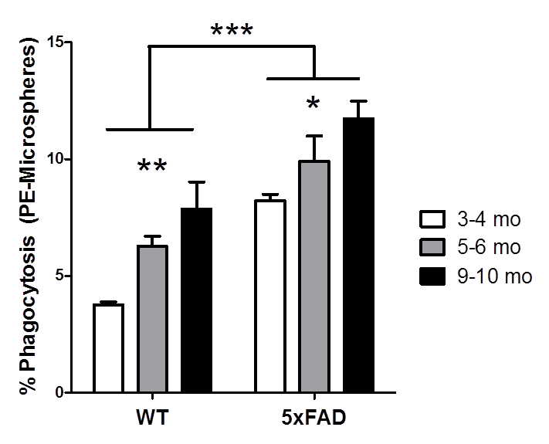
Supplemental Figure 2. Aging results in augmentation of PE-microsphere phagocytic capacity in CNS MPs. Acutely isolated CNS MPs from 6 mo WT and 5xFAD were used for these assays. PE microsphere phagocytic capacity was measured in all CD11b+ myeloid cells in the brain and group-wise and pair-wise comparisons were performed (n=3 mice/group, *p<0.05, **p<0.01, ***p<0.005).

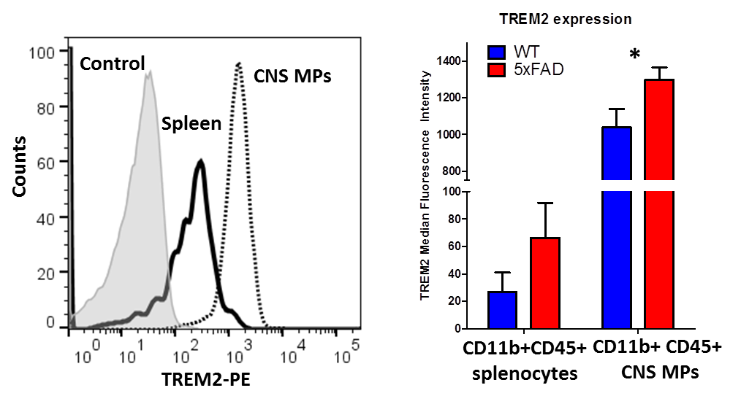
Supplemental Figure 3. Flow cytometric measurement of cell surfaceTREM2 expression by CD11b+CD45+ CNS MPs and splenic macrophages/monocytes. Acutely isolated CNS MPs and splenocytes from three adult (4-6 mo) WT mice were used for this experiment (*p<0.05). Median fluorescence intensity was compared across all groups after subtraction of background fluorescence.

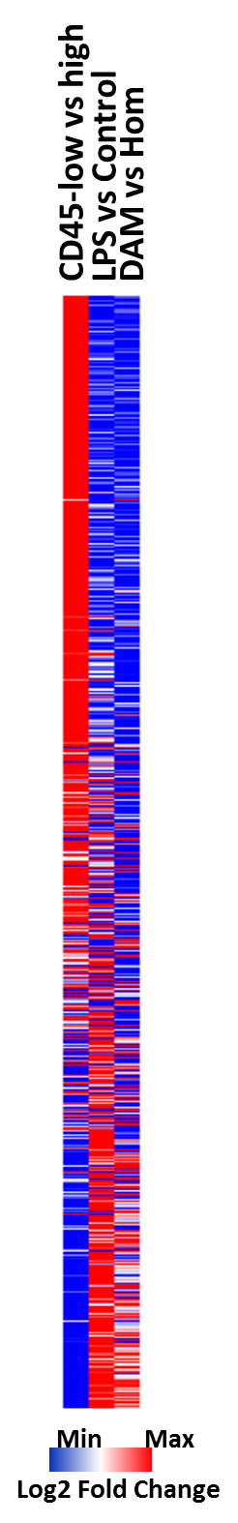
Supplemental Figure 4. Transcriptomic profiles of CD11b⁺CD45^{high} CNS MPs more closely resemble LPS-activated and DAM profiles. Relative expression data from two publicly available RNAseq datasets (Dataset 1: RNAseq of CD11b⁺CD45^{low} and CD11b⁺CD45^{high} CNS MPs from adult WT mice, and RNAseq of CD45^{low} CNS MPs from WT and LPS-treated WT mice; Dataset 2: Single cell RNAseq of CD45+ immune cells from WT and 5xFAD mice) were log2 transformed, followed by hierarchical cluster analysis and a heat map was generated using Morpheus (Broad Institute). All genes (n=5,434) that were present in both datasets were used for this analysis.

