Supplementary Information

The protein concentration of the lots of PF-06438179/GP1111, infliximab-EU, and infliximab-US used in the PK study are provided in Supplementary Table 1.
Supplementary Table 1. Protein concentration of test and reference products
Product | Protein concentration (mg/mL)
PF-06438179/GP1111 | 10.3
Infliximab-EU | 9.5
Infliximab-US | 9.7
EU, European Union; US, United States
The following formula was used to calculate the protein-content corrected value for each subject’s PK exposure parameters (Supplementary Figure 1).

Supplementary Figure 1. Calculation of protein-content corrected PK parameters

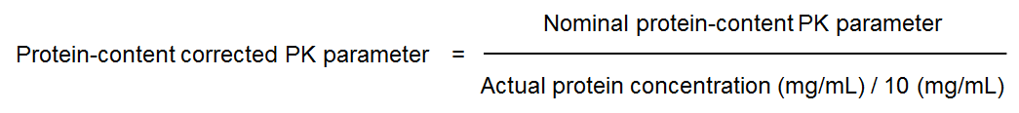
Statistical comparisons of the protein-content corrected PK exposure parameters between the test (PF-06438179/GP1111), and reference products (infliximab-EU, and infliximab-US) are shown in Supplementary Table 2.

Supplementary Table 2. Statistical comparison of protein-content corrected PK exposure parameters between test and reference products: Per-protocol analysis set
 |  |  | Adjusted geometric mean
Test | Reference | Parameter | Test | Reference | Ratio (%)ª | 90% CI (%)
PF-06438179/  GP1111 | Infliximab-EU | C_{max}, μg/mL | 211.1 | 208.0 | 101.48 | 93.45 – 110.21
 |  | AUC_{T}, μg·h/mL | 53990 | 52270 | 103.29 | 94.86 – 112.45
 |  | AUC_{inf}, μg·h/mL | 58010 | 56930 | 101.91 | 92.85 – 111.86
PF-06438179/  GP1111 | Infliximab-US | C_{max}, μg/mL | 211.1 | 209.4 | 100.81 | 92.79 – 109.53
 |  | AUC_{T}, μg·h/mL | 53990 | 53240 | 101.40 | 93.09 – 110.45
 |  | AUC_{inf}, μg·h/mL | 58010 | 57540 | 100.83 | 91.81 – 110.73
Infliximab-EU | Infliximab-US | C_{max}, μg/mL | 208.0 | 209.4 | 99.34 | 91.61 – 107.72
 |  | AUC_{T}, μg·h/mL | 52270 | 53240 | 98.17 | 90.31 – 106.73
 |  | AUC_{inf}, μg·h/mL | 56930 | 57540 | 98.94 | 90.29 – 108.41
ªTest/reference ratio of adjusted geometric means.
AUC_{inf}, area under the concentration–time curve from time 0 extrapolated to infinite time; AUC_{T}, area under the concentration–time curve from time 0 to last time point of measurable concentration; CI, confidence interval; C_{max}, maximum serum concentration; PK, pharmacokinetic

