Supplemental material
Scientific name | Common name | Description | Image
1. Ocimum basilicum L. | Basil | Evergreen, 0.3-0.5 meter tall, almost hairless, leafs are ovate and often puckered. | 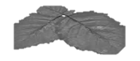
2. Lantana camara L. | Lantana | Evergreen, erect, vigorous shrub, leafs are ovate or ovate oblong, 2-10 cm long and 2-6 cm wide, rough, finely hairy. | 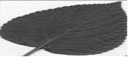
3. Azadirachta indica A.Juss. | Neem | Evergreen, shiny dark, green compound leafs up to 30 cm long. | 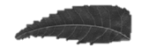
4. Malva parviflora L. | Cheese-weed | Evergreen, erect, growing to 50 cm in height, broadleaf, have 5 to 7 lobes, up to 8 to 10 cm in diameter | 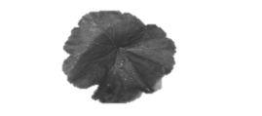
5. Ficus elastica L. | Rubber tree | Evergreen, tall up 30–40 meter tall to broadleaf, shrub. | 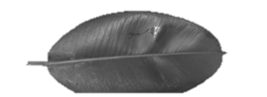
6. Ficus retusa L. | Indian laurel | Evergreen, dried leafs, soft, brittle, rough, curved surface with splintering, laminated fracture.
7. Hibiscus rosa sinensis L. | Hibiscus | Evergreen, leaves, Root is very fibrously. | 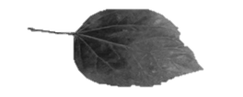
8. Nicotiana glauca Graham. | Tree tobacco | Evergreen, leafs stalked, elliptical greyish-green, glabrous soft-wooded shrub, tree up to 6 m tall, stems branched. | 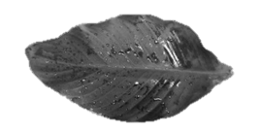
9. Rosa damascena Mill. | Kazanlak oil | Evergreen leafs pinnate, with five to seven leaflets, growing to 2.2 meters in tall, the stems densely. | 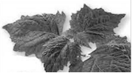
10. Thymelea hirsute | Mitnan | Evergreen, leafs small overlapped scales, cottony upper side, growing to about 2 meters
Table SM1: The specifications of studied plant species

