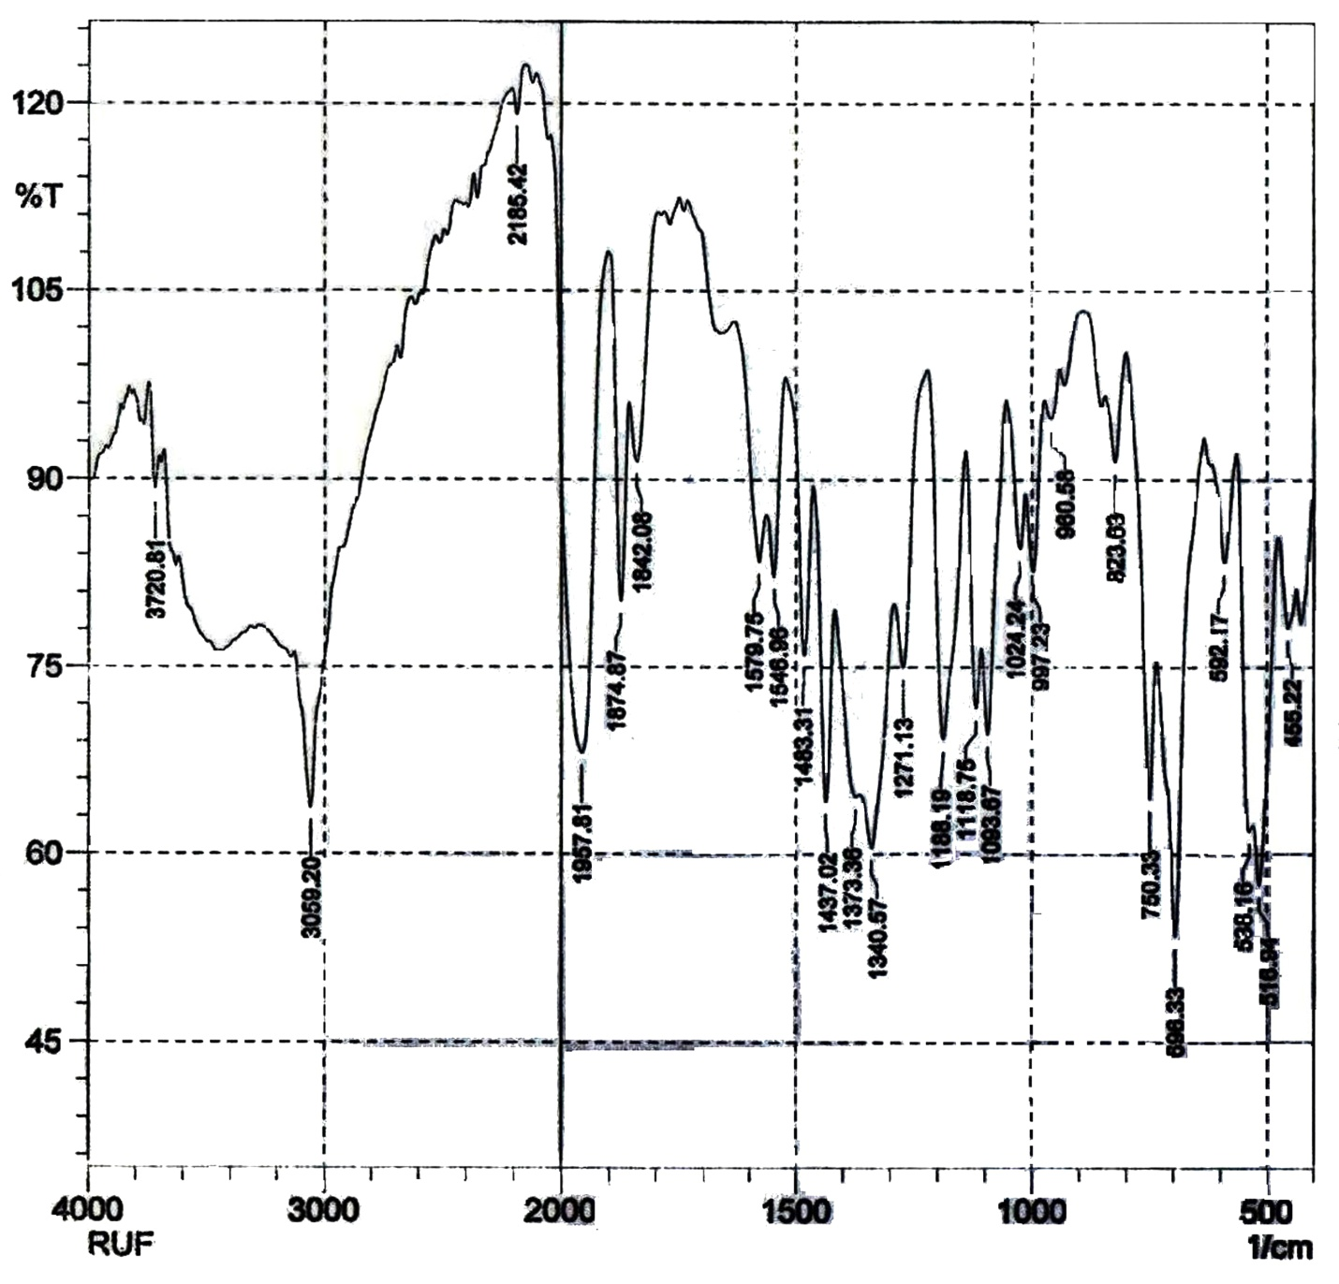
Fig. S1. Experimental FTIR Spectrum of the [RuHCl(CO)(bpy)(tpp)] complex
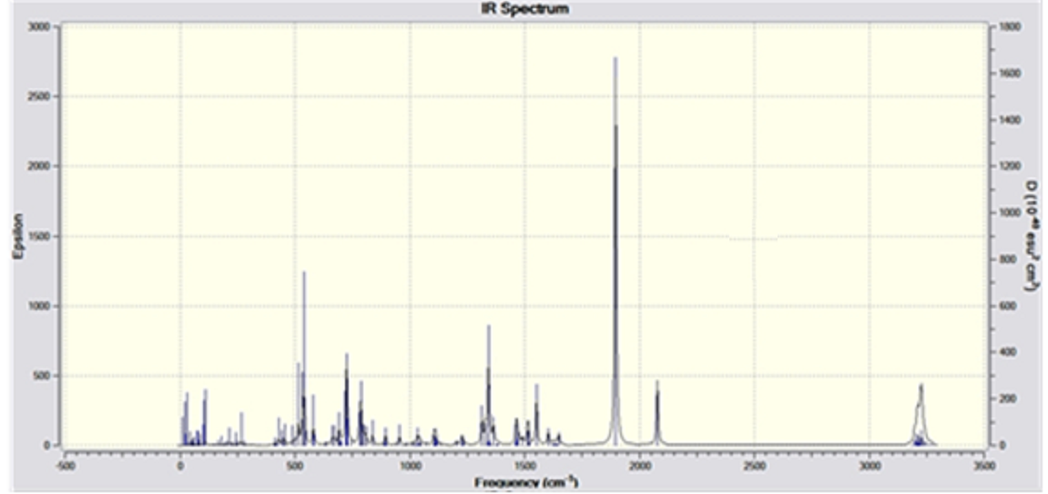
Fig. S2. Theoretical FTIR Spectrum of the complex
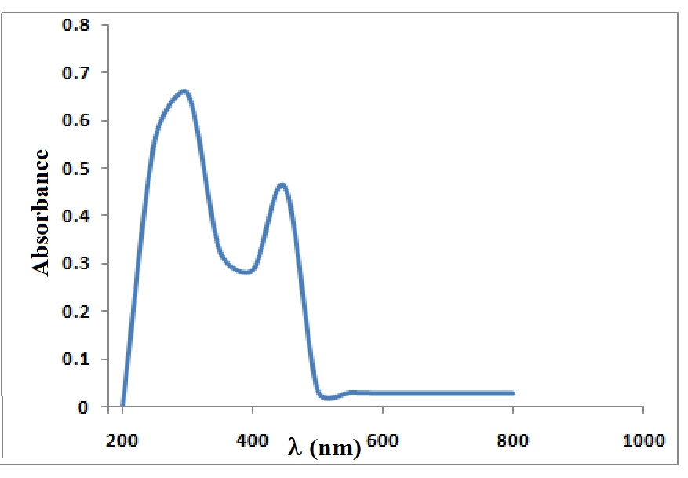
Fig. S3. Experimental UV-Visible spectrum of [RuHCl(CO)(bpy)(tpp)] Complex
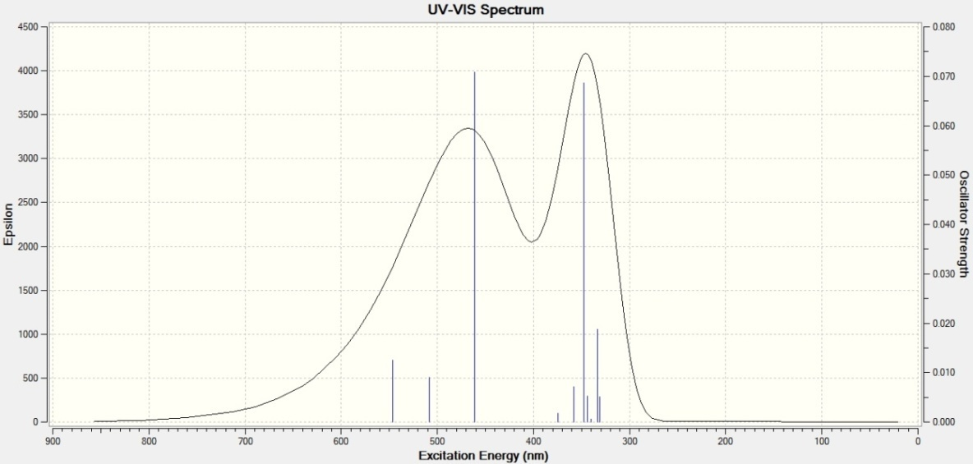
Fig. S4. TD-DFT UV-Vis Spectrum of [RuHCl(CO)(bpy)(tpp)] Complex
Fig. S5. 2D and 3D optimized structural presentation of benzoylpyridine
Fig. S6. 2D and 3D Optimized structural presentation of Triphenylphosphine

Fig. S7. HOMO-LUMO structure with energy level diagram of benzoyl pyridine ligand

Fig. S8 HOMO-LUMO structure with energy level diagram of Triphenylphosphine ligand
Fig. S9. DFT based IR Spectrum of benzoylpyridine based
Fig. S10. DFT based IR Spectrum of Tpp ligand

Table S1: Antiproliferative data of the compounds

S. No. | Sample | Absorbance by control | Concentration of sample (μg/mL) | Absorbance by sample | Cell Survival (%) | Cell Death  (%)
1 | [Ru(CO)(H)(Cl)(Tpp)₃ | 1.22 | 10 | 0.193 | 84.18 | 33.85
 | IC₅₀= 53 |  | 20 | 0.287 | 76.47 | 41.55
 |  |  | 40 | 0.343 | 71.88 | 46.14
 |  |  | 80 | 0.541 | 55.65 | 62.37
2 | [Ru(CO)(H)(Cl)(Bpy)(Tpp) | 1.94 | 10 | 0.211 | 89.12 | 59.33
 | IC₅₀= 40 |  | 20 | 0.343 | 82.32 | 66.13
 |  |  | 40 | 0.383 | 80.26 | 68.19
 |  |  | 80 | 0.508 | 73.81 | 74.64

