Statistical analysis results of other tested quadrats from Warden Head

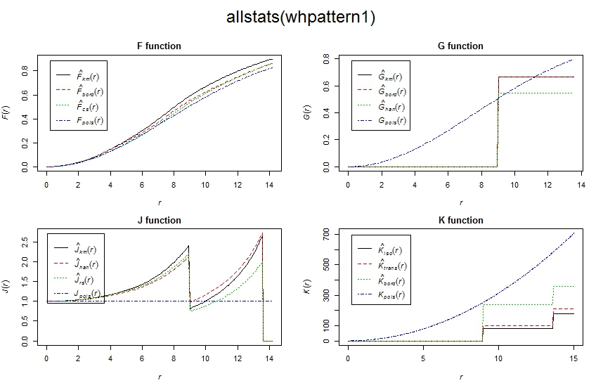
All statistical functions for dropstone distribution of quadrat WH1 from Warden Head.

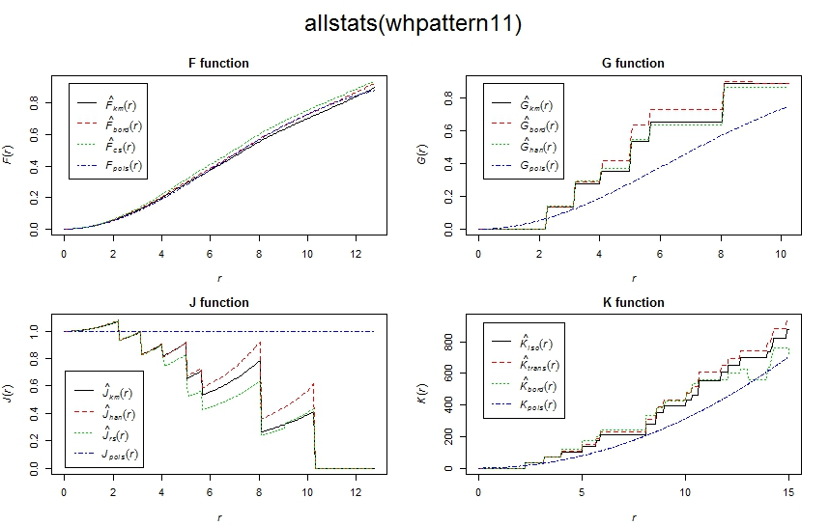
All statistical functions for brachiopod shell distribution of quadrat WH1 from Warden Head.

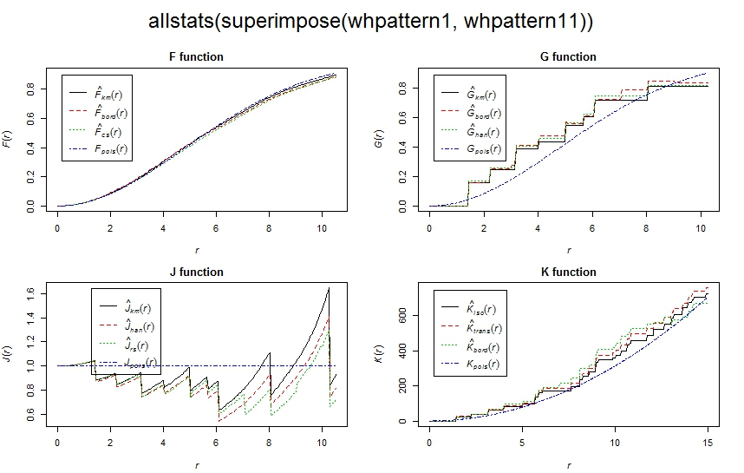
All statistical functions for distribution of co-occurring brachiopod shell and dropstone from quadrat WH1 at Warden Head.

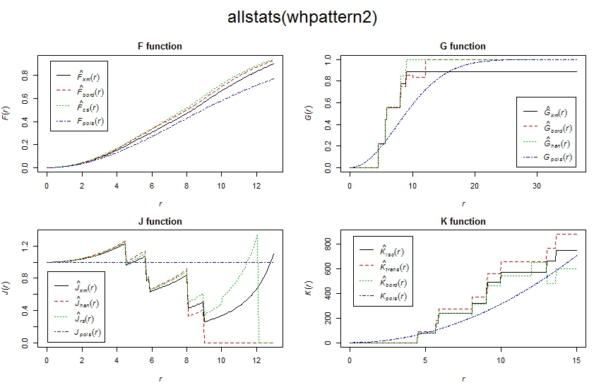
All statistical functions for dropstone distribution of quadrat WH2 from Warden Head.

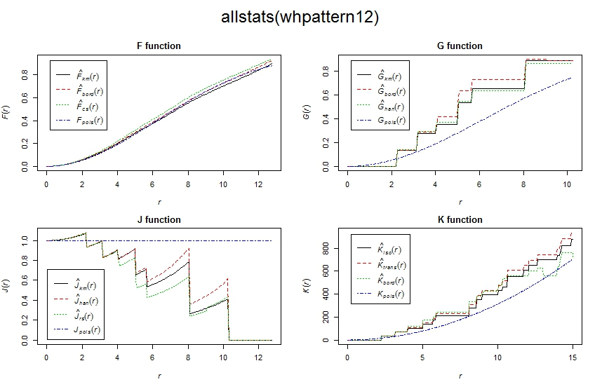
All statistical functions for brachiopod shell distribution of quadrat WH2 from Warden Head.

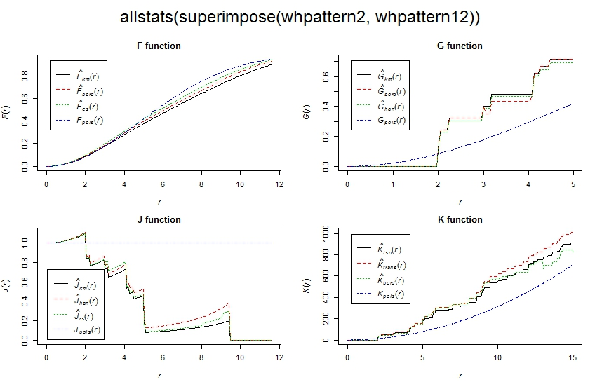
All statistical functions for distribution of co-occurring brachiopod shell and dropstone from quadrat WH2 at Warden Head.

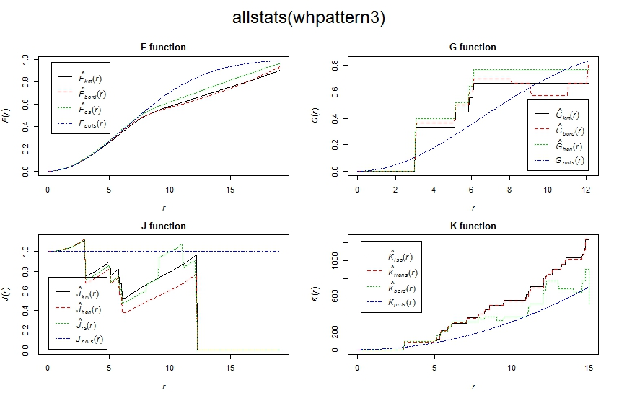
All statistical functions for dropstone distribution of quadrat WH3 from Warden Head.

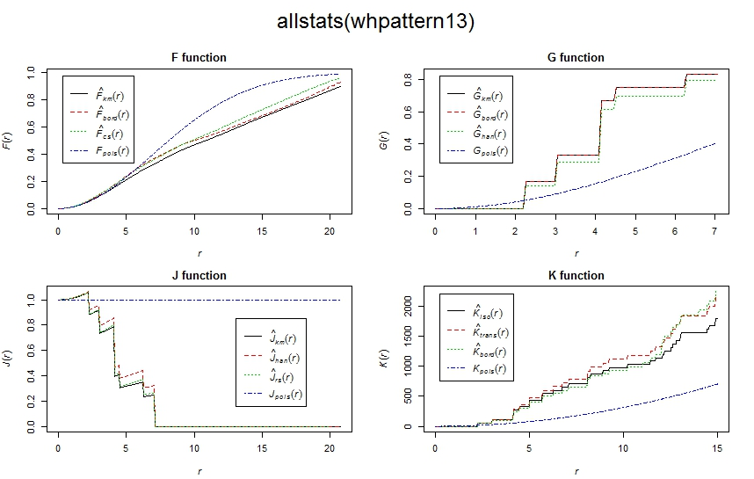
All statistical functions for brachiopod shell distribution of quadrat WH3 from Warden Head.

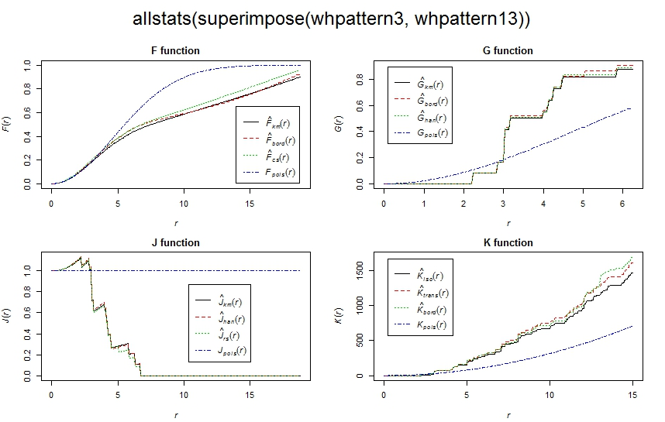
All statistical functions for distribution of co-occurring brachiopod shell and dropstone from quadrat WH3 at Warden Head.

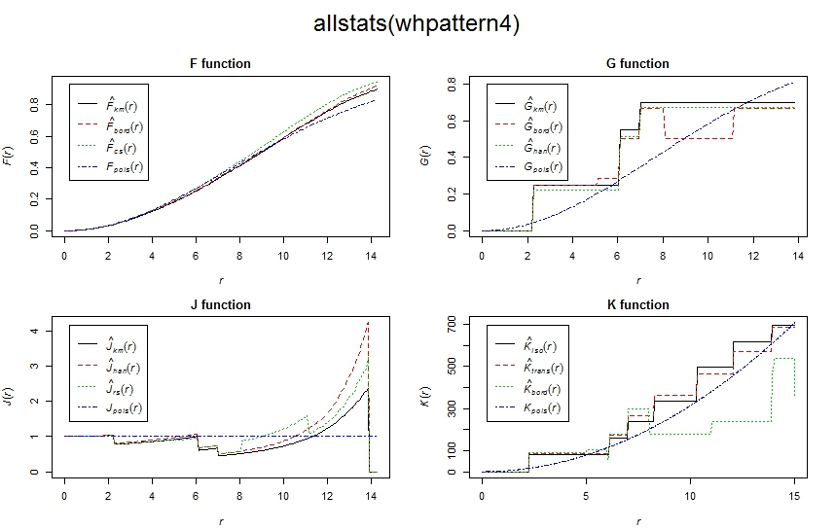
All statistical functions for dropstone distribution of quadrat WH4 from Warden Head.

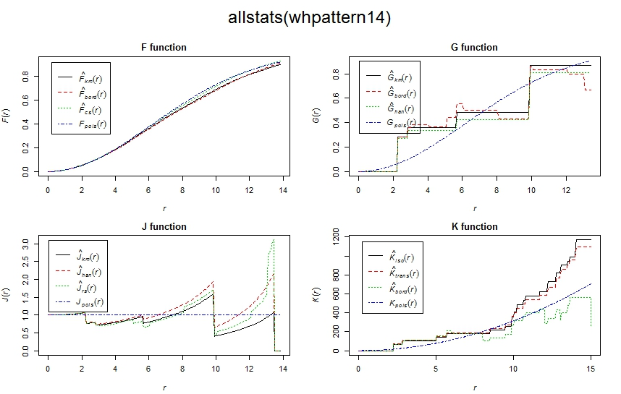
All statistical functions for brachiopod shell distribution of quadrat WH4 from Warden Head.

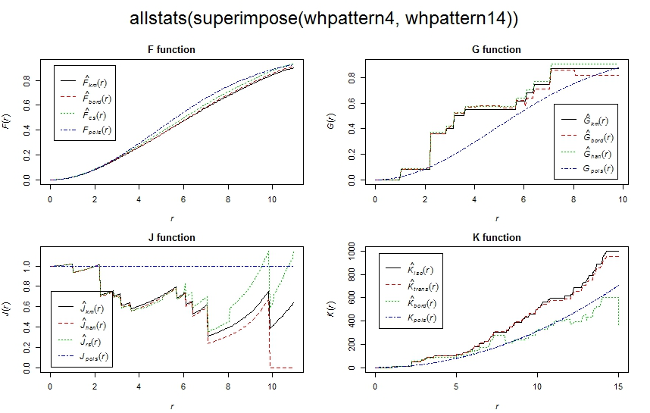
All statistical functions for distribution of co-occurring brachiopod shell and dropstone from quadrat WH4 at Warden Head.

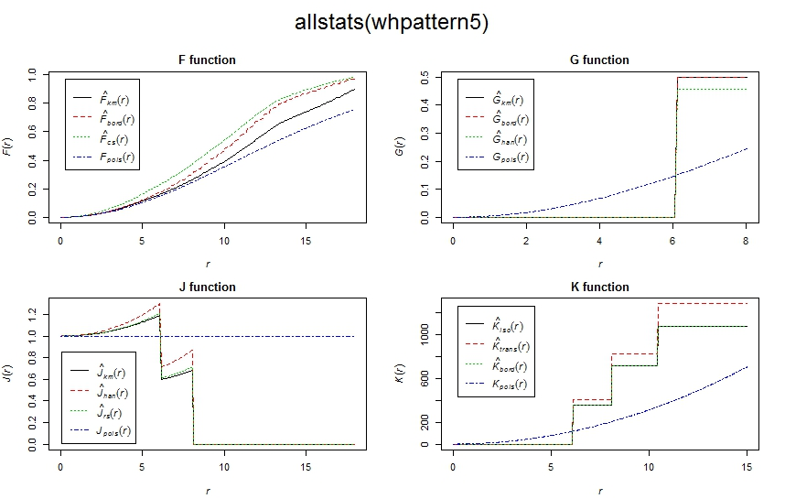
All statistical functions for dropstone distribution of quadrat WH5 from Warden Head.

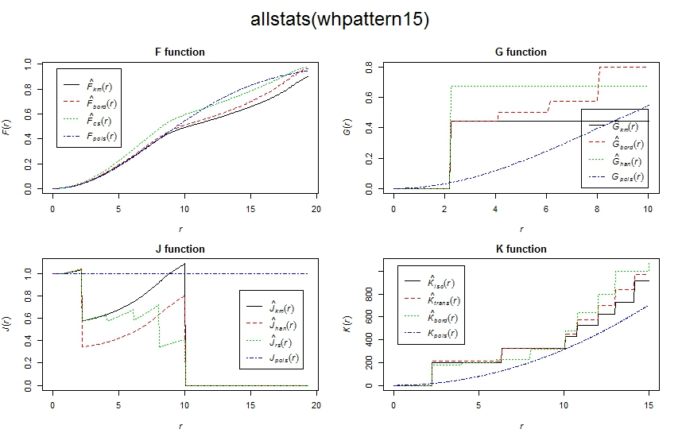
All statistical functions for brachiopod shell distribution of quadrat WH5 from Warden Head.
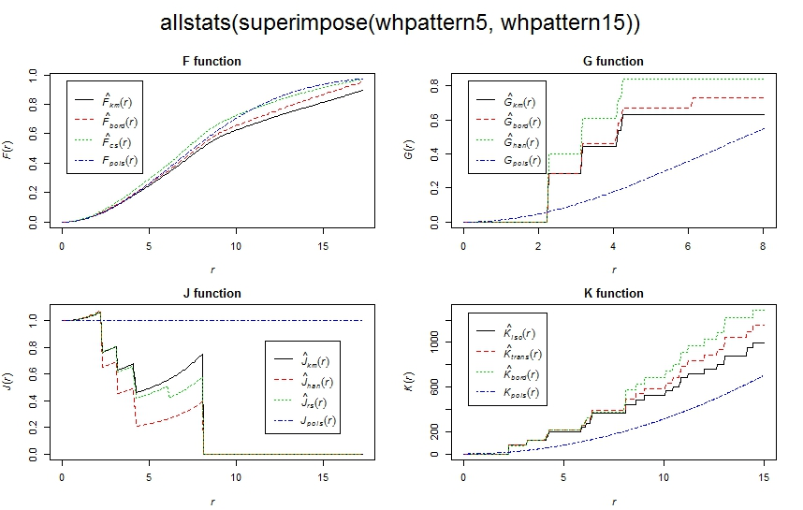
All statistical functions for distribution of co-occurring brachiopod shell and dropstone from quadrat WH5 at Warden Head.

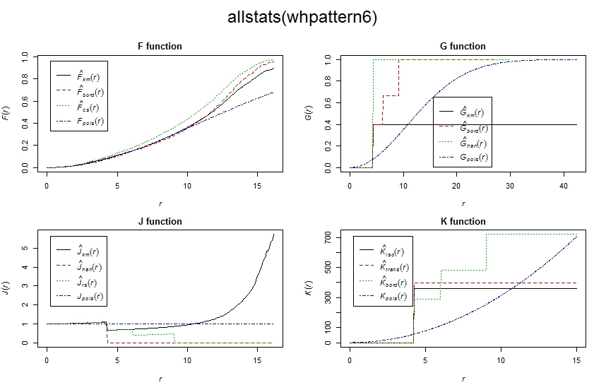
All statistical functions for dropstone distribution of quadrat WH6 from Warden Head.

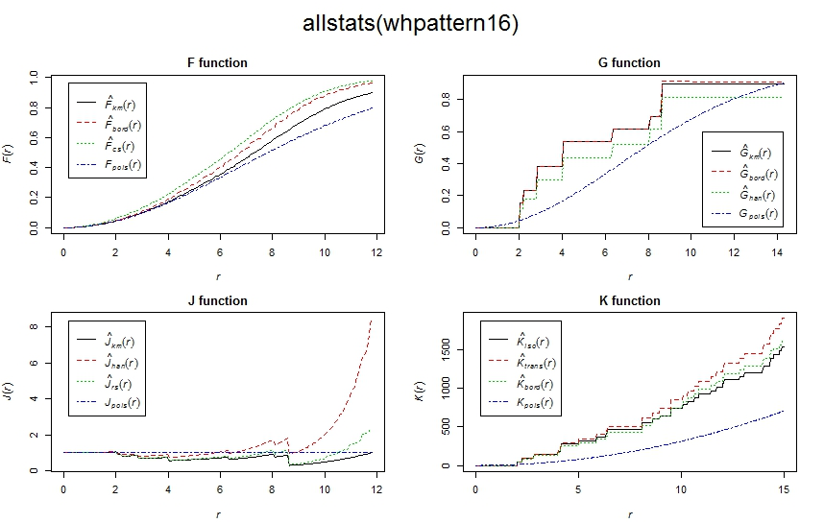
All statistical functions for brachiopod shell distribution of quadrat WH6 from Warden Head.

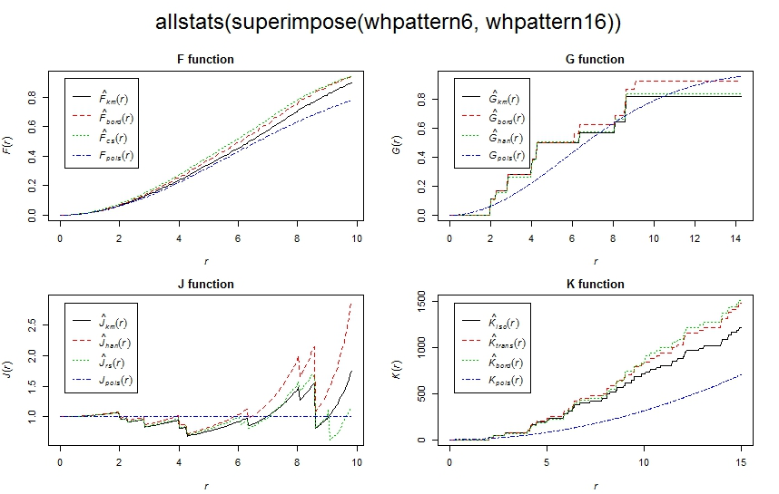
All statistical functions for distribution of co-occurring brachiopod shell and dropstone from quadrat WH6 at Warden Head.

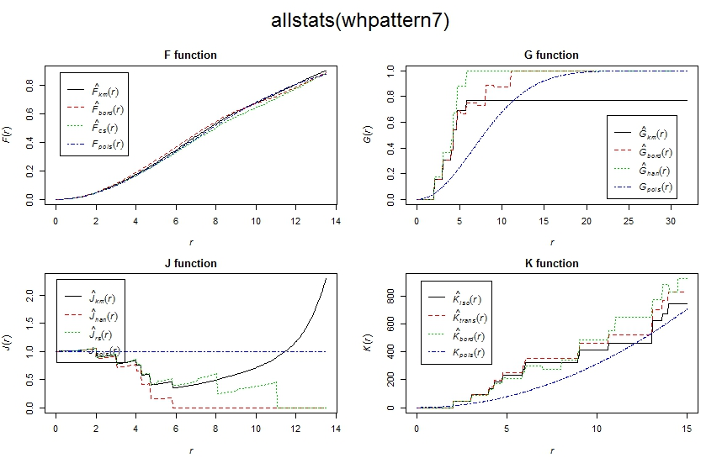
All statistical functions for dropstone distribution of quadrat WH7 from Warden Head.

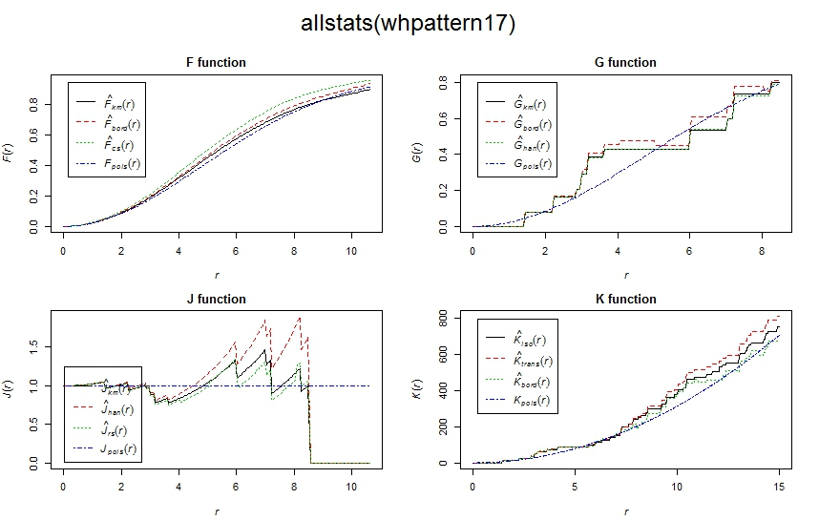
All statistical functions for brachiopod shell distribution of quadrat WH7 from Warden Head.

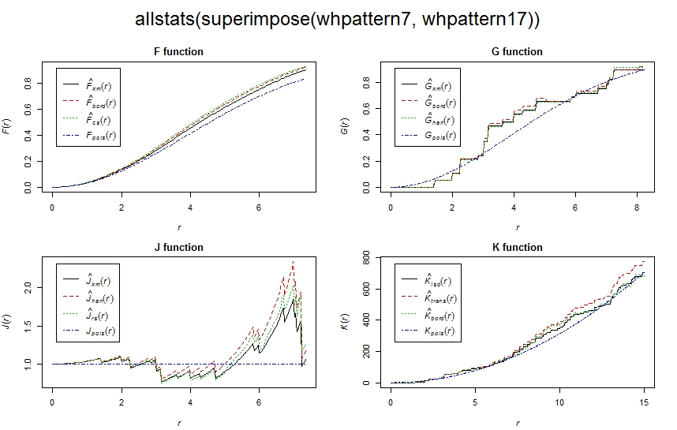
All statistical functions for distribution of co-occurring brachiopod shell and dropstone from quadrat WH7 at Warden Head.

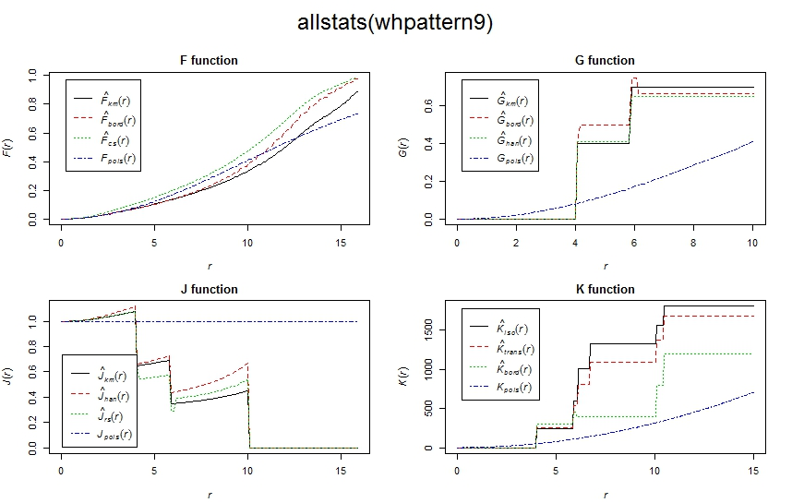
All statistical functions for dropstone distribution of quadrat WH9 from Warden Head.

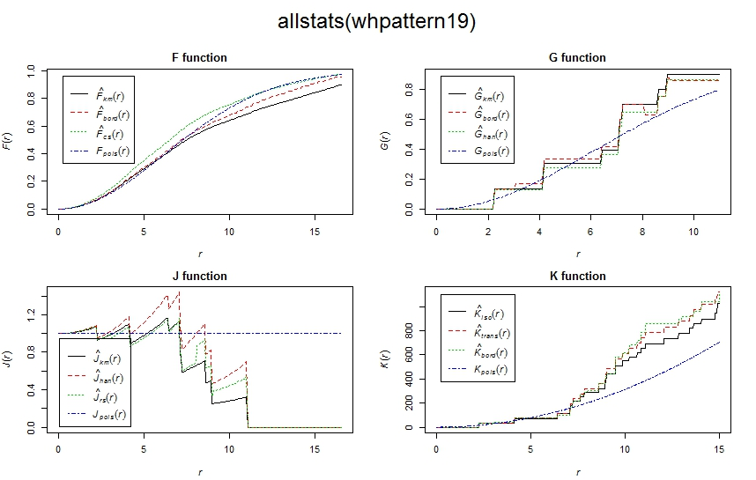
All statistical functions for brachiopod shell distribution of quadrat WH9 from Warden Head.

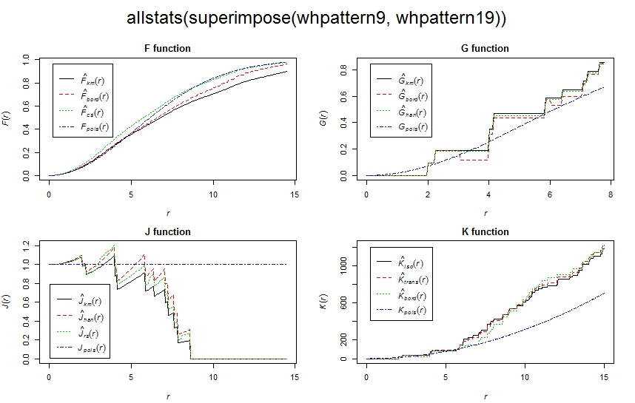
All statistical functions for distribution of co-occurring brachiopod shell and dropstone from quadrat WH9 at Warden Head.

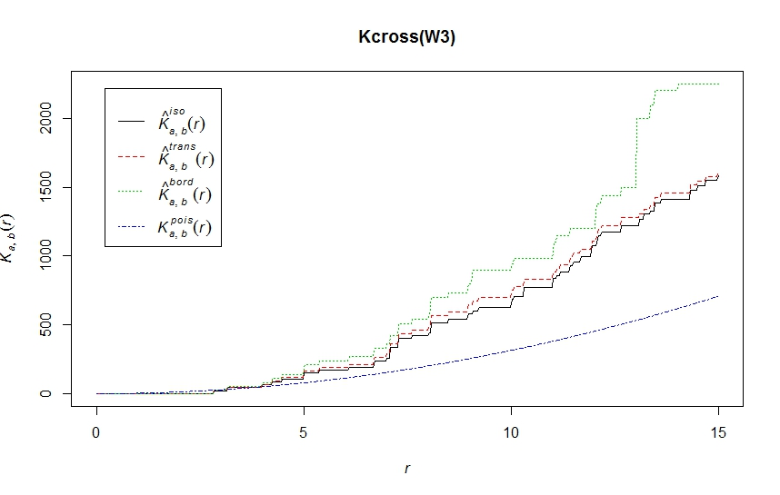
Results of spatial association tested by Kcross function of WH3 from Warden Head.

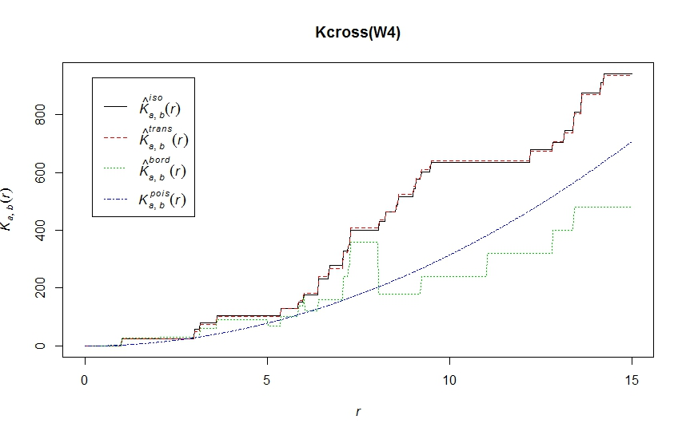
Results of spatial association tested by Kcross function of WH4 from Warden Head.
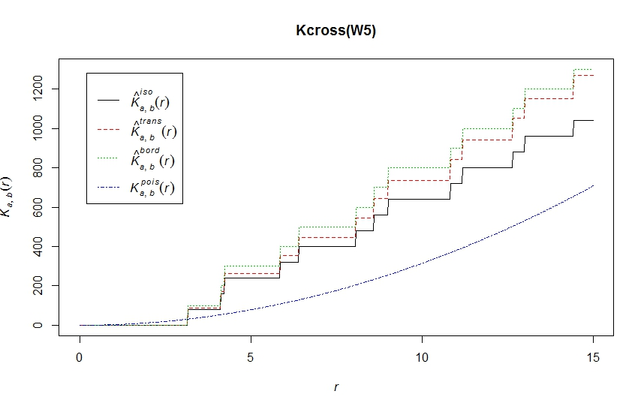
Results of spatial association tested by Kcross function of WH5 from Warden Head.
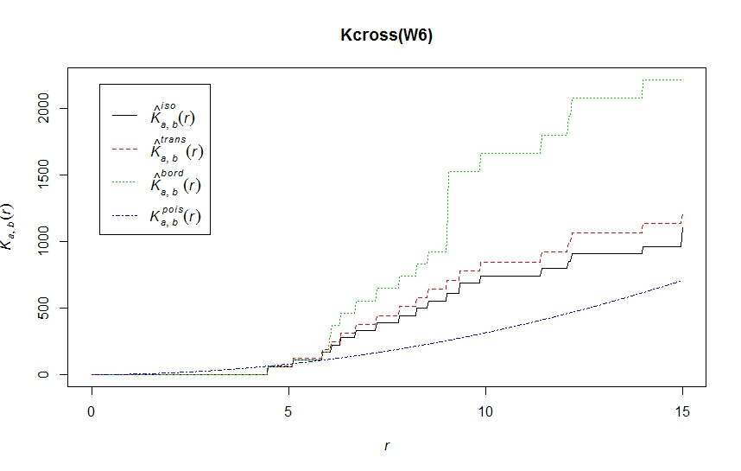
Results of spatial association tested by Kcross function of WH6 from Warden Head.
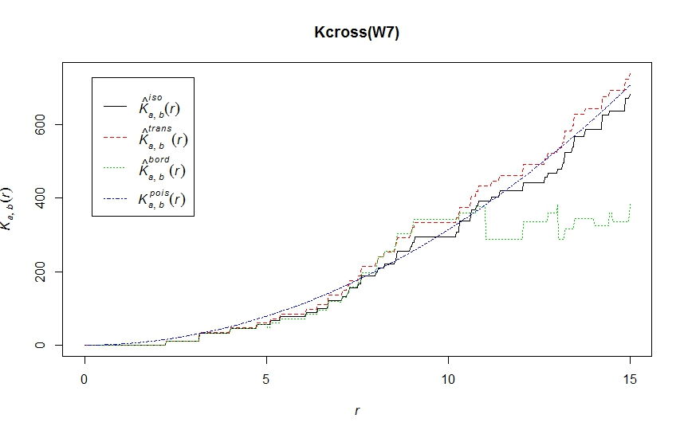
Results of spatial association tested by Kcross function of WH7 from Warden Head.

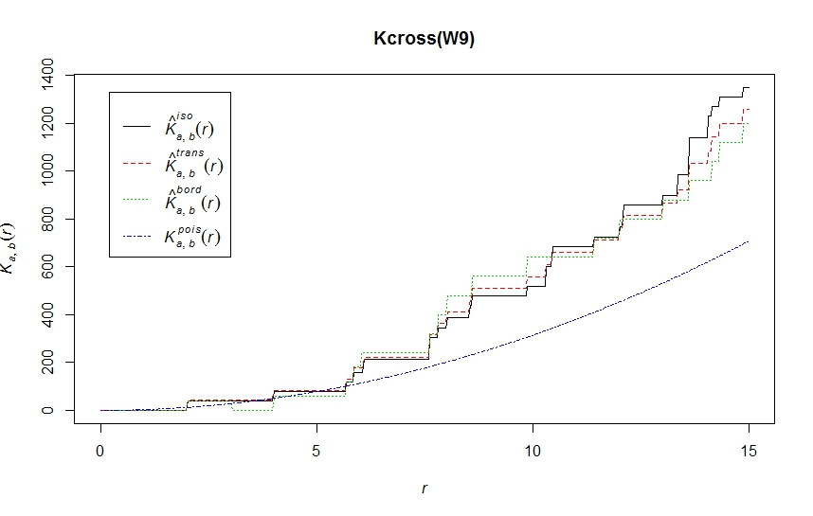
Results of spatial association tested by Kcross function of WH9 from Warden Head.

