Electronic Supplementary Material

Pollinator assemblages, pollen limitation, and pollen deposition effectiveness
Pollinator visits
Well-trained observers (8-9 observers) recorded pollinator visitation rate (V_{R}) from 07:00 am to noon and from 4:00 pm to 9:00 pm during 10 days in 2016 (104 h) and 12 days in 2017 (138 h). A visit was considered valid when pollinators entered into the floral tubes. The similarity in pollinator assemblage composition of 2016 and 2017 was estimated using the proportional similarity index (PS) (Kay & Schemske 2003). The index ranges from 0 to 1, where zero indicates lack of similarity. The confidence interval was estimated from 10000 bootstrap replications.

Pollen delivery onto stigmas
We collected flowers immediately after being visited for the first time. Stigmas were stored in Eppendorf vials 70% ethanol to ensure the fixation of the pollen grains. In the laboratory, the stigmas were stained following Kearns and Inouye (1993) methodology, and pollen grains were counted using a compound microscope ZEISS primo star.

Pollen limitation

We calculated L-values in 2016 and 2017 by supplementing pollination of experimental flowers and comparing their female fertility (seed production) with respect to open-pollinated controls (Larson & Barrett 2000). Stigmas of 50 flowers were saturated with a mix of pollen from plants at least 10 m distant from the focal plant, leaving 50 unmanipulated flowers as control. Not all treatment flowers could be recovered at the end of the experiment as indicated in Table S1. The seed number was recorded in the laboratory in a seed counter machine (Elmor C1). The confidence interval for L-estimates was calculated from 10000 bootstrap replications.

 | Control (N) | Supplement (N) | L-index (CI)
2016 | 411.2 ± 339.2 (50) | 568.4 ± 241.2 (37) | 0.28 (0.07 - 0.46)
2017 | 493.4 ± 339.8 (50) | 753.3 ± 298.0 (43) | 0.34 (0.19 - 0.48)

Table S1. Seed production in control and pollen-supplemented flowers. Values are mean ± 1 SD. N = sample size. CI = 95% confidence interval.
Phenotypic selection
Phenotypic selection was estimated on corolla size (mm²) and tube length (mm). Corolla size was measured in ImageJ from pictures taken in the field. A graduated rule (precision 0.1 mm) was used in each picture. All photos were taken from a perpendicular perspective to the corolla surface. Tube length was measured directly in the field using a digital caliper (precision 0.01 mm). Three one-day flowers were chosen per plant, and their flower measurements averaged and standardized to zero mean and unit variance in the population. In this way, standardized directional selection coefficients can be estimated and compared between years and traits. To ensure that flower traits within plants were less variable than between plants, we performed independent F-tests on flower traits per year (Table S2).
Individual female fitness was estimated as mean seed number per plant. Three capsules per plant were collected and transported to the laboratory where seeds were counted using the Seed Counter Elmor C1. Individual relative fitness was measured as the mean seed number per plant divided by the mean population seed production. Linear selection gradients were estimated using the multiple regression model proposed by Lande and Arnold (1983).

 | 2016 |  |  | 2017
Flower trait | F(98,198) | P |  | F(98,199) | P
Tube length | 1.45 | 0.014 |  | 2.04 | <0.001
Corolla size | 1.37 | 0.032 |  | 1.93 | <0.001

Table S2. F-values for between-plant and within-plant flower trait variation. Three flowers were analyzed per plant.

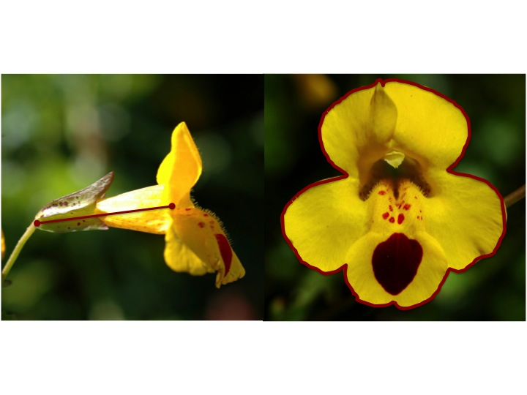
Figure S1. Lateral (a) and frontal (b) pictures of E. lutea indicating the way traits were measured. (a) Tube length (mm) and (b) Corolla size (mm²).

References
Kay KM, Schemske DW. 2003 Pollinator assemblages and visitation rates for 11 species of neotropical Costus (Costaceae). Biotropica 35, 198-207. (doi: 10.1111/j.1744 7429.2003.tb00279.x)
Kearns CA, Inouye DW. 1993 Techniques for pollination biologists. Colorado, USA: University Press of Colorado.
Lande R, Arnold SJ. 1983 The measurement of selection on correlated characters. Evolution 37: 1210–1226. (doi: 10.1111/j.1558-5646.1983.tb00236.x)
Larson BMH, Barrett SCH. 2000 A comparative analysis of pollen limitation in flowering plants. Biol. J. Linn. Soc. 69, 503-520. (doi: 10.1111/j.1095-8312.2000.tb01221.x)

