Supplemental digital content 1.
Supplementary Table 1A: Baseline Participant Characteristics by 24-Month Follow-Up
 | CN |  |  |  | EMCI
 | With 24 mo Visit | No 24 mo Visit | F or χ2 | p- value | With 24 mo Visit | No 24 mo Visit | F or χ2 | p- value
N | 363 | 55 | - | - | 242 | 66 | - | -
Age (years) | 74.9±5.8 | 73.7±5.3 | 1.803 | 0.180 | 71.0±7.3 | 72.0±8.1 | 0.882 | 0.348
Sex (% male) | 53.0 | 30.9 | 9.233 | 0.002* | 55.6 | 51.5 | 0.545 | 0.460
Education (years) | 16.4±2.7 | 15.7±3.0 | 2.605 | 0.107 | 16.1±2.6 | 15.4±2.7 | 3.162 | 0.076
APOE Genotype (%) | - | - | 0.322 | 0.851 | - | - | 3.421 | 0.181
ε4 − | 72.1 | 75.5 | - | - | 56.0 | 59.7 | - | -
ε4 + | 25.1 | 22.6 | - | - | 35.7 | 38.7 | - | -
ε4/ε4 + | 2.8 | 1.9 | - | - | 8.3 | 1.6 | - | -
PSD (%) | 10.9 | 16.5 | 1.135 | 0.287 | 33.3 | 39.7 | 0.881 | 0.348
Sedative/Hypnotic before conversion (%) | 7.4 | 9.1 | 0.185 | 0.667 | 14 | 11 | 0.421 | 0.516
CDRsb | 0.0±0.13 | 0.0±0.15 | 0.422 | 0.516 | 1.2±0.7 | 1.5±0.8 | 4.679 | 0.031*
ADAS-11 | 5.9±2.9 | 6.8±3.6 | 4.563 | 0.033* | 7.8±3.3 | 8.2±4.2 | 0.628 | 0.429
Comorbid Diagnoses
Hypertension(%) | 43.8 | 56.4 | 3.040 | 0.081 | 48.3 | 48.5 | 0.000 | 0.984
Diabetes(%) | 6.6 | 12.7 | 2.602 | 0.107 | 11.2 | 9.1 | 0.231 | 0.630
CAD (%) | 2.8 | 5.5 | 1.155 | 0.282 | 3.3 | 3.0 | 0.013 | 0.911
GDS | 0.8±1.1 | 0.8±1.1 | 0.005 | 0.943 | 1.8±1.5 | 1.9±1.6 | 2.410 | 0.121
mo = month, PSD = positive sleep disturbance, CDRsb = Clinical Dementia Rating Scale - Sum of Boxes Score, ADAS-11 = Alzheimer's Disease Assessment Scale-Cognitive Subscale, CAD = Coronary Artery Disease, GDS = Geriatric Depression Scale, continuous outcomes presented as mean±standard deviation, F-value from ANOVA, χ2 from chi-square test, *p < .05

Supplementary Table 1B: Baseline Participant Characteristics by 24-Month Follow-Up
 | LMCI |  |  |  | AD
 | With 24 mo Visit | No 24 mo Visit | F or χ2 | p- value | With 24 mo Visit | No 24 mo Visit | F or χ2 | p- value
N | 430 | 131 | - | - | 171 | 171 | - | -
Age (years) | 73.8±7.6 | 74.5±7.7 | 0.877 | 0.349 | 75.3±7.7 | 74.6±7.8 | 0.737 | 0.391
Sex (% male) | 60.5 | 63.4 | 0.354 | 0.552 | 53.8 | 56.7 | 0.296 | 0.587
Education (years) | 16.0±2.8 | 15.4±3.2 | 3.712 | 0.055 | 14.8±3.1 | 15.6±2.8 | 6.249 | 0.013*
APOE Genotype (%) | - | - | 0.067 | 0.967 | - | - | 4.115 | 0.125
ε4 − | 45.6 | 45.7 | - | - | 28.7 | 38.9 | - | -
ε4 + | 41.2 | 41.9 | - | - | 51.5 | 42.5 | - | -
ε4/ε4 + | 13.3 | 12.4 | - | - | 19.9 | 18.6 | - | -
PSD (%) | 30.5 | 34.9 | 0.848 | 0.357 | 38.6 | 50.9 | 5.216 | 0.022*
Sedative/Hypnotic before conversion (%) | 6.7 | 3.8 | 1.511 | 0.219 | 6.4 | 5.8 | 0.051 | 0.822
CDRsb | 1.7±0.9 | 1.6±0.9 | 0.054 | 0.8 | 4.3±1.6 | 4.5±1.7 | 0.634 | 0.4
ADAS-11 | 11.3±4.5 | 12.1±4.9 | 2.425 | 0.120 | 18.5±6.1 | 20.3±7.5 | 5.795 | 0.017*
Comorbid Diagnoses
Hypertension(%) | 48.1 | 50.4 | 0.202 | 0.653 | 51.5 | 49.1 | 0.187 | 0.665
Diabetes(%) | 7.9 | 9.2 | 0.210 | 0.647 | 6.4 | 12.9 | 4.058 | 0.044*
CAD (%) | 4.0 | 3.8 | 0.005 | 0.944 | 2.9 | 2.3 | 0.114 | 0.736
GDS | 1.6±1.3 | 1.8±1.5 | 1.915 | 0.167 | 1.7±1.4 | 1.6±1.5 | 0.069 | 0.793
mo = month, PSD = positive sleep disturbance, CDRsb = Clinical Dementia Rating Scale - Sum of Boxes Score, ADAS-11 = Alzheimer's Disease Assessment Scale-Cognitive Subscale, CAD = Coronary Artery Disease, GDS = Geriatric Depression Scale, continuous outcomes presented as mean±standard deviation, F-value from ANOVA, χ2 from chi-square test, *p < .05

Supplementary Table 2: Significant Contributors to Variance in Cognition over Time
 | Main Explanatory Variable | Covariate | Parameter Estimate | p-value | Interpretation
CN | EF | Education x Time | 0.001 | 0.048 | Higher education had a slower ADNI-EF decline.
EMCI | Memory | APOE genotype x Time | -0.009 | 0.044 | Increasing APOE ε4 allele number had a faster ADNI-Mem decline.
 | Memory | Age x Time | -0.001 | < 0.005 | Increasing age had a faster ADNI-Mem decline.
 | EF | APOE genotype x Time | -0.012 | 0.044 | Increasing APOE ε4 allele number had a faster ADNI-EF decline.
LMCI | Memory | APOE genotype x Time | -0.014 | <0.005 | Increasing APOE ε4 allele number had a faster ADNI-Mem decline.
 | Memory | Sex x Time | 0.002 | 0.031 | Men had a slower ADNI-Mem decline compared to women.
 | EF | APOE genotype x Time | -0.009 | <0.005 | Increasing APOE ε4 allele number had a faster ADNI-EF decline.
 | ADAS11 | APOE genotype x Time | 0.114 | <0.005 | Increasing APOE ε4 allele number had a faster ADAS-11 increase.
 | ADAS11 | Sex x Time | 0.05 | 0.010 | Men had a slower ADAs-11 increase compared to women.
AD-dementia | Memory | Age x Time | 0.001 | <0.005 | Increasing age had a slower ADNI-Mem decline.
 | EF | Age x Time | 0.001 | <0.005 | Increasing age had a slower ADNI-EF decline.
 | ADAS11 | Age x Time | -0.012 | <0.005 | Increasing age had a slower ADAS-11 increase.
 | ADAS11 | Sedative/hypnotic use x Time | 0.253 | 0.008 | Use of a sedative/hypnotic had a faster ADAS-11 increase.
CN = cognitively normal, EMCI = early Mild Cognitive Impairment, LMCI = late Mild Cognitive Impairment, AD = Alzheimer's disease, EF = executive function, ADAS-11 = Alzheimer's Disease Assessment Scale-Cognitive Subscale, Parameter estimates and p-values are for the listed coviariate that was used in the repeated measures linear mixed model.

Supplementary Table 3A: Effect of Sleep Disturbance on Outcomes of Change in Cognition over Time in Participants without Dementia
Outcome | Parameter Estimate | p-value
Memory | -0.001 | 0.221
EF | -0.002 | 0.417
ADAS-11 | 0.125 | 0.119
Supplemental Table 3B: Effect of Sleep Disturbance on Risk of Conversion in Particpants witout Dementia
Outcome | HR (95% CI) | p-value
Conversion | 0.92 (0.70,1.20) | 0.917
ADAS-11 = Alzheimer's Disease Assessment Scale-Cognitive Subscale, EF = Executive Function, PE = parameter estimate, HR = Hazard Ratio, CI = Confidence Interval, PEs are for a repeated measures linear mixed effects model, HRs and 95% CIs are for a Cox proportional hazards model

Supplementary Table 4: Significant Contributors to Variance of Cox Regression Model
 | Coviariate | HR (95% CI) | p-value | Interpretation
CM | APOE e4 | 1.51 (1.10-2.08) | 0.011 | Increasing APOE ε4 allele number had increased risk of conversion.
 | APOE e4e4 | 4.94 (1.37-17.74) | 0.014 | Increasing APOE ε4 allele number had increased risk of conversion.
 | ADAS-11 Baseline | 1.18 (1.05-1.34) | 0.005 | Higher baseline ADAS-11 score had increased risk of conversion.
EMCI | APOE e4 | 12.96 (1.64-102.16) | 0.015 | Increasing APOE ε4 allele number had increased risk of conversion.
 | APOE e4e4 | 19.00 (2.13-169.96) | 0.008 | Increasing APOE ε4 allele number had increased risk of conversion.
 | ADAS-11 Baseline | 1.19 (1.02-1.38) | 0.032 | Higher baseline ADAS-11 score had increased risk of conversion.
LMCI | APOE e4 | 1.51 (1.10-2.08) | 0.011 | Increasing APOE ε4 allele number had increased risk of conversion.
 | ADAS-11 Baseline | 1.12 (1.08-1.15) | <0.005 | Higher baseline ADAS-11 score had increased risk of conversion.
CN = cognitively normal, EMCI = early Mild Cognitive Impairment, LMCI = late Mild Cognitive Impairment, AD = Alzheimer's disease, EF = executive function, ADAS-11 = Alzheimer's Disease Assessment Scale-Cognitive Subscale, Parameter estimates and p-values are for the listed covariate that was used in the repeated measures linear mixed model.

Supplementary Table 5: Power Simulation for Linear Mixed Model
 | Outcome | 90% Power | 80% Power | 70% Power
CN | Δ ADAS11/year | 0.41 | 0.33 | 0.28
 | Δ EF/year | 0.044 | 0.036 | 0.031
 | Δ Memory/year | 0.054 | 0.045 | 0.039
EMCI | Δ ADAS11/year | 0.52 | 0.44 | 0.36
 | Δ EF/year | 0.057 | 0.048 | 0.039
 | Δ Memory/year | 0.043 | 0.036 | 0.029
LMCI | Δ ADAS11/year | 0.37 | 0.31 | 0.24
 | Δ EF/year | 0.036 | 0.029 | 0.024
 | Δ Memory/year | 0.026 | 0.021 | 0.018
AD-dementia | Δ ADAS11/year | 0.87 | 0.69 | 0.59
 | Δ EF/year | 0.052 | 0.045 | 0.037
 | Δ Memory/year | 0.042 | 0.035 | 0.029
CN = cognitively normal, EMCI = early Mild Cognitive Impairment, LMCI = late Mild Cognitive Impairment, AD = Alzheimer's disease, EF = executive function, ADAS11 = Alzheimer's Disease Assessment Scale-Cognitive Subscale

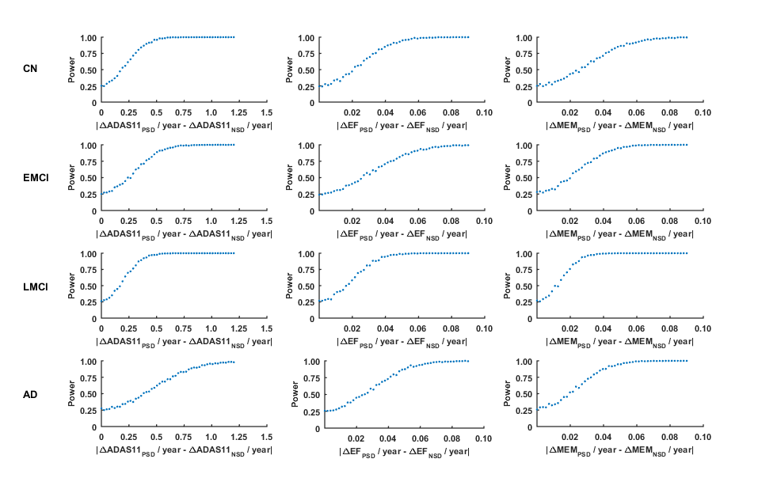Supplementary Figure 1: Power analyses performed with simulation for various cognitive outcomes. Simulations were performed to estimate power over a range of change in cognitive scores per year. CN = cognitively normal, EMCI = early MCI, LMCI = late MCI, AD = Alzheimer’s disease, MEM = ADNI memory score, EF = ADNI EF score, ADAS11 = Alzheimer’s disease assessment scale-cognitive subscale, PSD = positive sleep disturbance, NSD = negative sleep disturbance

