SUPPLEMENTARY APPENDIX
Supplementary Figure Legend
Supplementary Figure 1. Study cohort creation.

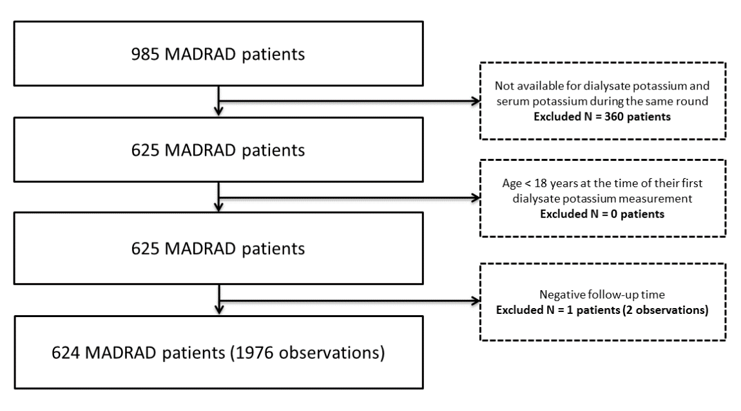
Supplementary Figure 1.

Supplementary Table 1. Baseline dialysate potassium concentration and mortality risk in the overall cohort.

OVERALL COHORT
 | Unadjusted |  | Case-mix |  | Case-mix+  Serum K |  | Case-mix+  Serum K+  Potassium-binding resin |  | Case-mix+  Serum K+  Potassium-modifying medication |  | Expanded case-mix+  Serum K+  Potassium-modifying medication
Dialysate K concentration | HR  (95% CI) | P | HR  (95% CI) | P | HR  (95% CI) | P | HR  (95% CI) | P | HR  (95% CI) | P | HR  (95% CI) | P
1 mEq/L | 1.33  (0.80-2.22) | 0.28 | 1.70  (1.01-2.88) | 0.05 | 1.71  (1.01-2.90) | 0.05 | 1.70  (1.00-2.88) | 0.05 | 1.72  (1.01- 2.93) | 0.04 | 1.70  (0.98-2.96) | 0.06
2 mEq/L | 1 (ref) | N/A | 1 (ref) | N/A | 1 (ref) | N/A | 1 (ref) | N/A | 1 (ref) | N/A | 1 (ref) | N/A
3 mEq/L | 1.10  (0.75-1.61) | 0.63 | 0.95  (0.64-1.39) | 0.78 | 0.94  (0.63-1.40) | 0.76 | 0.94  (0.63-1.39) | 0.75 | 0.91  (0.61- 1.36) | 0.64 | 0.91  (0.61-1.37) | 0.65
Abbreviations: CI, confidence interval; HR, hazard ratio; K, potassium.

STRATIFIED BY SERUM POTASSIUM LEVEL
 |  | Unadjusted |  | Case-mix |  | Case-mix+  Serum K |  | Case-mix+  Serum K+  Potassium-binding resin |  | Case-mix+  Serum K+  Potassium-modifying medication |  | Expanded case-mix+  Serum K+  Potassium-modifying medication
 | Dialysate K | HR  (95% CI) | P-int | HR  (95% CI) | P-int | HR  (95% CI) | P-int | HR  (95% CI) | P-int | HR  (95% CI) | P-int | HR  (95% CI) | P-int
Serum K  <5mEq/L | 1 mEq/L | 0.60  (0.22-1.66) | 0.04 | 0.74  (0.27-2.07) | 0.04 | 0.74  (0.27-2.08) | 0.04 | 0.74  (0.27-2.07) | 0.09 | 0.76  (0.27-2.14) | 0.01 | 0.78  (0.26-2.23) | 0.04
 | 2 mEq/L | 1 (ref) |  | 1 (ref) |  | 1 (ref) |  | 1 (ref) |  | 1 (ref) |  | 1 (ref)
 | 3 mEq/L | 1.12  (0.72-1.76) |  | 1.01  (0.64-1.58) |  | 0.99  (0.62-1.58) |  | 0.99  (0.62-1.58) |  | 0.95  (0.59-1.52) |  | 1.04  (0.63-1.70)
Serum K  ≥5mEq/L | 1 mEq/L | 2.18  (1.18-4.03) |  | 2.87  (1.51-5.46) |  | 2.85  (1.46-5.57) |  | 2.83  (1.45-5.53) |  | 2.74  (1.39-5.40) |  | 2.51  (1.24-5.06)
 | 2 mEq/L | 1 (ref) |  | 1 (ref) |  | 1 (ref) |  | 1 (ref) |  | 1 (ref) |  | 1 (ref)
 | 3 mEq/L | 0.85  (0.39-1.89) |  | 0.74  (0.33-1.66) |  | 0.75  (0.33-1.67) |  | 0.74  (0.33-1.65) |  | 0.75  (0.33-1.69) |  | 0.72  (0.31-1.65)
Abbreviations: CI, confidence interval; HR, hazard ratio; K, potassium; P-int, p-interaction.
Supplementary Table 2. Baseline dialysate potassium concentration and mortality, stratified by pre-dialysis serum potassium.

Supplementary Table 3. Time-dependent dialysate potassium concentration and all-cause mortality risk in the overall cohort.
OVERALL COHORT
 | Unadjusted |  | Case-mix |  | Case-mix+  Serum K |  | Case-mix+  Serum K+  Potassium-binding resin |  | Case-mix+  Serum K+  Potassium-modifying medication |  | Expanded case-mix+  Serum K+  Potassium-modifying medication
Dialysate K concentration | HR  (95% CI) | P | HR  (95% CI) | P | HR  (95% CI) | P | HR  (95% CI) | P | HR  (95% CI) | P | HR  (95% CI) | P
1 mEq/L | 0.89  (0.41-1.90) | 0.76 | 1.20  (0.55-2.62) | 0.64 | 1.35  (0.61-2.98) | 0.45 | 1.36  (0.61-2.99) | 0.45 | 1.36  (0.62-3.01) | 0.44 | 1.12  (0.50-2.52) | 0.78
2 mEq/L | 1 (ref) | N/A | 1 (ref) | N/A | 1 (ref) | N/A | 1 (ref) | N/A | 1 (ref) | N/A | 1 (ref) | N/A
3 mEq/L | 1.24  (0.86-1.81) | 0.25 | 1.00  (0.68-1.47) | 0.99 | 0.93  (0.63-1.38) | 0.72 | 0.93  (0.63-1.37) | 0.70 | 0.90  (0.60-1.34) | 0.60 | 1.02  (0.68-1.53) | 0.93
Abbreviations: CI, confidence interval; HR, hazard ratio; K, potassium.
Supplementary Table 4. Time-dependent dialysate potassium concentration and mortality, stratified by pre-dialysis serum potassium.

STRATIFIED BY SERUM POTASSIUM LEVEL
 |  | Unadjusted |  | Case-mix |  | Case-mix+  Serum K |  | Case-mix+  Serum K+  Potassium-binding resin |  | Case-mix+  Serum K+  Potassium-modifying medication |  | Expanded case-mix+  Serum K+  Potassium-modifying medication
 | Dialysate K | HR  (95% CI) | P-int | HR  (95% CI) | P-int | HR  (95% CI) | P-int | HR  (95% CI) | P-int | HR  (95% CI) | P-int | HR  (95% CI) | P-int
Serum K  <5mEq/L | 1 mEq/L | 0.65  (0.09-4.72) | 0.76 | 0.84  (0.11-6.1) | 0.81 | 0.89  (0.12-6.47) | 0.80 | 0.88  (0.12-6.46) | 0.81 | 0.89  (0.12-6.53) | 0.78 | 0.79  (0.11-5.94) | 0.89
 | 2 mEq/L | 1 (ref) |  | 1 (ref) |  | 1 (ref) |  | 1 (ref) |  | 1 (ref) |  | 1 (ref)
 | 3 mEq/L | 1.08  (0.69 -1.71) |  | 0.92  (0.58-1.46) |  | 0.86  (0.54-1.38) |  | 0.86  (0.54-1.38) |  | 0.83  (0.51-1.33) |  | 0.96  (0.59-1.55)
Serum K  ≥5mEq/L | 1 mEq/L | 1.08  (0.46-2.51) |  | 1.39  (0.59-3.28) |  | 1.54  (0.65-3.68) |  | 1.55  (0.65-3.7) |  | 1.56  (0.65-3.72) |  | 1.24  (0.52-1.98)
 | 2 mEq/L | 1 (ref) |  | 1 (ref) |  | 1 (ref) |  | 1 (ref) |  | 1 (ref) |  | 1 (ref)
 | 3 mEq/L | 1.40  (0.71-2.76) |  | 1.13  (0.57-2.23) |  | 1.05  (0.53—2.09) |  | 1.04  (0.52-2.07) |  | 1.03  0.52-2.05) |  | 1.09  (0.54-1.29)
Abbreviations: CI, confidence interval; HR, hazard ratio; K, potassium; P-int, p-interaction.

