Supplementary figures to the manuscript entitled

Rapid degradation of malachite green by CoFe₂O₄-SiC foam under microwave radiation
Yanpeng Mao†*, Shanxiu Yang†, Chao Xue, Miaomiao Zhang, Wenlong Wang, Zhanlong Song, Xiqiang Zhao, Jing Sun
National Engineering Laboratory of Coal-fired Pollutants Emission Reduction, School of Energy and Power Engineering, Shandong University, Jinan 250100, P. R. China

Submitted to Royal Society Open Science

on 17th January

*Corresponding author. Phone +86 531 88399372, Fax +86 531 88395877. E-mail: maoyanpeng@sdu.edu.cn.
† These authors contributed equally to this work.

Figure SF-1. XPS spectra of (a) C, (b) Co, (c) Fe, (d) Si, (e) O.
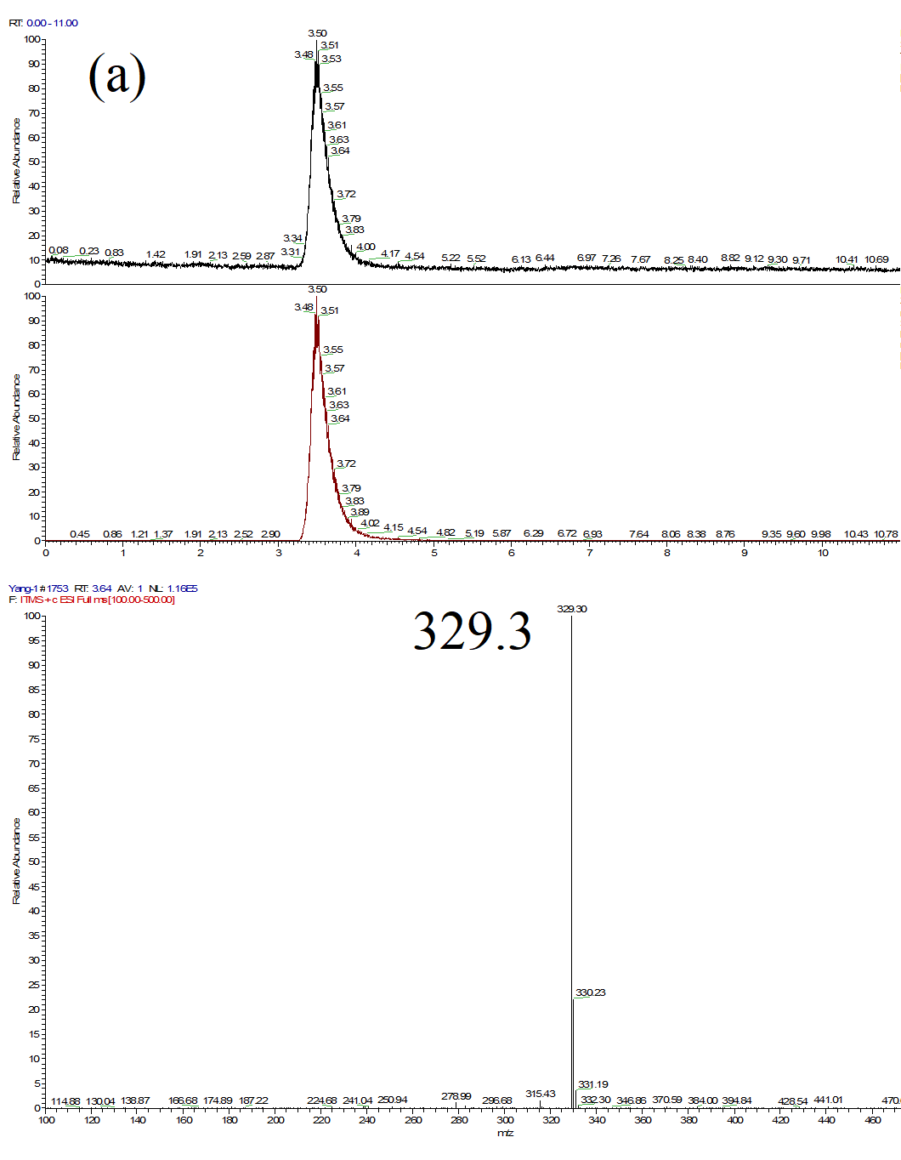
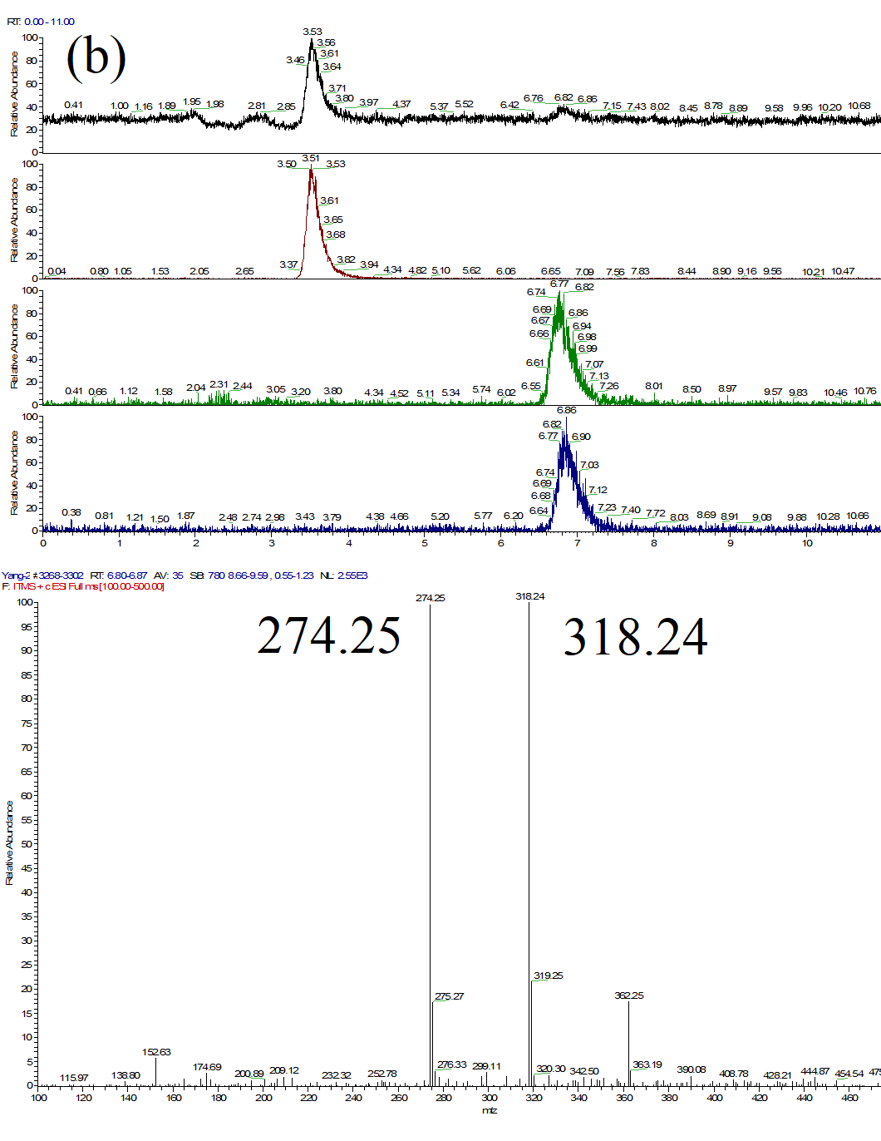
Figure SF-2. (a)LC-MS chromatograms of MG solution before the reaction; (b) LC-MS chromatograms of MG solution after reaction.

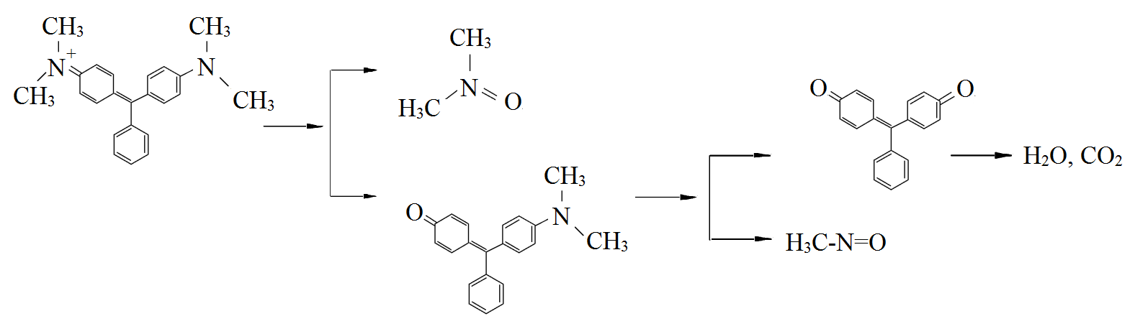
Figure SF-3. Proposed reaction scheme for the degradation of MG in the MW-catalytic process.

