P-T conditions of symplectite formation in the eclogites from the Western Gneiss Region (Norway)

Céline Martin

Supplementary Material 1: Excel Datasheet with quantified probe analyses.

Supplementary Material 2: Two generations of amphibole in NOG0018.

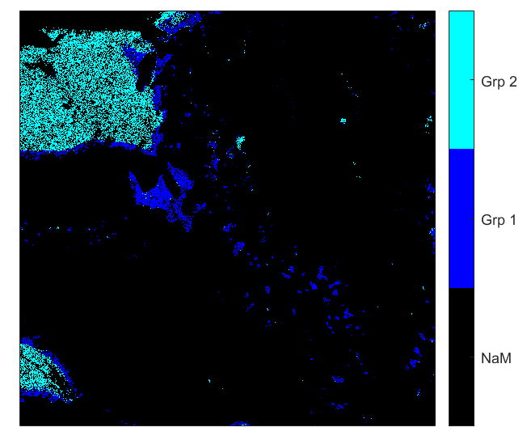
SM2: Map NOG0018 processed by XMapTools 2.4, displaying only amphibole. Grp 2 represents the coarse-grained amphibole, Grp 1 represents the amphibole crystals in the symplectite, and as overgrowth around coarse grains. The black area represents all the non-selected pixels.

Supplementary Material 3: Additional maps for NOG 641-2 and NOG0014.

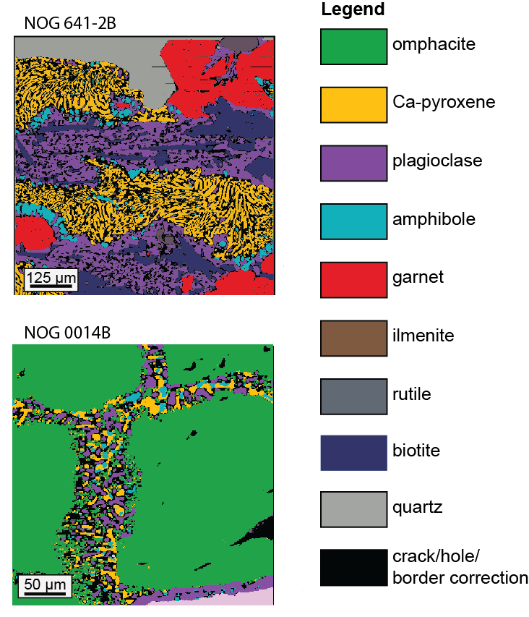
Supplementary Material 4: Amphibolite samples from Dalsfjord area: NOG0013 and NOG613.

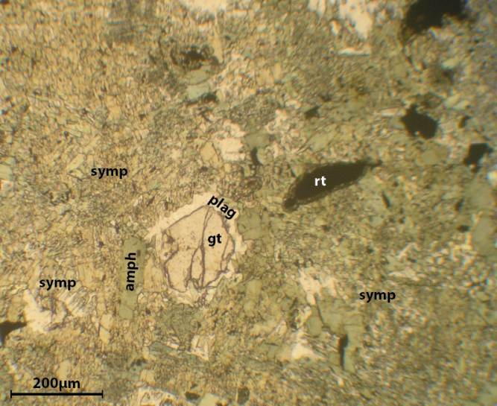

SM4a: Plane polarized light microphotograph of amphibolite NOG0013, coming from Vårdalsneset outcrop (Dalsfjord), showing garnet (gt) resorbed with a corona of plagioclase (plag), and a matrix of intergrowths of amphibole and plagioclase (symp).

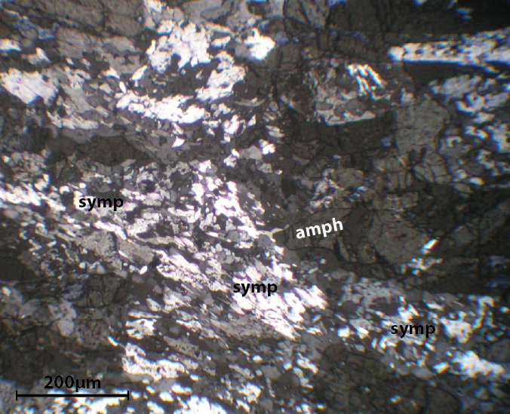

SM4b: Crosse-polarized light microphotograph of amphibolite NOG613, coming from Vårdalsneset outcrop (Dalsfjord), showing mainly intergrowths of amphibole and plagioclase (symp).

Supplementary Material 5: Two generations of amphibole in NOG616.

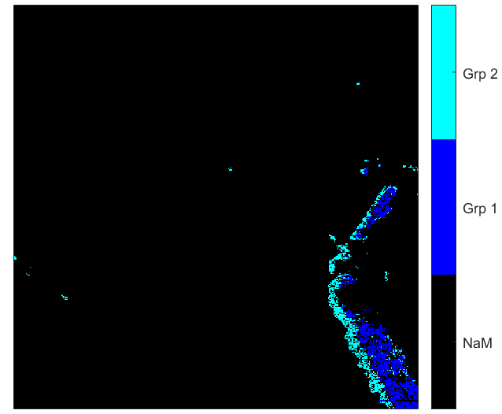

SM5: Map NOG616-2 processed by XMapTools 2.4, displaying only amphibole. Grp 1 represents the amphibole around garnet, Grp 2 represents amphibole in symplectite and overgrowth of the amphibole around garnet. The black area represents all the non-selected pixels.

Supplementary Material 6: P-T variation in kelyphite in NOG616.

P (kbar)

SM6a: Map NOG616-2 processed by XMapTools 2.4, displaying the pressure recorded by amphibole in the kelyphite, showing a decrease from the centre towards the rim. The black area represents all the non-selected pixels.

P (kbar)
SM6b: Map NOG616-5 processed by XMapTools 2.4, displaying the pressure recorded by amphibole in the kelyphite, showing a decrease from the centre towards the rim. The black area represents all the non-selected pixels.

