Additinal file 1 Figure S1. Additional gene and protein expression in mock and ETBF-induced tumors. A) Gene expression by qPCR relative to mock epithelium from indicated tissue 8 weeks post-infection. Mean +/- SEM. N=6. *P < 0.05 compared with mock Min epithelium. #P < 0.05 compared to Msh2^{l/l}VCMin ETBF tumors. B) Western blots were run using protein isolated from indicated tissue 8 weeks post-infection. Blots are representative of two independent sets of biological replicates.

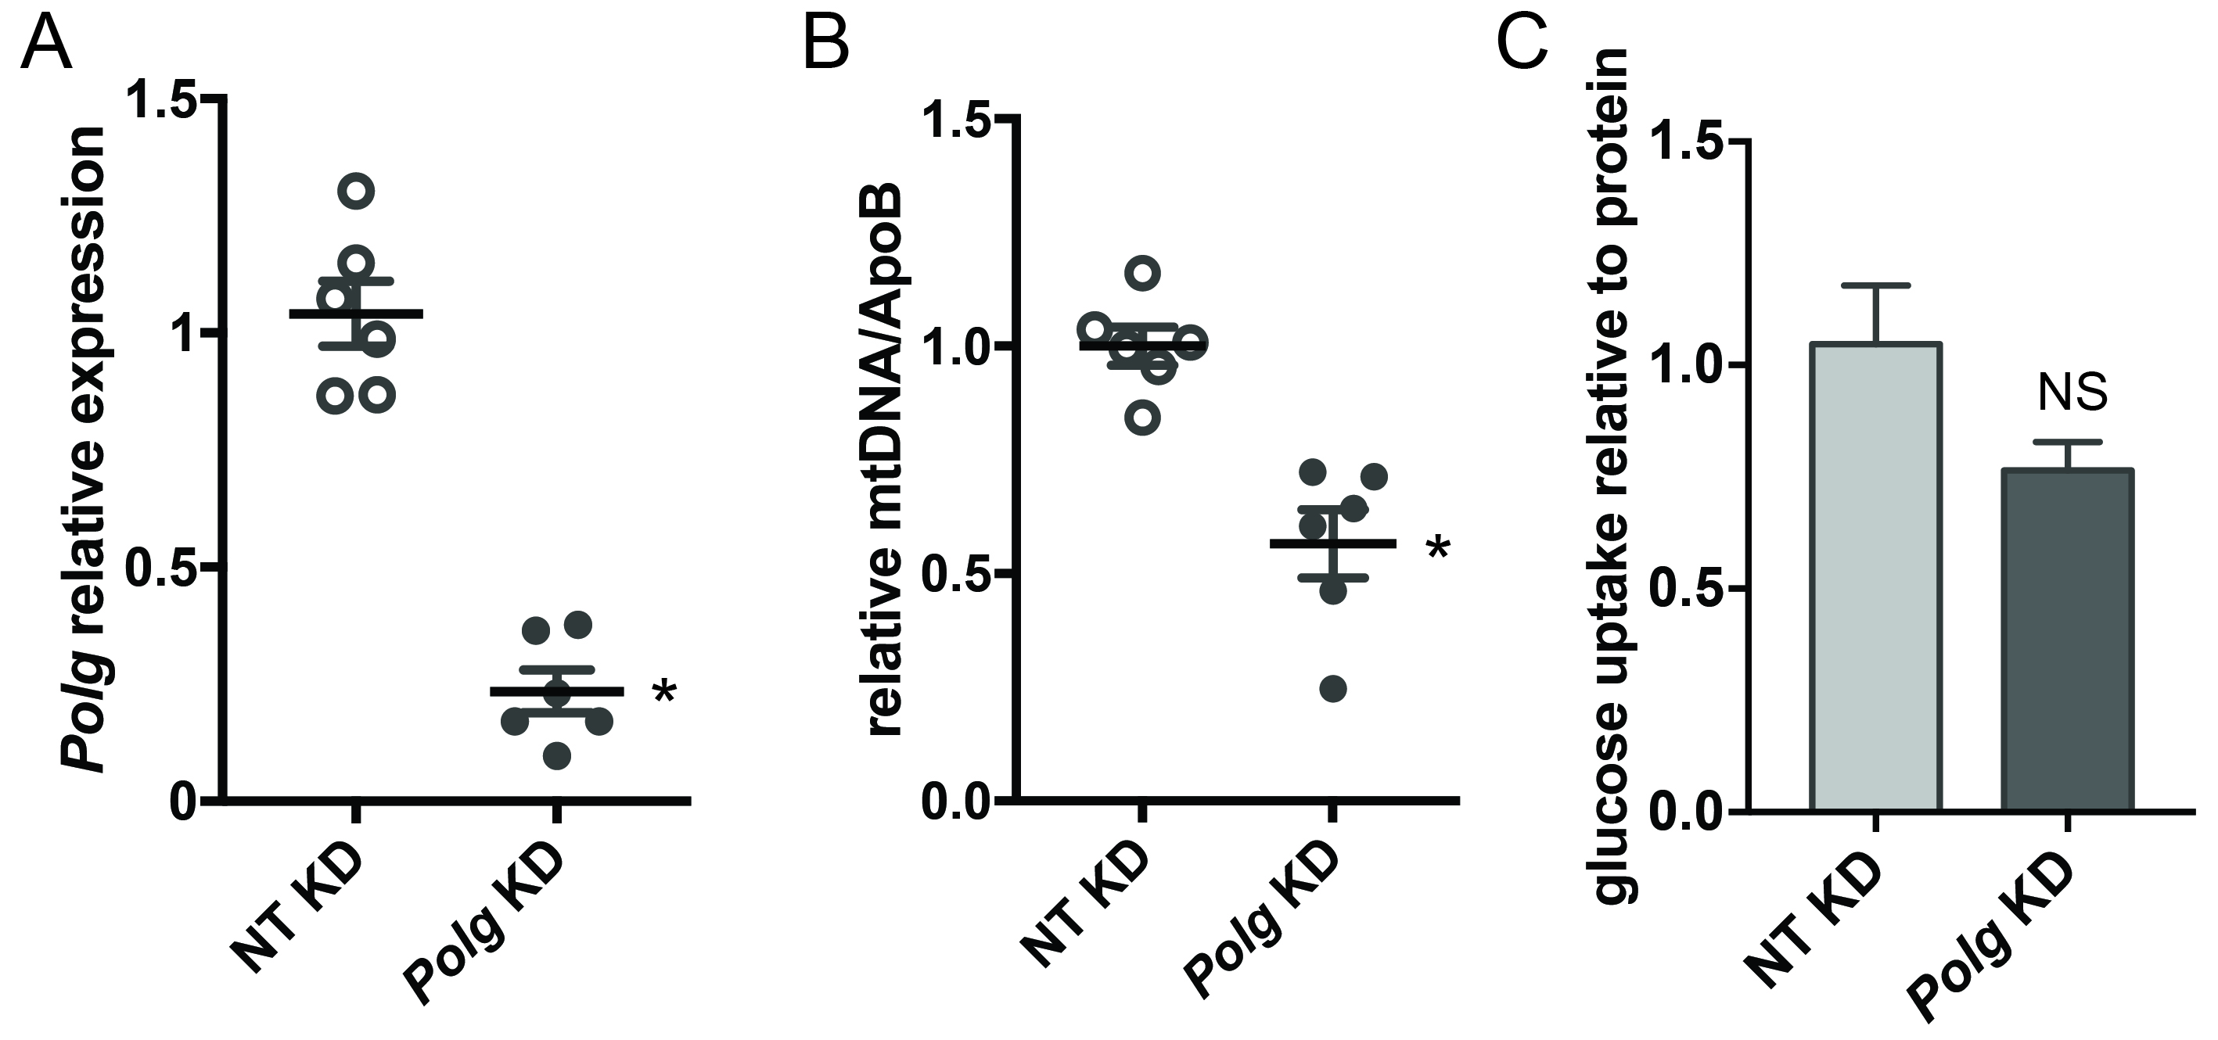

Additional file 1 Figure S2. Polg knockdown in colonoids derived from normal epithelium does not alter glucose uptake. A) Polg gene expression by qRTPCR relative to nontarget (NT) knockdown colonoids derived from wt epithelium. Bar represents mean +/- SEM. *P < 0.05. B) DNA from organoids as in A was used in qPCR assays with primer sets specific for a region of mitochondiral DNA or the genomic ApoB. Bars indicate mean +/- SEM. *P < 0.05. C) Glucose uptake by tumoroids derived as in A. Mean +/-SEM. NS – not significant.

Additional file 1 Table S1. Primer sequences for qMSP and mtDNA content and assays used for TaqMan gene expression.
qMSP Primer Sequences
Polg | Left M | GTTCGTGTTTTTGTAGGTGTTTTAC |  | Right M |  |  | CCCTCTACTCATCCAAATATTATCG
 | Left U | TTGTGTTTTTGTAGGTGTTTTATGT |  | Right U |  |  | CCCTCTACTCATCCAAATATTATCAA
Gapdh | Left M | GTATTGTATAAGAAGATGCGGTCGT |  | Right M |  |  | TACACGTAACTCAAACCTCTACGC
 | Left U | GGTATTGTATAAGAAGATGTGGTTGT |  | Right U |  |  | TACACATAACTCAAACCTCTACACC
Applied Biosystems Taqman Gene Expression Assays
Polg | mm00450527_m1
PPIA | Mm02342430_g1
mtDNA content
mtDNA set1 | Fwd | AATCAATGGTTCAGGTCA |  | Rev |  | ACGGAGGATGGTAGATTA
mtDNA set2 | Fwd | CTCCGTGCTACCTAAACACCTTATC |  | Rev |  | GACCTAAGAAGATTGTGAAGTAGATGATG
ApoB | Fwd | CACGTGGGCTCCAGCATT |  | Rev |  | TCACCAGTCATTTCTGCCTTTG

Additional file 1 Table S2. Fold change in expression by RT2 Profiler Glucose Metabolism PCR Array.
 | Fold change ETBF Min tumor relative to mock epithelium
Prps1l1 | 20.39
Hk3 | 6.23
Pygm | 2.6
Rpia | 2.27
Gck | -102.54
Aldob | -19.16
Phkg1 | -11.24
Pck1 | -6.5
Cs | -3.46
Galm | -2.97
Pdp2 | -2.93
Suclg1 | -2.85
Eno3 | -2.85
Eno2 | -2.73
Gapdh | -2.68
Pdk1 | -2.48
Idh3a | -2.46
Suclg2 | -2.46
Sdha | -2.33
Pdpr | -2.31
Aco1 | -2.28
Gsk3a | -2.23
Ogdh | -2.19
Ugp2 | -2.11
Idh3b | -2.07
Prps1 | -2.04
Changes in bold gene names were verified by qRTPCR.

