Supplementary Information

An efficient multicomponent synthesis and in vitro anticancer activity of dihydropyranochromene and chromenopyrimidine-2,5-diones
Manisha R. Bhosle,ª* Diksha B. Wahul, Giribala M. Bondle,ª Aniket Sarkate,^{b} Shailee V. Tiwari,^{c}
ªDepartment of Chemistry, Dr. Babasaheb Ambedkar Marathwada University, Aurangabad 431004, Maharashtra, India
^{b}Department of Biotechnology, Dr. Babasaheb Ambedkar Marathwada University, Aurangabad-431004, MS, India
^{c}Y. B. Chavan College of Pharmacy, Razabaug, Aurangabad-431001, MS. India
E-mail: d.manisha11@gmail.com

Table of contents
1. General Information....................................................................................................S2

2. Experimental Procedures.............................................................................................S2

3. Characterization Data for the Products......................................................................S3

4. References………………………………………………………………………….…..S15

EXPERIMENTAL
General: All the chemicals used were of laboratory grade. Melting points of all the synthesized compounds were determined in open capillary tubes and are uncorrected. ¹H NMR spectra were recorded with a Bruker Avance 400 spectrometer operating at 400 MHz using CDCl₃ solvent and tetramethylsilane (TMS) as the internal standard and chemical shift in δ ppm Mass spectra were recorded on a Sciex, Model; API 3000 LCMS/MS Instrument. The purity of each compound was checked by TLC using silica-gel, 60F₂₅₄ aluminum sheets as adsorbent and visualization was accomplished by iodine/ultraviolet light.
General Procedure for the synthesis of 2-amino-4,5-dihydro-5-oxo-4-(substitutedphenyl)pyrano[3,2-c]chromene-3-carbonitriles (4a-o)
A mixture of substituted benzaldehydes (1a-j) (4 mmol), malononitrile (2) (4 mmol), 4-hydroxy coumarin (4 mmol) and β-Cyclodextrin (10 mol%) in water (15 ml) was subjected to stirr at 60-65 ^{º}C. Progress of the reaction was monitored by thin layer chromatography. After 60 min, reaction mixture was cooled to room temperature, filtered and washed with hot water. Obtained solid was crystallized by ethanol:DMF. Synthesized compounds characterized by IR, ¹H NMR and are in good agreement with those reported in the literature.^{[1,2]}
General Procedure for the synthesis of 3,4-dihydro-4-(substituted phenyl)-1H-chromeno[4,3-d]pyrimidine-2,5-dione (6a-g)
A mixture of substituted benzaldehydes (1a-g) (4 mmol), urea (5) (4 mmol), 4-hydroxy coumarin (3) (4 mmol) and β-Cyclodextrin (10 mol%) in water (15 ml) was subjected to stirr at 60-65 ^{º}C. Progress of the reaction was monitored by thin layer chromatography. After 2 h, reaction mixture was cooled to room temperature, filtered and washed with hot water. Obtained solid was crystallized by ethanol:DMF. Synthesized compounds characterized by IR, ¹H NMR and are in good agreement with those reported in the literature.^{[1,2]}
Experimental procedure for MTT assays
The stock solutions of test compounds were prepared in DMSO. After 24 h incubation, different concentrations (2, 4, 6, 8 µM) of compounds, made by serial dilution in culture medium, were added in 48 h incubation. The final concentration of DMSO was 0.01% in each well. A separate well containing 0.01 % DMSO only was run as DMSO control, which was found inactive under applied conditions. The cell growth was determined using MTT (3-(4,5-dimethylthiazol-2-yl)-2,5-diphenyl tetrazolium bromide (Sigma) reduction assay, which is based on ability of viable cells to reduce a soluble yellow tetrazolium salt to blue farmazan crystal.^{[46]} Briefly, after 48 h of treatments, the10µl of MTT dye, prepared in phosphate buffered saline (PBS) were added to all wells. The plates were then incubated for 4h at 37ºC. Supernatant from each well was carefully removed, formazon crystals were dissolved in 100µL of DMSO and absorbance at 540 nm wavelength was recorded and each concentration was tested in threefold. The IC₅₀ values were determined as concentration of compounds that inhibited cancer cell growth by 50%.
Spectral Analysis of compounds as follow^{[1,2]}
2-Amino-4,5-dihydro-5-oxo-4-phenyl-pyrano[3,2-c]chromene-3-carbonitrile (4a)
White solid mp: 258-260 °C (lit. 258-260 °C) [ref. 1,2]; IR (ATR υ cm⁻¹) Characteristic absorptions: 3265 (N-H stretching), 2890 (C-H stretching), 1172 (C-O-C stretching), 1646 (C=O stretching). ¹H NMR (400 MHz, CDCl₃, δ ppm): 6.05 (s, 1H, CH), 7.13-7.32 (m, 4H, Ar-H), 7.39-7.47 (m, 5H, Ar-H), 11.17-11.26 (m, 2H, NH₂). ¹³C NMR (100 MHz, DMSO-d6 δ ppm): 159.95, 158.32, 153.87, 152.56, 143.78, 133.36, 128.93 (2C), 128.07 (2C), 127.54, 125.01, 122.88, 119.66, 116.98, 113.34, 104.38, 58.39, 37.35. Mass (LC-MS): m/z 317 [M+H]⁺. Anal. calcd. For C₁₉H₁₂N₂O₃: N: 8.86; C: 72.15; H: 3.82; Found: N: 8.82; C: 72.69; H: 4.25%.
2-Amino-4,5-dihydro-5-oxo-4- (4-methoxy phenyl)pyrano[3,2-c]chromene-3-carbonitrile (4b)
White solid mp: 231-233 °C (lit. 232-234 °C) [ref. 1,2]; IR (ATR υ cm⁻¹) Characteristic absorptions: 3278 (N-H stretching), 2885 (C-H stretching), 1177 (C-O-C stretching), 1637 (C=O stretching). ¹H NMR (400 MHz, CDCl₃, δ ppm): 3.58 (s, 3H, OCH3), 6.06 (s, 1H, CH), 7.27-7.39 (m, 4H, Ar-H), 7.42-7.49 (m, 4H, Ar-H), 11.42-11.45 (m, 2H, NH₂). ¹³C NMR (100 MHz, DMSO-d6 δ ppm): 160.12, 157.45, 156.31, 153.57, 143.43, 141.23, 134.23, 128.07 (2C), 127.89 (2C), 127.37, 124.20, 122.67, 120.13, 118.70, 116.31, 104.45, 58.85, 56.73, 37.46. Mass (LC-MS): m/z 347 [M+H]⁺. Anal. calcd. For C₂₀H₁₄N₂O₄: N: 8.09; C: 69.36; H: 4.07; Found: N: 8.08; C: 69.39; H: 4.04%.
2-Amino-4,5-dihydro-5-oxo-4- (4-methyl phenyl)pyrano[3,2-c]chromene-3-carbonitrile (4c)
White solid mp: 258-259 °C (lit. 258-260 °C) [ref. 1,2]; IR (ATR υ cm⁻¹) Characteristic absorptions: 3291 (N-H stretching), 2884 (C-H stretching), 1187 (C-O-C stretching), 1680 (C=O stretching). ¹H NMR (400 MHz, CDCl₃, δ ppm): 2.15 (s, 3H, CH3), 6.03 (s, 1H, CH), 7.09-7.37 (m, 6H, Ar-H), 7.49-7.54 (m, 2H, Ar-H), 11.21-11.49 (m, 2H, NH₂). ¹³C NMR (100 MHz, DMSO-d6 δ ppm): 160.49, 158.37, 153.66, 152.57, 140.82, 136.74, 133.36, 129.47 (2C), 127.91 (2C), 125.08, 122.87, 119.68, 116.97, 113.36, 104.56, 58.54, 36.97, 21.04. Mass (LC-MS): m/z 331 [M+H]⁺. Anal. calcd. For C₂₀H₁₄N₂O₃: N: 8.48; C: 72.72; H: 4.27; Found: N: 8.50; C: 72.69; H: 4.25%.
2-Amino-4,5-dihydro-5-oxo-4- (4-chloro phenyl)pyrano[3,2-c]chromene-3-carbonitrile (4d)
White solid mp: 263-265 °C (lit. 264-266 °C) [ref. 1,2]; IR (ATR υ cm⁻¹) Characteristic absorptions: 3807 (N-H stretching), 1142 (C-O-C stretching), 1657(C=O stretching); ¹H NMR (400 MHz, CDCl₃, δ ppm): 6.07 (s, 1H, CH), 7.24-7.41 (m, 4H, Ar-H), 7.47-7.54 (m, 4H, Ar-H), 11.28-11.37 (m, 2H, NH₂). ¹³C NMR (100 MHz, DMSO-d6 δ ppm): 159.94, 158.38, 153.94, 152.58, 142.74, 133.45, 132.13, 130.08, 130.04, 128.87 (2C), 125.07, 122.93, 119.50, 116.97, 113.33, 103.87, 57.96, 36.88. Mass (LC-MS): m/z 351 [M+H]⁺. Anal. calcd. For C₁₉H₁₁ClN₂O₃: N: 7.99; C: 65.06; H: 3.16; Found: N: 8.00; C: 65.07; H: 3.15%.
2-Amino-4,5-dihydro-5-oxo-4- (3-chloro phenyl)pyrano[3,2-c]chromene-3-carbonitrile (4e)
White solid mp: 259-261 °C (lit. 259-261 °C) [ref. 1,2]; IR (ATR υ cm⁻¹) Characteristic absorptions: 3832 (N-H stretching), 1146 (C-O-C stretching), 1645 (C=O stretching); ¹H NMR (400 MHz, CDCl₃, δ ppm): 6.04 (s, 1H, CH), 7.19-7.32 (m, 4H, Ar-H), 7.39-7.49 (m, 4H, Ar-H), 11.29-11.35 (m, 2H, NH₂). ¹³C NMR (100 MHz, DMSO-d6 δ ppm): 162.84, 160.4, 159.96, 158.36, 153.84, 152.56, 139.94, 139.92, 133.31, 130.07, 130.05, 125.04, 122.94, 119.57, 116.91, 115.73, 115.54, 113.28, 104.15, 58.27, 36.66. Mass (LC-MS): m/z 351 [M+H]⁺. Anal. calcd. For C₁₉H₁₁ClN₂O₃: N: 7.99; C: 65.06; H: 3.16; Found: N: 7.97; C: 65.07; H: 3.15%.
2-Amino-4,5-dihydro-5-oxo-4- (4-bromophenyl)pyrano[3,2-c]chromene-3-carbonitrile (4f)
White solid mp: 230-232 °C (lit. 233-235 °C) [ref. 1,2]; IR (ATR υ cm⁻¹) Characteristic absorptions: 3837 (N-H stretching), 1164 (C-O-C stretching), 1627 (C=O stretching); ¹H NMR (400 MHz, CDCl₃, δ ppm): 6.05 (s, 1H, CH), 7.27-7.36 (m, 4H, Ar-H), 7.41-7.45 (m, 4H, Ar-H), 11.14-11.26 (m, 2H, NH₂). ¹³C NMR (100 MHz, DMSO-d6 δ ppm): 160.02, 158.45, 154.25, 152.67, 148.31, 133.53, 129.07 (2C), 125.87 (2C), 125.16, 123.28, 122.989, 119.46, 117.05 (2C), 113.34, 103.56, 57.57, 37.26. Mass (LC-MS): m/z 396 [M+H]⁺. Anal. calcd. For C₁₉H₁₁BrN₂O₃: N: 7.09; C: 57.74; H, 2.81; Found: N: 7.03; C: 57.77; H: 2.80%.
2-Amino-4,5-dihydro-5-oxo-4- (4-hydroxy phenyl)pyrano[3,2-c] chromene-3-carbonitrile (4g)
White solid mp: 260-262 °C (lit. 261-263 °C) [ref. 1,2]; IR (ATR υ cm⁻¹) Characteristic absorptions: 3854 (N-H stretching), 1139 (C-O-C stretching), 1651 (C=O stretching); ¹H NMR (400 MHz, CDCl₃, δ ppm): 6.02 (s, 1H, CH), 7.19-7.26 (m, 4H, Ar-H), 7.32-7.41 (m, 4H, Ar-H), 11.19-11.27 (m, 2H, NH₂). ¹³C NMR (100 MHz, DMSO-d6 δ ppm): 160.04, 158.57, 154.31, 152.66, 148.27, 145.98, 135.16, 133.57, 130.48, 125.13, 123.00, 122.86, 122.68, 119.38, 117.01, 113.34, 103.27, 57.35, 37.04. Mass (LC-MS): m/z 333 [M+H]⁺. Anal. calcd. For C₁₉H₁₂N₂O₄: N: 8.43; C: 68.67; H: 3.64; Found: N: 8.42; C: 68.64; H: 3.64%.
2-Amino-4,5-dihydro-5-oxo-4-(4-hydroxy-3-methoxyphenyl)pyrano[3,2-c]chromene-3-carbonitrile (4i)
White solid mp: 255-257 °C (lit. 257-259 °C) [ref. 1,2]; IR (ATR υ cm⁻¹) Characteristic absorptions: 3412 (OH stretching), 3833 (N-H stretching), 1148 (C-O-C stretching), 1637 (C=O stretching); ¹H NMR (400 MHz, CDCl₃, δ ppm): 6.05 (s, 1H, CH), 7.15-7.29 (m, 3H, Ar-H), 7.32-7.39 (m, 4H, Ar-H), 11.25-11.32 (m, 2H, NH₂). ¹³C NMR (100 MHz, DMSO-d6 δ ppm): 160.05, 158.54, 154.35, 152.66, 148.27, 145.93, 135.17, 133.55, 130.48, 125.14, 123.06, 122.84, 122.69, 119.38, 117.02, 113.35, 103.27, 57.38, 56.36, 37.04. Mass (LC-MS): m/z 363 [M+H]⁺. Anal. calcd. For C₂₀H₁₄N₂O₅: N: 7.73; C: 66.30; H: 3.89; Found: N: 7.73; C: 66.32; H: 3.81%.
2-Amino-4,5-dihydro-5-oxo-4- (3,4-dimethoxy phenyl)pyrano[3,2-c]chromene-3-carbonitrile (4j)
White solid mp: 228-230 °C (lit. 225-227 °C) [ref. 1,2]; IR (ATR υ cm⁻¹) Characteristic absorptions: 2832 (N-H stretching), 1138 (C-O-C stretching), 1656 (C=O stretching); ¹H NMR (400 MHz, CDCl₃, δ ppm): 6.05 (s, 1H, CH), 7.17-7.24 (m, 4H, Ar-H), 7.27-7.39 (m, 4H, Ar-H), 11.21-11.33 (m, 2H, NH₂). ¹³C NMR (100 MHz, DMSO-d6 δ ppm): 159.85, 158.56, 154.57, 152.66, 139.83, 133.79, 133.53, 132.80, 132.55, 129.26, 128.28, 125.14, 122.94, 119.07, 117.05, 113.23, 102.93, 56.56, 56.41, 34.32. Mass (LC-MS): m/z 377 [M+H]⁺. Anal. calcd. For C₂₁H₁₆N₂O₅: N: 7.44; C: 67.02; H: 4.28; Found: N: 7.47; C: 67.05; H: 4.24%.
2-Amino-4,5-dihydro-5-oxo-4- (N,N dimethyl phenyl)pyrano[3,2-c]chromene-3-carbonitrile (4k)
White solid mp: 225-227°C (lit. 224-226°C) [ref. 1,2]; IR (ATR υ cm⁻¹) Characteristic absorptions: 3378 (N-H stretching), 3184 (Ar-H stretching), 2817(C-H stretching), 2188 (CN stretching), 1102 (C-O-C stretching), 1670(C=O stretching); ¹H NMR (400 MHz, CDCl₃, δ ppm): 2.33 (s, 3H, CH3), 2.45 (s, 3H, CH3), 6.06 (s, 1H, CH), 7.11-7.26 (m, 4H, Ar-H), 7.32-7.42 (m, 2H, Ar-H), 7.61-7.82 (m, 2H, Ar-H), 11.29-11.51 (m, 2H, NH₂); ¹³C NMR (100 MHz, DMSO-d6 δ ppm): 161.20, 160.47, 154.96, 152.48, 133.15, 125.01, 122.54, 121.07, 116.93, 113.39, 105.24, 51.87, 37.53, 33.17, 20.58, 16.88. Mass (LC-MS): m/z 360 [M+H]⁺. Anal. calcd. For C₂₁H₁₇N₃O₃: N: 11.69; C: 70.18; H: 4.77; Found: N: 11.75; C: 70.20; H: 4.71%.
2-Amino-4,5-dihydro-5-oxo-4- (4-nitro phenyl)pyrano[3,2-c]chromene-3-carbonitrile (4l)
White solid mp: 258-260 °C (lit. 255-257°C) [ref. 1,2]; IR (ATR υ cm⁻¹) Characteristic absorptions: 3365 (N-H stretching), 3174 (Ar-H stretching), 2815(C-H stretching), 2181 (CN stretching), 1107 (C-O-C stretching), 1669 (C=O stretching); ¹H NMR (400 MHz, CDCl₃, δ ppm): 6.05 (s, 1H, CH), 7.16-7.23 (m, 4H, Ar-H), 7.29-7.32 (m, 2H, Ar-H), 7.42-7.55 (m, 2H, Ar-H), 11.27-11.43 (m, 2H, NH₂); ¹³C NMR (100 MHz, DMSO-d6 δ ppm): 160.02, 158.46, 154.38, 152.66, 151.18, 147.05, 133.67, 129.56 (2C), 125.17, 124.15 (2C), 123.01, 119.37, 117.05, 113.29, 103.18, 57.17, 37.23. Mass (LC-MS): m/z 362 [M+H]⁺. Anal. calcd. For C₁₉H₁₁N₃O₅: N: 11.63; C: 63.16; H: 3.07; Found: N: 11.65; C: 63.20; H: 3.10%.
2-Amino-4-butyl-4,5-dihydro-5-oxopyrano[3,2-c]chromene-3-carbonitrile (4n)
White solid mp: 270-272 °C (lit. 265-267°C) [ref. 1,2]; IR (ATR υ cm⁻¹) Characteristic absorptions: 3370 (N-H stretching), 2813 (C-H stretching), 2180 (CN stretching), 1143 (C-O-C stretching), 1634 (C=O stretching); ¹H NMR (400 MHz, CDCl₃, δ ppm): 1.12 (m, 3H, CH₃), 1.26 (m, 4H, CH₂), 1.35 (m, 2H, CH₂), 3.27 (s, 1H, CH), 7.24-7.29 (m, 4H, Ar-H), 11.21-11.31 (m, 2H, NH₂); ¹³C NMR (100 MHz, DMSO-d6 δ ppm): 160.36, 159.84, 154.54, 133.12, 124.96, 122.55, 120.11, 116.93, 113.36, 104.75, 55.56, 36.58, 31.16, 19.46, 18.05, 14.27. Mass (LC-MS): m/z 297 [M+H]⁺. Anal. calcd. For C₁₇H₁₆N₂O₃: N: 9.45; C: 68.91; H: 5.44; Found: N: 9.41; C: 68.91; H: 5.45%.
2-Amino-4-benzyl-4,5-dihydro-5-oxopyrano[3,2-c]chromene-3-carbonitrile (4o)
White solid mp: 120-122 °C (lit. 121-123 °C) [ref. 1,2]; IR (ATR υ cm⁻¹) Characteristic absorptions: 3370 (N-H stretching), 3169 (Ar-H stretching), 2831 (C-H stretching), 2148 (CN stretching), 1121 (C-O-C stretching), 1640 (C=O stretching); ¹H NMR (400 MHz, CDCl₃, δ ppm): 2.91-3.05 (m, 2H, CH₂), 3.43 (s, 1H, CH), 7.19-7.21 (m, 5H, Ar-H), 7.26-7.31 (m, 2H, Ar-H), 7.38-7.45 (m, 2H, Ar-H), 11.24-11.31 (m, 2H, NH₂); Mass (LC-MS): m/z 331 [M+H]⁺. Anal. calcd. For C₂₀H₁₄N₂O₃: N: 8.48; C: 72.72; H: 4.27; Found: N: 8.48; C: 72.73; H: 4.24%.
3,4-Dihydro-4-phenyl-1H-chromeno[4,3-d]pyrimidine-2,5-dione (6a)
White solid mp: 238-240 °C (lit. 237-239 °C) [ref. 1,2]; IR (ATR υ cm⁻¹) Characteristic absorptions: 3282 (N-H stretching), 2882 (C-H stretching), 1181 and 1208 (C-O-C stretching); ¹H-NMR (400 MHz, CDCl3, δ ppm): 6.04 (s, 1H, CH), 7.15-7.17 (d, 2H, J = 8Hz, Ar-H), 7.26-7.30 (d, 2H, J = 8Hz, Ar-H), 7.41-7.43 (m, 2H, Ar-H), 7.99-8.09 (m, 3H, Ar-H ), 11.31 (s, 1H, NH) and 11.54 (s, 1H, NH); ¹³C NMR (100 MHz, DMSO-d6 δ ppm): 162.87, 158.00, 152.86, 149.96, 149.48, 141.56, 131.79, 129.68 (2C), 128.66 (2C), 127.34, 125.69, 119.89, 119.46, 88.43, 58.67. Mass (LC-MS): m/z 292 [M+H]⁺. Anal. calcd. For C₁₇H₁₂N₂O₃: N: 9.58; C: 69.86; H: 4.14; Found: N: 9.60; C: 70.00; H: 4.27%.
4-(4-Chlorophenyl)-3,4-dihydro-1H-chromeno[4,3-d]pyrimidine-2,5-dione (6b)
White solid mp: 163-165 °C (lit. 165-167 °C) [ref. 1,2]; IR (ATR υ cm⁻¹) Characteristic absorptions: 3276 (N-H stretching), 2876 (C-H stretching), 1146 and 1256 (C-O-C stretching); ¹H-NMR (400 MHz, CDCl3, δ ppm): 6.05 (s, 1H, CH), 7.16-7.29 (m, 4H, Ar-H), 7.49-7.53 (m, 2H, Ar-H), 7.61-7.65 (d, 2H, J = 7.8 Hz, Ar-H), 11.29 (s, 1H, NH) and 11.47 (s, 1H, NH); Mass (LC-MS): m/z 327 [M+H]⁺. Anal. calcd. For C₁₇H₁₁ClN₂O₃: N: 8.57; C: 62.49; H: 3.39; Found: N: 8.60; C: 62.50; H: 3.36%.
4-(4-Bromophenyl)-3,4-dihydro-1H-chromeno[4,3-d]pyrimidine-2,5-dione (6c)
White solid mp: 194-196 °C (lit. 195-196 °C) [ref. 1,2]; IR (ATR υ cm⁻¹) Characteristic absorptions: 3254 (N-H stretching), 2879 (C-H stretching), 1180 and 1224 (C-O-C stretching); ¹H-NMR (400 MHz, CDCl3, δ ppm): 6.07 (s, 1H, CH), 7.21-7.26 (d, 2H, J = 8Hz, Ar-H), 7.39-7.41 (m, 2H, Ar-H), 7.59-7.65 (d, 2H, J = 7.9 Hz, Ar-H), 7.97-8.04 (m, 2H, Ar-H ), 11.30 (s, 1H, NH) and 11.53 (s, 1H, NH); Mass (LC-MS): m/z 372 [M+H]⁺. Anal. calcd. For C₁₇H₁₁BrN₂O₃: N: 7.55; C: 55.01; H: 2.99; Found: N: 7.55; C: 55.05; H: 3.00%.
4-(4-Hydroxyphenyl)-3,4-dihydro-1H-chromeno[4,3-d]pyrimidine-2,5-dione (6d)
White solid mp: 174-176 °C (lit. 172-174 °C) [ref. 1,2]; IR (ATR υ cm⁻¹) Characteristic absorptions: 3279 (N-H stretching), 2889 (C-H stretching), 1176 and 1198 (C-O-C stretching); ¹H-NMR (400 MHz, CDCl3, δ ppm): 6.05 (s, 1H, CH), 7.17-7.19 (d, 2H, J = 7.9 Hz, Ar-H), 7.29-7.35 (d, 2H, J = 8Hz, Ar-H), 7.41-7.43 (m, 2H, Ar-H), 7.79-7.85 (m, 2H, Ar-H ), 11.37 (s, 1H, NH) and 11.52 (s, 1H, NH); Mass (LC-MS): m/z 309 [M+H]⁺. Anal. calcd. For C₁₇H₁₂N₂O₄: N, 9.09; C, 66.23; H, 3.92; Found: N: 9.07; C: 66.25; H: 3.95%.
4-(3-Hydroxyphenyl)-3,4-dihydro-1H-chromeno[4,3-d]pyrimidine-2,5-dione (6e)
White solid mp: 203-206 °C (lit. 201-203 °C) [ref. 1,2]; IR (ATR υ cm⁻¹) Characteristic absorptions: 3287 (N-H stretching), 2892 (C-H stretching), 1173 and 1193 (C-O-C stretching); ¹H-NMR (400 MHz, CDCl3, δ ppm): 6.04 (s, 1H, CH), 7.19-7.21 (m, 2H, Ar-H), 7.25-7.31 (d, 2H, J = 8Hz, Ar-H), 7.46-7.49 (m, 2H, Ar-H), 7.89-8.00 (m, 2H, Ar-H ), 11.35 (s, 1H, NH) and 11.51 (s, 1H, NH); Mass (LC-MS): m/z 309 [M+H]⁺. Anal. calcd. For C₁₇H₁₂N₂O₄: N, 9.09; C, 66.23; H, 3.92; Found: N: 9.10; C: 66.24; H: 3.93%.
3,4-Dihydro-4-(3,4-dimethoxyphenyl)-1H-chromeno[4,3-d]pyrimidine-2,5-dione (6g)
White solid mp: 260-262 °C (lit. 263-265 °C) [ref. 1,2]; IR (ATR υ cm⁻¹) Characteristic absorptions: 3289 (N-H stretching), 2878 (C-H stretching), 1180 and 1207 (C-O-C stretching); ¹H-NMR (400 MHz, CDCl3, δ ppm): 3.18 (s, 3H, OCH₃), 3.23 (s, 3H, OCH₃), 6.06 (s, 1H, CH), 7.11-7.16 (m, 2H, Ar-H), 7.21-7.29 (m, 2H, Ar-H), 7.76-7.79 (m, 3H, Ar-H), 11.37 (s, 1H, NH) and 11.58 (s, 1H, NH); Mass (LC-MS): m/z 353 [M+H]⁺. Anal. calcd. For C₁₉H₁₆N₂O₅: N: 7.95; C: 64.77; H: 4.58; Found: N: 7.95; C: 64.79; H: 4.57%.

IR of Compound (4k)
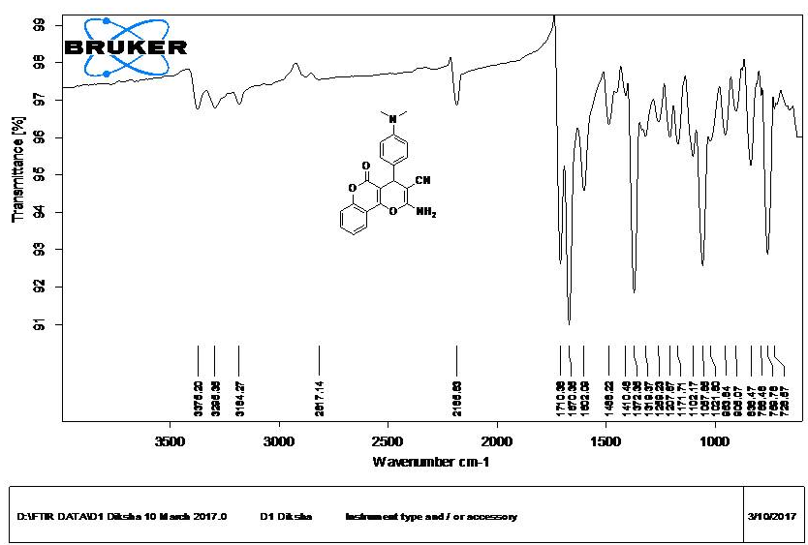
¹H NMR of Compound (4k)
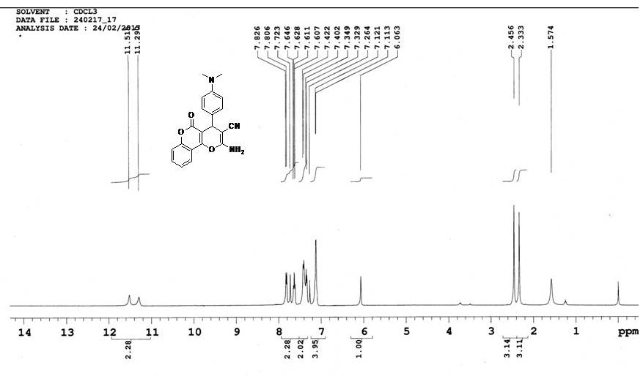

IR of Compound (4c)
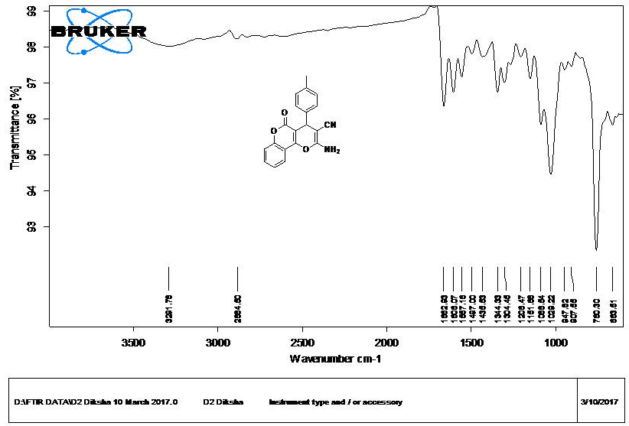
IR of Compound (4d)
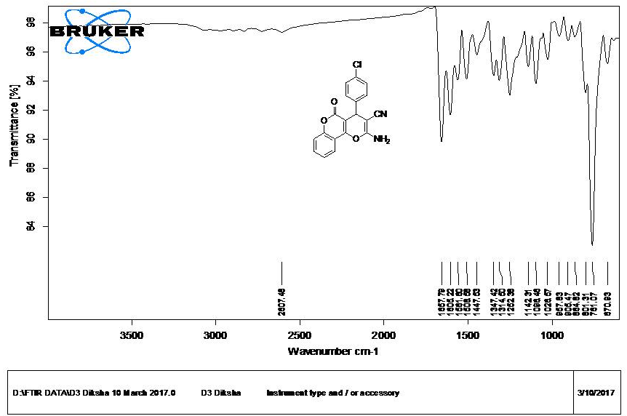

IR of Compound (6a)
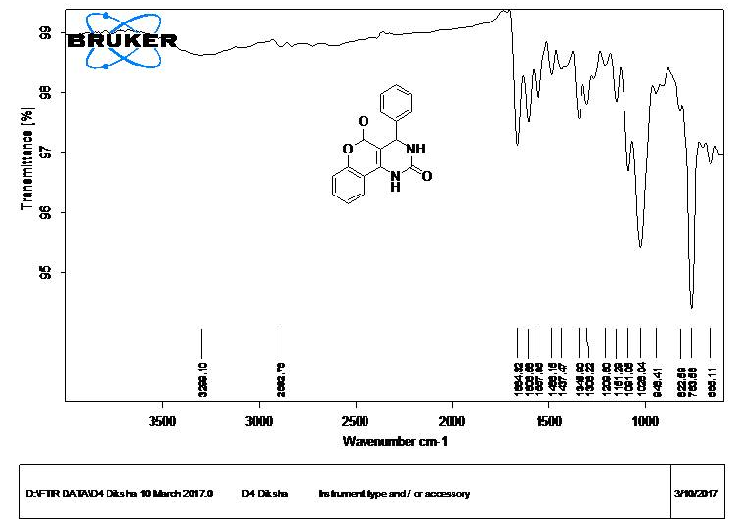
¹H NMR of Compound (6a)
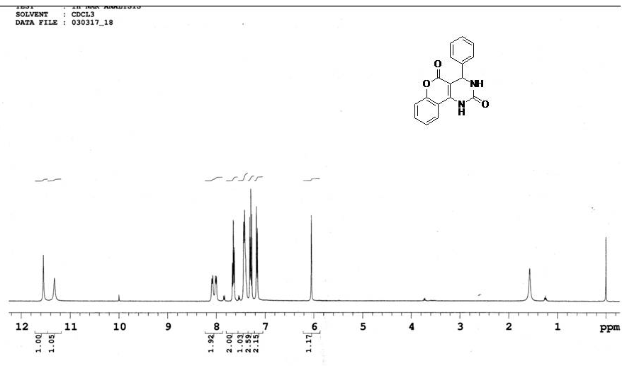
IR of Compound (6b)
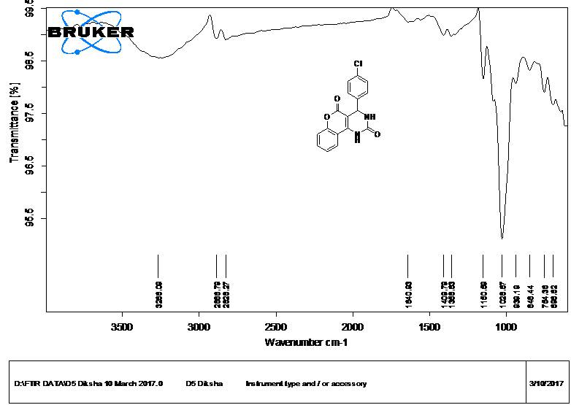

REFERENCES
- (a) Kiyani, H.; Ghorbani, F. Res. Chem. Intermed., 2015, 41, 4031-4046; (b) Niknam, K.; Jamali, A. Chin. J. Catal., 2012, 33, 1840-1849;
- (a) Tiwari, J.; Saquib, M.; Singh, S.; Tufail, F.; Singh, M.; Singh, J.; Singh, J. Green Chem., 2016, 18, 3221-3231; (b) Wang, H.-J.; Lu, J.; Zhang, Z.-H. Monatsh. Chem., 2010, 141, 1107-1112; (c) Kidwai, M.; Sapra, P. Synt Comm, 2002, 32(11), 1639-1645.

