**Supporting information**

**Highly efficient one-pot synthesis of fused pyrimidones from 2-heteroaryl amines and Morita-Baylis-Hillman carbonates *via* intermolecular cyclocondensation**

**Surendra Babu Inturia,b, Biswajit Kalitaa, *and A. Jafar Ahamedb, \***

a*Medicinal Chemistry Division, Jubilant Biosys Ltd, #96, Industrial Suburb, 2nd Stage, Yeshwanthpur, Bangalore 560022, Karnataka, India.*

b*Post Graduate and Research Department of Chemistry, Jamal Mohamed College (Autonomous), affiliated to Bharathidasan University, Tiruchirappalli - 620020, Tamil Nadu, India.*

*\*Corresponding authors.*

*E-mail address: Biswajit.kalita@jubilantbiosys.com*

*E-mail address: agjafar@yahoo.co.in*

**Table of contents**

General experimental methods.....................................................................................................S2

General procedure for the synthesis of compounds **3a–3p**, **5a–5n** & **6a–6h**...............................S3

1H-NMR / 13C-NMR spectra.......................................................................................................S15

Reference....................................................................................................................................S54

Experimental Section

**General experimental methods**

All chemicals and solvents were purchased from commercial suppliers and used without further purification. Solvents were used without drying. 1H and 13C NMR spectra were recorded at 400 MHz and 100.5 MHz on Varian NMR spectrometer with DMSO-*d6* as solvent. Chemical shifts were reported in δ ppm using residual solvent protons as internal standard (δ 2.48 ppm for DMSO-*d6* in 1H-NMR and δ 40.0 ppm for DMSO-*d6* in 13C-NMR). Coupling constants (*J*) were reported in Hz and refer to apparent peak multiplicity. The peak splitting patterns were indicated as follows: s, singlet; d, doublet; t, triplet; q, quartet; m, multiplet; dd, doublet of doublets; td, triplet of doublets; tt, triplet of triplets. High resolution mass spectra were obtained on WATERS Q-TOF Premier-HAB213 spectrometer in ESI mode. Melting points were recorded using Buchi melting point apparatus and temperatures were uncorrected. Thin layer chromatography was performed on aluminium plates coated with silica gel 60 with F254 indicator. The MBH carbonates **2** were synthesized according to the reported procedure.1

**General procedure for the synthesis of compounds 3a–3p, 5a–5n & 6a–6h**

To a stirred solution of 2-heteroaryl amine (0.5 mmol, 1 equiv.) and MBH carbonate (0.53 mmol, 1.05 equiv.) in ethanol (0.8 mL) was heated at 65 °C for 15 minutes. During the course of the reaction, product was precipitatedwhich was then diluted with diethyl ether (4 mL) and filtered to get the pure product.

In case of **3p,** reaction was continued to stir at 65 °C for 4 hours. After this time, ethanol was evaporated under reduced pressure; the obtained solid was diluted with diethyl ether (2 mL) and filtered to get the pure product.

**3-Benzyl-2*H*-pyrido[1,2-*a*]pyrimidin-2-one (3a):**2

White solid; Yield: 111 mg, 94%; M.p.: 219–221 °C (lit: 218–220 °C); 1H NMR (400 MHz, DMSO-*d6*): δ 8.19 (s, 1H), 8.14 (d, *J* = 6.4 Hz, 1H), 7.63 (tt, *J* = 6.8, 2.0 Hz, 1H), 7.30 – 7.25 (m, 4H), 7.21 – 7.16 (m, 1H), 7.13 (d, *J* = 9.2 Hz, 1H), 6.91 (td, *J* = 6.4, 0.8 Hz, 1H), 3.72 (s, 2H); 13C NMR (100.5 MHz, DMSO-*d6*): δ 167.6, 151.1, 139.2, 136.8, 136.6, 134.4, 129.3, 128.7, 127.9, 126.6, 122.9, 113.0, 34.1. ESI-MS [M+H]+ *m/z* 237.1.

**3-(4-Bromobenzyl)-2*H*-pyrido[1,2-*a*]pyrimidin-2-one (3b):**3

Yellow solid; Yield: 140 mg, 89%; M.p.: 237–239 °C (lit: 238–241 °C); 1H NMR (400 MHz, DMSO-*d6*): δ 8.20 (s, 1H), 8.14 (d, *J* = 6.4 Hz, 1H), 7.64 (t, *J* = 6.8 Hz, 1H), 7.46 (d, *J* = 8.4 Hz, 2H), 7.26 (d, *J* = 8.4 Hz, 2H), 7.13 (d, *J* = 9.2 Hz, 1H), 6.92 (t, *J* = 6.8 Hz, 1H), 3.69 (s, 2H); 13C NMR (100.5 MHz, DMSO-*d6*): δ 167.5, 151.2, 138.7, 137.0, 136.7, 134.5, 131.6, 131.6, 127.5, 123.0, 119.8, 113.1, 33.6. ESI-MS [M+H]+ *m/z* 315.0.

**3-(4-Methoxybenzyl)-2*H*-pyrido[1,2-*a*]pyrimidin-2-one (3c):2**

Off-white solid; Yield: 112 mg, 84%; M.p.: 220–222 °C (lit: 219–222 °C); 1H NMR (400 MHz, DMSO-*d6*): δ 8.14 (d, *J* = 6.8 Hz, 1H), 8.12 (s, 1H), 7.63 (t, *J* = 7.6 Hz, 1H), 7.21 (d, *J* = 8.4 Hz, 2H), 7.12 (d, *J* = 9.2 Hz, 1H), 6.90 (t, *J* = 6.8 Hz, 1H), 6.84 (d, *J* = 8.0 Hz, 2H), 3.70 (s, 3H), 3.65 (s, 2H); 13C NMR (100.5 MHz, DMSO-*d6*): δ 167.6, 158.2, 151.1, 136.6, 136.5, 134.4, 130.9, 130.4, 128.5, 122.9, 114.2, 113.0, 55.4, 33.3. ESI-MS [M+H]+ *m/z* 267.1.

**3-(4-(Trifluoromethyl)benzyl)-2*H*-pyrido[1,2-*a*]pyrimidin-2-one (3d):**

Pale yellow solid; Yield: 117 mg, 77%; M.p.: 292–293 °C; 1H NMR (400 MHz, DMSO-*d6*): δ 8.29 (s, 1H), 8.14 (d, *J* = 6.8 Hz, 1H), 7.67 – 7.62 (m, 3H), 7.52 (d, *J* = 8.4 Hz, 2H), 7.14 (d, *J* = 8.8 Hz, 1H), 6.93 (t, *J* = 6.4 Hz, 1H), 3.82 (s, 2H); 13C NMR (100.5 MHz, DMSO-*d6*): δ 167.5, 151.3, 144.3, 137.3, 136.8, 134.5, 130.1, 127.4 (q, *J*C-F = 31.3 Hz), 127.0, 125.5 (d, *J*C-F = 3.4 Hz), 124.8 (q, *J*C-F = 272.1 Hz), 123.0, 113.1, 34.0. HRMS–ESI (*m/z*): [M+H]+ calcd for C16H12F3N2O, 305.0902; found, 305.0901.

**3-(3-Chlorobenzyl)-2*H*-pyrido[1,2-*a*]pyrimidin-2-one (3e):**

Off-white solid; Yield: 94.5 mg, 70%; M.p.: 232–234 °C; 1H NMR (400 MHz, DMSO-*d6*): δ 8.28 (s, 1H), 8.16 (d, *J* = 7.2 Hz, 1H), 7.65 (t, *J* = 7.6 Hz, 1H), 7.39 (s, 1H), 7.34 – 7.26 (m, 3H), 7.15 (d, *J* = 8.8 Hz, 1H), 6.95 (t, *J* = 6.8 Hz, 1H), 3.74 (s, 2H); 13C NMR (100.5 MHz, DMSO-*d6*): δ 167.5, 151.2, 141.8, 137.2, 136.7, 134.5, 133.3, 130.5, 129.0, 128.0, 127.2, 126.6, 123.0, 113.1, 33.8. HRMS–ESI (*m/z*): [M+H]+ calcd for C15H12ClN2O, 271.0638; found, 271.0635.

**3-((2-Oxo-2*H*-pyrido[1,2-*a*]pyrimidin-3-yl)methyl)benzonitrile (3f):**

Yellow solid; Yield: 128 mg, 98%; M.p.: 284–285 °C; 1H NMR (400 MHz, DMSO-*d6*): δ 8.29 (s, 1H), 8.15 (d, *J* = 6.8 Hz, 1H), 7.78 (s, 1H), 7.69 – 7.65 (m, 3H), 7.51 (t, *J* = 7.8 Hz, 1H), 7.16 (d, *J* = 9.2 Hz, 1H), 6.96 (td, *J* = 6.4, 0.8 Hz, 1H), 3.80 (s, 2H); 13C NMR (100.5 MHz, DMSO-*d6*): δ 167.5, 151.3, 141.0, 137.5, 136.8, 134.5, 134.4, 132.8, 130.5, 129.9, 126.7, 123.0, 119.3, 113.1, 111.6, 33.7. HRMS–ESI (*m/z*): [M+H]+ calcd for C16H12N3O, 262.0980; found, 262.0985.

**3-(2-Methylbenzyl)-2*H*-pyrido[1,2-*a*]pyrimidin-2-one (3g):**

Off-white solid; Yield: 90 mg, 72%; M.p.: 244–246 °C; 1H NMR (400 MHz, DMSO-*d6*): δ 8.16 (d, *J* = 6.8 Hz, 1H), 7.85 (s, 1H), 7.63 (t, *J* = 7.8 Hz, 1H), 7.18 – 7.09 (m, 5H), 6.88 (t, *J* = 6.8 Hz, 1H), 3.70 (s, 2H), 2.25 (s, 3H); 13C NMR (100.5 MHz, DMSO-*d6*): δ 167.6, 151.1, 136.8, 136.7, 136.6, 136.4, 134.5, 130.5, 129.9, 127.6, 126.9, 126.3, 122.9, 112.9, 31.5, 19.6. HRMS–ESI (*m/z*): [M+H]+ calcd for C16H15N2O, 251.1184; found, 251.1181.

**3-(2-Fluorobenzyl)-2*H*-pyrido[1,2-*a*]pyrimidin-2-one (3h):**

White solid; Yield: 102 mg, 80%; M.p.: 232–233 °C; 1H NMR (400 MHz, DMSO-*d6*): δ 8.20 (d, *J* = 6.8 Hz, 1H), 8.12 (s, 1H), 7.65 (t, *J* = 7.8 Hz, 1H), 7.35 – 7.25 (m, 2H), 7.18 – 7.10 (m, 3H), 6.92 (t, *J* = 6.8 Hz, 1H), 3.74 (s, 2H); 13C NMR (100.5 MHz, DMSO-*d6*): δ 167.4, 161.0 (d, *J*C-F = 243.4 Hz), 151.2, 136.9, 136.7, 134.5, 131.8 (d, *J*C-F = 4.6 Hz), 128.9 (d, *J*C-F = 7.6 Hz), 126.5, 125.5 (d, *J*C-F = 15.2 Hz), 124.7 (d, *J*C-F = 3.0 Hz), 123.0, 115.6 (d, *J*C-F = 22.1 Hz), 113.0, 27.3 (d, *J*C-F = 3.1 Hz). HRMS–ESI (*m/z*): [M+H]+ calcd for C15H12FN2O, 255.0934; found, 255.0937.

**3-(2-Chlorobenzyl)-2*H*-pyrido[1,2-*a*]pyrimidin-2-one (3i):**2

Off-white solid; Yield: 130 mg, 96%; M.p.: 188–190 °C (lit: 186–188 °C); 1H NMR (400 MHz, DMSO-*d6*): δ 8.20 (dd, *J* = 6.0, 0.8 Hz, 1H), 8.01 (s, 1H), 7.65 (tt, *J* = 6.8, 1.6 Hz, 1H), 7.46 – 7.43 (m, 1H), 7.37 – 7.35 (m, 1H), 7.30 – 7.25 (m, 2H), 7.14 (dd, *J* = 8.4, 0.8 Hz, 1H), 6.91 (td, *J* = 7.2, 1.6 Hz, 1H), 3.82 (s, 2H); 13C NMR (100.5 MHz, DMSO-*d6*): δ 167.4, 151.2, 136.9, 136.8, 136.1, 134.5, 133.7, 131.7, 129.7, 128.8, 127.6, 126.3, 123.0, 113.1, 31.9. ESI-MS [M+H]+ *m/z* 271.1.

**3-(3,4-Difluorobenzyl)-2*H*-pyrido[1,2-*a*]pyrimidin-2-one (3j):**

Off-white solid; Yield: 102 mg, 75%; M.p.: 283–284 °C; 1H NMR (400 MHz, DMSO-*d6*): δ 8.22 (s, 1H), 8.15 (d, *J* = 6.4 Hz, 1H), 7.67 (t, *J* = 7.8 Hz, 1H), 7.41 – 7.31 (m, 2H), 7.16 (d, *J* = 8.8 Hz, 2H), 6.95 (t, *J* = 6.8 Hz, 1H), 3.73 (s, 2H); 13C NMR (100.5 MHz, DMSO-*d6*): δ 167.5, 151.2, 150.3 (d, *J*C-F = 116.7 Hz), 148.4 (d, *J*C-F = 12.9 Hz), 147.4 (d, *J*C-F = 12.2 Hz), 137.2, 136.8, 134.5, 127.2, 126.1, 123.0, 118.2 (d, *J*C-F = 16.7 Hz), 117.5 (d, *J*C-F = 16.7 Hz), 113.1, 33.3. HRMS–ESI (*m/z*): [M+H]+ calcd for C15H11F2N2O, 273.0839; found, 273.0835.

**3-(4-Chloro-2-fluorobenzyl)-2*H*-pyrido[1,2-*a*]pyrimidin-2-one (3k):**

Off-white solid; Yield: 125 mg, 87%; M.p.: 277–279 °C; 1H NMR (400 MHz, DMSO-*d6*): δ 8.19 (d, *J* = 6.8 Hz, 1H), 8.13 (s, 1H), 7.65 (tt, *J* = 6.8, 2.0 Hz, 1H), 7.39 – 7.35 (m, 2H), 7.21 (dd, *J* = 8.4, 2.0 Hz, 1H), 7.14 (d, *J* = 9.2 Hz, 1H), 6.92 (td, *J* = 6.8, 1.2 Hz, 1H), 3.71 (s, 2H); 13C NMR (100.5 MHz, DMSO-*d6*): δ 167.4, 160.8 (d, *J*C-F = 248.4 Hz), 151.3, 137.0, 136.8, 134.5, 133.0 (d, *J*C-F = 5.9 Hz), 132.3 (d, *J*C-F = 10.9 Hz), 126.1, 124.9 (d, *J*C-F = 3.4 Hz), 124.7 (d, *J*C-F = 16.0 Hz), 123.0, 116.2 (d, *J*C-F = 25.4 Hz), 113.1, 27.0 (d, *J*C-F = 2.5 Hz). HRMS–ESI (*m/z*): [M+H]+ calcd for C15H11ClFN2O, 289.0544; found, 289.0547.

**3-(Pyridin-2-ylmethyl)-2*H*-pyrido[1,2-*a*]pyrimidin-2-one (3l):**

Off-white solid; Yield: 97 mg, 82%; M.p.: 204–206 °C; 1H NMR (400 MHz, DMSO-*d6*): δ 8.44 (d, *J* = 4.0 Hz, 1H), 8.29 (s, 1H), 8.20 (d, *J* = 6.4 Hz, 1H), 7.70 – 7.63 (m, 2H), 7.34 (d, *J* = 7.6 Hz, 1H), 7.20 (t, *J* = 6.0 Hz, 1H), 7.14 (d, *J* = 9.2 Hz, 1H), 6.94 (t, *J* = 6.6 Hz, 1H), 3.86 (s, 2H); 13C NMR (100.5 MHz, DMSO-*d6*): δ 167.6, 158.8, 151.2, 149.4, 137.4, 136.9, 136.7, 134.3, 126.5, 123.8, 123.0, 122.0, 113.1, 36.8. HRMS–ESI (*m/z*): [M+H]+ calcd for C14H12N3O, 238.0980; found, 238.0985.

**3-((1-Methyl-1*H*-pyrazol-3-yl)methyl)-2*H*-pyrido[1,2-*a*]pyrimidin-2-one (3m):**

Pale yellow solid; Yield: 94 mg, 78%; M.p.: 210–212 °C; 1H NMR (400 MHz, DMSO-*d6*): δ 8.18 (d, *J* = 6.8 Hz, 1H), 8.11 (s, 1H), 7.63 (t, *J* = 7.8 Hz, 1H), 7.55 (s, 1H), 7.12 (d, *J* = 9.2 Hz, 1H), 6.90 (t, *J* = 6.6 Hz, 1H), 6.07 (s, 1H), 3.75 (s, 3H), 3.64 (s, 2H); 13C NMR (100.5 MHz, DMSO-*d6*): δ 167.6, 151.0, 148.5, 136.6, 136.5, 134.4, 131.7, 127.2, 122.9, 112.9, 105.1, 38.6, 27.1. HRMS–ESI (*m/z*): [M+H]+ calcd for C13H13N4O, 241.1089; found, 241.1091.

**3-(Thiophen-2-ylmethyl)-2*H*-pyrido[1,2-*a*]pyrimidin-2-one (3n):**

White solid; Yield: 97 mg, 80%; M.p.: 222–223 °C; 1H NMR (400 MHz, DMSO-*d6*): δ 8.27 (s, 1H), 8.17 (d, *J* = 6.4 Hz, 1H), 7.65 (t, *J* = 8.0 Hz, 1H), 7.32 (d, *J* = 4.4 Hz, 1H), 7.14 (d, *J* = 8.8 Hz, 1H), 6.94 – 6.91 (m, 3H), 3.92 (s, 2H); 13C NMR (100.5 MHz, DMSO-*d6*): δ 167.3, 151.2, 141.1, 136.9, 136.8, 134.5, 127.4, 127.3, 126.4, 124.9, 123.0, 113.1, 28.3. HRMS–ESI (*m/z*): [M+H]+ calcd for C13H11N2OS, 243.0592; found, 243.0591.

**3-(Thiazol-2-ylmethyl)-2*H*-pyrido[1,2-*a*]pyrimidin-2-one (3o):**

Pale yellow solid; Yield: 85 mg, 70%; M.p.: 223–225 °C; 1H NMR (400 MHz, DMSO-*d6*): δ 8.46 (s, 1H), 8.21 (d, *J* = 6.4 Hz, 1H), 7.71 – 7.67 (m, 2H), 7.57 (d, *J* = 3.6 Hz, 1H), 7.17 (d, *J* = 9.2 Hz, 1H), 6.97 (t, *J* = 6.8 Hz, 1H), 4.13 (s, 1H); 13C NMR (100.5 MHz, DMSO-*d6*): δ 167.2, 151.4, 142.5, 137.8, 137.0, 134.5, 125.1, 123.1, 120.5, 113.3, 32.1. HRMS–ESI (*m/z*): [M+H]+ calcd for C12H10N3OS, 244.0545; found, 244.0549.

**3-(Cyclohexylmethyl)-2*H*-pyrido[1,2-*a*]pyrimidin-2-one (3p):**

Pale yellow solid; Yield: 79 mg, 65%; M.p.: 199–201 °C; 1H NMR (400 MHz, DMSO-*d6*): δ 8.20 (s, 1H), 8.13 (d, *J* = 6.8 Hz, 1H), 7.62 (t, *J* = 7.8 Hz, 1H), 7.10 (d, *J* = 9.2 Hz, 1H), 6.91 (t, *J* = 6.6 Hz, 1H), 2.24 (d, *J* = 6.0 Hz, 2H), 1.63 – 1.61 (m, 6H), 1.19 – 1.11 (m, 3H), 0.94 – 0.88 (m, 2H); 13C NMR (100.5 MHz, DMSO-*d6*): δ 168.0, 151.0, 136.4, 134.1, 127.0, 122.9, 112.9, 36.1, 35.7, 33.2, 26.4, 26.1. HRMS–ESI (*m/z*): [M+H]+ calcd for C15H19N2O, 243.1497; found, 243.1493.

**3-Benzyl-9-methyl-2*H*-pyrido[1,2-*a*]pyrimidin-2-one (5a):**4

White solid; Yield: 113 mg, 90%; M.p.: 242–244 °C (lit: 241–242 °C); 1H NMR (400 MHz, DMSO-*d6*): δ 8.20 (s, 1H), 8.02 (d, *J* = 6.4 Hz, 1H), 7.53 (d, *J* = 6.4 Hz, 1H), 7.30 – 7.24 (m, 4H), 7.20 – 7.16 (m, 1H), 6.84 (t, *J* = 6.8 Hz, 1H), 3.72 (s, 2H), 2.27 (s, 3H); 13C NMR (100.5 MHz, DMSO-*d6*): δ 167.4, 150.7, 139.3, 137.1, 134.5, 132.3, 131.0, 129.2, 128.7, 127.7, 126.6, 112.6, 34.0, 18.0. ESI-MS [M+H]+ *m/z* 251.0.

**3-Benzyl-8-methyl-2*H*-pyrido[1,2-*a*]pyrimidin-2-one (5b):**

White solid; Yield: 96 mg, 77%; M.p.: 237–238 °C; 1H NMR (400 MHz, DMSO-*d6*): δ 8.12 (s, 1H), 8.04 (d, *J* = 6.8 Hz, 1H), 7.28 – 7.24 (m, 4H), 7.19 – 7.18 (m, 1H), 6.94 (s, 1H), 6.79 (d, *J* = 6.8 Hz, 1H), 3.69 (s, 2H), 2.30 (s, 3H); 13C NMR (100.5 MHz, DMSO-*d6*): δ 167.7, 151.1, 148.0, 139.3, 136.4, 133.5, 129.3, 128.7, 127.4, 126.6, 120.7, 115.4, 34.0, 21.2. HRMS–ESI (*m/z*): [M+H]+ calcd for C16H15N2O, 251.1184; found, 251.1187.

**3-Benzyl-8-methoxy-2*H*-pyrido[1,2-*a*]pyrimidin-2-one (5c):**

Off-white solid; Yield: 96 mg, 72%; M.p.: 252–254 °C; 1H NMR (400 MHz, DMSO-*d6*): δ 8.04 – 8.02 (m, 2H), 7.28 – 7.24 (m, 4H), 7.19 – 7.18 (m, 1H), 6.64 (dd, *J* = 7.6, 2.0 Hz, 1H), 6.48 – 6.47 (m, 1H), 3.87 (s, 3H), 3.67 (s, 2H); 13C NMR (100.5 MHz, DMSO-*d6*): δ 167.4, 164.5, 153.3, 139.4, 136.1, 135.4, 129.3, 128.7, 126.5, 126.0, 107.6, 99.0, 56.8, 34.0. HRMS–ESI (*m/z*): [M+H]+ calcd for C16H15N2O2, 267.1134; found, 267.1132.

**3-Benzyl-8-bromo-2*H*-pyrido[1,2-*a*]pyrimidin-2-one (5d):**

White solid; Yield: 94 mg, 60%; M.p.: 216–218 °C; 1H NMR (400 MHz, DMSO-*d6*): δ 8.18 (s, 1H), 8.09 (d, *J* = 7.2 Hz, 1H), 7.44 (s, 1H), 7.28 – 7.27 (m, 4H), 7.22 – 7.19 (m, 1H), 7.12 (d, *J* = 7.2 Hz, 1H), 3.70 (s, 2H); 13C NMR (100.5 MHz, DMSO-*d6*): δ 167.3, 150.9, 138.9, 136.7, 135.4, 131.0, 129.3, 128.7, 127.9, 126.7, 124.4, 116.3, 34.1. HRMS–ESI (*m/z*): [M+H]+ calcd for C15H12BrN2O, 315.0133; found, 315.0135.

**Ethyl 3-benzyl-2-oxo-2*H*-pyrido[1,2-*a*]pyrimidine-8-carboxylate (5e):**

Pale yellow solid; Yield: 100 mg, 65%; M.p.: 267–269 °C; 1H NMR (400 MHz, DMSO-*d6*): δ 8.29 (s, 1H), 8.25 (d, *J* = 7.2 Hz, 1H), 7.57 (s, 1H), 7.31 – 7.26 (m, 4H), 7.21 – 7.19 (m, 2H), 4.35 (q, *J* = 7.0 Hz, 2H), 3.74 (s, 2H), 1.33 (t, *J* = 7.0 Hz, 3H); 13C NMR (100.5 MHz, DMSO-*d6*): δ 167.5, 163.7, 150.8, 138.9, 137.1, 136.7, 135.5, 129.3, 128.7, 126.7, 124.8, 110.5, 62.5, 34.1, 14.3. HRMS–ESI (*m/z*): [M+H]+ calcd for C18H17N2O3, 309.1239; found, 309.1235.

**3-Benzyl-7-methyl-2*H*-pyrido[1,2-*a*]pyrimidin-2-one (5f):**5

White solid; Yield: 96 mg, 77%; M.p.: 254–256 °C; 1H NMR (400 MHz, DMSO-*d6*): δ 8.05 (s, 1H), 7.98 (s, 1H), 7.53 (dd, *J* = 9.2, 2.0 Hz, 1H), 7.28 – 7.25 (m, 4H), 7.22 – 7.16 (m, 1H), 7.08 (d, *J* = 9.2 Hz, 1H), 3.71 (s, 2H), 2.18 (s, 3H); 13C NMR (100.5 MHz, DMSO-*d6*): δ 167.6, 150.1, 139.3, 139.2, 136.4, 131.5, 129.3, 128.7, 127.9, 126.6, 122.5, 122.2, 34.1, 17.3. ESI-MS [M+H]+ *m/z* 251.2.

**3-Benzyl-7-methoxy-2*H*-pyrido[1,2-*a*]pyrimidin-2-one (5g):**

Off-white solid; Yield: 90.4 mg, 68%; M.p.: 244–245 °C; 1H NMR (400 MHz, DMSO-*d6*): δ 8.05 (s, 1H), 7.90 (d, *J* = 2.0 Hz, 1H), 7.48 (dd, *J* = 10.0, 2.8 Hz, 1H), 7.33 – 7.28 (m, 4H), 7.23 – 7.18 (m, 1H), 7.10 (d, *J* = 10.0 Hz, 1H), 3.74 (s, 3H), 3.71 (s, 2H); 13C NMR (100.5 MHz, DMSO-*d6*): δ 167.5, 148.4, 147.8, 139.1, 136.7, 131.4, 129.4, 128.8, 128.1, 126.7, 124.0, 115.4, 56.8, 34.1. HRMS–ESI (*m/z*): [M+H]+ calcd for C16H15N2O2, 267.1134; found, 267.1137.

**3-Benzyl-7-fluoro-2*H*-pyrido[1,2-*a*]pyrimidin-2-one (5h):**5

Off-white solid; Yield: 91.4 mg, 72%; M.p.: 309–310 °C; 1H NMR (400 MHz, DMSO-*d6*): δ 8.45 (d, *J* = 2.8 Hz, 1H), 8.08 (s, 1H), 7.80 (td, *J* = 10.4, 2.8 Hz, 1H), 7.29 – 7.28 (m, 4H), 7.22 – 7.18 (m, 2H), 3.72 (s, 2H); 13C NMR (100.5 MHz, DMSO-*d6*): δ 167.4, 151.4 (d, *J*C-F = 236.4 Hz), 149.4, 138.9, 136.8, 129.3, 129.0 (d, *J*C-F = 25.1 Hz), 128.8, 128.3, 126.7, 124.7 (d, *J*C-F = 7.5 Hz), 120.8 (d, *J*C-F = 41.2 Hz), 34.0. ESI-MS [M+H]+ *m/z* 255.2.

**3-Benzyl-7-bromo-2*H*-pyrido[1,2-*a*]pyrimidin-2-one (5i):**3

Off-white solid; Yield: 116.5 mg, 74%; M.p.: 237–239 °C (lit: 237–240 °C); 1H NMR (400 MHz, DMSO-*d6*): δ 8.53 (s, 1H), 8.08 (s, 1H), 7.75 (dd, *J* = 9.6, 2.0 Hz, 1H ), 7.28 – 7.27 (m, 4H), 7.23 – 7.18 (m, 1H), 7.08 (d, *J* = 9.6 Hz, 1H), 3.71 (s, 2H); 13C NMR (100.5 MHz, DMSO-*d6*): δ 167.4, 149.8, 139.2, 138.8, 136.3, 134.2, 129.3, 128.7, 128.1, 126.7, 124.4, 105.5, 34.1. ESI-MS [M+H]+ *m/z* 315.0.

**Methyl 3-benzyl-2-oxo-2*H*-pyrido[1,2-*a*]pyrimidine-7-carboxylate (5j):**

Off-white solid; Yield: 81 mg, 55%; M.p.: 255–256 °C; 1H NMR (400 MHz, DMSO-*d6*): δ 8.92 (d, *J* = 2.0 Hz, 1H), 8.39 (s, 1H), 7.91 (dd, *J* = 9.6, 2.0 Hz, 1H), 7.29 – 7.25 (m, 4H), 7.23 – 7.18 (m, 1H), 7.15 (d, *J* = 9.6 Hz, 1H), 3.86 (s, 3H), 3.71 (s, 2H); 13C NMR (100.5 MHz, DMSO-*d6*): δ 167.6, 164.1, 151.4, 138.9, 138.7, 137.5, 134.4, 129.3, 128.7, 128.2, 126.7, 122.9, 115.4, 52.9, 34.1. HRMS–ESI (*m/z*): [M+H]+ calcd for C17H15N2O3, 295.1083; found, 295.1081.

**3-Benzyl-7-chloro-8-methyl-2*H*-pyrido[1,2-*a*]pyrimidin-2-one (5k):**

White solid; Yield: 99.4 mg, 70%; M.p.: 240–241 °C; 1H NMR (400 MHz, DMSO-*d6*): δ 8.47 (s, 1H), 8.04 (s, 1H), 7.28 – 7.27 (m, 4H), 7.22 – 7.20 (m, 1H), 7.14 (s, 1H), 3.69 (s, 2H), 2.33 (s, 3H); 13C NMR (100.5 MHz, DMSO-*d6*): δ 167.5, 150.0, 146.1, 138.9, 135.8, 131.7, 129.3, 128.7, 127.8, 126.7, 122.3, 120.8, 34.1, 19.6. HRMS–ESI (*m/z*): [M+H]+ calcd for C16H14ClN2O, 285.0795; found, 285.0798.

**3-Benzyl-7-methyl-2*H*-pyrimido[1,2-*b*]pyridazin-2-one (5l):**

Brown solid; Yield: 90.4 mg, 72%; M.p.: 230–231 °C; 1H NMR (400 MHz, DMSO-*d6*): δ 8.18 (s, 1H), 7.55 (d, *J* = 9.6 Hz, 1H), 7.49 (d, *J* = 9.2 Hz, 1H), 7.32 – 7.25 (m, 4H), 7.21 – 7.17 (m, 1H), 3.73 (s, 2H), 2.43 (s, 3H); 13C NMR (100.5 MHz, DMSO-*d6*): δ 167.8, 152.9, 147.6, 139.1, 139.0, 131.8, 130.5, 129.4, 128.7, 128.1, 126.7, 33.9, 21.1. HRMS–ESI (*m/z*): [M+H]+ calcd for C15H14N3O, 252.1137; found, 252.1132.

**3-Benzyl-7-phenyl-2*H*-pyrimido[1,2-*b*]pyridazin-2-one (5m):**

White solid; Yield: 110 mg, 70%; M.p.: 230–231 °C; 1H NMR (400 MHz, DMSO-*d6*): δ 8.36 (s, 1H), 8.20 (d, *J* = 9.6 Hz, 1H), 8.03 – 7.98 (m, 2H), 7.73 (d, *J* = 10 Hz, 1H), 7.56 (s, 3H), 7.35 (d, *J* = 7.2 Hz, 2H), 7.29 (t, *J* = 7.4 Hz, 2H), 7.22 – 7.18 (m, 1H), 3.78 (s, 2H); 13C NMR (100.5 MHz, DMSO-*d6*): δ 167.8, 150.7, 147.8, 139.5, 139.0, 133.5, 132.8, 131.3, 129.6, 129.4, 129.2, 128.7, 128.7, 127.2, 126.7, 33.9. HRMS–ESI (*m/z*): [M+H]+ calcd for C20H16N3O, 314.1293; found, 314.1297.

**3-Benzyl-2*H*-pyrimido[1,2-*h*][1,7]naphthyridin-2-one (5n):**

Brown solid; Yield: 65 mg, 45%; M.p.: 294–296 °C; 1H NMR (400 MHz, DMSO-*d6*): δ 8.95 (s, 1H), 8.28 – 8.24 (m, 2H), 7.98 (d, *J* = 7.6 Hz, 1H), 7.82 – 7.79 (m, 1H), 7.33 – 7.20 (m, 6H), 3.77 (s, 2H); 13C NMR (100.5 MHz, DMSO-*d6*): δ 168.2, 151.3, 149.4, 140.8, 139.2, 138.3, 135.4, 130.2, 129.7, 129.3, 128.7, 127.4, 126.6, 126.5, 111.2, 33.9. HRMS–ESI (*m/z*): [M+H]+ calcd for C18H14N3O, 288.1137; found, 288.1141.

**7-Fluoro-8-methyl-3-(pyridin-2-ylmethyl)-2*H*-pyrido[1,2-*a*]pyrimidin-2-one (6a):**

Grey solid; Yield: 101 mg, 75%; M.p.: 276–278 °C; 1H NMR (400 MHz, DMSO-*d6*): δ 8.44 – 8.43 (m, 2H), 8.12 (s, 1H), 7.68 (t, *J* = 7.2 Hz, 1H), 7.33 (d, *J* = 8.0 Hz, 1H), 7.20 (t, *J* = 5.8 Hz, 1H), 7.10 (d, *J* = 7.6 Hz, 1H), 3.84 (s, 2H), 2.30 (s, 3H); 13C NMR (100.5 MHz, DMSO-*d6*): δ 167.5, 158.7, 151.4 (d, *J*C-F = 237.3 Hz), 149.5, 149.4, 140.0 (d, *J*C-F = 21.2 Hz), 136.8 (d, *J*C-F = 15.2 Hz), 126.4, 123.8, 123.0, 122.9, 122.0, 119.8 (d, *J*C-F = 42.4 Hz), 36.7, 15.0. HRMS–ESI (*m/z*): [M+H]+ calcd for C15H13FN3O, 270.1043; found, 270.1040.

**Ethyl 3-((1-methyl-1*H*-pyrazol-3-yl)methyl)-2-oxo-2*H*-pyrido[1,2-*a*]pyrimidine-8-carboxylate (6b):**

Pale yellow solid; Yield: 122 mg, 78%; M.p.: 220–221 °C; 1H NMR (400 MHz, DMSO-*d6*): δ 8.29 (d, *J* = 7.2 Hz, 1H), 8.21 (s, 1H), 7.57 – 7.56 (m, 2H), 7.18 (dd, *J* = 7.6, 2.0 Hz, 1H), 6.09 (d, *J* = 2.0 Hz, 1H), 4.34 (q, *J* = 6.9 Hz, 2H), 3.75 (s, 3H), 3.66 (s, 2H), 1.32 (t, *J* = 7.0 Hz, 3H); 13C NMR (100.5 MHz, DMSO-*d6*): δ 167.5, 163.6, 150.7, 148.1, 136.8, 136.6, 135.5, 131.7, 128.0, 124.8, 110.4, 105.2, 62.4, 38.6, 27.1, 14.3. HRMS–ESI (*m/z*): [M+H]+ calcd for C16H17N4O3, 313.1301; found, 313.1305.

**7-Chloro-8-methyl-3-(thiophen-2-ylmethyl)-2*H*-pyrido[1,2-*a*]pyrimidin-2-one (6c):**

Grey solid; Yield: 101.5 mg, 70%; M.p.: 206–208 °C; 1H NMR (400 MHz, DMSO-*d6*): δ 8.50 (s, 1H), 8.12 (s, 1H), 7.33 (s, 1H), 7.15 (s, 1H), 6.93 (s, 2H), 3.90 (s, 2H), 2.33 (s, 3H); 13C NMR (100.5 MHz, DMSO-*d6*): δ 167.2, 150.1, 146.3, 140.8, 135.9, 131.8, 127.3, 127.2, 126.5, 125.0, 122.4, 121.0, 28.3, 19.6. HRMS–ESI (*m/z*): [M+H]+ calcd for C14H12ClN2OS, 291.0359; found, 291.0363.

**7-Bromo-3-(thiazol-2-ylmethyl)-2*H*-pyrido[1,2-*a*]pyrimidin-2-one (6d):**

White solid; Yield: 104 mg, 65%; M.p.: 234–236 °C; 1H NMR (400 MHz, DMSO-*d6*): δ 8.58 (s, 1H), 8.32 (s, 1H), 7.78 (d, *J* = 9.6 Hz, 1H), 7.68 (s, 1H), 7.57 (s, 1H), 7.11 (d, *J* = 9.2 Hz, 1H), 4.10 (s, 2H); 13C NMR (100.5 MHz, DMSO-*d6*): δ 167.0, 166.7, 150.1, 142.5, 139.6, 137.1, 134.2, 125.3, 124.5, 120.6, 105.9, 32.0. HRMS–ESI (*m/z*): [M+H]+ calcd for C12H9BrN3OS, 321.9650; found, 321.9654.

**7-Methyl-3-(pyridin-2-ylmethyl)-2*H*-pyrimido[1,2-*b*]pyridazin-2-one (6e):**

Grey solid; Yield: 122 mg, 97%; M.p.: 255–256 °C; 1H NMR (400 MHz, DMSO-*d6*): δ 8.44 (d, *J* = 4.0 Hz, 1H), 8.26 (s, 1H), 7.68 (td, *J* = 7.2, 1.6 Hz, 1H), 7.56 (d, *J* = 9.2 Hz, 1H), 7.50 (d, *J* = 9.2 Hz, 1H), 7.32 (d, *J* = 8.0 Hz, 1H), 7.20 (dd, *J* = 7.2, 5.6 Hz, 1H), 3.89 (s, 2H), 2.45 (s, 3H); 13C NMR (100.5 MHz, DMSO-*d6*): δ 167.9, 158.7, 153.0, 149.4, 147.7, 139.8, 136.9, 131.9, 130.5, 126.4, 123.7, 122.0, 36.4, 21.2. HRMS–ESI (*m/z*): [M+H]+ calcd for C14H13N4O, 253.1089; found, 253.1093.

**7-Methyl-3-((1-methyl-1*H*-pyrazol-3-yl)methyl)-2*H*-pyrimido[1,2-*b*]pyridazin-2-one (6f):**

Grey solid; Yield: 108.4 mg, 85%; M.p.: 212–214 °C; 1H NMR (400 MHz, DMSO-*d6*): δ 8.02 (s, 1H), 7.57 – 7.54 (m, 2H), 7.49 (d, *J* = 9.2 Hz, 1H), 6.08 (d, *J* = 1.6 Hz, 1H), 3.76 (s, 3H), 3.65 (s, 2H), 2.43 (s, 3H); 13C NMR (100.5 MHz, DMSO-*d6*): δ 167.8, 152.9, 148.2, 147.5, 138.8, 131.8, 131.7, 130.5, 127.2, 105.2, 38.7, 26.8, 21.1. HRMS–ESI (*m/z*): [M+H]+ calcd for C13H14N5O, 256.1198; found, 256.1198.

**7-Methyl-3-(thiophen-2-ylmethyl)-2*H*-pyrimido[1,2-*b*]pyridazin-2-one (6g):**

Grey solid; Yield: 112 mg, 87%; M.p.: 203–205 °C; 1H NMR (400 MHz, DMSO-*d6*): δ 8.26 (s, 1H), 7.56 (d, *J* = 9.2 Hz, 1H), 7.50 (d, *J* = 9.2 Hz, 1H), 7.31 (dd, *J* = 5.2, 1.6 Hz, 1H), 6.96 – 6.92 (m, 2H), 3.94 (s, 2H), 2.44 (s, 3H); 13C NMR (100.5 MHz, DMSO-*d6*): δ 167.6, 153.1, 147.8, 141.0, 139.2, 131.9, 130.6, 127.4, 127.3, 126.5, 125.0, 28.1, 21.2. HRMS–ESI (*m/z*): [M+H]+ calcd for C13H12N3OS, 258.0701; found, 258.0705.

**7-Methyl-3-(thiazol-2-ylmethyl)-2*H*-pyrimido[1,2-*b*]pyridazin-2-one (6h):**

Grey solid; Yield: 113.5 mg, 88%; M.p.: 247–249 °C; 1H NMR (400 MHz, DMSO-*d6*): δ 8.49 (s, 1H), 7.67 (d, *J* = 2.8 Hz, 1H), 7.59 – 7.52 (m, 3H), 4.14 (s, 2H), 2.45 (s, 3H); 13C NMR (100.5 MHz, DMSO-*d6*): δ 167.5, 167.2, 153.3, 148.1, 142.5, 140.2, 131.9, 130.8, 124.9, 120.4, 31.7, 21.2. HRMS–ESI (*m/z*): [M+H]+ calcd for C12H11N4OS, 259.0654; found, 259.0653.

**Ethyl 2-(phenyl(pyridin-2-ylamino)methyl)acrylate (4):**

Colorless oil; Yield: 70.5 mg, 50%; 1H NMR (400 MHz, DMSO-*d6*): δ 7.94 (d, *J* = 4.0 Hz, 1H), 7.37 – 7.30 (s, 5H), 7.25 – 7.21 (m, 1H), 6.99 (d, *J* = 8.4 Hz, 1H), 6.60 (d, *J* = 8.4 Hz, 1H), 6.48 (t, *J* = 5.8 Hz, 1H), 6.19 (s, 1H), 6.11 (d, *J* = 8.4 Hz, 1H), 5.78 (s, 1H), 4.05 (q, *J* = 6.8 Hz, 2H), 1.09 (t, *J* = 7.0 Hz, 3H); 13C NMR (100.5 MHz, DMSO-*d6*): δ 166.1, 157.9, 147.8, 142.5, 141.8, 137.0, 128.6, 128.4, 128.0, 127.5, 127.4, 124.8, 112.7, 109.5, 60.7, 54.6, 14.3. HRMS–ESI (*m/z*): [M+H]+ calcd for C17H19N2O2, 283.3510; found, 283.3515.

**1H and 13C NMR Spectra for compounds 3a–3p, 5a–5n, 6a–6h & 4** 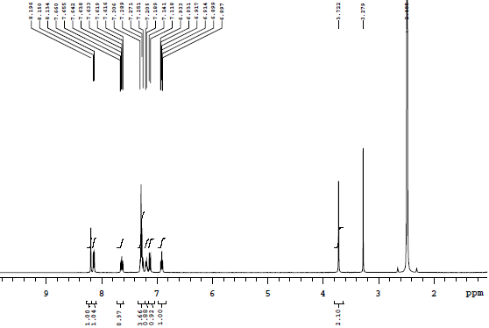



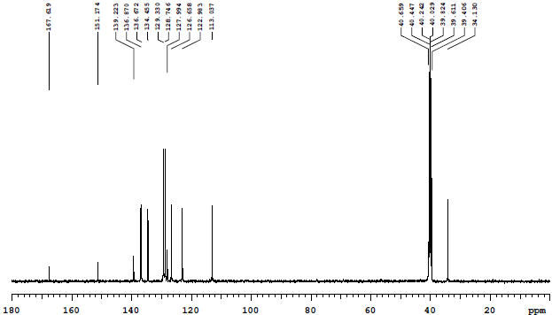



**Figure S1.** 1H NMR and 13C NMR Spectra for compound **3a** in DMSO-*d*6

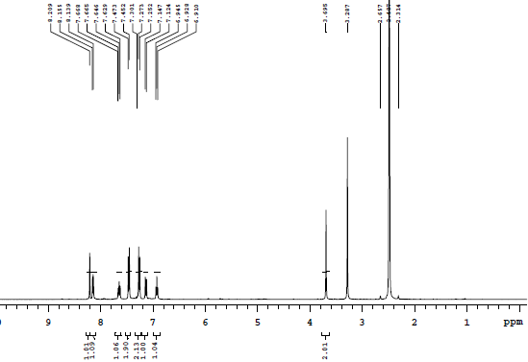



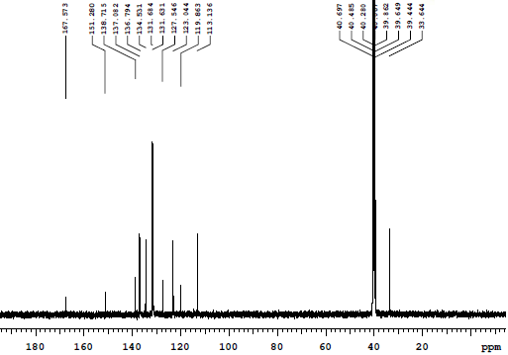



**Figure S2.** 1H NMR and 13C NMR Spectra for compound **3b** in DMSO-*d*6

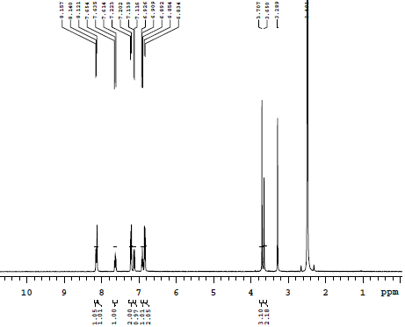



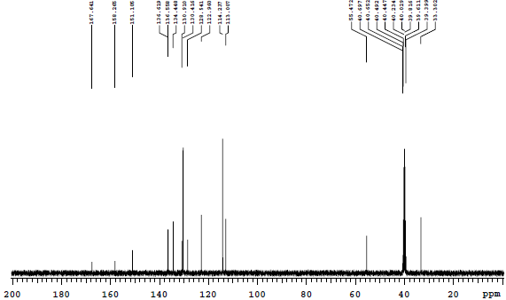



**Figure S3.** 1H NMR and 13C NMR Spectra for compound **3c** in DMSO-*d*6

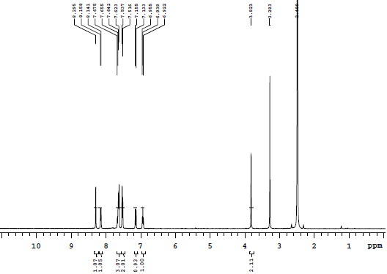



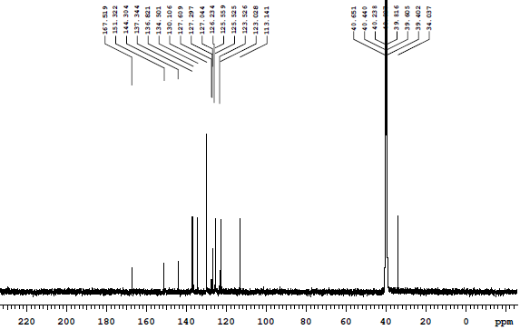



**Figure S4.** 1H NMR and 13C NMR Spectra for compound **3d** in DMSO-*d*6

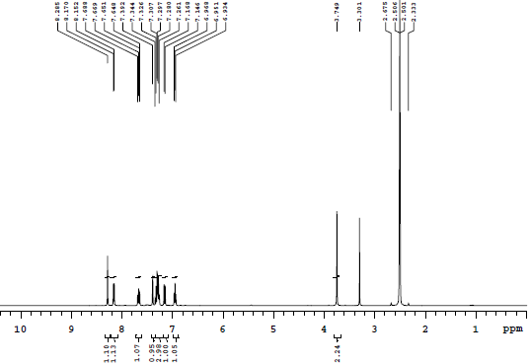



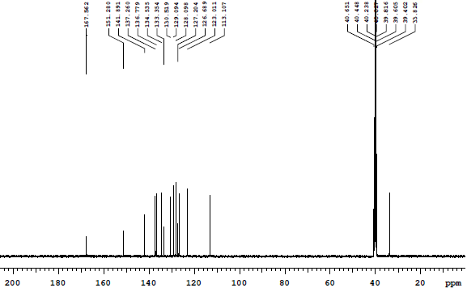



**Figure S5.** 1H NMR and 13C NMR Spectra for compound **3e** in DMSO-*d*6

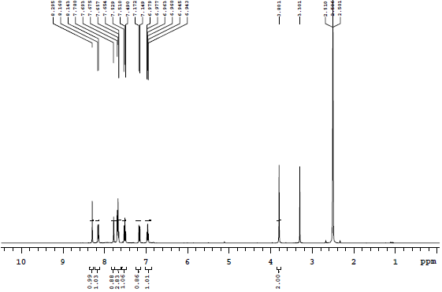



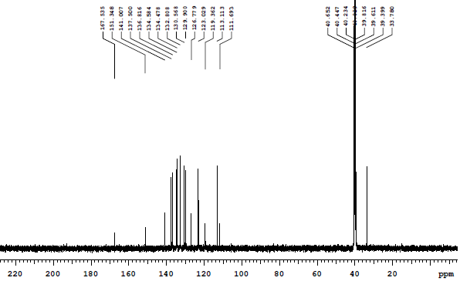



**Figure S6.** 1H NMR and 13C NMR Spectra for compound **3f** in DMSO-*d*6

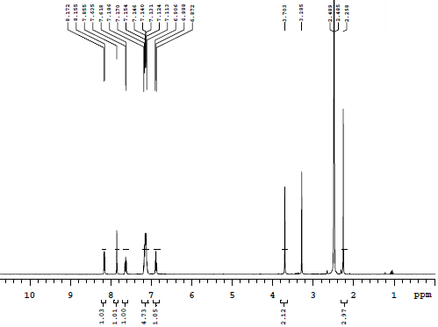



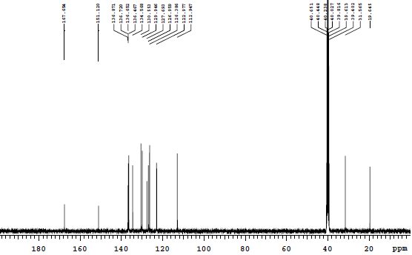



**Figure S7.** 1H NMR and 13C NMR Spectra for compound **3g** in DMSO-*d*6

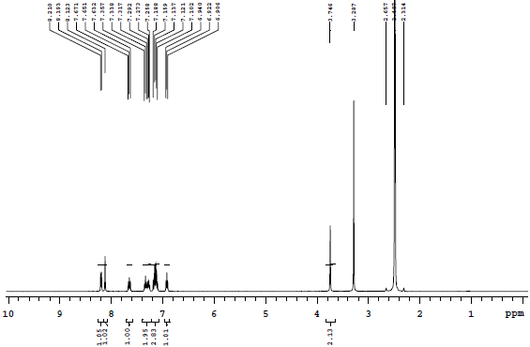



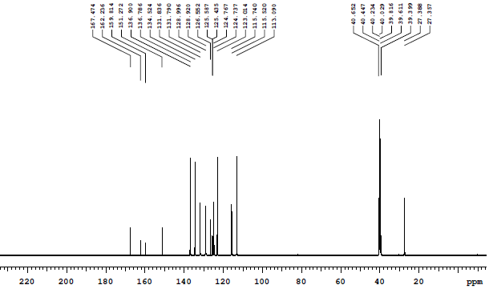



**Figure S8.** 1H NMR and 13C NMR Spectra for compound **3h** in DMSO-*d*6

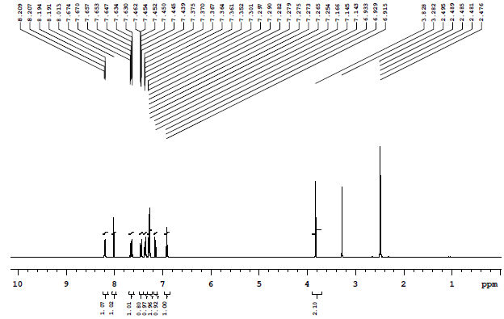



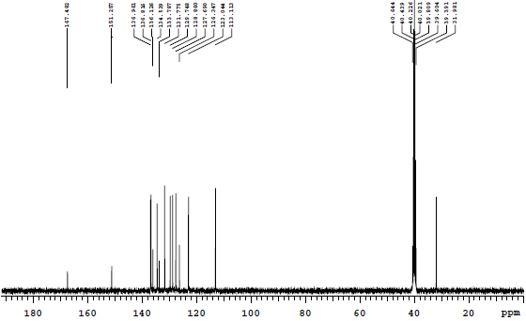



**Figure S9.** 1H NMR and 13C NMR Spectra for compound **3i** in DMSO-*d*6

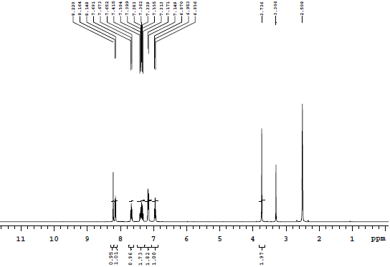



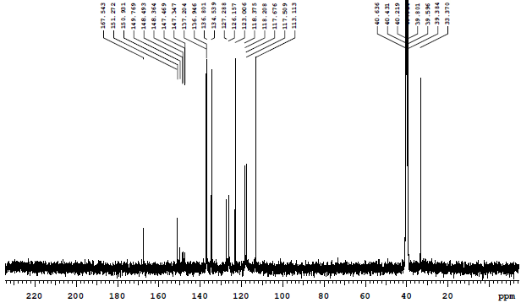



**Figure S10.** 1H NMR and 13C NMR Spectra for compound **3j** in DMSO-*d*6

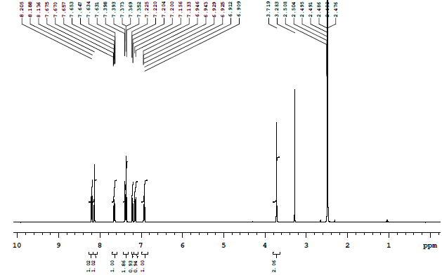



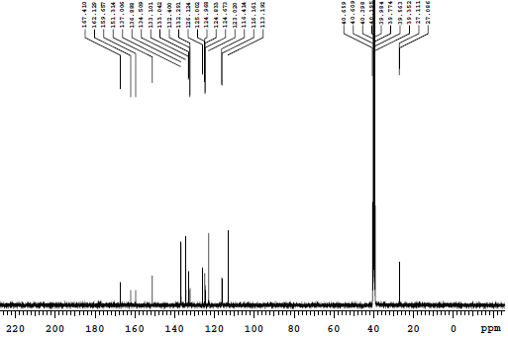



**Figure S11.** 1H NMR and 13C NMR Spectra for compound **3k** in DMSO-*d*6

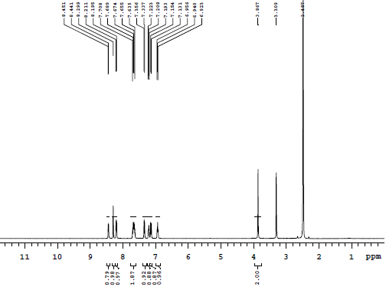



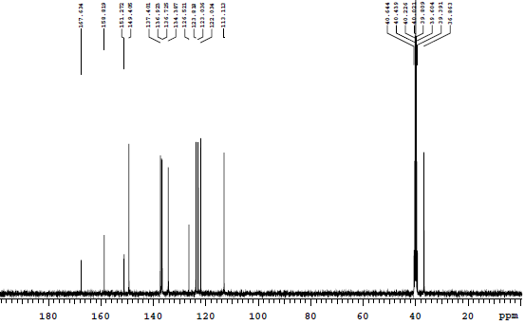



**Figure S12.** 1H NMR and 13C NMR Spectra for compound **3l** in DMSO-*d*6

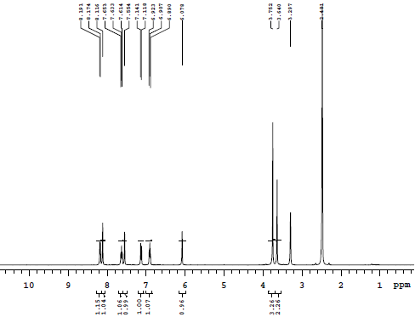



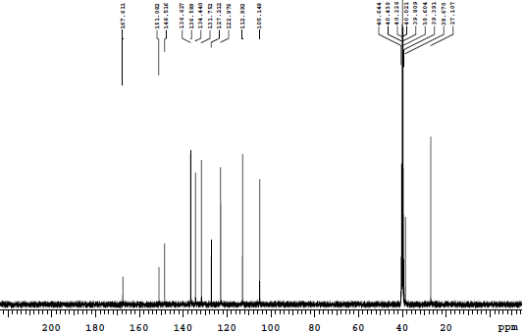



**Figure S13.** 1H NMR and 13C NMR Spectra for compound **3m** in DMSO-*d*6

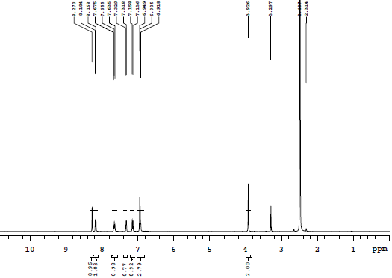



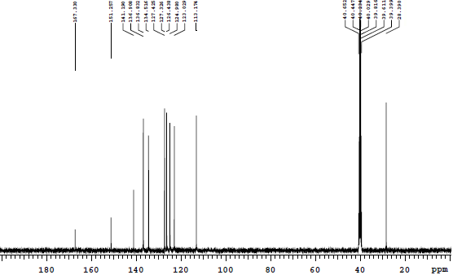



**Figure S14.** 1H NMR and 13C NMR Spectra for compound **3n** in DMSO-*d*6

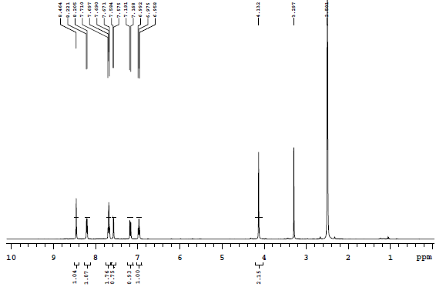



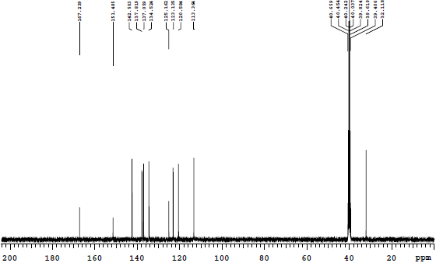



**Figure S15.** 1H NMR and 13C NMR Spectra for compound **3o** in DMSO-*d*6

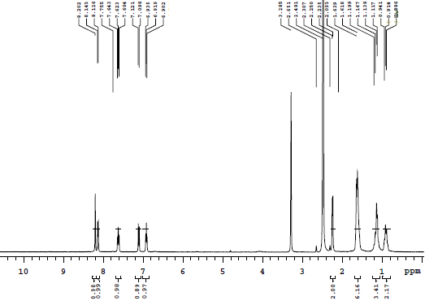



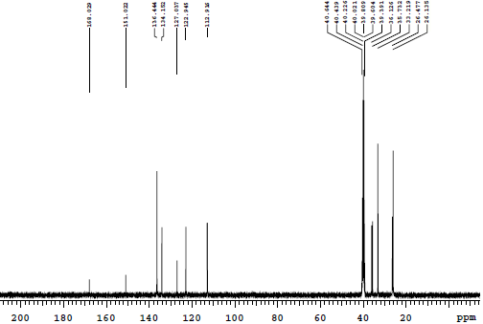



**Figure S16.** 1H NMR and 13C NMR Spectra for compound **3p** in DMSO-*d*6

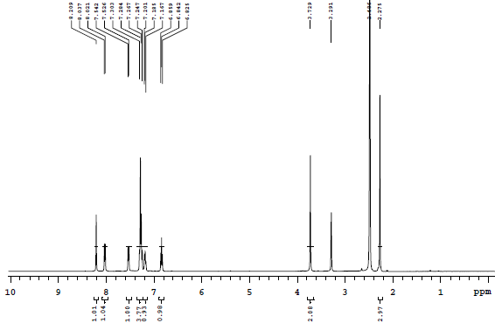



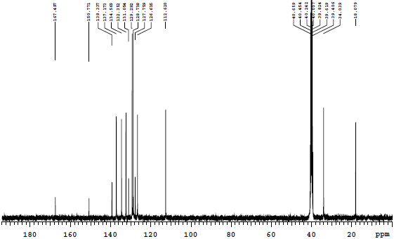



**Figure S17.** 1H NMR and 13C NMR Spectra for compound **5a** in DMSO-*d*6

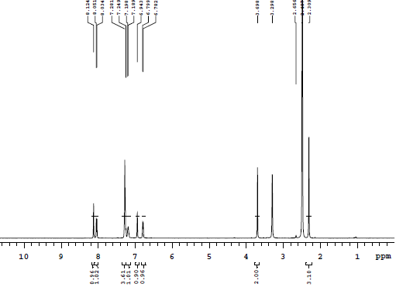



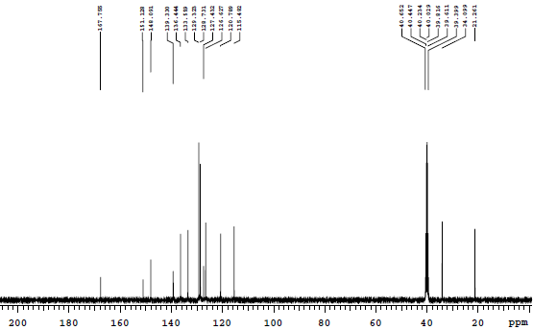



**Figure S18.** 1H NMR and 13C NMR Spectra for compound **5b** in DMSO-*d*6

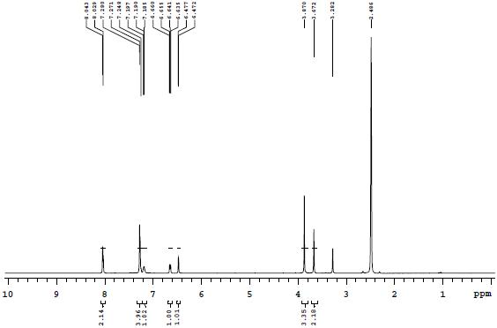



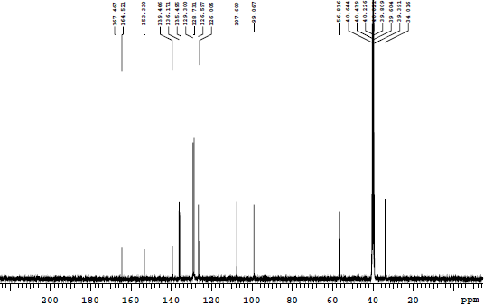



**Figure S19.** 1H NMR and 13C NMR Spectra for compound **5c** in DMSO-*d*6

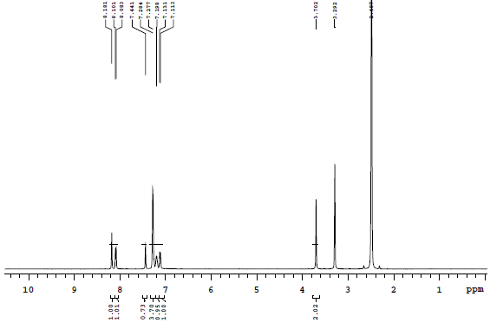



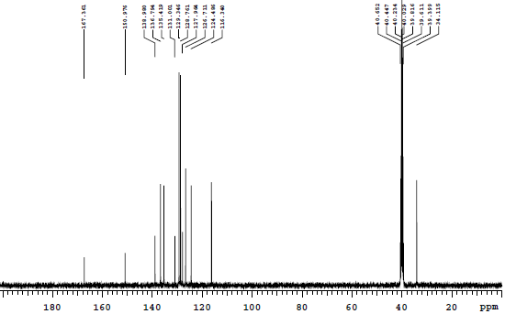



**Figure S20.** 1H NMR and 13C NMR Spectra for compound **5d** in DMSO-*d*6

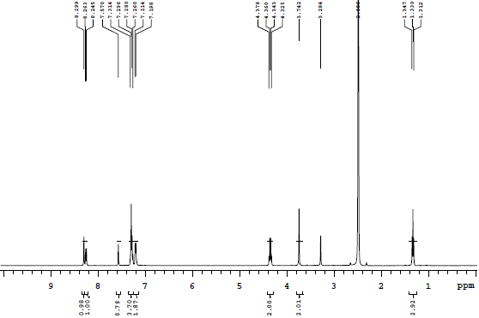



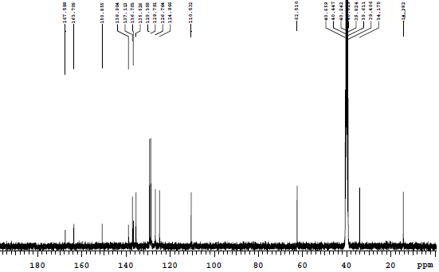



**Figure S21.** 1H NMR and 13C NMR Spectra for compound **5e** in DMSO-*d*6

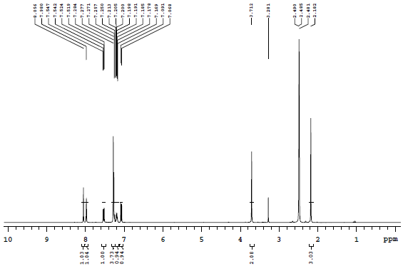



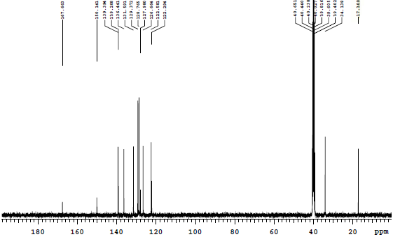



**Figure S22.** 1H NMR and 13C NMR Spectra for compound **5f** in DMSO-*d*6

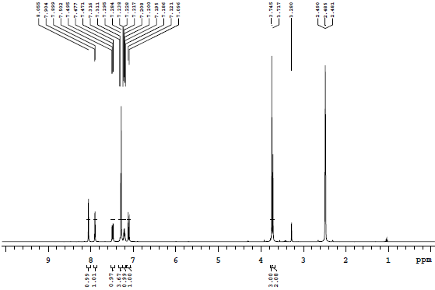



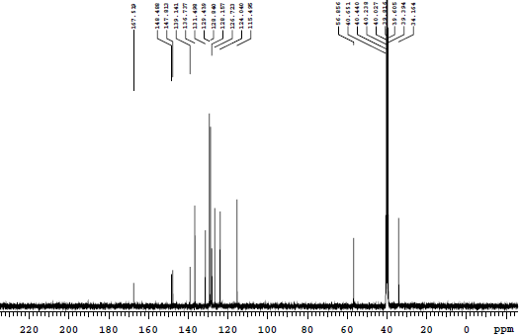



**Figure S23.** 1H NMR and 13C NMR Spectra for compound **5g** in DMSO-*d*6

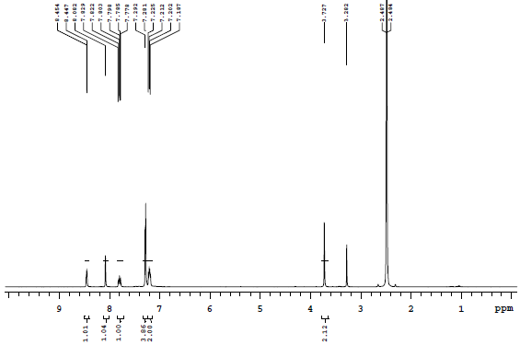



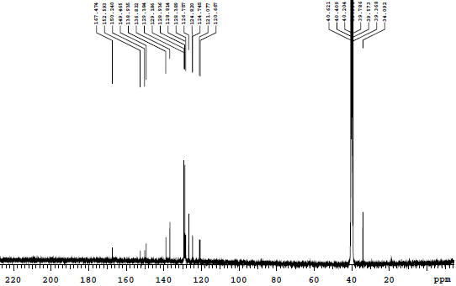



**Figure S24.** 1H NMR and 13C NMR Spectra for compound **5h** in DMSO-*d*6

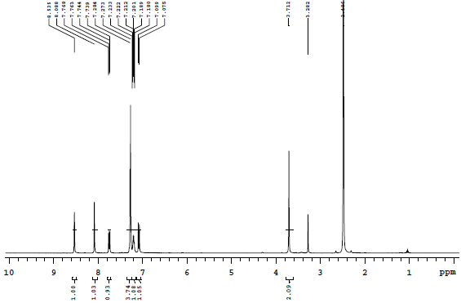



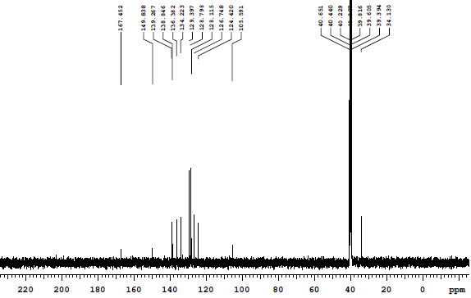



**Figure S25.** 1H NMR and 13C NMR Spectra for compound **5i** in DMSO-*d*6

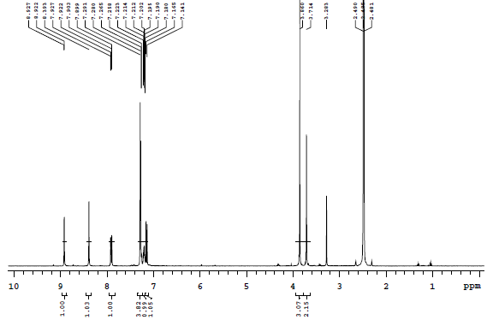



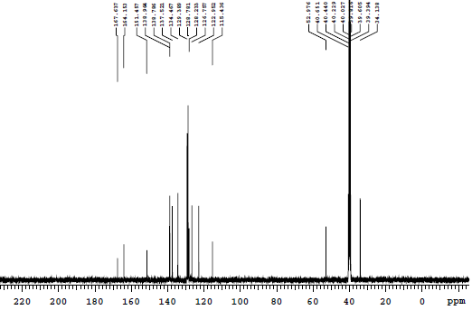



**Figure S26.** 1H NMR and 13C NMR Spectra for compound **5j** in DMSO-*d*6

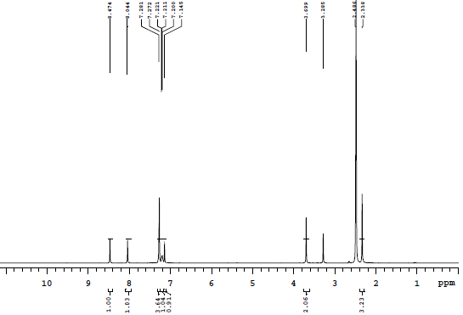



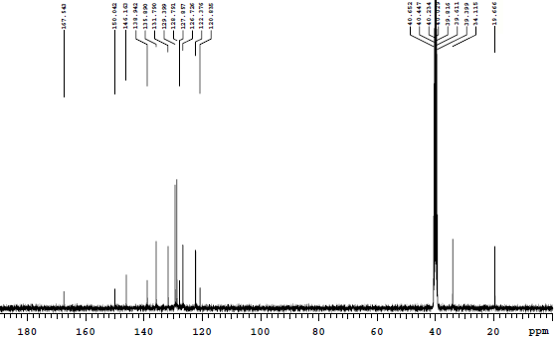



**Figure S27.** 1H NMR and 13C NMR Spectra for compound **5k** in DMSO-*d*6

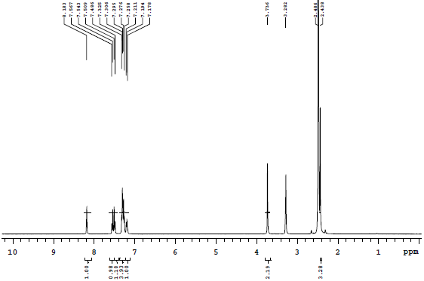



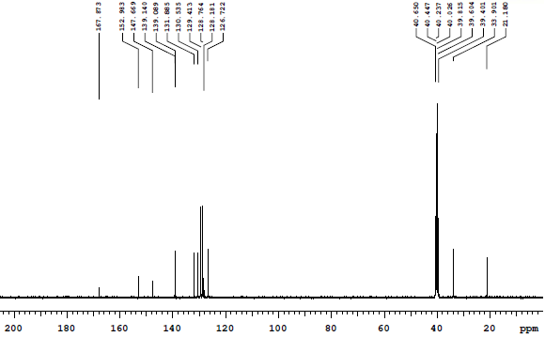



**Figure S28.** 1H NMR and 13C NMR Spectra for compound **5l** in DMSO-*d*6

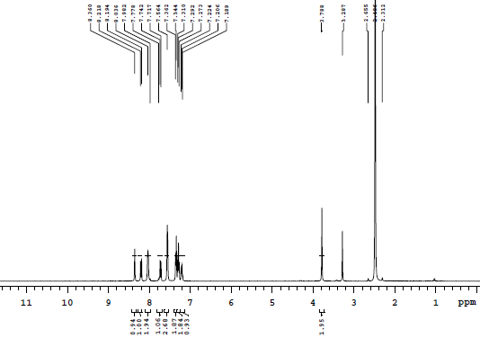



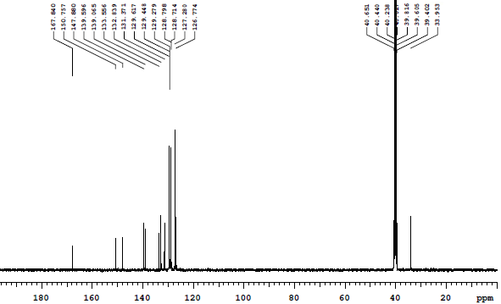



**Figure S29.** 1H NMR and 13C NMR Spectra for compound **5m** in DMSO-*d*6

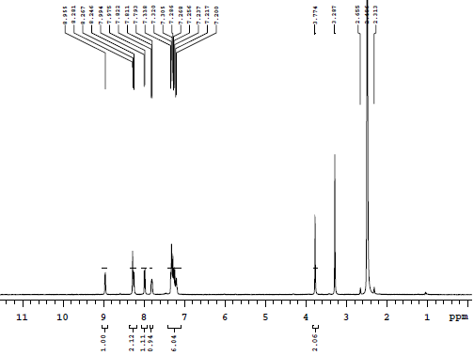



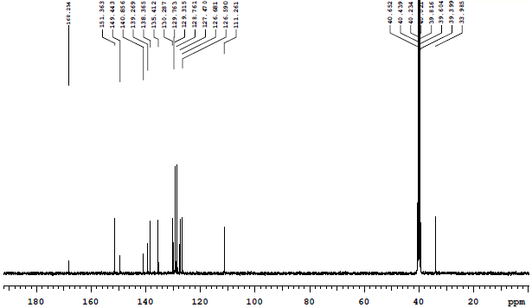



**Figure S30.** 1H NMR and 13C NMR Spectra for compound **5n** in DMSO-*d*6

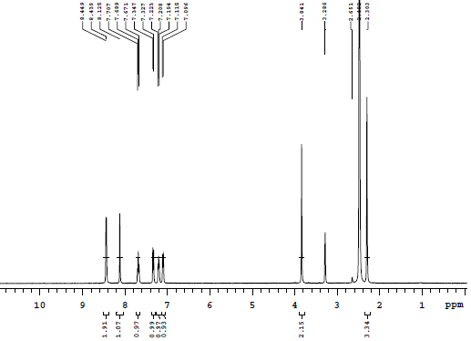



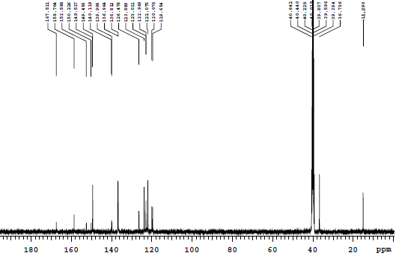



**Figure S31.** 1H NMR and 13C NMR Spectra for compound **6a** in DMSO-*d*6

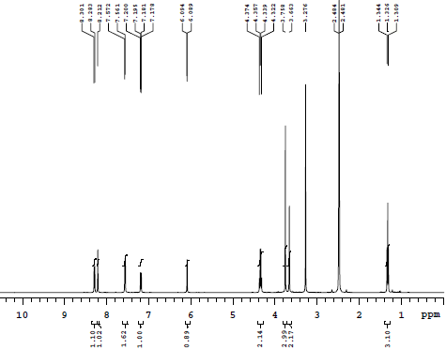



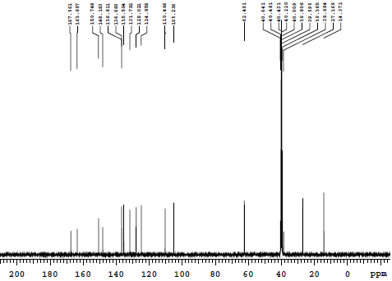



**Figure S32.** 1H NMR and 13C NMR Spectra for compound **6b** in DMSO-*d*6

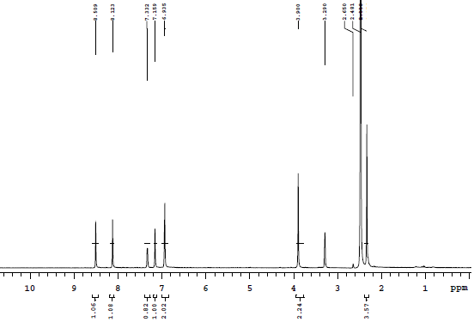



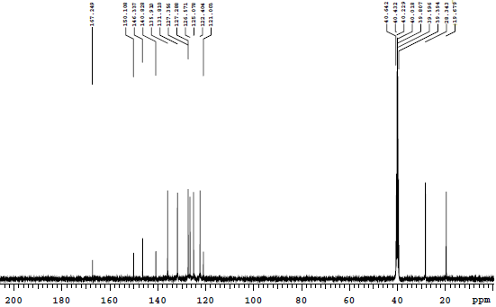



**Figure S33.** 1H NMR and 13C NMR Spectra for compound **6c** in DMSO-*d*6

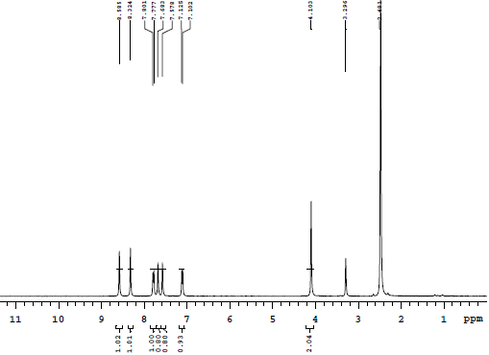



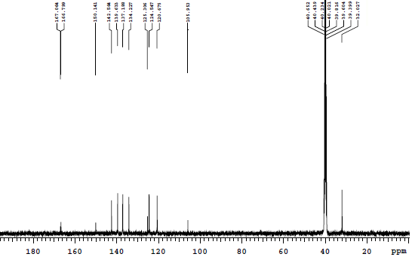



**Figure S34.** 1H NMR and 13C NMR Spectra for compound **6d** in DMSO-*d*6

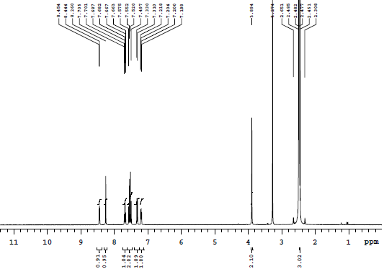



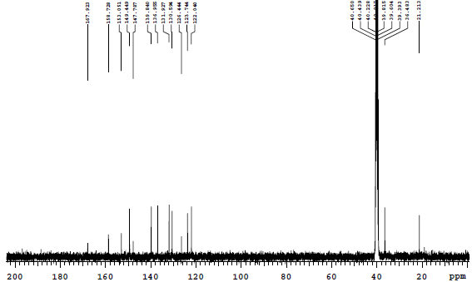



**Figure S35.** 1H NMR and 13C NMR Spectra for compound **6e** in DMSO-*d*6

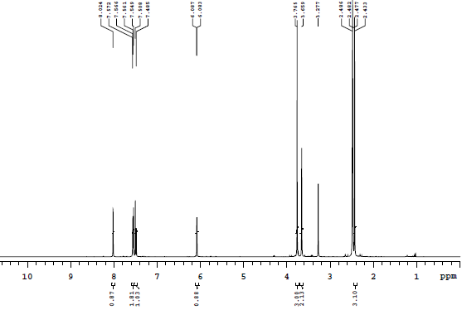



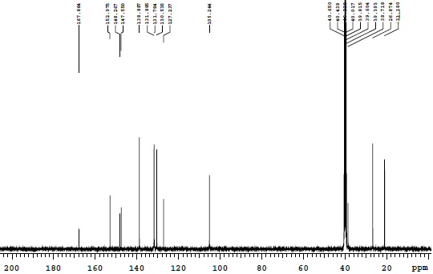



**Figure S36.** 1H NMR and 13C NMR Spectra for compound **6f** in DMSO-*d*6

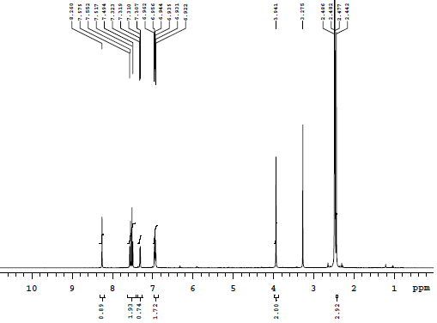



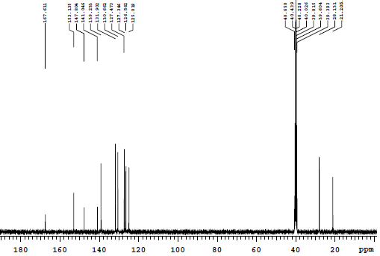



**Figure S37.** 1H NMR and 13C NMR Spectra for compound **6g** in DMSO-*d*6

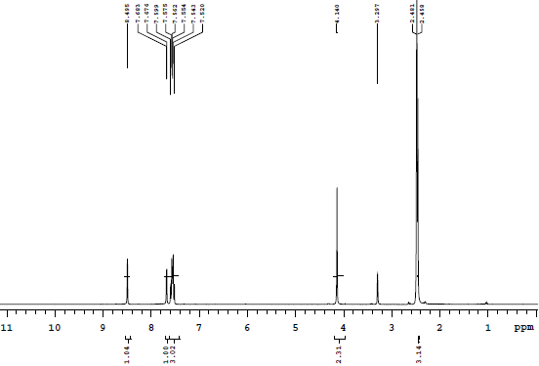



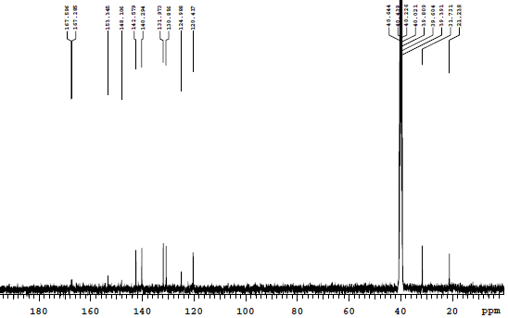



**Figure S38.** 1H NMR and 13C NMR Spectra for compound **6h** in DMSO-*d*6

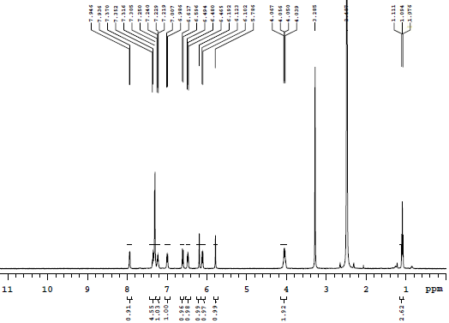



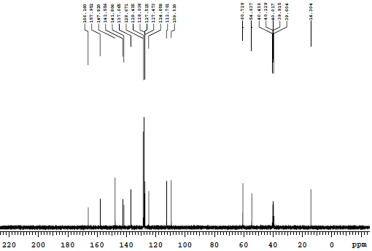



**Figure S39.** 1H NMR and 13C NMR Spectra for compound **4** in DMSO-*d*6

**Reference**

(1) Roy, S. J. S.; Mukherjee, S. *Chem. Commun.* **2014**, *50*, 121–123.

(2) Basavaiah, D.; Satyanarayana, T. *Tetrahedron Lett.* **2002**, *43*, 4301–4303.

(3) Sreevani, R.; Manjula, A.; Rao, B. V. *J. Heterocycl. Chem*. **2011**, *48*, 586–591.

(4) Satyanarayana, S.; Praveen Kumar, K.; Lakshmi Reddy, P.; Narender, R.; Narasimhulu, G.; Subba Reddy, B. V. *Tetrahedron Lett.* **2013**, *54*, 4892–4895.

(5) Alsharif, Z.; Ali, M. A.; Alkhattabi, H.; Jones, D.; Delancey, E.; Ravikumar, P. C.; Alam,M. A. *New J. Chem.* **2017**, *41*, 14862–14870.