Supplemental Material For:

The ribonuclease activity of Csm6 of the Type III-A CRISPR-Cas System is needed for CRISPR-Cas immunity

Kawanda Foster¹, Joshua Kalter², Walter Woodside¹, Rebecca M. Terns³ and Michael P. Terns^{1,2,4*}

¹Department of Microbiology,
²Department of Biochemistry and Molecular Biology,
³Office for Proposal Enhancement,
⁴Department of Genetics, University of Georgia, Athens, GA 30602, USA;

*Corresponding author: Michael P. Terns, mterns@uga.edu

Table S1: RNA and DNA substrates used in this study
Name | Associated Figure(s) | Sequence (5’-3’)
RNA1 | 1,3,4 | CCCCCCCCCCAUGAUGAUG
RNA2 | 1 | UUGUAGUAUGCGGUCCUUGCGGCUGAGAGCACUUCAG
RNA3 | 1 | CUGAAGUGCUCUCAGCCGCAAGGACCGCAUACUACAA
DNA1 | 1 | CTGAAGTGCTCTCAGCCGCAAGGACCGCATACTACAA
DNA2 | 1 | TTGTAGTATGCGGTCCTTGCGGCTGAGAGCACTTCAG
RNA4 | 2 | AUUGAAAGUUGUAGUAUGCGGUCCUUGCGGCUGAGAGCACUUCAGUCGUUAUCUCUUACGAAGUCUU
RNA5 | 2-4 | GUUACAAUAAGACCAAAAUAGAAUUGAAAG
RNA6 | 3 | AUGAGUAUUCAACAUUUCCGUGUCGCCCUUAUUCCCU
RNA7 | 3 & 4 | AUUGAAAGUUGUAGUAUGCGGUCCUUGCGGCUGAGAGCA

Table S2: Oligonucleotides used for mutagenesis

Oligo | Alteration | Sequence (5’-3’)
LLACsm6H360A-FP (2771) | Csm6 H360A | AGGACCGCAATAAAGTTGCAGCAAGTCTGCAGGCATTTGAC
LLACsm6H360A-RP (2772) | Csm6 H360A | GTCAAATGCCTGCAGACTTGCTGCAACTTTATTGCGGTCCT
SEPCsm6H369A-FP (2767) | Csm6 H369A | CCTGCGTAATAGCATTGCCGCAAACCTGGATACCCTGAAC
SEPCsm6H369A-RP (2768) | Csm6 H369A | GTTCAGGGTATCCAGGTTTGCGGCAATGCTATTACGCAGG
AIOCsm6_Tag/Mut#1 (3672) | LLA H360A &/or tag | ACTGGAAGAACTGAAATAACCTAGGCGCTTCAACGGAACG
AIOCsm6_Tag/Mut#2 (3673) | LLA H360A &/or tag | AACTGCGCTAATCAGGATTTTCATACCGCTGCTTCCATGGTGGTGATGATGATGCATTATTTACCTCCTTTATCCATG
AIOCsm6_Tag/Mut#3 (3674) | LLA H360A &/or tag | ATGAAAATCCTGATTAGCGCAGTT
AIOCsm6_Tag/Mut#4 (3675) | LLA H360A &/or tag | TGCAACTTTATTGCGGTCCT
AIOCsm6_Tag/Mut#5 (3676) | LLA H360A &/or tag | ACCGCAATAAAGTTGCAGCAAGTCTGCAGGCATTTGAC
AIOCsm6_Tag/Mut#6 (3677) | LLA H360A &/or tag | GTTTTCCATGAGCAAACTGAAACGTTTTCATCGCTCTGGAGTGA
Csm6_Del_InvPCR#1 (4419) | SEP & STH Csm6 del | TGCCCTACTTGGTCTCCGAGAC
Csm6_Del_InvPCR#2 (4420) | SEP & STH Csm6 del | CTCGAGAGGTTACAGCCTGCATAATG
STHCsm6H347A-FP (2769) | Csm6 H347A | CAGCCGTAATAAAGTTGCCGCAAGCCTGAGTCCGCTG
STHCsm6H347A-RP (2770) | Csm6 H347A | CAGCGGACTCAGGCTTGCGGCAACTTTATTACGGCTG
WW_LLAAIO_mut2R (3186) | LLA H13A/D14A | GTGCCACGATAGATAATTTTGCCAATAGCAGCCAGCAGGCTACCACAAACC
WW_LLAAIO_mut3F (3187) | LLA H13A/D14A | ATTGGCAAAATTATCTATCGTGGCAC
WW_LLAAIO_mut4R (3188) | LLA & D576A/D577A | CGCCACCGGCATAAATAAC
WW_LLAAIO_mut5F (3189) | LLA D576A/D577A | GTTATTTATGCCGGTGGCGCCGCCCTGTTTATGATTGGTGCATGGC
P1_revision (3197) | LLA H13A/D14A & D576A/D577A | AAGCAACCTCGAGGCTGTGGTCTA
P6_revision (3198) | LLA H13A/D14A | AAAAGCCATATGTTAGCGTTCACG
SthSOE_P1 for (3892) | STH H15A/D16A & D575A/D576A | GGGAGAGGATCCATAAAGGAGG
SthSOE_P2 rev (3893) | STH H15A/D16A | TGCACGCTGAATAACTTTACCAATGGCTGCCAGCAGTGCACCATAGAACAG
SthSOE_P3 for (3894) | STH H15A/D16A | ATTGGTAAAGTTATTCAGCGTGCA
SthSOE_P4 rev (3895) | STH D575A/D576A | ACCACCGGCATAGATAATGGA
SthSOE_P5 for (3896) | STH D575A/D576A | TCCATTATCTATGCCGGTGGTGCAGCAGTTTTTGCAATTGGTAGCTGGC
SthSOE_P6 rev (3897) | STH H15A/D16A & D575A/D576A | CGCAGCCATATGTTAATCTTTACG
Sep csm1F (5043) | SEP H14A/D15A & D586A/D587A | CCTCTAGTGGCTGGCTAAG
Sep csm1R (5044) | SEP H14A/D15A & D586A/D587A | CGCAGCCATATGTTAGTCG
Sep ggdd F (5045) | SEP D586A/D587A | GCAGCACTGTTTCTGATTGGTGCATGG
Sep ggdd R (5046) | SEP D586A/D587A | TCCGCCACTATAAATTGCGGTAA
Sep hd F (5047) | SEP H14A/D15A | GCAGCAATTGGCAAAATTATCTATCGTAGCG
Sep hd R (5048) | SEP H14A/D15A | CAGCAGGCTGCCATACAT

Figure S1: Purification of tagged Csm proteins

3
2
1
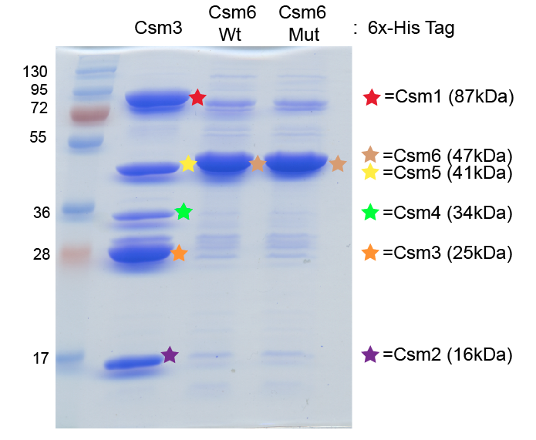

Purification of Csm proteins using co-expression plasmids than result in expression of a 6x-Histidine tag on either Csm3 (lane 1) or Csm6 (lanes 2 and 3) following separation by SDS-PAGE and Coomassie blue staining. In all sampes Csm1-6 proteins are co-expressed. The first lane shows that Csm1-5 proteins co-purify when His-tagged Csm3 is affinity purified. Lanes 2 and 3 show that no additional Csm proteins co-purify with His-tagged Csm6. The identities of the proteins in each major band were determined by mass spectrometry.

