Supporting information
Phosphonate Coating of SiO₂ Nanoparticles Abrogates Inflammatory Effects and Local Changes of the Lipid Composition in the Rat Lung: A Complementary Bioimaging Study

Mandy Großgarten,^{1*} Matthias Holzlechner,^{2*} Antje Vennemann,³ Anna Balbekova,² Karin Wieland,² Michael Sperling,¹ Bernhard Lendl,² Martina Marchetti-Deschmann,²
Uwe Karst,¹ and Martin Wiemann³

¹ University of Münster, Institute of Inorganic and Analytical Chemistry, Corrensstraße 28/30, 48149 Münster, Germany
² TU Wien, Institute of Chemical Technologies and Analytics, Getreidemarkt 9, 1060 Vienna, Austria
³ IBE R&D Institute for Lung Health gGmbH, Mendelstraße 11, 48149 Münster, Germany
* These authors contributed equally
Corresponding Author: martin.wiemann@ibe-ms.de
Phone: ++49 251 9802340
Fax: ++49 251 9802349

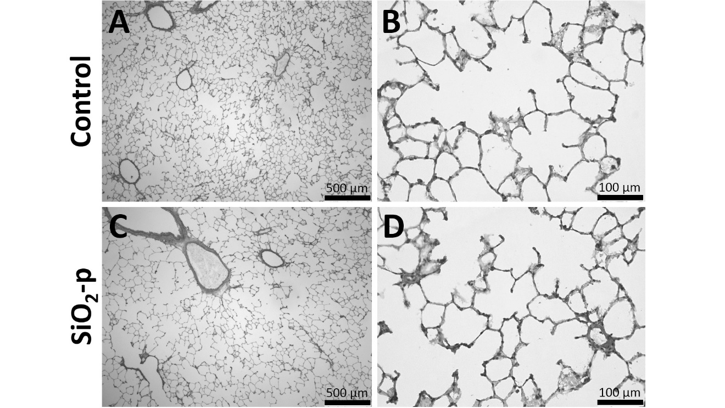
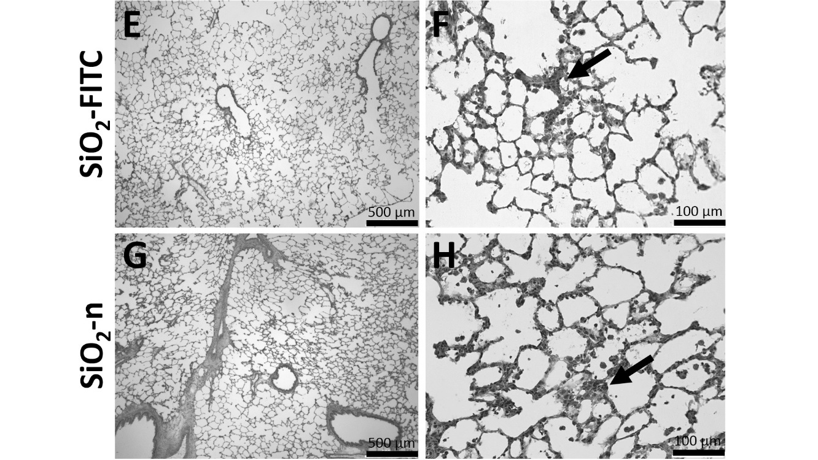
Figure S1. Effect of different SiO₂ NP on lung histology. Typical aspects from lung parenchyma 3 days after intratracheal instillation of 0.5 mL vehicle control fluid (A, B), 0.36 mg SiO₂-p (C, D), 0.36 mg SiO₂-FITC (E, F), or 0.36 mg SiO₂-n (G, H). Hematoxylin-eosin stained cryo-sections. Note that SiO₂-FITC (F) and SiO₂ (H) leads to confined regions with increase macrophage numbers, slightly deteriorated septal structures and focal hypercellularity (arrows in F and H). These changes were largely absent in lungs treated with vehicle control (B) or SiO₂-p (D).

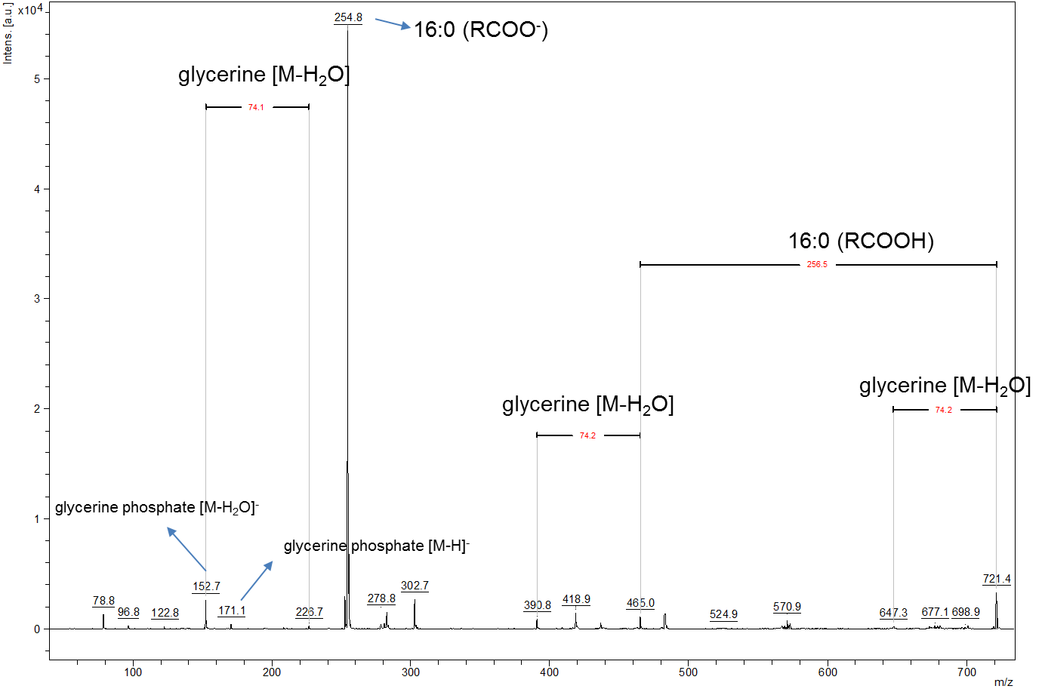
Figure S2. MALDI-MS/MS spectrum resulting from the fragmentation of precursor m/z 721.4. Fragment ions confirm the assignment of the respective MS ion image to PG (32:0) and indicate a fatty acyl composition of two (16:0) chains.
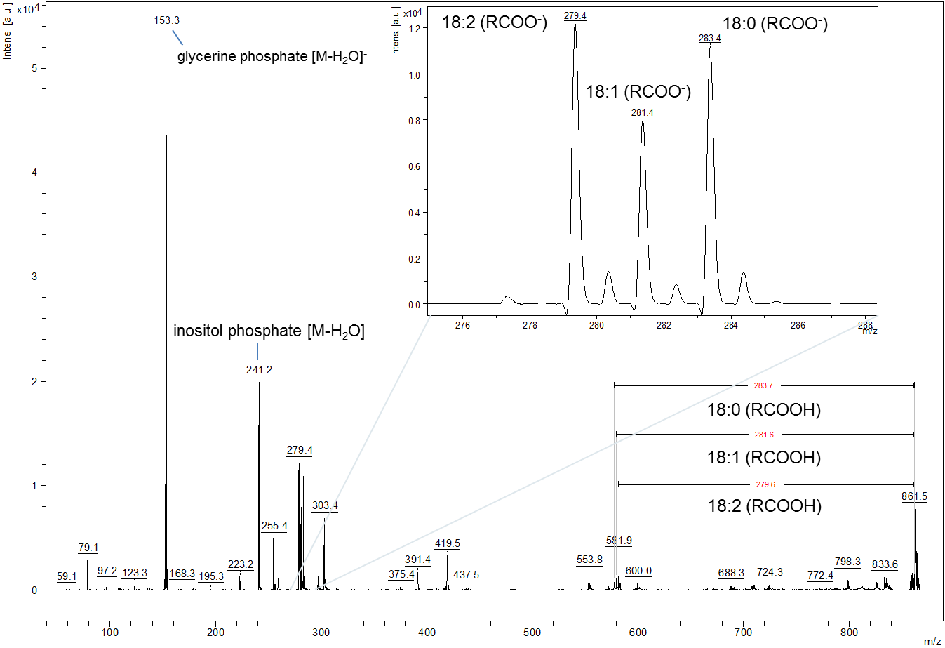
Figure S3. MALDI-MS/MS spectrum resulting from the fragmentation of precursor m/z 861.5. Fragment ions confirm the assignment of the respective MS ion image to PI (36:2), whereby both fatty acyl compositions, PI (18:1|18:1) and PI (18:0|18:2) are deduced.

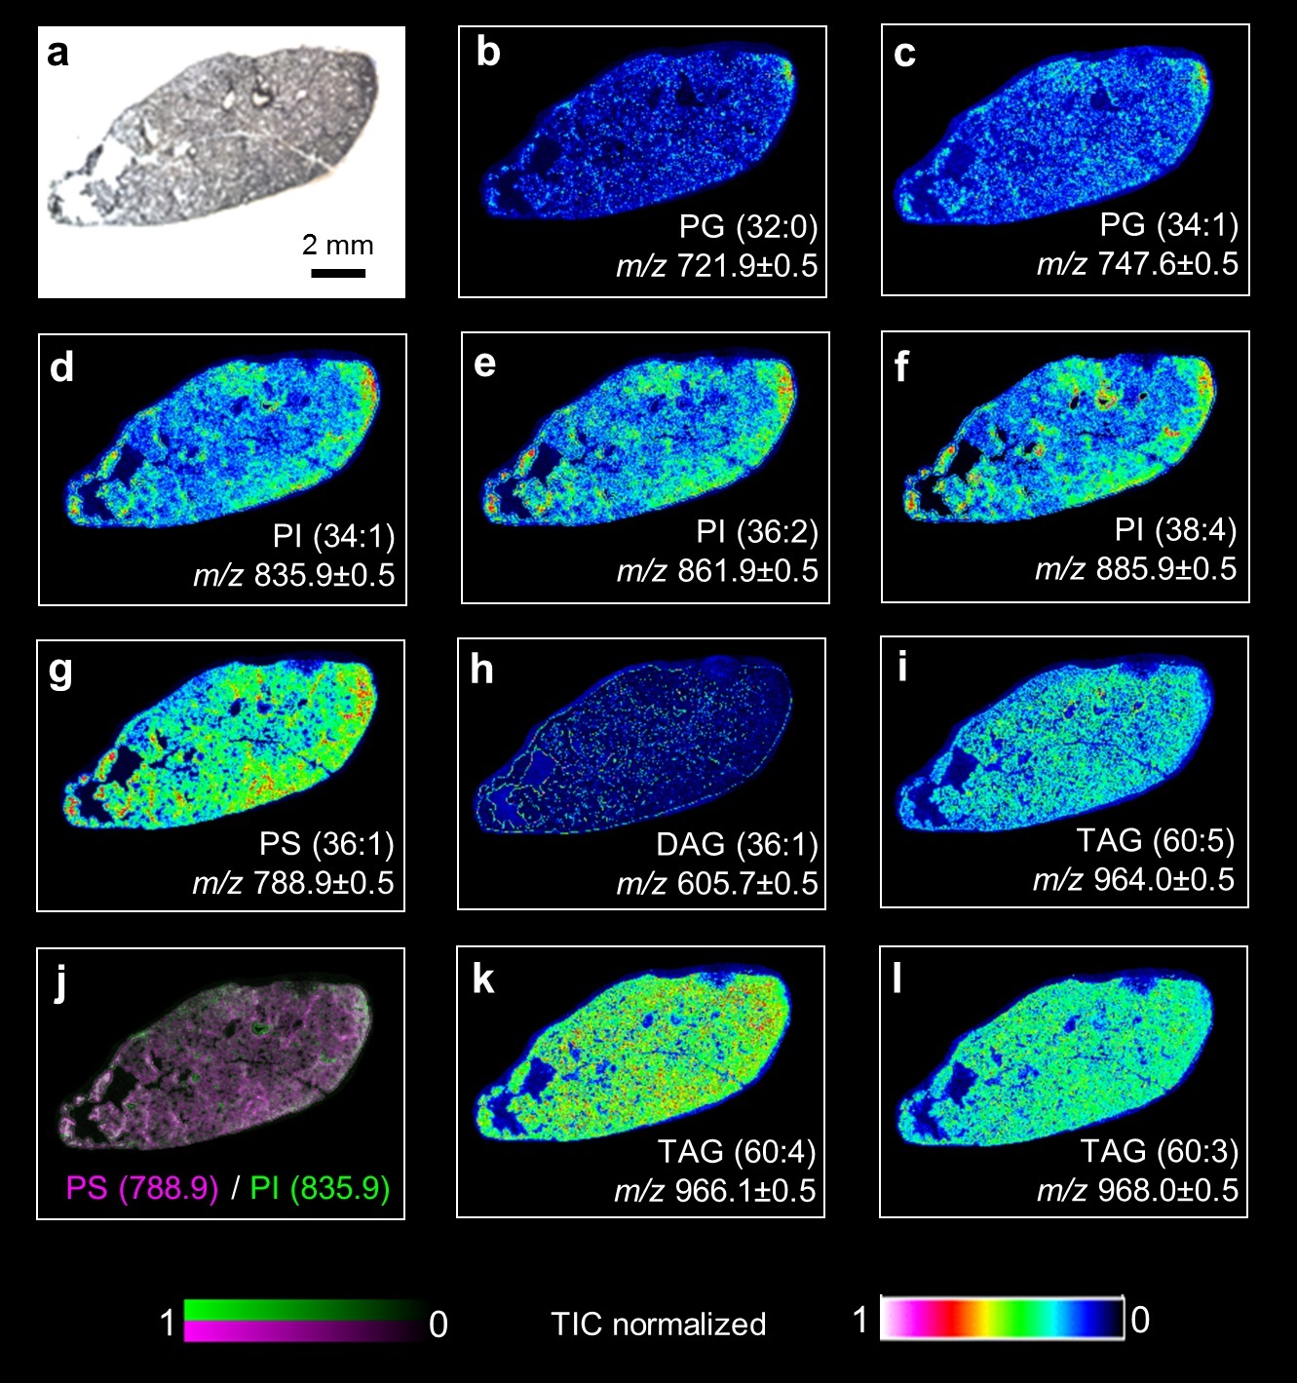
Figure S4. Ion images from a vehicle-treated control lung. m/z values are shown underneath each panel and were measured in the negative ion mode, except m/z 605.7 which was measured in the positive ion mode. Data were normalized by division through the total ion current (TIC). (a) microscopic image, (b, c) phosphatidylglycerol (PG), (d-f) phosphatidylinositol (PI), (g) phosphatidylserine (PS), (h) diacylglycerol (DAG)-like fragment, (j) overlay from (d) and (g), (i, k ,l) triacylglycerol (TAG)-like fragments. Note that all analytes are evenly distributed unless compression or damage of the tissue slice, as obvious from (a), has led to an irregular color coding.
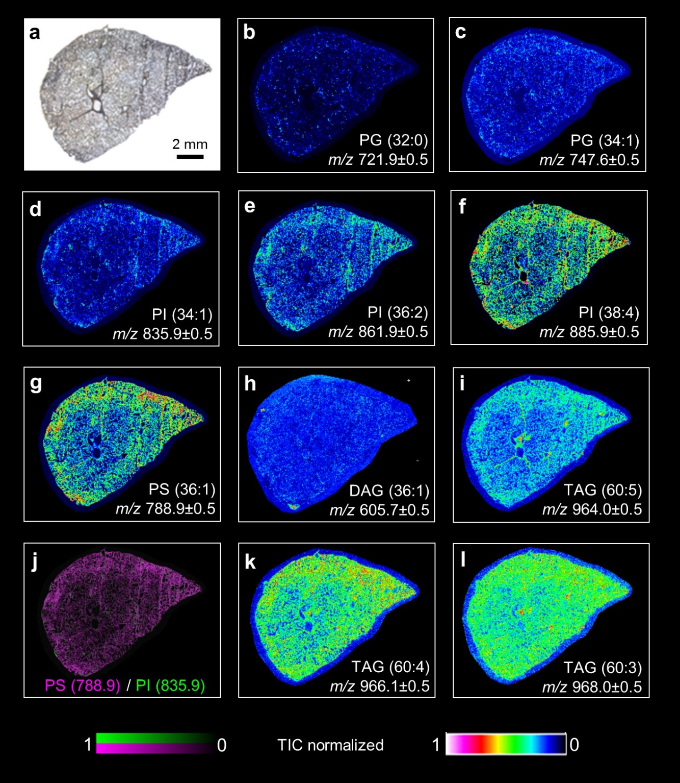
Figure S5. Ion images from a SiO₂-p-treated control lung. m/z values are shown underneath each panel and were measured in the negative ion mode, except m/z 605.7 which was measured in the positive ion mode. Data were normalized by division through the total ion current (TIC). (a) microscopic image, (b, c) phosphatidylglycerol (PG), (d-f) phosphatidylinositol (PI), (g) phosphatidylserine (PS), (h) diacylglycerol (DAG)-like fragment, (j) overlay from (d) and (g), (i, k ,l) triacylglycerol (TAG)-like fragments. Note that all analytes are evenly distributed unless compression or damage of the tissue slice, as obvious from (a), has led to an irregular color coding.

