Table S20 Sensitivity analysis by excluding studies with high risk of bias
 | OR | (95%CI) | I² (%) | Test subgroups differences  (p-value)
All-cause discontinuation | 0.97 | (0.82, 1.14) | 14.9 | 0.358
Discontinuation due to AE | 1.18 | (0.89, 1.56) | 34.4 | 0.623
Discontinuation due to LoE | 0.40 | (0.18, 0.87) | 0 | 0.997
 | SMD | (95%CI) | I² (%) | Test subgroups differences  (p-value)
Cognitive function | 0.12 | (0.05, 0.20) | 11.8 | 0.272
Global change | 0.15 | (0.06, 0.25) | 34.1 | 0.755
Neuropsychiatric symptoms | 0.14 | (0.02, 0.26) | 30.0 | 0.119
Functional capacity | 0.05 | (-0.04, 0.14) | 32.8 | 0.375
 | OR | (95%CI) | I² (%) | Test subgroups differences  (p-value)
Proportion patients AE | 1.05 | (0.88, 1.25) | 0 | 0.978
Proportion patients SAE | 0.89 | (0.69, 1.15) | 18.3 | 0.534
Mortality | 1.03 | (0.74, 1.44) | 0 | 0.911

AE, adverse events; LoE, Lack of efficacy; CI, confidence interval; I² , heterogeneity; OR, Odds ratio; SAE, severe adverse events; SMD, standardized mean difference.

Table S21 Sensitivity analysis by including Nakamura et al. 2014 pooled analysis
 | OR | (95%CI) | I² (%) | Test subgroups differences  (p-value)
All-cause discontinuation | 0.94 | (0.81, 1.10) | 10.7 | 0.614
Discontinuation due to AE | 1.17 | (0.91, 1.51) | 29.7 | 0.702
Discontinuation due to LoE | 0.40 | (0.18, 0.87) | 0 | 0.997
 | SMD | (95%CI) | I² (%) | Test subgroups differences  (p-value)
Cognitive function | 0.15 | (0.08, 0.22) | 24.3 | 0.491
Global change | 0.16 | (0.09, 0.22) | 11.6 | 0.907
Neuropsychiatric symptoms | 0.16 | (0.09, 0.23) | 19.8 | 0.254
Functional capacity | 0.06 | (-0.02, 0.14) | 22.4 | 0.758
 | OR | (95%CI) | I² (%) | Test subgroups differences  (p-value)
Proportion patients AE | 1.05 | (0.88, 1.25) | 0 | 0.978
Proportion patients SAE | 0.89 | (0.69, 1.15) | 18.3 | 0.534
Mortality | 1.03 | (0.74, 1.44) | 0 | 0.911

AE, adverse events; LoE, Lack of efficacy; CI, confidence interval; I² , heterogeneity; OR, Odds ratio; SAE, severe adverse events; SMD, standardized mean difference.

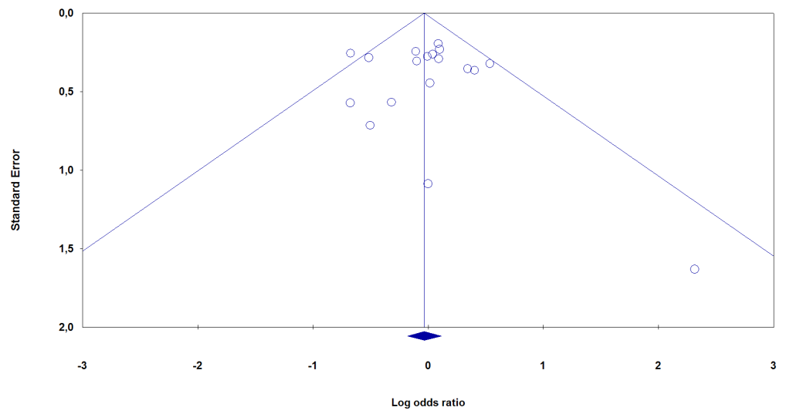  A | 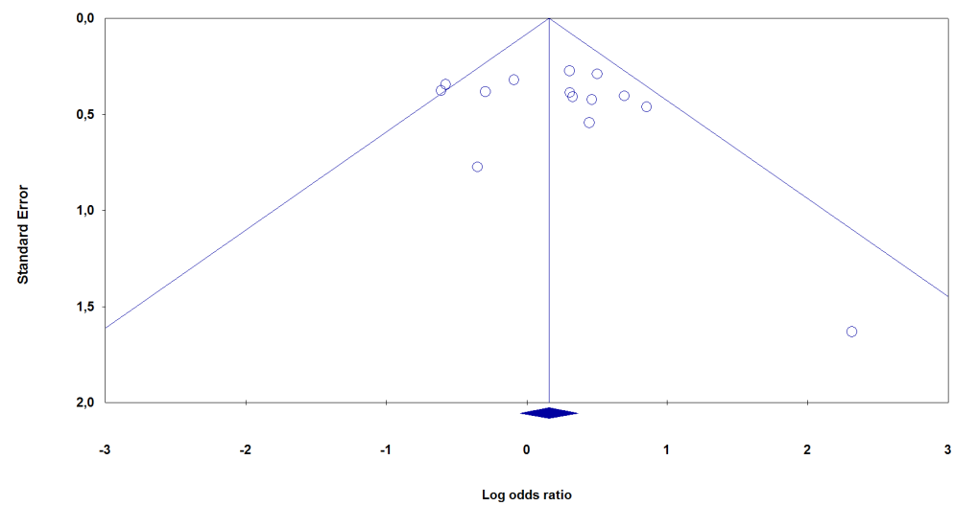  B
Begg’s test (p-value)= 0.485  Egger’s test (p-value)= 0.372 | Begg’s test (p-value)= 0.856  Egger’s test (p-value)= 0.226
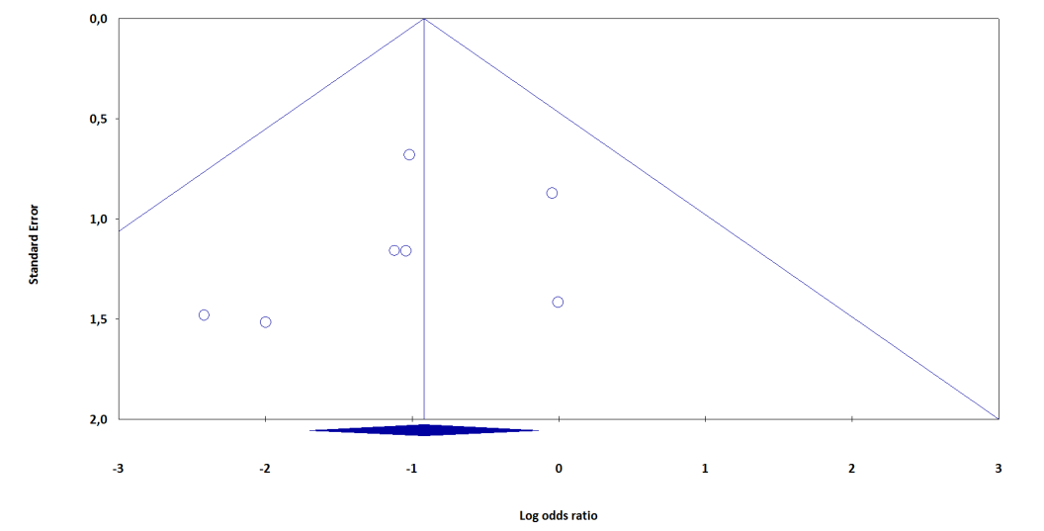  C | 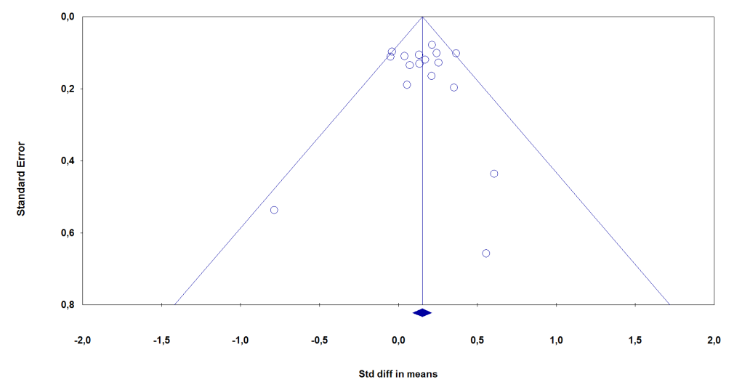  D
Begg’s test (p-value)= 0.147  Egger’s test (p-value)= 0.203 | Begg’s test (p-value)= 0.371  Egger’s test (p-value)= 0.491
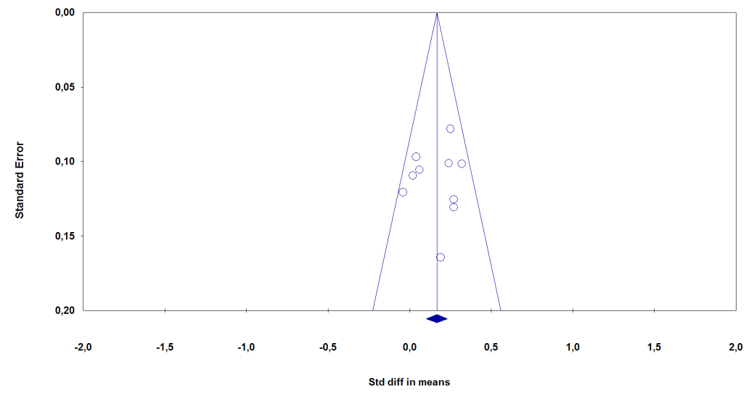  E | 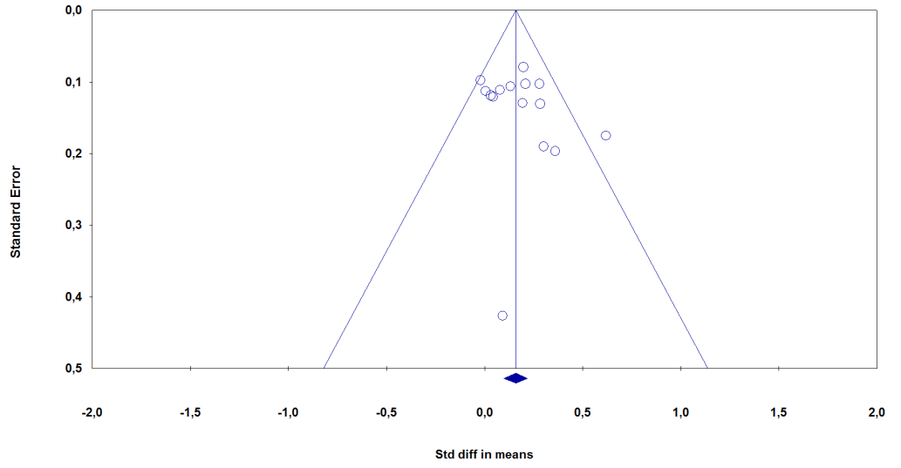  F
Begg’s test (p-value)= 0.266  Egger’s test (p-value)= 0.357 | Begg’s test (p-value)= 0.128  Egger’s test (p-value)= 0.127
G | H
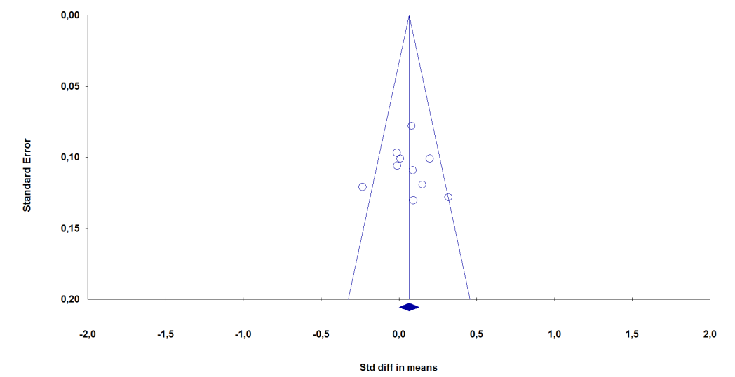Begg’s test (p-value)= 0.429  Egger’s test (p-value)= 0.424 | 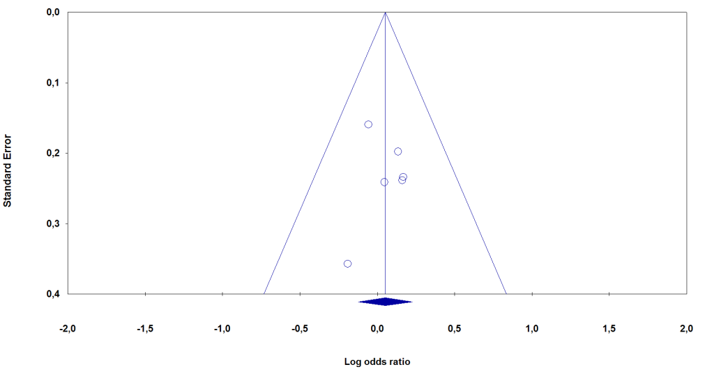  Begg’s test (p-value)= 0.425  Egger’s test (p-value)= 0.485
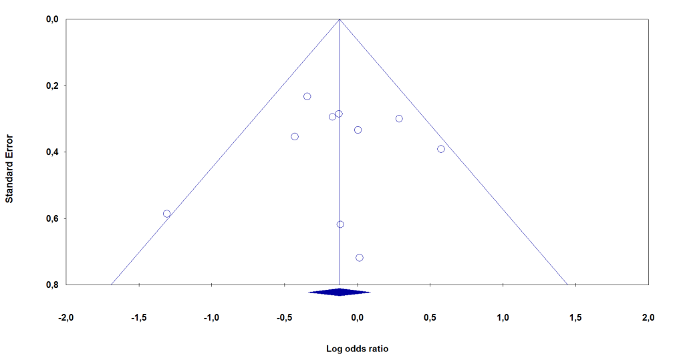  I | 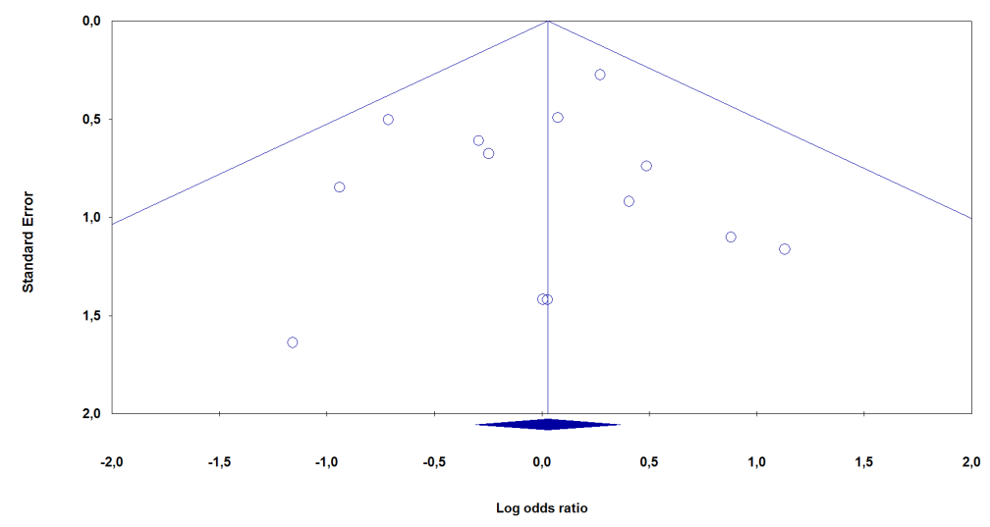  J
Begg’s test (p-value)= 0.266  Egger’s test (p-value)= 0.410 | Begg’s test (p-value)= 0.500  Egger’s test (p-value)= 0.348
Figure S10 Funnel plots, Egger’s test and Begg and of study outcomes A. All-cause discontinuation outcome; B. Discontinuation due to adverse events; C. Discontinuation due to lack of efficacy; D. Efficacy on cognitive function; E. Efficacy on global change; F. Efficacy on neuropsychiatric symptoms; G. Efficacy on functional ability; H. Proportion patients with any adverse event; I. Proportion patients with severe adverse events; J. Mortality.

