Supplementary Material

Ecology and Breeding Biology of a tropical bird, the Lovely Fairy-wren Malurus amabilis

Ana V. Leitão ^{a *}, Michelle L. Hall ª, Brian Venables ^{b}, Raoul A. Mulder ª

ª School of BioSciences, University of Melbourne, Melbourne, VIC 3010, Australia
^{b} Edge Hill, Cairns, QLD 4870, Australia
* Corresponding author: anamvleitao@gmail.com

Methods

Molecular sexing
Nestlings, fledglings, and adults that could not be sexed based on plumage characteristics or behavioural observations were sexed using PCR-methods (n = 29) described in detail in Griffiths et al. (1998). DNA was extracted from blood samples using the standard salt extraction method (Bruford et al. 1992). We used known sexed individuals as controls.

Nesting behaviour
Observations at different stages during the nesting cycle were used to estimate key nesting parameters (first egg date, hatch date, etc.). Estimates were based on subsets of nests checked every day to three days, to accurately calculate the following periods: duration of construction (from early frame until lining was complete and female was not seen building), laying period (between the first egg and the last egg laid), incubation (between the last egg being laid and the female seen sitting until eggs hatched), nestling period (between hatching and fledgling). Once the timing of nesting stages was known, nest checks occurred during period-changing events (e.g. laying, hatching, fledging). When the attempt was found at later stages, we estimated the date the first egg was laid by calculating back from the hatch date; if found with nestlings, we estimated their age by the length of primary wing feathers. We recorded the outcome for each nest found –abandoned or destroyed, parasitised, predated and at which stage, and fledgling survival.
Nestling development was followed by taking note of colour of the skin, emerging of feathers, and opening of eyes. Between day 7 and 9 after hatching, we took morphometric measurements, a small blood sample and colour-banded the nestlings. We estimated fledgling survival by checking the nest and then observed the group for presence of fledglings. Fledgling age was estimated by the tail length (juveniles one month after fledging or younger had shorter tails than adults), and/or behaviour (fledglings called constantly and displayed begging behaviour). We calculated productivity and reproductive success as the number of nests in which at least one nestling fledged and survived for more than a month, considering all the nests found across seasons (2015-2017).

Description of behaviours recorded during focal watches
Aggressive displays were performed by males, females and subordinates and consisted of individuals opening wings and erecting feathers, rapid flights. singing, production of loud calls bill snapping, and chasing intruders.
Courtship displays were very brief and given usually by males in the presence of their females, and consisted of males erecting their blue back feathers, the red shoulders, and the blue of the ears, combining with very rapid flights and the male chasing the female.
Petal displays were performed by males only (Figure S6) and consisted of displaying their in bills petals of different sizes and colours (red and yellow) combined it with flights and sometimes chasing and aggressive behaviour, depending on the context.
Male courtship feeding was mainly observed towards their partner and sometimes in response to female wing-fluttering display. On two occasions, a dominant male was seen feeding a subordinate male (in full adult plumage), but never the other way-around.
Copulation was seen on three occasions always in the morning: at 11.05am on the 27/08/2015, just after the female was seen building and a male did courtship display; at 07.28am on the 22/07/2016, after the dominant male was observed actively singing and the female performed a wing fluttering display (a week after a complete nest with no eggs was found); the third event occurred at 09.10 am on the 20/08/2017, after the female was seen actively building a nest.

References
Bruford, M. W., Hanotte, O., Brookfield, J. F. Y. and Burke, T. (1992). 'Single-locus and multilocus DNA fingerprinting.' (Oxford, IRL Press).
Griffiths, R., Double, M. C., Orr, K. and Dawson, R. J. (1998). A DNA test to sex most birds. Molecular ecology 7(8), 1071-1075.

Figures
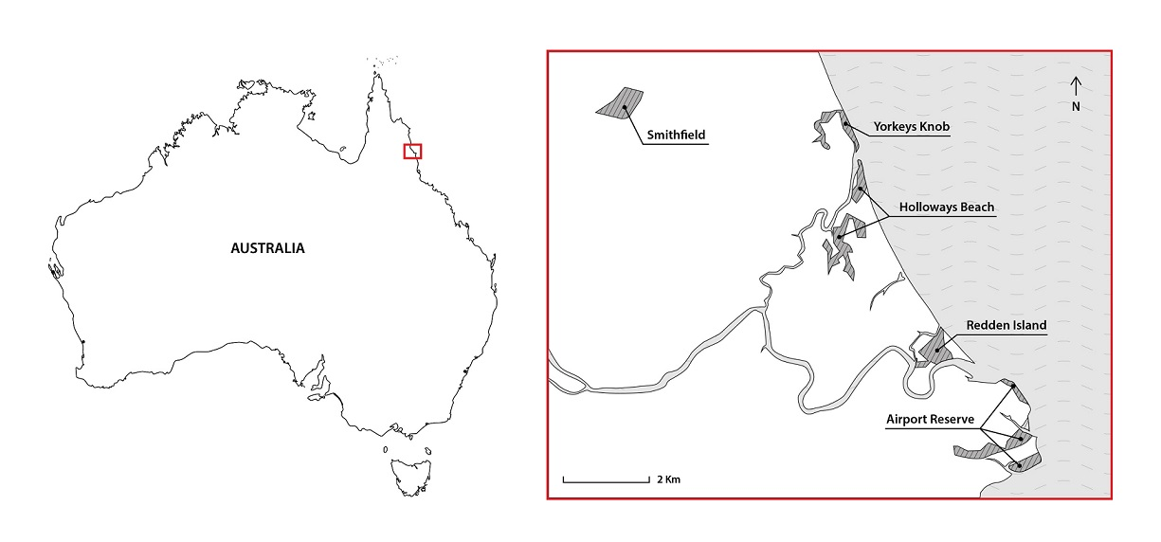

Figure S1. Study areas in north of Cairns, Queensland, Australia. Shaded lined areas show the location of all areas where territories were monitored.

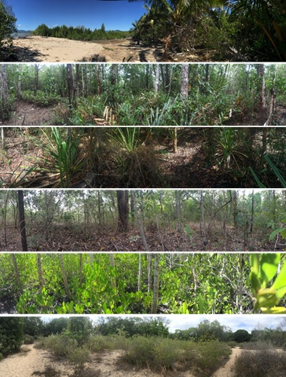

Figure S2. Habitat within a territory where Lovely fairy-wren Malurus amabilis nests where found. Photos taken in the Airport Reserve, Redden Island and Yorkeys Knob, Cairns, Australia.

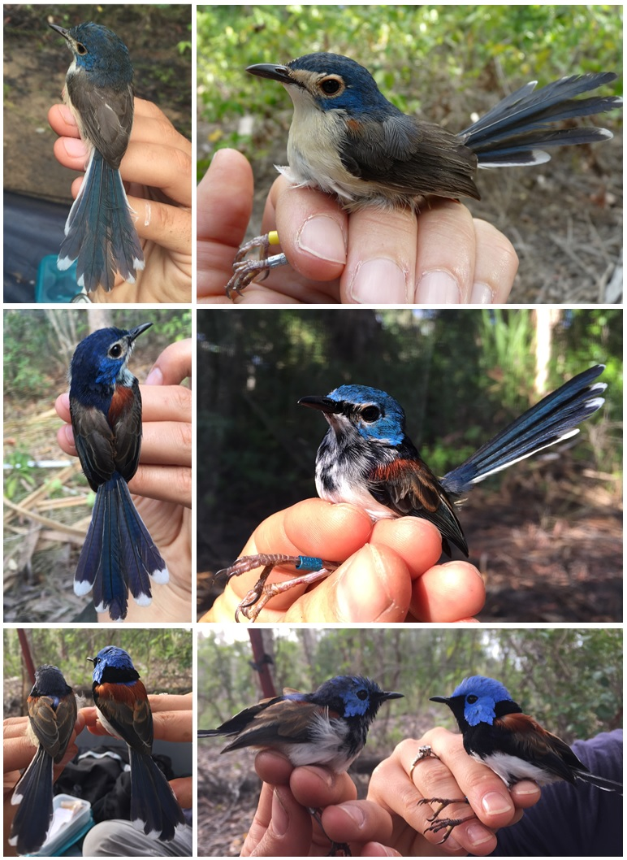

Figure S3. Patterns of male moult from juvenile to adult bright plumage. From top left to right: male with juvenile plumage; 5 % moult; 30 % moult; 60 % moult; the two photos in the bottom row show the same two males, in dorsal and side views, respectively in 70 % moult 100 % adult bright plumage.

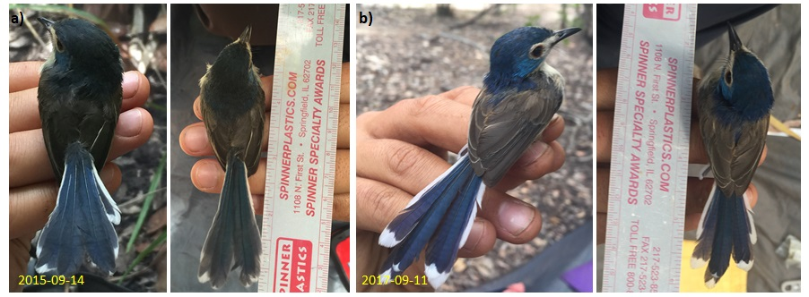

Figure S4. Female plumage of xM/xan. a) First captured as juvenile in the natal territory, with dull plumage, on 14 Sep 2015 b) Re-capture as adult in the breeder territory, with bright plumage, on 11 Sep 2017.

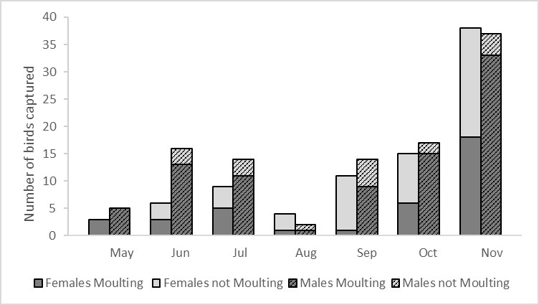

Figure S5. Seasonal variation in body moult of individuals captured between 2013 and 2017. Bars show, for each month, the number of different males (hatched) and females (clear) captured that were moulting (pin feathers present, dark grey) or had no sign of body moult (light grey).

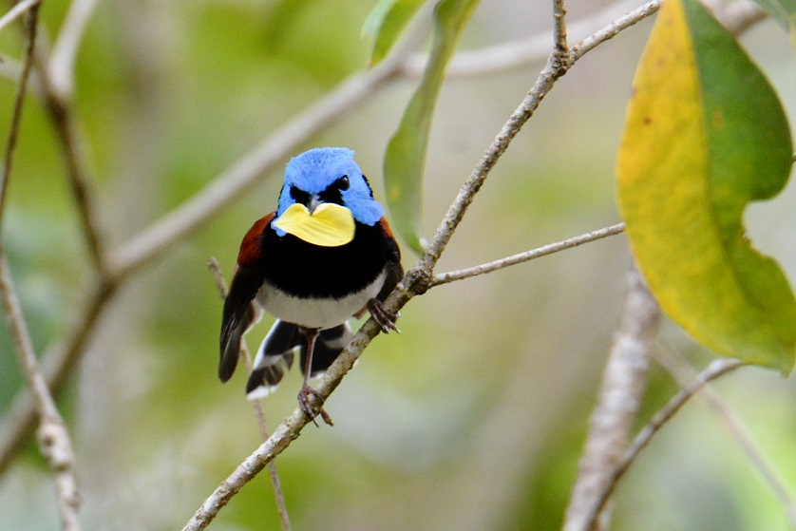

Figure S6. Male Lovely fairy-wren performing a petal display, credit: Patrick De Geest.

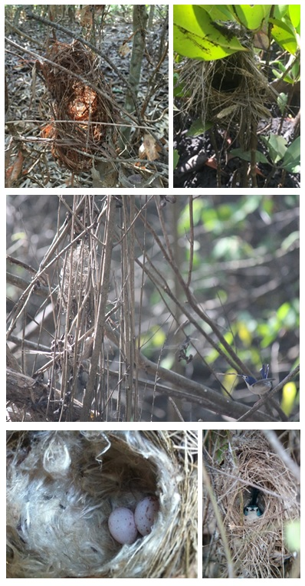

Figure S7. Breeding activity. From top left to right: Nests medium frame; complete nest; female building early frame nest, credit: Kristal Cain; complete nest with two eggs laid; female incubating, credit: Philip Chaon.

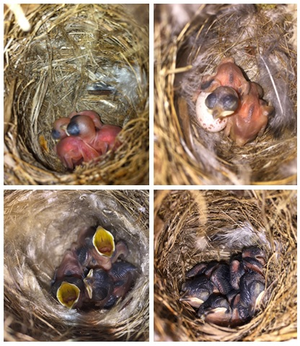

Figure S8. Lovely fairy-wren nestlings from different breeding attempts. From top left to right, nestlings Day 2, Day 3, Day 5, Day 7 (hatch day = Day 1).

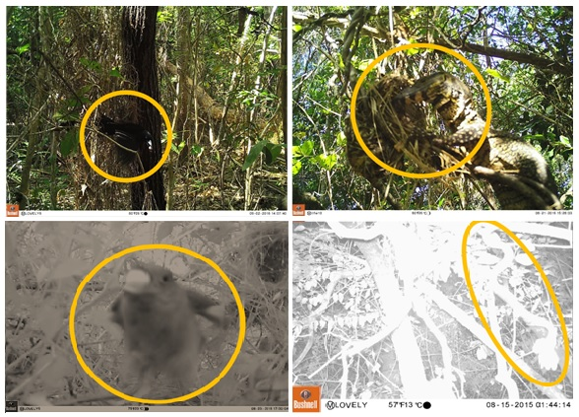

Figure S9. Nest predation events by Black Butcherbird Melloria quoyi, Lace Monitor Varanus varius, Brush Cuckoo Cacomantis variolosus, unidentified snake (photographs taken with Bushnell Trophy Cam HD Aggressor).

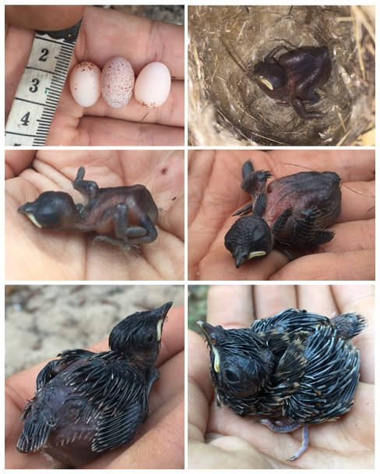

Figure S10. Brood parasitism by Brush cuckoo. From top left to right, 3 eggs (cuckoo egg in the middle), nestling Brush Cuckoo Cacomantis variolosus (species identity confirmed by L. Brooker pers. comm.) Day 2, Day 3, Day 6, Day 9 and possibly Day 11. The first 5 images are from the second attempt found with parasitism where we followed all stages, and the sixth photo is from the first attempt found with a nestling, so age is an estimate based on the growth of feathers.

Tables

Table S1. Ethogram of behaviours recorded
Behaviour | Description
Feed nestling or juvenile | Frequency that birds are seen carrying food to nest, or feeding juveniles that are begging
Lost focal individual | Focal individual is not seen but behavioural watch is still being conducted
Wing flutter | Number of times individual flaps the wings quickly and does a begging behaviour, usually females
Courtship feed | Focal individual feeds another individual
Courtship display | Focal individual (male) is seen chasing female and erecting cheek, crown, and shoulder feathers
Copulation | When mating is seen
Petal display | Frequency and duration a focal individual (male) is seen carrying a petal. Also recorded the colour of the petal and context in which it was observed – other males around, intrusion, towards females, alone.
Carrying nesting material | Number of times female is seen carrying nesting material.
Building nest | Number of times female is seen building nest
Sitting on the nest | Occurrence: when the nest is being observed and female is sitting on it.
Aggression display | Frequency and duration of aggression display – loud calls, feathers erected, rapid movements and physical contact, chasing. Context of aggression is registered
Intrusion on territory | When focal individuals intrude a territory or focal individuals are intrude by other(s).

Table S2. Annual survival (%) of female and male adults (dominant/breeders), and sample size.
 | Females | Males | Total
2014 | 100% (7) | 100% (9) | 100% (16)
2015 | 100% (10) | 93.3% (14) | 96.6% (24)
2016 | 76.3% (29) | 85.3% (35) | 80.8% (64)
2017 | 61.5% (24) | 71.4% (30) | 66.4% (54)

Table S3. Morphological differences between the sexes (mean ± sd (sample size)). Sexual size dimorphism was calculated as 100 * ((Male - Female) / (Male + Female) / 2). P values represent significance Mann-Whitney tests of male and female parameters.
 | Female | Male | Average size dimorphism (%) | Sex difference
Body mass (g) | 8.52 ± 0.84 (75) | 8.76 ± 0.46 (84) | 2.8% | P < 0.001
Tarsus length (mm) | 20.82 ± 0.67 (76) | 21.34 ± 0.63 (83) | 2.5% | P < 0.001
Head–bill length (mm) | 28.98 ± 1.44 (76) | 29.83 ± 0.73 (83) | 2.8% | P < 0.001
Wing length (mm) | 49.26 ± 1.33 (75) | 50.86 ± 1.52 (83) | 3.2% | P < 0.001
Tail length (mm) | 56.99 ± 4.03 (68) | 57.97 ± 3.47 (78) | 1.7% | P = 0.054

Table S4. Breeding and related behaviours from dominant/breeder male (Dom Male), dominant/breeder female (Dom Fem.) and subordinate male (Sub Male), regarding context, location, and display receiver (Directed towards). Number of observed behaviours in parenthesis.
Behav. | Actor | Context* | Location |  |  | Directed towards
 |  |  | In territory | Outside | Border | Dom Fem | Male intruder | Female extra-pair | Alone | Play-back
Court. display | Dom  Male | U; BN; NB; L; N; NF | 83.3% (15) | 16.6% (3) | - | 83.3% (15) | - | 16.6%  (3) | - | -
Petal display |  | U; TD; NB | 69.7% (23) | 9.1% (3) | 21.2% (7) | 24.2% (8) | 30.3% (10) | ? | 3.0% (1) | 33.3% (11)
 | Sub Male |  |  |  |  | - | 3.0%  (1) | ? | - | 6.1% (2)
Feed. | Dom  Male | NB; I; B | 100% (87) | - | - | 97.7% (85) | - | - | - | -
 | Sub Male |  |  |  |  | 2.3% (2) | - | - | - | -
* U – Unknown; TD - Territorial dispute; BN- Before nest building; NB – Nest building;
L- Laying; N- Nestlings; I -Incubating; B – Brooding; FN- Feeding nestlings; NF – Nest failure.

