Supplementary information

Synthesis of sulfur-doped carbon nanotubes from sulfur powder using chemical vapor deposition

Fahimeh Hassani and Hossein Tavakol*

Department of Chemistry, Isfahan University of Technology, Isfahan 84156-83111, Iran. Tell: +98-3133913241
Fax: +98-3133912350.
Email: hosein_ta@yahoo.com , h_tavakol@cc.iut.ac.ir

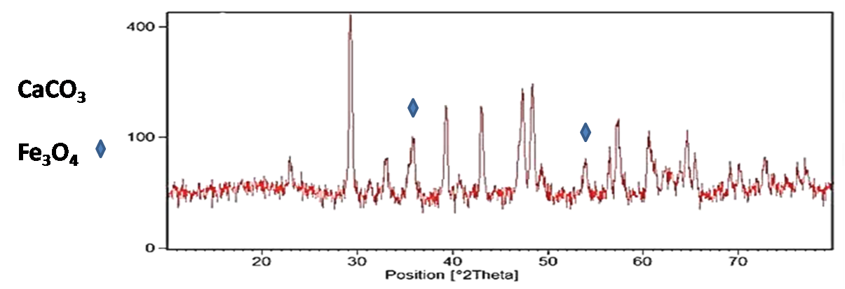
Fig. S1 The XRD analysis of the employed catalyst (Fe3O4/CaCO3)

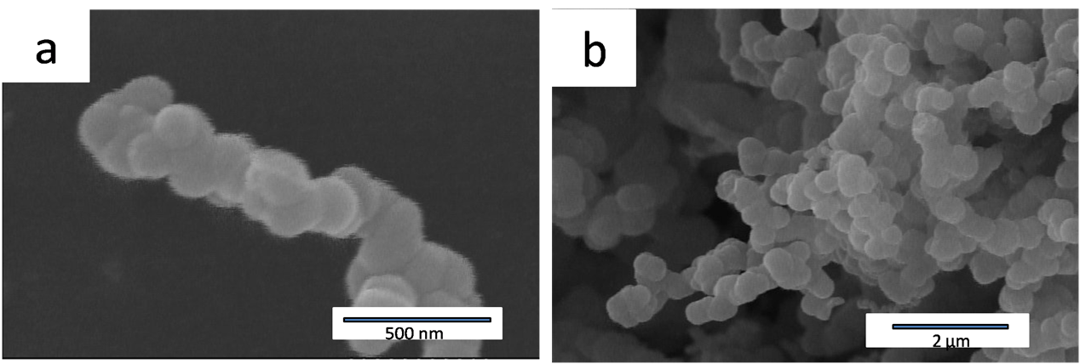

Fig S2 The FESEM images of the employed catalyst (Fe3O4/CaCO3)

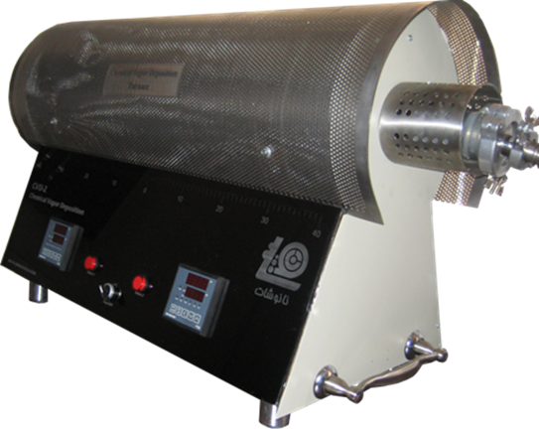

Fig. S3 A view of the two temperature zone furnace (CVD) used for synthesis of SCNT.

More details concerning utilized techniques:

FESEM, elemental mapping and EDS:
Instrument: Mira 3-XMU FE-SEM
Company: Tescan Co, Brno, Czech Republic
Operating Voltage: 15 kV
Detectors: BSE (Back-scattered electron), In-Beam BSE and In-Beam secondary electron detector
Max resolution: 7.0×10⁶

TEM:
Instrument: EM208S TEM micro-scope
Company: Philips Co, The Netherland
Operating Voltage: 120.0 kV
Resolution: 2 nm
Imaging modes: BF (bright field) and diffraction

XRD:
Instrument: XPERT
Company: Philips Co, The Netherland
Operating Voltage: 40 kV
Current: 30 mA
Radiation sources: Line K_{α} of Cu

XPS:
Instrument: Specs model EA10 plus
Company: Bestec Co, Germany
Operating Voltage: 15 kV
Radiation sources: Line K_{α} of Al
Detecting elements: All except H and He

Raman spectroscopy:
Instrument: Senterra
Company: Bruker Co, USA
Laser excitation: 514 nm
Operating Voltage: 15 kV
Detectors: CCD, point to point analysis
Sample: Powder and solid films

