__________________________________________________________________________________________________________
Sample | age (ky) | 238U [µg/g] | 232 [ng/g] | 230 [pg/g] | 230Thxs/238U [dpm/dpm] |  | 234U/238U [dpm/dpm] | 230Th/232Th [dpm/dpm] | Location of sample |  | comments
____________________________________________________________________________________________________________________

SP AGA1 | 31.3 +- 0.2 | 2.901 +- 0.002 | 20.89 +- 0.03 | 13.30 +- 0.03 | 0.2753 +- 0.0009 | 1.1014 +- 0.0014 |  | 118.8 +- 0.3 |  | Agathi Beach, 9 m asl | Mod. altered
SP AGA2 | 17.8 +- 0.1 | 1.622 +- 0.001 | 7.673 +- 0.008 | 4.503 +- 0.008 | 0.1666 +- 0.0005 | 1.1046 +- 0.0013 |  | 109.6 +- 0.2 |  | Agathi Beach, 16 m asl | Mod. altered
LAD-T | 79.6 +- 1.0 | 0.3734 +- 0.0003 | 0.768 +- 0.004 | 3.705 +- 0.006 | 0.601 +- 0.004 | 1.1455 +- 0.0013 |  | 900.2 +- 4.7 |  | Ladiko Valley, 37 m asl | Mod. altered
LADZ | 38.5 +- 0.4 | 2.551 +-  0.003 | 6.48 +- 0.03 | 14.40 +- 0.05 | 0.346 +- 0.003 | 1.1547 +- 0.0021 |  | 416.4 +- 2.5 |  | Ladiko Valley, 37 m asl | Mod. altered
L2 | 86.7 +- 0.9 | 0.147 +- 0.0001 | 4.964 +- 0.006 | 1.578 +- 0.004 | 0.640 +- 0.003 | 1.1512 +- 0.0016 |  | 59.4 +- 0.2 |  | Lindos Bay, 11 m asl | Mod. altered
SP PEFE X | 58.2 +- 0.9 | 0.3398 +- 0.0002 | 0.469 +- 0.003 | 2.649 +- 0.004 | 0.473 +- 0.005 | 1.1346 +- 0.0011 |  | 1054.4 +- 7.9 |  | Pefka Beach, 10 m asl | Sligh. altered

Table: Results of U/Th dating on the aragonitic parts of Spondylus gaederopus. For the correction of detrital Th230 a Th230/Th232 activity ratio of 0.7 ± 0.2 was used (description of the method in Fietzke et al. (2005). Mod.: Moderately; Sligh.: Slightly

The specimens sampled for UTh dating have been identified as Spondylus gaederopus, thus, belonging to the same species as used by Titschack et al. (2008, 2009) (1, 2). As mentioned in the main text samples collected had been attached their substrate. Sampling focused on micro-structurally best preserved aragonite shell parts of the respective spondylids.
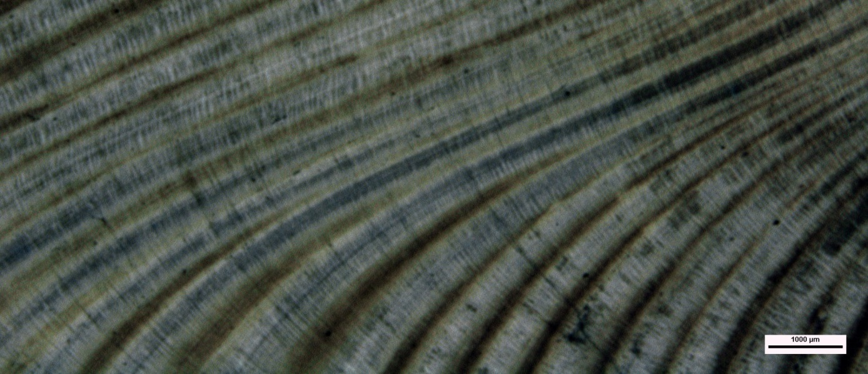
Photograph: microscopic view of the well-preserved aragonitic part of inner shell PEFE X. Light- and dark-coloured growth bands represent one year of growth (e.g., Maier & Titschack 2010).

The analytical results of the 6 samples cover an age range from 17.8ka to 86.7ka (see main text, Table1). UTh dating of Pleistocene mollusk shells has been shown to be challenged by diagenesis (recrystallization from aragonite to calcite, post-depositional exchange of uranium, secondary mineral formation…) (3). While not studied for UTh dating applications, Titschack et al. (2009) found recrystallization from aragonite to calcite to be a major problem when using ESR dating. As both dating methods rely on entirely different principles it is an open question to what degree UTh dating is facing similar problems. The later would require a strong exchange of U (and Th) with the environment (“open system behavior”), shifting the radiometric UTh clock from the initial conditions as discussed e.g. by Rowe et al. (2015).
Thus, we need to take a closer look at our measured radionuclide data to identify possible indications of sample alterations impacting the dating results. Typical criteria for such an evaluation are:
- Concentrations of U238 and Th232 isotopes (post-depositional exchange)
- Activity ratio of Th230/Th232, respectively U238/Th232 (impact of contamination indicated by relatively higher Th232)
- Activity ratio of U234/U238 (consistency with marine U isotope signature as initial source composition)
U238 and Th232 concentrations are showing a large degree of variability (U238: 0.15-2.9 µg/g; Th232: 0.5-20.9 ng/g). To our best knowledge there is no systematic study published on the typical concentration levels and their respective variability of both isotopes concentrations in the shells of Spondylus gaederopus specimens collected alive. We therefore cannot make the full use of the above mentioned criterion 1. In any way no systematic correlation of U concentration with apparent age or related to the sampling situation (loose ore attached to a boundstone) can be observed. The variability in U concentration could be related to natural variability in the initial U238 concentrations within the shell or between individual specimens. As mentioned before, without any systematic study on this issue, we cannot apply this criterion as decisive whether or not the samples underwent post-depositional U exchange (U loss or gain).
Th232 concentrations have been used as indicators for post-depositional shell alteration (3). Again, we do not have found any published data on the typical concentration and variability in recent shells. Nevertheless, systematic changes with sample age in shells of a different mollusk species (Lithophaga lithophaga) have been reported by e.g. Rowe et al. (2015) (3). These authors found Th232 concentration ranges of 2.9-8.3 ng/g in live-collected, 13.1-34.3 ng/g in Holocene shells and 21.5-328.7 ng/g in Pleistocene shells, respectively. In their study they found the Holocene samples to be well-suited for UTh dating in contrast to the more strongly altered Pleistocene samples, which rarely provided satisfying ages. Our samples display Th232 concentrations comparable to the well-suited group of samples (modern and Holocene) from Rowe et al. (2015), all being below (<21ng/g) the critical range found for the Pleistocene shells. Still, we can only use this as a positive indication, not proof, as both sample groups belong to different mollusk species, allowing for a significant variability in initial Th232 concentrations of their shells.
A more robust criterion could be the activity ratio of Th230/Th232 (respectively U238/Th232). Typically, higher ratios are associated with lower impacts of any correction for contamination (represented by the relative amount of Th232). Conventionally, a ratio of >200 for the Th230/232 is considered as precondition for highly reliable ages. Obviously, the actual ratio is pretty much dependent on the ingrown Th230, thus the U238/Th232 is the better, not age-dependent measure. While Rowe et al. (2015) found U238/Th232 ratios of 54.9-195.7 for the Holocene sample group providing questionable ages, only one of our samples (L2) has a U238/Th232 ratio <200. All other samples range between 438 and 2285. We take this as indications that contamination is less of a concern in our samples.
Finally, the U234/U238 ratio can be used to constrain apparent UTh ages and marine origin of the carbonate dated. For our samples the back-calculated U234/238 initial ratios range from 1.11 to 1.19. This deviation can be considered as indication of sample alteration. The apparently least altered sample SP PEFE X displays a U234/U238 initial ratio of 1.158 which puts it closest to the modern seawater value of 1.147.
This leaves us mostly with criterion 2 to evaluate the robustness of our age estimates. Again, according to that criterion sample SP PEFE X (U238/Th232=2285) provides the strongest, most reliable age. In contrast sample L2 (U238/Th232=93.4) appears the weakest, also showing the largest deviation in the back-calculated U234/U238. All other 4 samples appear to be strongly supported by the high U238/Th232 ranging from 433 to 1533. Nevertheless, the U234/U238 criterion indicates moderate alteration of the samples as indicated in the table1 (main text).

References
1) Titschack J, Nelson CS, Beck T, et al. (2008) Sedimentary evolution of a Late Pleistocene temperate red algal reef (Coralligène) on Rhodes, Greece: correlation with global sea-level fluctuations. Sedimentology 55:1747-1776
2) Titschack J, Radtke U, Freiwald A (2009) Dating and characterization of polymorphic transformation of aragonite to calcite in Pleistocene bivalves from Rhodes (Greece) by combined shell microstructure, stable isotope, and electron spin resonance study. Journal of Sedimentary Research 79:332-346
3) Rowe PJ, Turner JA, Andrews JE, et al. (2015) Uranium-thorium dating potential of the marine bivalve Lithophaga lithophaga. Quaternary Geochronology 30:80-89

