Supplementary Material
Summary of included studies 2
Supplementary tables 11
Supplementary Table 1: Number of patients with “Complicated Infections” and “favorable prognosis site of infection” per study 11
Supplementary Table 2: Mortality per study 13
Supplementary Table 3: Urinary tract infections (UTI) per study 14
Supplementary Table 4: Leave-one-out sensitivity analysis 15
Supplementary Table 5: Leave-one-sensitivity analysis (excluding UTIs subgroup) 16
Supplementary Table 6: Comparison of analysis with the random effect model vs the fixed effect model 17
Funnel plots 18
Supplementary Forrest plots 20
Association of SABU with septic embolism 20
Association of SABU with “complicated infection” 20
Association of SABU with “favorable prognosis site of infection” 21
Association of SABU with urinary tract infection (UTI) 21
Association of SABU with persistent SAB 22

Summary of included studies
Abbreviations: CI= confidence interval, NS= non-significant (p>0.05), SAB= S. aureus bacteremia, SABU= S. aureus bacteriuria, UTI= urinary tract infection.
* Sites of infections included in the meta-analysis as “complicated infection”
# Sites of infection included in the meta-analysis as “favorable prognosis site of infection”
Lee et al 1978 [4]
Methods: | Design: Retrospective. Setting: Veterans Administration Hospital. Inclusion criteria/definitions: Patients with SAB and urine cultures within 48 hours of a positive blood culture. SAB definition: ≥ 2 positive blood cultures, or a single positive blood culture and S. aureus isolation from another site. SABU was defined as ≥10⁵ CFU in pure culture. Only cases with isolates with identical antibiogram to the blood isolate were considered.
Results: | Study sample:  - Excluded: SAB but without urine culture within 48 hours n=17, 10 cases with positive urine cultures not fulfilling the above criteria: SABU of different antibiogram n=2, SABU in mixed culture n=2, Enterococci n=2, gram-negative bacilli n=4.  - SAB with SABU: n=16, mean age 62.9, 100% male  - SAB without SABU: n=31, mean age 60.5, 100% male  Site of infection (SAB with versus without SABU): endocarditis n=5 (31%) vs 8 (26%)*, bone/joint n=1 (6%) vs 2 (6%)*, intravenous device infection n=2 (13%) vs 9 (29%)#, skin n=0 vs 5 (16%)#, respiratory n=0 vs 4 (13%), genitourinary n=6 (38%) vs 1 (3%), unknown n=2 (13%) vs 2 (6%), hospital acquired infection n=7 (44%) vs 16 (45%).  Outcomes (SAB with versus without SABU): mortality n=6 (38%) vs 13 (42%), NS  Timing of urine and blood cultures and prior antibiotic use (SAB with versus without SABU): A day before the positive blood culture n=3 (18%) vs 4 (13%). Either the same day or within 48hours after n=13 (82%) vs 27 (87%). 8 patients without SABU (26%) were receiving appropriate antibiotic therapy at the time of the urine culture (vs 0 patients with SABU).  Performance of echocardiography: not reported.  Indwelling urinary tract devices or prior instrumentation: not reported  Infectious disease expert consultation: not reported.

Ekkelenkamp et al 2007 [5]
Methods: | Design: Retrospective. Setting: University Hospital in Netherlands. Inclusion criteria/definitions: “Group 1”: Patients with documented SAB and a urine culture obtained on the same day as the positive blood culture. “Group 2”: Patients with SAB and SABU documented on any other day during the 5-year study period, provided that the SABU isolate had a similar susceptibility pattern to the SAB isolate. Patients with a UTI were analyzed separately.
Results: | Study sample:  - Excluded: 16 patients with UTIs were analyzed separately. It is unclear from the published data how many of these 16 patients would otherwise belong to “Group 1”.  - Included: “Group 1” n=153. 12 patients had SABU.  Site of infection (SAB with versus without SABU): endocarditis n=2 (12%) vs 11 (8%)*, intravascular catheter infection n=3 (25%) vs 39 (28%)#, phlebitis/infected endovascular prosthesis n=0 vs 19 (13%), skin/wound infection n=0 vs 9 (6%)#, abscess n=0 vs 12 (9%), other n=3 (25%)(osteomyelitis, spondylodiscitis and upper respiratory tract infection) vs 21 (15%), unknown n=4 (25%) vs 30 (21%).  Outcomes (SAB with versus without SABU): not reported  Timing of urine and blood cultures and prior antibiotic use (SAB with versus without SABU): Although urine culture where obtained at the same day as blood culture antibiotic use before obtaining urine cultures cannot be excluded.  Performance of echocardiography: Not reported.  Indwelling urinary tract devices or prior instrumentation: 10 of 12 patients with SABU had an indwelling urinary catheter.  Infectious disease expert consultation: Not reported.

Huggan et al 2008 [6]
Methods: | Design: Retrospective. Setting: Tertiary hospital in New Zealand. Inclusion criteria/definitions: Patients ≥18 with SAB and a urine culture obtained within 24 hours of the first positive blood culture
Results: | Study sample:  - Excluded: 157 patients with SAB but without concomitant urine cultures. 15 patients with missing clinical records.  - SAB with SABU: n=35, median age 67, 77% male  - SAB without SABU: n=171, median age 67, 54% male  Site of infection (SAB with versus without SABU): endocarditis n=4 (11%) vs 20 (12%)*. None of the bacteriuric patients were thought to have a UTI.  Outcomes (SAB with versus without SABU): ICU admission n=8 (23%) vs 20 (12%), in-hospital mortality n=13 (37%) vs 30 (18%).  Timing of urine and blood cultures and prior antibiotic use (SAB with versus without SABU): Within 24 hours of the first positive blood culture. Antibiotic use prior to urine culture was not reported.  Performance of echocardiography: not reported.  Indwelling urinary tract devices or prior instrumentation (with vs without SABU): any abnormality 77% vs 43%, indwelling catheter 31% vs 22%, surgery/instrumentation 23% vs 4%, history of transurethral prostatectomy 6% vs 4%, other abnormality 51% vs 19%.  Infectious disease expert consultation: not reported.

Choi et al 2009 [7]
Methods: | Design: Retrospective. Setting: Inclusion criteria/definitions: Patients with more than one set of positive blood cultures within 24 h concurrent with clinical evidence of systemic infection and urine cultures performed within two calendar days of bacteremia. SABU was defined as urine cultures containing ≥10⁴ colonies/mL of S. aureus with the same pattern of antimicrobial susceptibility as the corresponding blood isolates. Previous antimicrobial use was defined as the receipt of antimicrobial agents for which the cultured strain was susceptible within three days prior to SABU.
Results: | Study sample:  - Excluded: 128 cases with SAB were excluded.  - SAB with SABU: n=31, median age=60, 64.5% male.  - SAB without SABU: n=172, median age=???, 60.5% male.  Site of infection (SAB with versus without SABU): endocarditis n=3 (9.7%) vs 12 (7%)*, vertebral osteomyelitis n=6 (19.4%) vs 6 (3.5%)*, central venous catheter n=5 (16.1%) vs 52 (30.2%)#, pneumonia n=3 (9.7%) vs 27 (15.7%), skin and soft tissue infection n=3 (9.7%) vs 24 (13.9%)#, abdomen n=0 vs 8 (4.6%), central nervous system infection n=3 (9.7%) vs 11 (6.4%), UTI n=7 (22.6%) vs 1 (0.6%).  Outcomes (SAB with versus without SABU): severe sepsis/septic shock n=14 (45.2%) vs n=72 (41.9%). 30-day mortality n= 8/26 vs 36/153 of evaluable patients.  Timing of urine and blood cultures and prior antibiotic use (SAB with versus without SABU): Within two calendar days of bacteremia. Prior antibiotic use: 3 (9.7%) vs 26 (15.1%).  Performance of echocardiography (with vs without SABU): TTE n=15 (48.4%) vs 74 (43%).  Indwelling urinary tract devices or prior instrumentation (with vs without SABU): indwelling urinary catheter n=6 (19.4%) vs 68 (39.5%), recent urinary tract surgery n=3 (9.7%) vs 2 (1.2%), urinary tract obstruction n=8 (25.8%) vs 10 (5.8%),  Infectious disease expert consultation: Not reported.

Pulcini et al 2009 [8]
Methods: | Design: Prospective observational. Setting: Multicenter. 2 teaching hospitals in France. Inclusion criteria/definitions: Patients aged ≥18 years with ≥1 positive  blood culture for S. aureus and evidence of systemic inflammatory  response syndrome. Complicated SAB included: SAB with endocarditis, osteomyelitis or septic arthritis, endophthalmitis, prostatitis, brain, kidney, spleen or lung abscesses, either at the time of initial hospitalisation or during the 90 days after the initial positive blood culture result. Persistent bacteremia was defined as the presence of positive blood cultures for S. aureus after 48-96 h of appropriate antibiotic therapy. Relapse was defined as a recurrence of bacteremia within 90 days after initial SAB. Urine culture results were considered only if sampled 48 h before or 24 h after the time of the first positive blood culture for S. aureus. Length of follow-up: up to 90 days.
Results: | Study sample:  - Excluded: no ID advice n=158, second episode of SAB n=14, outpatient n=12, <18 years n=9, polymicrobial infection n=10, death before evaluation n=6.  - Included: n=68 had SAB and concomitant urine cultures. 23 of 68 had SABU.  - Comparison between SAB with versus without SABU not reported  Site of infection (SAB with versus without SABU): endocarditis n=5 (22%) vs 6 (13%)*, complicated SAB n=15 (65%) vs 17 (38%), complicated SAB other than endocarditis n=10 (44%) vs 11 (24%). UTIs were considered three times on a clinical basis as a primary source of S. aureus infection and three times as a complicated SAB secondary to haematogenous seeding.  Outcomes (SAB with versus without SABU): A comparison of outcomes between patients with vs without SABU was not feasible from the published data.  Timing of urine and blood cultures and prior antibiotic use (SAB with versus without SABU): 48h before to 24h after the positive blood culture. No information regarding antibiotic use before urine cultures.  Performance of echocardiography: Of 104 patients with SAB, either TTE or TEE was performed in 88 (85%) (TTE only in 67, both in 21).  Association with indwelling urinary tract devices or prior instrumentation: Not reported.  Infectious disease expert consultation: Cases without such consultation were excluded.

Perez-Jorge et al [9]
Methods: | Design: Retrospective. Setting: Community teaching hospital. Ohio. Inclusion criteria/definitions: SAB (at least 1 positive blood culture) and a documented urine culture within 7 days of the episode of SAB. Persistent SAB: lasting more than 5 days after starting adequate SA treatment.
Results: | Study sample:  - Excluded: The number of excluded patients was not reported.  - SAB with SABU: n=28, mean age=66.3, 42.9% male  - SAB without SABU: n=90, mean age 62.4, 53.3% male  Site of infection (SAB with versus without SABU): endocarditis n=1 (3.6%) vs 5 (5.6%)*, osteomyelitis n=3 (10.7%) vs 5 (5.6%)*, septic arthritis n=2 (7.1%) vs 3 (3.3%)*, thrombophlebitis n=1 (3.6%) vs 3 (3.3%), septic embolism/abscess n=6 (21.4%) vs 6 (6.7%)*. Whether any of the patients had UTI is not reported.  Outcomes (SAB with versus without SABU): Persistent SAB n=3 (10.7%) vs 3 (3.3%), recurrent SAB n=3 (10.7%) vs 8 (8.9%), mortality 9 (32.1%) vs 13 (14.4%), septic shock n=6 (21.4%) vs 6 (6.7%).  Timing of urine and blood cultures and prior antibiotic use (SAB with versus without SABU): Urine culture within 7 days of SAB. Prior antibiotic use was not reported.  Performance of echocardiography: not reported.  Indwelling urinary tract devices or prior instrumentation: not reported  Infectious disease expert consultation: not reported.

Chihara et al 2010[10]
Methods: | Design: Retrospective. Case-control. Setting: Safety-net hospital in Chicago. Inclusion criteria/definitions: Cases: patients who had a positive urine culture for S. aureus within 72 hours of a positive blood culture for S. aureus. Controls: randomly sampled from all eligible patients with S. aureus bacteremia but without bacteriuria (i.e., with negative urine cultures), with the aim of 4 controls per case. Excluded: age < 18 years, who were seen only in the emergency department or in the clinic, or who did not have a urine culture performed within 72 hours of the positive blood cultures, were excluded.
Results: | Study sample:  - Excluded: 6 cases and 21 controls  - SAB with SABU: n=57, mean age 49.1, 70% males  - SAB without SABU: n=232, mean age 47.9, 68% males  Site of infection (SAB with versus without SABU): endocarditis n=7 (12%) vs 17 (7%)*, line infection/phlebitis n=6 (11%) vs 52 (22%)#, skin soft tissue infections n=10 (18%) vs 47 (20%)#, bone/joint infection n=7 (12%) vs 20 (9%)*, pulmonary infection n=12 (21%) vs 29 (13%), UTIs n=12 (21%) vs 10 (4%).  Outcomes (SAB with versus without SABU): mortality n=14 (24.6%) vs 22 (9.5%)  Timing of urine and blood cultures and prior antibiotic use (SAB with versus without SABU): Included patients had urine cultures within 72 hours of the positive blood culture. The frequency of antibiotic use prior to the urine culture is not reported.  Performance of echocardiography: not reported.  Indwelling urinary tract devices or prior instrumentation (with versus without SABU): Bladder catheter n=20 (35%) vs 85 (37%). Recent urological surgery n= 6 (11%) vs 7 (3%).  Infectious disease expert consultation: 50% of the included patients were managed by infectious diseases clinician or with infectious diseases consultation.

Asgeirsson et al 2011 [11]
Methods: | Design: Retrospective. Setting: Cases were identified from the clinical microbiology laboratories of a University and a Teaching Hospital in Iceland (including cases from other institutions using these laboratories). Inclusion criteria/definitions: Patients ≥18 with SABU and urine cultures obtained within 24 hours of the index blood culture. Cases with negative urine culture were excluded if antibiotics were administered before obtaining the urine culture. Only counts > 10⁴ CFU/ml were usually reported. Relapse was defined as recurrence of SAB within 90 days after the index bacteremia. The focus of SAB was defined as being either primary focus (localized primary infection causing the SAB, such as skin infections and intravascular catheter related infections), secondary focus (deep infection, most likely being a result of previous haematogenous seeding, such as vertebral osteomyelitis or endocarditis) or being unknown. Complicated SAB was defined as bacteraemia with a secondary or unknown focus; three day persistence on active intravenous antibiotics; or subsequent manifestation of metastatic infection remote from the initial focus. Persistent SAB: three day persistence on active intravenous antibiotics.
Results: | Study sample:  - Excluded: SAB considered contamination n=1, no urine culture within 24 hours n=101, unreliable urine culture due to prior antibiotic use n=33.  - SAB with SABU: n=27, median age=70, 81.5% males.  - SAB without SABU:  Site of infection (SAB with versus without SABU): UTI n= 11 (41%) vs 3 (2%), endocarditis n=3 (11.1%) vs 5 (3.6%), primary focus n=14 (51.9%) vs 75 (54.3%)#, secondary focus n=6 (22.2%) vs 25 (18.1%)*, unknown focus n=7 (25.9%) vs 38 (27.5%).  Outcomes (SAB with versus without SABU): complicated bacteremia n=15 (55.6%) vs 72 (52.2%), persistent bacteremia n=6 (50%) vs 8 (19%), ICU admission n=6 (22%) vs 25 (18%), 30-day mortality n=3 (11%) vs 23 (16.5%), relapse n=3 (11.5%) vs 9 (7.1%).  Timing of urine and blood cultures and prior antibiotic use (SAB with versus without SABU): Within 24 hours of index blood culture. Negative urine culture with prior antibiotic use were excluded.  Performance of echocardiography: an echocardiography was done in 89 of 166 cases (53.6%) with a reliable urine culture, being trans-oesophageal in 43 (25.9%).  Indwelling urinary tract devices or prior instrumentation (with vs without SABU): urinary tract foreign material 33.3% vs 13.7%. Of the 11 patients with SABU and UTI 6 patients having undergone instrumentation or operation of the urinary tract in the previous five days, 5 of whom also having a foreign urinary tract material at the time of SAB.  Infectious disease expert consultation: “At the university hospital SAB patients are usually assessed by an infectious disease specialist”. However, more information is not reported.

Manandhar et al 2016 [12]
Methods: | Design: Retrospective. Setting: Teaching Hospital in Pittsburgh. Inclusion criteria/definitions: Patients with SAB and urine culture within 48 hours of blood culture. SAB definition: isolation of S. aureus from at least 1 blood culture bottle. Persistence: positive blood culture despite 48 hours of appropriate antibiotic treatment. Recurrence: re-isolation of S. aureus in blood after complete treatment of SAB in the first episode until the end of the study (3-year period). SABU was defined as S. aureus growth ≥10⁵ CFU/ml. Excluded: urine culture not performed, SABU<10⁵ CFU/ml, coagulase-negative SABU.
Results: | Study sample:  - Excluded: Of 274 patients with SAB a urine culture was not available for 95.  - SAB with SABU: n=36, 63.9% male  - SAB without SABU: n=143, 54.5% male.  Site of infection (SAB with versus without SABU): endocarditis n=4 (11.1%) vs 16 (11.2%)*, septic embolic events n=8 (22.2%) vs 11 (7.7%). None of the patients with SABU had UTI.  Outcomes (SAB with versus without SABU): persistence n=2 (5.6%) vs 2 (1.4%), recurrence n=3 (8.3%) vs 18 (12.6%), ICU admission n=20 (55.6%) vs 77 (54.2%), 30-day mortality n=12 (33.3%) vs 29 (20.4%).  Timing of urine and blood cultures and prior antibiotic use (SAB with versus without SABU): Within 48 hours of blood culture. Prior antibiotic use: not reported.  Performance of echocardiography: Of a total of 274 bacteremic patients, 227, that is, 82%, had TEE or TTE performed with TEE in 134 and TTE in 93 patients. Similarly, of the 36 patients with SABU, 22 (61%) had done TEE.  Indwelling urinary tract devices or prior instrumentation: 24 (66%) of SABU patients had an indwelling urinary catheter.  Infectious disease expert consultation: not reported.

Supplementary tables

Supplementary Table 1: Number of patients with “Complicated Infections” and “favorable prognosis site of infection” per study
 | Number of complicated infections/ total number of patients |  | Number of favorable infections/ total number of patients
 | SABU | No SABU | SABU | No SABU
Lee 1978 [4] | 6/16¹ | 10/31¹ | 2/16¹⁰ | 14/31¹⁰
Ekkelenkamp 2007 [5] | 2/12² | 11/141² | 3/12¹¹ | 48/141¹¹
Huggan et al 2008 [6] | 4/35³ | 20/171³ | NR | NR
Choi et al 2009 [7] | 9/31⁴ | 18/172⁴ | 8/31¹² | 76/172¹²
Pulcini et al 2009 [8] | 5/23⁵ | 6/45⁵ | NR | NR
Perez-Jorge et al [9] | 12/28⁶ | 23/90⁶ | NR | NR
Chihara et al 2010[10] | 14/57⁷ | 37/232⁷ | 16/57¹³ | 99/232¹³
Asgeirsson 2011 [11] | 6/27⁸ | 25/139⁸ | 3/27¹⁴ | 72/139¹⁴
Manandhar 2016 [12] | 11/36⁹ | 27/143⁹ | NR | NR
Complicated infections: ¹ SABU: endocarditis n=5 + bones/joints n=1, No SABU: endocarditis n=8 + bones/joint n=2. Septic embolism was not reported. ² SABU: endocarditis n=2, No SABU: endocarditis n=11. Bone/joint and septic embolism was not reported.³ SABU: endocarditis n=4. No SABU: endocarditis n=20. Bone/joint and septic embolism was not reported. ⁴ SABU: endocarditis n=3 + vertebral osteomyelitis n=6. No SABU: endocarditis n=12 + vertebral osteomyelitis n=6. ⁵ SABU: endocarditis n=5, Although osteomyelitis and septic embolism was also considered, such a comparison between SABU and no SABU cannot be derived from the published data. ⁶ SABU: endocarditis n=1, osteomyelitis n=3, septic arthritis n=2, septic embolism/abscess n=6. No SABU: endocarditis n=5, osteomyelitis n=5, septic arthritis n=3, septic embolism/abscess n=10. Whether there was overlap between patients with septic embolism and endocarditis was not commented. ⁷ SABU: endocarditis n= 7 + bone/joint infection n=7. No SABU: endocarditis n= 17 + bone/joint infection n=20. ⁸ SABU: secondary focus of infection n= 6. No SABU: secondary n=25. Secondary focus of infection= deep infection, most likely being a result of previous haematogenous seeding, such as vertebral osteomyelitis or endocarditis. ⁹ SABU: endocarditis n=4 + septic emboli n=7. No SABU: endocarditis n= 16 + septic emboli n=11. Of patients with SABU 8 patients had septic embolism. 5 of 8 had echocardiography performed and 1 of those 5 had endocarditis. This patient was subtracted from the total number of patients with complicated infection. Similar data for the “no SABU” group were not reported. Nevertheless, such overlap in the non-SABU group would bias the results against our hypothesis.
Favorable prognosis site of infection: NR= not reported. ¹⁰ SABU: intravenous device n=2 + skin n=0. No SABU: intravenous device n=9 + skin n=5. ¹¹ SABU: intravascular catheter n=3 + skin/wound n=0. No SABU: intravascular catheter n=39 + skin/wound n=9. ¹² SABU: central venous catheter n=5 + skin and soft tissue n=3. No SABU: central venous catheter n=52 + skin and soft tissue n=24. ¹³ SABU: line infection/phlebitis n=6 + skin and soft tissue n=10. No SABU: line infection/phlebitis n=52 + skin and soft tissue n=47. ¹⁴ SABU: primary focus (excluding UTIs) n=3. No SABU: primary focus (excluding UTIs) n=72. Primary focus= localized primary infection causing the SAB, such as skin infections and intravascular catheter related infections. Based on the results of the study, UTIs were also considered a primary focus of infections. It is unclear which other sites of infection were included. This might overestimate the association of “no SABU” with favorable sites of infection. For example, S. aureus pneumonia could be considered as a primary focus of infection however such patients do not have a favorable prognosis.

Supplementary Table 2: Mortality per study
 | Type of mortality measured | Number of patients that died/Total number of patients
 |  | SABU | Without SABU
Lee 1978 [4] | Unclear* | 6/16 | 13/31
Ekkelenkamp 2007 [5] | Not reported | Not reported | Not reported
Huggan et al 2008 [6] | In-hospital mortality | 13/35 | 30/171
Choi et al 2009 [7] | 30-day mortality | 8/26 | 36/153
Pulcini et al 2009 [8]
Perez-Jorge et al [9] | Unclear* | 9/28 | 13/90
Chihara et al 2010[10] | In-hospital mortality | 14/57 | 22/232
Asgeirsson 2011 [11] | 30-day mortality | 3/27 | 23/139
Manandhar 2016 [12] | 30-day mortality | 12/36 | 29/143
* Most likely in-hospital mortality was measured. However this is not clarified in the text.

Supplementary Table 3: Urinary tract infections (UTI) per study
 | Number of patients with UTI/Total number of patients
 | SABU | Without SABU
Lee 1978 [4] | 6/16 | 1/31¹
Ekkelenkamp 2007 [5] | 0/12² | 0/141²
Huggan et al 2008 [6] | 0/35³ | 0/171³
Choi et al 2009 [7] | 7/31⁴ | 1/172⁴
Pulcini et al 2009 [8] | At least 3/23⁵ | ?/45⁵
Perez-Jorge et al [9] | ?/28⁶ | ?/90⁶
Chihara et al 2010[10] | 12/57 | 10/232
Asgeirsson 2011 [11] | 11/27⁷ | 3/139⁷
Manandhar 2016 [12] | 0/36⁸ | 0/143⁸
SABU= S. aureus bacteriuria.
¹ Prostatic abscess with negative urine culture.
² UTIs were excluded by study design.
³ “None was thought by attending clinicians to have urinary tract infection as a primary source of S. aureus infection”. Whether any of the patients had symptomatic UTI not thought as the primary source of infection is not clarified.
⁴ “Urinary tract infection was defined if leukocyturia was present and ≥3 of the following criteria were met: 1) localized symptoms/signs, 2) a diagnosis of urinary tract infection by an attending physician, 3) radiological findings suggestive of acute pyelonephritis or renal abscess, 4) the presence of urinary tract surgery or obstruction and 5) the presence of SABU.” “For each patient, all foci of infection were recorded without distinguishing between primary and metastatic foci of infection, because of the uncertainty of their differentiation.”. Therefore, overlap between UTI and endocarditis/bone-joint infection cannot be ruled-out.
⁵ “Among the 104 SAB included in the study, urinary tract infections were considered three times on a clinical basis as a primary source of S. aureus infection and three times as a complicated SAB secondary to haematogenous seeding.” “…haematogenous renal seeding was manifest in 20/23 bacteriuric patients in this study, since among the 104 SAB included in the study, urinary tract infection was considered only three times on a clinical basis as a primary source of S. aureus infection.” Therefore, at least 3 patients with SABU had a diagnosis of UTI. However, it is unclear to which group the other 3 patients belonged (SABU vs without SABU). Therefore, for the subgroup meta-analysis we hypothesized that these 3 patients belonged to the “without SABU” group. This approach results in a bias against our hypothesis.
⁶ How many (if any) patients had a UTI was not reported.
⁷ The only study that by design provided a subgroup analysis excluding the cases with UTI. “SAB was regarded as being of urinary tract origin if fulfilling two criteria: 1. Presence of localizing symptoms of urinary tract infection in those without known abnormality of the genitourinary tract; or clinical suspicion of genitourinary infection in the presence of foreign material, known structural anomaly or recent instrumentation of the urinary tract regardless of localizing symptoms; and 2. No other identifiable focus for the SAB.”
⁸ “None of our patients with SABU had symptoms consistent with UTI.”

Supplementary Table 4: Leave-one-out sensitivity analysis
Excluded study | Odds ratios (95% confidence intervals) per outcome (SABU versus no SABU)
 | Endocarditis | Bone/joint | Endocarditis  or bone/joint | Endocarditis  or bone/joint* | Complicated  infection | Favorable site of infection | Persistence | Recurrence | Mortality
Lee 1978 [4] | 1.49 [0.95, 2.35] | 2.63 [1.09, 6.35] | 1.68 [1.17, 2.41] | 2.08 [1.27, 3.41] | 1.87 [1.33, 2.62] | 0.51 [0.32, 0.82] | NA | NA | 2.11 [1.42, 3.13]
Ekkelenkamp 2007 [5] | 1.42 [0.91, 2.22] | NA | 1.61 [1.13, 2.31] | NA | 1.80 [1.29, 2.51] | 0.45 [0.28, 0.73] | NA | NA | NA
Huggan et al 2008 [6] | 1.58 [0.99, 2.51] | NA | 1.73 [1.20, 2.50] | NA | 1.80 [1.29, 2.51] | NA | NA | NA | 1.75 [1.10, 2.81]
Choi et al 2009 [7] | 1.48 [0.94, 2.33] | 1.44 [0.99, 2.11] | 1.41 [0.95, 2.10] | 1.60 [0.94, 2.72] | 1.82 [1.30, 2.55] | 0.48 [0.28, 0.83] | NA | NA | 1.99 [1.25, 3.17]
Pulcini et al 2009 [8] | 1.44 [0.91, 2.27] | NA | 1.63 [1.13, 2.34] | NA | 1.65 [1.16, 2.35] | NA | NA | 0.78 [0.29, 2.12] | NA
Perez-Jorge et al [9] | 1.52 [0.98, 2.36] | 2.44 [0.76, 7.82] | 1.64 [1.14, 2.38] | 2.04 [1.20, 3.46] | 1.85 [1.28, 2.68] | NA | 4.22 [1.36, 13.04] | NA | 1.79 [1.13, 2.84]
Chihara et al 2010[10] | 1.40 [0.86, 2.28] | 3.18 [1.20, 8.44] | 1.62 [1.08, 2.42] | 2.14 [1.15, 3.98] | 1.77 [1.24, 2.51] | 0.41 [0.21, 0.80] | NA | NA | 1.72 [1.11, 2.68]
Asgeirsson 2011 [11] | 1.37 [0.87, 2.14] | NA | 1.69 [1.17, 2.46] | NA | 1.89 [1.34, 2.68] | NA | 3.74 [1.04, 13.40] | 0.86 [0.33, 2.20] | 2.18 [1.52, 3.12]
Manandhar 2016 [12] | 1.57 [0.99, 2.49] | NA | 1.73 [1.20, 2.49] | NA | 1.81 [1.26, 2.58] | NA | 3.92 [1.36, 11.27] | 1.16 [0.41, 3.33] | 1.86 [1.14, 3.06]
None excluded | 1.47 [0.96, 2.27] | 2.39 [1.11, 5.14] | 1.64 [1.16, 2.33] | 1.95 [1.23, 3.09] | 1.82 [1.31, 2.52] | 0.47 [0.30, 0.74] | 3.97 [1.56, 10.09] | 0.91 [0.40, 2.05] | 1.92 [1.28, 2.88]
NA= Not Applicable. SABU= S. aureus bacteriuria. *Considering only the studies that reported both endocarditis and bone/joint infection.

Supplementary Table 5: Leave-one-sensitivity analysis (excluding UTIs subgroup)
Excluded study | Odds ratios (95% confidence intervals) per outcome (SABU vs no SABU)
 | Endocarditis | Bone/joint | Endocarditis  or bone/joint | Endocarditis  or bone/joint* | Complicated  infection | Favorable site of infection | Persistence | Recurrence | Mortality
Lee 1978 [4] | 1.73 [1.09, 2.73] | 3.19 [1.22, 8.35] | 2.08 [1.42, 3.04] | 2.65 [1.43, 4.91] | 2.26 [1.60, 3.20] | 0.66 [0.40, 1.09] | NA | NA | NA
Ekkelenkamp 2007 [5] | 1.76 [1.12, 2.78] | NA | 2.11 [1.44, 3.10] | NA | 2.29 [1.62, 3.24] | 0.62 [0.37, 1.03] | NA | NA | NA
Huggan et al 2008 [6] | 2.00 [1.24, 3.22] | NA | 2.33 [1.59, 3.41] | NA | 2.50 [1.75, 3.56] | NA | NA | NA | 1.75 [0.73, 4.16]
Choi et al 2009 [7] | 1.79 [1.12, 2.84] | 1.95 [0.96, 3.95] | 1.84 [1.24, 2.72] | 2.15 [1.23, 3.75] | 2.05 [1.43, 2.94] | 0.62 [0.35, 1.08] | NA | NA | NA
Pulcini et al 2009 [8] | 1.78 [1.12, 2.82] | NA | 2.13 [1.45, 3.15] | NA | 2.32 [1.63, 3.29] | NA | NA | NA | NA
Perez-Jorge et al [9] | 1.70 [1.04, 2.78] | 3.30 [0.99, 10.99] | 2.21 [1.50, 3.25] | 3.03 [1.77, 5.19] | 2.32 [1.61, 3.34] | NA | 4.85 [1.44, 16.28] | 1.01 [0.33, 3.12] | 1.82 [0.80, 4.12]
Chihara et al 2010[10] | 1.88 [1.20, 2.94] | 3.80 [1.26, 11.46] | 2.08 [1.35, 3.20] | 3.02 [1.46, 6.23] | 2.31 [1.57, 3.38] | 0.56 [0.28, 1.10] | NA | NA | NA
Asgeirsson 2011 [11] | 1.62 [1.02, 2.55] | NA | 2.07 [1.40, 3.06] | NA | 2.26 [1.59, 3.23] | NA | 3.74 [1.04, 13.40] | 0.86 [0.33, 2.20] | 2.45 [1.50, 4.00]
Manandhar 2016 [12] | 1.99 [1.24, 3.19] | NA | 2.31 [1.58, 3.39] | NA | 1.89 [0.83, 4.31] | NA | 4.38 [1.42, 13.46] | 1.52 [0.52, 4.39] | 2.00 [0.79, 5.06]
None excluded | 1.80 [1.16, 2.79] | 2.95 [1.31, 6.64] | 2.13 [1.48, 3.06] | 2.67 [1.65, 4.32] | 2.30 [1.64, 3.22] | 0.62 [0.38, 1.00] | 4.32 [1.62, 11.50] | 1.06 [0.47, 2.40] | 2.13 [1.20, 3.78]
NA= Not Applicable. SABU= S. aureus bacteriuria. *Considering only the studies that reported both endocarditis and bone/joint infection.

Supplementary Table 6: Comparison of analysis with the random effect model vs the fixed effect model
Association with: | Odds ratios (95% confidence intervals) per outcome (SABU vs no SABU)
 | Random effect | Fixed effect
Endocarditis | 1.47 [0.96, 2.27] | 1.42 [0.93, 2.18]
Endocarditis (excluding UTIs) | 1.80 [1.16, 2.79] | 1.69 [1.10, 2.60]
Bone/joint infections | 2.39 [1.11, 5.14] | 2.21 [1.22, 3.99]
Bone/joint (excluding UTIs) | 2.95 [1.31, 6.64] | 2.69 [1.48, 4.89]
Endocarditis or bone/joint infections | 1.64 [1.16, 2.33] | 1.60 [1.13, 2.26]
Endocarditis or bone/joint (excluding UTIs) | 2.13 [1.48, 3.06] | 2.05 [1.43, 2.92]
Septic emboli | 2.81 [1.33, 5.90] | 2.78 [1.32, 5.84]
Complicated infection | 1.82 [1.31, 2.52] | 1.78 [1.29, 2.47]
Complicated infection (excluding UTIS) | 2.30 [1.64, 3.22] | 2.24 [1.60, 3.13]
Persistence | 3.97 [1.56, 10.09] | 3.97 [1.56, 10.10]
Persistence (excluding UTIs) | 4.32 [1.62, 11.50] | 4.33 [1.64, 11.49]
Recurrence | 0.91 [0.40, 2.05] | 0.89 [0.40, 1.99]
Recurrence (excluding UTIs) | 1.52 [0.52, 4.39] | 1.49 [0.51, 4.32]
ICU admission | 1.40 [0.85, 2.30] | 1.37 [0.83, 2.27]
ICU admission (excluding UTIs) | 1.71 [0.94, 3.10] | 1.59 [0.95, 2.67]
Mortality | 1.92 [1.28, 2.88] | 1.90 [1.36, 2.67]
Mortality (excluding UTIs) | 2.13 [1.20, 3.78] | 2.02 [1.28, 3.20]

Funnel plots
Funnel plots for the association of SABU with some outcomes are not presented due to the very small number of relevant studies.
Endocarditis
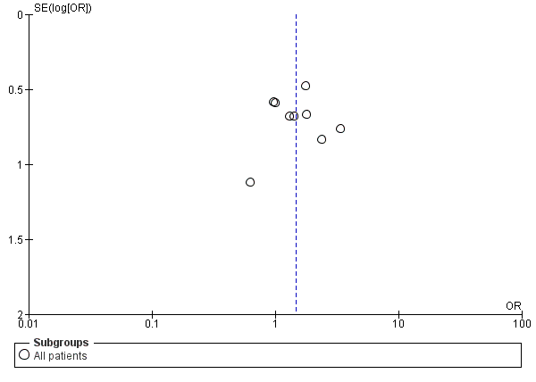
Endocarditis or Bone/joint infections
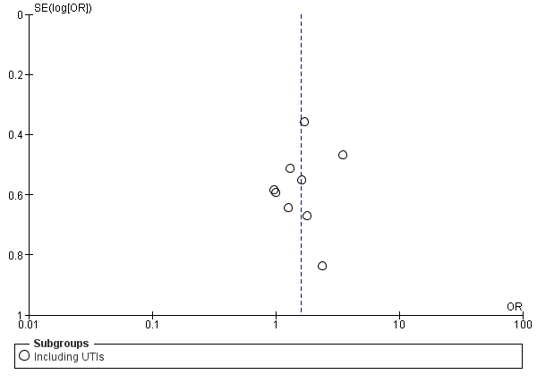
Complicated infections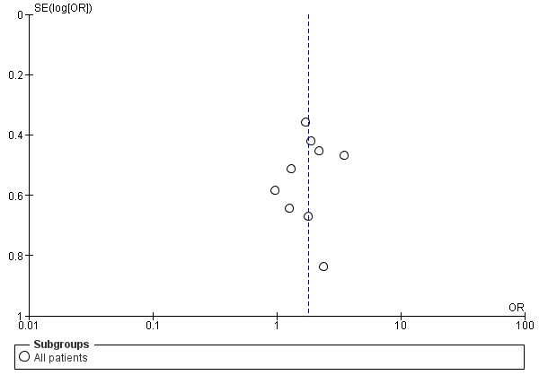
Mortality
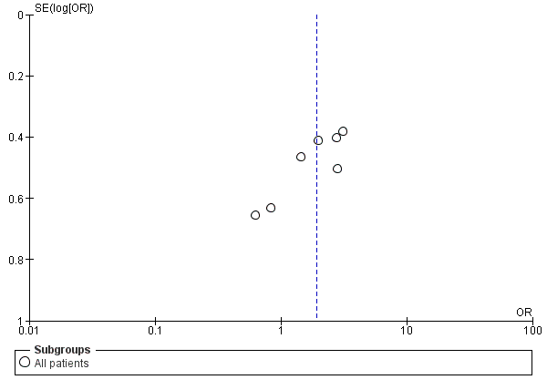

Supplementary Forrest plots

Association of SABU with septic embolism
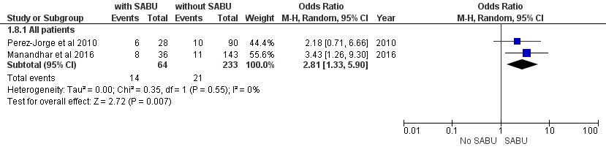

Association of SABU with “complicated infection”
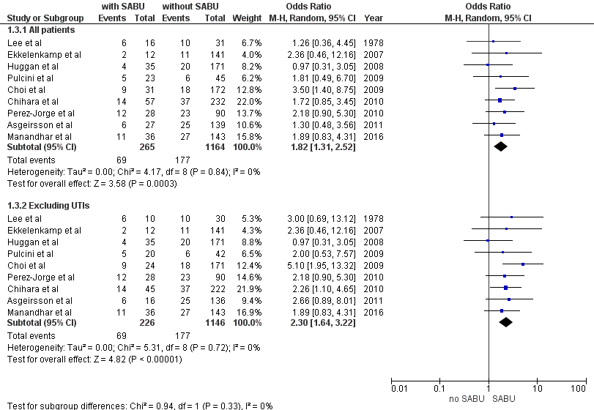

Association of SABU with “favorable prognosis site of infection”
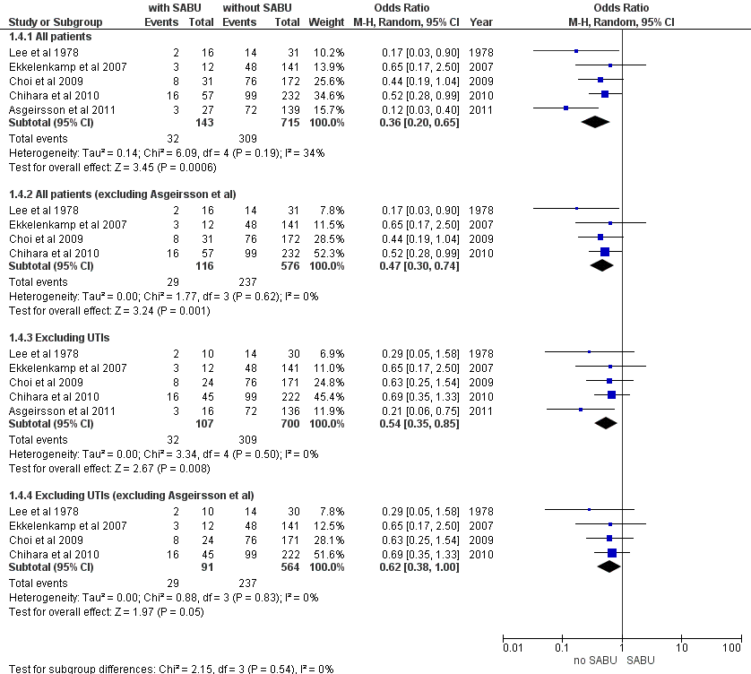

Association of SABU with urinary tract infection (UTI) 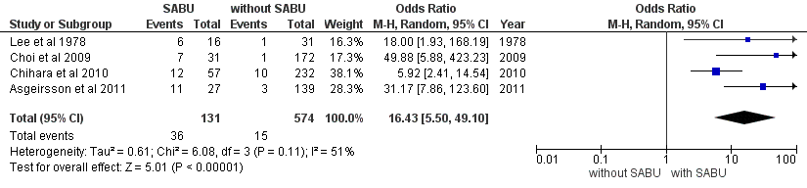

Association of SABU with persistent SAB
Including all patients of Asgeirsson et al 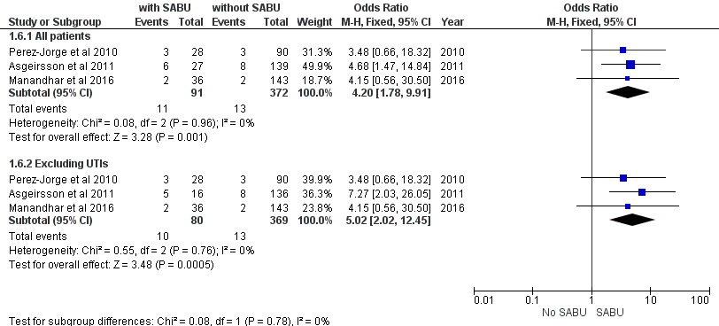

Excluding patients without follow-up cultures from the study of Asgeirsson et al 