Title: Effect of anti-hypertensive medication history on arteriovenous fistula maturation outcomes.

Supplemental Material

Supplemental Table 1: Baseline characteristics by beta-blocker use.
Supplemental Table 2: Baseline characteristics by diuretic use.
Supplemental Figure 1: AVF diameter and flow characteristics of ACE-I users and non-users.
Supplemental Figure 2: AVF diameter and flow characteristics of CCB users and non-users.
Supplemental Figure 3: AVF diameter and flow characteristics of beta-blocker users and non-users.
Supplemental Figure 4: AVF diameter and flow characteristics of diuretic users and non-users.

Figure legend
Supplemental Figure 1. AVF diameter and flow characteristics of ACE-I users and non-users.
Box plots of AVF vein diameter (mm) and flow rate (mL/min) over time for ACE-I users versus non-users. Plots are grouped by upper-arm (a and b) and forearm AVFs (c and d). The median AVF inner vein diameter is shown for preoperative to 6-week postoperative time points (a and c). The median AVF flow rate is shown for 1-day to 6-week postoperative time points (b and d). Each box plot depicts the 25th percentile, median, 75th percentile, and outlying values of AVF vein diameter and flow rate. White box plots represent ACE-I non-users, and gray box plots represent ACE-I users.
Supplemental Figure 2. AVF diameter and flow characteristics of CCB users and non-users.
Box plots of AVF vein diameter (mm) and flow rate (mL/min) over time for CCB users versus non-users. Plots are grouped by upper-arm (a and b) and forearm AVFs (c and d). The median AVF inner vein diameter is shown for preoperative to 6-week postoperative time points (a and c). The median AVF flow rate is shown for 1-day to 6-week postoperative time points (b and d). Each box plot depicts the 25th percentile, median, 75th percentile, and outlying values of AVF vein diameter and flow rate. White box plots represent CCB non-users, and gray box plots represent CCB users.
Supplemental Figure 3. AVF diameter and flow characteristics of beta-blocker users and non-users.
Box plots of AVF vein diameter (mm) and flow rate (mL/min) over time for beta-blocker users versus non-users. Plots are grouped by upper-arm (a and b) and forearm AVFs (c and d). The median AVF inner vein diameter is shown for preoperative to 6-week postoperative time points (a and c). The median AVF flow rate is shown for 1-day to 6-week postoperative time points (b and d). Each box plot depicts the 25th percentile, median, 75th percentile, and outlying values of AVF vein diameter and flow rate. White box plots represent beta-blocker non-users, and gray box plots represent beta-blocker users.
Supplemental Figure 4. AVF diameter and flow characteristics of diuretic users and non-users.
Box plots of AVF vein diameter (mm) and flow rate (mL/min) over time for diuretic users versus non-users. Plots are grouped by upper-arm (a and b) and forearm AVFs (c and d). The median AVF inner vein diameter is shown for preoperative to 6-week postoperative time points (a and c). The median AVF flow rate is shown for 1-day to 6-week postoperative time points (b and d). Each box plot depicts the 25th percentile, median, 75th percentile, and outlying values of AVF vein diameter and flow rate. White box plots represent diuretic non-users, and gray box plots represent diuretic users.
Supplemental Table 1. Baseline characteristics by beta-blocker use.

 | Beta-blocker use
 | Yes  (N = 440) | No  (N = 162)
Age (years) | 55.2 ± 13.2 | 54.6 ± 13.9
Male sex | 312 (70.9) | 111 (68.5)
Race/ethnicity
White | 205 (46.6) | 78 (48.1)
Black | 194 (44.1) | 70 (43.2)
Other | 41 (9.3) | 14 (8.6)
Education¹
No high school diploma | 111 (25.2) | 50 (30.9)
High school diploma | 121 (27.5) | 42 (25.9)
Post-secondary education | 195 (44.3) | 65 (40.1)
Smoking²
Current | 79 (18.1) | 26 (16.1)
Former | 166 (38.1) | 54 (33.5)
Never | 191 (43.8) | 81 (50.3)
Maintenance dialysis | 277 (63.0) | 106 (65.4)
History of diabetes | 271 (61.6) | 82 (50.6)
Prevalent cardiovascular disease | 236 (53.6) | 54 (33.3)
History of congestive heart failure | 139 (31.6) | 26 (16.0)
Body mass index (kg/m²) | 30.5 ± 7.6 | 29.9 ± 7.4
Systolic blood pressure (mmHg) | 152.4 ± 23.9 | 148.1 ± 23.5
Estimated GFR (mL/min/1.73m²)* | 13.5 ± 4.6 | 14.7 ± 5.3
AVF location
Forearm | 110 (25.0) | 33 (20.4)
Upper arm | 330 (75.0) | 129 (79.6)
Antihypertensive medication use
No antihypertensive medications | 0 (0.0) | 32 (19.8)
ACE-I/ARB | 219 (49.8) | 65 (40.1)
Beta-blockers | 440 (100.0) | 0 (0.0)
CCB | 301 (68.4) | 92 (56.8)
Diuretics | 238 (54.1) | 54 (33.3)
Values in the table expressed as mean ± standard deviation or number (percent).
GFR=glomerular filtration rate
¹Education data missing for 18 participants.
²Smoking status missing for 5 participants.
*Excludes participants on dialysis

Supplemental Table 2. Baseline characteristics by diuretic use.

 | Diuretic use
 | Yes  (N = 292) | No  (N = 310)
Age (years) | 56.9 ± 11.8 | 53.3 ± 14.5
Male sex | 199 (68.2) | 224 (72.3)
Race/ethnicity
White | 150 (51.4) | 133 (42.9)
Black | 116 (39.7) | 148 (47.7)
Other | 26 (8.9) | 29 (9.4)
Education¹
No high school diploma | 78 (26.7) | 83 (26.8)
High school diploma | 68 (23.3) | 95 (30.6)
Post-secondary education | 131 (44.9) | 129 (41.6)
Smoking²
Current | 44 (15.2) | 61 (19.8)
Former | 115 (39.8) | 105 (34.1)
Never | 130 (45.0) | 142 (46.1)
Maintenance dialysis | 131 (44.9) | 252 (81.3)
History of diabetes | 206 (70.5) | 147 (47.4)
Prevalent cardiovascular disease | 159 (54.5) | 131 (42.3)
History of congestive heart failure | 88 (30.1) | 77 (24.8)
Body mass index (kg/m²) | 32.5 ± 7.8 | 28.4 ± 6.8
Systolic blood pressure (mmHg) | 153.9 ± 23.2 | 148.6 ± 24.2
Estimated GFR (mL/min/1.73m²)* | 13.7 ± 4.6 | 13.9 ± 5.3
AVF location
Forearm | 68 (23.3) | 75 (24.2)
Upper arm | 224 (76.7) | 235 (75.8)
Antihypertensive medication use
No antihypertensive medications | 0 (0.0) | 32 (10.3)
ACE-I/ARB | 141 (48.3) | 143 (46.1)
Beta-blockers | 238 (81.5) | 202 (65.2)
CCB | 215 (73.6) | 178 (57.4)
Diuretics | 292 (100.0) | 0 (0.0)
Values in the table expressed as mean ± standard deviation or number (percent).
GFR=glomerular filtration rate
¹Education data missing for 18 participants.
²Smoking status missing for 5 participants.
*Excludes participants on dialysis

Supplemental Figure 1. AVF diameter and flow characteristics of ACE-I/ARB users and non-users.
Minimum AVF vein diameter
AVF Flow
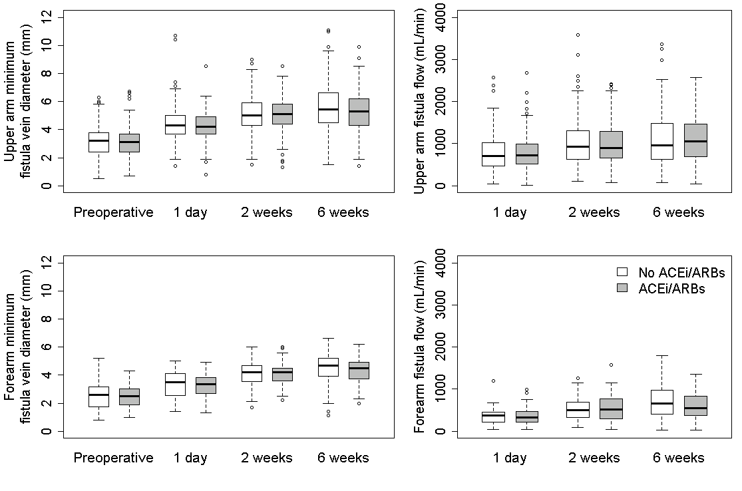

Supplemental Figure 2. AVF diameter and flow characteristics of CCB users and non-users.
AVF Flow
Minimum AVF vein diameter
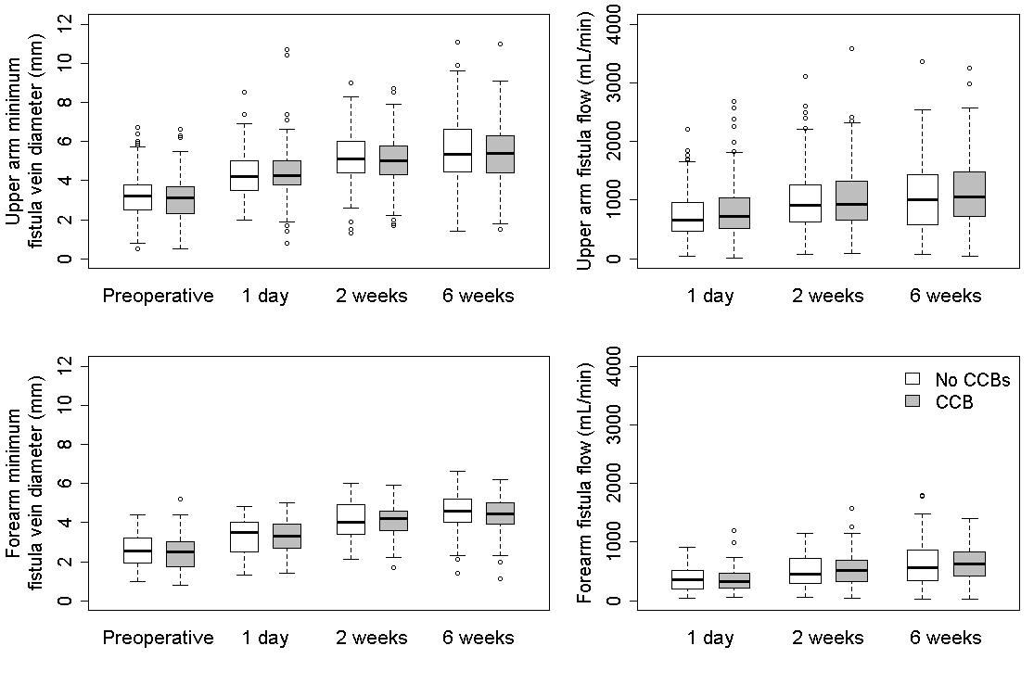
a.
b.
c.
d.
Supplemental Figure 3. AVF diameter and flow characteristics of beta-blocker users and non-users.
Minimum AVF vein diameter
AVF Flow
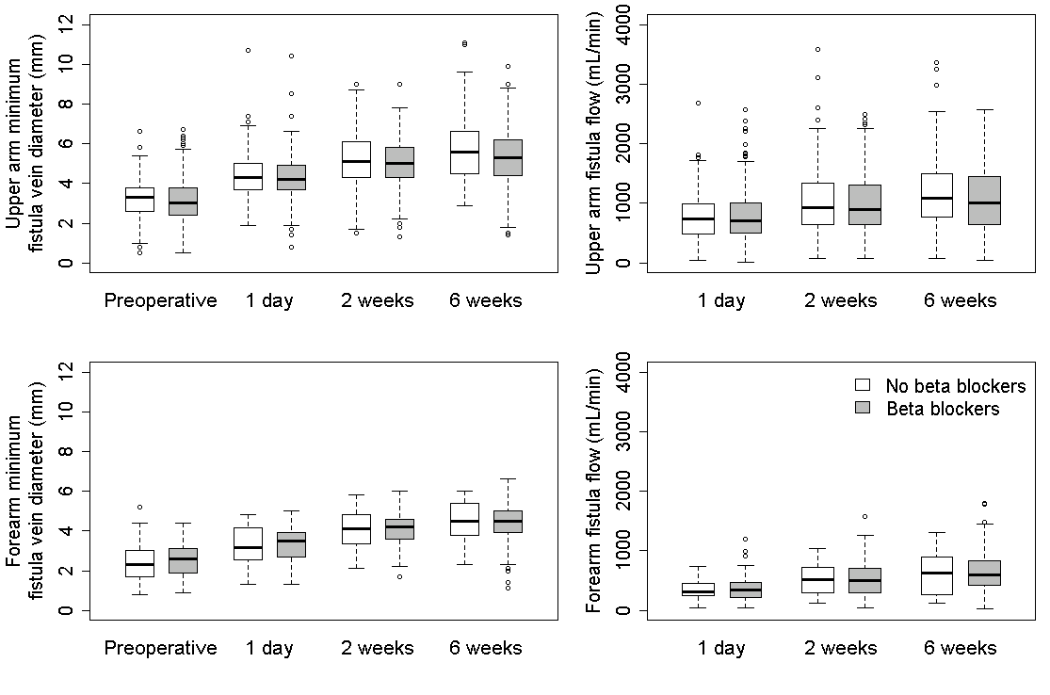
a.
b.
c.
d.
Supplementary Figure 4. AVF diameter and flow characteristics of diuretic users and non-users.
Minimum AVF vein diameter
AVF Flow
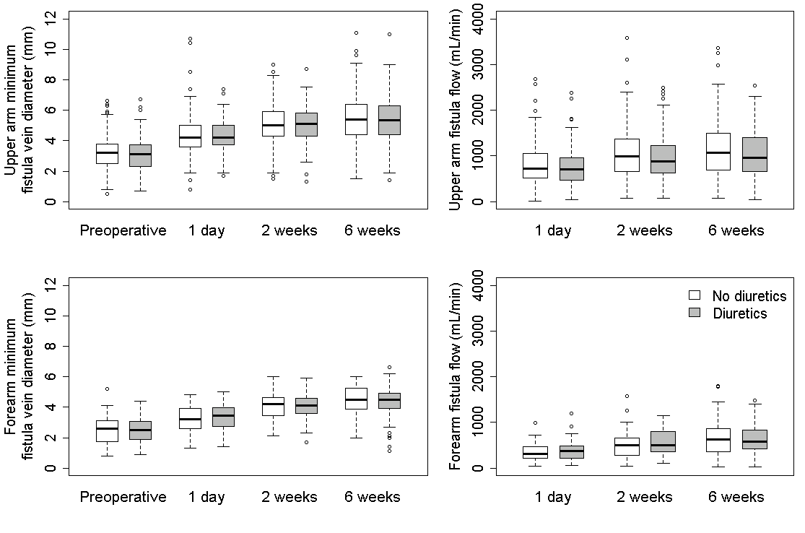
d.
b.
a.
c.

