Appendices

Table of Contents
Appendix 1: Site locations by country 2
Appendix 2: TANDEM TB diagnosis algorithm 10
Appendix 3: Description of published DM risk scores 11
Appendix 4: Sample size calculations 12
Appendix 5: Univariate DM probability curves 13
Appendix 6: DM diagnostics – By country and overall 15
Appendix 7: DM diagnostics – DM status confirmed by repeated testing following TB treatment 25
Appendix 8: DM diagnostics - FBG as gold standard 26
Appendix 9: Mean laboratory HbA1c by haemoglobin category 28

APPENDIX 1 – SITE LOCATIONS FOR TANDEM STUDY

Summary - Study site locations and dates of recruitment

In Bandung, Indonesia, suspected TB patients were recruited in 44 community health centres (CHCs) and from a district and a referral hospital. In Lima, Peru, patients were recruited at three primary health facilities and one secondary level hospital. In Romania, patients with TB were recruited from two secondary level hospitals, in two counties (Gorj and Dolj). In South Africa, patients were recruited at six community health care clinics in the northern Cape Town metropolitan area. All consecutive pulmonary tuberculosis (PTB) patients were recruited between the following dates:

February 2014 to February 2017 in Indonesia;
January 2014 to June 2016 in Peru
March 2014 to June 2016 in Romania
February 2014 to September 2016 in South Africa

Country and site selection
For the TANDEM study, it was important to select countries from different geographic regions so that diverse cultural, health system structures and population demographics could be represented. The burden of TB and DM also needed to be sufficiently high so that there would be sufficient TB-DM burden within the populations to be able to detect a causal effect. The countries also needed to be typical of settings where economic improvement and changes in lifestyles would be likely to increase the risk of DM substantially. During the TANDEM proposal development in 2011, current data indicated that Peru and Romania had some of the highest TB incidence rates in the South American and European regions respectively (106 and 159 per 100,000 population respectively) and an expected increase of DM between 90% and 160% ¹. With a TB incidence of 189 per 100,000 population ¹, Indonesia’s burden was well above the recommended screening threshold for TB in people with DM of 100 per 100,000, as recommended by the WHO/Union Framework ², even though it was not one of the highest in the South-East Asia region at that time.
The feasibility of conducting the studies was also an important criterion in the country selection and this was largely informed by long-term pre-existing research relationships between the TANDEM project principal investigators and research institutions within the countries as well as the collaborators’ capacity to recruit, test and treat patients for TB and DM and their access to potential participants. Given these considerations, Indonesia, Peru, Romania, and South Africa each with a high burden of TB and an increasing prevalence of DM, were selected.
The research team based in the Universitas Padjadjaran (UNPAD) in Bandung, Indonesia has a pre-existing research relationship with the main public tertiary teaching Hospital (RSHS), thus the DOTS and Endocrinology clinics at RSHS were selected for recruitment of people with TB and DM, respectively. The CHCs with the greatest number of patients with TB in Bandung were contacted and asked to participate in the TANDEM study, with the permission and endorsement of the City Health Office. Patients with TB were recruited from those facilities along with the 14 additional satellite CHCs. Recruitment of patients with TB was lower than expected, particularly from CHCs in the east. Therefore, the second hospital, Ujung Berung District Hospital, was later added so that patients with suspected TB at CHCs in east Bandung could be sent to Ujung Berung hospital for confirmation and enrolment in TANDEM.
In Peru, TANDEM made a request to the Ministry of Health to get permission and access to health facilities in Lima to conduct the studies in WP1 and WP2. The Ministry of Health then provided a list of facilities with sufficient patient volume to meet the Peru recruitment targets and that were not already involved in another research project, conducted by any other local or international institution. HAMA, the reference hospital for almost one million people in South Lima, was chosen for recruitment of people with DM since the Endocrinology Department and the daily DM clinic are the most accessed DM services in the area, particularly by uninsured people with DM. To recruit people with TB, four health facilities with a high or medium prevalence of TB in the Metropolitan area of Lima were chosen.
In Romania, sites were also purposively selected based on pre-existing research collaborations with the country principal investigator in Dolj and Gorj counties as well as a high volume of patients with TB at the Victor Babes Hospital and the Runcu Hospital, and patients with DM at the two general hospitals.
In South Africa, all clinical sites used for recruitment were located in the northern part of the Cape Town metropolitan area. The facilities were selected because they are relatively close to Stellenbosch University's Faculty of Medicine and Health Sciences and cater for people with low- to lower-middle income for whom interventions are most needed. The areas have previously been reported to have a high prevalence of TB and diabetes, and the study team have a longstanding relationship with the personnel due to previous research activities. Diabetes patients were recruited from 3 Community Health Centres, under the management of Western Cape Provincial Health Department. Tuberculosis patients were recruited from 6 Primary Health Centres, under the management of City of Cape Town Health Department.

TANDEM – GLOBAL LOCATIONS (See tandem-fp7.eu)

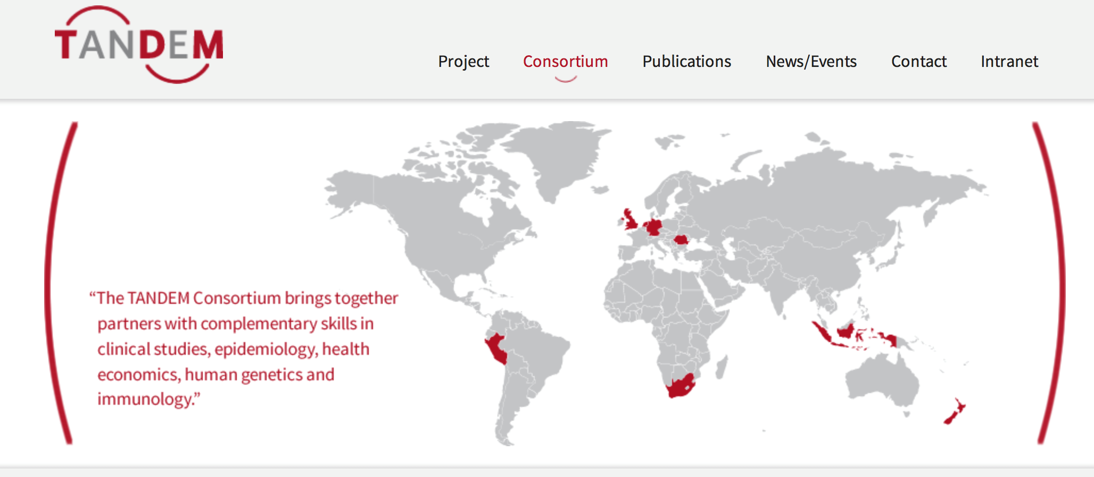
TANDEM - SITES IN BANDUNG, INDONESIA
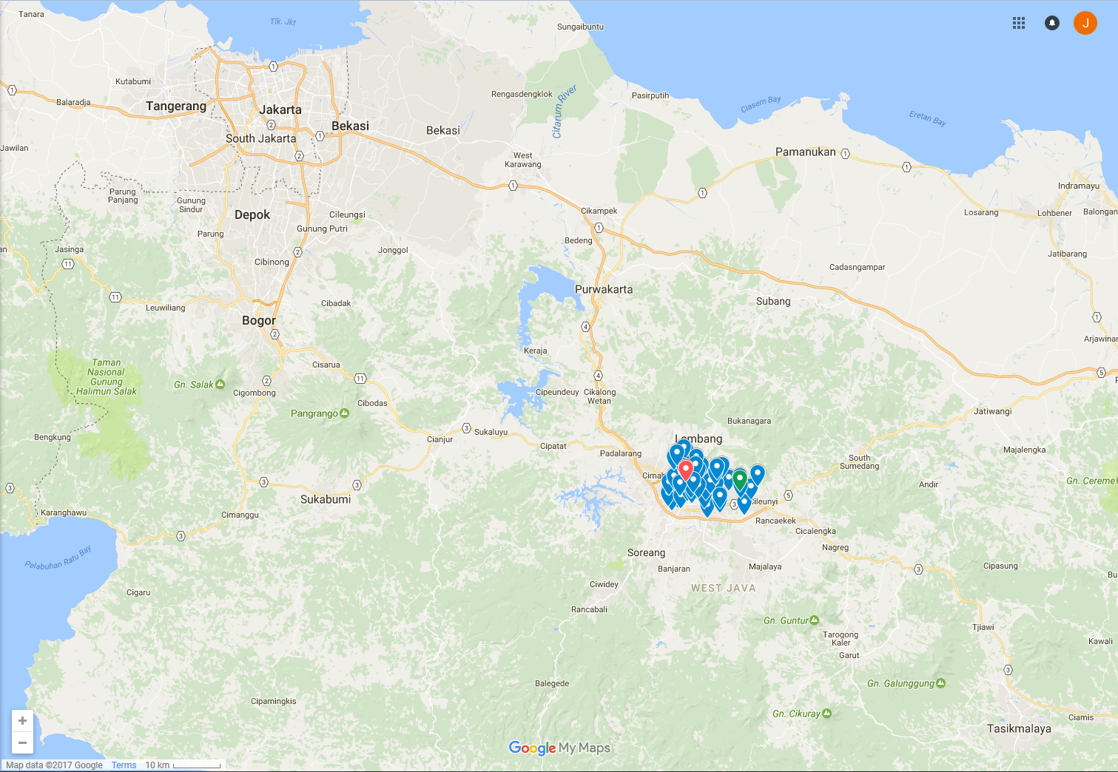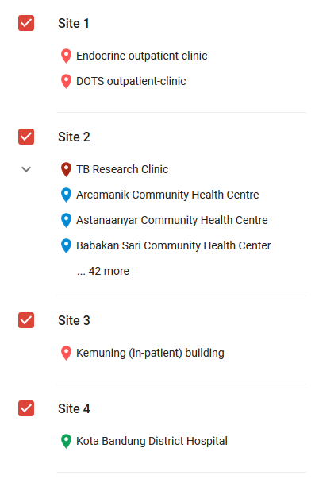

TANDEM - SITES IN LIMA, PERU 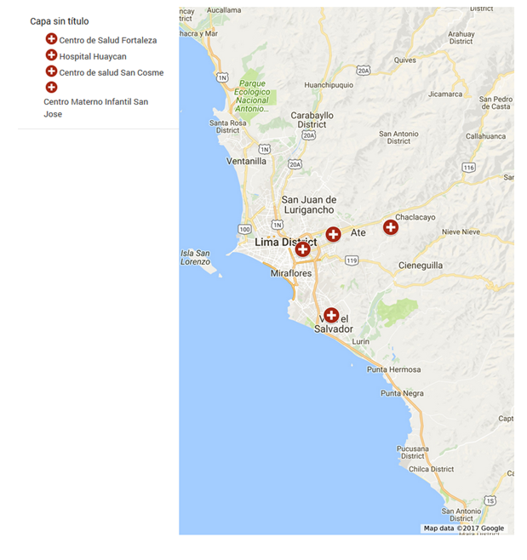
TANDEM – SITES IN CRAIOVA ROMANIA
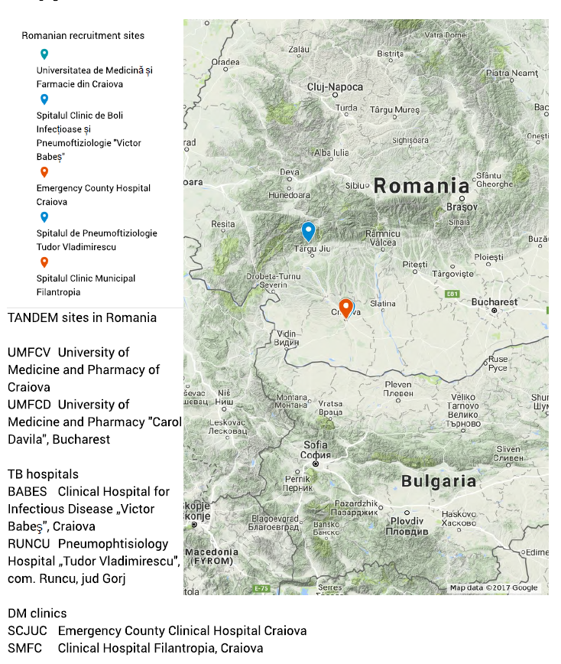

TANDEM - SITES IN STELLENBOSCH, SOUTH AFRICA
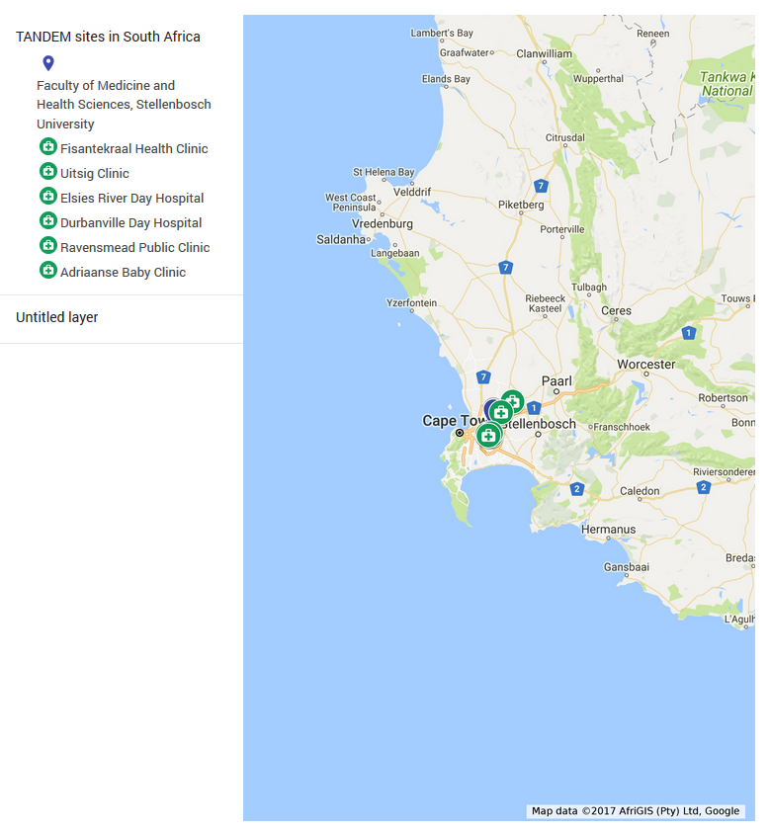

APPENDIX 2 TANDEM TB diagnosis algorithm

Case Definition | Criteria
Definite TB | Culture or Gene Xpert positive | With or without:  Suggestive TB on X-ray  Possible TB on X-ray  TB symptoms
Probable TB | Smear Positive | And either:  Suggestive TB on X-ray  Possible TB on X-ray and TB Symptoms
Possible TB | Smear Positive | And either:  Possible TB on X-ray  TB symptoms
 | TB Symptoms | And either:  Suggestive TB on X-ray  Possible TB on X-ray
No TB | Does not fulfil any of the above criteria

In Indonesia and Peru, in order to obtain a positive result using the microscopic observation drug susceptibility assay (MODS) two colony forming units must be observed. Negative results require no growth. Indeterminate results occur when only one colony forming unit is observed, but is insufficient for bacterial confirmation. Indeterminate results are ignored by the case definition algorithm and are by default treated as negative¹.

¹ Moore DA, Mendoza D, et al. Microscopic observation drug susceptibility assay, a rapid, reliable diagnostic test for multidrug-resistant tuberculosis suitable for use in resource-poor settings. J Clin Microbiol. 2004;42:4432–4437.

APPENDIX 3: Description of published DM risk scores

A recent systematic review of published DM risk scores identified a number of viable diagnostic scores³. Two particular scores stood out as having the highest sensitivity for detecting DM with good repeatability in validation studies. The FINDRISC score, developed using the Finnish National Population Register, includes the following variables: age, body mass index (BMI), waist circumference (WC), current blood pressure medication, history of high blood glucose, physical activity, and consumption of fruits and vegetables, and takes values 0-20 with a suggested optimal diagnostic cut-point of ≥9⁴. The Indian Risk Score, developed on a South Indian Asian population using the National Urban Diabetes Survey (NUDS), includes: age, BMI, WC, family history of DM, and physical activity, and takes values 0-42 with a suggested cut-point of ≥21⁵. The Oman Diabetes Risk Score, developed using the 1991 National Diabetes Survey of Oman including the following variables: age, WC, sex, BMI, hypertension, and family history of DM, was also selected for demographic diversity and its complimentary set of variables, and takes values 0-25 with a suggested cut-point of ≥10⁶.

1. WHO. Global Tuberculosis Report 2010. Geneva: World Health Organization,; 2010.

2. The Union, WHO. Collaborative framework for care and control of tuberculosis and diabetes. Geneva: World Health Organization; 2011.

3. Brown N, Critchley J, Bogowicz P, Mayige M, Unwin N. Risk scores based on self-reported or available clinical data to detect undiagnosed type 2 diabetes: a systematic review. Diabetes research and clinical practice. 2012; 98(3): 369-85.

4. Lindström J, Tuomilehto J. The Diabetes Risk Score A practical tool to predict type 2 diabetes risk. Diabetes care. 2003; 26(3): 725-31.

5. Ramachandran A, Snehalatha C, Vijay V, Wareham N, Colagiuri S. Derivation and validation of diabetes risk score for urban Asian Indians. Diabetes research and clinical practice. 2005; 70(1): 63-70.

6. Al-Lawati J, Tuomilehto J. Diabetes risk score in Oman: a tool to identify prevalent type 2 diabetes among Arabs of the Middle East. Diabetes research and clinical practice. 2007; 77(3): 438-44.

7. WHO. Haemoglobin concentrations for the diagnosis of anaemia and assessment of severity. Geneva World Health Organisation; 2011.

APPENDIX 4: Sample size calculations

Diabetes markers and risk scores were piloted for use in TB clinics. We expected to be able to estimate site sensitivity and specificity with reasonable precision. If sensitivity (for our combined testing approach) is around 90%, with an estimated undiagnosed DM prevalence of 8%, we would need 27 patients with previously undiagnosed diabetes to estimate this statistic with a precision (95% CI) of +/‐ 0.15 at each site (sample size calculation based on exact mid-P method, Fosgate et al 2005). Allowing for patient attrition, we therefore aim to recruit 400 newly diagnosed TB patients per site (expecting 8% or 32 to have undiagnosed diabetes). With four sites taking part, our total sample size will permit regression analysis to investigate heterogeneity by site and a range of patient characteristics (such as age, gender, initial HBA1c levels) that may be associated with test accuracy. We will evaluate the: 1) the risk score, 2) rcg, 3) combinations of risk score then rcg and/or urine glucose and 4) POC HbA1c against laboratory HbA1c. “

As the prevalence of undiagnosed diabetes was slightly lower than initially predicted, we recruited just over 2000 patients (instead of 1600) in total across the 4 sites.

Fosgate, Geoffrey. (2005). Modified exact sample size for a binomial proportion with special emphasis on diagnostic test parameter estimation. Statistics in medicine. 24. 2857-66. 10.1002/sim.2146.

APPENDIX 5: Univariate DM probability curves

DM predicted probability curve by age, with 95% CI
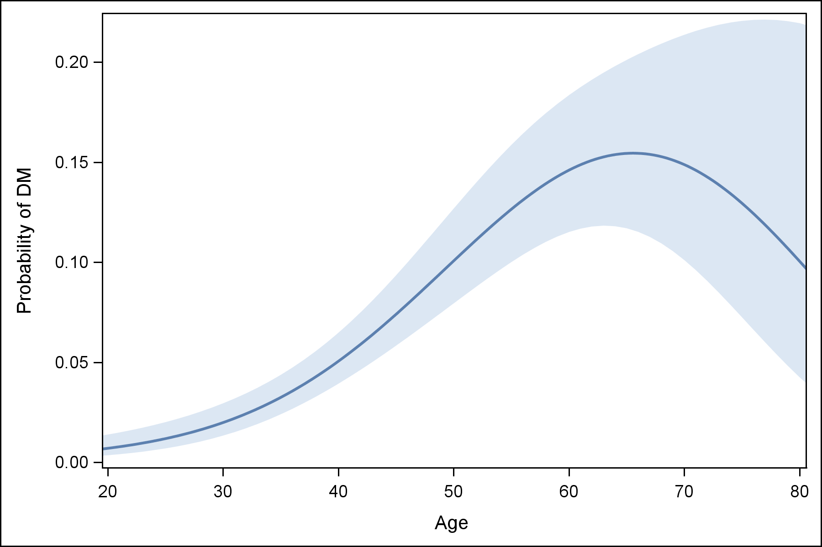
Predicted probability of DM from the model: logit(p) = β₀ + β₁ Age² + β₂ Age² log(Age)

DM predicted probability curve by RPG, with 95% CI
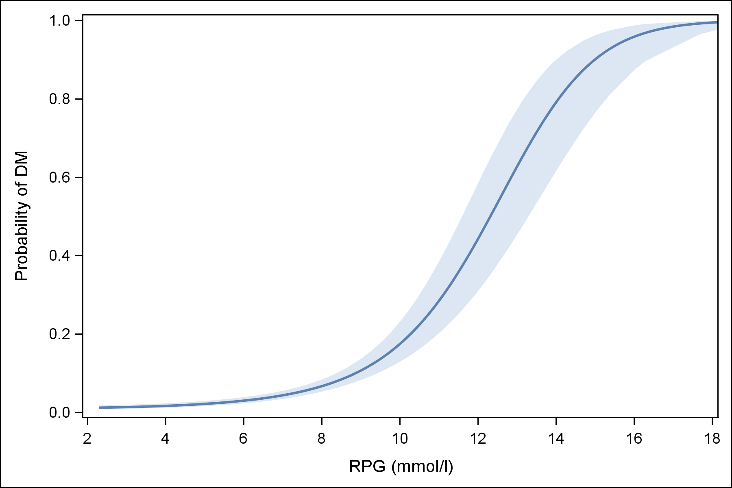
Predicted probability of DM from the model: logit(p) = β₀ + β₁ RPG²
DM predicted probability curve by POC HbA1c, with 95% CI
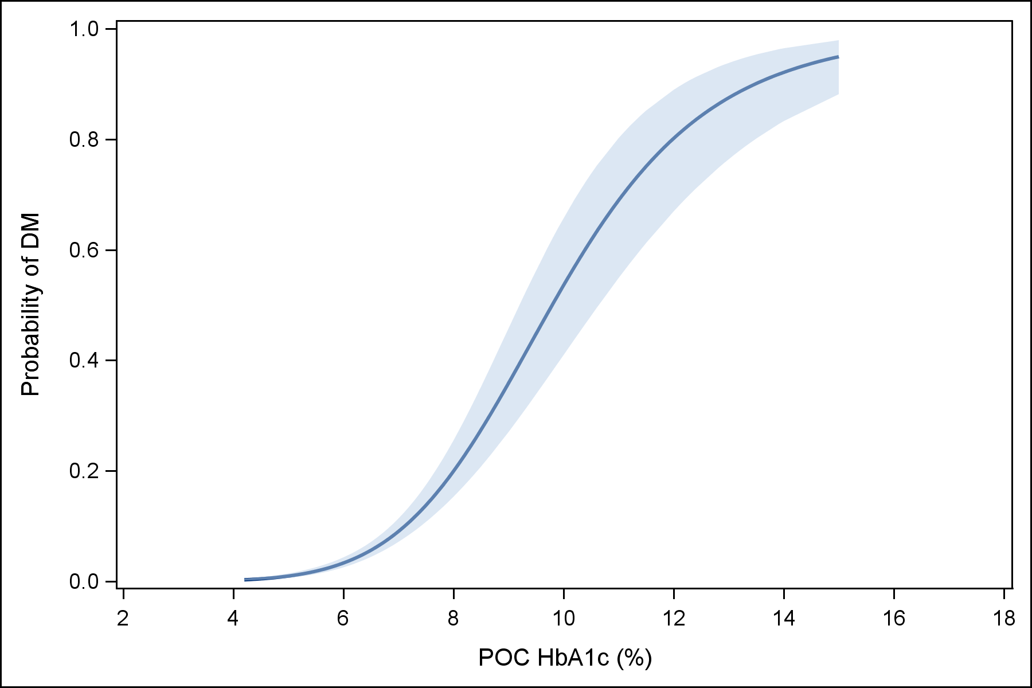
Predicted probability of DM from the model: logit(p) = β₀ + β₁ log(POc HbA1c)

APPENDIX 6a DM diagnostics - Area under the ROC curve and sensitivity and specificity estimates in INDONESIA
New DM cases defined using laboratory HbA1c ≥6.5%

DM Marker | Cut-point | AUROC | Sensitivity (%) | Specificity (%)
RPG/POC HbA1c Combination¹ | POC HbA1c ≥ 6.0% |  | 94.1 (80.3 - 99.3) | 91.1 (88.5 - 93.2)
 | POC HbA1c ≥ 6.5% |  | 88.2 (72.5 - 96.7) | 96.0 (94.2 - 97.4)
POC HbA1c | ≥ 5.7% | 0.98 (0.96 - 1.00) | 100.0 (89.4 - 100.0) | 52.6 (48.6 - 56.7)
 | ≥ 6.0% |  | 100.0 (89.4 - 100.0) | 64.2 (60.2 - 68.0)
 | ≥ 6.5% |  | 87.9 (71.8 - 96.6) | 88.0 (85.1 - 90.4)
Full TANDEM Score² | ≥ 11.6 | 0.97 (0.94 - 1.00) | 97.0 (84.2 - 99.9) | 61.2 (57.2 - 65.1)
 | ≥ 12.4 |  | 93.9 (79.8 - 99.3) | 88.8 (86.0 - 91.2)
RPG | ≥ 5.3 mmol/l | 0.95 (0.91 - 0.99) | 97.1 (84.7 - 99.9) | 42.3 (38.3 - 46.3)
 | ≥ 6.9 mmol/l |  | 88.2 (72.5 - 96.7) | 88.0 (85.1 - 90.4)
 | ≥ 11.1 mmol/l |  | 67.6 (49.5 - 82.6) | 99.3 (98.3 - 99.8)
Restricted TANDEM Score³ | ≥ 3.1 | 0.94 (0.89 - 1.00) | 94.1 (80.3 - 99.3) | 60.8 (56.8 - 64.7)
 | ≥ 3.5 |  | 94.1 (80.3 - 99.3) | 83.1 (79.9 - 86.0)
FBG | ≥ 4.8 mmol/l | 0.89 (0.77 - 1.00) | 81.8 (48.2 - 97.7) | 60.6 (50.7 - 69.8)
 | ≥ 5.2 mmol/l |  | 81.8 (48.2 - 97.7) | 82.6 (74.1 - 89.2)
 | ≥ 7.0 mmol/l |  | 54.5 (23.4 - 83.3) | 97.2 (92.2 - 99.4)
Age | ≥ 38 | 0.78 (0.70 - 0.85) | 85.3 (68.9 - 95.0) | 59.2 (55.2 - 63.1)
 | ≥ 45 |  | 76.5 (58.8 - 89.3) | 74.3 (70.7 - 77.7)
Oman Score | ≥ 10 | 0.75 (0.66 - 0.83) | 38.2 (22.2 - 56.4) | 89.1 (86.4 - 91.5)
 | ≥ 5 |  | 85.3 (68.9 - 95.0) | 58.9 (54.9 - 62.8)
Indian Risk Score | ≥ 10.6 | 0.74 (0.65 - 0.83) | 88.2 (72.5 - 96.7) | 43.7 (39.8 - 47.8)
 | ≥ 21 |  | 67.6 (49.5 - 82.6) | 67.6 (63.8 - 71.3)
Findrisc Score | ≥ 2 | 0.73 (0.64 - 0.83) | 73.5 (55.6 - 87.1) | 64.8 (60.8 - 68.5)
 | ≥ 9 |  | 20.6 (8.7 - 37.9) | 98.0 (96.6 - 99.0)
Urine Dipstick | ≥ trace | 0.67 (0.59 - 0.76) | 35.3 (19.7 - 53.5) | 99.5 (98.6 - 99.9)
WHR | ≥ 0.77 | 0.65 (0.56 - 0.74) | 97.1 (84.7 - 99.9) | 22.3 (19.1 - 25.9)
 | Male ≥ 0.89  Female ≥ 0.85 |  | 44.1 (27.2 - 62.1) | 78.3 (74.8 - 81.5)
 | Male ≥ 0.9  Female ≥ 0.8 |  | 47.1 (29.8 - 64.9) | 69.8 (66.0 - 73.4)
BMI | ≥ 25 | 0.63 (0.53 - 0.73) | 20.6 (8.7 - 37.9) | 97.9 (96.4 - 98.9)
 | ≥ 30 |  | 5.9 (0.7 - 19.7) | 99.8 (99.1 - 100.0)

APPENDIX 6b DM diagnostics - Area under the ROC curve and sensitivity and specificity estimates in PERU
New DM cases defined using laboratory HbA1c ≥6.5%

DM Marker | Cut-point | AUROC | Sensitivity (%) | Specificity (%)
RPG/POC HbA1c Combination¹ | POC HbA1c ≥ 6.0% |  | 82.4 (56.6 - 96.2) | 87.7 (84.6 - 90.4)
 | POC HbA1c ≥ 6.5% |  | 70.6 (44.0 - 89.7) | 92.7 (90.1 - 94.8)
Restricted TANDEM Score³ | ≥ 3.1 | 0.95 (0.92 - 0.99) | 100.0 (80.5 - 100.0) | 67.3 (63.2 - 71.2)
 | ≥ 3.5 |  | 94.1 (71.3 - 99.9) | 80.2 (76.6 - 83.5)
Full TANDEM Score² | ≥ 11.6 | 0.95 (0.90 - 0.99) | 100.0 (80.5 - 100.0) | 66.4 (62.2 - 70.5)
 | ≥ 12.4 |  | 88.2 (63.6 - 98.5) | 86.2 (82.9 - 89.0)
POC HbA1c | ≥ 5.7% | 0.93 (0.89 - 0.98) | 100.0 (80.5 - 100.0) | 43.0 (38.8 - 47.4)
 | ≥ 6.0% |  | 100.0 (80.5 - 100.0) | 61.5 (57.2 - 65.7)
 | ≥ 6.5% |  | 88.2 (63.6 - 98.5) | 81.1 (77.5 - 84.4)
RPG | ≥ 5.3 mmol/l | 0.86 (0.75 - 0.97) | 94.1 (71.3 - 99.9) | 46.0 (41.8 - 50.3)
 | ≥ 6.9 mmol/l |  | 70.6 (44.0 - 89.7) | 90.2 (87.4 - 92.6)
 | ≥ 11.1 mmol/l |  | 35.3 (14.2 - 61.7) | 99.6 (98.7 - 100.0)
Indian Risk Score | ≥ 10.6 | 0.86 (0.79 - 0.93) | 100.0 (80.5 - 100.0) | 50.1 (45.8 - 54.4)
 | ≥ 21 |  | 94.1 (71.3 - 99.9) | 60.4 (56.1 - 64.5)
Oman Score | ≥ 10 | 0.86 (0.80 - 0.91) | 70.6 (44.0 - 89.7) | 79.6 (76.0 - 82.9)
 | ≥ 5 |  | 94.1 (71.3 - 99.9) | 65.3 (61.2 - 69.3)
Age | ≥ 38 | 0.85 (0.78 - 0.92) | 82.4 (56.6 - 96.2) | 71.0 (67.0 - 74.8)
 | ≥ 45 |  | 76.5 (50.1 - 93.2) | 81.7 (78.1 - 84.8)
Findrisc Score | ≥ 2 | 0.85 (0.78 - 0.91) | 100.0 (80.5 - 100.0) | 49.8 (45.5 - 54.1)
 | ≥ 9 |  | 35.3 (14.2 - 61.7) | 91.5 (88.9 - 93.7)
Urine Dipstick | ≥ trace | 0.82 (0.69 - 0.94) | 66.7 (38.4 - 88.2) | 95.9 (93.8 - 97.4)
FBG | ≥ 4.8 mmol/l | 0.77 (0.60 - 0.93) | 82.4 (56.6 - 96.2) | 46.9 (42.1 - 51.7)
 | ≥ 5.2 mmol/l |  | 76.5 (50.1 - 93.2) | 65.7 (61.0 - 70.2)
 | ≥ 7.0 mmol/l |  | 47.1 (23.0 - 72.2) | 98.8 (97.3 - 99.6)
WHR | ≥ 0.77 | 0.71 (0.59 - 0.83) | 100.0 (80.5 - 100.0) | 3.1 (1.8 - 4.9)
 | Male ≥ 0.89  Female ≥ 0.85 |  | 88.2 (63.6 - 98.5) | 43.5 (39.3 - 47.8)
 | Male ≥ 0.9  Female ≥ 0.8 |  | 88.2 (63.6 - 98.5) | 36.9 (32.8 - 41.1)
BMI | ≥ 25 | 0.71 (0.56 - 0.85) | 47.1 (23.0 - 72.2) | 82.8 (79.3 - 85.8)
 | ≥ 30 |  | 11.8 (1.5 - 36.4) | 97.2 (95.5 - 98.5)

APPENDIX 6c DM diagnostics - Area under the ROC curve and sensitivity and specificity estimates in ROMANIA
New DM cases defined using laboratory HbA1c ≥6.5%

DM Marker | Cut-point | AUROC | Sensitivity (%) | Specificity (%)
RPG/POC HbA1c Combination¹ | POC HbA1c ≥ 6.0% |  | 37.5 (18.8 - 59.4) | 87.8 (84.1 - 90.9)
 | POC HbA1c ≥ 6.5% |  | 25.0 (9.8 - 46.7) | 97.4 (95.3 - 98.7)
FBG | ≥ 4.8 mmol/l | 0.73 (0.64 - 0.83) | 83.9 (66.3 - 94.5) | 45.4 (40.6 - 50.2)
 | ≥ 5.2 mmol/l |  | 71.0 (52.0 - 85.8) | 61.8 (57.0 - 66.3)
 | ≥ 7.0 mmol/l |  | 22.6 (9.6 - 41.1) | 98.2 (96.4 - 99.2)
POC HbA1c | ≥ 5.7% | 0.69 (0.56 - 0.82) | 60.9 (38.5 - 80.3) | 71.2 (66.4 - 75.7)
 | ≥ 6.0% |  | 43.5 (23.2 - 65.5) | 85.2 (81.3 - 88.6)
 | ≥ 6.5% |  | 17.4 (5.0 - 38.8) | 97.9 (96.0 - 99.1)
Full TANDEM Score² | ≥ 11.6 | 0.69 (0.58 - 0.79) | 60.9 (38.5 - 80.3) | 55.3 (50.2 - 60.4)
 | ≥ 12.4 |  | 39.1 (19.7 - 61.5) | 85.7 (81.8 - 89.1)
Indian Risk Score | ≥ 10.6 | 0.68 (0.59 - 0.76) | 93.5 (78.6 - 99.2) | 37.2 (32.7 - 41.9)
 | ≥ 21 |  | 58.1 (39.1 - 75.5) | 65.8 (61.1 - 70.2)
Age | ≥ 38 | 0.66 (0.55 - 0.78) | 83.9 (66.3 - 94.5) | 40.4 (35.8 - 45.2)
 | ≥ 45 |  | 74.2 (55.4 - 88.1) | 59.6 (54.8 - 64.2)
Oman Score | ≥ 10 | 0.66 (0.56 - 0.76) | 35.5 (19.2 - 54.6) | 83.1 (79.3 - 86.5)
 | ≥ 5 |  | 83.9 (66.3 - 94.5) | 44.3 (39.6 - 49.1)
Findrisc Score | ≥ 2 | 0.66 (0.56 - 0.76) | 66.7 (47.2 - 82.7) | 58.9 (54.0 - 63.6)
 | ≥ 9 |  | 6.7 (0.8 - 22.1) | 98.1 (96.3 - 99.2)
Restricted TANDEM Score³ | ≥ 3.1 | 0.65 (0.56 - 0.75) | 71.4 (51.3 - 86.8) | 47.0 (42.1 - 52.0)
 | ≥ 3.5 |  | 42.9 (24.5 - 62.8) | 69.5 (64.7 - 73.9)
Urine Dipstick | ≥ trace | 0.57 (0.43 - 0.71) | 14.3 (0.4 - 57.9) | 99.6 (97.6 - 100.0)
BMI | ≥ 25 | 0.55 (0.43 - 0.66) | 12.9 (3.6 - 29.8) | 94.0 (91.4 - 96.1)
 | ≥ 30 |  | 6.5 (0.8 - 21.4) | 100.0 (99.2 - 100.0)
WHR | ≥ 0.77 | 0.52 (0.39 - 0.66) | 90.0 (73.5 - 97.9) | 16.2 (12.9 - 20.1)
 | Male ≥ 0.89  Female ≥ 0.85 |  | 30.0 (14.7 - 49.4) | 73.5 (69.0 - 77.6)
 | Male ≥ 0.9  Female ≥ 0.8 |  | 26.7 (12.3 - 45.9) | 69.3 (64.7 - 73.6)
RPG | ≥ 5.3 mmol/l | 0.49 (0.35 - 0.64) | 64.3 (44.1 - 81.4) | 32.8 (28.2 - 37.6)
 | ≥ 6.9 mmol/l |  | 42.9 (24.5 - 62.8) | 70.9 (66.3 - 75.3)
 | ≥ 11.1 mmol/l |  | 14.3 (4.0 - 32.7) | 98.8 (97.1 - 99.6)

APPENDIX 6d DM diagnostics - Area under the ROC curve and sensitivity and specificity estimates in SOUTH AFRICA
New DM cases defined using laboratory HbA1c ≥6.5%

DM Marker | Cut-point | AUROC | Sensitivity (%) | Specificity (%)
RPG/POC HbA1c Combination¹ | POC HbA1c ≥ 6.0% |  | 22.2 (6.4 - 47.6) | 90.9 (86.5 - 94.3)
 | POC HbA1c ≥ 6.5% |  | 22.2 (6.4 - 47.6) | 96.6 (93.3 - 98.5)
Full TANDEM Score² | ≥ 11.6 | 0.74 (0.61 - 0.87) | 66.7 (41.0 - 86.7) | 71.1 (64.8 - 76.9)
 | ≥ 12.4 |  | 33.3 (13.3 - 59.0) | 89.2 (84.5 - 92.9)
POC HbA1c | ≥ 5.7% | 0.72 (0.59 - 0.84) | 55.6 (30.8 - 78.5) | 70.3 (63.9 - 76.1)
 | ≥ 6.0% |  | 50.0 (26.0 - 74.0) | 82.3 (76.8 - 87.0)
 | ≥ 6.5% |  | 33.3 (13.3 - 59.0) | 92.7 (88.5 - 95.7)
Restricted TANDEM Score³ | ≥ 3.1 | 0.67 (0.53 - 0.80) | 77.8 (52.4 - 93.6) | 51.3 (44.7 - 57.7)
 | ≥ 3.5 |  | 50.0 (26.0 - 74.0) | 68.8 (62.5 - 74.6)
Age | ≥ 38 | 0.66 (0.55 - 0.78) | 66.7 (41.0 - 86.7) | 58.9 (52.4 - 65.2)
 | ≥ 45 |  | 55.6 (30.8 - 78.5) | 69.3 (63.1 - 75.1)
Indian Risk Score | ≥ 10.6 | 0.63 (0.49 - 0.77) | 77.8 (52.4 - 93.6) | 35.7 (29.6 - 42.1)
 | ≥ 21 |  | 72.2 (46.5 - 90.3) | 50.2 (43.7 - 56.7)
Findrisc Score | ≥ 2 | 0.61 (0.48 - 0.74) | 77.8 (52.4 - 93.6) | 46.2 (39.8 - 52.8)
 | ≥ 9 |  | 11.1 (1.4 - 34.7) | 92.0 (87.8 - 95.1)
RPG | ≥ 5.3 mmol/l | 0.60 (0.45 - 0.76) | 77.8 (52.4 - 93.6) | 32.9 (27.0 - 39.3)
 | ≥ 6.9 mmol/l |  | 38.9 (17.3 - 64.3) | 76.7 (70.8 - 81.9)
 | ≥ 11.1 mmol/l |  | 11.1 (1.4 - 34.7) | 99.6 (97.7 - 100.0)
Oman Score | ≥ 10 | 0.60 (0.45 - 0.74) | 27.8 (9.7 - 53.5) | 85.9 (80.8 - 90.0)
 | ≥ 5 |  | 61.1 (35.7 - 82.7) | 51.9 (45.4 - 58.3)
BMI | ≥ 25 | 0.60 (0.47 - 0.72) | 5.6 (0.1 - 27.3) | 95.4 (91.9 - 97.7)
 | ≥ 30 |  | 100.0 (81.5 - 100.0) | 98.8 (96.4 - 99.7)
WHR | ≥ 0.77 | 0.58 (0.45 - 0.70) | 100.0 (81.5 - 100.0) | 8.4 (5.2 - 12.6)
 | Male ≥ 0.89  Female ≥ 0.85 |  | 38.9 (17.3 - 64.3) | 69.5 (63.2 - 75.2)
 | Male ≥ 0.9  Female ≥ 0.8 |  | 44.4 (21.5 - 69.2) | 61.5 (55.0 - 67.7)
Urine Dipstick | ≥ trace | 0.56 (0.45 - 0.67) | 27.8 (9.7 - 53.5) | 60.8 (54.3 - 67.0)

¹RPG ≥ 11.1 is deemed to be DM. If RPG ≥ 6.1 then a POC HbA1c test is performed.
²Full TANDEM score includes POC HbA1c, RPG and age.
³Restricted TANDEM score includes RPG, age, BMI and physical activity.
OVERALL DM diagnostics - Area under the ROC curve and sensitivity and specificity estimates

New DM cases defined using laboratory HbA1c ≥6.5%

DM Marker | Cut-point | AUROC | Sensitivity (%) | Specificity (%)
RPG/POC HbA1c Combination¹ | POC HbA1c ≥ 6.0% |  | 63.4 (52.8 - 73.2) | 89.3 (87.8 - 90.7)
 | POC HbA1c ≥ 6.5% |  | 55.9 (45.2 - 66.2) | 95.4 (94.3 - 96.3)
Full TANDEM Score² | ≥ 11.6 | 0.85 (0.81 - 0.90) | 82.4 (73.0 - 89.6) | 62.8 (60.5 - 65.1)
 | ≥ 12.4 |  | 67.0 (56.4 - 76.5) | 87.4 (85.7 - 88.9)
Restricted TANDEM Score³ | ≥ 3.1 | 0.84 (0.79 - 0.88) | 85.6 (77.0 - 91.9) | 58.4 (56.1 - 60.7)
 | ≥ 3.5 |  | 71.1 (61.0 - 79.9) | 77.2 (75.2 - 79.2)
POC HbA1c | ≥ 5.7% | 0.81 (0.75 - 0.86) | 81.3 (71.8 - 88.7) | 56.2 (53.8 - 58.5)
 | ≥ 6.0% |  | 75.8 (65.7 - 84.2) | 70.4 (68.2 - 72.6)
 | ≥ 6.5% |  | 59.3 (48.5 - 69.5) | 88.7 (87.2 - 90.2)
FBG | ≥ 4.8 mmol/l | 0.78 (0.70 - 0.85) | 83.1 (71.0 - 91.6) | 47.7 (44.6 - 50.9)
 | ≥ 5.2 mmol/l |  | 74.6 (61.6 - 85.0) | 65.8 (62.8 - 68.8)
 | ≥ 7.0 mmol/l |  | 35.6 (23.6 - 49.1) | 98.4 (97.3 - 99.1)
RPG | ≥ 5.3 mmol/l | 0.77 (0.70 - 0.83) | 83.5 (74.6 - 90.3) | 40.0 (37.7 - 42.3)
 | ≥ 6.9 mmol/l |  | 62.9 (52.5 - 72.5) | 83.3 (81.5 - 85.0)
 | ≥ 11.1 mmol/l |  | 36.1 (26.6 - 46.5) | 99.3 (98.8 - 99.7)
Age | ≥ 38 | 0.75 (0.70 - 0.80) | 81.0 (71.9 - 88.2) | 58.2 (55.9 - 60.5)
 | ≥ 45 |  | 72.0 (62.1 - 80.5) | 72.3 (70.2 - 74.4)
Indian Risk Score | ≥ 10.6 | 0.72 (0.67 - 0.77) | 90.0 (82.4 - 95.1) | 43.0 (40.7 - 45.3)
 | ≥ 21 |  | 70.0 (60.0 - 78.8) | 62.8 (60.5 - 65.0)
Oman Score | ≥ 10 | 0.72 (0.66 - 0.77) | 41.0 (31.3 - 51.3) | 84.4 (82.7 - 86.1)
 | ≥ 5 |  | 82.0 (73.1 - 89.0) | 56.4 (54.1 - 58.7)
Findrisc Score | ≥ 2 | 0.70 (0.64 - 0.75) | 76.8 (67.2 - 84.7) | 56.5 (54.2 - 58.8)
 | ≥ 9 |  | 17.2 (10.3 - 26.1) | 95.3 (94.2 - 96.2)
Urine Dipstick | ≥ trace | 0.66 (0.60 - 0.71) | 37.8 (26.8 - 49.9) | 92.5 (91.1 - 93.8)
WHR | ≥ 0.77 | 0.59 (0.53 - 0.65) | 96.0 (90.0 - 98.9) | 13.3 (11.8 - 15.0)
 | Male ≥ 0.89  Female ≥ 0.85 |  | 46.5 (36.4 - 56.8) | 65.6 (63.4 - 67.8)
 | Male ≥ 0.9  Female ≥ 0.8 |  | 47.5 (37.3 - 57.8) | 58.8 (56.5 - 61.1)
BMI | ≥ 25 | 0.57 (0.51 - 0.63) | 20.0 (12.7 - 29.2) | 92.1 (90.8 - 93.3)
 | ≥ 30 |  | 6.0 (2.2 - 12.6) | 99.0 (98.4 - 99.4)

¹RPG ≥ 11.1 is deemed to be DM. If RPG ≥ 6.1 then a POC HbA1c test is performed.
²Full TANDEM score includes age, POC HbA1c, and RPG.
³Restricted TANDEM score includes age, RPG, BMI, and physical activity.

APPENDIX 7 DM diagnostics - Area under the ROC curve and sensitivity and specificity estimates
New DM cases confirmed with repeat HbA1c or FBG following TB treatment
DM Marker | Cut-point | AUROC | Sensitivity (%) | Specificity (%)
RPG/POC HbA1c Combination¹ | POC HbA1c ≥ 6.0% |  | 93.5 (78.6 – 99.2) | 81.0 (58.1 – 94.6)
 | POC HbA1c ≥ 6.5% |  | 93.5 (78.6 – 99.2) | 100.0 (83.9 – 100.0)
POC HbA1c | ≥ 5.7% | 0.99 (0.92 – 1.0) | 96.8 (83.8 - 99.9) | 56.2 (29.8-74.3)
 | ≥ 6.2% |  | 96.8 (83.3 - 99.9) | 76.2 (52.8 – 91.8)
 | ≥ 6.5% |  | 93.5 (78.6 – 99.2) | 90.5 (69.6 – 98.8)
RPG | ≥ 5.3mmol/l  ≥ 6.9mmol/l | 0.88 (0.79 - 0.98) | 93.8(79.2 – 99.2)  93.5 (78.6-99.2) | 18.2 (5.2. 40.3)  30.8 (9.1-61.4)
 | ≥ 11.1mmol/l |  | 68.8 (50.0 – 83.9) | 100.0 (84.6 – 100.0)
Of the initial 100 newly diagnosed DM patients, 54 (54%) had a confirmatory test for DM following TB treatment. These 54 patients were from Indonesia (24), Peru (2), Romania (16) and South Africa (12). Of this 54, 32 had DM status confirmed by this test (59%). TANDEM scores were not repeated due to the small sample size and other tests were not repeated due to the modest AUC at baseline.

APPENDIX 8 DM diagnostics - Area under the ROC curve and sensitivity and specificity estimates, FBG as gold standard

New DM cases defined using FBG ≥7.0mmol/l

DM Marker | Cut-point | AUROC | Sensitivity (%) | Specificity (%)
RPG/POC HbA1c Combination¹ | POC HbA1c ≥ 6.0% |  | 45.0 (32.1 - 58.4) | 84.1 (81.5 - 86.4)
 | POC HbA1c ≥ 6.5% |  | 28.3 (17.5 - 41.4) | 92.0 (90.1 - 93.7)
Restricted TANDEM Score³ | ≥ 3.1 | 0.67 (0.59 - 0.75) | 68.8 (55.9 - 79.8) | 53.5 (50.2 - 56.7)
 | ≥ 3.5 |  | 50.0 (37.2 - 62.8) | 71.3 (68.3 - 74.2)
Full TANDEM Score² | ≥ 11.6 | 0.65 (0.57 - 0.74) | 61.0 (47.4 - 73.5) | 58.1 (54.8 - 61.4)
 | ≥ 12.4 |  | 37.3 (25.0 - 50.9) | 83.8 (81.3 - 86.2)
Oman Score | ≥ 10 | 0.65 (0.58 - 0.72) | 41.2 (29.4 - 53.8) | 82.2 (79.7 - 84.6)
 | ≥ 5 |  | 72.1 (59.9 - 82.3) | 54.1 (50.9 - 57.3)
Age | ≥ 38 | 0.65 (0.57 - 0.72) | 66.2 (53.7 - 77.2) | 54.6 (51.4 - 57.8)
 | ≥ 45 |  | 58.8 (46.2 - 70.6) | 69.6 (66.6 - 72.5)
RPG | ≥ 5.3 mmol/l | 0.64 (0.55 - 0.72) | 78.1 (66.0 - 87.5) | 34.6 (31.5 - 37.7)
 | ≥ 6.9 mmol/l |  | 46.9 (34.3 - 59.8) | 76.5 (73.6 - 79.2)
 | ≥ 11.1 mmol/l |  | 15.6 (7.8 - 26.9) | 98.9 (98.0 - 99.5)
POC HbA1c | ≥ 5.7% | 0.63 (0.55 - 0.72) | 62.7 (49.1 - 75.0) | 57.2 (53.9 - 60.5)
 | ≥ 6.0% |  | 52.5 (39.1 - 65.7) | 72.1 (69.0 - 75.0)
 | ≥ 6.5% |  | 28.8 (17.8 - 42.1) | 87.8 (85.5 - 89.9)
Findrisc Score | ≥ 2 | 0.63 (0.55 - 0.71) | 68.2 (55.6 - 79.1) | 54.3 (51.1 - 57.5)
 | ≥ 9 |  | 9.1 (3.4 - 18.7) | 94.6 (93.0 - 96.0)
Indian Risk Score | ≥ 10.6 | 0.63 (0.55 - 0.70) | 75.0 (63.0 - 84.7) | 41.4 (38.3 - 44.6)
 | ≥ 21 |  | 60.3 (47.7 - 72.0) | 62.5 (59.4 - 65.6)
Urine Dipstick | ≥ trace | 0.61 (0.54 - 0.68) | 24.4 (12.4 - 40.3) | 97.4 (96.0 - 98.4)
WHR | ≥ 0.77 | 0.56 (0.48 - 0.65) | 85.3 (74.6 - 92.7) | 10.0 (8.2 - 12.1)
 | Male ≥ 0.89  Female ≥ 0.85 |  | 44.8 (32.6 - 57.4) | 60.1 (57.0 - 63.3)
 | Male ≥ 0.9  Female ≥ 0.8 |  | 40.3 (28.5 - 53.0) | 55.0 (51.8 - 58.2)
BMI | ≥ 25 | 0.46 (0.38 - 0.54) | 14.7 (7.3 - 25.4) | 89.0 (86.8 - 90.9)
 | ≥ 30 |  | 5.9 (1.6 - 14.4) | 98.8 (97.8 - 99.4)

¹RPG ≥ 11.1 is deemed to be DM. If RPG ≥ 6.1 then a POC HbA1c test is performed.
²Full TANDEM score includes POC HbA1c, RPG and age.
³Restricted TANDEM score includes RPG, age, BMI and physical activity.

FBG was not available for all TANDEM study participants (approximately 50% of the total study population had received an FBG test). FBG was not routinely taken when RPG at baseline was <6.1 mmol/l to negate the requirement for a fasting return visit to the clinic. The exception was in Romania where all TB patients are treated as in-patients during the acute phase and hence all received FBG.

APPENDIX 9 Mean laboratory HbA1c by haemoglobin category

Anaemia Category | N | HbA1c (Mean (95% CI))
Severe | 26 | 5.30 (5.09 - 5.52)
Moderate | 349 | 5.79 (5.69 – 5.89)
Mild | 555 | 5.83 (5.75 - 5.91)
No anaemia | 901 | 5.76 (5.69 - 5.83)

Likelihood ratio test for general association between anaemia category and mean laboratory HbA1c: P=0.071
Wald chi-square test comparing severe anaemia with no anaemia: P=0.027

Anaemia categories based on standard WHO definitions, for men and women separately. Among non-pregnant women (>15 years) non-anaemia defined as haemoglobin levels >120g/L, mild anaemia defined as 110-119g/L, moderate anaemia was defined as 80-109g/L, and severe anaemia was defined as <80g/L; among men, non-anaemia defined as >130g/L, mild anaemia was defined as 110-129g/L, moderate anaemia defined as 80-109g/L, and severe anaemia defined as <80g/L.

WHO. Haemoglobin concentrations for the diagnosis of anaemia and assessment of severity. Vitamin and Mineral Nutrition Information System. Geneva World Health Organisation, 2011.

