**Supplementary information**

Chromotropism studies on copper(II) compounds. Part II. Dinuclear copper(II) complexes with triply-bridged hydroxo, acetate and halo ligands

ROYA NAZARI, HAMID GOLCHOUBIAN* and GIUSEPPE BRUNO



**Figure S1**. Picture of the structural types of the local geometry of each of the copper centers describing the A-F classes of triply bridged dinuclear complexes considered in this work. The dotted lines state the type of basis (square base pyramidal coordination (SP) or trigonal bipyramidal coordination (TBP)).

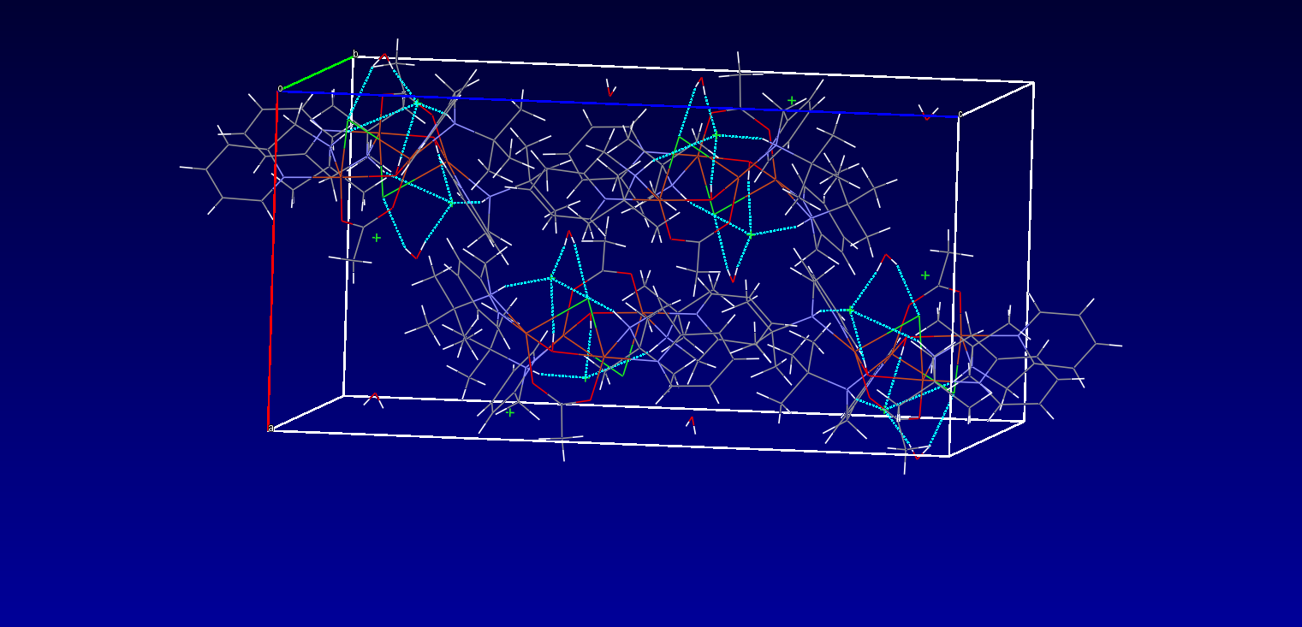

**Figure S2.** Hydrogen bonding in compound **1** along the ‘b’ axis**.**

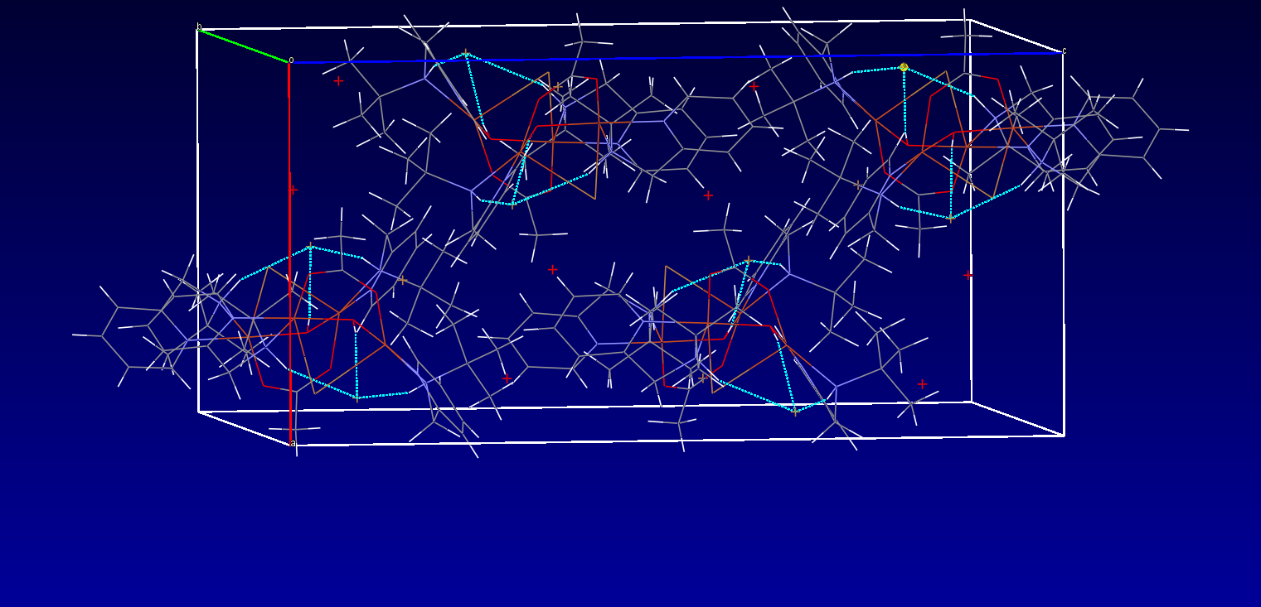

**Figure S3.** Hydrogen bonding in compound **2** along the ‘b’ axis.

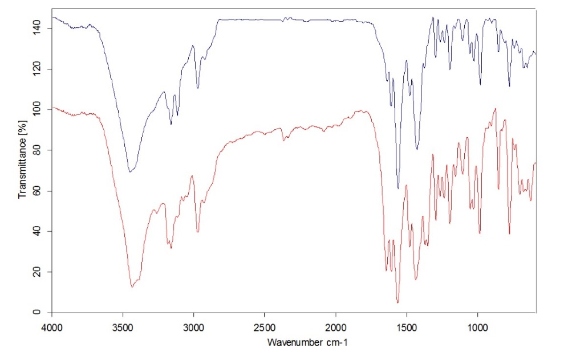

**2**

**1**

**Figure S4.** The infrared spectra of complexes **1** and **2**.

**g**║= **2.286**

**Complex 1**

**g**┴ = **2.041**

**176 x 10-4 cm-1**

**A**║

**Figure S5.** X-band EPR spectra of complexes **1** and **2** in the frozen solution at 77 K. There are uncertainties in g⊥ values due to significant overlap in the region 3200-3350 G.

**Complex 1**

**Figure S6.** TG and DSC curves for complexes **1** and **2**.

**Figure S7**. The UV-visible spectra of complexes **1** and **2** in CH2Cl2.

**Figure S8**. The comparison visible spectra of heated complex **1** and **2** in DMF. (a) After heating the complex in DMF; (b) the diamine ligand that was added to the heated CuCl2 in DMF.

**Figure S9**. The comparison visible spectra of heated complex **1** and **2** in DMDS. (a) After heating the complex in DMSO; (b) the diamine ligand that was added to the heated CuCl2 in DMSO.

**Figure S10**. The visible spectra of complexes in aqueous solution in original pH.

**Fig. S11**. Comparison spectra of the acidified complex in aqueous solution (a) and the acidified solution of ligand L and copper(II) perchlorate (b).

**Figure S12.** The pH-dependent visible spectrum of complex **2** in aqueous solution at 25 °C.

**Figure S13.** The pH titration of complex **2** with NaOH (0.10 M). The inset graphs show isosbestic points observed in the pH range of 7.5–11.37.

**Table S1**. Hydrogen bonds for **1** [Å and °].

|  |  |  |  |  |
| --- | --- | --- | --- | --- |
| D-H⋅⋅⋅A | d(D-H | d(H⋅⋅⋅A) | d(D⋅⋅⋅A) | <(DHA) |
| N(4)-H(4)...Cl(2) | 0.86(3) | 2.49(3) | 3.333(3) | 166(3) |
| N(2)-H(2)...Cl(2) | 0.835(18) | 2.63(2) | 3.433(3) | 161(3) |
| O(4)-H(4B)...Cl(1) | 0.85 | 2.27 | 3.053(8) | 153.0 |
| O(4)-H(4C)...Cl(2) | 0.85 | 2.21 | 3.053(9) | 172.8 |
| O(3)-H(3)...Cl(2) | 0.93(3) | 3.251(9) | 3.341(9) | 167.47 |

**Table S2**. Hydrogen bonds for **2** [Å and °].

|  |  |  |  |  |
| --- | --- | --- | --- | --- |
| D-H⋅⋅⋅A | d(D-H | d(H⋅⋅⋅A) | d(D⋅⋅⋅A) | <(DHA) |
| N(4)-H(4)...Br(2) | 0.86(1) | 2.469(1) | 3.444(1) | 164(1) |
| N(2)-H(2)...Br(2) | 0.85(1) | 2.577(1) | 3.524(2) | 164.92(2) |
| O(4)-H(4B)...Br(1) | 0.85(1) | 2.271 | 3.111(2) | 163.02 |
| O(4)-H(4C)...Br(2) | 0.85(1) | 2.29(1) | 3.163(1) | 163.8(1) |
| O(3)-H(3)...Br(2) | 0.71(2) | 2.705(1) | 3.397(9) | 164.16 |

**Table S3**. List of the dinuclear triply-bridged copper(II) compounds.

|  |  |
| --- | --- |
| Compounds | Ref. |
| [(dpyam)Cu(μ-OH)(μ-O2CH)(μ-Cl)Cu(dpyam)]PF6 | 18 |
| [(dpyam)Cu(μ-OH)(μ-O2CH)(μ-OMe)Cu(dpyam)]PF6 | 18 |
| [(dpyam)Cu(μ-OH)(μ-O2CH2CH3)2Cu(dpyam)]ClO4 | 18 |
| [(bpy)Cu(μ-OH)(μ-H2O)(μ-O2CMe)Cu(bpy)]ClO4 | 18 |
| [(dpyam)Cu(μ-OH)(μ-O2CH)(μ-Cl)Cu(dpyam)]PF6 | 18 |
| [(dpyam)Cu(μ-OH)(μ-O2CH)2Cu(dpyam)](PF6)2 | 18 |
| [(dpyam)Cu(μ-OH)(μ-O2CH)2Cu(dpyam)](S2O8)2 | 18 |
| [(dpyam)Cu(μ-OH)(μ-O2CH)2Cu(dpyam)] S2O8 | 18 |
| [(dpyam)Cu(μ-OH)(μ-O2CH)2Cu(dpyam)](NO3)2 | 18 |
| [(dpyam)Cu(μ-OH)(μ-O2CH)2Cu(dpyam)](BF4)2 | 18 |
| [(dpyam)Cu(μ-OH)(μ-O2CCH2CH3)Cu(dpyam)](ClO4) | 18 |
| [(bpy)Cu(μ-OH)(μ-O2CCH3)(μ-Cl)Cu(bpy)]Cl | 18 |
| [(dpyam)Cu(μ-OH)(μ-O2CH)(μ-Cl)Cu(dpyam)]ClO4 | 39 |
| [(dpyam)Cu(μ-OH)(μ-O2CH)(μ-OMe)Cu(dpyam)](ClO4)2 | 39 |
| [L1Cu(μ-OH)(μ-X)CuLX2]Cl | 40 |
| [L1Cu(μ-OH)(μ-X)CuLX2]Br | 40 |
| [L2Cu(μ-OH)(μ-X)CuLX2]Cl | 40 |
| [L2Cu(μ-OH)(μ-X)CuLX2]Br | 40 |
| [L3Cu(μ-OH)(μ-X)CuLX2]Cl | 42 |
| [L3Cu(μ-OH)(μ-X)CuLX2]Br | 42 |
| [(bpy)Cu(μ-O2CMe)3Cu(bpy)]ClO4 | 43 |
| [(bpy)Cu(μ-O2CMe)3Cu(bpy)]PF6 | 43 |
| [(phen)Cu(μ-OH)(μ-OAc)(μ-H2O)Cu(phen](ClO4)2 | 43 |
| [(bpy)Cu(μ-OH)(μ-O2CCH2CH3)(μ-H2O)Cu(bpy)](ClO4)2 | 44 |
| [(bpy)Cu(μ-OH)(μ-OH2)(μ-O2CCH3)Cu(bpy)](CF3SO3)2 | 44 |
| [(4,4'-dmbpy)Cu(μ-OH)(μ-OH2)(μ-O2CH)Cu(4,4'-dmbpy)](ClO4)2 | 44 |
| [(4,4'-dmbpy)Cu(μ-OH)(μ-OH2)(μ-O2CCH3)Cu(4,4'-dmbpy)](ClO4)2 | 44 |
| [(5,5'-dmbpy)Cu(μ-OH)(μ-OH2)(μ-O2CCH3)Cu(5,5'-dmbpy)](ClO4)2 | 44 |
| [(5,5'-dmbpy)Cu(μ-OH)(μ-OH2)(μ-O2CC(CH3)3)Cu(5,5'-dmbpy)](ClO4)2 | 44 |
| [(5,5'-dmbpy)Cu(μ-OH)(μ-OH2)(μ-O2CCH3)Cu(5,5'-dmbpy)](CF3SO3)2 | 44 |
| [(5,5'-dmbpy)Cu(μ-OH)(μ-OH2)(μ-O2CCH2CH3)Cu(5,5'-dmbpy)](CF3SO3)2 | 44 |
| {[(phen)Cu(μ-OH)(μ-OH2)(μ-O2CC(CH3)3)Cu(phen)](ClO4)2}2(CH3CH2OH) | 42 |
| [(bpy)Cu(μ-OH)(μ-O2SOCF3) (μ-O2CCH2CH3)Cu(bpy)](CF3SO3)(DMF)0.5 | 40 |
| [(phen)Cu(μ-OH)(μ-OH2)(μ-O2CCH2CH3)Cu(phen)](NO3)2 | 40 |
| [(bpy)Cu(μ-OCOPh)(μ-O2CPh)2)Cu(bpy)](ClO4)2 | 40 |
| [(bpy)Cu(μ-OCOPh)(μ-O2CPh)2)Cu(bpy)](BF4)2 | 40 |
| [(bpy)Cu(μ-OCOPh)(μ-O2CPh)2)Cu(bpy)](PF6)2 | 40 |

Abbreviations: L1 = phthalazine; L2 = pyridazine; L3 = 2,7-bis(2-pyridyl)-1,8-naphthyridine; bpy = 2,2'-bipyridine; dpyam = di-2-pyridylamine; 4,4'-dmbpy = 4,4'‑dimethyl-2,2'-bipyridine; 5,5'-dmbpy = 5,5'-dimethyl-2,2'-bipyridine; phen = 1,10‑phenanthroline