Conformational Equilibrium Study of calix[4]tetraloranes using Density Functional Theory and Molecular Dynamics Simulations
SUPPLEMENTARY INFORMATION

Table S1. Optimized Structures of calix[4]tetrolarenes at B97D/6-31G* level of approximation
4a | 4b
cone | 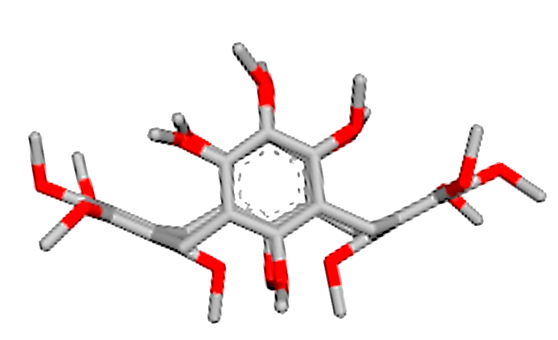  cone
partial cone | partial cone
1,2-alternate | 1,2-alternate
1,3-alt | 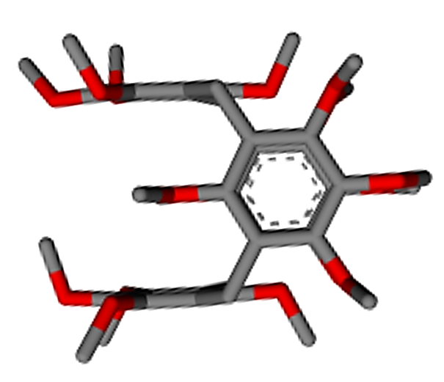  1,3-alt

Table S2: Dipole moments (in Debye) of calix[4]tetrolarenes conformers along various components
4a_cone | wB97XD/6-31 G(d) | X=2.7844 | Y=-0.7566 | Z= 3.2087 | µ= 4.3152
 | wB97XD/6-31+G(d) | X=0.8542 | Y=-2.3004 | Z= 1.4351 | µ= 2.8427
 | B97D/6-31G(d) | X=0.7402 | Y=-2.0926 | Z= 1.2472 | µ= 2.5460
 | B97D/6-31+ G(d) | X=0.7776 | Y=-2.2360 | Z= 1.9396 | µ= 3.0605
 | B3LYP/6-31 G(d) | X=2.6654 | Y=-0.7862 | Z= 3.0353 | µ= 4.1153
 | B3LYP/6-31+ G(d) | X=0.6492 | Y=-2.2174 | Z= 2.1518 | µ= 3.1573
 | CAMB3LYP/6-31 G(d) | X=0.6122 | Y=-2.2690 | Z= 2.1700 | µ= 3.1987
 | CAMB3LYP/6-31+ G(d) | X=0.7113 | Y=-2.3003 | Z= 2.1258 | µ= 3.2120
4a_partial-cone | wB97XD/6-31 G(d) | X=-5.2295 | Y=-0.2743 | Z= -2.9376 | µ=6.0044
 | wB97XD/6-31+G(d) | X=-5.2038 | Y= 0.3050 | Z= 3.0243 | µ= 6.0266
 | B97D/6-31G(d) | X=-2.5467 | Y=-2.7507 | Z=1.0042 | µ=3.8808
 | B97D/6-31+ G(d) | X=3.0190 | Y= 2.5973 | Z=0.3890 | µ=4.0015
 | B3LYP/6-31 G(d) | X=-2.5450 | Y=-1.7150 | Z= -0.6764 | µ=3.1426
 | B3LYP/6-31+ G(d) | X=2.5372 | Y= 1.5315 | Z= -0.4957 | µ=3.0048
 | CAMB3LYP/6-31 G(d) | X=2.6196 | Y=1.7372 | Z= -0.7343 | µ=3.2279
 | CAMB3LYP/6-31+ G(d) | X= 2.5497 | Y= 1.7016 | Z=-0.6776 | µ= 3.1394
4a_1,3-Alter | wB97XD/6-31 G(d) | X=1.1960 | Y=-0.0503 | Z=1.7106 | µ=2.0879
 | wB97XD/6-31+G(d) | X=1.3863 | Y=-0.1900 | Z=1.5484 | µ=2.0870
 | B97D/6-31G(d) | X=1.3161 | Y=-0.1214 | Z=1.6022 | µ=2.0770
 | B97D/6-31+ G(d) | X=1.4724 | Y=-0.1053 | Z=1.4753 | µ=2.0870
 | B3LYP/6-31 G(d) | X=0.7713 | Y=-0.0251 | Z=1.3283 | µ=1.5362
 | B3LYP/6-31+ G(d) | X=0.8779 | Y=-0.0974 | Z=1.3149 | µ=1.5840
 | CAMB3LYP/6-31 G(d) | X=0.8939 | Y=-0.0545 | Z=1.3732 | µ=1.6394
 | CAMB3LYP/6-31+ G(d) | X=0.8939 | Y=-0.0545 | Z=1.3732 | µ=1.6394
4a_1,2-Alter | wB97XD/6-31 G(d) | X=2.9884 | Y=-2.5671 | Z= -2.0256 | µ=4.4299
 | wB97XD/6-31+G(d) | X=2.8041 | Y=-2.5036 | Z= -2.1688 | µ=4.3399
 | B97D/6-31G(d) | X=2.9538 | Y=-2.2839 | Z= -1.8059 | µ=4.1476
 | B97D/6-31+ G(d) | X=2.7624 | Y=-2.2643 | Z= -1.9876 | µ=4.0876
 | B3LYP/6-31 G(d) | X=0.9643 | Y=-3.9190 | Z= -1.8535 | µ=4.4412
 | B3LYP/6-31+ G(d) | X=0.8458 | Y=-3.6295 | Z= -1.9593 | µ=4.2104
 | CAMB3LYP/6-31 G(d) | X=3.0256 | Y=-2.7276 | Z= -1.9694 | µ=4.5246
 | CAMB3LYP/6-31+ G(d) | X=2.9132 | Y=-2.4618 | Z= -2.0506 | µ=4.3304
4b_cone | wB97XD/6-31 G(d) | X=-1.0326 | Y=-4.3175 | Z=1.3209 | µ=4.6316
 | wB97XD/6-31+G(d) | X=-1.0525 | Y=-4.3116 | Z= 1.3216 | µ= 4.6308
 | B97D/6-31G(d) | X= 0.4395 | Y= -4.6868 | Z= -0.3463 | µ=4.7201
 | B97D/6-31+ G(d) | X= -0.0427 | Y= -4.6650 | Z= -0.8113 | µ=4.7352
 | B3LYP/6-31 G(d) | X=0.7162 | Y=-2.1845 | Z=0.5845 | µ=2.3721
 | B3LYP/6-31+ G(d) | X=-2.9836 | Y=-0.8895 | Z= 1.9324 | µ= 3.6643
 | CAMB3LYP/6-31 G(d) | X=0.0541 | Y=-4.6780 | Z=-0.2777 | µ=4.6865
 | CAMB3LYP/6-31+ G(d) | X= 0.0696 | Y=-4.7649 | Z=-0.3100 | µ= 4.7755
4b_partial-cone | wB97XD/6-31 G(d) | X=1.4526 | Y=-1.5593 | Z= -3.9943 | µ=4.5272
 | wB97XD/6-31+G(d) | X= 1.2876 | Y= -1.5004 | Z= -4.0337 | µ=4.4921
 | B97D/6-31G(d) | X=1.7396 | Y=-1.6896 | Z= -3.6685 | µ=4.3976
 | B97D/6-31+ G(d) | X= 1.5463 | Y= -1.6989 | Z= -3.6959 | µ=4.3517
 | B3LYP/6-31 G(d) | X=1.1563 | Y=-1.5173 | Z= -3.4143 | µ=3.9111
 | B3LYP/6-31+ G(d) | X= 1.2602 | Y= -1.4634 | Z= -3.2296 | µ=3.7630
 | CAMB3LYP/6-31 G(d) | X=0.9524 | Y=-1.6020 | Z= -3.6883 | µ=4.1324
 | CAMB3LYP/6-31+ G(d) | X= 1.2245 | Y= -1.5347 | Z= -3.5392 | µ=4.0473
4b_1,3-Alter | wB97XD/6-31 G(d) | X=-1.2997 | Y=-1.3759 | Z= -2.0281 | µ=2.7741
 | wB97XD/6-31+G(d) | X=1.3445 | Y= 1.4734 | Z= -1.7879 | µ=2.6787
 | B97D/6-31G(d) | X= 0.8788 | Y= 1.5495 | Z= -1.9212 | µ=2.6200
 | B97D/6-31+ G(d) | X=1.0205 | Y=1.3871 | Z=-1.7288 | µ=2.4401
 | B3LYP/6-31 G(d) | X=0.4820 | Y= 1.9861 | Z= -0.8335 | µ=2.2072
 | B3LYP/6-31+ G(d) | X=0.4968 | Y= 2.0951 | Z=-0.4047 | µ=2.1909
 | CAMB3LYP/6-31 G(d) | X=1.0322 | Y= 1.5287 | Z= -1.8413 | µ=2.6063
 | CAMB3LYP/6-31+ G(d) | X=0.5632 | Y= 2.0515 | Z= -1.0215 | µ=2.3600
4b_12Alter | wB97XD/6-31 G(d) | X=1.8457 | Y= 0.2026 | Z=2.4010 | µ=3.0352
 | wB97XD/6-31+G(d) | X=1.9297 | Y= 0.1957 | Z=2.3246 | µ=3.0275
 | B97D/6-31G(d) | X= 1.7313 | Y= 0.3271 | Z= 2.0860 | µ= 2.7305
 | B97D/6-31+ G(d) | X= 1.7741 | Y= 0.3205 | Z= 2.2240 | µ= 2.8629
 | B3LYP/6-31 G(d) | X=2.2962 | Y= 0.2991 | Z=2.2754 | µ=3.2465
 | B3LYP/6-31+ G(d) | X= 2.0124 | Y= 0.3325 | Z= 2.3693 | µ= 3.1263
 | CAMB3LYP/6-31 G(d) | X=2.1384 | Y= 0.1782 | Z=2.3314 | µ=3.1686
 | CAMB3LYP/6-31+ G(d) | X=2.1859 | Y= 0.2454 | Z=2.2273 | µ=3.1304
X,Y,Z indicates the components whereas µ designates the total dipole moment.

Table S3. Structural comparison of 4b at various level of theories
 | B97D/6-31d | B97D/6-31+d | CAMB3LYP/6-31+d | CAMB3LYP/6-31d | WB97XD/6-31+d | WB97XD/6-31d | B3LYP/6-31d | B3LYP/6-31+d
B97D/6-31d |  | 0.1545 | 0.2612 | 0.1867 | 0.5155 | 0.5149 | 0.9883 | 0.9883
B97D/6-31+d | 0.1545 |  | 0.2070 | 0.2202 | 0.5743 | 0.5775 | 0.9797 | 0.9797
CAMB3LYP/6-31+d | 0.2612 | 0.2070 |  | 0.1658 | 0.5871 | 0.5990 | 0.9242 | 0.9242
CAMB3LYP/6-31d | 0.1867 | 0.2202 | 0.1658 |  | 0.5423 | 0.5469 | 0.9372 | 0.9372
WB97XD/6-31+d | 0.5155 | 0.5743 | 0.5871 | 0.5423 |  | 0.0468 | 1.1234 | 1.1234
WB97XD/6-31d | 0.5149 | 0.5775 | 0.5990 | 0.5469 | 0.0468 |  | 1.1305 | 1.1305
B3LYP/6-31d | 0.9883 | 0.9797 | 0.9242 | 0.9372 | 1.1234 | 1.1305 |  | 0.00
B3LYP/6-31+d | 0.9883 | 0.9797 | 0.9242 | 0.9372 | 1.1234 | 1.1305 | 0.00

Table S4. Energetics of the components and the anionic complexes computed at B97D/6-31G* level
components | E_{total} | Enthalpy | Gibbs energy | ZPE
Cl⁻ | -460.25685304 | -460.254493 | -460.271876 | -460.256853
F⁻ | -99.70360519 | -99.701245 | -99.717764 | -99.703605
4a cone | -2754.75379913 | -2753.866805 | -2754.014589 | -2753.925273
4a cone-Cl⁻ | -3215.07019336 | -3214.183995 | -3214.339523 | -3214.244933
4a cone-F⁻ | -2854.63793590 | -2853.753030 | -2853.905156 | -2853.813068
*energies are represented in a.u.

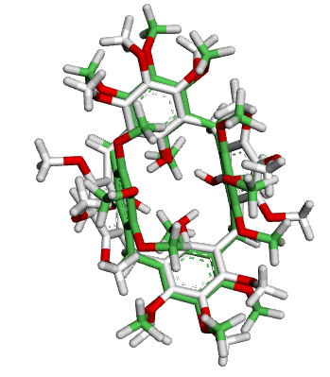
Figure S1. Superimposed Structure (4a in cone conformer) of experimental and theoretically predicted B97D/6-31+d Level

Figure S2. Naming scheme for NBO charges of cone conformer of 4a and 4b

4a_13Alternate | 4a_partial-cone
4a_12Alternate | 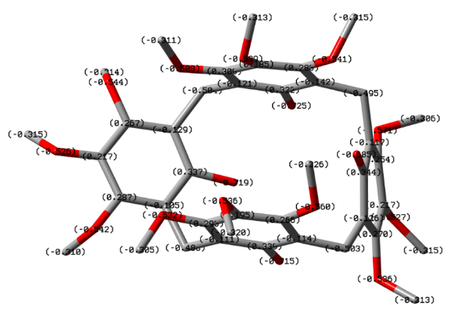  4a_cone
4b_12Alternate | 4b_13Alternate
4b_partial-cone | 4b_cone
Figure S3. NBO charges of conformer of 4a and 4b

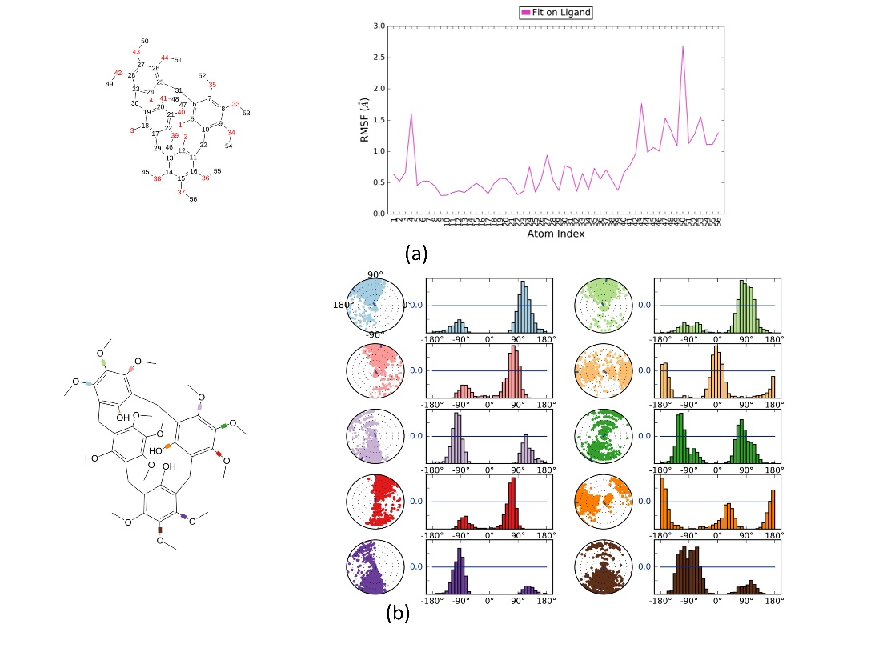
Figure S4. MD properties of 4a

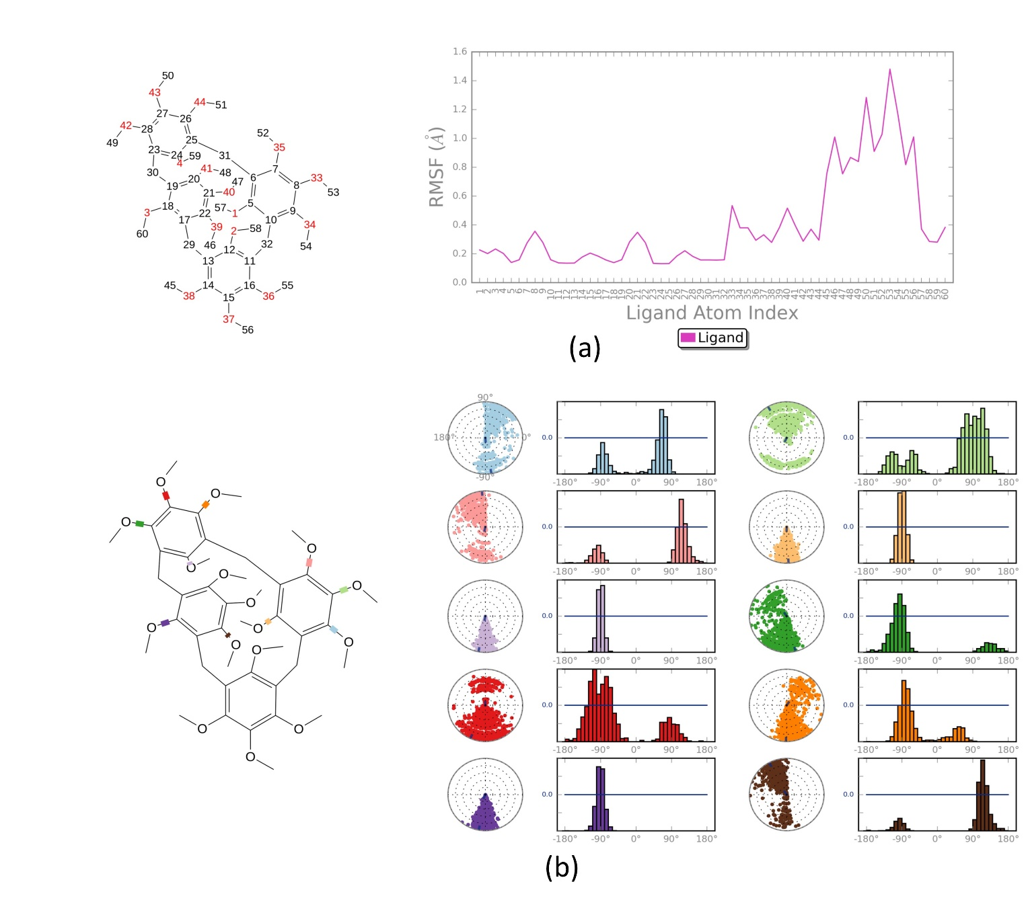
Figure S5. MD properties of 4b

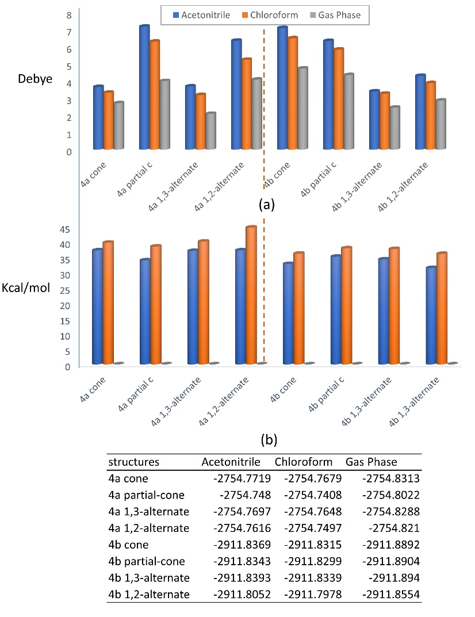
Figure S6. Solvation properties of calix[4]tetrolarenes (a) Dipole moments of conformers, (b) Energy difference of solvation phase and the gas phase (solvation energy)

