Phenanthroline-based fluorescence sensors for Eu³⁺ ion
and subsequent enantioselective discriminating of malate
Xiaoyan Liuª, Jiaxin Fuª, Kun Yaoª, Yongxin Changª, Kuoxi Xu^{a, b*}, Li Yang^{a, b∗}
ª Institute of Functional Organic Molecular Engineering, College of Chemistry and Chemical Engineering, Henan University, Kaifeng, 475004, China;
^{b} Engineering Laboratory for Flame Retardant and Functional Materials of Hennan Province, College of Chemistry and Chemical Engineering, Henan University, Kaifeng, 475004, China

Figure S1. Job's plot for the determination of stoichiometry of [L1–Eu³⁺] system in DMSO-H₂O solution (v/v = 1:5, 10 mM HEPES, pH=7.4).

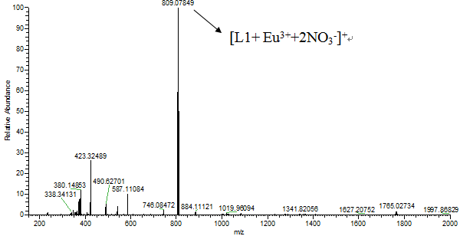
Figure S2. HRMS of L1–Eu³⁺

Figure S3. Fluorescence intensity of L1 (3.33× 10⁻⁵ M) in the absence and presence of Eu³⁺ (2.0 equiv.) in different pH (2.3-12.3) buffer solution.

Figure S4. Fluorescence spectroscopy of D1 (3.33×10⁻⁵ M) upon addition of different metals (3.0 equiv. Li⁺, Na⁺, K⁺, Ag⁺, Mg²⁺, Ba²⁺, Ca²⁺, Mn²⁺, Pb²⁺, Cu²⁺, Ni²⁺, Co²⁺, Zn²⁺, Cd²⁺, Fe²⁺, Cr³⁺, Fe³⁺ Al³⁺ and Eu³⁺) in DMSO-H₂O solution (v/v = 1:5, 10 mM HEPES, pH=7.4).

Figure S5.(A) Fluorescence spectra of D1(3.3× 10⁻⁵ M) upon addition of Eu³⁺ (0-1.3 equiv) in DMSO-H₂O solution(v/v = 1:5, 10 mM HEPES, pH=7.4, λex=358 nm).(B) The line shown was a line-fitted curve by Benesi-Hildebrand equation. The correlation coefficient (R) was0.9900. K=(0.38±0.01)×10⁴, λex= 358 nm, λem=431 nm.
Figure S6. Job's plot for the determination of stoichiometry of [D1–Eu³⁺] system in DMSO-H₂O solution(v/v = 1:5, 10 mM HEPES, pH=7.4, λex=358 nm).

Figure S7. Fluorescence intensity of D1(3.3× 10⁻⁵ M) in the absence and presence of Eu³⁺ (2.0 equiv) in different pH(2.3-12.3) buffer solution. (λex = 358 nm).

Figure S8. Fluorescence spectra of D1-Eu³⁺(3.3× 10⁻⁵ M) upon addition of different chiral carboxylic acid anion (50 equiv.) (A= D1-Eu³⁺, B= L-dibenzoyl tartrate, C= D-dibenzoyltartrate, D= L- benzene lactate, E= D- benzene lactate, F= L- methoxyphenylacetate, G= D- methoxyphenylacetate, H= L-alanine salts, I=D-alanine salts, J= L- glutamate, K= D-glutamate, L= L-mandelate, M= D-mandelate, N= L-phenylalanine salts, O= D-phenylalanine salts, P= L-tartrate, Q=D-tartrate, R= L-malate, S= D-malate)in DMSO-H₂O solution (v/v = 1:5, 10 mM HEPES, pH=7.4, λex=358 nm).

Figure S9. Fluorescent spectra of D1-Eu³⁺ (3.3× 10⁻⁵ M) with 50 equiv. of D- and L-MA in DMSO-H₂O solution (v/v = 1:5, 10 mM HEPES, pH=7.4, λex=358 nm).

Corresponding author: E-mail: xukx@henu.edu.cn.

