Additional File 7 Untransformed and first derivative spectra during root decay.
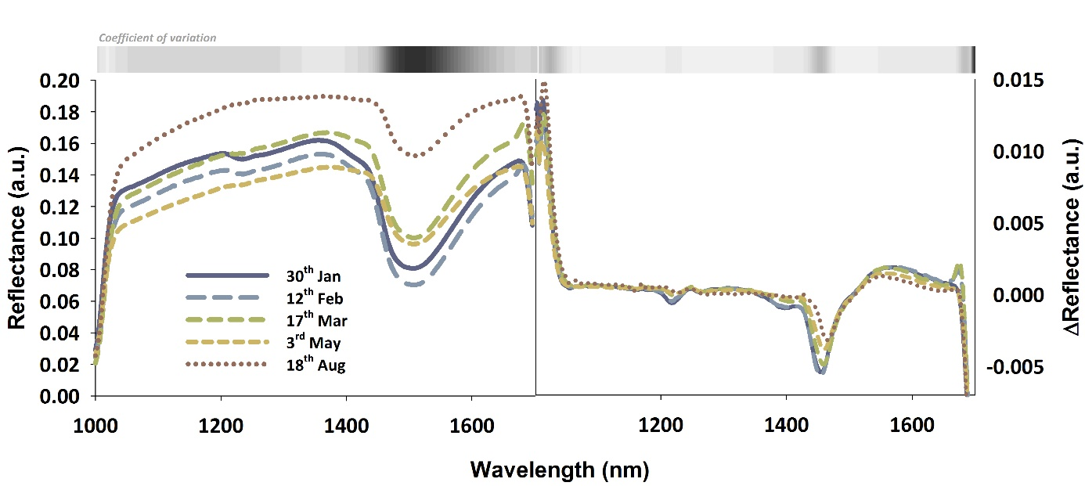

Additional File 7 Untransformed (left) and first derivative (right) mean spectra of roots at different dates after clipping of the shoot on 30th of January. The grey shaded area at the top shows the coefficient of variation indicating the wavelength region with highest distinction between the spectral lines.

