Additional File 8 Histograms at wavelengths with maximum separation between initial and final decay time for different pre-treatments.
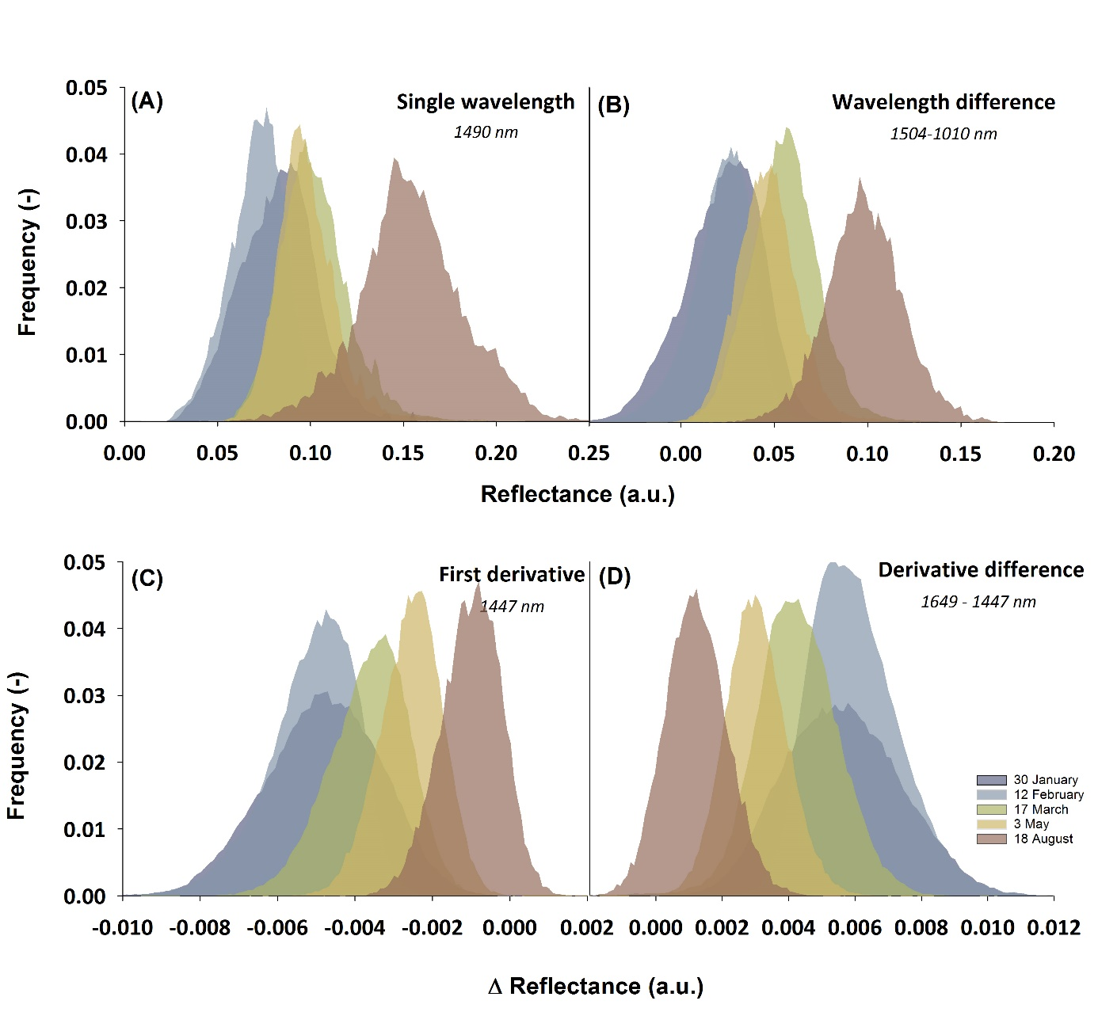
Additional File 8 Histograms showing distribution of spectral reflectance values at the waveband with highest differentiation according to Bhattacharyya distance. (A) untransformed spectra, (B) difference spectra, (C) first derivative and (D) difference first derivative spectra.

