Supporting Information
Design and Synthesis of novel enantiomerically enriched Morpholino [4, 3-a] Benzimidazole derivatives as potential bioactive agents
Pawankumar R. Tiwari, Marina E. John & Anil V. Karnik*
Department of Chemistry, University of Mumbai, Vidyanagari, Kalina,
Santacruz (E), Mumbai – 400 098 (India)

Table of Contents
- General Procedure for the synthesis of 3-5(a-e) & 6 … ……………..………...…….......2-9
- Spectral analysis of 3..…………………………………………………………….. …. .10-15
- Spectral analysis of 4 ……………………..………………………………………......16-20
- Spectral analysis of 5(a-e)…...…………… …………………………………………….21-49
- Spectral analysis of 6…………………………………………………………………….50-54
- Antibacterial and antifungal activity…...…………… ………………………………. ...55-57

Materials and Methods:
The chemicals and spectral grade solvents were purchased from S/D Fine Chemicals (India), SRL Laboratories and Sigma-Aldrich and used as received. Column chromatography was carried out using silica gel (S.D. Fine Chemicals / SRL Laboratories) 60–120 mesh. Reactions were monitored by thin-layer chromatography (TLC) on silica gel. Petroleum ether refers to the fraction with boiling point in the range of 60-90°C. All reactions were carried with dry, freshly distilled solvents under anhydrous conditions, unless otherwise noted. Melting points reported are uncorrected. IR spectra were recorded on Perkin Elmer FT-IR spectrometer. ¹H NMR and ¹³C NMR spectra were scanned in CDCl₃ and DMSO (d₆) on Bruker (300 MHz) spectrometer taking TMS as an internal standard. Mass spectra were recorded on Thermo GC-MSQP-1000, Polaris IQ spectrometer.Elemental analyses were done on Carlo Enra instrument EA-1108 Elemental analyzer. Chiral HPLC analysis was carried out on Thermo Fischer Scientific using Chiralpack-OD column. All the characterization was performed at Micro Analytical laboratory, Department of Chemistry, University of Mumbai.

General procedure for the synthesis of 2-[2-(1-Hydroxyethyl)-benzoimidazol-1-yl]-1-phenyl ethanone) (3a-e):
An equimolar proportion of [(S)-(-)-2-(α-hydroxyethyl)-benzimidazole] 2g (12.34 mmol) and Phenacyl bromide (α-bromo acetophenone) 2.45g (12.34 mmol) was taken in DMF (15 ml) and reaction was carried out in presence of 2.040g (14.80 mmol) K₂CO₃. The reaction was found to be over on tlc in 6-8 hrs at RT. Purification of the product, obtained on aq. work up, was carried out with column chromatography. The solvent eluent mixture was 80:20 (Chloroform: Pet Ether) which afforded pure white solid product. 2-[2-(1-Hydroxyethyl)-benzoimidazol-1-yl]-1-phenyl ethanone) (3a):
Optical Rotation:[α]589²⁵= - 130⁰(c 1, MeOH), The melting point was found to be 178-180 ⁰ C.

IR (KBr): ν = 3220cm⁻¹, 3059cm⁻¹, 2932cm⁻¹, 1685cm⁻¹, 1578cm⁻¹, 1249cm⁻¹, 1076cm⁻¹, 986cm⁻¹.
¹H NMR (300 MHz, CDCl₃, ppm) :δ7.16-6.98 (m, 2H; ArH), 7.25-7.19 (m, 2H; ArH), 7.50-7.39 (m, 1H; ArH), 7.70-7.53 (m, 2H; ArH), 8.00-7.76 (m, 2H; ArH), 5.77-5.51 (two doublets, J= 18.3 Hz; 2H; CH₂, coupled due to geminal coupling), 5.01-4.99 (q, J= 6.6 Hz, 1H;CH), 1.77 -1.582(two doublets for CH₃attached to CH, J = 6.6 Hz).
.
¹³ C NMR (75 MHz, CDCl₃, ppm) :δ 19.22, 21.88, 49.88, 52.17, 64.46, 65.07, 94.63, 108.88, 109.04, 119.12, 119.67, 122.28, 122.39, 156.17, 192.17.
Anal.calcd forC₁₇H₁₆N₂O₂C, 72.85 H 5.75 N 10.01 foundC 72.74; H 5.65; N 10.01
DEPT ¹³⁵ (75 MHz, CDCl₃, ppm): Two negative peaks one at δ 49.87 and other at δ 52.17 indicating two methylene protons in compound.
Mass Spectrum: Molecular ion m/z value of 280.

General procedure for the synthesis of 2-[2-(1-Hydroxyethyl)-benzoimidazol-1-yl]-phenyl ethanol) (4a-e):
The 2-[2-(1-Hydroxyethyl)-benzoimidazol-1-yl]-1- phenyl ethanone) 1 g (3.57 mmol) was taken in methanol and was treated with sodium borohydride 0.033 g (0.892 mmol) with external cooling. The reaction was stopped after complete disappearance (3a) was observed on TLC. The reaction mixture was poured on ice cold water and stirred for half an hour resulting in a white solid product which was filtered, washed and dried. 2-[2-(1-Hydroxyethyl)-benzoimidazol-1-yl]-phenyl ethanol) (4a):
Optical Rotation:[α]589²⁵= - 107⁰(c 1, MeOH), The melting point was found to be 108-112⁰ C.

IR (KBr, cm⁻¹): ν =3291cm⁻¹, 3055cm⁻¹, 2671cm⁻¹, 1614cm⁻¹,1495cm⁻¹, 1330cm⁻¹, 1068cm⁻¹.
¹H NMR (300 MHz, CDCl₃, ppm): δ = 7.268-7.231 (m, 2H; ArH), 7.37- 7.273 (m, 2H; ArH), 7.429-7.378 (m, 2H; ArH),7.501- 7.45 (m, 1H; ArH), 7.72-7.769 (m, 2H; ArH), 5.205-5.114 (m, 1H; CH attached to CH₂ group)5.009 - 4.961- (q, 1H; J = 3.3 Hz; CH), -4.2743.994 (m, 2H; CH₂ attached to CH group), 1.526-1.411 (d, J = 6.6 Hz; 3H; CH₃ group).
¹³ C NMR (75 MHz, CDCl₃, ppm): 20.49, 22.35, 51.48, 51.67, 61.62, 63.89, 71.63, 72.13, 109.65, 118.92, 122.35, 134.59, 141.41, 156.37, 156.71.
Anal.calcd forC₁₇H₁₈N₂O₂ C, 72.34; H, 6.38; N 9.9 Found C, 72.42; H, 6.48; N 9.7
DEPT ¹³⁵ (75 MHz, CDCl₃, ppm): Two negative peaks one at δ 51.47 and other at 51.67 indicating two methylene protons in the product.
Mass Spectrum: Molecular ion m/z value of 282.

General procedure for the synthesis of 2’-aryl-6’-methyl morpholino [4, 3-a] Benzimidazole) (5):
5(a)Synthsis of 2’-(phenyl)-6’-methyl morpholino [4, 3-a] Benzimidazole
The 2-[2-(1-Hydroxyethyl)-benzoimidazol-1-yl]-1-phenylethanol 1g (3.54mmol) was taken in a round bottom flask and refluxed for 5-6 hrs in 4N HCl after complete disappearance of starting material on tlc. The reaction mixture was poured on ice cold water followed by neutralization using NaHCO₃ which afforded a sticky mass. The crude mass was subjected to column chromatography by taking eluent mixture as 90:10 (CHCl₃:CH₃COOC₂H₅) resulting in semisolid product. The m.p. of the compound obtained was 56-60⁰C.
Optical Rotation:[α]589²⁵= - 40⁰(c 1, MeOH)
IR (KBr, cm⁻¹): ν = 3062 cm⁻¹, 2981cm⁻¹, 2206cm⁻¹, 1616cm⁻¹, 1519cm⁻¹, 1474cm⁻¹, 1109cm⁻¹, 944cm⁻¹.
¹H NMR (300 MHz, CDCl₃, ppm) : δ = 7.362-.7.196 (m, 7H; ArH), 7.742- 7.373 (m, 2H; ArH), 7.429-7.378 (m, 2H; ArH),7.501-7.45 (m, 1H; ArH), 7.72-7.769 (m, 2H; ArH), 5.205-5.114 (m, 1H; CH attached to CH₂ group) 5.009-4.961 (q, 1H; J = 3.3 Hz; CH), 4.274-3.994 (m, 2H; CH₂ attached to CH group), 1.853-1.752 (two doublets for CH₃attached to CH, J = 6.6 Hz).
¹³ C NMR (75 MHz, CDCl₃, ppm):19.34, 19.50, 47.46, 48.40, 69.23,69.71, 72.19, 75.63, 108.90, 119.45, 122.34, 126.11, 128.75, 134.05, 151.68.
Anal.calcd forC₁₇H₁₆N₂OC, 72.77 H 5.55 N 10.08 found C 72.74; H 5.45; N 10.05
DEPT ¹³⁵ (75 MHz, CDCl₃, ppm): Two negative peaks one at δ 47.46 and other at 48.39 indicating two methylene protons in the product.
Mass Spectrum: Molecular ion m/z value of 264.
Chiral HPLC:Chiralcel OD column of diacel, Solvent system: IPA: Hexane, 15:85, Flow rate = 0.5 mL/min, λ = 255 nm, t = 14.243 min, t = 19.393 min.

5(b)Synthesis of 2’-(p-methoxyphenyl)-6’-methyl morpholino [4, 3-a] Benzimidazole
The 2-[2-(1-Hydroxyethyl)-benzoimidazol-1-yl]-1-p-methoxy-phenyl-ethanol 1g (3.20 mmol) was taken in a round bottom flask and refluxed for 5-6 hrs in 4N HCl after complete disappearance of starting material on tlc the reaction mixture was poured on ice cold water along with neutralization by NaHCO₃ afforded sticky mass which was subjected to column chromatography by taking eluent mixture as 90:10 (CHCl₃:CH₃COOC₂H₅) resulting in semisolid product. The m.p. of the compound obtained was 58-62 ⁰C.
IR (KBr, cm⁻¹): ν = 2981cm⁻¹, 2931cm⁻¹, 2204cm⁻¹, 1615cm⁻¹, 1519cm⁻¹, 1474cm⁻¹, 1110cm⁻¹, 944cm⁻¹
¹H NMR (300 MHz, CDCl₃, ppm): δ = 7.73-7.75 (m, 1H; ArH), 7.400- 7.217 (m, 5H; ArH), 6.948-6.888 (m, 2H; ArH), 5.334-5.088 (m, 1H; CH attached to CH₂ group) 4.905-4.870 (q, 1H; J = 3.3 Hz; CH), 4.179-3.995 (m, 2H; CH₂ attached to CH group), 3.784 (s, 3H, OCH₃ attached to aromatic ring), 1.824-1.728 (two doublets for 3H, J = 6.6 Hz).
¹³ C NMR (75 MHz, CDCl₃, ppm):19.33, 19.48, 47.29, 48.30, 55.31, 68.99, 69.41, 72.11, 75.31, 75.60, 76.74, 77.16, 77.59, 108.94, 112.12, 113.86, 114.20, 116.06, 119.50, 121.41, 122.29, 122.44, 122.58, 122.67, 125.76, 127.10, 127.56, 127.92, 129.53, 129.97, 130.32, 133.78, 134.06, 142.74, 151.74, 159.90, 159.94.
DEPT ¹³⁵ (75 MHz, CDCl₃, ppm):Two negative peaks one at δ 47.27 and other at 48.02 indicating two methylene protons in the product.
Mass Spectrum: Molecular ion m/z value of 294
Chiral HPLC:Chiralcel OD column of diacel, Solvent system:IPA: Hexane, 15:85, Flow rate = 0.5 mL/min, λ = 255 nm, t = 14.857min, t = 20.130 min.
5(c)Synthsis of 2’-(p-methylphenyl)-6’-methyl morpholino [4, 3-a] Benzimidazole
The 2-[2-(1-Hydroxyethyl)-benzoimidazol-1-yl]-1-p-tolyl-ethanol 1g (3.37mmol) was taken in a round bottom flask and refluxed for 5-6 hrs in 4N HCl after complete disappearance of starting material on tlc the reaction mixture was poured on ice cold water along with neutralization by NaHCO₃ afforded sticky mass which was subjected to column chromatography by taking eluent mixture as 90:10 (CHCl₃:CH₃COOC₂H₅) resulting in semisolid product. The m.p. of the compound obtained was 56-58⁰C.
IR (KBr, cm⁻¹): ν = 2981cm⁻¹, 2211cm⁻¹, 1616cm⁻¹, 1594cm⁻¹, 1518cm⁻¹, 1488cm⁻¹, 1230cm⁻¹, 1148cm⁻¹
¹H NMR (300 MHz, CDCl₃, ppm): δ = 7.742- 7.387 (m, 1H; ArH),7.362-7.196 (m, 7H; ArH), 5.961-5.343(m, 1H; CH attached to CH₂ group) 5.138-4.939 (q, 1H; J = 3.3 Hz; CH), 4.312-3.999 (m, 2H; CH₂ attached to CH group), 2.372 (s, 3H;CH₃attached to aromatic ring), 1.834-1.740 (two doublets for CH₃attached to CH , J = 6.6 Hz).
¹³ C NMR (75 MHz, CDCl₃, ppm):19.34, 19.49, 21.16, 21.19, 47.41, 48.40, 69.11, 69.65, 72.17, 75.57, 76.65, 77.08, 77.50, 108.90, 119.46, 119.57, 122.31, 122.46, 122.60, 122.68, 125.82, 126.11, 129.18, 129.47, 134.51, 134.91, 138.62, 142.70.
DEPT ¹³⁵ (75 MHz, CDCl₃, ppm): Two negative peaks one at δ 47.42 and other at 48.39 indicating two methylene protons in the product.
Mass Spectrum:Molecular ion m/z value of 279
Chiral HPLC:Chiralcel OD column of diacel, Solvent system: IPA: Hexane, 15:85, Flow rate = 0.5 mL/min, λ = 255 nm, t = 14.447 min, t = 19.853 min.

5(d)Synthesis of 2’-(p-bromophenyl)-6’-methyl morpholino [4, 3-a] Benzimidazole
The 2-[2-(1-Hydroxyethyl)-benzoimidazol-1-yl]-1-p-bromo-phenyl-ethanol 1g (2.77 mmol) was taken in a round bottom flask and refluxed for 5-6 hrs in 4N HCl after complete disappearance of starting material on tlc the reaction mixture was poured on ice cold water along with neutralization by NaHCO₃ afforded sticky mass which was subjected to column chromatography by taking eluent mixture as 90:10 (CHCl₃:CH₃COOC₂H₅) resulting in semisolid product. The m.p. of the compound obtained was 54-56⁰C.
IR (KBr, cm⁻¹): ν = 3061cm⁻¹, 2981cm⁻¹, 2931cm⁻¹, 1427cm⁻¹, 1474cm⁻¹, 1449cm⁻¹, 1229cm⁻¹, 1042cm⁻¹, 908cm⁻¹.
¹H NMR (300 MHz, CDCl₃, ppm): δ = 7.721-7.545 (m, 1H; ArH), 7.521-7.353 (m, 2H; ArH), 7.324-7.251 (m, 5H; ArH), 5.374-5.117 (m, 1H; CH attached to CH₂ group), 5.100-4.891 (q, 1H; J = 3.3 Hz; CH), 4.271-3.892 (m, 2H; CH₂ attached to CH group), 1.821-1.716 (two doublets for 3H, J = 6.6 Hz).
¹³ C NMR (75 MHz, CDCl₃, ppm):19.285, 19.452, 47.353, 48.272, 69.168, 69.598, 72.070, 75.479, 76.768, 77.193, 77.617, 108.883, 119.368, 119.486, 122.254, 122.405, 122.546, 122.629, 126.056, 126.430, 128.370, 128.665, 128.742, 133.708, 134.003, 137.485, 137.848, 142.707, 142.722, 151.530, 151.607
DEPT ¹³⁵ (75 MHz, CDCl₃, ppm) :Two negative peaks one at δ 47.34 and other at 48.25 indicating two methylene protons in the product.
Mass Spectrum:Molecular ion m/z value of 343
Chiral HPLC:Chiralcel OD column of diacel, Solvent system:IPA: Hexane, 15:85, Flow rate = 0.5 mL/min, λ = 255 nm, t = 14.857 min, t = 20.130 min.

5(e)Synthesis of 2’-(p-chlorophenyl)-6’-methyl morpholino [4, 3-a] Benzimidazole
The 2-[2-(1-Hydroxyethyl)-benzoimidazol-1-yl]-1-p-chloro-phenyl-ethanol 1g (3.16 mmol) was taken in a round bottom flask and refluxed for 5-6 hrs in 4N HCl after complete disappearance of starting material on tlc the reaction mixture was poured on ice cold water along with neutralization by NaHCO₃ afforded sticky mass which was subjected to column chromatography by taking eluent mixture as 90:10 (CHCl₃:CH₃COOC₂H₅) resulting in semisolid product. The m.p. of the compound obtained was 54-58⁰C.
IR (KBr, cm⁻¹): ν = 3361cm⁻¹, 2981cm⁻¹, 2931cm⁻¹, 1653cm⁻¹, 1427cm⁻¹, 1222cm⁻¹, 1111cm⁻¹, 928cm⁻¹.
¹H NMR (300 MHz, CDCl₃, ppm):δ = 7.776-7.752 (m, 1H; ArH), 7.737-7.357 (m, 4H; ArH), 7.291-7.231 (m, 3H; ArH), 5.402-5.176 (m, 1H; CH attached to CH₂ group), 5.159-4.961 (q, 1H; J = 3.3 Hz; CH), 4.286-4.032 (m, 2H; CH₂ attached to CH group), 1.853-1.752 (two doublets for 3H, J = 6.6 Hz).
¹³ C NMR (75 MHz, CDCl₃, ppm):19.26, 19.461, 47.298, 48.134, 68.99, 69.26, 72.121, 74.80, 76.70, 77.133, 77.558, 108.885, 119.381, 119.494, 122.418, 122.565, 122.590, 122.62, 122.691, 122.781, 122.781, 127.728, 128.094, 131.877, 133.904, 136.525, 136.856, 142.576, 151.292, 151.381.
DEPT ¹³⁵ (75 MHz, CDCl₃, ppm) :Two negative peaks one at δ 47.294 and other at 48.123 indicating two methylene protons in the product.
Mass Spectrum:Molecular ion m/z value of 298

6 Synthesis of 2-(2-Acetyl-1H-benzimidazol-1-yl)-1-phenylethanone

To a solution of 3a 1 g (3.57mmol) in dil H₂SO₄ (5% 10 ml) was added at RT a solution of K₂Cr₂O₇ 1.05 g (3.57mmol) in water (6ml) and conc. H₂SO₄ (4 ml) in a dropwise fashion, over a period of 20 mins. The reaction mixture was stirred vigorously during addition. The separated solid was filtered and washed with water (3 x 5ml). The precipitate was resuspended in water (10 ml) and treated very carefully with aq. NH₃ to a pH of 6.0 – 6.5. The suspension was stirred for 0.5 hr and filtered. The residue was washed with water (3 x 5 ml) and dried to obtain 6. The m.p. of the compound obtained was 166-168⁰C.
IR (KBr, cm⁻¹): ν =2939 cm⁻¹, 1683cm⁻¹, 1613cm⁻¹, 1595cm⁻¹, 1480cm⁻¹, 1449cm⁻¹, 1397cm⁻¹,1356 cm⁻¹.
¹H NMR (300 MHz, CDCl₃, ppm):δ =8.049-7.934(m, 3H;3 Ar protons), 7.657-7.264(m, 6H;6 Ar protons) 6.024 (s, 2H; CH₂ group), 2.81 (s, for 3H, CH₃group).
¹³ C NMR (75 MHz, CDCl₃, ppm):27.750, 51.340, 9.962, 122.199, 123.965, 126.302, 128.053, 129.015, 134.159, 134.597, 136.685, 141.741, 146.035, 191.797, 193.600.
DEPT ¹³⁵ (75 MHz, CDCl₃, ppm): One negative peaks at δ 51.45 indicating methylene proton in the product.
Mass Spectrum: Molecular ion m/z value of 278

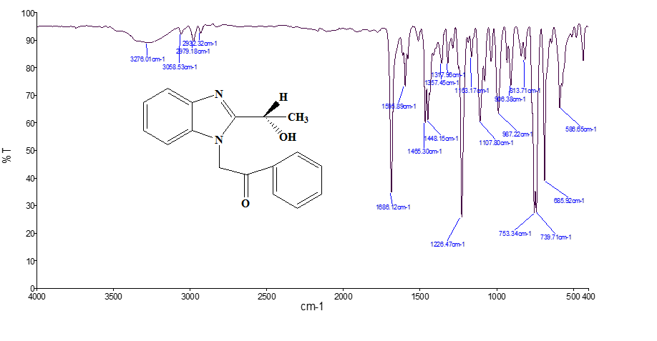
Spectrum -1
IR Spectrum of 2-[2-(1-Hydroxyethyl)-benzoimidazol-1-yl]-1-phenylethanone (3a)
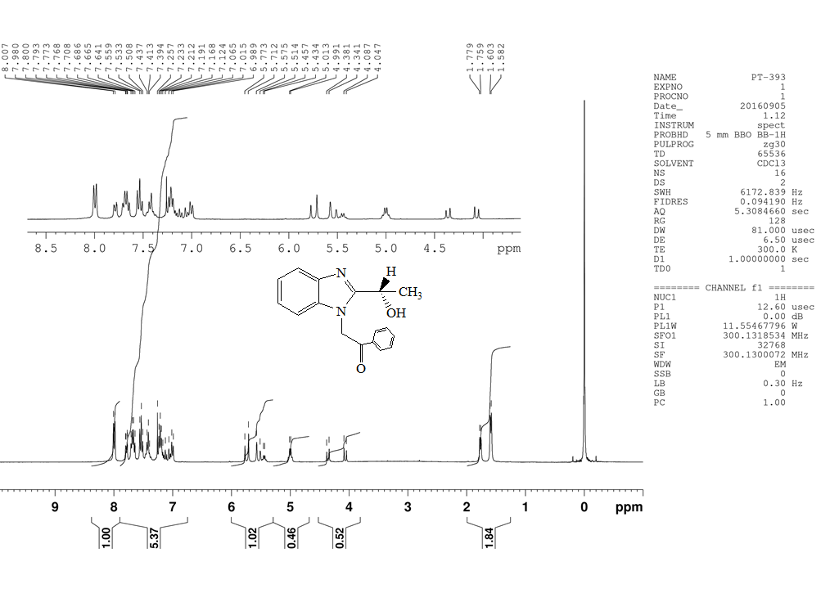
Spectrum-2
¹H NMR Spectrum of 2-[2-(1-Hydroxyethyl)-benzoimidazol-1-yl]-1-phenylethanone (3a)

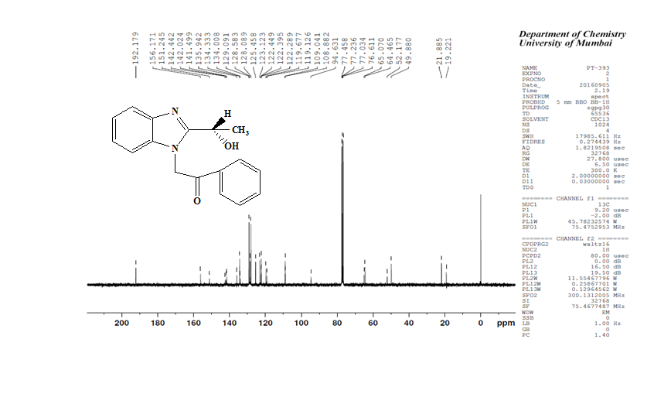

Spectrum-3
¹³C NMR Spectrum of 2-[2-(1-Hydroxyethyl)-benzoimidazol-1-yl]-1-phenylethanone (3a)

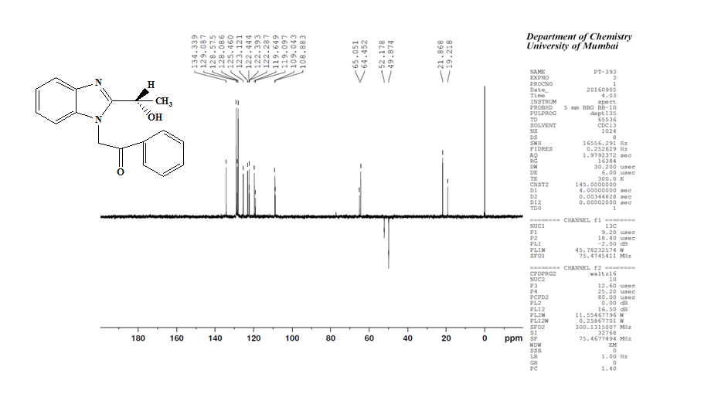
Spectrum-4
¹³C NMR DEPT Spectrum of 2-[2-(1-Hydroxyethyl)-benzoimidazol-1-yl]-1-phenylethanone (3a)

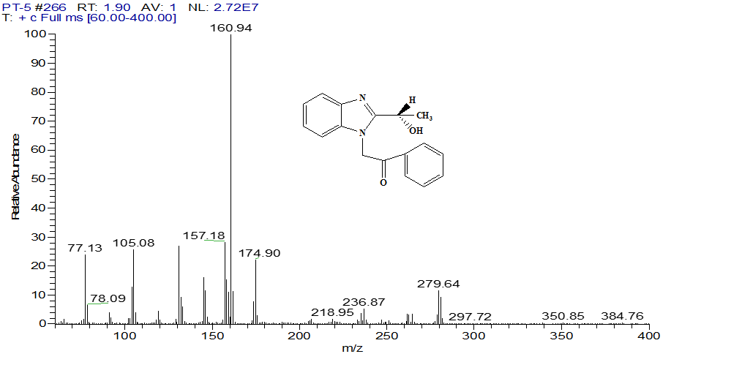

Spectrum-5
Mass Spectrum of 2-[2-(1-Hydroxyethyl)-benzoimidazol-1-yl]-1-phenylethanone (3a)

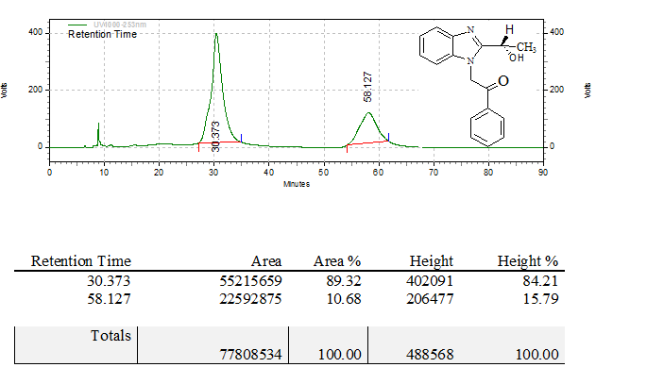

Spectrum-6
HPLC Spectrum of 2-[2-(1-Hydroxyethyl)-benzoimidazol-1-yl]-1-phenylethanone (3a)

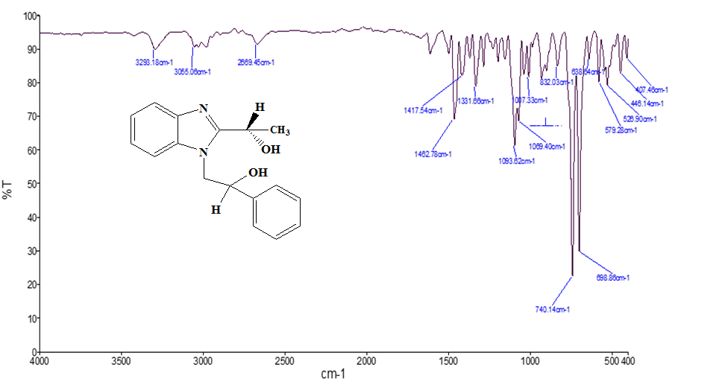

Spectrum-7
IR Spectrum of 2-[2-(1-Hydroxyethyl)-benzoimidazol-1-yl]-1-phenylethanol (4a)
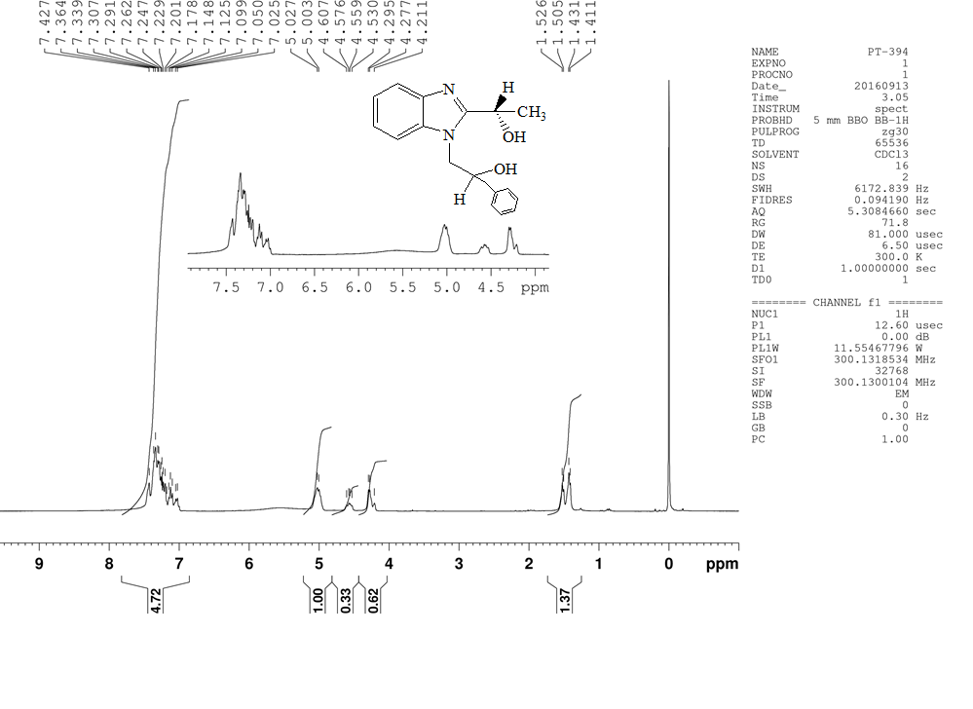Spectrum-8
¹H NMR Spectrum of 2-[2-(1-Hydroxyethyl)-benzoimidazol-1-yl]-1-phenylethanol (4a)
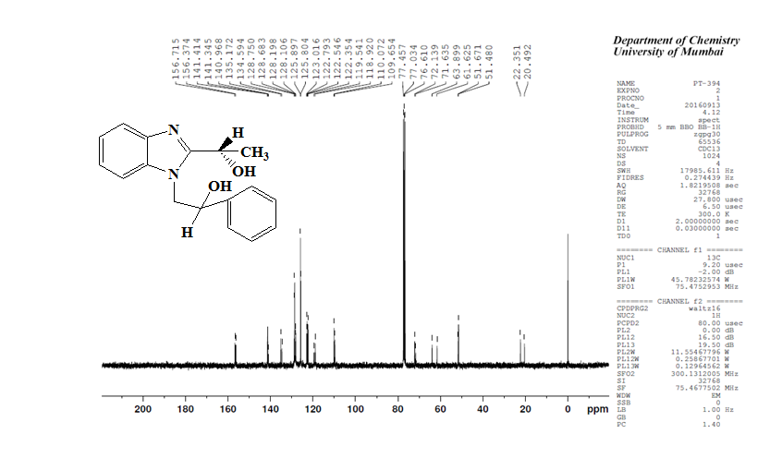
Spectrum-9
¹³C NMR Spectrum of 2-[2-(1-Hydroxyethyl)-benzoimidazol-1-yl]-1-phenylethanol (4a)
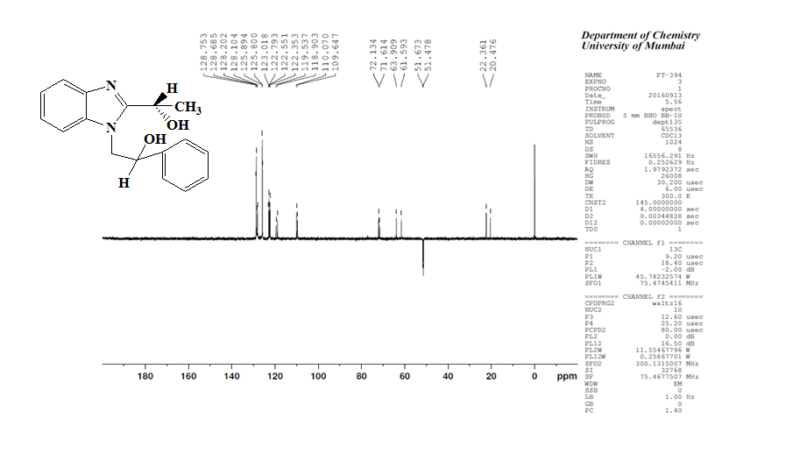
Spectrum-10
¹³C NMRDEPT Spectrum of 2-[2-(1-Hydroxyethyl)-benzoimidazol-1-yl]-1-phenylethanone (4a)
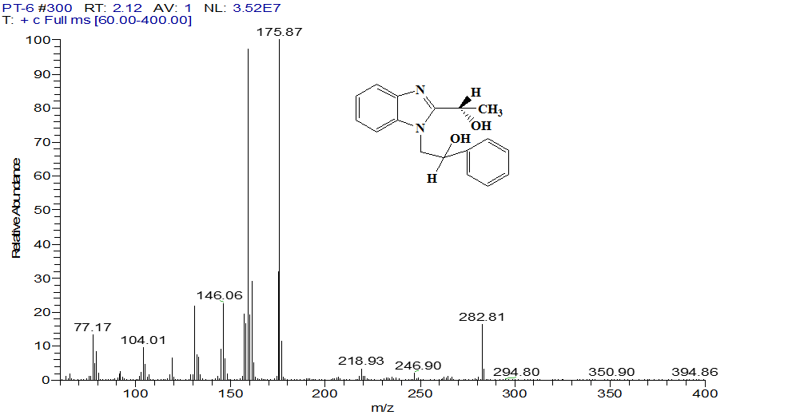
Spectrum-11
Mass Spectrum of 2-[2-(1-Hydroxyethyl)-benzoimidazol-1-yl]-1-phenylethanol (4a)
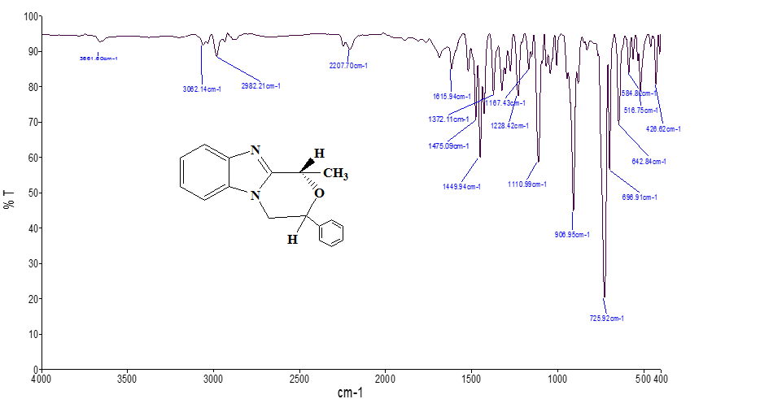
Spectrum-12
IR Spectrum of 2’aryl-6’methylmorpholino [4, 3-a] Benzimidazole (5a)
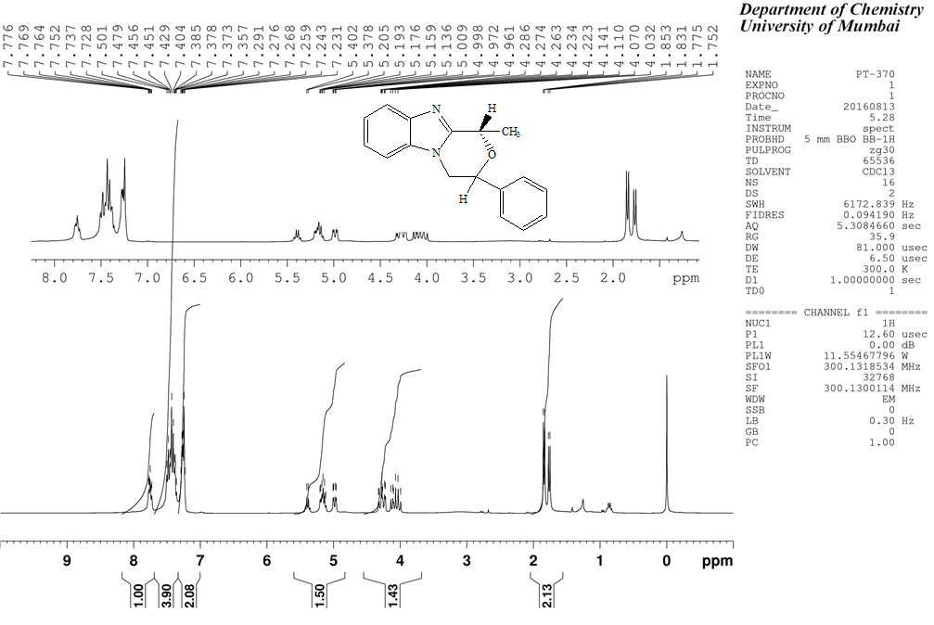
Spectrum-13
¹H NMR Spectrum of 2’aryl-6’methylmorpholino [4, 3-a] Benzimidazole (5a)
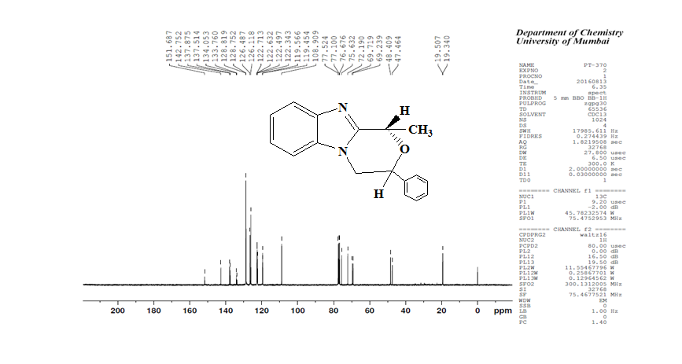

Spectrum-14
¹³C NMR Spectrum of 2’aryl-6’methylmorpholino [4, 3-a] Benzimidazole (5a)
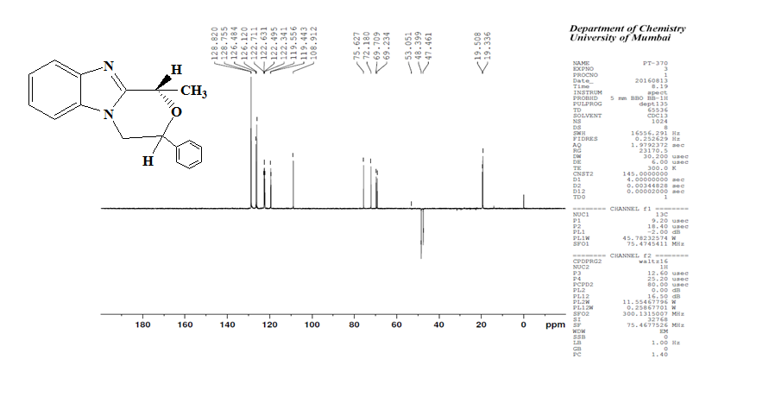

Spectrum-15
¹³C NMR DEPT Spectrum 2’aryl-6’methylmorpholino [4, 3-a] Benzimidazole (5a)

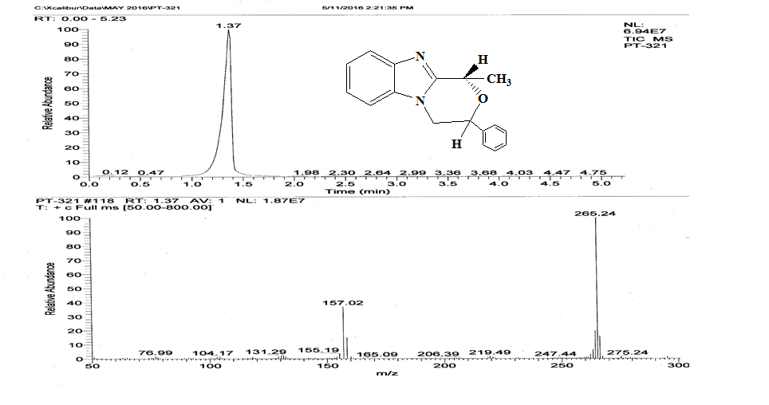

Spectrum-16
Mass Spectrum of 2’aryl-6’methylmorpholino [4, 3-a] Benzimidazole (5a)
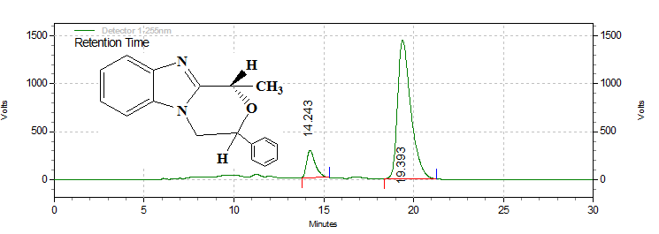
Retention Time | Area | Area % | Height | Height %
14.243 | 9416440 | 11.32 | 284905 | 16.51
19.393 | 73754839 | 88.68 | 1440335 | 83.49
Totals
 | 83171279 | 100.00 | 1725240 | 100.00

Spectrum-17
Chiral HPLC of 2’aryl-6’methylmorpholino [4, 3-a] Benzimidazole (5a)
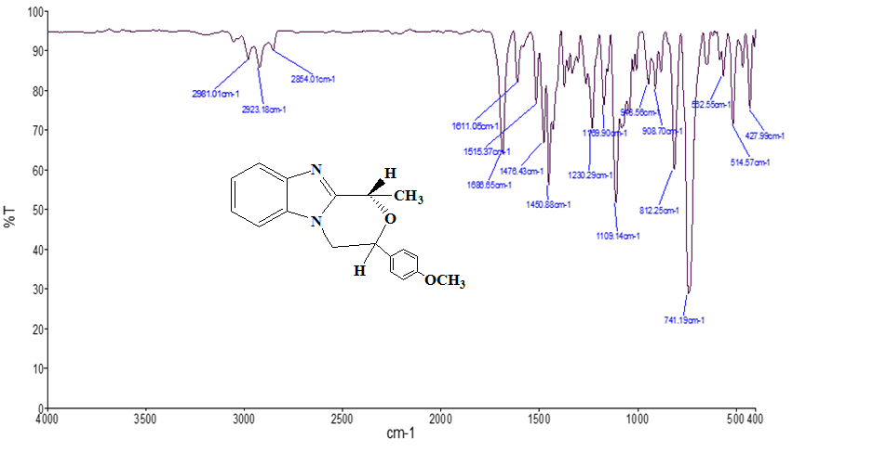

Spectrum-18
IR Spectrum of 2’-(p-methoxyphenyl)-6’-methylmorpholino [4, 3-a] Benzimidazole (5b)
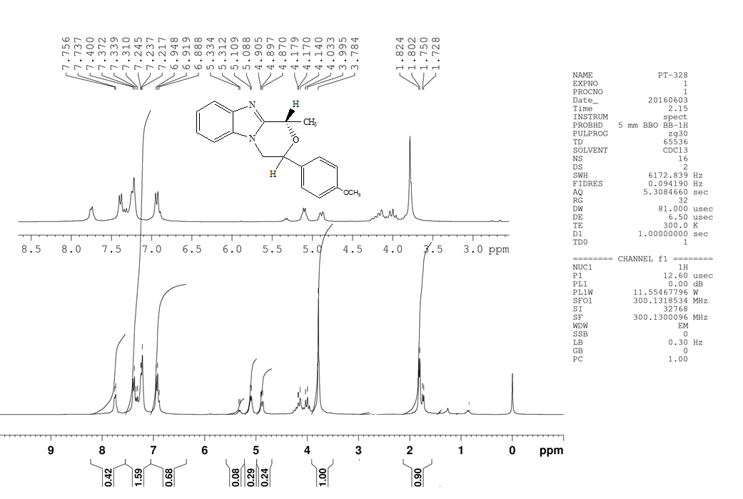

Spectrum-19
¹H NMR Spectrum of 2’-(p-methoxyphenyl)-6’-methylmorpholino [4, 3-a] Benzimidazole (5b)

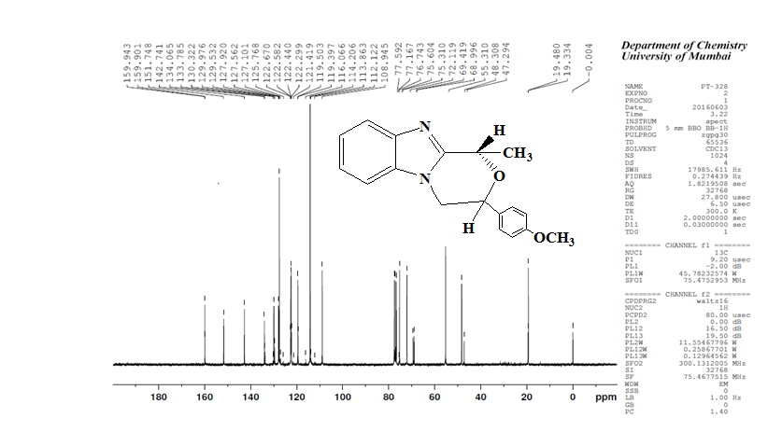
Spectrum-20
¹³C NMR Spectrum of 2’-(p-methoxyphenyl)-6’-methylmorpholino [4, 3-a] Benzimidazole (5b)

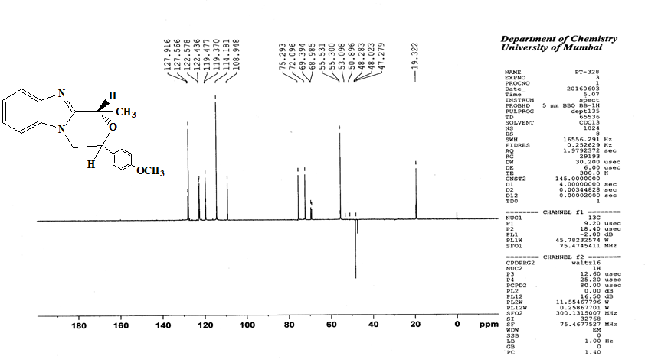
Spectrum-21
¹³C NMR DEPT Spectrum of 2’-(p-methoxyphenyl)-6’-methylmorpholino [4,3-a] Benzimidazole (5b)

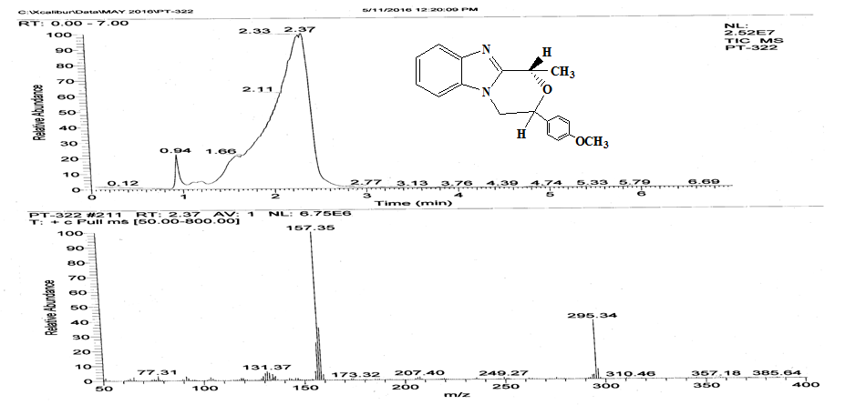
Spectrum-22
Mass Spectrum of 2’-(p-methoxyphenyl)-6’-methylmorpholino [4, 3-a] Benzimidazole (5b)
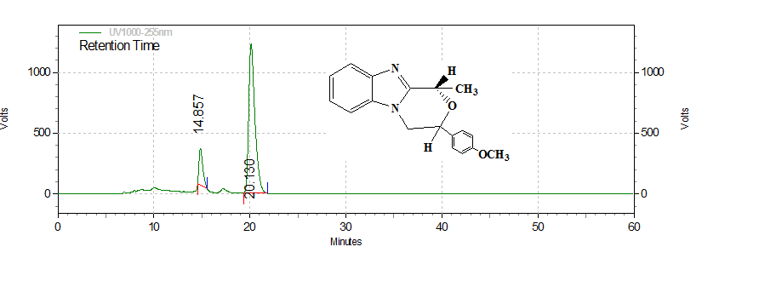
Retention Time | Area | Area % | Height | Height %
14.857 | 8476949 | 13.08 | 304052 | 19.80
20.130 | 56313604 | 86.92 | 1231612 | 80.20
Totals
 | 64790553 | 100.00 | 1535664 | 100.00

Spectrum-23
Chiral HPLC of 2’-(p-methoxyphenyl)-6’-methylmorpholino [4, 3-a] Benzimidazole (5b)
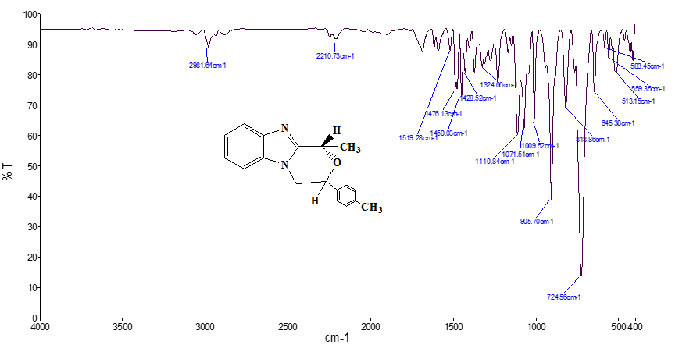

Spectrum-24
IR Spectrum of 2’-(p-methylphenyl)-6’-methylmorpholino [4, 3-a] Benzimidazole (5c)

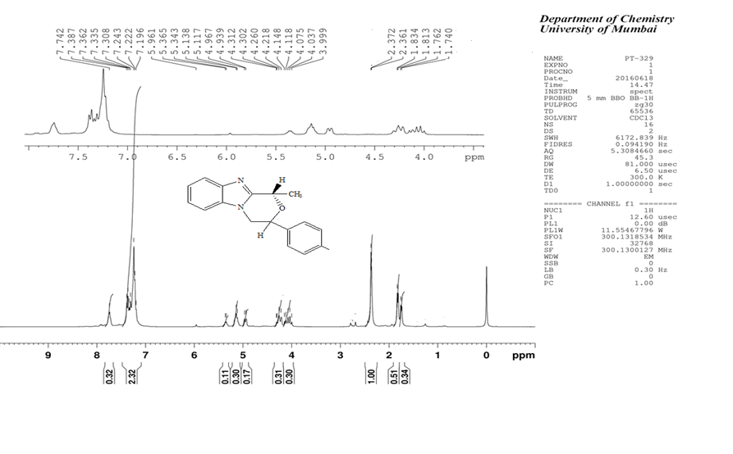
Spectrum-25
¹H NMR Spectrum of 2’-(p-methylphenyl)-6’-methylmorpholino [4, 3-a] Benzimidazole(5c)

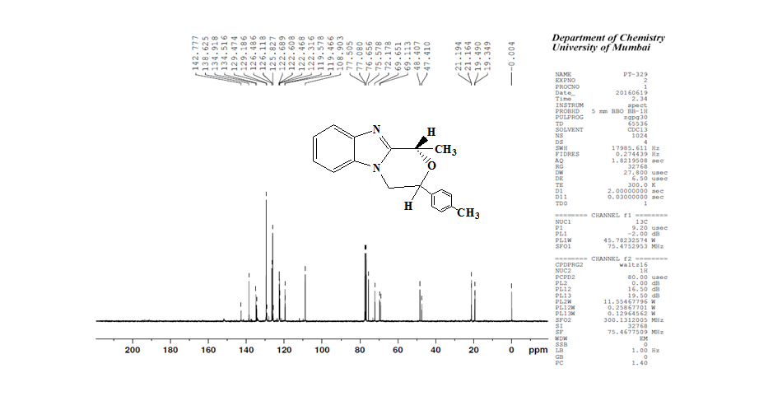
Spectrum-26
¹³ C NMR Spectrum of 2’-(p-methylphenyl)-6’-methylmorpholino [4, 3-a] Benzimidazole (5c)
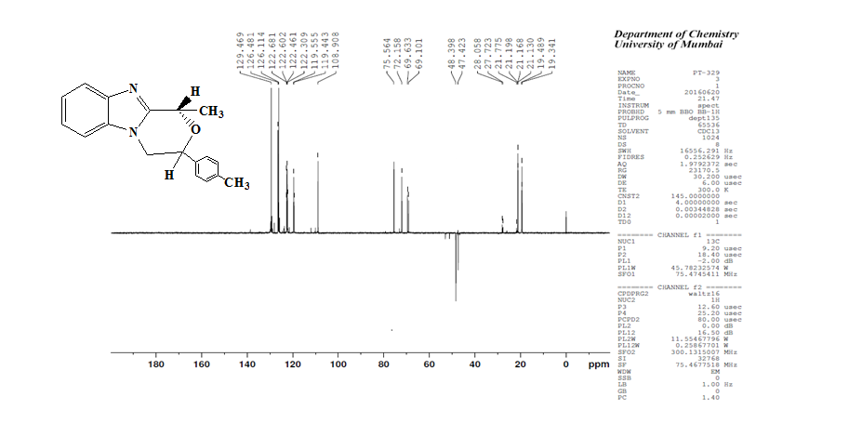

Spectrum-27
¹³ C NMR DEPT Spectrum of 2’-(p-methylphenyl)-6’-methylmorpholino [4, 3-a] Benzimidazole (5c)

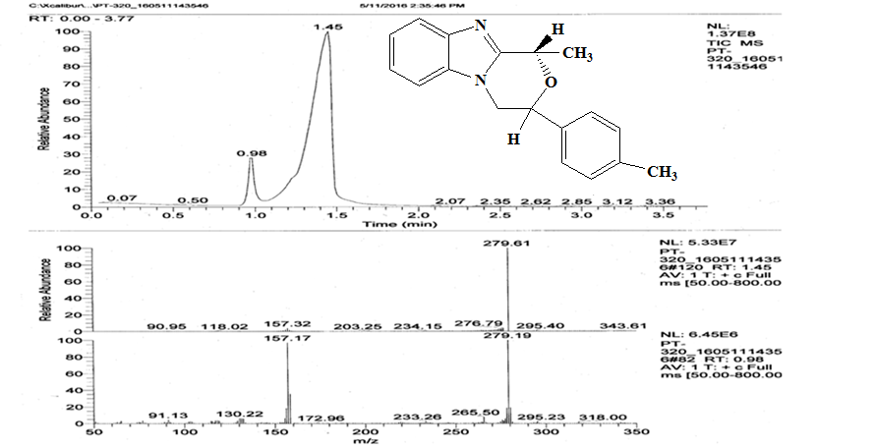
Spectrum-28
Mass Spectrum of 2’-(p-methylphenyl)-6’-methylmorpholino [4, 3-a] Benzimidazole (5c)
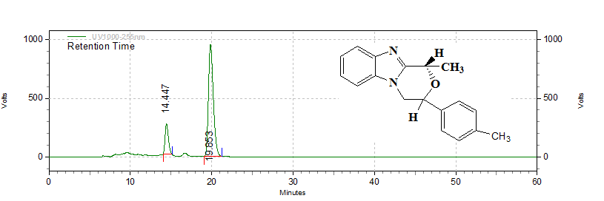
Retention Time | Area | Area % | Height | Height %
14.447 | 7168696 | 15.42 | 258453 | 21.33
19.853 | 39321965 | 84.58 | 953056 | 78.67
Totals
 | 46490661 | 100.00 | 1211509 | 100.00

Spectrum-29
Chiral HPLC of 2’-(p-methylphenyl)-6’-methylmorpholino [4, 3-a] Benzimidazole (5c)
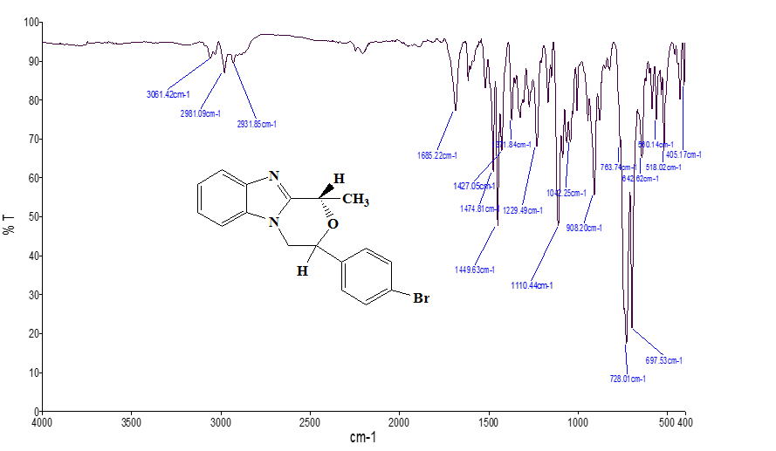
Spectrum-30
IR Spectrum of 2’-(p-bromophenyl)-6’-methylmorpholino [4, 3-a] Benzimidazole (5d)
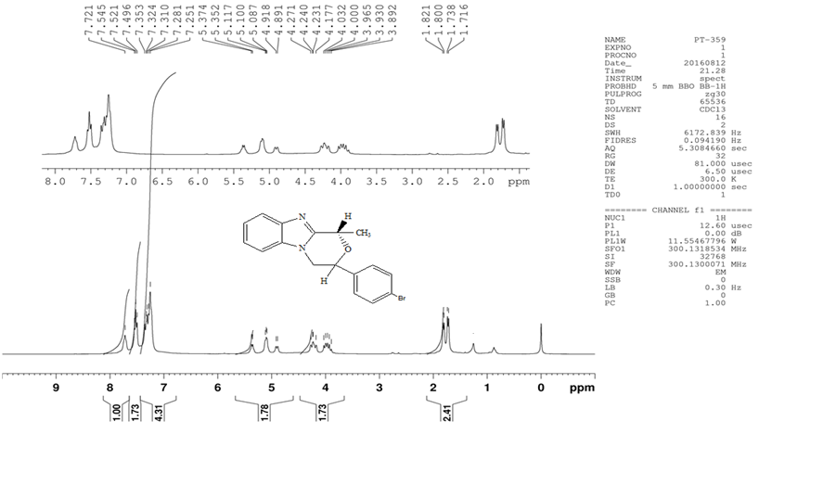
Spectrum-31
¹HNMR Spectrum of 2’-(p-bromophenyl)-6’-methylmorpholino [4, 3-a] Benzimidazole (5d)
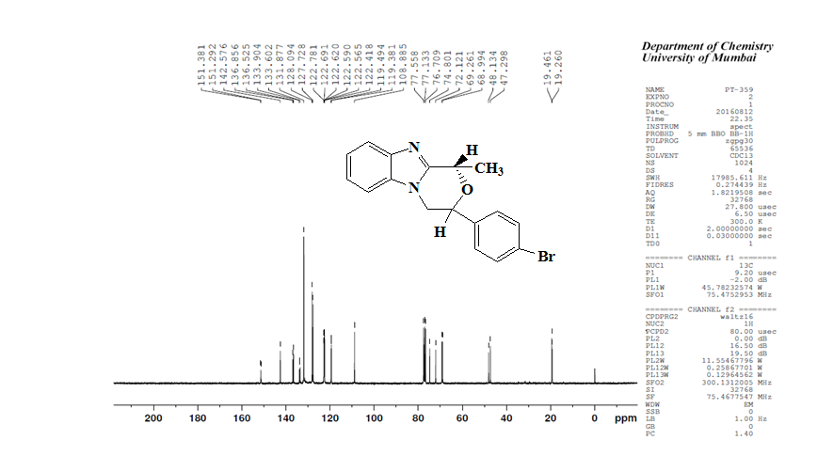
Spectrum-32
¹³C NMR Spectrum of 2’-(p-bromophenyl)-6’-methylmorpholino [4, 3-a] Benzimidazole (5d)
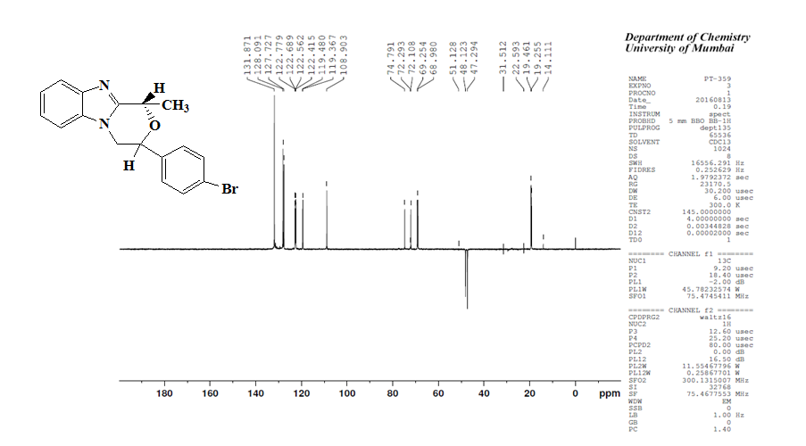
Spectrum-33
¹³C NMR DEPT Spectrum of 2’-(p-bromophenyl)-6’-methylmorpholino [4, 3-a] Benzimidazole (5d)
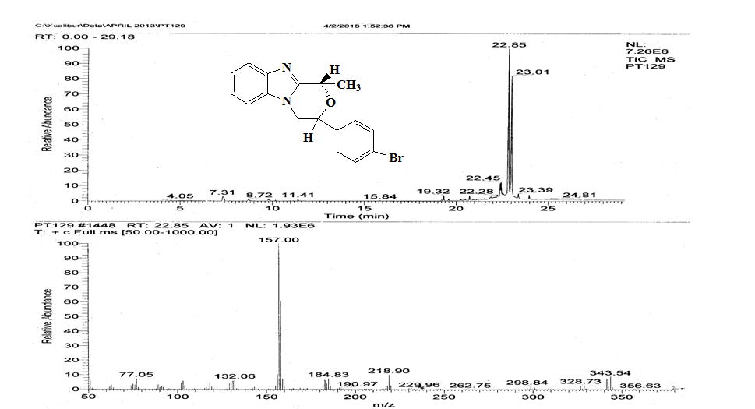
Spectrum-34
Mass Spectrum of 2’-(p-bromophenyl)-6’-methylmorpholino [4, 3-a] Benzimidazole (5d)

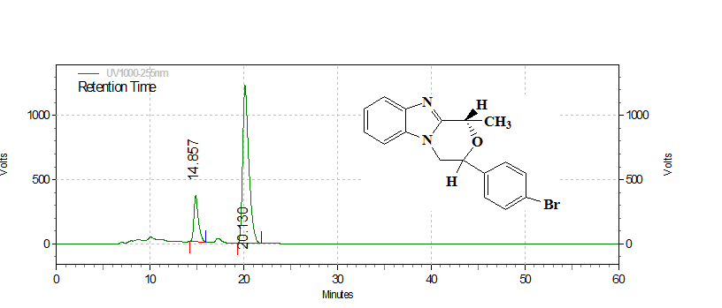

Retention Time | Area | Area % | Height | Height %
14.857 | 11719471 | 17.23 | 357520 | 22.50
20.130 | 56313604 | 82.77 | 1231612 | 77.50
Totals
 | 68033075 | 100.00 | 1589132 | 100.00

Spectrum-35
Chiral HPLC of 2’-(p-bromophenyl)-6’-methylmorpholino [4, 3-a] Benzimidazole (5d)
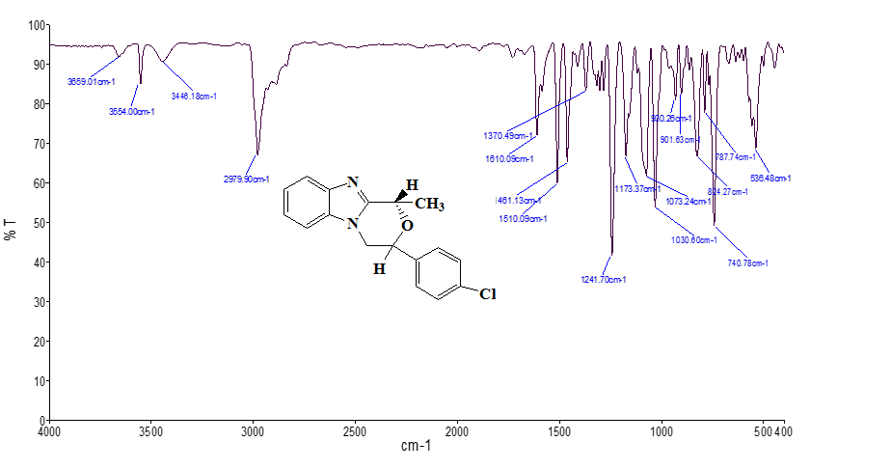

Spectrum-36
IR Spectrum of 2’-(p-chlorophenyl)-6’-methylmorpholino [4, 3-a] Benzimidazole (5e)
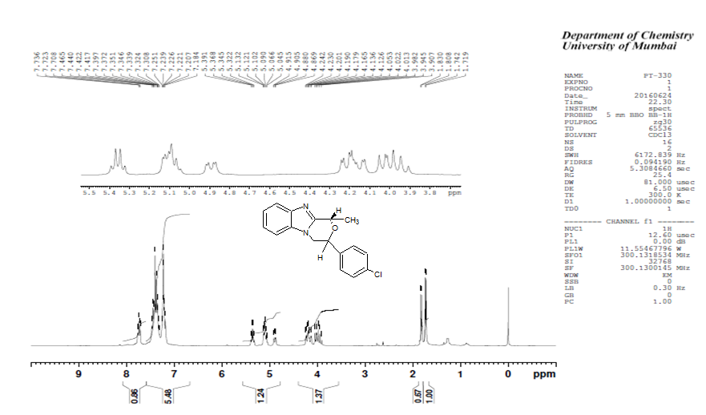
Spectrum-37
¹H NMR Spectrum of 2’-(p-chlorophenyl)-6’-methylmorpholino [4, 3-a] Benzimidazole (5e)
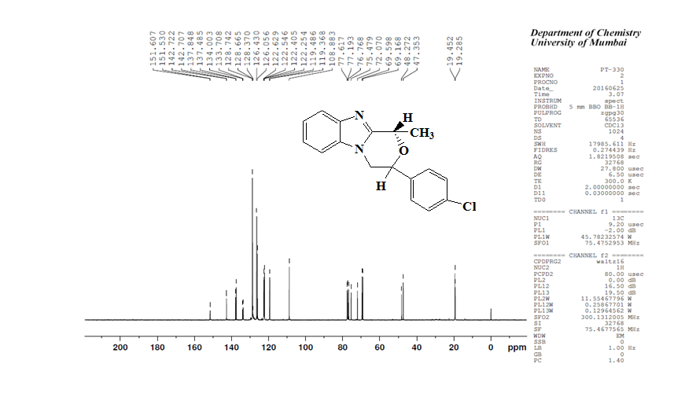
Spectrum-38
¹³C NMR Spectrum of 2’-(p-chlorophenyl)-6’-methylmorpholino [4, 3-a] Benzimidazole (5e)
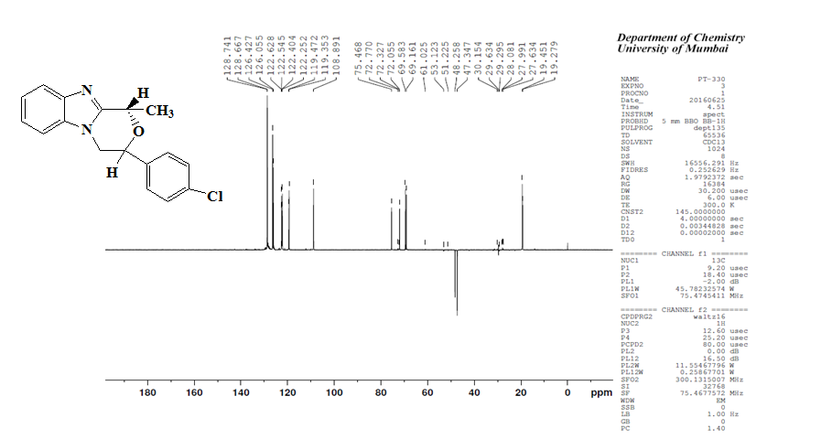
Spectrum-39
¹³C NMR DEPT Spectrum of 2’-(p-chlorophenyl)-6’-methylmorpholino [4, 3-a] Benzimidazole (5e)
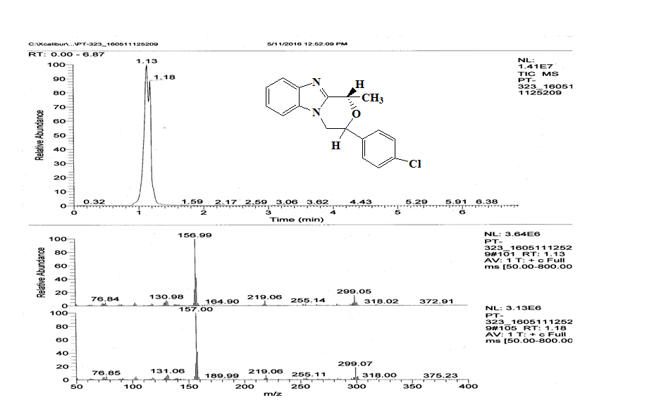

Spectrum-40
Mass Spectrum of 2’-(p-chlorophenyl)-6’-methylmorpholino [4, 3-a] Benzimidazole (5e)

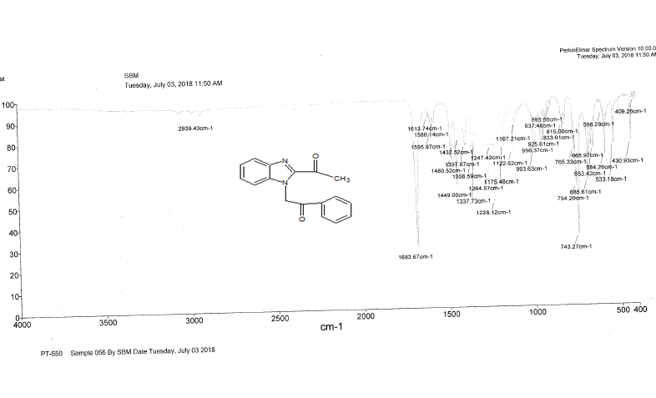
Spectrum-41
IR Spectrum of 2-(2-Acetyl-1H-benzimidazol-1-yl)-1-phenylethanone (6)
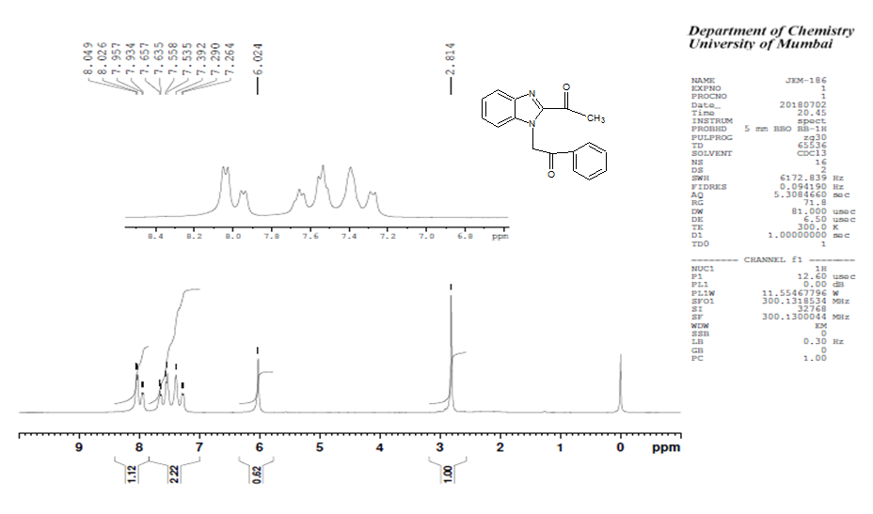
Spectrum-42
¹H NMR Spectrum of 2-(2-Acetyl-1H-benzimidazol-1-yl)-1-phenylethanone (6)

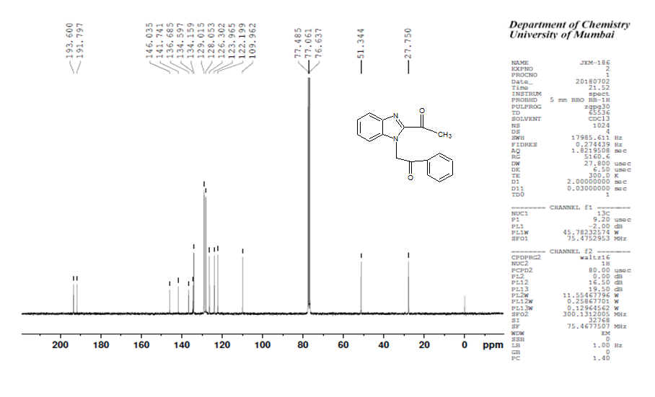
Spectrum-43
¹³C NMR Spectrum of 2-(2-Acetyl-1H-benzimidazol-1-yl)-1-phenylethanone (6)

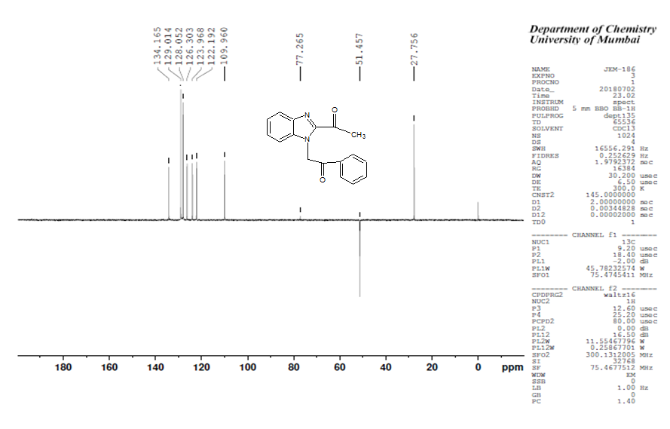
Spectrum-44
¹³C NMR DEPT Spectrum of 2-(2-Acetyl-1H-benzimidazol-1-yl)-1-phenylethanone (6)

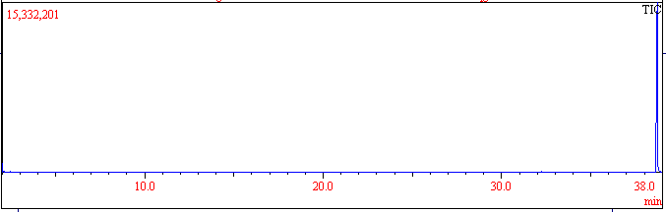
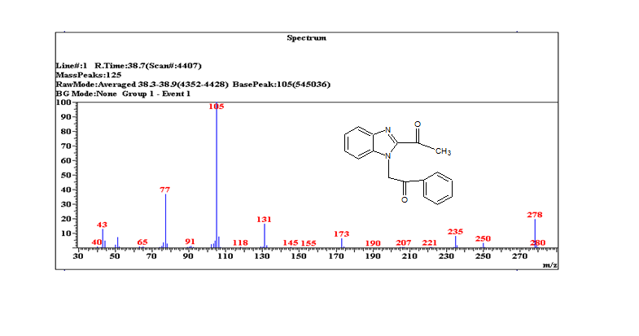Spectrum-45
Mass Spectrum of 2-(2-Acetyl-1H-benzimidazol-1-yl)-1-phenylethanone (6)

Antibacterial and antifungal activity of Lactic acid Benzimidazole derived Morpholine
The Antimicrobial activities of synthesized compounds were determined by broth micro dilution method. ^{[24-28]} All Synthesized compounds and standard drugs were assessed against two representatives of Gram-Negative and Gram- Positive bacterial strain viz. E.coli (MTCC443), Aeruginosa ( MTCC 1688), S.aureus (MTCC 96)and S.pyogenus ( MTCC442)and three fungi viz.C.albicans( MTCC 227), A.niger (MTCC 282) and A.clavatus (MTCC1323). The strains employed for the activitywere procured from Institute of Microbial Technology, Chandigarh (India). Mueller Hinton Broth was used as a nutrient medium and used to dilute the compound suspension for the test bacterial strain while Sabouraud Dextrose Broth was used for fungal nutrition. Ampicillin, Chloramphenicol and Nystatin, Griseofulvin were used as reference standards for anti-bacterial and anti-fungal drugs respectively. Bacterial strains were primarily inoculated into Mueller–Hinton agar for overnight growth. A number of colonies were directly suspended in saline solution until the turbidity matched the turbidity of McFarland standard (approximately 105 CFU mL⁻¹] i.e. inoculum size for test strain was adjusted to 105 CFU mL⁻¹ (Colony Forming Unit per milliliter) per well by comparing the turbidity (turbidimetric method). Similarly, fungi were inoculated on Sabouraud Dextrose Broth and the procedures of inoculum standardization were similar. DMSO was used as solvent to get the desired concentration of the synthesized compounds and standard drugs to test upon standard microbial strains. Each compound and standard drug was diluted obtaining 2000 µg /mL concentration, as a stock solution. By further progressive dilutions with test medium, the required concentrations were obtained for primary and secondary screening. In primary screening 0.2 mL of 1000, 500 and 250 µg / mL concentrations of the synthesized compounds were tested. The active compounds found in this primary screening were further diluted and 0.2 mL of 200, 100, 62.5, 50, 25, 12.5 and 6.25 µg/ mL concentrations for secondary screenings to test against all microorganisms. Briefly, the control tube containing no antibiotic was immediately sub cultured [before inoculation] by spreading a loopful evenly over a quarter of plate of medium suitable for growth of tested organisms. The tubes were then put for incubation at 37 ⁰C for 24h for bacteria and 48 h for fungi. Growth or lack of growth in the tubes containing the antimicrobial agent was determined by comparison with the growth control, indicated by turbidity. The lowest concentration that completely inhibited visible growth of organism was recorded as the minimal inhibitory concentration (MIC, µg/mL), i.e., the amount of growth from the control tube before incubation (which represents the original inoculum) is compared. A set of tubes containing only seeded broth and the solvent controls were maintained under identical conditions so as to make sure that the solvent had no influence on strain growth. The result of this is much affected by size of the inoculum. The interpretation of the results was based on the standard drugs used for bacterial and fungi strain respectively.The results are summarized in Table-1 as minimal inhibitory concentration (MIC, µg / mL).

Table 1 - Antibacterial and Antifungal activity of compounds 5 (a-e)
Minimum inhibitory concentration ( MIC, µM)
Compound Gram +ve bacteria Gram -ve bacteria Fungi
E.coli P.aeruginosa S. aureus S.pyogenus C.albicans A.niger A.clavatus
5a 200 100 250 250 500 1000 500
5b 62.5 125 100 250 1000 1000 1000
5c 250 250 250 500 1000 250 250
5d 200 100 250 250 500 1000 1000
5e 62.5 100 250 100 1000 1000 1000
Standard Drugs
Ampicillin 100 - 250 100 - - -
Chloramphenicol 50 50 50 50 - - -
Nystatin - - - - 100 100 100
Griseofulvin----500100100

