Changes in smoking during retirement transition: A longitudinal cohort study
Pulakka A, Halonen JI, Pentti J, Kivimäki M, Vahtera J, Stenholm S

Supplemental Figure S1. Number of the Finnish Public Sector Study participants at each possible survey wave and illustration of the survey wave pairs included in the pseudo trial.

Wave | w₋₃ | w₋₂ | w₋₁ | RETIREMENT | w₊₁ | w₊₂ | w₊₃
N in smoking status analysis | 374 | 838 | 1,432 |  | 1,432 | 786 | 294
N in smoking intensity analysis | 135 | 316 | 489 |  | 489 | 247 | 73
Data collection years |  |  | 2000-2002 |  | 2005 | 2009 | 2013
 |  | 2000-2002 | 2004 |  | 2009 | 2013
 | 2000-2002 | 2004 | 2008 |  | 2013
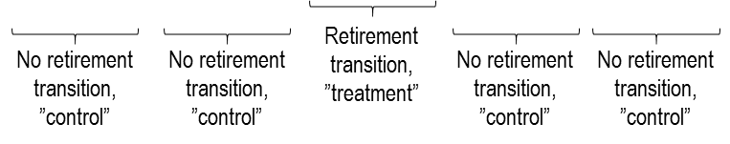

Supplemental Figure S2. Flow chart of the selection of the study sample

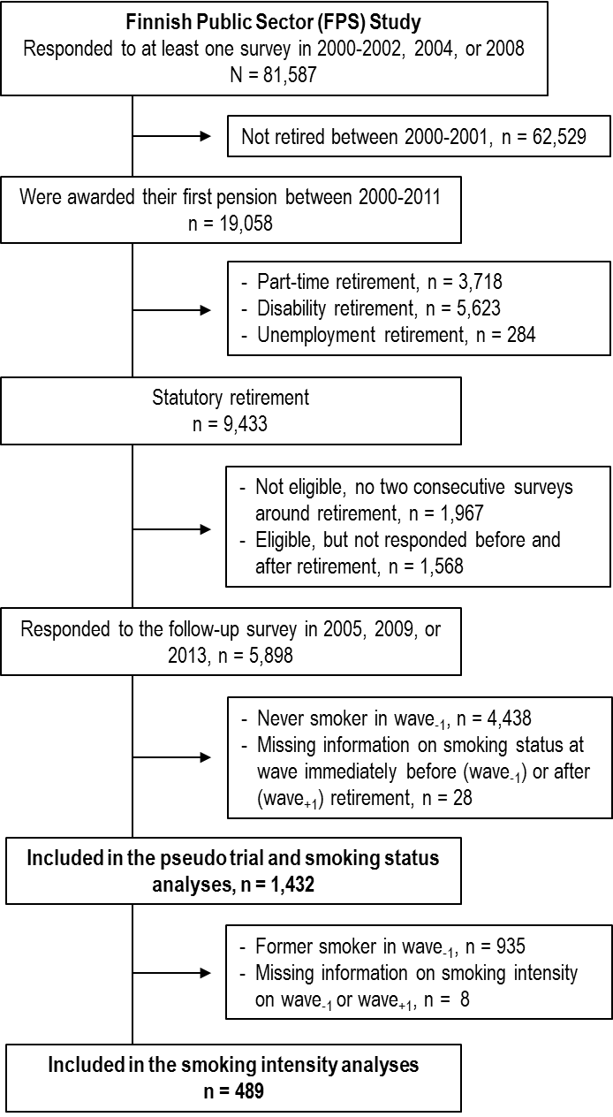

Supplemental table S1. Model fit statistics of the latent class analysis (LCA) models with different one to five latent classes.
 | Number of latent classes
Fit statistic | 1 | 2 | 3 | 4 | 5
Smoking status
Log-likelihood | -3046.5 | -1949.0 | -1887.7 | -1876.1 | -1875.4
G² | 2347.5 | 152.6 | 30.0 | 6.7 | 5.3
Degrees of freedom | 57 | 50 | 43 | 36 | 29
p (G²) | <0.001 | <0.001 | 0.93 | 1.00 | 1.00
AIC | 2359.5 | 178.6 | 70.0 | 60.1 | 73.3
BIC | 2391.1 | 247.1 | 175.4 | 202.9 | 252.3
Entropy | 1 | 0.93 | 0.82 | 0.80 | 0.82
Average posterior  probabilities | 1 | 0.99/0.97 | 0.83/0.91/ 0.97 | 0.66/0.84/ 0.87/0.96 | 0.49/0.81/0.86/ 0.74/0.96
Smoking intensity
Log-likelihood | -1159.7 | -960.5 | -1930.7 | -923.9 | -922.1
G² | 481.2 | 82.9 | 23.2 | 9.7 | 6.1
Degrees of freedom | 57 | 50 | 43 | 36 | 29
p (G²) | <0.001 | 0.002 | 0.99 | 1.00 | 1.00
AIC | 493.2 | 108.9 | 63.2 | 63.7 | 74.1
BIC | 518.4 | 163.4 | 147.0 | 176.9 | 216.7
Entropy | 1 | 0.74 | 0.68 | 0.69 | 0.65
Average posterior  probabilities | 1 | 0.90/0.94 | 0.83/0.86/ 0.90 | 0.81/0.87/ 0.79/0.88 | 0.81/0.73/0.58/ 0.85/0.86
AIC, Akaike’s Information Criterion; BIC, Bayesian Information Criterion

