Supplementary Material

High calcification costs limit mussel growth at low salinity

Trystan Sanders*, Lara Schmittmann, Jennifer C. Nascimento-Schulze, Frank Melzer

**\* Correspondence:** Trystan Sanders: tsanders@geomar.de

# Supplementary methodologies

**Animal collection**

Juvenile mussels were chosen for investigation as they have higher relative growth and calcification rates compared to adults. Mussels (shell length (SL) 4.8 ± 0.4 mm) were collected in September 2015 from 3 subtidal populations of Baltic *Mytilus* along the Baltic Sea salinity gradient from 1 m water depth at Kiel (*M. edulis*-like, 54° 19' 48.846'' N, 10° 8' 59.6436'' E), Ahrenshoop (hybrid transition zone, 54° 23' 7.3032'' N, 12° 25' 24.0564'' E) and Usedom (*M. trossulus*-like, 54° 3' 20.5668'' N, 14° 0' 40.0572'' E, Figure S1). Animals were transported in cool boxes to GEOMAR labs within 5 hours after collection (see: supplementary methods).

**Animal acclimation**

Animals were kept at 15° C in climate chambers in 10 L aerated plastic aquaria (n = ~500 per aquarium) and fed twice daily with 15,000 cells ml-1 *Rhodomonas salina* for 4 weeks prior to the experiment. Complete water changes were done three times weekly with water prepared 24 hours before and aerated at the correct experimental temperature (for details on water preparation see supplementary section: Water chemistry). Salinity at each of the three collection sites was monitored over 2 years using *in situ* CTD (conductivity, temperature, depth) loggers (StarOddi, Iceland) at 1 meter depth with a measurement frequency of 3 hours.

**Water chemistry**

Water was prepared by filtering (0.22 µm) Kiel fjord water and salinity was adjusted to 16, 11 and 6 psu with deionized water using a Cond 3110 conductivity meter (WTW, Germany). Dilution of salt water with deionized water also dilutes the total alkalinity (*A*T) which influences calcification rate. The *A*T was therefore increased with 1 M HCO3- solution to natural levels found in the Baltic Sea at the respective experimental salinities using a published salinity-*A*T relationship (Beldowski et al. 2010). pH was monitored twice weekly using a 340*i* pH meter (WTW, Germany). Every two weeks, total inorganic carbon (*C*T) samples were taken and analysed using an AIRICA C*T* analyser (Marianda, Germany) and aragonite saturation state (Ωarag) was calculated using pHNBS and *C*T values input into the CO2sys_v2.1 programme using the KHSO4 constant (Dickson 1990) and carbonate system dissociation constants K1 and K2 (Dickson 1987).

**Microalgae food cultures**

Microalgae food was cultured at 25 °C and three salinities (16, 11 and 6 psu) using F2 medium and vitamins. At the beginning of the experiment, microalgae cell dry mass was calculated by filtering cultures onto pre-ashed GF/F filters and dried at 60 °C and weighed. Filters were then ashed at 450°C for 4 hours to calculate the organic content per algal cell. As organic content was found to differ significantly between culture salinities food rations were mixed between salinities to achieve an average salinity of 11 psu and a cell number ratio of 1:1:1 for all three species prior to feeding to ensure an equal ration of organic content for all treatment tanks. Culture cell densities and cell diameter was measured daily using a Multisizer 3 Coulter Counter (Beckman Coulter, USA). Field chlorophyll *a* concentrations were obtained from model predictions acquired from the publicly available EU database, CMEMS (EU, Copernicus Marine Service).

**Filtration**

Filtration rate measurements were not used in SfG calculations as food was not applied *ad libitum,* but measured to ensure complete clearance of microalgae food within each treatment tank. Measurements were conducted in experimental plastic aquaria (2 L) with sufficient bubbling to ensure constant mixing of algal cells. *Rhodomonas salina* (concentrations: 6000, 3000 or 1000 cells ml-1 for high medium and low food treatments, respectively) were used exclusively to measure filtration rate to keep cell size uniform and was measured weekly in two 25 ml samples taken 1 hour apart measured using a Coulter Counter. Filtration rate measurements indicated that all tanks were feeding at high enough rates to consume all food before algae cells stagnated and died (Fig. S3). Filtration rates were calculated using the equation from Riisgård et al. 2013.

**References**

1. Dickson, A.G., Millero, F.J. (1987). A comparison of the equilibrium constants for the dissociation of carbonic-acid in seawater media. *Deep Sea Res.* 34, 1733–1743.
2. Dickson, A.G. (1990). Standard potential of the reaction – AgClS+1/2 H2 = AgS+HClAq and the standard acidity constant of the ion HSO4 – in synthetic sea-water from 273.15-K to 318.15- K. J. Chem. Thermodyn., 22, 113–127.
3. Riisgård, H.U., Lüskow, F., Pleissner, D., Lundgreen, K., López, M.Á.P. (2013). Effect of salinity on filtration rates of mussels *Mytilus edulis* with special emphasis on dwarfed mussels from the low-saline Central Baltic Sea. Helgoland Mar. Res. 67, 591-598.

# Supplementary Figures and Tables

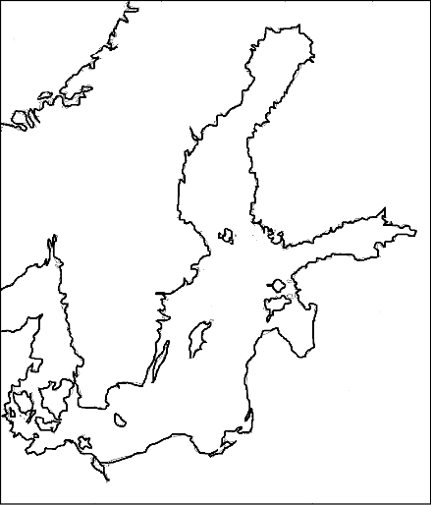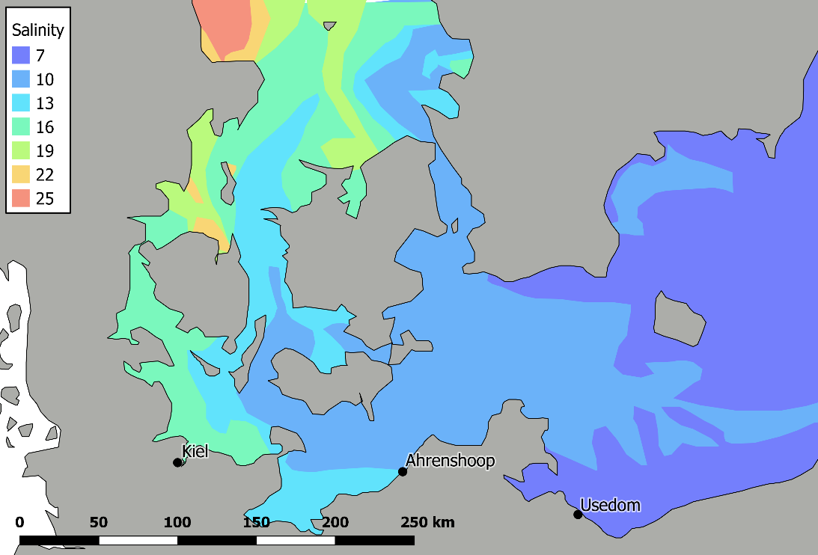

Fig. S1. Map of the south west Baltic Sea showing surface salinity distribution and the three sampling sites on the German Baltic Sea coast. Inlay shows the sampling area in relation to the entire Baltic Sea. Salinity data taken from: EU Copernicus Marine Service. (2017). Copernicus marine environment monitoring service - CMEMS. Available at: http://marine.copernicus.eu/. Last accessed 10 October 2017.

|  |  |  |  |  |  |  |
| --- | --- | --- | --- | --- | --- | --- |
| **Collection site** | **Salinity (psu)** | **Temperature (°C)** | **pHNBS** | ***A*T (µmol kg SW-1)** | **Chl *a* (µg l-1)** | **Ωaragonite** |
| Kiel | 15.5 (±3.07 se) | 16.5 | 7.82 | 1972.76 | 5.08 | 1.29 |
| Ahrenshoop | 10.5 (±2.34 se) | 18.5 | 7.93 | 1811.72 | 1.34 | 1.46 |
| Usedom | 7.1 (±0.56 se) | 17.9 | 7.83 | 1790.41 | 2.44 | 1.13 |

Table S1. Environmental conditions at each of the three sampling sites on the day of sampling. *A*T represents the total alkalinity which is the sum of all inorganic bases. Standard errors for salinities were calculated from 2 years of monitoring data which will be published in a separate manuscript. Details on calculating saturation states (Ω) are given in the supplementary methods.

S = 16

Kiel

S = 11

Ahrenshoop

8 °C

8 °C

S = 6

Usedom

8 °C

18 °C

18 °C

18 °C

Low food

Med food

High food

Low food

Med food

High food

Low food

Med food

High food

Low food

Med food

High food

Low food

Med food

High food

Low food

Med food

High food

Fig. S2. Schematic of experimental design showing the three salinities/populations, two temperatures and three food treatments with 4 replicate tanks, each containing 40 mussels. The total number of tanks = 72. Measurements were averaged or summed to a total value (depending on measurement) per tank and statistically analysed with tanks as replicates.

**B**

**A**

Fig. S3. (A) An example of a single replicate tank clearance measurement for all food levels with samples taken every 20 minutes for 1 hour. Trendlines show an exponential decrease in algae concentrations in all food treatments. (B) Filtration rate measured throughout the course of the experiment on a log scale plotted against shell length with exponential trend lines for all temperature and salinity treatments. Open circles and dotted trend lines represent 8 °C whereas closed circles and solid lines represent 18 °C. Clearance rates show sufficient feeding to clear water of all particles between feeds.

Table S2. Mean water chemistry parameters within each treatment for salinity, temperature, pH, total inorganic carbon (C*T*), calcite saturation state (Ωcalcite) and aragonite saturation state (Ωaragonite) over the entire experiment +/- standard error.

|  |  |  |  |  |  |  |
| --- | --- | --- | --- | --- | --- | --- |
| **Salinity (psu)** | **Temperature (°C)** | **pHNBS** | **C*T* (µmol kgSW-1)** | **Ωcalcite** | **Ωaragonite** | |
| 6.16 ± 0.01 | 18.07 ± 0.02 | 7.98 ± 0.02 | 1694 ± 68 | 1.72 ± 0.08 | 0.96 ± 0.05 | |
| 6.10 ± 0.02 | 8.09 ± 0.02 | 8.13 ± 0.02 | 1670 ± 71 | 1.56 ± 0.08 | 0.85 ± 0.04 | |
| 11.10 ± 0.02 | 18.19 ± 0.02 | 7.91 ± 0.02 | 1629 ± 70 | 1.66 ± 0.05 | 0.95 ± 0.03 | |
| 11.21 ± 0.02 | 8.03 ± 0.02 | 8.06 ± 0.02 | 1647. ± 72 | 1.53 ± 0.05 | 0.86 ± 0.03 | |
| 16.42 ± 0.08 | 18.08 ± 0.02 | 7.90 ± 0.02 | 1952 ± 13 | 2.05 ± 0.08 | 1.22 ± 0.45 | |
| 16.64 ± 0.05 | 8.08 ± 0.02 | 8.05 ± 0.02 | 2037 ± 6 | 1.91 ± 0.07 | 1.12 ± 0.04 | |
|  | | | | | | |

Table S3. R2 values for all regression analyses using ANCOVA. Costs represent calcification costs from linear regressions. All other regressions were performed on power relationships.

|  |  |  |  |  |  |
| --- | --- | --- | --- | --- | --- |
| **Temperature** | **Salinity** | **R2** | | | |
| **Costs** | **O2** | **DM** | **SM** |
| 18 °C | 16 psu | 0.60 | 0.627 | 0.948 | 0.943 |
| 18 °C | 11 psu | 0.40 | 0.578 | 0.918 | 0.745 |
| 18 °C | 6 psu | 0.75 | 0.702 | 0.953 | 0.993 |
| 8 °C | 16 psu | 0.93 | 0.798 | 0.917 | 0.981 |
| 8 °C | 11 psu | 0.89 | 0.675 | 0.948 | 0.97 |
| 8 °C | 6 psu | 0.63 | 0.491 | 0.969 | 0.597 |

Table S4. Summary of literature values of absorption efficiency using the Conover ratio (Conover, 1966) for *Mytilus edulis* and *Mytilus trossulus* based on a combination of laboratory experiments and field experiments across a range of different salinities and microalgae species.

|  |  |  |  |
| --- | --- | --- | --- |
| **Reference** | **Species** | **Absorption efficiency (AE, %)** | **Microalgae species used** |
| Bayne *et al*., 1993 | *Mytilus edulis* | 0.51 | *Tetraselmis Suecica, Phaeodactylum tricornutum* |
| Widdows & Johnson 1988 | *Mytilus edulis* | 0.40 | Natural mix – field experiment |
| Reid *et al*., 2010 | *Mytilus edulis* and *Mytilus trossulus* | 0.84 | *Phaeodactylum tricornutum, Chaetoceros-B, Nanochloropsis oculata* |
| Hawkins 1996 | *Mytilus edulis* | 0.90 | Natural mix – field experiment |
| Okumuş 1994 | *Mytilus edulis* | 0.46 | Natural mix – field experiment |
| Tedengren *et al*., 1990 | Baltic *Mytilus trossulus*, *Mytilus edulis* | 0.575 | *Pyramimonas* sp. |
|  | **Mean** | **0.61** |  |
|  | *standard deviation* | 0.21 |  |

1. Bayne BL, Iglesias JIP, Hawkins AJS, Navarro E, Heral M, Deslous-Paoli JM. 1993 Feeding behaviour of the mussel *Mytilus edulis*: responses to variations in quantitz and organic content of the seston. *J. Mar. Biol. Ass. U.K.* 73, 813-829.
2. Conover RJ. 1966 Assimilation of organic matter by zooplankton. *Limnol. Oceanogr.* 11, 338-354.
3. Hawkins AJS, Smith RFM, Bayne BL, Héral M. 1996 Novel observations underlying the fast growth of suspension-feeding shellfish in turbid environments: *Mytilus edulis*. *Mar. Ecol. Prog. Ser.* 131, 179-190.
4. Okumuş İ, Stirling HP. 1994 Physiological energetics of cultivated mussel (*Mytilus edulis*) populations in two Scottish west coast sea lochs. *Mar. Biol.* 119, 125-131.
5. Reid GK, Liutkus M, Bennett A, Robinson SMC, MacDonald B, Page F. 2010 Absorption efficiency of blue mussels (*Mytilus edulis* and *M. trossulus*) feeding on Atlantic salmon (*Salmo salar*) feed and fecal particulates: Implications for integrated multi-trophic aquaculture. *Aquaculture* 299, 165-169.
6. Tedengren M, André C, Johannesson K, Kautsky N. 1990 Genotypic and phenotypic differences between Baltic and North Sea populations of *Mytilus edulis* evaluated through reciprocal transplantations. III. Physiology. *Mar. Ecol. Prog. Ser.* 59, 221-227.
7. Widdows J, Johnson D. 1988 Physiological energetics of Mytilus edulis: Scope for Growth. Mar. Ecol. Prog. Ser. 46, 113-121.

Fig. S4. Total dry mass vs shell length with all food treatments pooled at the end of the experiment. Power relationships showed the highest R2 values. Dotted lines represent 8 °C treatments and solid lines represent 18 °C treatments

Fig. S5. Total shell mass including organic vs shell length with all food treatments pooled at the end of the experiment. Power relationships showed the highest R2 values. Dotted lines represent 8 °C treatments and solid lines represent 18 °C treatments. Relationships between CaCO3 mass and shell length are not shown as shell organic mass did not differ statistically between treatments.

Fig. S6. The energetic costs of calcification calculated across a range of different food absorption efficiencies based on the standard error (0.21) of mean literature values for *Mytilus edulis* and *Mytilus trossulus*. The grey horizontal bar represents the mean absorption efficiency (0.61) from literature values.

Fig S7. The proportion of energy allocated to calcification across a range of absorption efficiencies. The grey horizontal bar represents the mean absorption efficiency taken from literature values for *Mytilus edulis* and *Mytilus trossulus* feeding on a range of microalgae food species.

Table S5. Statistical results from ANCOVA’s (sum of squares method) with co-variable significance shown. Post-hoc analyses (Tukey HSD) results are also shown for significant factors. Significant *p*-values are shown in bold

|  |  |  |  |  |  |  |
| --- | --- | --- | --- | --- | --- | --- |
|  | factor | *df* | Sum sq | Mean sq | F-value | *p*-value |
| DM vs SL | SL | 1 | 12.21 | 12.21 | 702.02 | **< 0.001** |
| salinity | 2 | 0.26 | 0.13 | 7.57 | **0.001** |
| temperature | 1 | 0.00 | 0.00 | 0.09 | 0.767 |
| salinity*temperature | 2 | 0.02 | 0.01 | 0.49 | 0.614 |
| residuals | 60 | 1.04 | 0.02 |  |  |
|  |  |  | post-hoc analyses | | |
|  |  |  | salinity | 16-11 | 0.992 |
|  |  |  | 6-11 | **< 0.001** |
|  |  |  | 6-16 | **< 0.001** |
| SM vs SL | SL | 1 | 28.14 | 28.14 | 352.45 | **< 0.001** |
| salinity | 2 | 1.11 | 0.55 | 6.95 | **0.002** |
| temperature | 1 | 0.26 | 0.26 | 3.27 | 0.076 |
| salinity*temperature | 2 | 0.82 | 0.41 | 5.12 | **0.009** |
| residuals | 60 | 4.79 | 0.08 |  |  |
|  |  |  | post-hoc analyses | | |
|  |  |  | salinity | 16-11 | 0.166 |
|  |  |  | 6-11 | 0.059 |
|  |  |  | 6-16 | **0.001** |
| Oxygen consumption | TM | 1 | 247627 | 247627 | 322.69 | **< 0.001** |
| temperature | 1 | 27767 | 27767 | 36.18 | **< 0.001** |
| salinity | 2 | 2627 | 1336 | 1.74 | 0.177 |
| salinity*temperature | 2 | 484 | 242 | 0.32 | 0.730 |
| residuals | 268 | 205659.00 | 767.00 |  |  |
| Calcification cost | calcification | 1 | 159116 | 159116 | 86.07 | **< 0.001** |
| temperature | 1 | 1836 | 1836 | 0.99 | 0.323 |
| salinity | 2 | 10447 | 5224 | 2.83 | 0.067 |
| salinity*temp | 2 | 25216 | 12608 | 6.82 | **0.002** |
| residuals | 60 | 110917 | 1849 |  |  |

Table S6. Statistical results from ANOVA’s (sum of squares method) with post-hoc analyses (Tukey HSD) results are also shown for significant factors. Significant *p*-values are shown in bold

|  |  |  |  |  |  |  |
| --- | --- | --- | --- | --- | --- | --- |
|  |  |  |  |  |  |  |
|  | factor | *df* | Sum sq | Mean sq | F-value | *p*-value |
| CaCO3 growth | temperature | 1 | 1.51 | 1.51 | 0.7 | 0.408 |
| salinity | 2 | 57.39 | 28.7 | 13.26 | **< 0.001** |
| food | 2 | 843.39 | 421.7 | 194.83 | **< 0.001** |
| temp*sal | 2 | 27.01 | 13.5 | 6.24 | **0.004** |
| temp*food | 2 | 0.96 | 0.48 | 0.22 | 0.802 |
| sal*food | 2 | 51.47 | 12.87 | 5.94 | **< 0.001** |
| temp*sal*food | 4 | 59.29 | 14.82 | 6.85 | **< 0.001** |
| residuals | 54 | 116.88 | 2.16 |  |  |
|  |  |  | post-hoc analyses | | |
|  |  |  | salinity | 16-11 | 0.967 |
|  |  |  | 6-11 | **< 0.001** |
|  |  |  | 6-16 | **< 0.001** |
|  |  |  | food | low-high | **< 0.001** |
|  |  |  | med-high | **< 0.001** |
|  |  |  | med-low | **< 0.001** |
| Soft tissue growth | temperature | 1 | 0.28 | 0.28 | 29.21 | **< 0.001** |
| salinity | 2 | 0.29 | 0.15 | 15.17 | **< 0.001** |
| food | 2 | 4.62 | 2.31 | 239.90 | **< 0.001** |
| temp*sal | 2 | 0.23 | 0.12 | 12.05 | **< 0.001** |
| temp*food | 2 | 0.13 | 0.06 | 6.60 | **< 0.001** |
| sal*food | 2 | 0.26 | 0.06 | 6.70 | **< 0.001** |
| temp*sal*food | 4 | 0.04 | 0.01 | 0.97 | 0.434 |
| residuals | 54 | 0.52 | 0.01 |  |  |
|  |  |  | post-hoc analyses | | |
|  |  |  | salinity | 16-11 | 0.084 |
|  |  |  | 6-11 | **< 0.001** |
|  |  |  | 6-16 | **0.005** |
|  |  |  | food | low-high | **< 0.001** |
|  |  |  | med-high | **< 0.001** |
|  |  |  | med-low | **< 0.001** |
| Energy allocation to calcification | temperature | 1 | 8468 | 8468 | 7.15 | **0.015** |
| salinity | 2 | 6065 | 3033 | 2.56 | 0.105 |
| temperature*salinity | 2 | 2502 | 1251 | 1.06 | 0.368 |
| residuals | 18 | 21311 | 1184 |  |  |

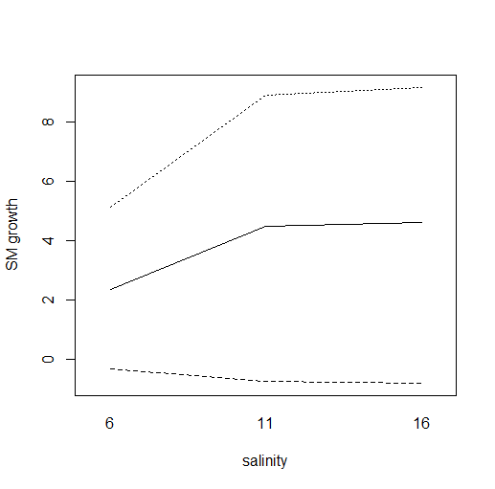 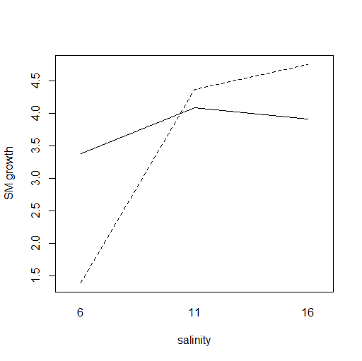

Medium food

High food

**B**

**A**

18 °C

8 °C

Low food

Fig. S8. (**A**)Two-way interactions plot between food and salinity (psu) and (**B**) salinity and temperature for shell mass growth (SM growth; µg CaCO3 day-1). There was no significant interaction between food and temperature.

**B**

**A**

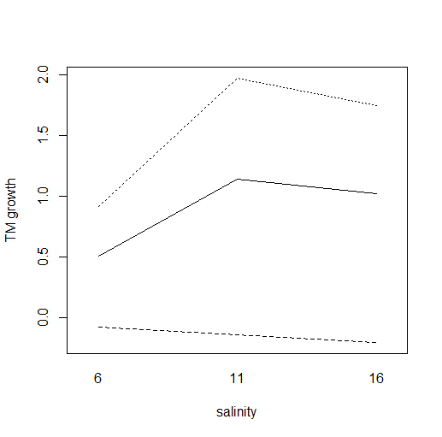

**C**

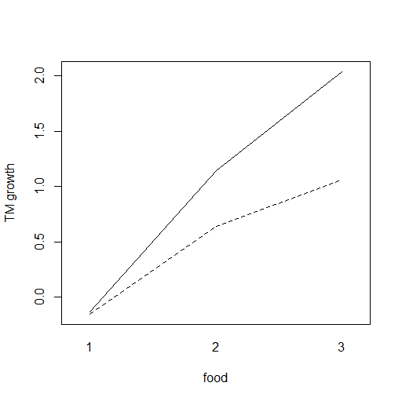

Low medium high

18 °C

8 °C

Low food

Medium food

High food

18 °C

8 °C

Fig. S9. (**A**) Two-way interactions plot between food and salinity (psu) and (**B**) temperature and salinity and (**C**) temperature and food for soft tissue mass growth (TM growth; µg day-1).