ONLINE SUPPLEMENT

Supplemental Figure S1. Change from baseline in CGI-assessed overall health status (A), therapeutic effectiveness (B), and therapeutic risks (C) at week 12.

(A)

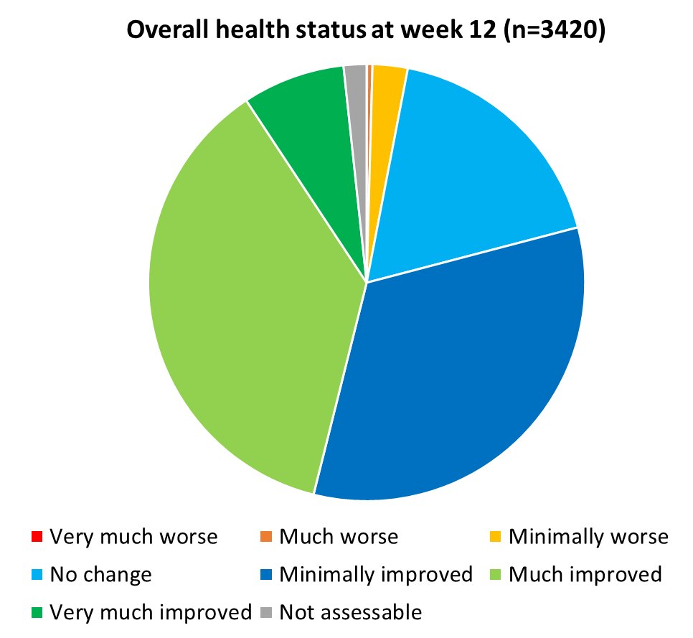
(B)

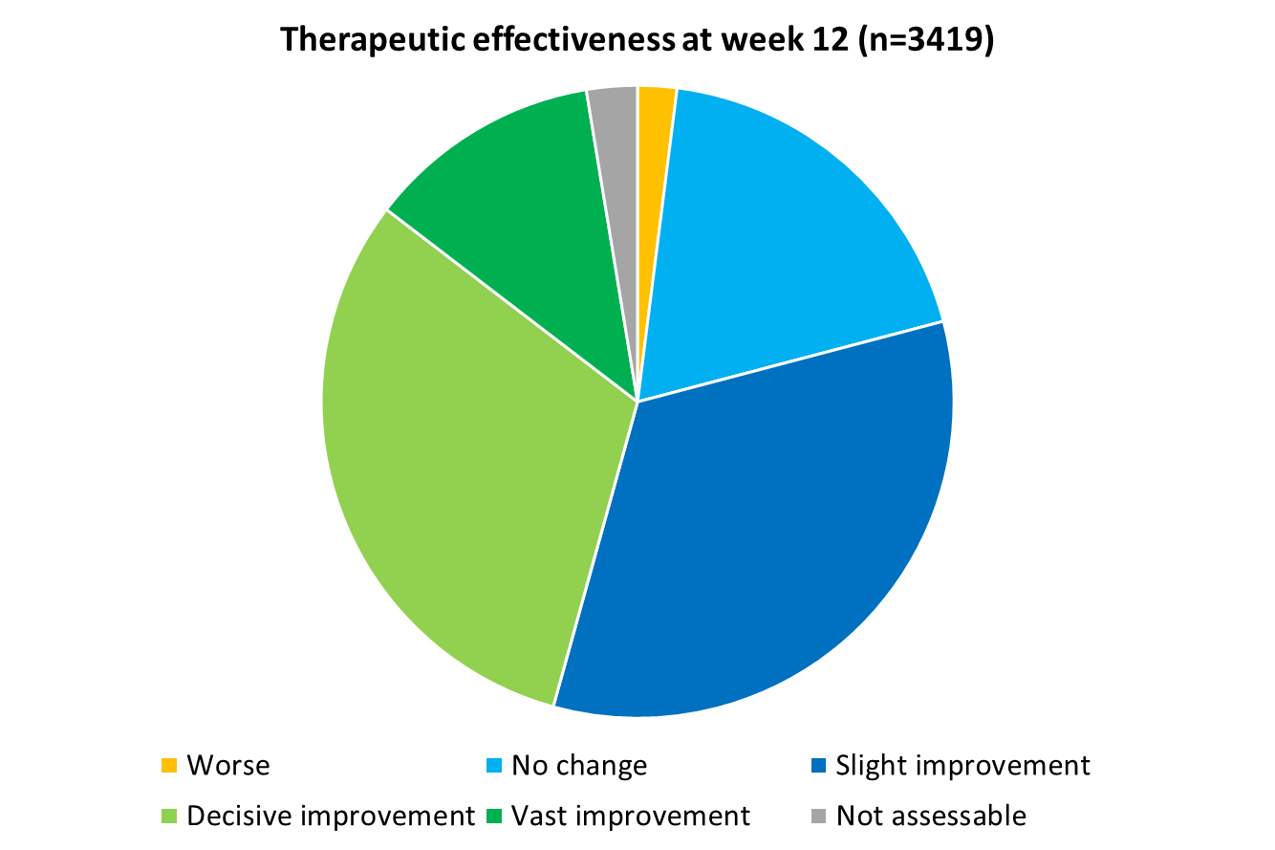
(C)

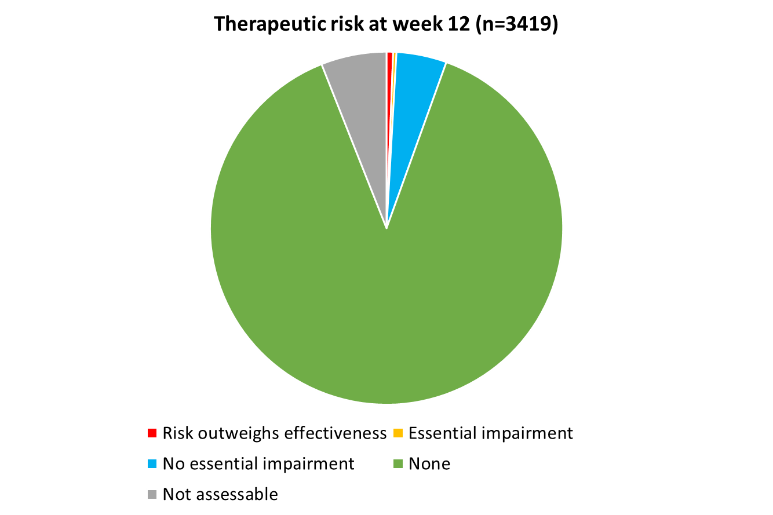
CGI, Clinical Global Impression Scale.
Essential impairment denotes significant interference with the patient’s functioning.
Supplemental Figure S2. Guideline-defined asthma control (A) and COPD disease severity (B) (as rated by physicians) at baseline, week 4, and week 12.
(A)
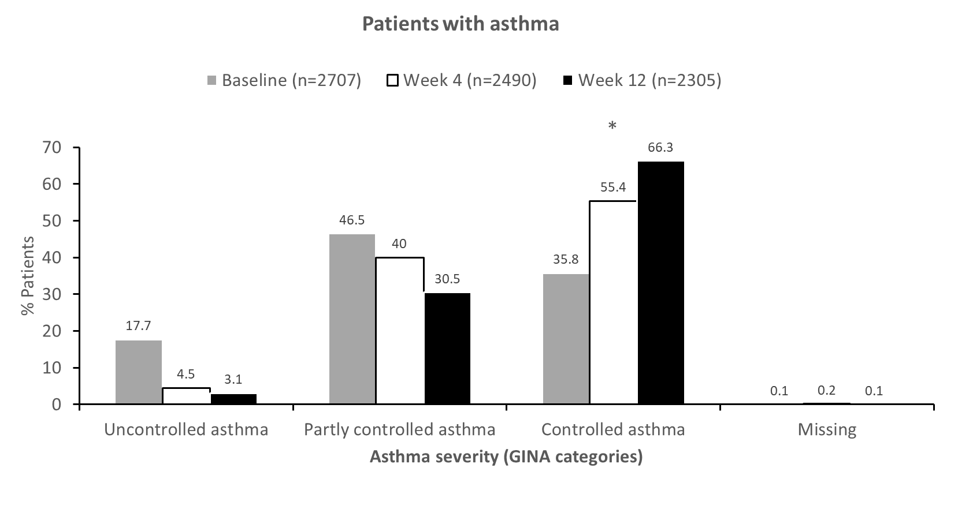
(B)
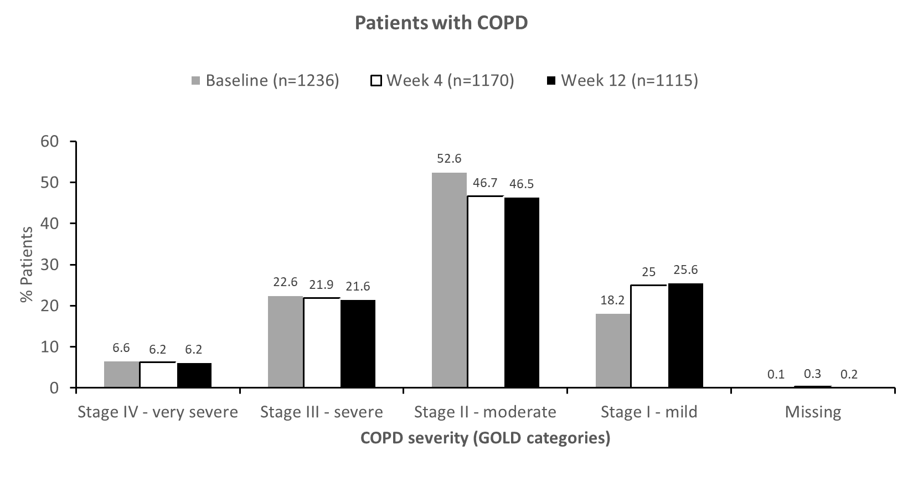
* p < 0.0001 for the proportion of patients with controlled asthma and valid documentation at each visit.
COPD, chronic obstructive pulmonary disease; GINA, Global Initiative for Asthma; GOLD, Global Initiative for Chronic Obstructive Lung Disease.
Supplemental Table S1. Frequency of inhalation (inhalations in the morning–evening) in the FAS at baseline, second visit, and last documentation.

Inhalations: mornings-evenings | Baseline |  | Week 4 |  | Week 12
 | N | % | N | % | N | %
Total | 3,943 | 100.0 | 3,660 | 100.0 | 3,420 | 100.0
0–0 | 2 | 0.1 | 12 | 0.3 | 7 | 0.2
0–1 | 6 | 0.2 | 10 | 0.3 | 9 | 0.3
0–2 | 1 | <0.1 | 0 | - | 0 | -
1–0 | 96 | 2.4 | 84 | 2.3 | 80 | 2.3
1–1 | 3,082 | 78.2 | 2,898 | 79.2 | 2,710 | 79.2
1–2 | 7 | 0.2 | 8 | 0.2 | 6 | 0.2
2–0 | 14 | 0.4 | 11 | 0.3 | 8 | 0.2
2–1 | 50 | 1.3 | 48 | 1.3 | 48 | 1.4
2–2 | 632 | 16.0 | 547 | 14.9 | 514 | 15.0
4–4 | 1 | <0.1 | 0 | - | 0 | -
Missing | 52 | 1.3 | 42 | 1.1 | 38 | 1.1

Supplemental Table S2. Severity of illness, as assessed by the Clinical Global Impression Scale, in the FAS
Severity of disease | Baseline |  | Week 4 |  | Week 12
 | n | % | n | % | n | %
Total | 3,943 | 100.0 | 3,660 | 100.0 | 3,420 | 100.0
Missing | 2 | 0.1 | 1 | <0.1 | 1 | <0.1
Not assessable | 56 | 1.4 | 41 | 1.1 | 41 | 1.2
Normal, not at all ill | 31 | 0.8 | 52 | 1.4 | 67 | 2.0
Borderline mentally ill | 94 | 2.4 | 171 | 4.7 | 203 | 5.9
Mildly ill | 1057 | 26.8 | 1397 | 38.2 | 1422 | 41.6
Moderately ill | 1740 | 44.1 | 1408 | 38.5 | 1168 | 34.2
Markedly ill | 796 | 20.2 | 466 | 12.7 | 406 | 11.9
Severely ill | 151 | 3.8 | 111 | 3.0 | 99 | 2.9
Among the most extremely ill patients | 16 | 0.4 | 13 | 0.4 | 13 | 0.4
FAS, full analysis set.

Supplemental Table S3. Patient-reported asthma control (as assessed by ACT).
 | Baseline |  | Week 4 |  | Week 12
 | n | % | n | % | n | %
Total | 2,200 | 100.0 | 2,033 | 100.0 | 1,886 | 100.0
Question 1 (impairment)*
All of the time | 99 | 4.5 | 23 | 1.1 | 20 | 1.1
Most of the time | 388 | 17.6 | 119 | 5.9 | 81 | 4.3
Some of the time | 829 | 37.7 | 624 | 30.7 | 404 | 21.4
A little of the time | 462 | 21.0 | 668 | 32.9 | 718 | 38.1
None of the time | 378 | 17.2 | 517 | 25.4 | 595 | 31.5
Question 2 (shortness of breath)*
More than once a day | 426 | 19.4 | 162 | 8.0 | 89 | 4.7
Once a day | 339 | 15.4 | 199 | 9.8 | 148 | 7.8
3 to 6 times a week | 512 | 23.3 | 356 | 17.5 | 242 | 12.8
Once or twice a week | 639 | 29.0 | 837 | 41.2 | 850 | 45.1
Not at all | 240 | 10.9 | 395 | 19.4 | 490 | 26.0
Question 3 (night-time symptoms)*
4 or more nights a week | 286 | 13.0 | 75 | 3.7 | 49 | 2.6
2 to 3 nights a week | 465 | 21.1 | 211 | 10.4 | 139 | 7.4
Once a week | 364 | 16.5 | 331 | 16.3 | 215 | 11.4
Once or twice in the previous 4 weeks | 435 | 19.8 | 553 | 27.2 | 547 | 29.0
Not at all | 607 | 27.6 | 780 | 38.4 | 871 | 46.2
Question 4 (rescue medication use)*
3 or more times per day | 160 | 7.3 | 35 | 1.7 | 26 | 1.4
1 or 2 times per day | 427 | 19.4 | 232 | 11.4 | 145 | 7.7
2 or 3 times per week | 398 | 18.1 | 363 | 17.9 | 237 | 12.6
Once a week or less | 410 | 18.6 | 579 | 28.5 | 639 | 33.9
Not at all | 741 | 33.7 | 735 | 36.2 | 771 | 40.9
Question 5 (asthma control)*
Not controlled at all | 131 | 6.0 | 13 | 0.6 | 12 | 0.6
Poorly controlled | 401 | 18.2 | 76 | 3.7 | 42 | 2.2
Somewhat controlled | 769 | 35.0 | 550 | 27.1 | 341 | 18.1
Well controlled | 630 | 28.6 | 919 | 45.2 | 924 | 49.0
Completely controlled | 220 | 10.0 | 389 | 19.1 | 502 | 26.6
*Questionnaire was not available or data were missing in <5% of patients. Question 1: In the past 4 weeks, how much of the time did your asthma keep you from getting as much done at work, school or at home? Question 2: During the past 4 weeks, how often have you had shortness of breath? Question 3: During the past 4 weeks, how often did your asthma symptoms (wheezing, coughing, shortness of breath, chest tightness or pain) wake you up at night or earlier than usual in the morning? Question 4: During the past 4 weeks, how often have you used your rescue inhaler or nebuliser medication (such as albuterol) Question 5: How would you rate your asthma control during the past 4 weeks?
ACT, Asthma Control Test.

Supplemental Table S4. Patient-reported COPD symptom control (as assessed by CAT).
 | n | Mean | SD | Min | Q1 | Median | Q3 | Max
Cough
Baseline | 921 | 2.7 | 1.3 | 0.0 | 2.0 | 3.0 | 4.0 | 5.0
Week 4 | 870 | 2.1 | 1.1 | 0.0 | 1.0 | 2.0 | 3.0 | 5.0
Week 12 | 821 | 2.0 | 1.1 | 0.0 | 1.0 | 2.0 | 3.0 | 5.0
Phlegm in chest
Baseline | 922 | 2.6 | 1.3 | 0.0 | 2.0 | 3.0 | 4.0 | 5.0
Week 4 | 870 | 2.0 | 1.2 | 0.0 | 1.0 | 2.0 | 3.0 | 5.0
Week 12 | 823 | 1.9 | 1.2 | 0.0 | 1.0 | 2.0 | 3.0 | 5.0
Chest tightness
Baseline | 922 | 2.0 | 1.4 | 0.0 | 1.0 | 2.0 | 3.0 | 5.0
Week 4 | 867 | 1.6 | 1.3 | 0.0 | 0.0 | 2.0 | 2.0 | 5.0
Week 12 | 821 | 1.5 | 1.2 | 0.0 | 0.0 | 1.0 | 2.0 | 5.0
Shortness of breath while climbing one flight of stairs
Baseline | 922 | 3.4 | 1.3 | 0.0 | 3.0 | 4.0 | 5.0 | 5.0
Week 4 | 870 | 2.9 | 1.4 | 0.0 | 2.0 | 3.0 | 4.0 | 5.0
Week 12 | 823 | 2.7 | 1.5 | 0.0 | 2.0 | 3.0 | 4.0 | 5.0
Limited activities at home
Baseline | 921 | 2.4 | 1.5 | 0.0 | 1.0 | 3.0 | 4.0 | 5.0
Week 4 | 866 | 1.9 | 1.4 | 0.0 | 1.0 | 2.0 | 3.0 | 5.0
Week 12 | 823 | 1.8 | 1.4 | 0.0 | 1.0 | 2.0 | 3.0 | 5.0
Confidence leaving home despite lung condition
Baseline | 921 | 1.4 | 1.4 | 0.0 | 0.0 | 1.0 | 3.0 | 5.0
Week 4 | 869 | 1.2 | 1.3 | 0.0 | 0.0 | 1.0 | 2.0 | 5.0
Week 12 | 821 | 1.1 | 1.2 | 0.0 | 0.0 | 1.0 | 2.0 | 5.0
Sleep quality
Baseline | 921 | 2.1 | 1.5 | 0.0 | 1.0 | 2.0 | 3.0 | 5.0
Week 4 | 869 | 1.8 | 1.3 | 0.0 | 1.0 | 2.0 | 3.0 | 5.0
Week 12 | 823 | 1.6 | 1.3 | 0.0 | 0.0 | 2.0 | 3.0 | 5.0
Energy level
Baseline | 920 | 2.6 | 1.4 | 0.0 | 2.0 | 3.0 | 4.0 | 5.0
Week 4 | 868 | 2.2 | 1.3 | 0.0 | 1.0 | 2.0 | 3.0 | 5.0
Week 12 | 821 | 2.2 | 1.3 | 0.0 | 1.0 | 2.0 | 3.0 | 5.0
CAT parameter | Change from baseline at week 12
 | N | Mean difference | 95% CI | SD | 95% CL of the SD | Max | Min | p-value
Cough | 775 | –0.75 | –0.84, –0.66 | 1.25 | 1.19, 1.31 | –5.0 | +5.0 | <0.0001
Phlegm in chest | 778 | –0.69 | –0.77, –0.60 | 1.25 | 1.19, 1.31 | –5.0 | +4.0 | <0.0001
Chest tightness | 776 | –0.55 | –0.64, –0.46 | 1.23 | 1.69, 1.29 | –5.0 | +5.0 | <0.0001
Shortness of breath while climbing a flight of stairs | 777 | –0.74 | –0.82, –0.66 | 1.13 | 1.07, 1.19 | –5.0 | +4.0 | <0.0001
Limited daily activities | 777 | –0.61 | –0.70, –0.52 | 1.26 | 1.20, 1.33 | –5.0 | +5.0 | <0.0001
Confidence leaving home | 776 | –0.35 | –0.43, –0.27 | 1.16 | 1.11, 1.22 | –5.0 | +5.0 | <0.0001
Sleep quality | 777 | –0.49 | –0.58, –0.40 | 1.29 | 1.12, 1.36 | –5.0 | +5.0 | <0.0001
Energy level | 775 | –0.47 | –0.55, –0.39 | 1.15 | 1.09, 1.21 | –5.0 | +4.0 | <0.0001
CAT, COPD assessment test; CI, confidence intervals; CL, confidence limits; COPD, chronic obstructive pulmonary disease; Max, maximum; Min, minimum; Q, quartile; SD, standard deviation
Supplemental Table S5. Improvements in lung function with B/F Spiromax.
Measure | Baseline |  | Week 4 |  | Week 12 |  | P-value*
 | n | Mean (SD) | n | Mean (SD) | n | Mean (SD)
Vital capacity (% predicted)  Overall population  Asthma  COPD | 3,527  2,473  1,054 | 81.7 (17.5)  85.7 (15.8)  72.3 (17.7) | 2,218  1,516  702 | 84.1 (17.3)  88.5 (15.4)  74.7 (17.3) | 2,508  1,749  759 | 85.3 (17.6)  89.8 (15.3)  75.0 (18.1) | <0.0001  <0.0001  <0.0001
FEV₁ pre-bronchodilation (% predicted)  Overall population  Asthma  COPD | 3,209  2,267  942 | 74.4 (19.8)  79.8 (17.4)  61.5 (19.1) | 1,920  1,328  592 | 78.0 (19.7)  84.0 (16.7)  64.6 (19.3) | 2,050  1,446  604 | 79.0 (20.0)  85.1 (16.9)  64.4 (19.3) | <0.0001  <0.0001  <0.0001
FEV₁ post-bronchodilation (% predicted)  Overall population  Asthma  COPD | 1,607  1,066  541 | 78.6 (19.0)  84.1 (16.1)  67.7 (19.8) | 938  611  327 | 81.4 (18.0)  86.6 (14.9)  71.8 (19.4) | 1,045  675  370 | 81.3 (19.2)  87.9 (15.1)  69.3 (20.2) | <0.0001  <0.0001  <0.0001
*Two-tailed t-test for comparison between baseline and week 12.
COPD, chronic obstructive pulmonary disease; FAS, full analysis set; FEV₁, forced expiratory volume in 1 second; SD, standard deviation.

Supplemental Table S6. Incidence of adverse events and adverse drug reactions among the FAS, and in patients with asthma and COPD.
Characteristic | Overall population  (N = 3943) | Asthma  (n = 2707) | COPD  (n = 1236)
Non-serious AEs, n (%) | 115 (2.9) | 82 (3.0) | 33 (2.7)
Serious AEs, n (%) | 33 (0.8) | 14 (0.5) | 19 (1.5)
Non-serious ADRs, n (%) | 113 (2.9) | 88 (3.3) | 25 (2.0)
Serious ADRs, n (%) | 4 (0.1) | 3 (0.1) | 1 (0.1)
Specific non-serious AEs reported in ≥0.2% patients, n (%)  Nasopharyngitis  Bronchitis  Asthma  Condition aggravated | 13 (0.33)  10 (0.25)  10 (0.25)  8 (0.20) | 11 (0.41)  6 (0.22)  9 (0.33)  6 (0.22) | 2 (0.16)  4 (0.32)  1 (0.08)  2 (0.16)
Specific non-serious ADRs reported in ≥0.2% patients, n (%)  Dysphonia  Headache  Cough  Dyspnoea  Muscle spasms | 12 (0.30)  11 (0.28)  10 (0.25)  9 (0.23)  9 (0.23) | 12 (0.44)  11 (0.41)  9 (0.33)  6 (0.22)  8 (0.30) | 0 (0)  0 (0)  1 (0.08)  3 (0.24)  1 (0.08)
Specific serious AEs reported in ≥2 patients, n (%)*  COPD  Pneumonia | 3 (0.08)  3 (0.08) | 0 (0)  1 (0.04) | 3 (0.24)  2 (0.16)
* No individual serious ADRs were reported in ≥2 patients.
ADR; adverse drug reaction; AE, adverse event; COPD, chronic obstructive pulmonary disease; FAS, full analysis set.

