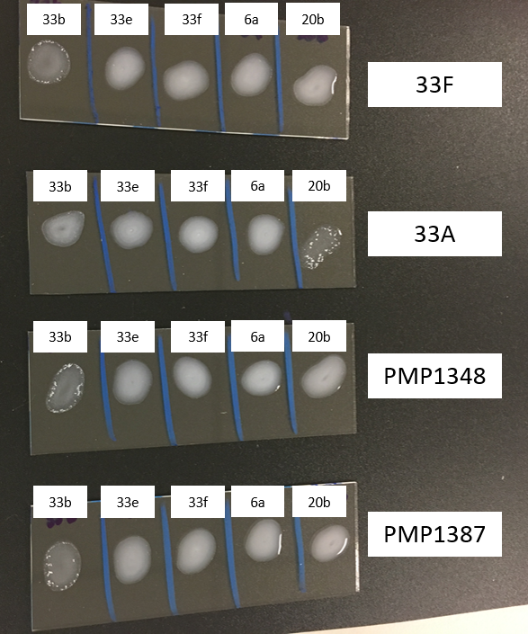

S1 Fig. Representative latex agglutination reactions of Statens Serum Institut (SSI) 33F and 33A reference strains, and two representative 33F-1 isolates from this study (PMP1348 and PMP1387). Latex reagents were prepared using SSI antisera (33b, 33e, 33f, 6a and 20b) as described in the materials and methods. A positive reaction was defined by the presence of clumping and a reduction in background turbidity.

