**Leadership Styles and Organizational Agility Relationship in Science Parks: An Industry 4.0 Perspective**

**Abstract**

The aim of this study is to reveal the influence of multiple leadership types on organizational agility. For this purpose, data is collected through a survey and interviews from randomly selected 333 managers in İzmir Dokuz Eylül Technology Development Zone. Mixed method approach is used to analyze this study. The data obtained based on the sequential explanatory, one of the mixed method design, was analyzed. Reliability, correlation, explanatory and confirmatory factor analysis, structural equation modeling (SEM), path analysis and content analysis were performed to reach the findings. Results show that transformational and transactional leadership have significant while laissez faire has insignificant influence on organizational agility. The quantitative analysis results of the study are also supported by the qualitative analysis results.

**Key words**: Mixed Method, Technology, Science-Parks, Multiple Leadership Styles, Organizational Agility, Adaptation

**INTRODUCTION**

Change is an indispensable fact of our lives.Change happens in organizations, in people behaviors and ideas and in every area of the world we live in.In particular, the continuous changes in customers’ demands and needs make it inevitable for managers and leaders of companies to constantly adapt to these changes in order to keep their firms in a competitive environment.Leaders and managers have sought new solutions in order to manage and survive their enterprises in dynamic and changing business environment. For that, they firstly focused on adaptation, then on flexibility and finally they focused on organizational agility, especially in production in order to adapt to change. Especially after 2000s, this change has been getting increased and for companies it has been inevitable to be agile organizationally.

Because we live in a digital time, and in this time, most of the people are in communication with the technology itself instead of each other.The change in this time forces leaders and managers to understand both changes and developments in the environment ant to adapt them to enterprises. Kouzes and Posner (2003a) state that leaders and managers are expected to have four qualities such as vision, trust, courage and knowledge in order to achieve this adaptation.

In today's competitive environment, agile firms tend to be more successful. If today's technology companies, which are leaders in their sector, failed to be agile in that competitive environment, it would be possible that they might lose their market leadership in the future. Because some companieswhich were in the top in market in their own sector in the past are likely to be stand back from their competitors fornot adapting to market changeconditions. Alcatel and Motorola, which once were in top in the mobile phone market in Turkey, and RodiMood and Wenice Kids in clothing market in Turkey, too, are examples of these. Some of these firms do not have high market share they had in the past, although they keep their surviving in Turkey. It may be said that one of the main reasons these companies losing their leadership in their sector in Turkey is not to meet customers’ needs and demands. Companies need to develop their structures and processes according to customers’ demands, by taking into consideration variables in both internal and external environment in order to get competitive advantage and maintain their market position. Therefore, agility is quick turning into a key driver for organizations additionally as an important issue to a firm's ability to survive and thrive in uncertainty market (Ganguly et al., 2009, p.411).

Organizational agility, which has been used in the field of production in 1990s and after that has been used in different fields, was first systematized in the literature of organization and management in 1990s. For example, organizational agility has been studied in the field of human resources (Shafer, 1997), in the field of production (Lopes, 2009), in terms of sustainable competition (Mason, 2010) and in the performance of employees (Latham, 2014). However, the important problem here is that there are few studies about leadership styles and organizational agility. Even no study is seen in literature that examine the relation between multiple leadership style and organizational agility in techno-enterprise firms which create technology and mostly need to adapt changes in environment. This gap in literature leads us to focus on this basic research question in our study whether "Multiple leadership styles in techno-enterprise firms have an effect on organizational agility?" or not.

In addition, there were limited studies in foreign literature and no study in local literature to compare results with our findings have led us to prefer mixed method as a method to compare our quantitative and qualitative results.

Thus, this research has three aims;

*- To determine organizational agility skills (speed-flexibility-responsiveness-competence) of techno-enterprise firms operating in İzmir Dokuz Eylül Technology Development Zone*

*-To find the effect of multiple leadership styles on organizational agility in these firms*

*- To suggest a research model including transformational, transactional and laissez faire leadership as independent variables and organizational agility as dependent variable.*

In this conceptual framework created to reach these aims, theoretical knowledge is given about technology and technoparks (scienceparks), multiple leadership styles, organizational agility and its components.In addition, the studies and analyzes about the effect of multiple leadership styles on organizational agility, the mixed method used for analysis, the findings obtained from analysis, and the results and suggestions reached at the end of findings are mentioned below.

**1. TECHNOLOGY AND SCIENCEPARKS**

Science parks (techno parks) have a critical role for organizational agility which is inevitable for them. Because these parks create technology by itself. Technology can be defined as to create a product, to transform an existence product or service to another new one. So it can be said using and improving of technology has an aim. As Burgelman (1991) said that the enterprises create new marketing and technologies to introduce new services and products, to meet customers’ demands (p.240). Thus, by using technology to meet both customer's needs and expectations and new market demands, the enterprises can transform their own resource and organizational structure (Brown and Eisenhardt, 1995, p.343).

It may be said that the enterprises can create new markets by offering new products and services that meet customers' demands and expectations. They can do it with some abilities such as to be innovative, adaption to change and respond to this change. Furthermore they can do it more easily and faster with the technology. This is a dynamism which is more common in techno parks where technology is very intense. The first technopark was founded in the prior of Stanford University in California. The first project for developing of technoparks started at the beginning of 1990s in Turkey. With the law of Technology Development Zone (4691), which was accepted 26 of June, 2001, legitimate ground provided. By then, the number of technoparks increased in a short time and by May 2016 the number of technoparks increased to 69 and the number of companies conducting R & D in technoparks was about 4,510 ([www.tgbd.org.tr](http://www.tgbd.org.tr/), 18.03.2018). The rapid increase in the number of companies shows that the technoparks are successful. Those companies contribute to both the region and the country's economy. In addition, these companies operate in different sectors such as software sector, computer and communications, electronics, machinery and equipment, medical, energy, chemical, food, defense and automotive (Table 1).

Table 1: Sectoral Distribution of Firms Operating in the Technoparks

|  |  |  |
| --- | --- | --- |
| **Sector of Activity** | **Number (Average)** | **Percentage in total Technoparks** |
| Software Sector | 1668 | %37 |
| Computer and Communication | 767 | %17 |
| Electronic | 361 | %8 |
| Machinery and equipment, | 271 | %6 |
| Medical, Energy, Chemistry, Food, Defense, Automotive | 1443 | %32 |
| **Total** | **4.510** | %100 |

Cited from: http://www.tgbd.org.tr(18.03.2018)

The statistical information given above shows that the number of technoparks and the number of people working in these companies are rather high. Like other companies, these companies also need leaders who will direct the employees, adapt them to the changing environment, motivate them and at the same time manage change. These kinds of leaders are to adapt to the competition by starting organizational change and innovation with their abilities (Sığrı, et al.,2010, p.52).

**2. MULTIPLE LEADERSHIP APPROACH**

Organizations have needed a leader to reach their goals, to maximize their profit and value, to overcome chaos, turbulent and incomprehensible situations and the leaders have been able to rescue organizations from these adverse situations with the least harm and also they have been able to maintain their organizations presence. Throughout history, different leadership approaches and styles have been defined by different researchers.The multiple leadership approach, one of these approaches, will be discussed and as independent variable of this research.

Firstly introduced in 1978 by Burns and play an important role in the success of present-day organization, multiple leadership approach includes three leadership styles named transformational, transactional and laissez faire leadership. Since then, multiple leadership approach has drawn attention both in Turkey and in the world that has been studied in different disciplines.

**Transformational Leadership**

Burns to begin with presented the concept of changing authority in his expressive inquire about on political pioneers, but this term is presently utilized in organizational brain research. According to Burns (1978), changing authority may be a handle in which "leaders and followers help each other to advance to a higher level of morale and motivation"(p.425).Lewis (1987) stated that the transformational leader links an organization’s vision to the aims and personal standards of its employees. Such leaders prefer internal tools to reward their employees, rather than material values and they are based on personal value systems(Kuhnert & Lewis,1987, p.649).Transformational leaders based on these values have features. These features are expressed as follows by (Tichy & Devanna, 1986, p.264);

* They are visionaries seeing themselves as change agents,
* They are leaders taking risks,
* They believe in the people in their organization,
* They learn from their experiences
* They overwhelm uncertainty which brought by change.

Transformational leaders thanks to these features play a crucial role in managing this change in today's businesses where change happens fast.

**Transactional Leadership**

Mutual interest relationship is very important betweentransactional leader and followers. If the leader meets the needs and expectations of their followers, they perform the demands of the leader. Therefore, it may be said that in the transactional leadership understanding, the effectiveness of the leader depends on the extent to which the changing needs of followers. The interaction between followers and the leader is based more on moral values in the transformational leadership while the interaction between followers and the leader is based on the material and external rewards such as salary increase, permission (Kuhnert & Lewis, 1987, p.649).As Tichy&Devanna (1986) state that “Transactional leaders are concerned about a more stable environment with slight competition.”

**Laissez-Faire Leadership**

In multiple leadership approach, transformational and transactional leaders are mostly compared with laissez-faire leadership styles (Bass and Stogdill, 1990, p.798). Laissez-faire leaders hesitate to decide or take positions, hesitate to act, hesitate to use their authority, and often disappear when they are needed.

Each of these leadership styles stated above has its own components. These components are shown in Table 2.

**Table 2**: Multiple Leadership Styles and Components.

|  |  |  |
| --- | --- | --- |
| **Transformational Leadership** | **Transactional Leadership** | **Laissez-Faire Leadership** |
| **Idealize Influence-Attitude**  Leaders are admired, respected,and trust. | **Contingent Reword**  Leaders get agreement on what needs to be performed, and promise rewards in exchange for carrying out the agreement between leaders and followers. | **Laissez-Faire**  Leaders are inactive, ineffective and nothing is transacted. |
| **Idealize Influence-Behavior**  Leaders demonstrate high standards of ethical and moral conduct. | **Management by Exception-Active.** Leaders arrange to actively monitor deviances from standards, mistakes, and errors in the follower's agreement and to correct mistakes and errors when necessary. |  |
| ***Inspirational Motivation***  Leaders motivate and inspire their followers. | **Management by Exception-Passive**Leaders keep waiting for deviances, errors and mistakes to occur and then correct them. |  |
| ***Intellectual Stimulation***  Leaders stimulate their followers’perform to be more innovative and creative. |  |  |
| **Individualized Consideration**  Leaders pay special attention to each individual's needs for achievement as coach. |  |  |

**Cited from:** Avolio, B. J., & Bass, B. M. (2002) *Developing potential across a full range of Leadership Tm: Cases on transactional and transformational leadership*, (pp.2-4).

**3. ORGANIZATIONAL AGILITY AND ABILITIES**

There are many researches and studies related to adaptation of organizational structure and processes to changing environmental conditions in the field of management organization, and also researches has been conducted on how organizations have coped with ambiguity and change by adaptation to environmental conditions (Burns & Stalker, 1961; Hage& Dewar, 1973). Competition is no longer local, but global, technology is getting more evolved, environment is changing rapidly and industrial environment is developing more. That's why enterprises must be agile in order to manage their environment and to survive in dynamic and competitive environment. In order to get over this problem leaders managers have being trying to find new solutions. For that, firstly they focused on adaptation, then on flexibility and finally they focused on agility, especially in production in order to adapt to change. As a natural consequence of this, the concept of organizational agility can be stated as rapidly change and adapt in response to changes not only in the production department but in all departments in firms.

Organizational agility, which has been used in the field of production in 1990s and after that been used in different fields, is a new concept so it has not a common definition but it is defined as an organization capability to respond rapidly to market changes by Breu et al. (2001, p.21) and organizational agility is the manufacturer's ability to react quickly to sudden and unpredictable changes (Putnik, 2001, p. 79). Organizational agility can be also explained as the ability of the enterprise to respond quickly to unforeseen and unexpected changes in business internal and external environment.

**Organizational Agility Abilities**

Organizational agility has its own characteristics and abilities. To tell whether an enterprise or organization is organizationally agile, it must have some capabilities. The organizational agility model usually has an identical structure consisting of three elements. These are (Sharifi& Zhang, 1999, p.11; 2001, p.775);

* "Agility Drivers" which are defined as the way in which the enterprises operate. (the pressures which force enterprises to adapt the changes in the business environment, the need for agility, the strategic intent to be agile and agility strategy),
* "Agility Capabilities" which are explained as the organizational agility of the business (these are the skills required for businesses to respond positively to the changes in business environment, consisting of four dimensions: responsiveness, competence, flexibility, and speed),
* "Agility Providers" which mean that administrators/managers use the agility capabilities of the businepp.(practices that are necessary for agility skills to be acquired),

Although there are some differences in opinion in different researchers in the literature, Sharifi &Zhang (1999), Zhang &Sharifi(2000), Sharifi et al. (2001), Crocitto&Youssef (2003), Lin et al. (2006), Shahaei, (2008), Zhang (2011), Nejatian & Hossein Zarei (2013), Mohammadi et al. (2015) state that organizational agility has four basic abilities: Responsiveness - Competence - Flexibility - Speed

**Responsiveness:** This ability is stated to be the first ability of a business organizational agility(Sharifi& Zhang, 1999; 2001), Sharifi et al. (2001), Crocitto&Youssef (2003), Lin et al. (2006), Shahaei (2008), Zhang (2011), Nejatian & Hossein Zarei (2013), Mohammadi et al.(2015). It is the ability to be aware of the changes in the market, and the ability to react these change quickly.

Due to technological and environmental changes, customer demands and needs may change over time. Businesses must respond to these changes on the right time and right place. If they respond to those changes, they could gain a competitive advantage. This is due to the fact that the business being agile organizationally and using its responsiveness ability.

**Flexibility:** The ability of a business to be flexible means to adapt to environmental changes (Sanchez, 1993, p.254), to reach the optimum size and to respond continuously to unexpected changes (Kundi and Sharma, 2015, p. 227). Flexibility can be stated that a business adaptation its own structure and resources to change, to increase its market share or to create new product and technology. Moreover it can be stated the ability of a business to rechange its internal resources (employees, machines, equipment, architectural structure, etc.) according to the demands and needs of the customers. If it were succeeded, the enterprises could maximize its profit.

**Speed:** There is a strong relation between speed and responsiveness. As a matter of fact, some researchers (Sharp et al., 1999, p.157, Gunasekaran& Yusuf, 2002, p.1357, Lin et al., 2006, p.356, Jain et al., 2008, p.6649) stated that after having decided how to react to the changes, businesses should be able to apply these decisions quickly. It is the ability to complete an activity as quickly as possible (Zhang & Sharifi, 2000, p. 508), in other words, is the ability to do an activity as soon as possible (Christopher, 2000, p. 37) or the ability to respond quickly to changes in the environment of the business (Hoyt et al., 2007, p 1573, Shahaei, 2008, p.15).

Speed is important for a business in aspect of innovation abilities, improving a new knowledge against change. Speed can be explained as the ability of a business to deliver the product or service effectively and in short time.

**Competence:** The competence dimension can be stated as the ability to use the other three abilities of organizational agility. Because the ability of a business to carry out an event is related to its ability to use its competence.Competence is the ability and capacity to renew existing or potential skills to adapt a business to changes in environment(Teece et al., 1997, p.510) or the ability to reach business goals effectively and efficiently (Sharifi & Zhang, 1999, p.17).

**Studies about Multiple Leadership Styles and Organizational Agility**

There are some researches about organizational agility and leadership styles in literature. But most of them are about agile production, job satisfaction, organizational success, performance or service quality(Table 3).

**Table 3:** Studies about Multiple Leadership Styles and Agility

|  |  |  |  |
| --- | --- | --- | --- |
| **Researcher** | **Year** | **Topic** | **Result** |
| **Zhang &Sharifi** | 2000 | A methodology for achieving agility in manufacturing organizations | A model has been identified and an organizational agility model has been designed to provide agility in the manufacturing sector. |
| **Tetik** | 2008 | The Role of transformational leader in managing change | The transformational leader has an important role in managing change. |
| **Xu et al.** | 2008 | The impact of transformational leadership style on organizational performance: The intermediary effects of leader-member exchange | The results show that the transformational leader increase organizational performance. |
| **Hüseynov** | 2010 | The role of organizational agility in Strategic management of human resources | Strategic management of human resources is important to create organizational agility. |
|  |  |  |  |
| **Judkrue** | 2012 | The influence of transformational leadership style on organizational success: A study on MNCs in Bangkok, Thailand | The results show that transformational leaders can increase employee performance in multinational companies. |
| **Young** | 2013 | Identifying the impact of leadership practices on organizational agility | The results show that leadership style increases organizational agility in the service sector . |
| **Chou** | 2014 | Does Transformational Leadership matter during Organizational Change? | The results show that transformational leaders affect employees' behaviors supporting change directly. |
| **Veiseh et al.** | 2014 | A study on ranking the effects of transformational leadership style on organizational agility and mediating role of organizational creativity | The results show that transformational leaders have effect on organizational agility. |
| **Karimi et al.** | 2016 | The Effect of Transformational Leadership Style on Components of Organizational Agility in Isfahan University of Technology | The results show that transformational leadership style affect on organizational agility dimensions. |

Those researches are mostly about agile production, job satisfaction, organizational success, performance or service quality and especially transformational leadership style which is only a style of multiple leadership styles. However, there are no studies in the literature that take multiple leadership styles, consisting of transformational, transactional and laissez faire leadership, as independent variables and organizational agility as dependent variable, in other words the interaction between those two components. And it has formed the basic research model of this study and is explained in detail below.

**The Importance and Purpose of Research**

In today's world, technology companies, especially, in developed countries are working hard to become a company with organizational agility which is one of the production strategies in today's manufacturing enterprises (Nagel & Bhargava, 1994, p.331, Nath et al., 2008, p.1080, Sukati et al., 2012, p.275). Organizational agility is becoming an essential element in eliminating the environmental uncertainties of the supply chain, especially when supply chain management is critical (Sahin et al., 2017, p.338). The concept of organizational agility emerged after manual production, mass production and lean production, and has been seen by researchers as the top development of the thought of production management and is a critical approach to manufacturing operations(Hormozi, 2001, p.132). Managers and owners of today's enterprises are aware of the need to be agile to meet customer needs and demands. Therefore, our research about "Organizational Agility", which is an important topic in the literature, and "Leadership Styles" that can achieve this may provide significant contributions literature. In particular, it is important to determine the effective and agile leadership type that will provide organizational agility in technopark firms where change and technology are very fast.

**Sample of Research**

The sample of this research is the managers, who accepted to join research, of Dokuz Eylül Technology Development Zone companies. There are 136 companies operating, 66 of which are entrepreneurial firms in there by March 2017. For quantitative analysis 302, for qualitative analysis 31 managers were interviewed randomly. Multiple Leadership Questionnaire (MLQ-5X)developed by Avolio and Bass (1995), bought from [www.mindgarden](http://www.mindgarden/), and Organizational Agility Questionnaire developed by Sharifi and Zhang (1999) were used to collect data from managers. Descriptive statistics about sample is on Table 4.

**Table 4:** Descriptive Statistics

|  |  |  |  |
| --- | --- | --- | --- |
| **DEMOGRAPHIC** | **CATEGORY** | **NUMBERS** | **PERCENTAGE** |
| **Age** | 18-24 | 55 | 18,2 |
|  | 25-34 | 171 | 56,6 |
|  | 35-44 | 63 | 20,9 |
|  | 45-and over | 13 | 4,3 |
| **Sex** | Men | 217 | 71,9 |
|  | Women | 85 | 28,1 |
| **Education** | Associate Degree | 51 | 16,9 |
|  | Bachelor Degree | 193 | 63,9 |
|  | Postgraduate (PhD,Master) | 58 | 19,2 |
| **Position in the Company** | Top Managers | 63 | 20,9 |
|  | Marketing Managers | 10 | 3,3 |
|  | R & D Managers | 18 | 6,0 |
|  | Human Resources Managers | 5 | 1,7 |
|  | Department Managers (Production-Accounting-Finance, Public Relations, etc.) | 208 | 68,2 |
| **Company Sector** | Service | 8 | 12,1 |
|  | Technology Software | 35 | 53,0 |
|  | Technology Hardware Graphics and Design | 9 | 13,7 |
|  | Others (Energy, Medical, etc.) | 14 | 21,2 |
|  | 0-9 | 24 | 36,4 |
| **Number of Employees** | 10-49 | 31 | 46,9 |
|  | 50-249 | 6 | 9,1 |
|  | 250 -and more | 5 | 7.6 |

**Research Method**

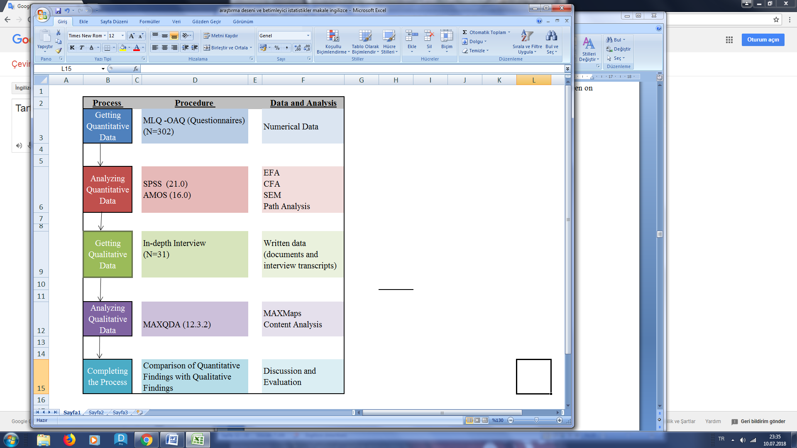 After getting permission from Avolio & Bass, Sharifi & Zhang for using the questionnaire they developed, we applied Ethics Committee of İzmir Katip Çelebi University and Ethics Committee date is 15.03.2017 and number is 03.

Mix method was used to analyze data. According to Creswell (2003, pp.284-285) and Greene (2005, p.209) studies tend to be more quantitative or qualitative (mixed method) in nature. Onwuegbuzie and Leech (2004, p.15) emphasize that the mixed method helps to create a link and bridge between quantitative and qualitative research. In this research sequential explanatory, a design of mixed method developed by Creswell (2003). In this design; quantitative data are first collected and analyzed then qualitative data are collected especially to compare both data (Creswell, 2003, p. 215; Ivankova et al., 2006, p.5; Ratliff, 2013, p.53). The research design based on the sequential explanatory design is seen on Figure 1.

**Figure 1:** Research Design

**Statistical Methods Used in Research**

Firstly, averages of all variables, descriptive statistics and standard deviations were found. Exploratory factor analysis (EFA) and confirm factor analysis(CFA) were done and Pearson Correlation was calculated. Structural equation modeling (SEM) and Path analysis were used in order to find whether there is a relation between independent variables (transformational, transactional and laissez faire leadership) and dependent variable (organizational agility).

**4. FINDINGS**

**Findings of Quantitative Data**

Exploratory factor analysis was done to find how many factors in organizational agility questionnaire. The result showed that there are 4 factors as the original and total variance is 64.5% and Cronbach Alpha value of all dimensions is more than 0.70 and the total Cronbach Alpha value of the questionnaire is 0.92.After that CFA was done for all variables and all values were in acceptable range (Table 5).

**Table 5**: Results of CFA

|  |  |  |  |  |  |
| --- | --- | --- | --- | --- | --- |
| **Model** | **∆χ²/df** | **RMSEA** | **CFI** | **GFI** | **AGFI** |
| **Organizational Agility** | 1,92 | 0,05 | 0,96 | 0,92 | 0,90 |
| **Transformational Leadership** | 1,43 | 0,03 | 0,93 | 0,93 | 0,91 |
| **Transactional Leadership** | 1,86 | 0,05 | 0,90 | 0,95 | 0,92 |
| **Laissez Faire Leadership** | 4,28 | 0,08 | 0,98 | 0,99 | 0,99 |

Minimum, maximum, mean values and standard deviations of all variables can be seen on Table 6.

**Table 6.** Descriptive Statistics

|  |  |  |  |  |  |
| --- | --- | --- | --- | --- | --- |
| **VARIABLES** | **NUMBER OF PARTICIPANTS** | **MIN.** | **MAX.** | **MEAN** | **SD.** |
| **Components of Transformational Leadership** |  |  |  |  |  |
| Inspirational Motivation | 302 | 2,00 | 5,00 | 4,06 | ,53 |
| Idealized Influence-Attitude | 302 | 2,00 | 5,00 | 4,02 | ,55 |
| Idealized Influence-Behavior | 302 | 2,00 | 5,00 | 4,04 | ,53 |
| Individualized Consideration | 302 | 1,50 | 5,00 | 3,96 | ,55 |
| Intellectual Stimulation | 302 | 1,75 | 5,00 | 4,02 | ,51 |
| **Components of Transactional Leadership** |  |  |  |  |  |
| Contingent Reward | 302 | 1,25 | 5,00 | 4,05 | ,53 |
| Management-by-Exception-Active | 302 | 1,75 | 5,00 | 3,81 | ,58 |
| Management-by-Exception-Passive | 302 | 1,00 | 5,00 | 3,22 | ,69 |
| **Laissez Faire-Leadership** |  |  |  |  |  |
| Laissez Faire-Leadership | 302 | 1,00 | 5,00 | 2,33 | ,91 |
| **Organizational Agility Leadership** |  |  |  |  |  |
| Competence | 302 | 2,11 | 5,00 | 4,21 | ,42 |
| Flexibility | 302 | 1,25 | 5,00 | 4,07 | ,65 |
| Responsiveness | 302 | 1,00 | 5,00 | 4,12 | ,55 |
| Speed | 302 | 1,00 | 5,00 | 4,20 | ,59 |

Correlation analysis was performed to find out whether there is an autocorrelation among independent variables. If the value is more than 0.8 it means there is an autocorrelation problem (Kalaycı, 2010, p.267). In this study correlation values are between -0.16 and 0.69 which means there is not an autocorrelation among independent variables (Table 7).Some other researches also support that results: (Erturgut, 2007; Geçmez, 2009; Eryeşil, 2012; Sandıkçıoğlu et al., 2015; Daskin, 2016; Ahmet et al., 2016; Huysamen et al., 2003; Gillespie & Mann, 2004; Shibru & Darshan, 2011).

**Table 7**: Correlation among Variables

* Correlation is significant at 0.05 level (2-tailed). ** Correlation is significant at the level of 0.001 (2-tailed).

Furthermore a model was designed including independent variables (transformational, transactional and laissez faire leadership) and dependent variable (organizational agility). SEM was used to find direct or indirect relationships between those variables. Path analysis was done whether there is a positive relation between independent variables and dependent variable

When the relations between the variables in the model and the path that these variables follow are examined;

**“*Organizational Agility <---Laissez-Faire Leadership*”** statistically insignificant relation (p> 0.05),

**“*Organizational Agility <---Transformational Leadership*”** statistically significant relation (p<0,001),

**“*Organizational Agility <---Transactional Leadership*”** statistically significant relation p<0, 05).

To make the model more significant, laissez-faire leadership variable was removed from model. The model showing significant relationships is seen on Figure 2 and the results of goodness of fit are seen on Table 8.

There are some letters in the model which used instead of variables.

DL: **Transformational Leader**

F1: Inspirational Motivation

F2: Idealized Influence-Attitude

F3: Idealized Influence-Behavior

F4: Individualized Consideration

F5: Intellectual Stimulation

EL: **Transactional Leader**

F6: Contingent Reward

F7: Management-by-Exception-Active

F8: Management-by-Exception-Passive

OC: **Organizational Agility**

S1: Competence

S2: Flexibility

S2: Responsiveness

S4: Speed

**Figure 2:** model showing significant relationships

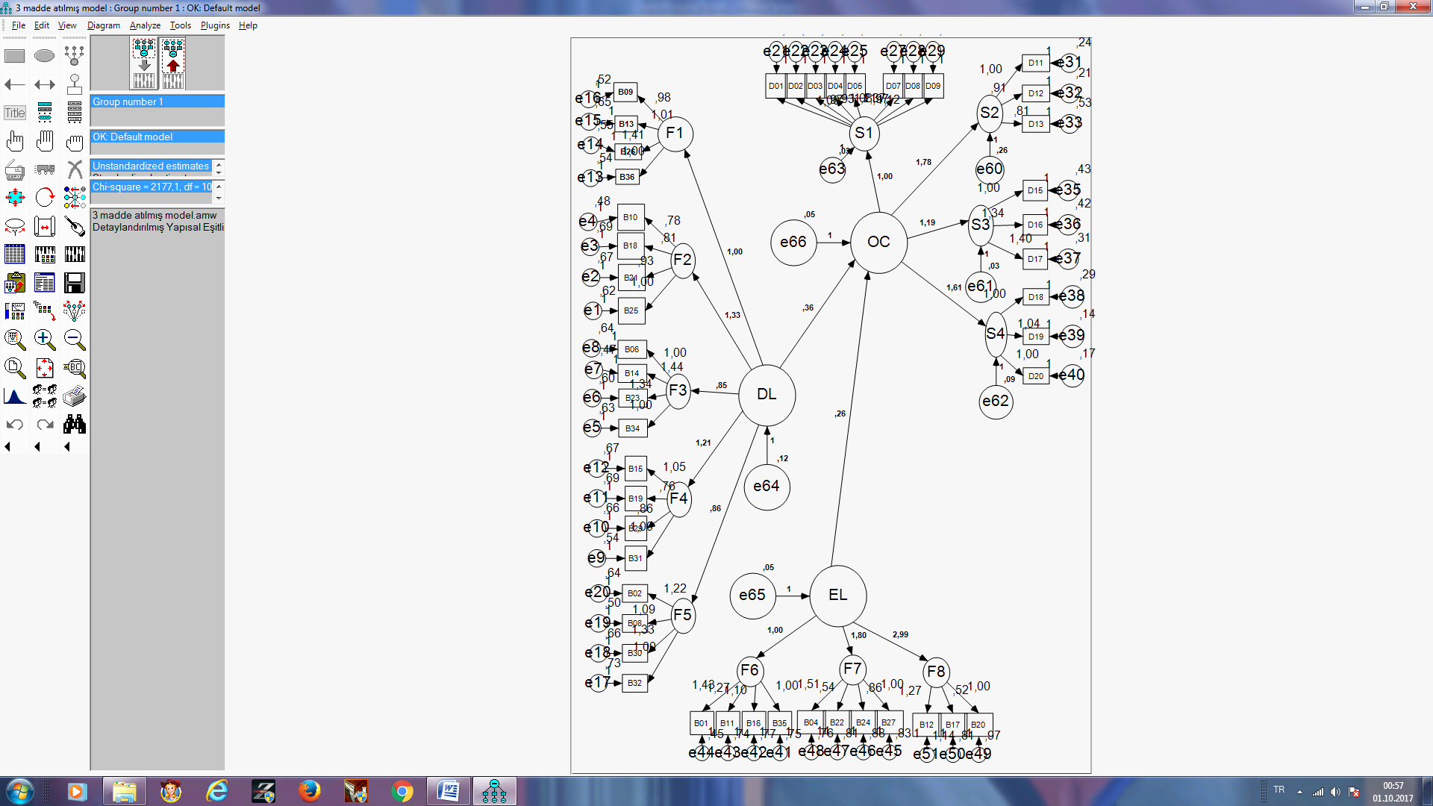

**Table 8:** the results of goodness of fit of model

|  |  |  |  |  |  |  |  |
| --- | --- | --- | --- | --- | --- | --- | --- |
| **Model** | **∆χ²** | **Df** | **∆χ²/df** | **RMSEA** | **NFI** | **GFI** | **AGFI** |
| **Model** | **205,660** | **113** | **1,82** | **0,05** | **0,94** | **0,92** | **0,90** |

RMSEA= RootMeanSquareError of Approximation; NFI= Normed Fit Index- GFI= Goodness of Fit Index; AGFI= Adjusted of Goodness Fit Index, df= Degrees of Freedom

**Findings of qualitative data**

Content analysis method was used for qualitative analysis. Content analysis is a research technique used to give reproducible and valid results on its content (Krippendorff, 1980, p. 25, cited by Kochak&Arun, 2006, p.22). In this context, content analysis was conducted with the MAXQDA program to analyze whether there is a relationship between the variables. MAXMaps "Code Subcode-Part Model" from the visual tools of the MAXQDA program was used. Since the variables of the research and the sub-dimensions of these variables are metaphorical concepts, some of them are not seen in the interview texts directly. Therefore, firstly the codes were created according to expressions related to variables then four main themes were created, namely, ***Transformational Leadership***, ***Transactional Leadership***, ***Laissez-Faire Leadership*** and ***Organizational Agility*** in accordance with the common directions and similarities of these codes. Each sentence related to one of these themes is written into these codes, and the number and frequency of the values are calculated. The frequency distributions of the coding of these variables are shown in Table 9.

**Table 9:** Frequency of Themes and Codings

|  |  |  |  |
| --- | --- | --- | --- |
| Theme \ Sub Code Names | Frequency | Percent % | Valid Percent % |
| **Transformational Leader** \ Idealized Influence-Behavior | 70 | 31,25 | 31,25 |
| **Transformational Leader** \Inspirational Motivation | 23 | 10,27 | 0,1 |
| **Transformational Leader** \Individualized Consideration | 7 | 3,13 | 0,03 |
| **Transformational Leader** \Idealized Influence-Attitude | 5 | 2,23 | 0,02 |
| **Transformational Leader**\Intellectual Stimulation | 4 | 1,79 | 0,02 |
| **Transformational Leader** | 14 | 6,25 | 0,06 |
| **Transactional Leader**\Contingent Reward | 11 | 4,91 | 0,05 |
| **Transactional Leader**\Management-by-Exception-Active | 2 | 0,89 | 0,01 |
| **Transactional Leader**\Management-by-Exception-Passive | 1 | 0,45 | 0 |
| **Transactional Leader** | 5 | 2,23 | 0,02 |
| **Laissez FaireLeader** | 4 | 1,79 | 0,02 |
| **Organizational Agility**\Responsiveness | 3 | 1,34 | 0,01 |
| **Organizational Agility**\Competence | 4 | 1,79 | 0,02 |
| **Organizational Agility**\Speed | 8 | 3,57 | 0,04 |
| **Organizational Agility**\Flexibility | 6 | 2,68 | 0,03 |
| **Organizational Agility** | 57 | 25,45 | 0,25 |
| **Total** | 224 | 100 | 100 |

Table 9 shows that the participants prefer the type of transformational leadership more, especially on the dimensions of "Idealized Influence-Behavior" and "Inspirational Motivation" and “Contingent Reward", one of dimension of Transactional leadership. In addition to this, it is seen that the participants pay attention to organizational agility, but little mention about laissez faire leadership.

Figure 3 shows the relationship between these themes and codes numerically. The higher this number, the thicker the line shows the relation. If the relationship between dependent and independent variables is examined and if these lines lead to a dependent variable, they show that there is a relationship between them and the thickness of the line and the high number show that the relationship is strong.

The map showing the relationship between the variables of this study is shown in Figure 3.

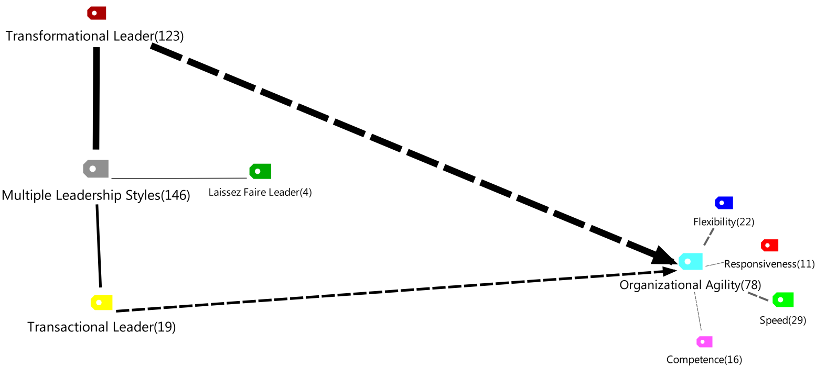**Figure 3:** Multiple Leadership Styles and Organizational Agility Relationship Map

Figure 3 shows that there is a relationship between organizational agility and transformational and transactional leadership but not any relation with laissez faire leadership.

**CONCLUSION and SUGGESTIONS**

Meeting the needs and demands of customers in today's competitive environment has become one of important goals of enterprises. To meet these demands and needs on time, and to cope with technology and environmental change, businesses need to have agile skills as an organization. It is undoubtedly the managers and leaders of enterprises who will provide this agility. In this study, organizational agility skills were examined, and it is concluded that transformational and transactional leaders are the type of leaders that to adapt to change, to improve and develop employees skills. In other words, organizational agility is not affected by laissez-faire leadership significantly while affectedby transformational leadership and transactional leadership significantly. The perceptions of organizational agility of transformational and transactional leadership were high; especially managers’ motivation employees, inspiration, and the consistent of award-winning behavior increase organizational agility.

A research model was developed to clarify the interrelationships between variables in the research. It is the model based on the influence multiple leadership types on organizational agility. Basically, the model that takes transformational, transactional and laissez-faire leadership types as independent variables and takes an organizational agility dependent variable. When the structural equation model is considered as a whole, there is a statistically significant relation between transformational, transactional leadership (p <0.001) and organizational agility (p <0.05).

This study examined multiple leadership styles and organizational agility by taking managers of firms operating in İzmir Dokuz Eylül Technology Development Zone. To see more relations of other leadership styles and components of organizational agility more samples may be examined. Furthermore, working with more variables and more samples may contribute to organizational behavior and management. More precise and meaningful results could be generated if data were gathered from more samples.

In future studies, agile leadership behaviors of top and middle managers and employees can be evaluated in terms of organizational agility. The sequential explanatory, one of the mixed method design was applied to analyze data, the sequential exploratory or the Concurrent triangulation, other mixed method designs can be applied to analyze.Also, organizational agility has been conceptualized in the literature, is it possible that “Agile Leadership” can be conceptualized? In this context, how an agile leader can use organizational agility skills (flexibility, responsiveness, competence, speed) is suggested as in Figure 4.

**Figure 4:** Suggested Model 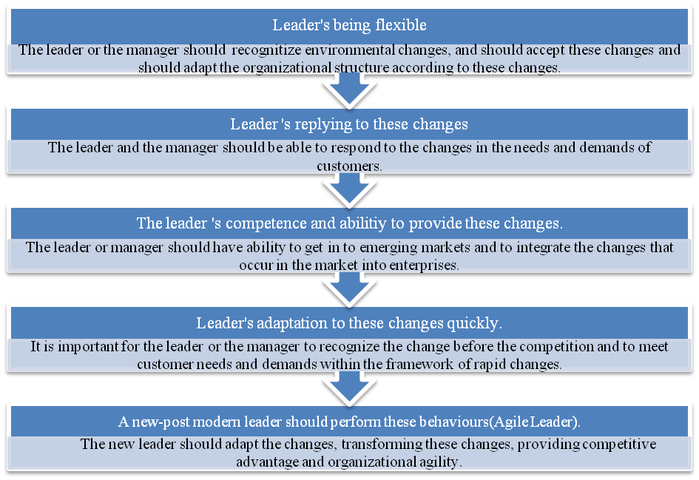

**REFERENCES**

Ayık, A., Diş, O &Çelik, Z. (2016).Okul Müdürlerinin Dönüşümcü Liderlik Rolleri ile Okulların Değişime Açıklığı Arasındaki İlişki, Kastamonu Eğitim Dergisi, Cilt:24 No:2, pp. 547-564

Arpacı, I. (2013). Organizational adoption of mobile communication technologies. *The Department of Information System.School of Informatics of Middle East Technical University*. (PhD Thesis)

Avolio, B. J. & Bass, B. M.,(1995). MLQ: Multifactor Leadership Questionnaire for Research: Permission Set. Mind Garden.

Avolio, B. J., & Bass, B. M. (2002). Developing potential across a full range of Leadership Tm: Cases on transactional and transformational leadership. Psychology Press, London

Bass, B. M. (1990). Bass and Stogdill's Handbook of Leadership (Rev. Ed.).

Breu, K., C. J. Hemingway, M. Strathern& D. Bridger (2001). Workforce Agility: The New Employee Strategy For The Knowledge Economy”, Journal Of Information Technology, 17, pp. 21-31

Brown, S.L.,& Eisenhardt K.M. (1995). Product development: Pastresearch, present findings, and future directions. Acad. Management Rev. 20(April), pp. 343–378.

Burgelman, R. (1991) Intra organizational ecology of strategy making and organizational adaptation: Theory and field research. Organization Science, 2:,pp.239-262.

Burns, James MacGregor. (1978). Leadership. New York: Harper ve Row, pp. 425-430

Burns, T. E. ve Stalker, G. M. (1961).The management of innovation. London: Tavistock.

Büyüköztürk, S., KılıçÇakmak, E., Akgün, O. E., Karadeniz, S., &Demirel, F. (2008). Bilimselaraştırmayöntemleri. Ankara: PegemAkademi.

Cesur, K. (2012). Examining Competencies Of Prospective English Teachers Through Their Pedagogical Content Knowledge: A casestudy. *YayımlanmamışPhD Thesis, GaziÜniversitesi: Ankara*.

Chou, P. (2014). Does Transformational Leadership matter during Organizational Change? European Journal of Sustainable Development, 3(3), pp. 49-62.

Christopher, M. (2000). The Agile Supply Chain, Industrial Marketing Management, Vol. 29, No.1, pp. 37-44.

Creswell, J. W. (2003). Research Design: Qualitative, quantitative, and mixed methods approaches (2nd ed.). Thousand Oaks, CA: Sage

Crocitto, M.& Youssef, M. (2003) The Human Side of Organizational Agility. Industrial Management ve Data Systems, 103(6), pp.388-397

Daskin, M.(2016). The Role of Leadership Style on Frontline Employees’ Perceived Ethical Climate, Polychronicity and Service Recovery Performance: An Evaluation from Customer Service Development Perspective. Journal of Entrepreneurship and Innovation Management Volume 5( 2 ), pp.125-157

Erdoğan, M.,Y. (2014). SivilToplumÖrgütleriGönüllüYönetimiYaklaşımlarıveSosyalGirişimcilikGönüllüYönetimiModeliÖnerisi (Master Thesis) GaziÜniversitesiSosyalBilimlerEnstitüsü

Erturgut, R. (2007). ToplamKaliteYönetimiUygulamaları İle DönüştürücüLiderlikArasındakiİlişki: UlusalKaliteÖdülüAlmış Olan KamuÖrgütlerindeBirAraştırma. YayınlanmamışPhD Thesis, Kocael: KocaeliÜniversitesiSosyalBilimlerEnstitüsü.

Eryeşil, K. (2012). *Liderliktarzlarıileörgütselbağlılıkarasındakiilişkininincelenmesineyönelikbiralanaraştırması* (PhD Thesis), SelçukÜniversitesiSosyalBilimlerEnstitüsü

Ganguly, A., Nilchiani, R. & Farr, J. V. (2009).Evaluating agility in corporate enterprises. International Journal of Production Economics, 118(2), pp. 410-423.

Geçmez, T. (2009).Yöneticilerindönüşümcüve etkileşimci liderlikstilleriileçatışmayönetimistilleriarasındakiilişkivekimyasektöründebiraraştırma. *YayınlanmamışMaster Thesis, Marmara Üniversitesi, Türkiye*.

Gillespie, N. A. & Mann, L. (2004). Transformational leadership and shared values: The building blocks of trust. *Journal of Managerial Psychology*, *19*(6), pp.588-607.

Greene, J. C. (2005). The generative potential of mixed methods inquiry. International Journal of Research ve Method in Education, 28(2): pp. 207 – 211.

Gunasekaran, A.& Yusuf, Y.Y. (2002). Agile Manufacturing: A Taxonomy of Strategic and Technological Imperatives, International Journal of Production Research, Vol. 40, No. 6, pp.1357-1385.

Hage, J. & Dewar, R. (1973).Elite values versus organizational structure in predicting innovation.Administrative science quarterly, pp. 279-290.

Hormozi M. Amir (2001). Agile Manufacturing: The Next Logical Step, Benchmarking: An International Journal, Vol.8 No.2,pp. 132-143.

Hoyt, J., Huq, F. &Kreiser, P. (2007).Measuring organizational responsiveness: the development of a validated survey instrument. Management Decision, 45(10): pp. 1573-1594.

Huysamen, R., Schepers, J. M., &Zaaiman, J. (2003).The behavioural and personality correlates of transactional and transformational leadership. *SA Journal of Human Resource Management*, *1*(2), 53-59.

Hüseynov, V. (2010).İnsanKaynaklarınınStratejikYönetimindeÖrgütselAtikliğinRolü, Master Thesis, DokuzEylülÜniversitesiSosyalBilimlerEnstitüsü, İzmir.

Ivankova, N. V., Creswell, J. W. & Stick, S. L. (2006). Using mixed-methods sequential explanatory design: From theory to practice. Field methods, 18(1), pp.3-20.

Jain, V., Benyoucef, L. &Deshmukh, S.G. (2008). What’s the Buzz about Moving from “Lean” to “Agile” Integrated Supply Chains? A Fuzzy Intelligent Agent-Based Approach”, International Journal of Production Research, Vol. 46, No. 23, pp. 6649-6677.

Judkrue, A. (2012). The influence of transformational leadership style on organizational success: A study on MNCs in Bangkok, Thailand. In ICT and Knowledge Engineering (ICT ve Knowledge Engineering), 10th International Conference on, pp. 14-18.

Kalaycı, Ş. (2010).SPSS uygulamalıçokdeğişkenliistatistikteknikleri. Ankara, Turkiye: AsilYayınDağıtım.

Karimi, O., Daraei, M. &Sepehr, M. (2016).The Effect of Transformational Leadership Style on Components of Organizational Agility in Isfahan University of Technology.International Research Journal of Management Sciences. Vol. 4 (2),pp. 149-155

Koçak, A. & Arun, Ö. (2006).İçerikanaliziçalışmalarındaörneklemsorunu.SelçukÜniversitesiİletişimFakültesiAkademikDergisi, 4(3), pp. 21-28.

Kouzes, J. & Posner, B. (2003a). The five practices of exemplary leadership. In J. Gallos (Ed.), Business leadership, pp. 72-84, San Francisco, CA: John Wiley and Sons.

Kuhnert, K. W.&Lewis, P. (1987). Transactional and transformational leadership: A constructive/developmental analysis. *Academy of Management review*, *12*(4), pp.648-657.

Kundi, M. ve Sharma, S. (2015). Efficiency Analysis and Flexibility: A Case Study of Cement Firms in India. Global Journal of Flexible Systems Management, 16(3), pp.221-234.

Latham, L. J. (2014). Organizational agility: Exploring impact of adoption on team performance from the human resource perspective(PhD Thesis).

Lin, C.T., Chiu, H. & Chu, P.Y. (2006), Agility Index in the Supply Chain, International Journal of Production Economics, Vol. 100, No. 2, pp. 285-299.

Lopes, K. J. (2009). Organizational agility: Exploring how the U.S. coast guard chooses and implements effective courses of action(PhD Thesis).

Mason, A. J. (2010). Inside the black box: Investigating agility as a dynamic capability for sustaining a competitive advantage within consulting firms(PhD Thesis).

Mohammadi, M., Nikpour, A., &Chamanifard, R. (2015). The Relationship between Organizational Agility and Employee’s Productivity (Case Study: Ministry of Youth Affairs and Sports, Iran), pp.66-70

Nagel, R. N.& Bhargava, P. (1994). Agility: The ultimate requirement for world‐class manufacturing performance. Global Business and Organizational Excellence, 13(3), pp.331-340

Nath, A. K., Saha, P. &Salehi-Sangari, E. (2008).Transforming Supply Chains in Digital Content Delivery: A Case Study in Apple. In Research and Practical Issues of Enterprise Information Systems II (pp. 1079-1089). Springer, Boston, MA.

Nejatian, M.& Hossein Zarei, M. (2013). Moving Towards Organizational Agility: Are We Improving in the Right Direction?.Global Journal of Flexible Systems Management, 14(4), pp.241–253.

Onwuegbuzie, A. J. & Leech, N. L. (2004).Enhancing the interpretation of significant findings: The role of mixed methods research. *The qualitative report*, *9*(4), pp. 770-792.

Özdemir, M. ( 2017). TravmaYaşantısınaSahipÜniversiteÖğrencilerininPsikolojikYardımAramaDavranışları İle İlişkiliFaktörler (Master Thesis) KaradenizTeknikÜniversitesiEğitimBilimleriEnstitüsüEğitimBilimleriAnabilim Dalı RehberlikvePsikolojikDanışmanlıkBilim Dalı

Putnik, G.D. (2001) BM-Virtual Enterprise Architecture Reference Model, Agile Manufacturing: The 21st Century Competitive Strategy, Elsevier Science, pp. 73-94.

Ratliff, J. R. (2013). Perceptions and experiences of university administrators on internationalization planning and implementation at a midwestern university: A mixed methods study. Bowling Green State University (PhD Thesis).

Sanchez, R. (1993). Strategic flexibility, firm organization, and managerial work in dynamic markets: A strategic options perspective. In Advances in Strategic Management, ed. P. Shrivastava, A. Huff and J. Dutton, pp. 251-291

Sandıkcı, M., Vural, T. &Zorlu, Ö. (2015).OtelİşletmelerindeDönüştürücüLiderlikDavranışlarınınÖrgütSağlığıÜzerineEtkileri: AfyonkarahisarİlindeBirAraştırma. *Journal of Administrative Sciences/YonetimBilimleriDergisi*, *13*(25).pp.161-200.

Shafer, R. A. (1997). Creating organizational agility: The human resource dimension (PhD Thesis).

Shahaei, B. (2008). Paradigm Of Agility, Definitions, Features And Concepts. Tadbir Publication, 194th Issue, pp.14-18.

Sharifi H. (1999). A Methodology for Assisting Manufacturing Organisations to Implement Agile Manufacturing, Liverpool University(PhD Thesis).

Sharifi, H. & Zhang, Z. (2001).Agile manufacturing in practice—application of a methodology. International Journal of Operations and Production Management 21 (5–6), 772–794.

Sharifi, H., Colquhoun, G., Barclay, I. & Dann, Z. (2001). Agile Manufacturing: A Management And Operational Framework. Proceedings of The Institution of Mechanical Engineers - Part B -- Engineering Manufacture (Professional Engineering Publishing), 215(6), pp.857-869.

Sharifi, H. & Zhang, Z. (1999). A Methodology For Achieving Agility In Manufacturing Organisations: An Introduction. International journal of production economics, 62(1), pp. 7-22.

Sharma, S. (1996).Applied Multivariate Techniques, New York, John Willey & Sons.Inc.

Sharp, J.M., Irani, Z. & Desai, S. (1999). Working towards Agile Manufacturing in the UK Industry, International Journal of Production Economics, Vol. 62, No. 1/2, pp. 155-169.

Shibru, B. & Darshan, G. M. (2011).Transformational leadership and its relationship with subordinate satisfaction with the leader (the case of Leather Industry in Ethiopia). *Interdisciplinary Journal of Contemporary Research in Business*, *3*(5),pp. 686-697.

Sığrı, Ü.,et.all. (2010). Özyeterliğindönüştürücüliderliküzerineetkisi: Kamusektöründebiraraştırma. İstanbul TicaretÜniversitesiSosyalBilimlerDergisi Yıl:9 Sayı:17 Bahar, pp. 51-56.

Sukati, I., Hamid, A. B., Baharun, R., Yusoff, R. M. &Anuar, M. A. (2012). The effect of organizational practices on supply chain agility: An empirical investigation on Malaysia manufacturing industry. Procedia-Social and Behavioral Sciences, 40, pp. 274-281.

Şahin, E., Çemberci, M., Civelek, M. E. &Uca, N. (2017).The Role of Agility in the Effect of Trust in Supply Chain on Firm Performance.Management Studies. 5, pp. 336-345.

Teece, D., Pisano, G., &Shuen A. (1997). Dynamic Capabilities And Strategic Management. Strategic Management Journal 18: pp. 509-533.

Tetik, S.(2008).DeğişimYönetimindeDönüştürücüLiderinRolü, Celal Bayar ÜniversitesiSosyalBilimlerEnstitüsü, Manisa

Tichy, N. M. &Devanna, M. A. (1986). The Transformational Leader, New York: Wiley

Veiseh, S.,&Eghbali, N. (2014).A study on ranking the effects of transformational leadership style on organizational agility and mediating role of organizational creativity. Management Science Letters, 4(9), pp. 2121-2128.

Xu, G. Y.& Wang, Z. S. (2008). The impact of transformational leadership style on organizational performance: The intermediary effects of leader-member exchange. In Management Science and Engineering, 2008.ICMSE 2008. 15th Annual Conference Proceedings., International Conference on, pp. 1090-1097.

Young, A. G. (2013). Identifying the impact of leadership practices on organizational agility, Pepperdine University(Master Thesis).

Zhang, D. Z. (2011).Towards theory building in agile manufacturing strategies—Case studies of an agility taxonomy. International Journal of Production Economics, 131(1), pp. 303-312.

Zhang, Z. & Sharifi, H. (2000). A Methodology for Achieving Agility in Manufacturing Organizations, International Journal of Operations and Production Management, Vol. 20, No. 4, pp.496-513.