Supplementary material

Quantification of multiclass antibiotics by UHPLC-MS/MS analysis combined with salt-assisted acetonitrile extraction: Comparative evaluation of dairy and poultry manure
Serap Karaca¹, Erol Kabil², Işıl Akmehmet Balcıoğlu^{1*}

¹Bogazici University, Institute of Environmental Sciences, 34342 Bebek-Istanbul, Turkey
²Pendik Veterinary Control and Research Institute, 34890 Pendik-Istanbul, Turkey
*Corresponding author. Email: balcioglu@boun.edu.tr

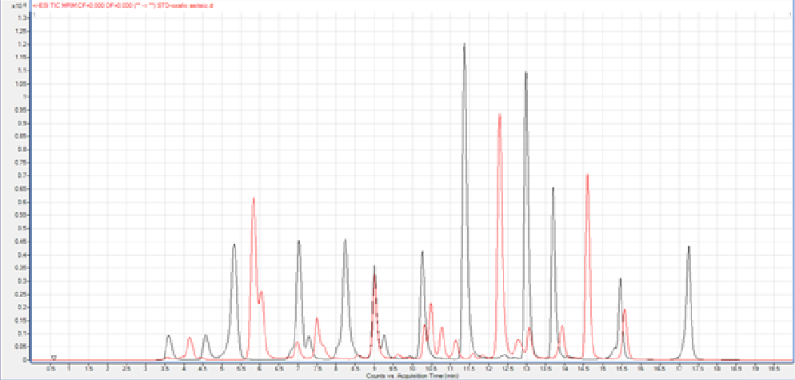  Mobile Phase (A) 1 0.2% HCOOH, 1 mM HCOONH₄ in water  Mobile Phase (A) 2 0.2% HCOOH, 1 mM HCOONH₄ and 1 mM oxalic ocid in water  Mobile Phase A2  Mobile Phase A1 | Antibiotic Mobile Phase A1 Retention Time (min) Mobile Phase A2 Retention Time (min)  sulfadiazine 3.6 3.6  sulfathiazole 4.5 4.6  sulfamethazine 10.8 11.4  sulfamethizole 7.6 8.1  sulfamonomethoxine 9.6 6.8  sulfamethoxipyridazine 9.6 6.8  sulfachloropyridazine 9.9 10.4  sulfadimethoxine 10.8 11.4  sulfadoxine 10.8 11.4  sulfamethoxazole 11.1 11.5  sulfaquinoxaline 13.2 7.9  sulfisoxazole 11.8 10.9  difloxacin 10.5 11.4  marbofloxacin 6.0 7.3  oxolinic acid 14.6 15.5  flumequine 14.6 15.5  sarafloxacin 10.3 11.3  norfloxacin 7.0 7.3  enrofloxacin 9.0 10.3  danofloxacin 8.6 6.0  ciprofloxacin 7.5 7.5  spiramycin 11.6 12.7  erythromycin 17.5 14.2  tylosin 13.9 14.0  josamycin 15.6 15.8  tilmicosin 12.8 13.0  oxytetracycline 6.7 7.4  tetracycline 6.2 7.3  doxycycline 6.2 7.3  chlortetracycline 11.5 11.4  thiamphenicol 6.8 6.3  florfenicol 11.2 11.7  chloramphenicol 12.4 13.1  trimethoprim 5.8 7.0  lincomycin 4.2 5.3
Figure S1 Ion Chromatograms of mixed antibiotic standards for mobile phase Aqua I and Aqua II (antibiotic concentration=100 µg/L)

Matrix Effect (%)

Figure S2 Matrix effect in determination of antibiotics (n=3, 25-100 µg/kg) in dairy manure (a) and poultry manure (b) by using two different mobile phase in LC-MS/MS analysis. The antibiotics with ME>150 are not shown.

Recovery (%)

Figure S3 Effect of agitation type on the extraction performance of antibiotics (each 100 µg/kg) in dairy (a) and poultry (b) manure samples (n=3).

