Innovative green synthesis of 4-aryl-pyrazolo[5,6]pyrano[2,3-d]pyrimidines under catalyst-free conditions
Rathinam Ramesh,ª Velmurugan Tamilselvi,ª Pullar Vadivel,^{b} Appaswami Lalitha*^{,a}
ª Department of Chemistry, Periyar University, Periyar Palkalai Nagar, Salem-636011, Tamil Nadu, India.
^{b} Department of Chemistry, Salem Sowdeswari College, Salem-636010, Tamil Nadu, India.
E-mail: lalitha2531@yahoo.co.in
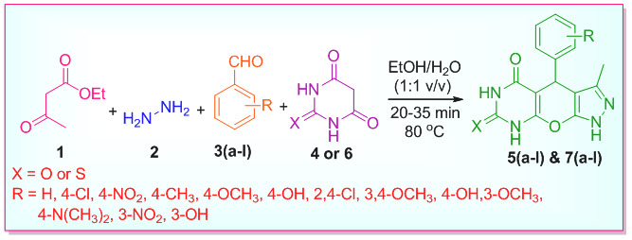
General schematic representation of the preparation of fused heterocyclic compounds

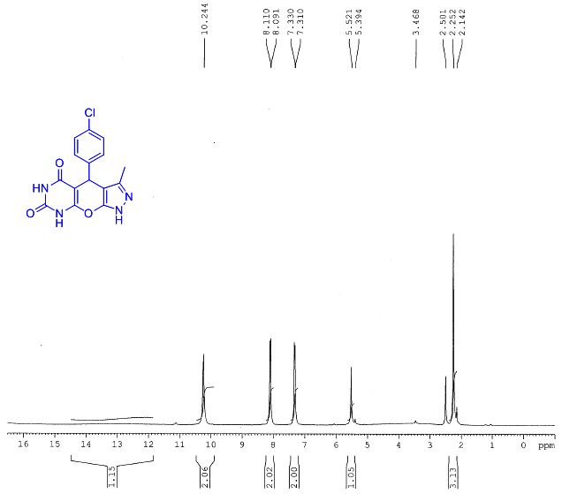
¹H NMR Spectrum of compound 5b
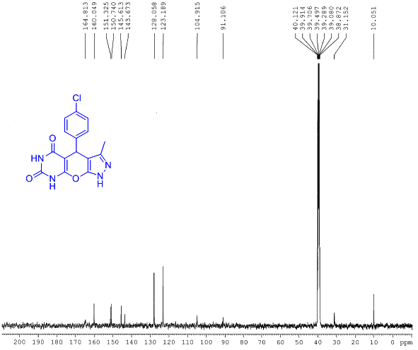
¹³C NMR Spectrum of compound 5b
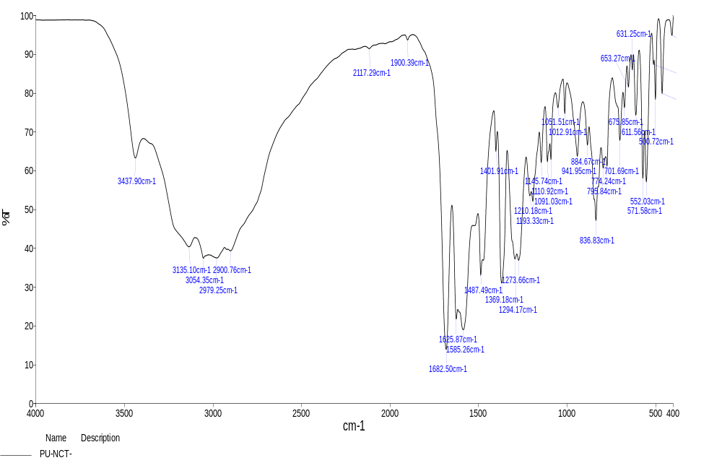
FT-IR Spectrum of compound 5b
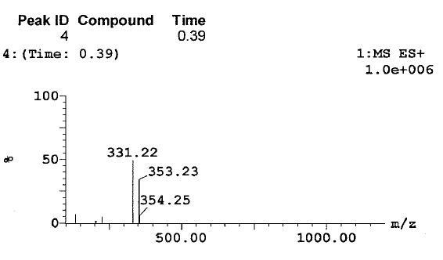
Mass Spectrum of compound 5b

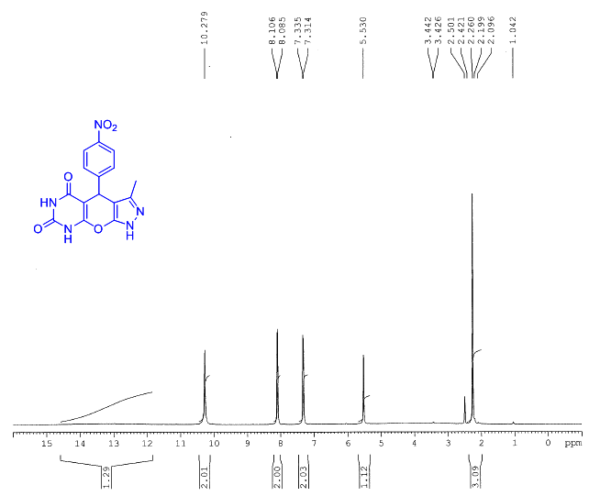
¹H NMR Spectrum of compound 5c
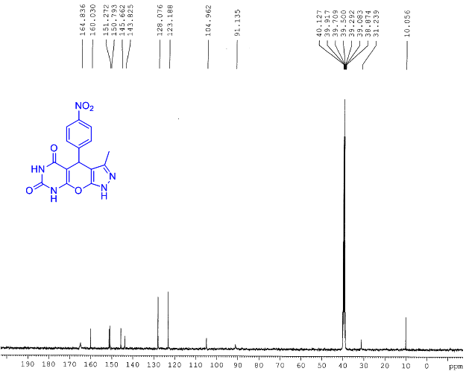
¹³C NMR Spectrum of compound 5c
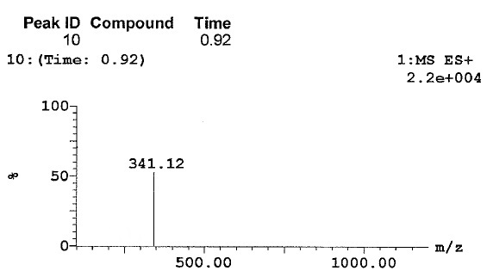
Mass Spectrum of compound 5c

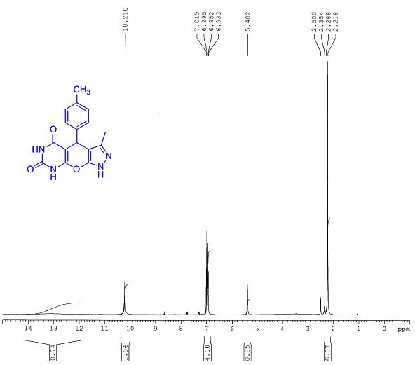
¹H NMR Spectrum of compound 5d
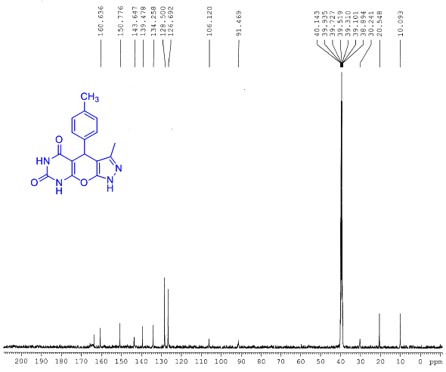
¹³C NMR Spectrum of compound 5d
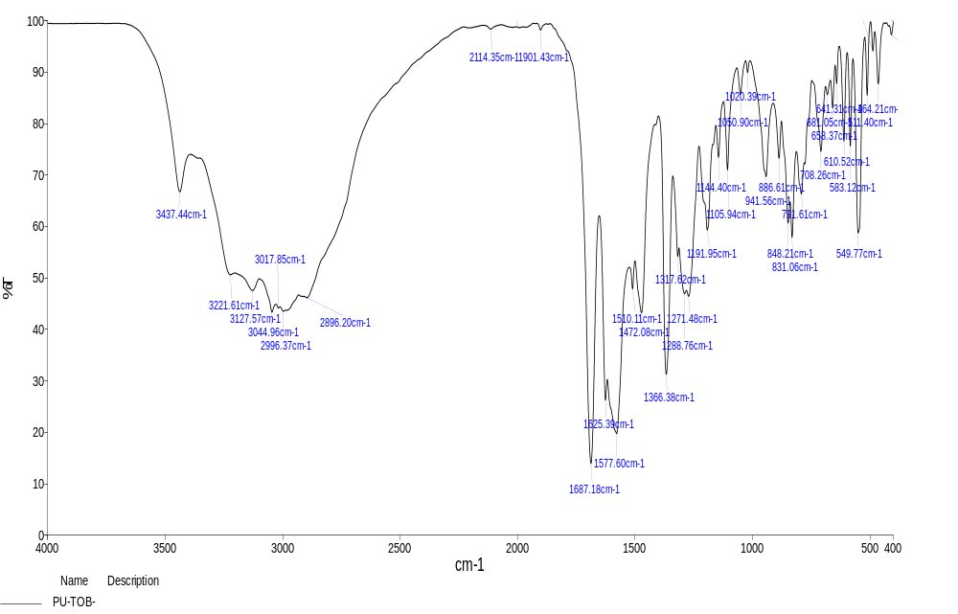
FT-IR Spectrum of compound 5d
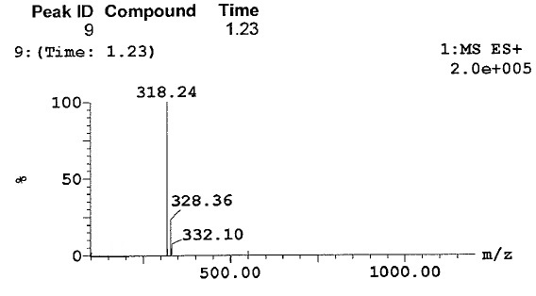
Mass Spectrum of compound 5d

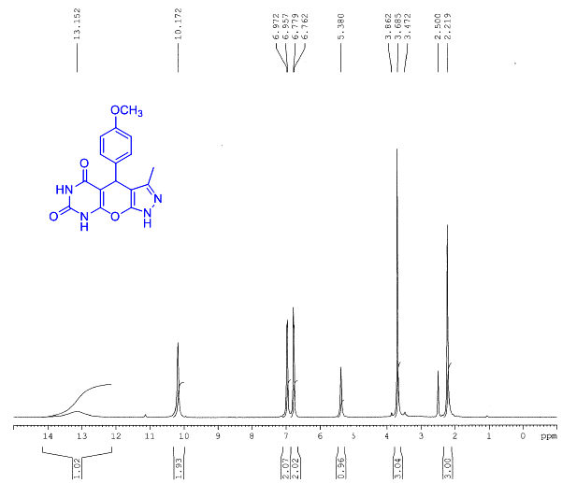
¹H NMR Spectrum of compound 5e
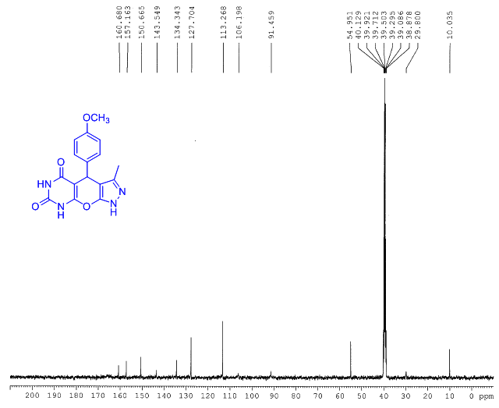
¹³C NMR Spectrum of compound 5e
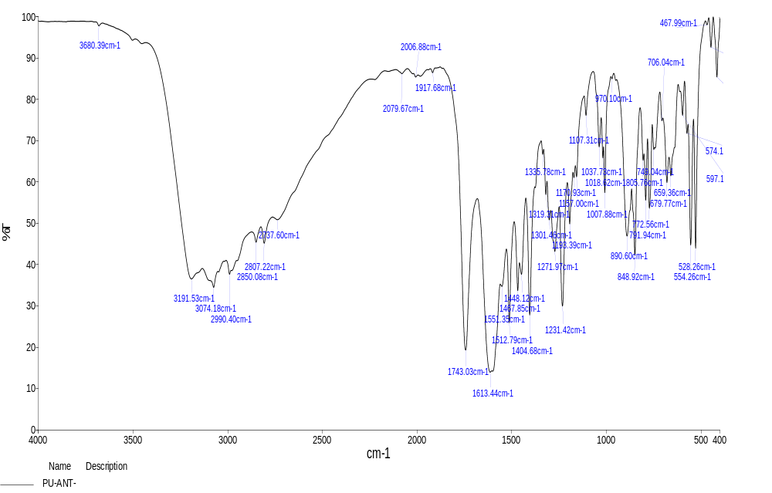
FT-IR Spectrum of compound 5e
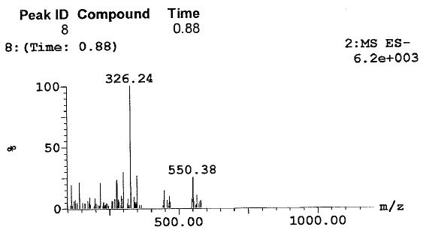
Mass Spectrum of compound 5e

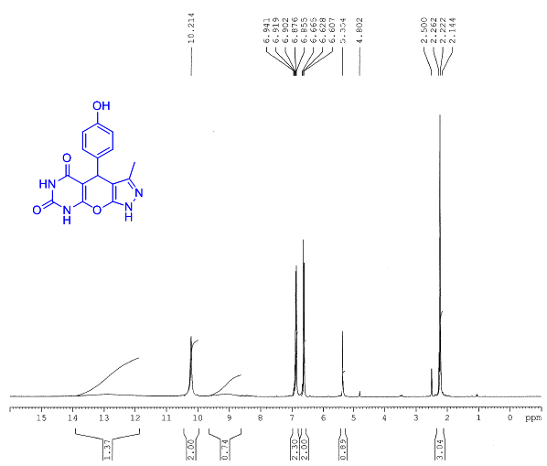
¹H NMR Spectrum of compound 5f
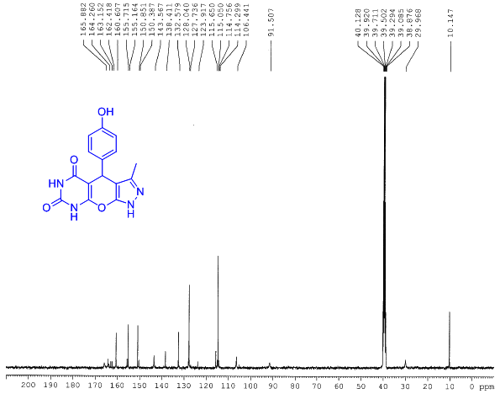
¹³C NMR Spectrum of compound 5f
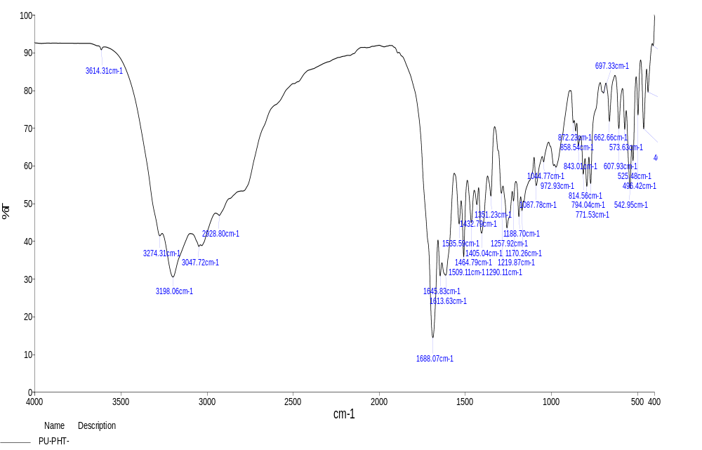
FT-IR Spectrum of compound 5f
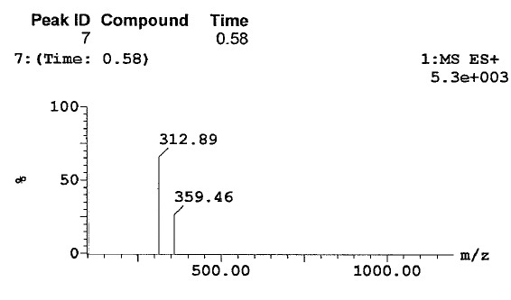
Mass Spectrum of compound 5f

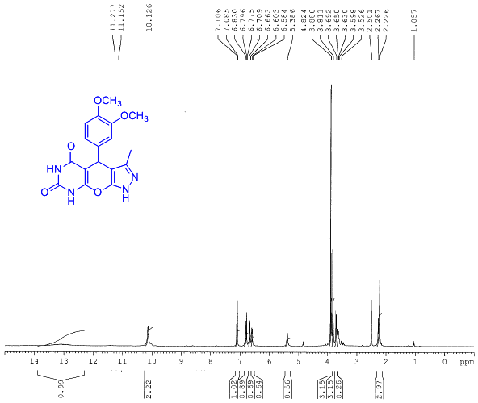
¹H NMR Spectrum of compound 5h
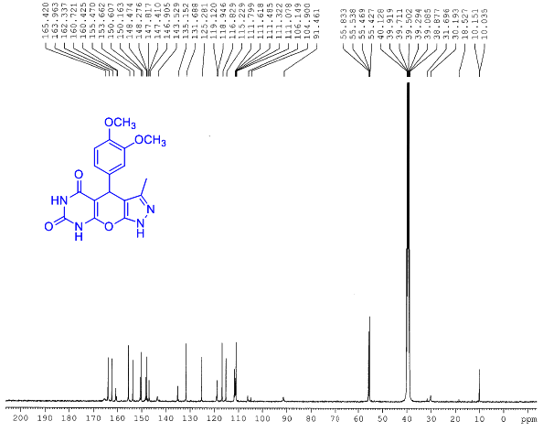
¹³C NMR Spectrum of compound 5h

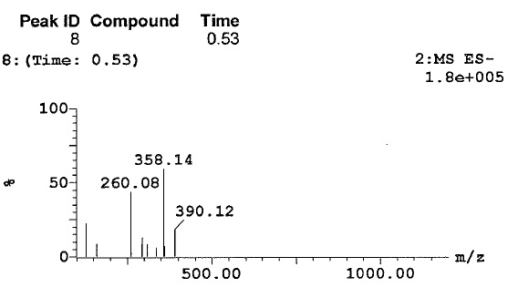
Mass Spectrum of compound 5h

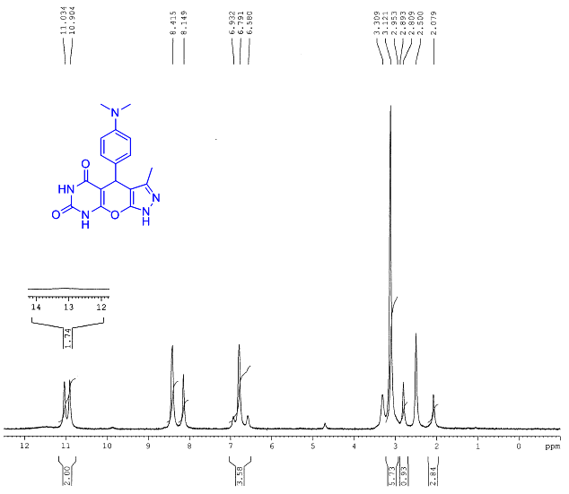
¹H NMR Spectrum of compound 5j
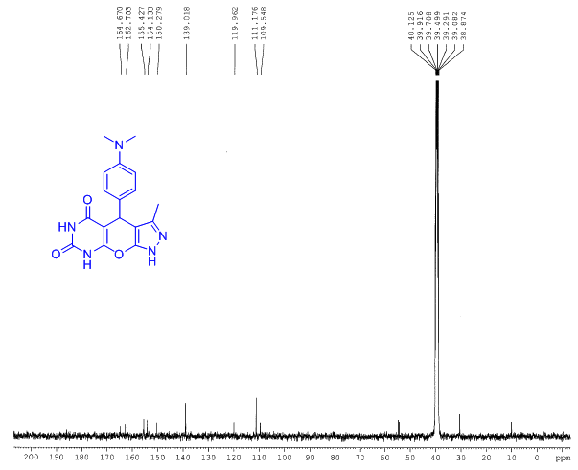
¹³C NMR Spectrum of compound 5j
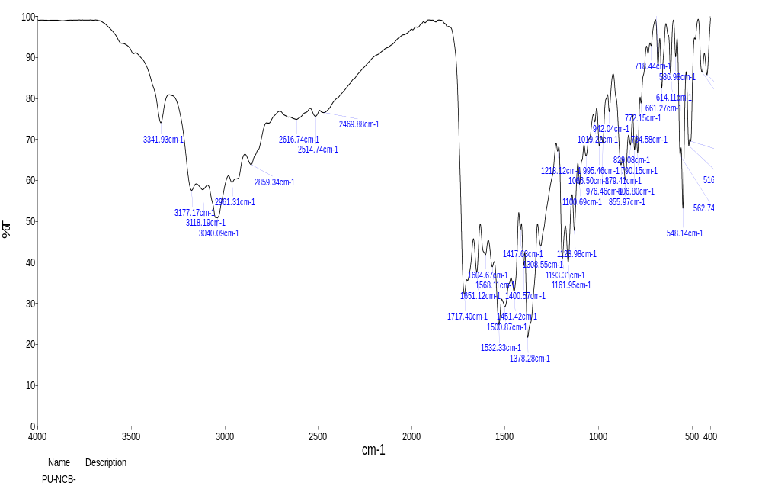
FT-IR Spectrum of compound 5j
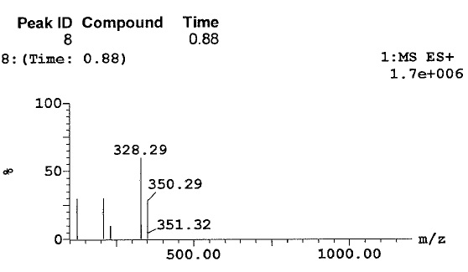
Mass Spectrum of compound 5j

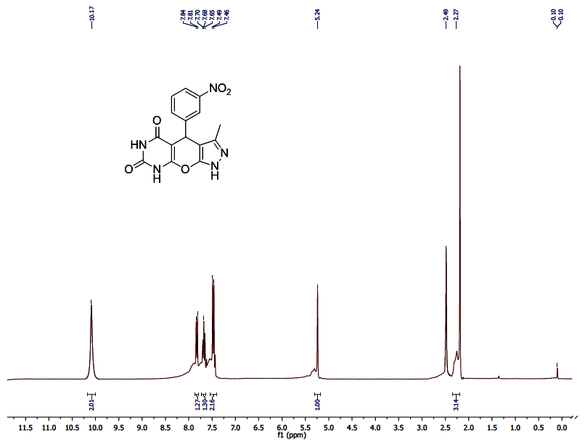
¹H NMR Spectrum of compound 5k
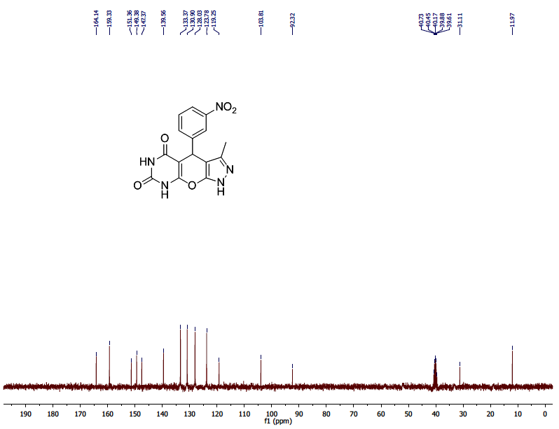
¹³C NMR Spectrum of compound 5k
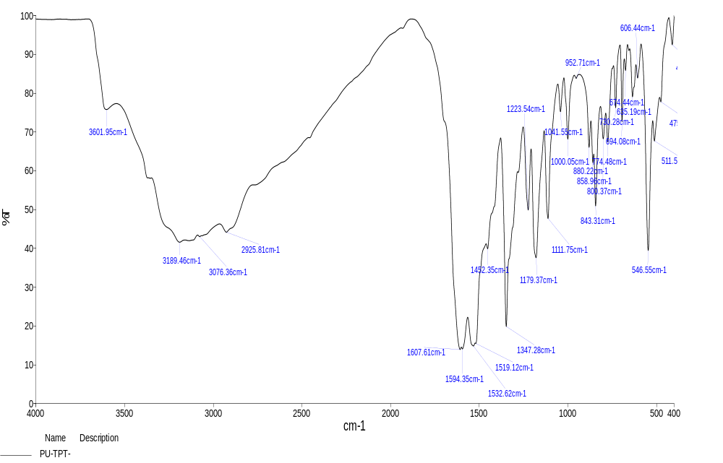
FT-IR Spectrum of compound 5k
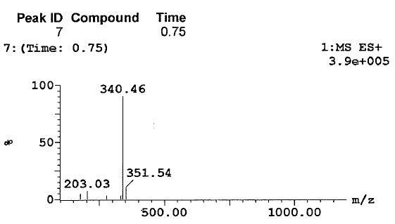
Mass Spectrum of compound 5k

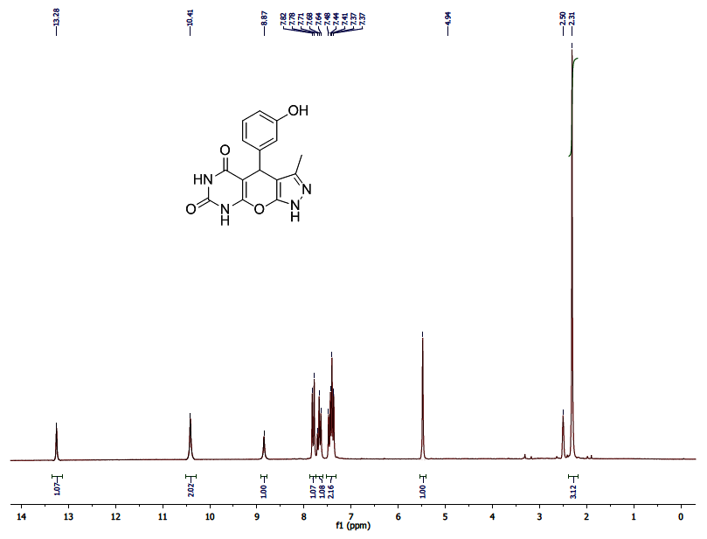
¹H NMR Spectrum of compound 5l
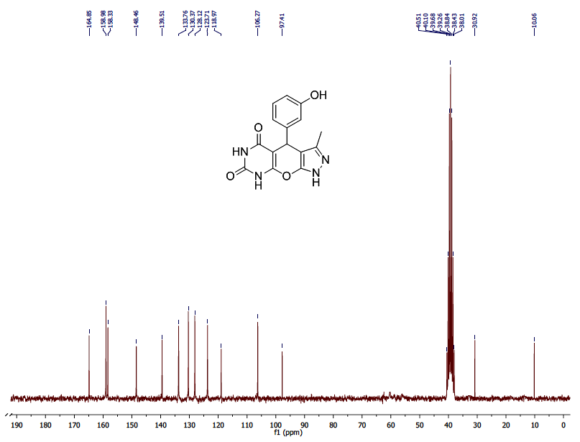
¹³C NMR Spectrum of compound 5l
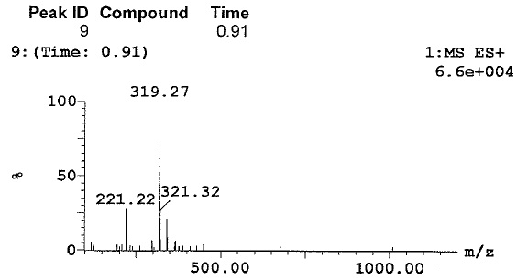
Mass Spectrum of compound 5l

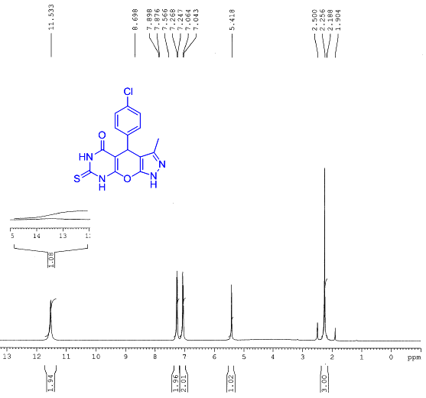
¹H NMR Spectrum of compound 7b
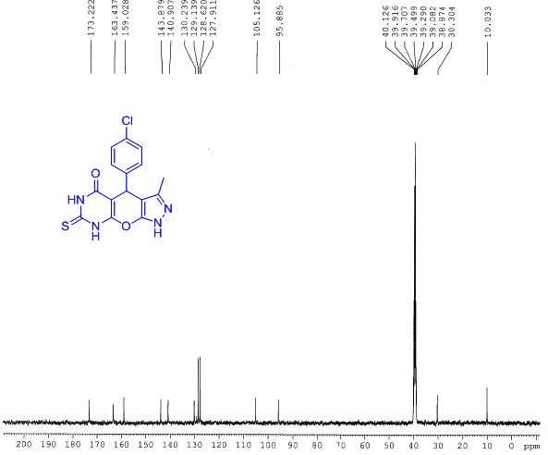
¹³C NMR Spectrum of compound 7b
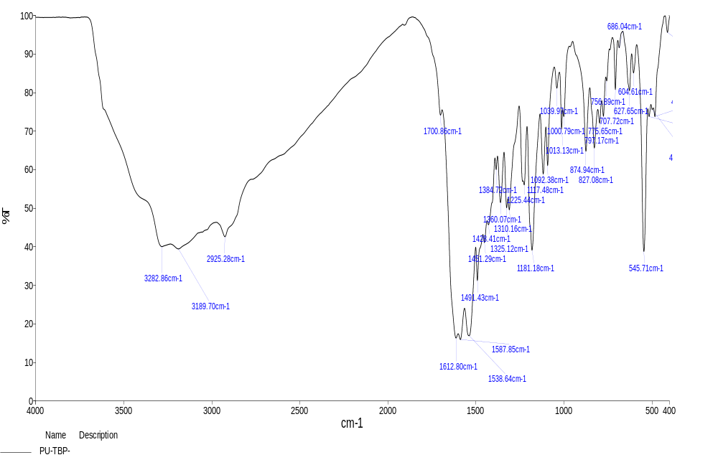
FT-IR Spectrum of compound 7b
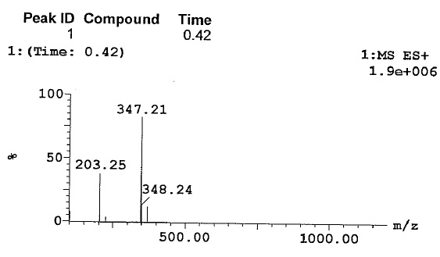
Mass Spectrum of compound 7b

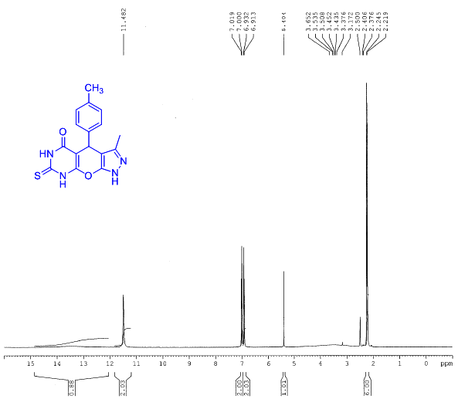
¹H NMR Spectrum of compound 7d
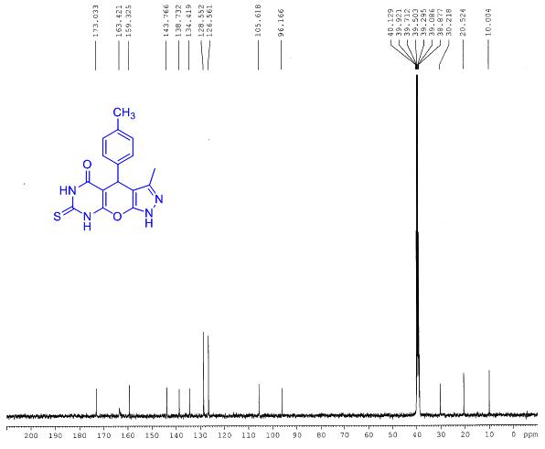
¹³C NMR Spectrum of compound 7d
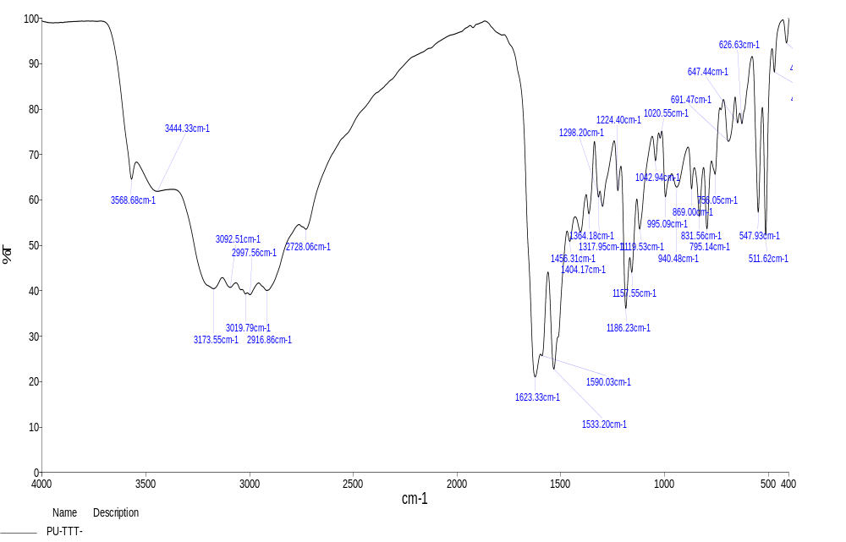
FT-IR Spectrum of compound 7d
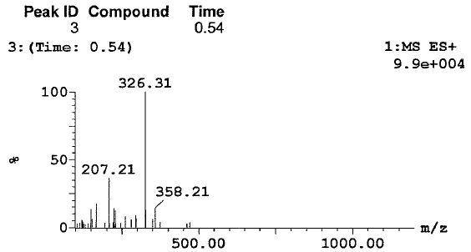
Mass Spectrum of compound 7d

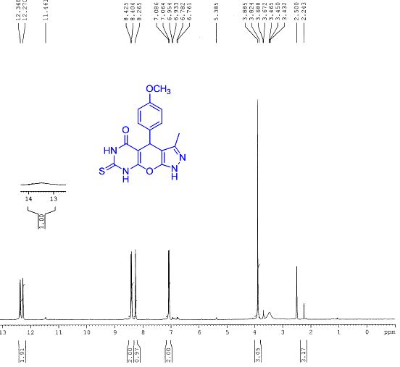
¹H NMR Spectrum of compound 7e
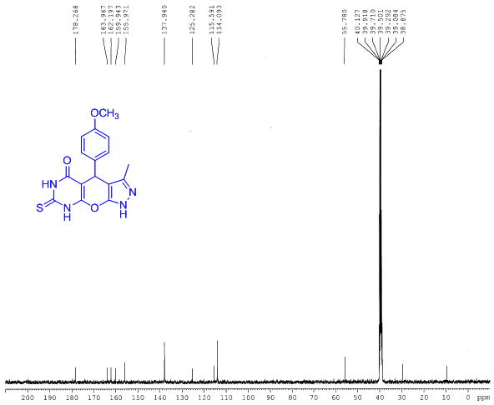
¹³C NMR Spectrum of compound 7e
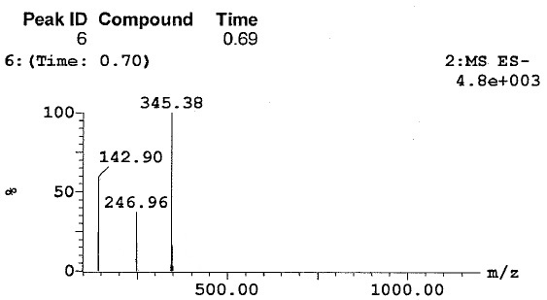
Mass Spectrum of compound 7e

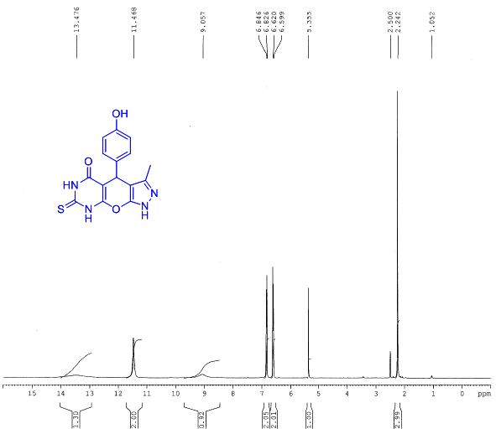
¹H NMR Spectrum of compound 7f
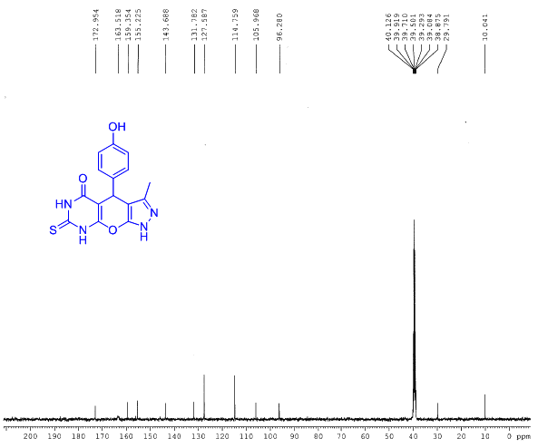
¹³C NMR Spectrum of compound 7f
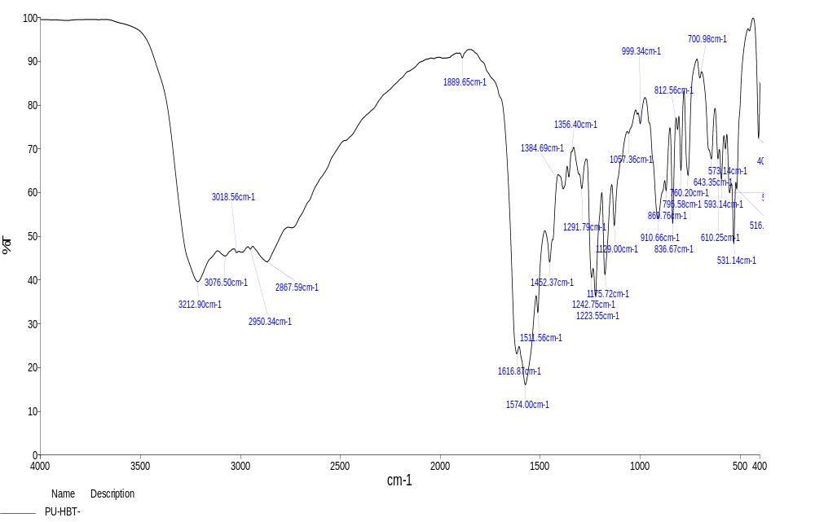
FT-IR Spectrum of compound 7f
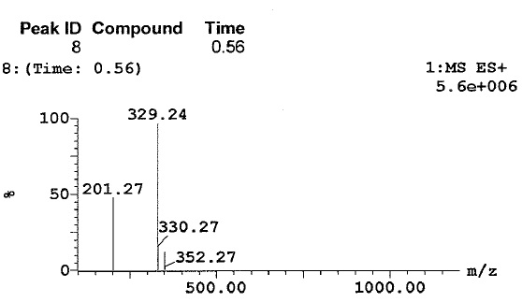
Mass Spectrum of compound 7f

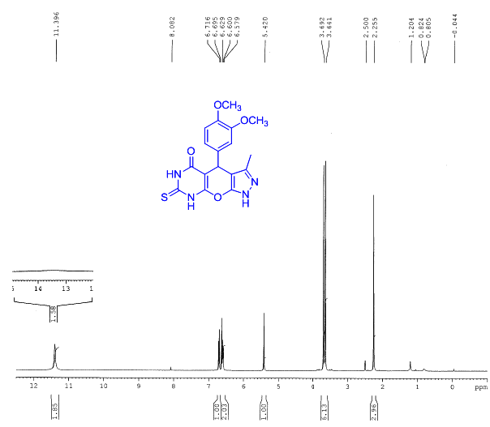
¹H NMR Spectrum of compound 7h
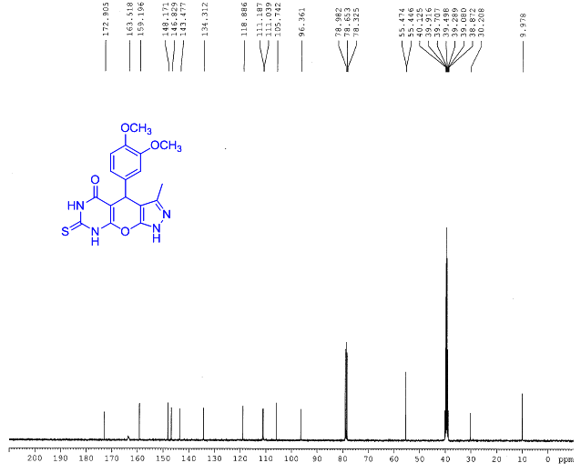
¹³C NMR Spectrum of compound 7h
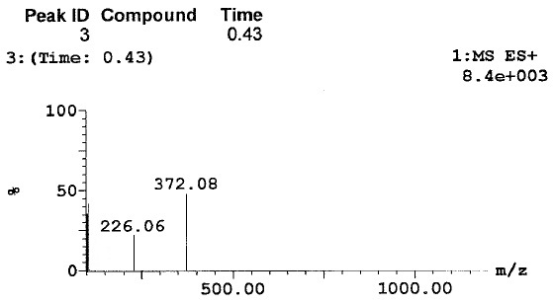
Mass Spectrum of compound 7h

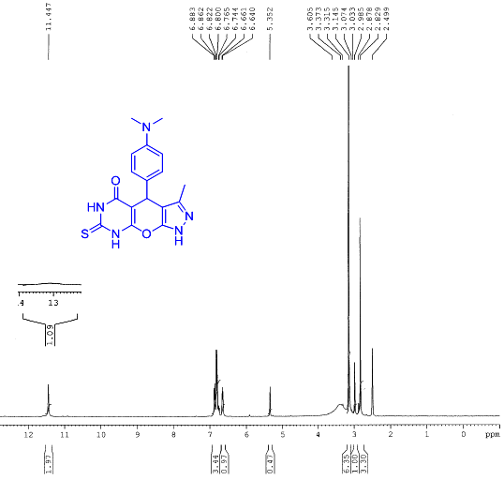
¹H NMR Spectrum of compound 7j
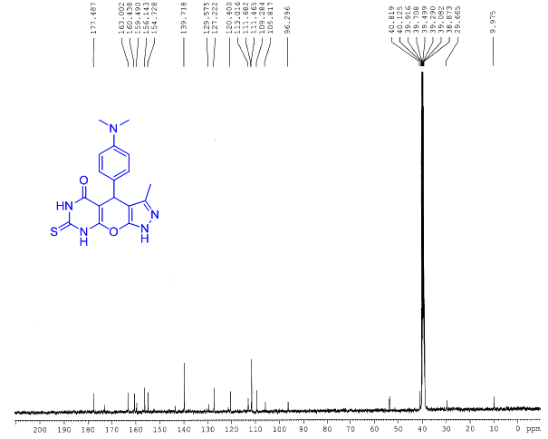
¹³C NMR Spectrum of compound 7j
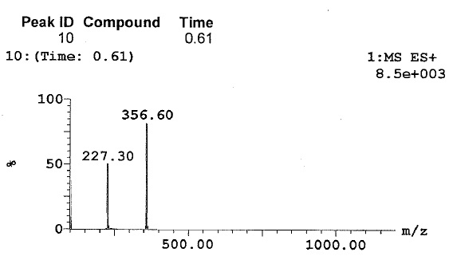
Mass Spectrum of compound 7j

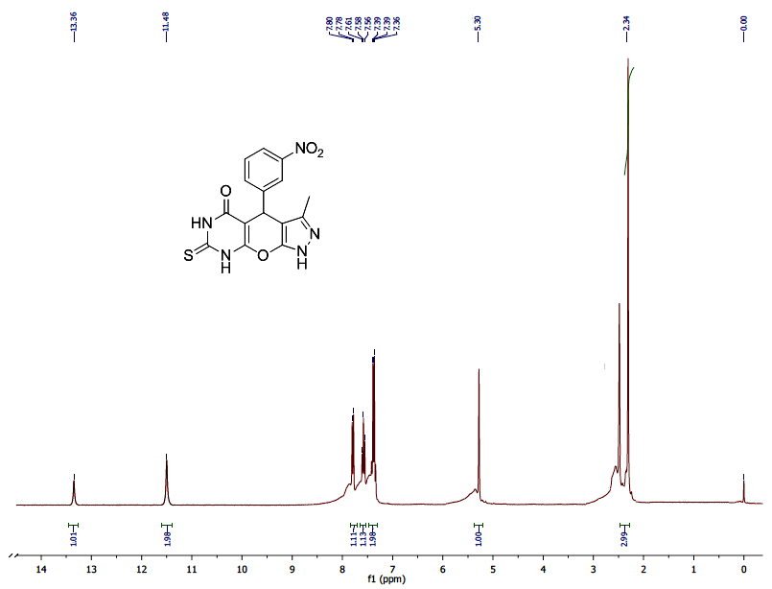
¹H NMR Spectrum of compound 7k
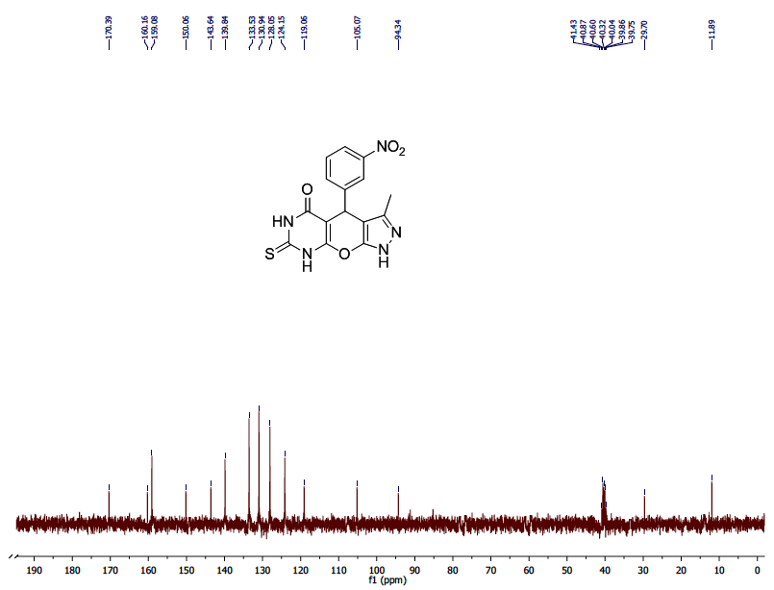
¹³C NMR Spectrum of compound 7k
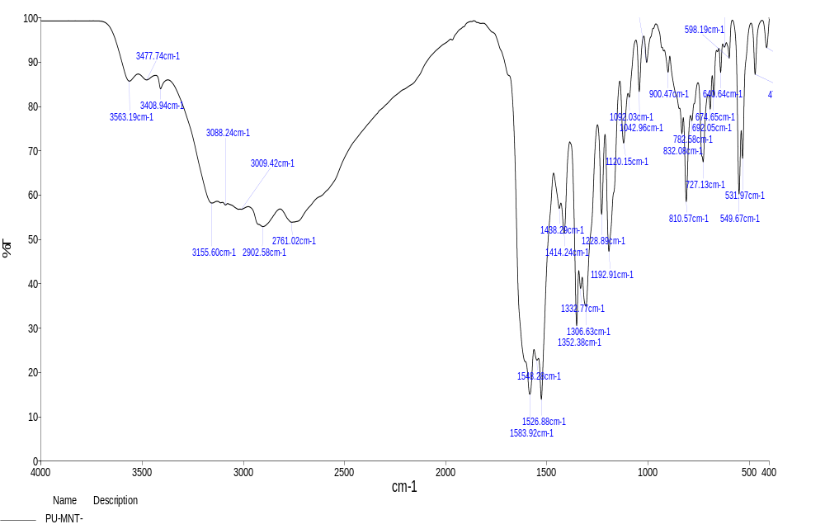
FT-IR Spectrum of compound 7k

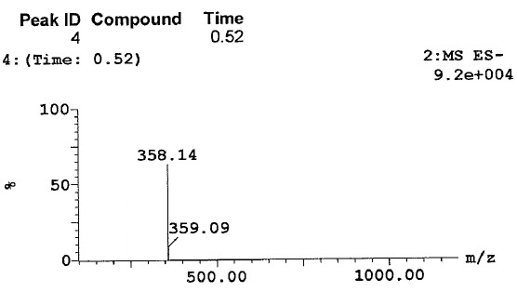
Mass Spectrum of compound 7k

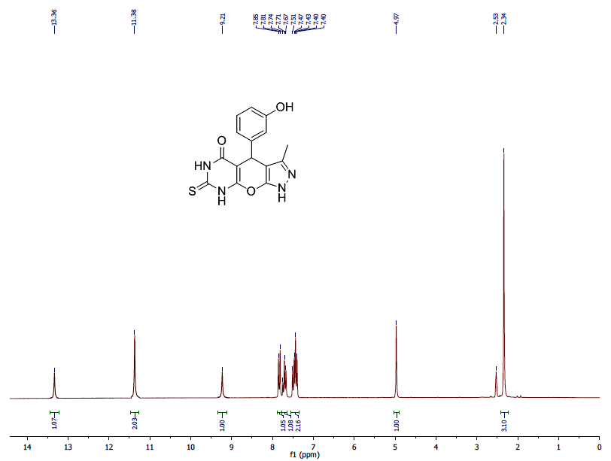
¹H NMR Spectrum of compound 7l
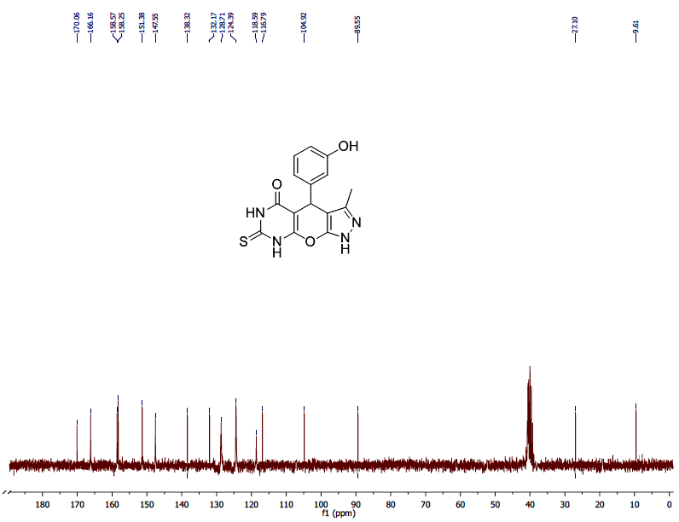
¹³C NMR Spectrum of compound 7l
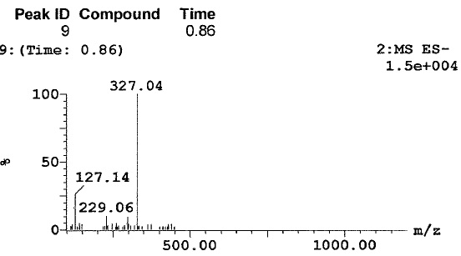
Mass Spectrum of compound 7l

