High strength, deformable nanotwinned Al-Co alloys

S. Xueª, Q. Liª, D.Y. Xie^{b}, Y.F. Zhangª, Han Wangª, Haiyan Wangª, J. Wang^{b}, and X. Zhang^{a*}

ª School of Materials Engineering, Purdue University, West Lafayette, IN 47906, United States
^{b} Nebraska Center for Energy Science Research, University of Nebraska-Lincoln, Lincoln, NE 68583-0857, United States

*Corresponding author: X. Zhang, xzhang98@purdue.edu

1 Sample fabrication and characterization
Al and Al-Co alloy films were deposited by the direct-current magnetron sputtering technique on HF etched single crystal Si (111) substrates. The base pressure before the deposition is ~ 5×10⁻⁸ torr and the ultra-high purity Ar gas at a pressure of 2×10⁻³ torr was used during depositions. The deposition rates of Al and Co targets were tuned to vary the Co composition in Al films. XRD experiments were measured by a Panalytical Empyream X’pert PRO MRD diffractometer with a Cu Kα₁ source. Cross-section transmission electron microscopy (TEM) specimens and pillars were prepared by focus ion beam (FIB) instrument equipped in an FEI Quanta 3D FEG scanning electron microscope. And the microstructure of Al-Co specimens before and after the pillar compression experiment was examined using an FEI Talos 200X transmission electron microscope operated at 200 kV. In situ micropillar compression tests were conducted by a Hysitron PI 88×R PicoIndeter with an average drift rate of 0.2 nm/s installed inside the FEI Quanta 3D FEG SEM microscope. The force noise during the compression tests is below 5 µN and the displacement noise is less than 1 nm.
The sputtered Al-Co alloys contain homogenously distributed Co solutes. The Density Function Theory (DFT) has been used to calculate the formation energy of pairs of Co solute atoms and four nearest solute atoms. Based on the calculation results, although it is energetically favorable to form the Co solute cluster in terms of the negative formation energy, it is more thermodynamically favorable for Co solute atoms homogenously distributed in Al matrix due to the smaller formation energy compared to that of Co solute segregation. EDS maps in Fig. S6 also confirm that there is no obvious Co segregation before or after the compression test.

2 Density function theory (DFT) calculations

Validation of Pseudo potentials

The Vienna ab-initio simulation package (VASP) was employed to conduct density functional theory (DFT) calculations. Atomic relaxations and calculations of total energies are performed with projector augmented wave (PAW) method [1] and generalized gradient approximation (GGA) approach [2]. Perdew-Burke-Ernzerhof (PBE) exchange-correlation density functional theory [3] were used during the computation. For Al and Co, the pseudopotentials were constructed using electron configurations of s²p¹ and d⁸s¹ respectively [4]. A 500-eV cut-off on kinetic energy was used for the plane wave basis set. The first Brillouin zone of Al and Co unit cell were sampled by 12 × 12 × 12 and 16 × 16 × 10 Monkhorst–Pack k-point grid [5]. The self-consistent iteration was stopped, when the change of total energy is smaller than 10⁻⁵ eV. The convergence criteria of geometry optimizations are chosen such that the forces acting on each atom is smaller than 0.01eV/Å. For Al with FCC structure, the calculated lattice parameter is 4.037 Å and the cohesive energy is 3.50 eV. The optimized lattice parameters and cohesive energy of HCP Co are a = 2.492 Å, c = 4.025 Å, and 5.17eV respectively. With these optimized parameters, we further studied the pinning effect of solute Co on the formation and migration of various disk-sized of clusters on Al (111). These calculations were performed to understand the influence of Co solute Co on the formation and stability of stacking faults in Al-Co alloys.

Formation energy of substitutional and interstitial solute atoms

To calculate the formation energies of Cobalt solute atoms, the unit cell of aluminum was repeated in three <100> directions and formed a 3×3×3 supercell, which contains 108 atoms. A 4×4×4 M–P k-point grid is used in this part of calculation. After adding or substituting Cobalt atom in this model, we can calculate the formation energy of Cobalt solute atoms. The formation energy of an individual substitutional Cobalt atom is -0.847 eV. For the Cobalt atoms located at tetrahedral and octahedral site, the formation energy is 1.952eV and 0.171eV.
Bulk stacking fault energies
In this calculation, the stacking fault energies of aluminum with and without solute atoms on fault plane were calculated. Calculations of SFEs were performed with slab models, as shown in the insertion of Fig. 4d, containing 8 layers of FCC (111) plane. There are 16 atoms in each layer. The first Brillouin zone was integrated by 9×9×3 M-P K points. The computed stacking fault energy of pure aluminum is 119.9 mJ/m², which consists with experimental stacking fault energy 120-144 mJ/m² [6]. To simulate the effect of Co solute, two solute atoms are placed on the two neighboring fault planes. We minutely analyzed the relative position of two solutes before and after shearing the upper four layers to annihilate a stacking fault. The plane view of (111) plane are shown in Fig. 4c, the black circle is the position of lower fault plane, and the position of solute atom is fill in black. The red square is the position of neighboring upper fault plane. The blue triangle is the position of upper plane in FCC stacking sequence. After annihilation, the solute atom on upper plane can take the first, second, and third nearest sites which are fill in yellow, red and blue respectively. There are seven paths to annihilate the stacking fault and reach the nearest sites we talked above. To find out the most favored path, the formation energies of solute atoms in different stacking fault configuration are evaluated. The formation energy of solute atoms at fault planes corresponded to different paths range from -0.552 to -0.381 eV/atom. The lowest formation energy -0.552 eV/atom is obtained from path 1 and path 3. For the corresponding fault free configuration, the formation energy of solute is -0.575 eV/atom and -0.501 eV/atom for path 1 and path 3 respectively. So, the path 1 is the most favored path. Then we calculated the energy barrier of path 1. The result is shown in Fig. 4d. The red curve indicates that the energy barrier of annihilating stacking fault is increased to 59.22 mJ/m².
Generalized stacking fault energies of surface atomic clusters
In order to know how difficult it is to annihilate stacking fault and de-twin, generalized stacking fault energies are calculate using surface trimer and heptamer, as shown in Fig. 4a. Two atomic layers of {111} Al are used as substrate in the x-y plane. Each monolayer contains 16 and 36 atoms for trimer and heptamer. 6×6×3 and 3×3×3 M-P K points grids are used for trimer and heptamer model respectively. The bottom layer (A layer in Fig. 4a) is fixed, when calculating the energy of models with FCC stacking and faulted stacking. Then a chain of transient states is produced by linearly interpolating between models with FCC stacking and faulted stacking. The transient state models are relaxed while fixing the atoms in the x-y plane (atoms can only move along the z direction). The excess energy per surface atom was obtained and plotted in Fig. 4b. The stacking fault recovery energy barrier for pure aluminum heptamer and heptamer with Co is 0.064eV and 0.101 eV. The energy barrier is dramatically increased by solute atom.

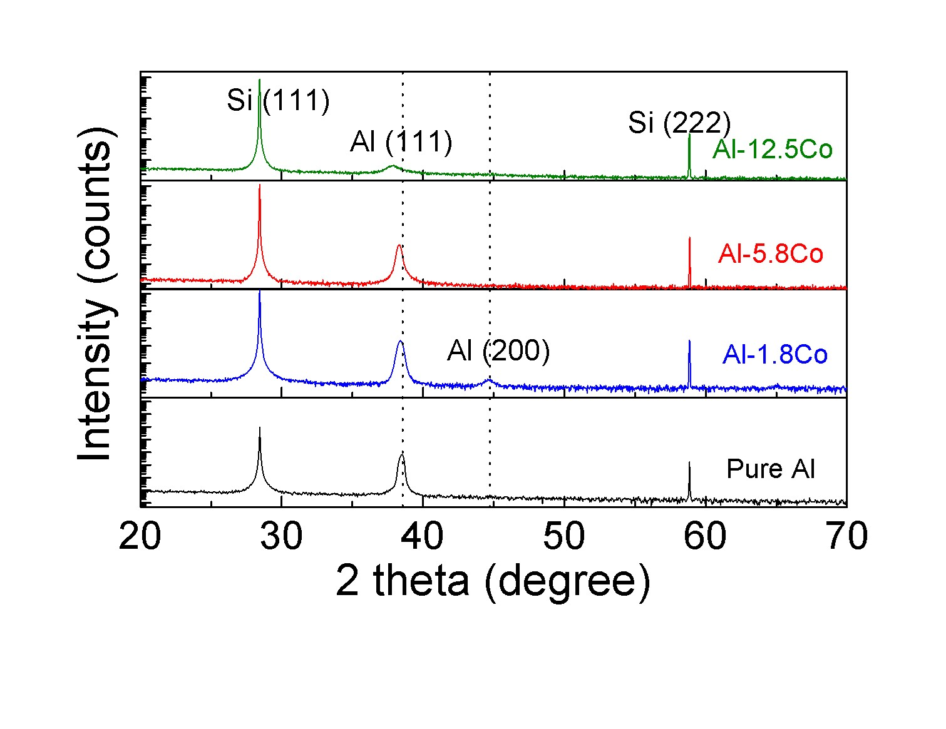
Figure S1. XRD profiles of as-deposited pure Al and AlCo films. Al-5.8Co, Al-1.8Co and pure Al deposited on Si(111) substrates show a strong in-plane (111) texture. Al-12.5Co film deposited on Si(111) substrate shows a weak (111) texture compared with other films.

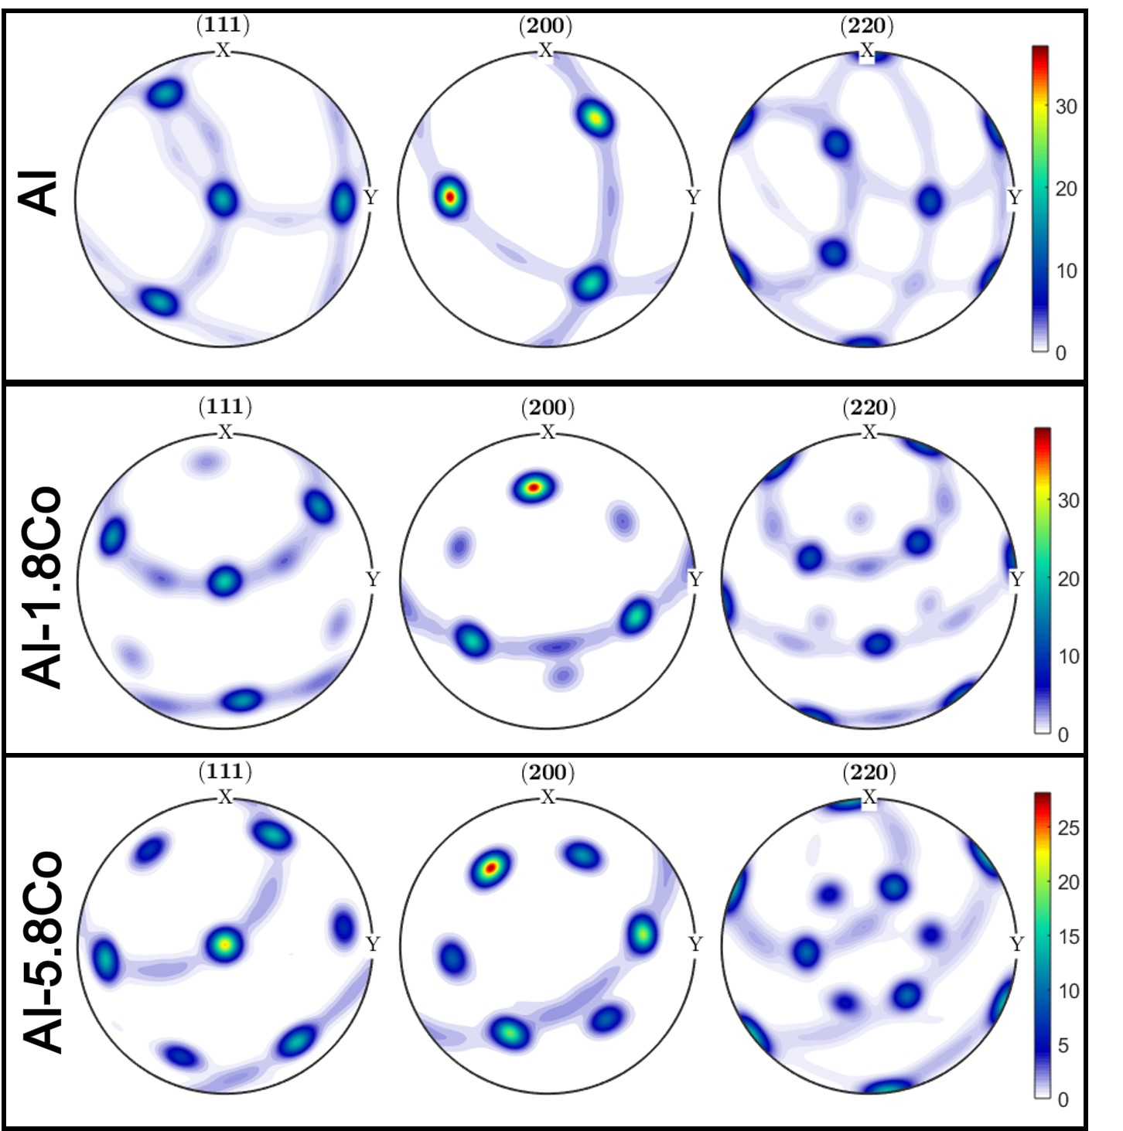
Figure S2. The XRD pole figures of Al and Al-Co films. The projection plane is the sample surface. The three-fold symmetry of {111} pole figure in Al indicates the single-crystal-like structure. While the six-fold symmetry of {111} pole figures in Al-1.8Co and Al-5.8Co suggest the formation of twins in Al-Co alloys. The intensity ratio of matrix spots and twin spots reflects the twin density qualitatively.

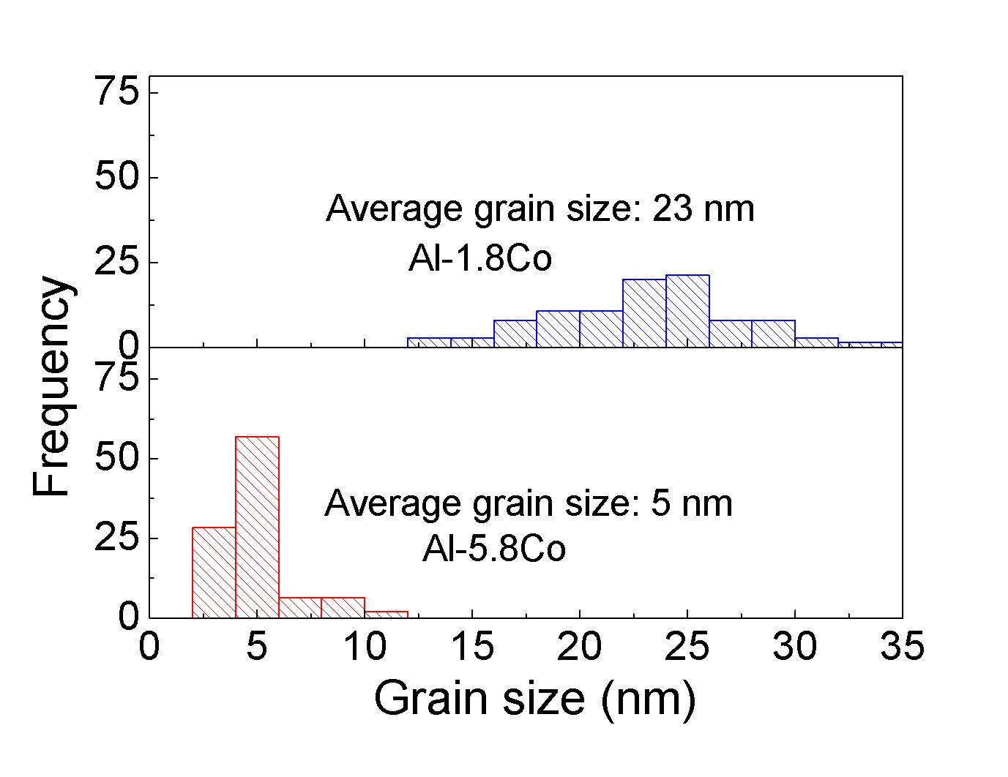
Figure S3. Grain size statistic distributions for Al-Co alloys showing the formation of nanograins in the solid solution alloys.

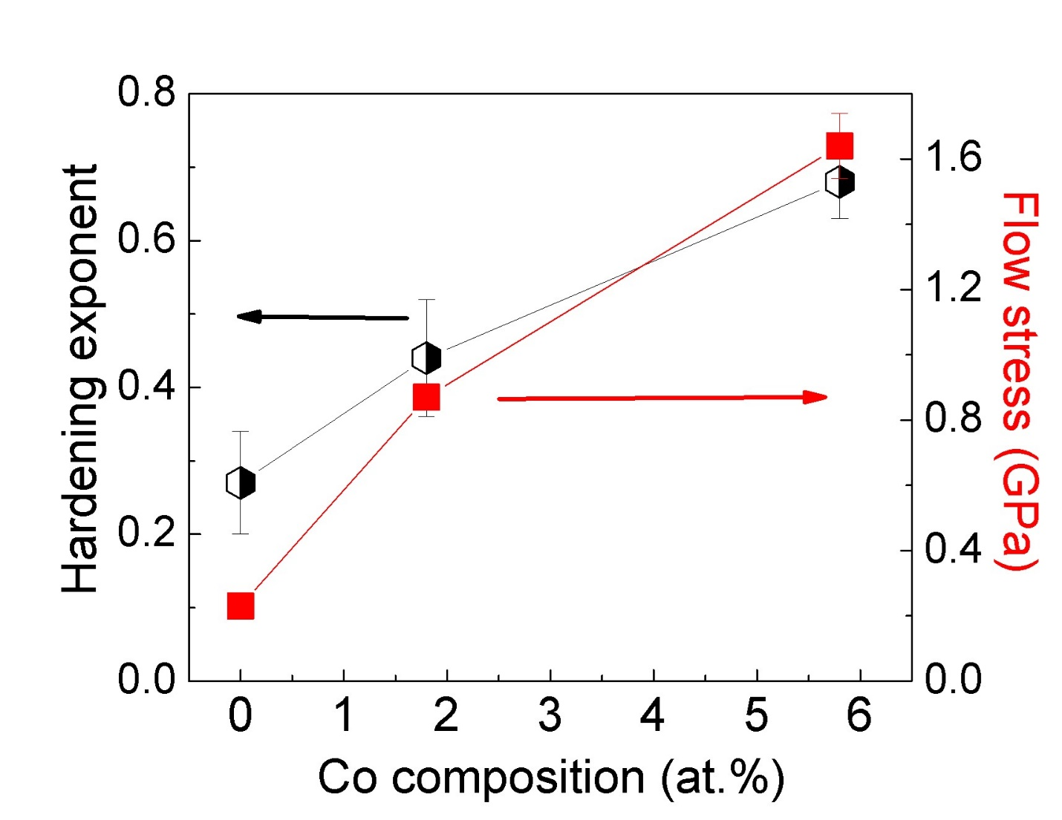
Figure S4. Work hardening exponent and flow stress plot of pure Al, Al-1.8Co, and Al-5.8Co.

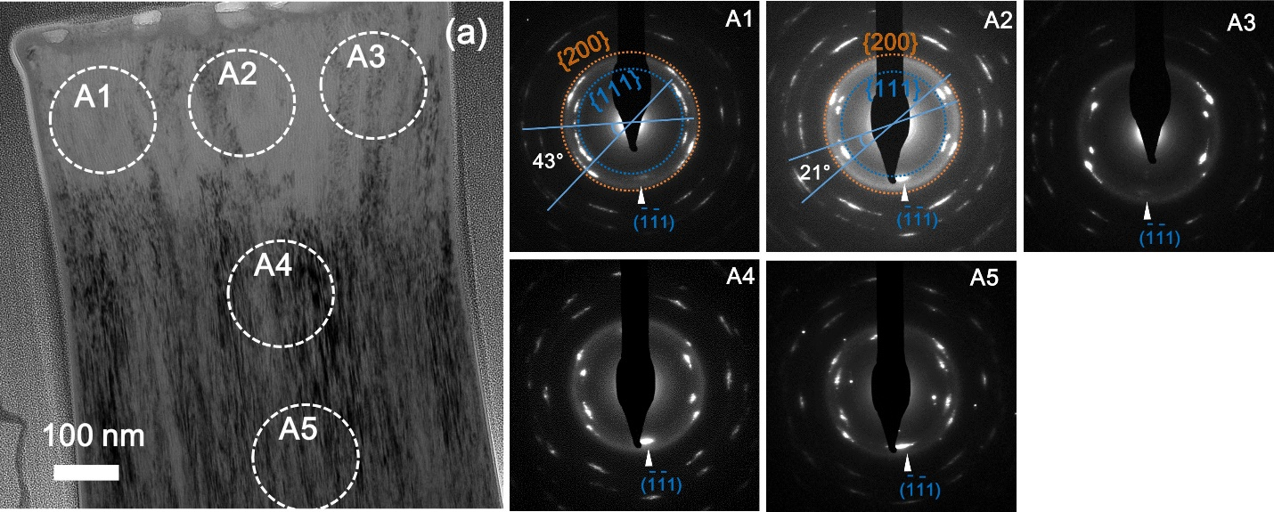
Figure S5. The diffraction patterns of compressed Al-5.8Co pillar at different locations.

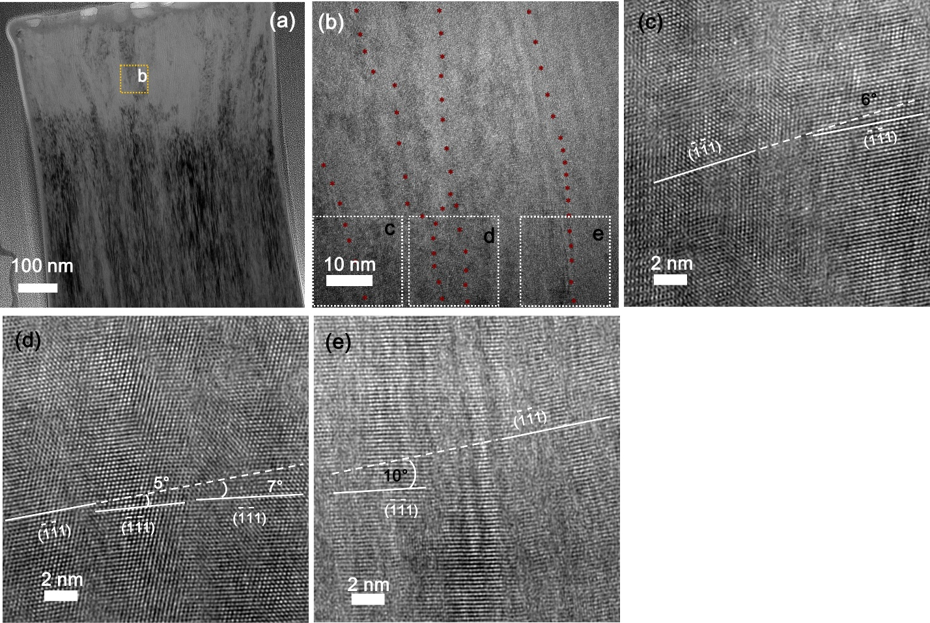
Figure S6. Microstructure of in situ compressed Al-5.8Co pillar. (a) The post-mortem bright-field TEM image showing the overview of compressed pillar (to 15% strain). (b) Enlarged TEM image from location b in Fig. S5a shows the domain boundaries after the pillar compression test. (c, d, e) The HRTEM micrographs from Fig. S6b show the grain rotation.
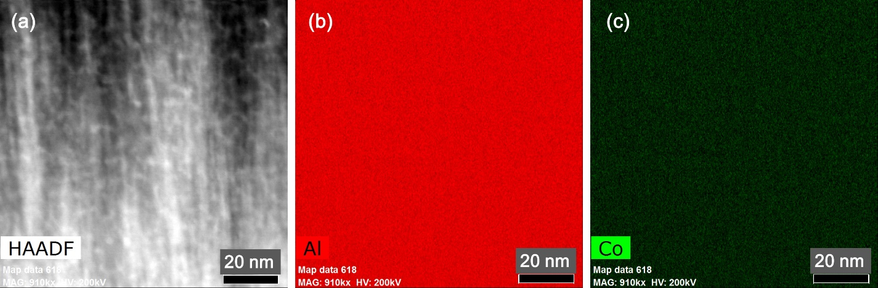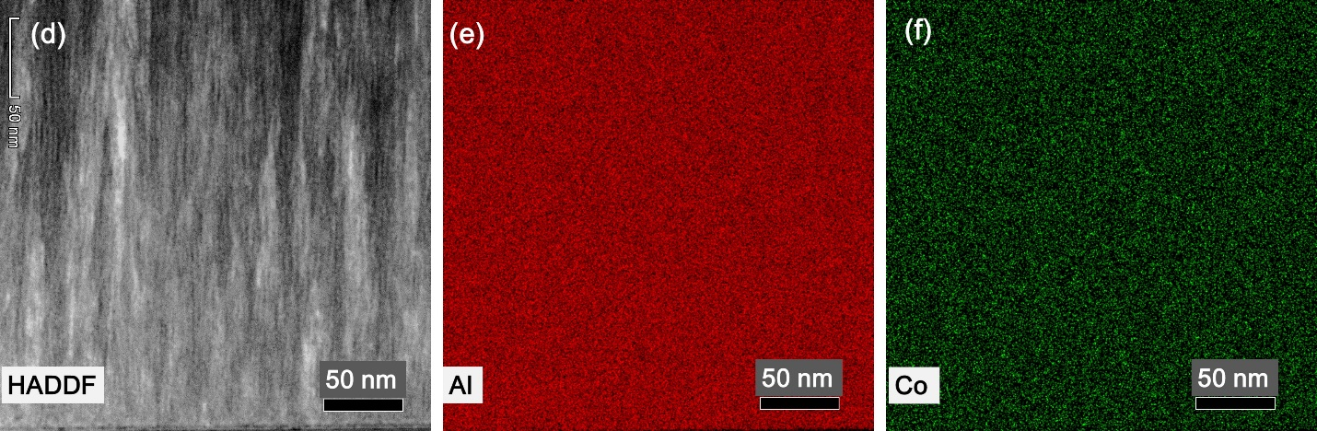
Figure S7. Cross-sectional scanning transmission electron microscopy (STEM) images (a, d) of Al-5.8Co sample before (a-c) and after (d-f) in situ pillar compression test. The EDS maps show the homogeneous distribution of Co in Al matrix.

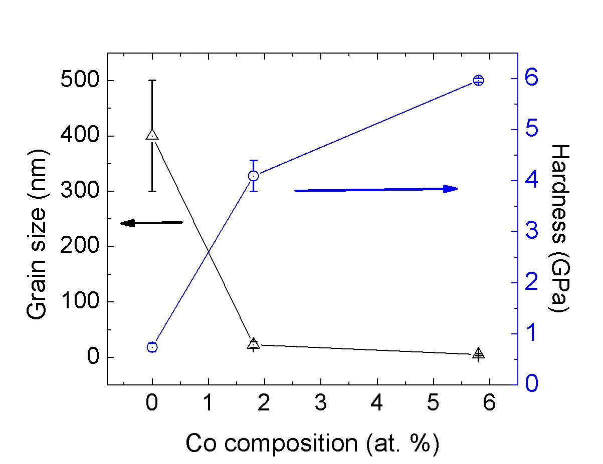
Figure S8. Evolution of harnesses and grain sizes with Co composition in the Al-Co solid solution alloy films.

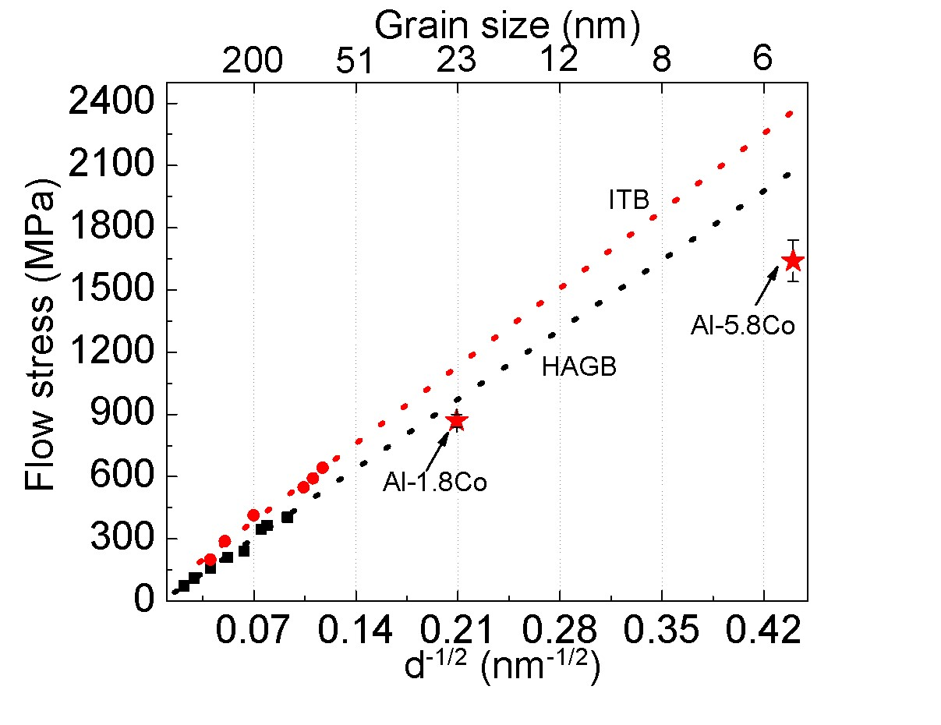Figure S9. The grain size versus flow stress plot of Al and AlMg alloys. The black squares indicate equal-channel angular pressing (ECAP) Al and AlMg alloys with high angle grain boundaries (HAGB) [7,8]. The red circles show Al and AlMg thin films with high-density incoherent twin boundaries [9].

Supplementary video captions:
Video S1: The in-situ micropillar compression video of pure Al.
Video S2: The in-situ micropillar compression video of nanotwinned Al-1.8 Co.
Video S3: The in-situ micropillar compression video of nanotwinned Al-5.8 Co.

[1] P. E. Blöchl, Physical review B 50, 17953 (1994).
[2] D. C. Langreth and M. Mehl, Physical Review B 28, 1809 (1983).
[3] J. P. Perdew, K. Burke, and M. Ernzerhof, Physical review letters 77, 3865 (1996).
[4] G. Kresse and D. Joubert, Physical Review B 59, 1758 (1999).
[5] H. J. Monkhorst and J. D. Pack, Physical review B 13, 5188 (1976).
[6] R. Rautioaho, physica status solidi (b) 112, 83 (1982).
[7] N. Tsuji, Y. Ito, Y. Saito, and Y. Minamino, Scripta materialia 47, 893 (2002).
[8] R. Hayes, D. Witkin, F. Zhou, and E. Lavernia, Acta materialia 52, 4259 (2004).
[9] D. Bufford, Y. Liu, Y. Zhu, Z. Bi, Q. Jia, H. Wang, and X. Zhang, Materials Research Letters 1, 51 (2013).

