Supplementary information

Deformation induced intermediate metastable lattice structures facilitate ordered B2 nucleation in a fcc-based high entropy alloy

Deep Choudhuri^{1,2}* Shivakant Shukla², Bharat Gwalani¹, Rajarshi Banerjee^{1,2}, and R.S. Mishra^{1,2}

¹ Advanced Materials and Manufacturing Processes Institute, University of North Texas
Denton, TX-76207, USA
² Department of Materials Science and Engineering, University of North Texas
Denton, TX-76207, USA

*Corresponding author: deep.choudhuri@unt.edu

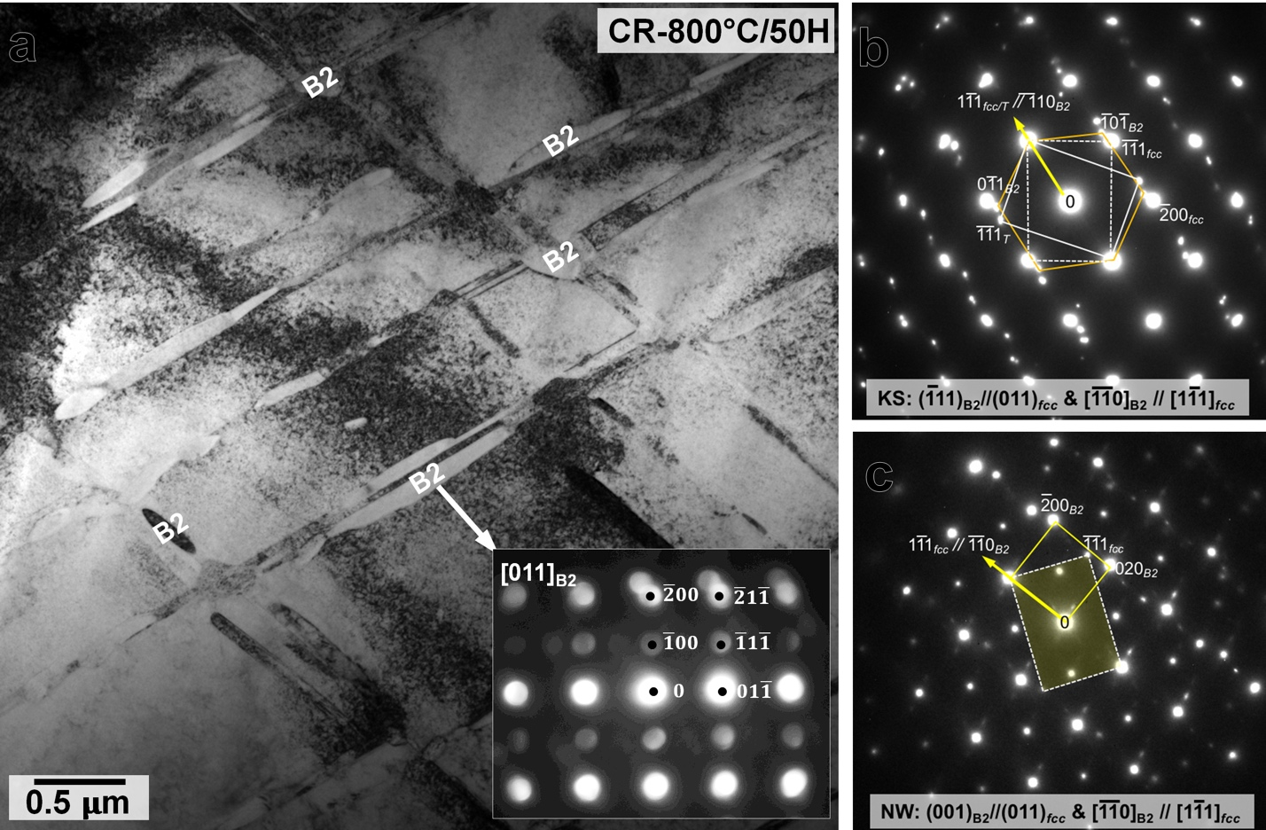
Supplementary Figure S1. Microstructure after annealing at 800˚C for 50H. (a) BFTEM showing arrangement of B2 precipitates along the twin boundaries. Inset shows the [011]_{B2} micro-diffraction pattern from a B2 plate. SADP patterns recorded from different regions show that the B2 plates share both (a) Kurdjumov-Sachs and (c) Nishiyama-Wasserman orientation relationships with the parent fcc phase.

Supplementary Figure S2. Microstructure after annealing at 800˚C for 0.5H (30 mins). (a) a DFTEM showing B2 precipitates decorated along the twin boundaries, and (b) a g-3g weak-beam DFTEM using g=${[\overline{1}1\overline{1}]}_{fcc}$ shows the fringes at the B2-fcc interface.

Supplementary Figure S3. Microstructure after annealing at 800˚C for 0.5H (30 mins). (a) SADP depicting Nishiyama-Wasserman OR between B2 and fcc, and a corresponding HRTEM showing B2 precipitate next to the fcc matrix. The inset in (b) depicts (001) ordering within B2.

Supplementary Figure S4. STEM-EDS results of (a) elemental map of the cold-rolled microstructure, and line profiles across B2 precipitates after (b) 0.5H (30 mins) and (c) 50H of annealing at 800˚C.

Supplementary Table 1. B2 composition in at.% at different stages of annealing.
 | Al |  | Co |  | Cr |  | Fe |  | Ni
Time (H) | Avg | Stdev | Avg | Stdev | Avg | Stdev | Avg | Stdev | Avg | Stdev
0.5 | 3.90 | 1.27 | 22.55 | 3.00 | 22.55 | 3.00 | 13.17 | 1.83 | 55.20 | 3.47
50 | 18.94 | 0.98 | 14.30 | 1.76 | 2.03 | 0.58 | 9.20 | 1.37 | 55.53 | 1.87

