Supplementary Information:
Direct Analysis Real Time-High Resolution Mass Spectrometry to discriminate Triticum species.

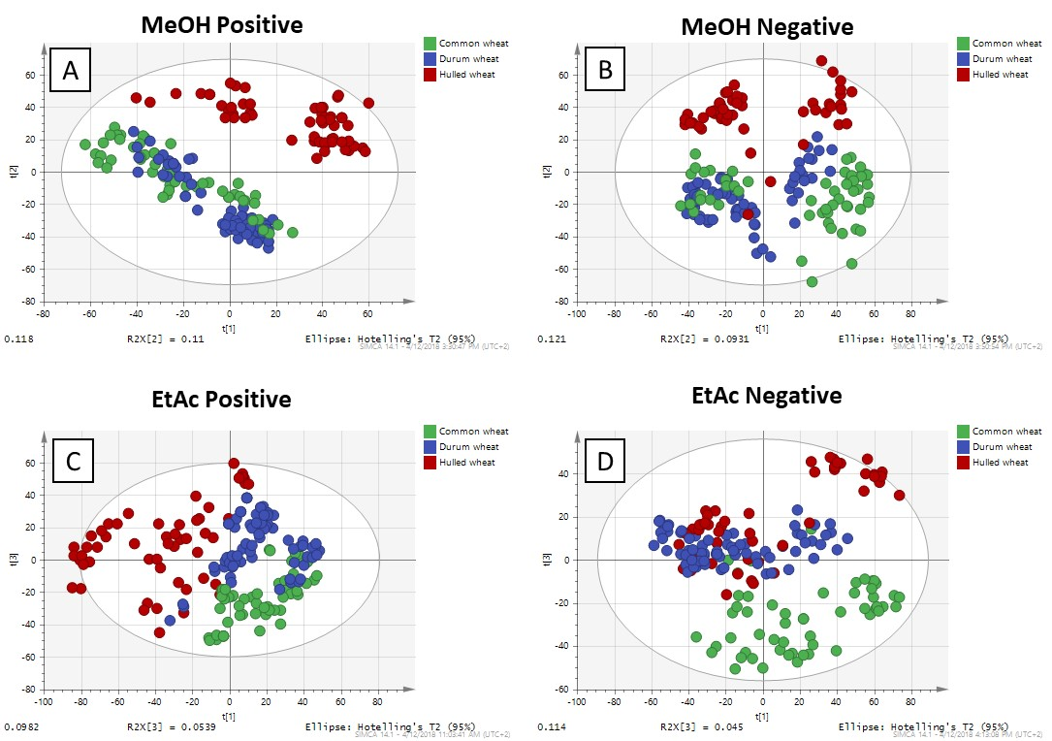
Figure 1S. Comparison of metabolic fingerprinting obtained using different extraction procedures and DART–HRMS analysis. PCA scores plot for methanol/water extract analyzed in positive (A) and negative (B) ionization modes; ethyl acetate extract run in positive (C) and negative (D) modes.

Table 1S. Summary of parameters considered in the evaluation of the four models built. R²X (cum) represent the variance of the x variable explained by the model, while Q² is the cumulative predicted variation in the Y matrix.

Considered parameters | Positive ionization mode |  |  | Negative ionization mode
 | Ethyl Acetate | MeOH/Water |  | Ethyl Acetate | MeOH/Water
Aligned metabolites | 4537 | 3648 |  | 4846 | 3295
R²X (cum) PCA | 0.482 | 0.497 |  | 0.454 | 0.444
Q² (cum) PCA | 0.392 | 0.373 |  | 0.305 | 0.322

